Experience Levels

Our survey includes detailed information about levels of experience in R graphic basics, R advanced, Reproducible documentation with R, Matlab, and Github, which gives us more insight than the yes-or-no response of the technical background of our students. With regard to this information, how the numbers of students of different levels distribute for each of above tools? Is there any tool most students are familiar with, or any little students know? How varied are the distributions for different tools?

We use a stacked bar chart to visualize the distributions of numbers of students of different levels. Here is a link to it:

[https://rawgit.com/QianyiZhao/EDAV-Project-1/master/plot_tool_experience_level/experience_le](https://rawgit.com/QianyiZhao/EDAV-Project-1/master/plot_tool_experience_level/experience_level.html)

[vel.html](https://rawgit.com/QianyiZhao/EDAV-Project-1/master/plot_tool_experience_level/experience_level.html)

This chart is realignable, e.g. it aligns at the level clicked on, for better and clearer comparison between distributions for different tools. As an example, the following screenshot of it shows it aligning at the level “Confident”.

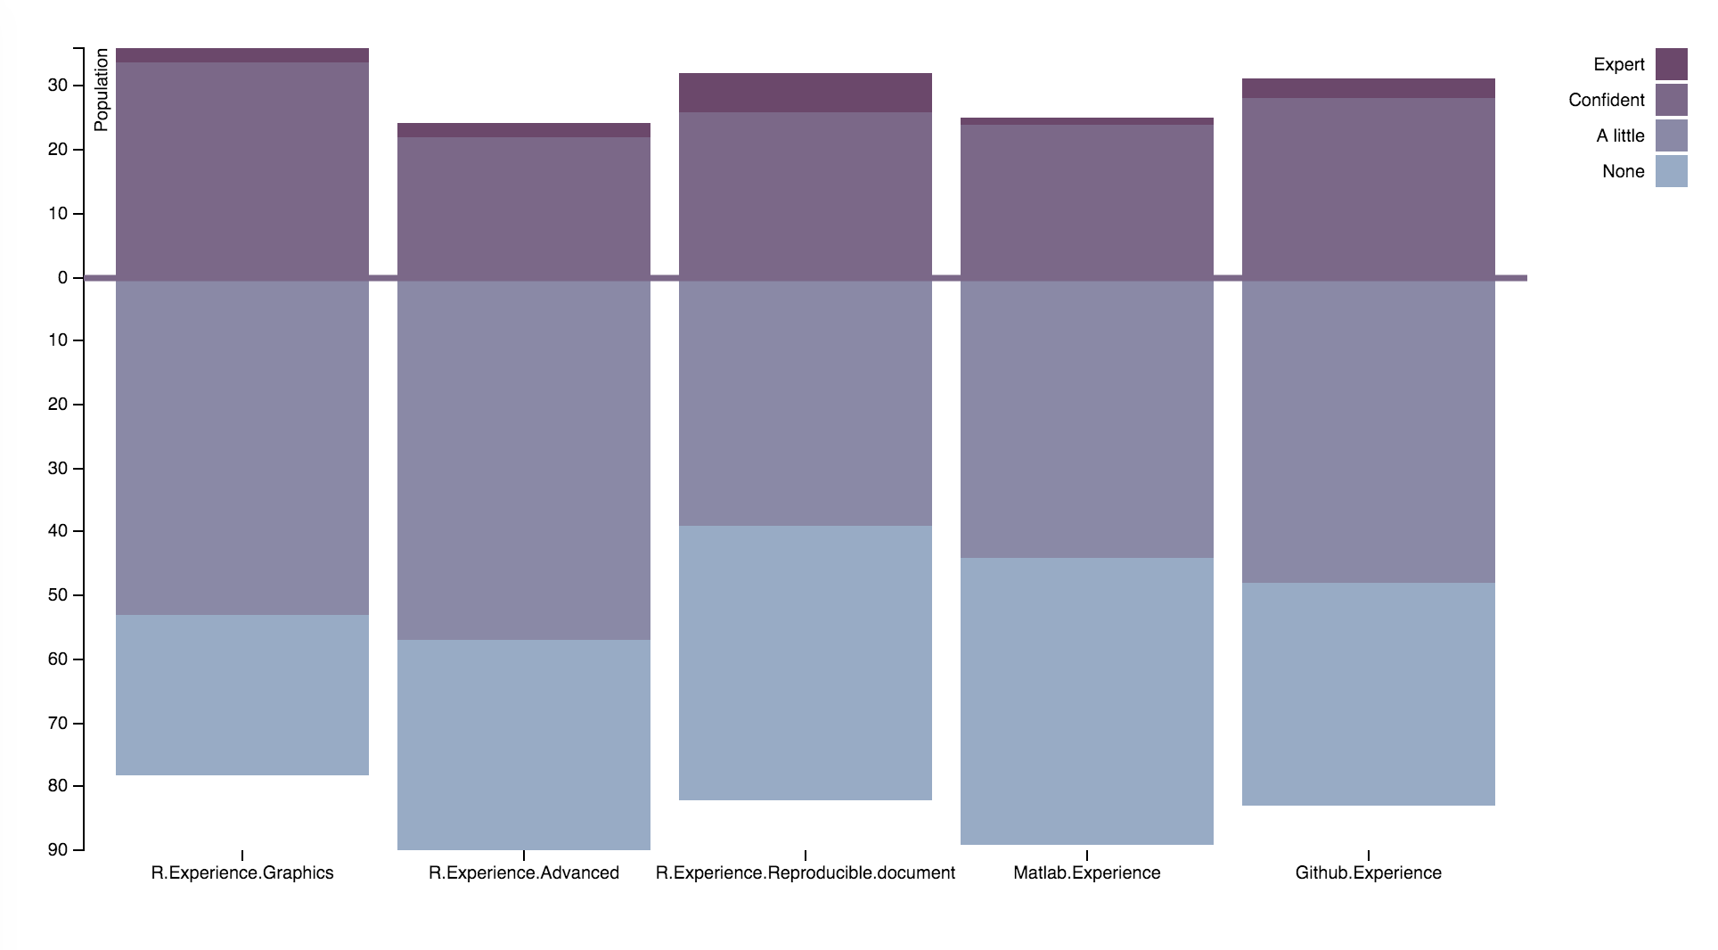

It is clear that, for all of the tools, the majority of the students have experience level lower than the baseline, e.g. just a little of even none experience. This result justifies the importance of learning the tools in our course.

Also, the tools seem to have similar distributions, though among which R reproducible document has most expert users (this will be more obvious if aligns at the level “Expert”), and R graphics has most confident or better users (ironically, :( , our report is in .docx format).