Lec 7 Compositional semantics and sentence representations

Semantic composition

The meaning of a sentence is determined by the meaning of words+gramma.

Eg. What is the meaning of following sentence? 分析它的语法来猜测它的意思

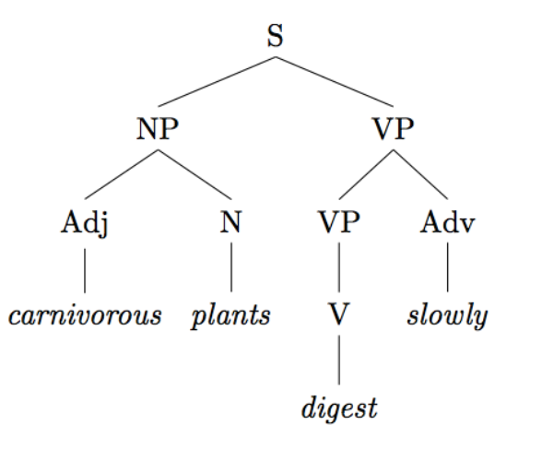

semantic composition model 所遇到的困难/无法解决的问题 (slide 10)

Similar syntactic structures may have different meanings

Different syntactic structures may have the same meaning

Idioms

Logical metonymy

Metaphor

Recursive ccomposition

Modelling compositional semantics

Unsupervised: compositional distributional semantics (in vector space)

Vector mixture model:

Assumption: old, dog, old dog have the same dim

phrase = 两个word相加 old+dog=old dog

phrase = 两个word相乘 old elementwise\* dog = ??

Lexical function model

Phrase (old dog) = Matrix(adj, old) \* Vector (noun, dog)

How to learn adj matrix (slide 33)

Supervised: neural network. Compositional semantics with NN

Def:Learn sentence(or phrase) representation

Make predictions based on sentence (or phrase) representation

BOW

Continuous BOW

Deep Continuous BOW

Deep CBOW with pretrained word embeddings

LSTM

Tree LSTM

Tree LSTM variants: Child sum tree LSTM, N-ary Tree LSTM

Lec8 Discourse Processing

Rhetorical relation

Explanation, narration, justification

Coherence

Salience rule