MATH 6602 HW 20

Qiaochu Zhang

For global finite difference, I first use all points to calculate the derivative for x and then use Euler forward for t, but it seems that the error always blows up. So I do not show it in the graph.

For u1, T=3

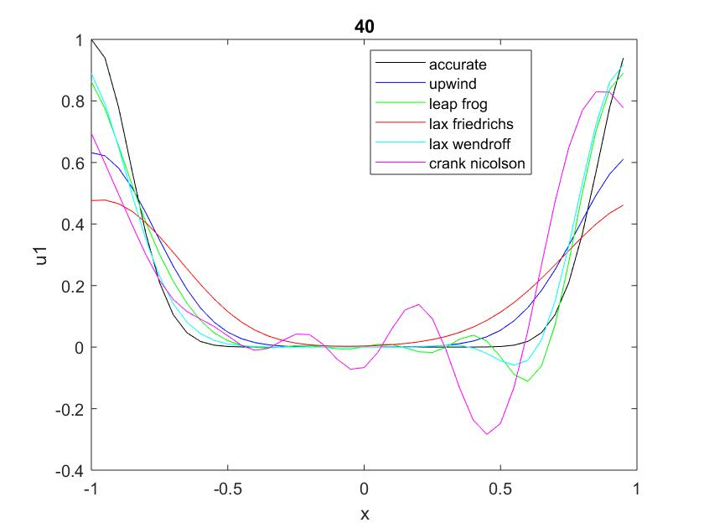

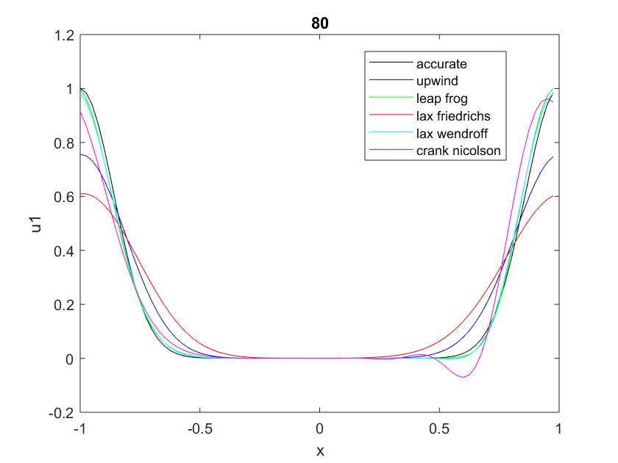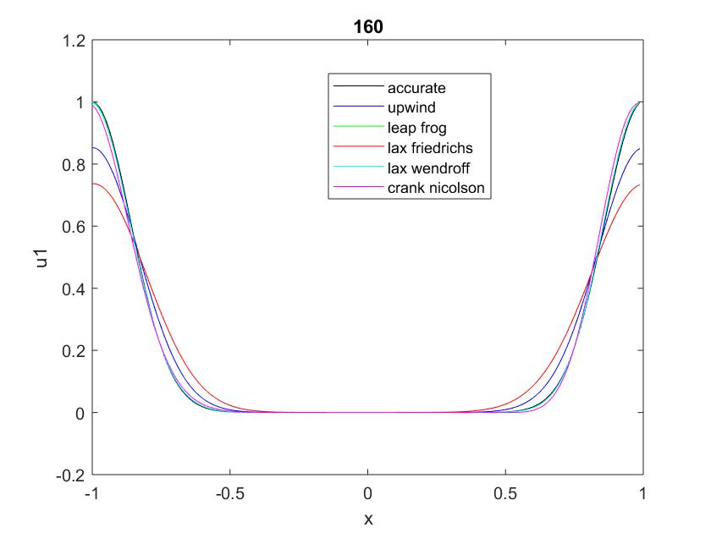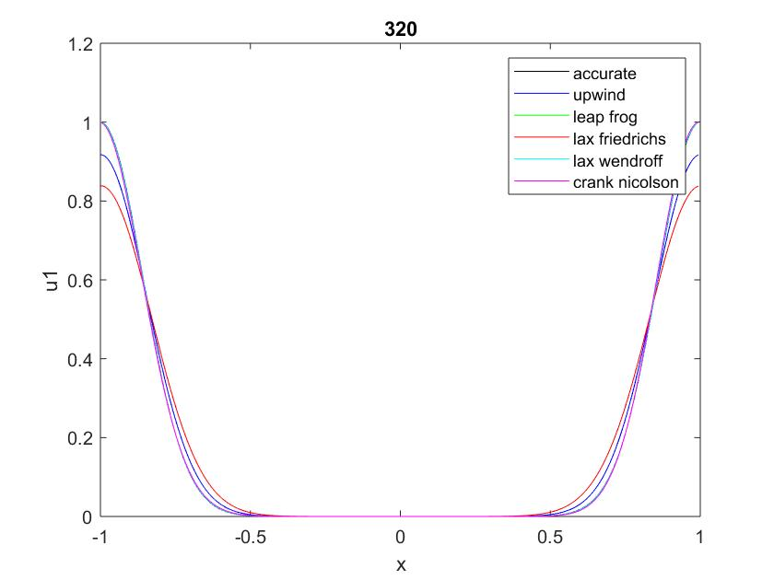

For u1 T=30

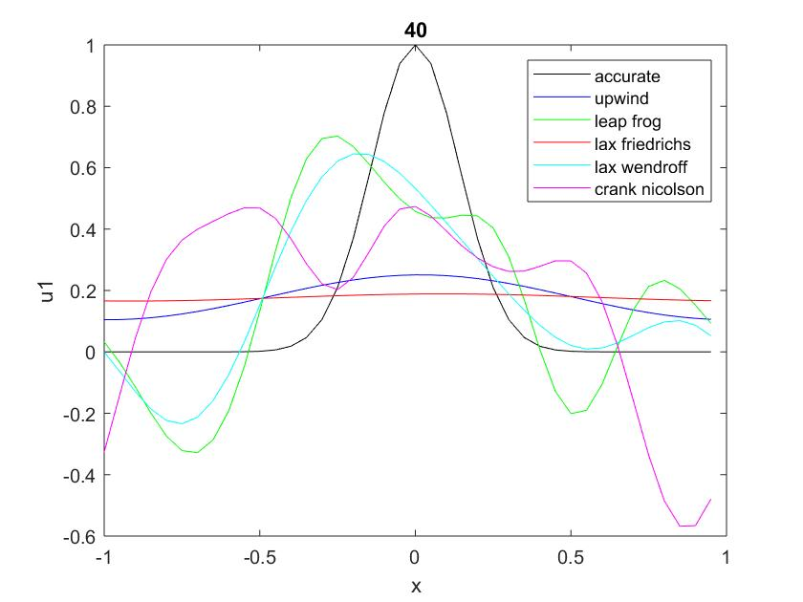

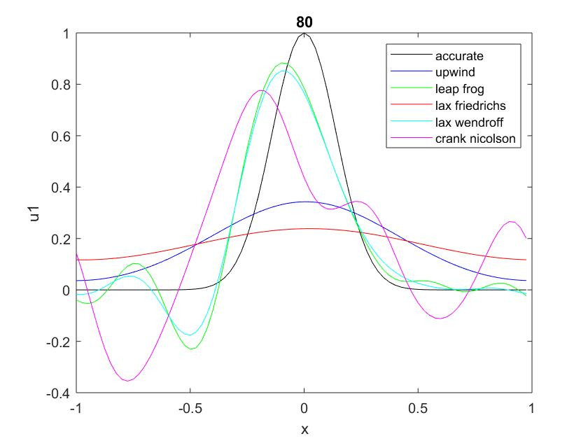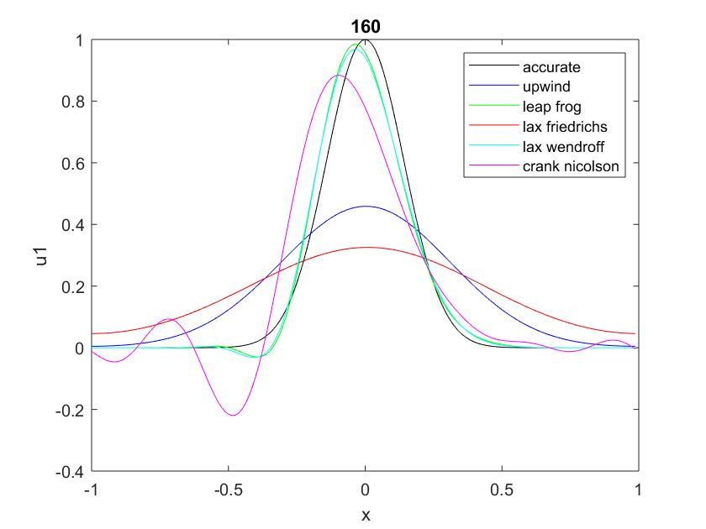

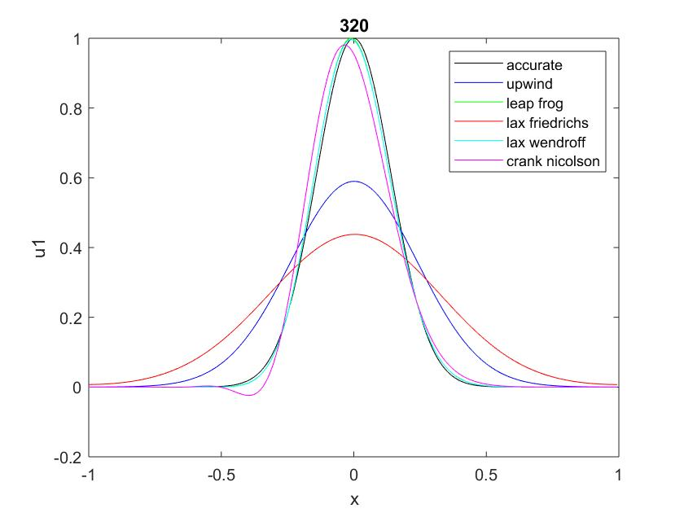

For u2 T=3

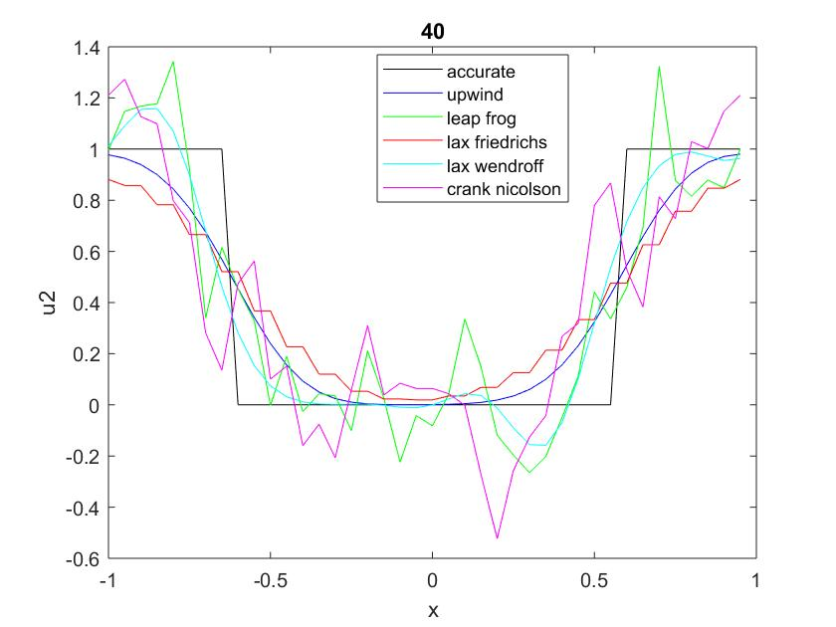

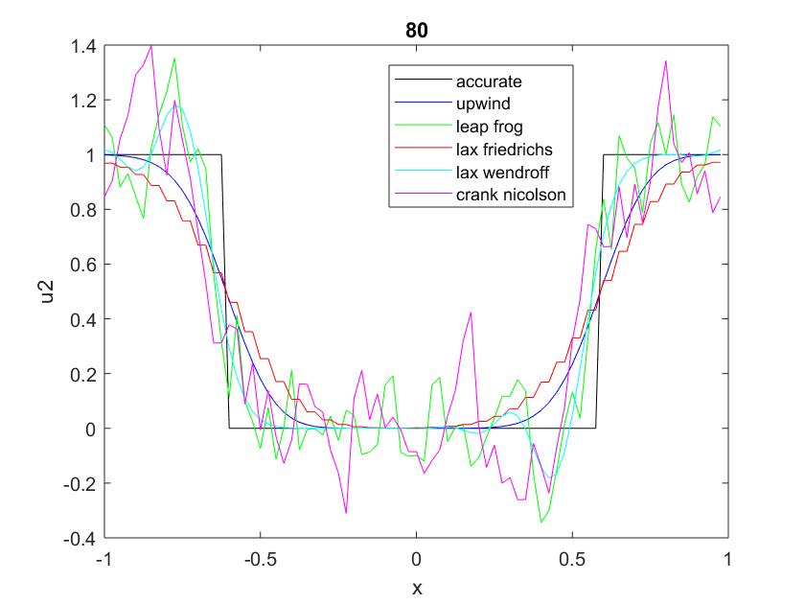

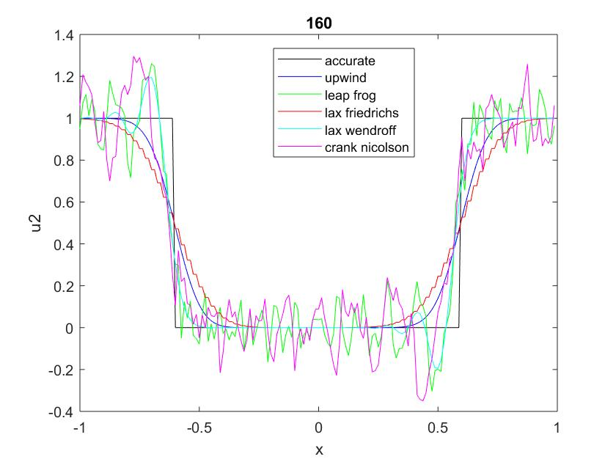

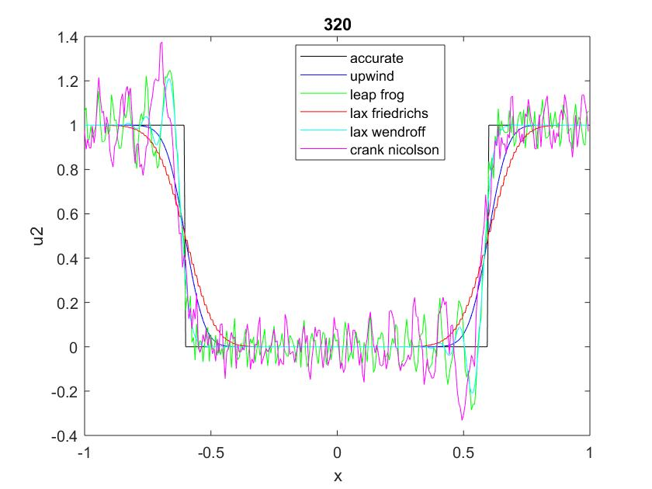

For u2 T=30

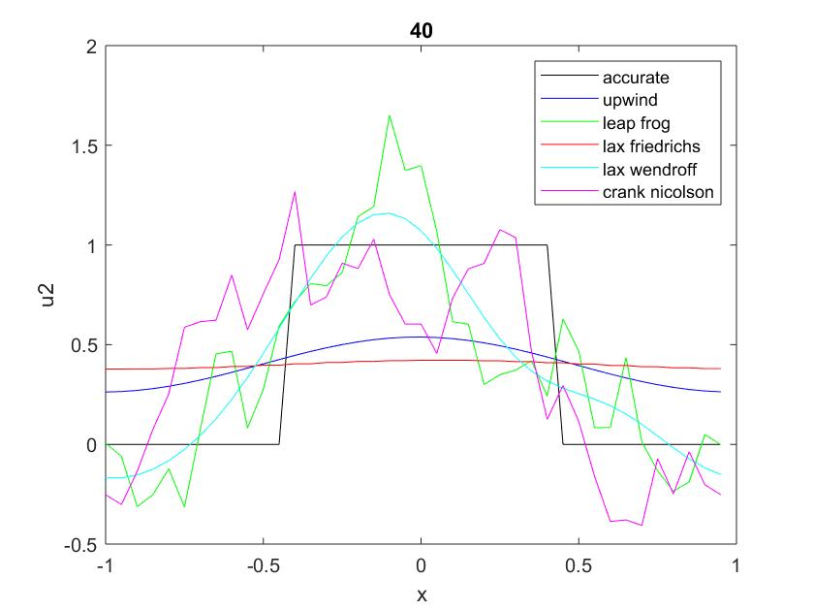

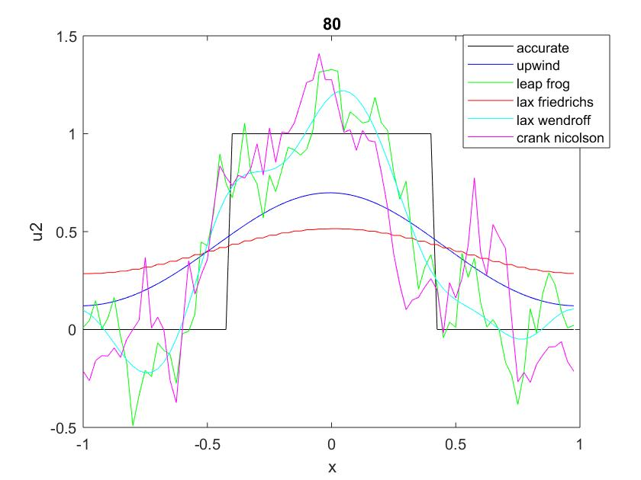

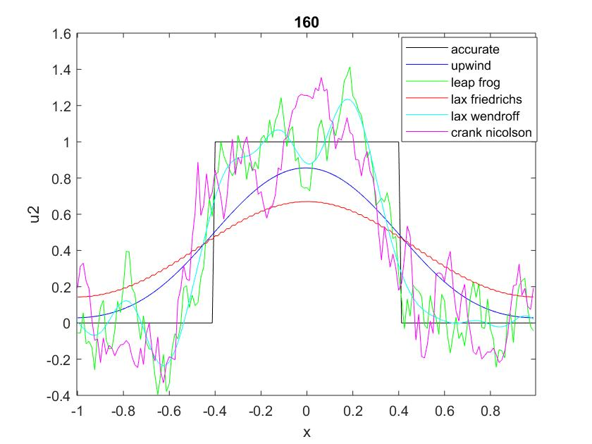

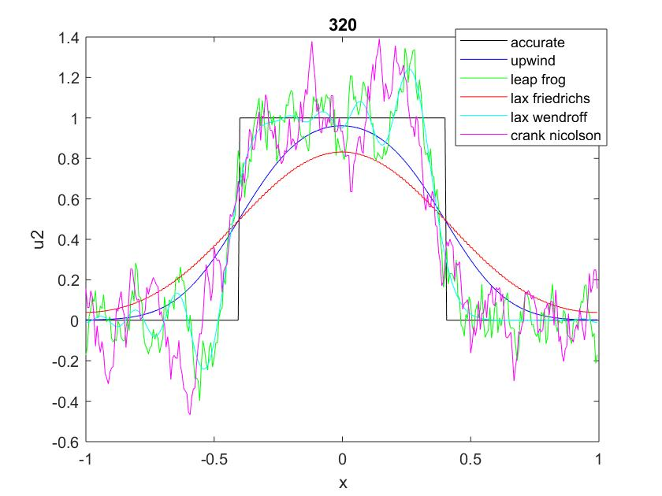

All the graphs above the results I achieve from Matlab (CFL=0.8).

By comparing them, I find some characteristics:

1. If other conditions are the same, the more grid points the higher efficiency.
2. Usually smoothness and accuracy cannot be achieved at the same time. If one method is very smooth, it may lose some information about a sharp change. Upwind and Lax Friedrich are always very smooth but they lose a lot of information, so they are not suitable for catching a shock. Usually Upwind method gives a better result than Lax Friedrichs (greater accuracy and smoothness).
3. Crank Nicolson, Leap Frog and Lax Wendroff are sharper than former methods, and within them: sharpness: Crank Nicolson > Leap Frog > Lax Wendroff. But Crank Nicolson sometimes give the largest deviation (a lot of unreasonable fluctuation) when the grid points are not enough or the curves is very sharp. Lax Wendroff does not give very sharp results so its ability to capture shock is also not very good.

Code:

NT=[40 80 160 320];

T=30;

for i=1:4

N=NT(i);

dx=2/N;

cfl=0.8;

dt=cfl*dx;

x=zeros(1,N);

u1=x;

u2=x;

u1_acu=u1;

u2_acu=u2;

u1lft=u1;

u2lft=u2;

D=zeros(N,N);

for j=1:N

x(j)=-1+(j-1)*dx;

u1(j)=exp(-x(j)^2/.04);

if x(j)>=-0.4 && x(j)<=0.4

u2(j)=1;

else

u2(j)=0;

end

end

Nt=round(T/dt);

Nx=N;

xgrid=(-1):dx:(-1+(Nx-1)*dx);

Nxs=Nx+1;

u1up=u1;

u2up=u2;

u1lf0=u1;

u2lf0=u2;

for kk1=1:N

for jj1=1:N

if kk1==jj1

D(kk1,jj1)=0;

else

D(kk1,jj1)=pi/2*(-1)^(kk1-jj1)/sin(pi/N*(kk1-jj1));

end

end

end

for kxa=1:Nx

xt=dx*(kxa-1)-1-T;

% u1_acu(kxa)=exp(-xt^2/0.04);

xt_j=abs(xt)+1-2*floor((abs(xt)+1)/2)-1;

u1_acu(kxa)=exp(-xt_j^2/.04);

if xt_j>=-0.4 && xt_j<=0.4

u2_acu(kxa)=1;

else

u2_acu(kxa)=0;

end

end

for k21=1:Nx

u1lf0tem=[u1lf0(end),u1lf0,u1lf0(1)];

u2lf0tem=[u2lf0(end),u2lf0,u2lf0(1)];

u1lf0(k21)=u1lf0tem(k21+1)-dt/dx/2*(u1lf0tem(k21+2)-u1lf0tem(k21));

u2lf0(k21)=u2lf0tem(k21+1)-dt/dx/2*(u2lf0tem(k21+2)-u2lf0tem(k21));

end

u1lftem1=u1;

u2lftem1=u2;

u1lftem2=u1lf0;

u2lftem2=u2lf0;

u1lf=u1;

u2lf=u2;

u1lw=u1;

u2lw=u2;

u1temcn=u1';

u2temcn=u2';

u1gl=u1';

u2gl=u2';

for kt=1:Nt

u1temup=[u1up(end),u1up];

u2temup=[u2up(end),u2up];

u1lftem=[u1lftem2(end),u1lftem2,u1lftem2(1)];

u2lftem=[u2lftem2(end),u2lftem2,u2lftem2(1)];

u1temlf=[u1lf(end),u1lf,u1lf(1)];

u2temlf=[u2lf(end),u2lf,u2lf(1)];

u1temlw=[u1lw(end),u1lw,u1lw(1)];

u2temlw=[u2lw(end),u2lw,u2lw(1)];

%Crank Nicolson

cn=dt/4/dx;

Mcn=diag(ones(1,Nx))+diag(cn*ones(1,(Nx-1)),1)-diag(cn*ones(1,(Nx-1)),-1);

Mcn(1,Nx)=-cn;

Mcn(Nx,1)=cn;

u1cn=Mcn\(Mcn'*u1temcn);

u2cn=Mcn\(Mcn'*u2temcn);

u1temcn=u1cn;

u2temcn=u2cn;

u1cn0=u1cn';

u2cn0=u2cn';

%Global

u1gltem=u1gl;

u2gltem=u2gl;

du1gl=D*u1gltem;

du2gl=D*u2gltem;

u1gl=u1gltem-dt*du1gl;

u2gl=u2gltem-dt*du2gl;

for kx=1:Nx

% Upwind

u1up(kx)=u1temup(kx+1)-dt/dx*(u1temup(kx+1)-u1temup(kx));

u2up(kx)=u2temup(kx+1)-dt/dx*(u2temup(kx+1)-u2temup(kx));

%leap frog

u1lft(kx)=u1lftem1(kx)-dt/dx*(u1lftem(kx+2)-u1lftem(kx));

u2lft(kx)=u2lftem1(kx)-dt/dx*(u2lftem(kx+2)-u2lftem(kx));

% lax friedrich

u1lf(kx)=.5*(u1temlf(kx)+u1temlf(kx+2))-dt/dx/2*(-u1temlf(kx)+u1temlf(kx+2));

u2lf(kx)=.5*(u2temlf(kx)+u2temlf(kx+2))-dt/dx/2*(-u2temlf(kx)+u2temlf(kx+2));

%lax wendroff

u1lw(kx)=u1temlw(kx+1)+dt^2/dx^2/2*(u1temlw(kx)+u1temlw(kx+2)-2*u1temlw(kx+1))-dt/dx/2*(-u1temlw(kx)+u1temlw(kx+2));

u2lw(kx)=u2temlw(kx+1)+dt^2/dx^2/2*(u2temlw(kx)+u2temlw(kx+2)-2*u2temlw(kx+1))-dt/dx/2*(-u2temlw(kx)+u2temlw(kx+2));

end

u1lftem1=u1lftem2;

u2lftem1=u2lftem2;

u1lftem2=u1lft;

u2lftem2=u2lft;

end

u1lfr=u1lftem1;

u2lfr=u2lftem1;

figure(10*i)

plot(xgrid,u1_acu,'k')

hold on

plot(xgrid,u1up,'b')

plot(xgrid,u1lfr,'g')

plot(xgrid,u1lf,'r')

plot(xgrid,u1lw,'c')

plot(xgrid,u1cn0,'m')

% plot(xgrid,u1gl,'y')

hold off

legend('accurate','upwind','leap frog','lax friedrichs','lax wendroff','crank nicolson','global')

ss=num2str(N);

title(ss);

xlabel('x')

ylabel('u1')

% figure(100*i)

% plot(xgrid,u1_acu,'k')

% figure(100*i+1)

% plot(xgrid,u2_acu)

figure(10*i+1)

plot(xgrid,u2_acu,'k')

hold on

plot(xgrid,u2up,'b')

plot(xgrid,u2lfr,'g')

plot(xgrid,u2lf,'r')

plot(xgrid,u2lw,'c')

plot(xgrid,u2cn0,'m')

% plot(xgrid,u2gl,'y')

hold off

legend('accurate','upwind','leap frog','lax friedrichs','lax wendroff','crank nicolson','global')

title(ss);

xlabel('x')

ylabel('u2')

end