# HW 21 MATH 6602

# Qiaochu Zhang

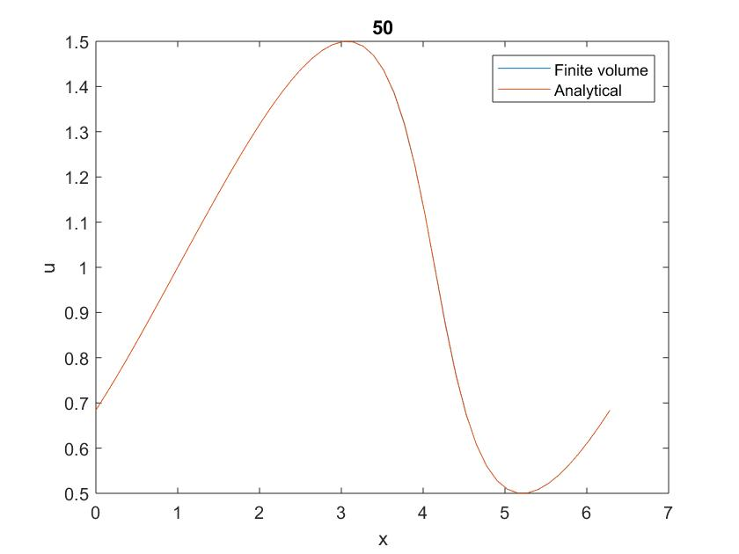

Figure 1. T=1 N=50

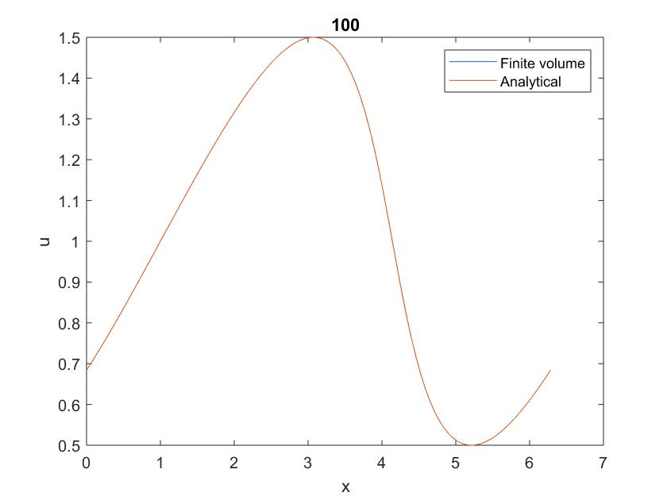

Figure 2. T=1 N=100

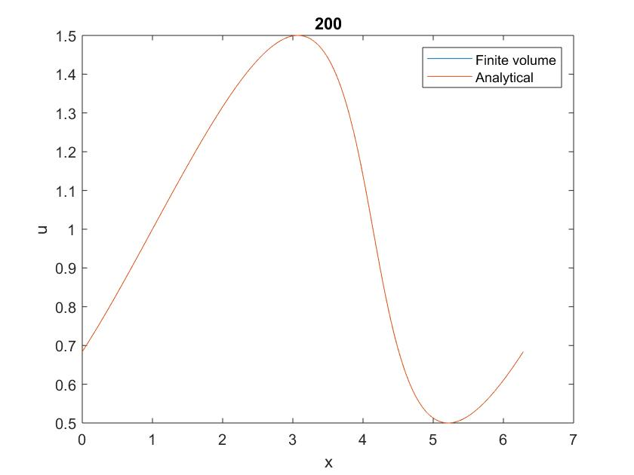

Figure 3. T=1 N=200

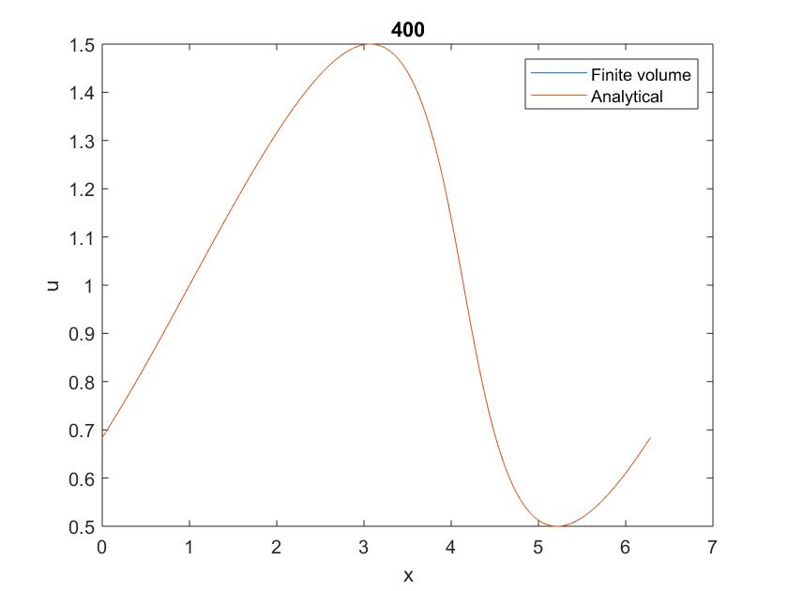

Figure 4. T=1 N=400

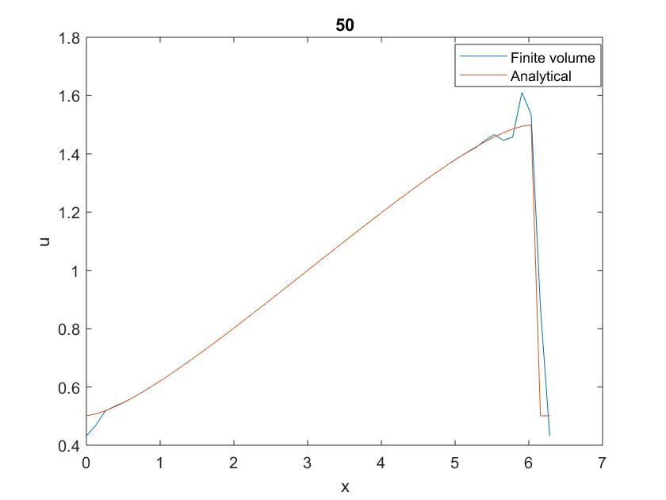

Figure 5. T=3 N=50

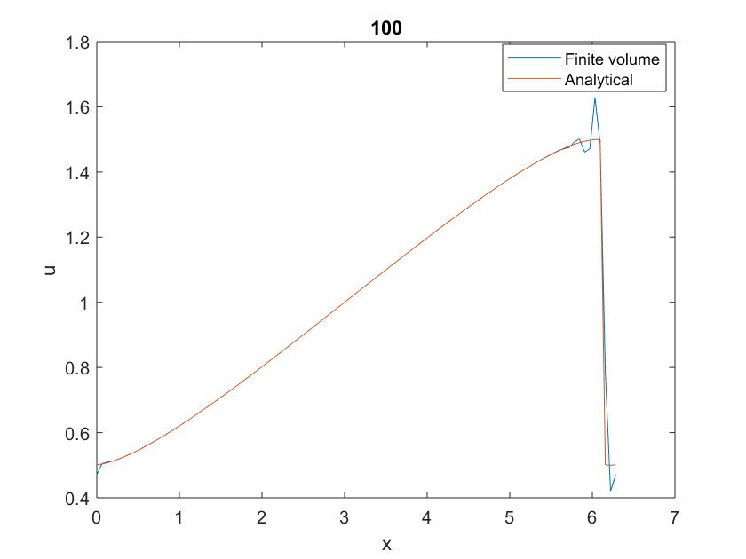

Figure 6. T=3 N=100

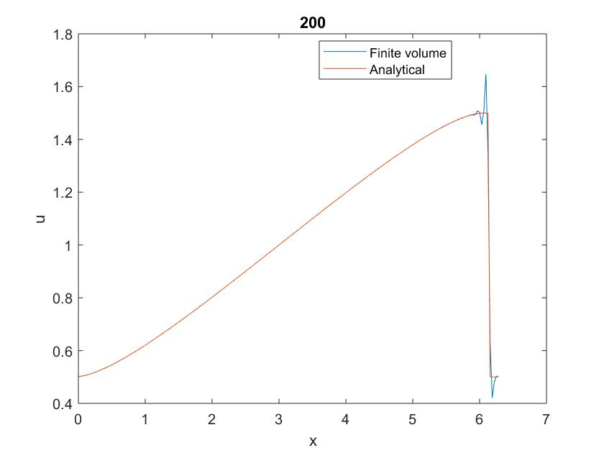

Figure 7. T=3 N=200

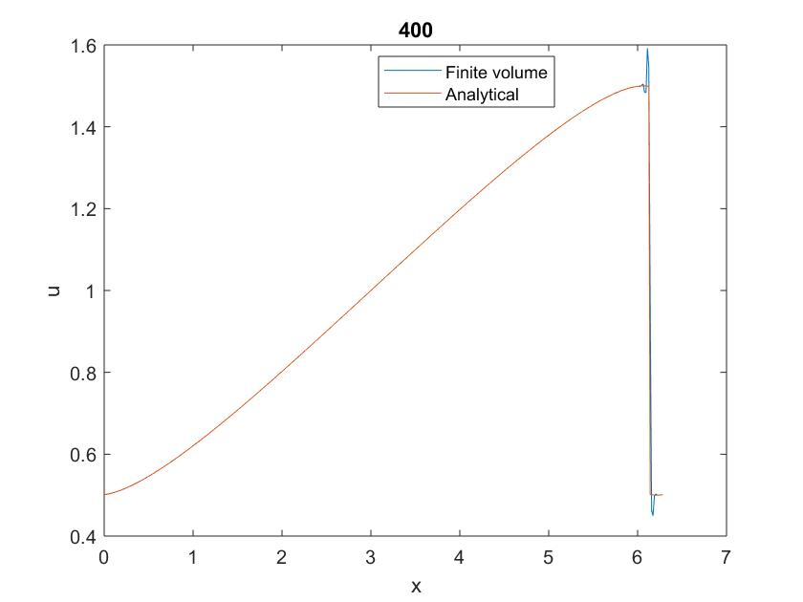

Figure 8. T=3 N=400

## Error for T=1:

|  |  |  |  |  |
| --- | --- | --- | --- | --- |
| N | 50 | 100 | 200 | 400 |
| Error | 0.000463 | 6.15E-05 | 7.92E-06 | 1.14E-06 |

Comments:

Here I use dt=0.01. This is semi-discrete mode for pde, so the accuracy about time and space is independent.

For T=1, from figure 1-4 we can see that the results from finite volume method and analytical solution overlap so we can only see one red curve on the graph. So the accuracy of finite volume method is very high. But based on the error form we can know as N doubles, Δx decreases by half, the error decrease to about 1/8 the value that it was. The speed of the decrease of the error is also very high.

For T=3, from figure 5-8 we can see both solutions overlap in smooth parts and there is a sharp change at the (T+ $π$), where there may be a shock. And around the shock, the analytical solution performs better because there is Gibbs phenomenon around the shock for numerical method (finite volume method). And as we increase N we can see the accuracy around the shock improves but there is still two spikes near the shock because of the high energy and instability at the shock.

## Code:

NT=[50 100 200 400];

global T

T=1;

global dx

global N

global m

app=0;

app1=0;

kkp=100*ones(4,(N+1));

error=ones(1,4);

for i=1:4

% i=4;

N=NT(i);

xp=2*pi;

dx=xp/N;

dt=0.01;

cfl=1.5*dt/dx;

% dt=.8*dx;

Ntime=round(T/dt);

% cfl=dt/dx

x=ones(1,N);

u_a=x;

u_p=ones(1,N+1);

for j=1:N

x(j)=0+(j-1)*dx;

u_a(j)=(fhw21cos(x(j)+dx)-fhw21cos(x(j)))/dx;

end

for it=1:Ntime

uatem=u_a;

% u_a=fivohw21(uatem)*dt+uatem;

k1=fivohw21(uatem);

k2=fivohw21(uatem+.5*k1*dt);

k3=fivohw21(uatem-k1*dt+k2*dt*2);

u_a=uatem+1/6*dt*(k1+4*k2+k3);

% figure(100)

% plot(u_a)

% drawnow

end

% figure(88)

% plot(u_a)

u_ab=[u_a(N-1),u_a(N),u_a,u_a(1)];

x_p=[x,(x(N)+dx)];

x_ana1=zeros(1,(N+1));

x_ana2=x_ana1;

x_ana=x_ana1;

u_ana=x_ana;

for m=1:(N+1)

u_p(m)=-1/6*u_ab(m)+5/6*u_ab(m+1)+1/3*u_ab(m+2);

ppana1=dx*(m-1)-3/2*T;

x_ana1(m)=fsolve(@fhw21sin,ppana1);

% n1=0;

% n2=0;

% while fhw21sin(x_ana1(m))>0.001

% n1=n1+1;

% % tt11=x_ana1(m);

% ppana1=ppana1+0.1;

% x_ana1(m)=fsolve(@fhw21sin,ppana1);

% if n1>31

% app1=500;

% break

% end

% end

ppana2=dx*(m-1)-1/2*T;

x_ana2(m)=fsolve(@fhw21sin,ppana2);

% while fhw21sin(x_ana2(m))>0.001

% % tt11=x_ana2(m);

% n2=n2+1;

% ppana2=ppana2-0.1;

% x_ana1(m)=fsolve(@fhw21sin,ppana2);

% if n2>30

% app1=501;

% break

% end

% end

f_ana1=fhw21sin(x_ana1(m));

f_ana2=fhw21sin(x_ana2(m));

xxnew=(m-1)*dx;

if abs(x_ana1(m)-x_ana2(m))<10^(-6)

x_ana(m)=x_ana1(m);

kkp(i,m)=0;

elseif abs(f_ana1)<abs(f_ana2) && abs(f_ana1-f_ana2)>10^(-6)

x_ana(m)=x_ana1(m);

kkp(i,m)=1;

elseif abs(f_ana1)>abs(f_ana2) && abs(f_ana1-f_ana2)>10^(-6)

x_ana(m)=x_ana2(m);

kkp(i,m)=2;

elseif abs(f_ana1)<10^(-6) && abs(f_ana2)<10^(-6)

xjg=(xxnew-T);

if xjg<pi && xjg>0

x_ana(m)=x_ana1(m);

kkp(i,m)=3;

else

x_ana(m)=x_ana2(m);

kkp(i,m)=4;

end

else

app=99;

kkp(i,m)=5;

break

end

u_ana(m)=1+.5*sin(x_ana(m));

end

% if app==99

% break

% end

figure(i)

plot(x_p,u_p)

hold on

plot(x_p,u_ana)

hold off

legend('Finite volume','Analytical')

xlabel('x')

ylabel('u')

title(NT(i))

% figure(i*2)

% plot(x_p,u_p)

% drawnow

% xlabel('x')

% ylabel('u')

% figure(i*3)

% plot(x_p,u_ana)

% drawnow

% xlabel('x')

% ylabel('u')

error(i)=norm(u_ana-u_p)/((N+1)^0.5);

end

function f=fhw21sin(x)

global m

global T

global dx

f=T+.5*sin(x)*T-(m-1)*dx+x;

function f=fhw21cos(x)

f=x-.5*cos(x);

function f=fivohw21(u)

global dx

global N

utem=[u(N-1),u(N),u,u(1)];

Nt=N+1;

u05=zeros(1,Nt);

f05=u05;

for ii=1:Nt

u05(ii)=-1/6*utem(ii)+5/6*utem(ii+1)+1/3*utem(ii+2);

f05(ii)=.5*u05(ii)^2;

end

f=zeros(1,N);

for jii=1:N

f(jii)=-(f05(jii+1)-f05(jii))/dx;

end