Analyzing COVID-19 Stimulus Checks and their Impact on Consumer Price Index

Qiaojuan Tu, Siting Liu, Mark Kelly

12/3/2021

# PROJECT DESCRIPTION

The coronavirus disease 2019 (COVID-19) pandemic is having a profound impact on the United States, especially on its economic aspects. In response to prevent the economy from going into a recession, the United States government passed the Coronavirus Aid, Relief, and Economic Security, known as **the CARES Act**, on March 25, 2020. To provide various means of aid to help American people get over the hard time as well as help the economy to recover, under the CARES Act, starting in March 2020, payments of $1,200 for each eligible adult and $500 for each qualifying child under age 17 were disseminated. In late December of 2020, **the Tax Relief Act** of 2020 was enacted, and in early March 2020, **the American Rescue Plan** of 2021 was enacted as pandemic continues evolving. In total of around $350 billion of the three rounds of Economic Impact Payments or called economic stimulus payments has been issued to state and local governments to distribute. Although the “free” cash may help people to support daily spending, people has been observing that goods they buy at grocery stores gets more expensive. From an economic perspective, the hypothesis of extra money flows into the market drives the price of goods to go up is reasonable. Therefore, this project will analyze the relationship between the issuance of Economic Impact Payments and the price of goods. In other words, how the increase of price of goods is associated with the COVID-19 relief payments.

In this project, there are two key variables that we are examining — amount of stimulus payments distributed over time and the Consumer Price Index (CPI) for each month. The CPI is a composite measurement of trends in the prices of a market basket of consumer goods and services and the data for CPI is obtained from the FRED Economic Data website. The raw data for the stimulus checks is obtained from the website of official Internal Revenue Service of the United States.

# RESEARCH QUESTIONS

The project is targeting the following of the research questions:

**Question 1**: Does price of goods shows abnormal increase during the COVID-19 pandemic periods?

**Question 2**: How does Economic Relief Payments during the COVID-19 pandemic impact the price of normal goods.

# STATISTICAL QUESTIONS

To answer the research questions, we investigated the following statistical questions:

**Question 1**: Does CPI change more over the COVID-19 pandemic period than it’s previous years?

**Question 2**: Does issuance of Economic Relief Payments over the COVID-19 pandemic period have a significant impact on the price of goods?

# VARIABLES OF INTEREST

We analyzed the two variables that obtained in the project; stimulus is used as explanatory variable, and the CPI is used as response variable. Since the data obtained only contains the CPI for 4 region of the United State, the stimulus is adjusted to be the monthly average of stimulus for each rounds of payments. Table 1 provides the name and a brief description of each variable along with the variable type and units.

# EXPLORATORY DATA ANALYSIS (EDA)

The value for the CPI data is obtained for both pre and during COVID-19 pandemic. We looked at the plot of CPI over the 15 months during pandemic (Figure 2) and before the pandemic (Figure 1), the slope for the CPI over time during the pandemic is more steeper than it’s previous slope. Further more, we calculated the averaged change in CPI for both periods, and the results shows in table 2 which the results matches the plots of Figure 1 and Figure 2.

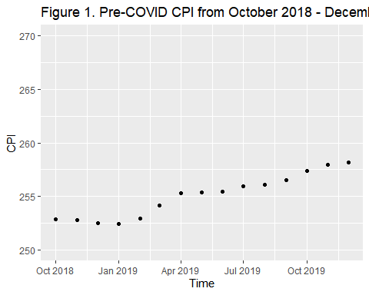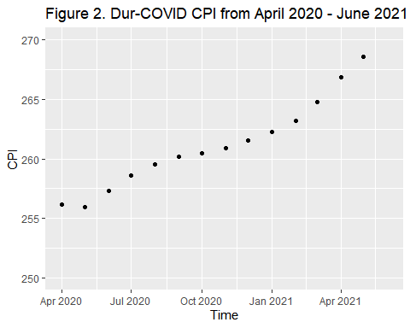

This exploratory data analysis answers the first research question that we conclude that the CPI changes more over the COVID-19 pandemic period compared to 15 month ahead of it. Further statistical analysis about the association will be conducted below.

Next, the data that we have lists all of the values for the CPI and the total amount of Stimulus checks in chronological order, starting at April 2020 to June 2021 by the regions. This gives us a hint that we want to look at the CPI and Stimulus check totals by region. We first want to plot the time series for the CPI by the regions of the Untied States.

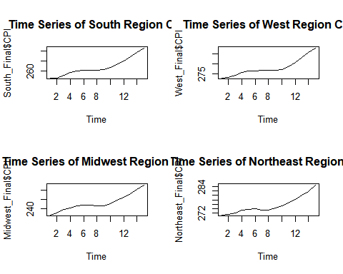 **Figure 3. Times Series for CPI by regions of the U.S.**

This gives us a detailed look at what the CPI looks like at each region. From here, we can see that each of the region’s CPI are non-stationary. Stationarity means that there is a constant mean over the given time period of our data and a variance that does not depend on the time. Since our data is not stationary, we need to transform our data in order to make it stationary. Once our data is stationary, we are able to then make inferences about our data.

In order to make our data stationary, we use time series regression. This process removes the nonstationarity from our model, which in turn will allow us to use these results to answer our questions.

# STATISTICAL ANALYSIS

In order to use regression to manipulate our data, we must first find out which of the time series models best fits our data. This is done by simulating ARMA(p,q) models with our data as a basis and looking at the results of the output. The coefficient(s) that are given will then be used to create the regression model that will be our final results.

Checking all possible ARMA(p,q) models, we found out that the ARMA(1,0) (also called AR(1)) model to provide the most beneficial results.

##   
## Call:  
## arima(x = residuals(regmodel2), order = c(1, 0, 0), include.mean = F)  
##   
## Coefficients:  
## ar1  
## 0.4647  
## s.e. 0.1186  
##   
## sigma^2 estimated as 9.636: log likelihood = -153.22, aic = 308.45

From the output, we can see that the AR(1) model with our data gives us an AIC value equal to $308.45$, which was the lowest of all the possible models. The coefficient that we will use for our regression model will be $0.4647$. The standard error given in the output tells us that there is no possibility of the value $0$ for our coefficient.

Next, we will create the regression model for our data using the AR(1) coefficient we found and the data that we are given. Below is the process of doing said regression model.

## (Intercept)   
## 235.1106

##   
## Call:  
## lm(formula = y.new ~ x.new + Master$Region[-1])  
##   
## Residuals:  
## Min 1Q Median 3Q Max   
## -25.2678 -1.5233 -0.4215 2.2237 6.4449   
##   
## Coefficients:  
## Estimate Std. Error t value Pr(>|t|)   
## (Intercept) 1.259e+02 1.631e+00 77.161 < 2e-16 ***  
## x.new 1.168e-06 4.347e-07 2.686 0.00958 **   
## Master$Region[-1]Northeast 1.937e+01 1.589e+00 12.190 < 2e-16 ***  
## Master$Region[-1]South 1.088e+01 1.659e+00 6.556 2.17e-08 ***  
## Master$Region[-1]West 2.052e+01 1.589e+00 12.914 < 2e-16 ***  
## ---  
## Signif. codes: 0 '***' 0.001 '**' 0.01 '*' 0.05 '.' 0.1 ' ' 1  
##   
## Residual standard error: 4.35 on 54 degrees of freedom  
## Multiple R-squared: 0.8021, Adjusted R-squared: 0.7874   
## F-statistic: 54.71 on 4 and 54 DF, p-value: < 2.2e-16

From this output, we can see that there is a significant relationship between the CPI and Stimulus checks by the regions of the United States using a 95% confidence level. The p-value for the Stimulus checks is 0.00958. The p-value for each of the regions is a very small value. Next, we want to see if the regression assumptions for our model are checked.

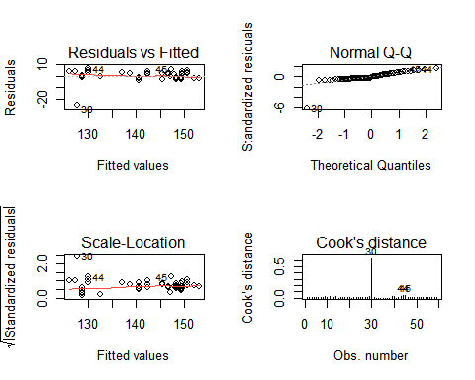

**Figure 4. Checking Assumptions**

We can see from our regression output that the assumptions are met. The only concern is for the data point 30 in our data which has a high Cook’s distance, however, it is the only point within our data with that high of a Cook’s distance. We also do not want to remove said data point since we’re working with limited data.

Next, we will take a look at the Autocorrelation Function (ACF) and Partial-Autocorrelation Function (PACF) for the residuals of our model.

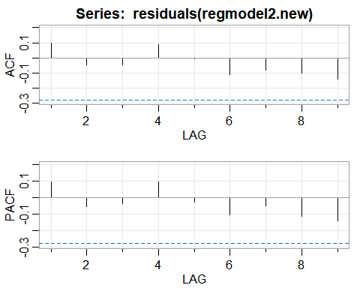

## [,1] [,2] [,3] [,4] [,5] [,6] [,7] [,8] [,9]  
## ACF 0.1 -0.04 -0.04 0.09 0.00 -0.11 -0.08 -0.10 -0.14  
## PACF 0.1 -0.05 -0.03 0.10 -0.03 -0.10 -0.05 -0.11 -0.14

**Figure 5. ACF and PACF of the regression**

Looking at Figure 5, we can see that there is no autocorrelation within the model that we created. This means that none of the data points influence the outcome or results of data points before or after it. In conclusion, we have a regression model that fits all assumptions.

# RECOMMENDATIONS

According to the times series analysis, there is a significant relationship between the CPI during the COVID-19 pandemic and the COVID Stimulus checks and the regions of the United States. When factoring the regions in the model, we see that the Stimulus checks has a significant effect to United States CPI.

# CONSIDERATIONS

Although this project has showed that there is a significant relationship between the issuance of COVID-19 pandemic relief payments and the price of goods over this period, distributing the money by the government may not be the only reason that drives the price of goods to go up. Considering the economic concepts behind this, price of goods goes up may simply be the reason of the high demand or shortage of a certain product.

Additionally, this study assumes that people would spend all of the payments that they get within each rounds of payments, and we expect the monetary effect reflects in the CPI in the month that person spends.We all know it’s never the case in real world. We suspect there are other factors that contribute the increase of CPI over the COVID-19 pandemic period, and further complicated methods could be used to extend this study.

*We would like to give a special “thank you” to Dr.Conor B Ryan, who is an Assistant Professor in the Department of Economics at Penn State, for the help and support to this project.*

# TECHNICAL APPENDIX

## R code

# clean up & set default chunk options  
rm(list = ls())  
knitr::opts_chunk$set(echo = FALSE)  
  
# packages  
library(data.table)  
library(readr)  
library(knitr)  
library(dplyr)  
library(ggplot2)  
library(kableExtra)  
library(lubridate)  
  
# inputs  
Variables <- read.csv("Variables_Table.csv")  
setnames(Variables, c("Variables", "Description", "Type", "Units"))  
  
Diff <- read.csv("CPI_Diff.csv")  
setnames(Diff, c("Period", "Averaged Change in CPI "))  
  
Master <- fread("./Master.csv")  
plot.ts(Master$CPI, main="Time Series of CPI")  
  
South_Final <- fread("./South_Final.csv")  
West_Final <- fread("./West_Final.csv")  
Midwest_Final <- fread("./Midwest_Final.csv")  
Northeast_Final <- fread("./Northeast_Final.csv")  
par(mfrow=c(2,2))  
plot.ts(South_Final$CPI, main="Time Series of South Region CPI")  
plot.ts(West_Final$CPI, main="Time Series of West Region CPI")  
plot.ts(Midwest_Final$CPI, main="Time Series of Midwest Region CPI")  
plot.ts(Northeast_Final$CPI, main="Time Series of Northeast Region CPI")  
require(TSA)  
require(astsa)  
## read in the data  
x=ts(Master$Stimulus)  
y=ts(Master$CPI)  
  
## plot our data  
plot.ts(x)  
plot.ts(y)  
plot.ts(x, y, xy.lines=F, xy.labels=F)  
  
## create our simple linear regression model  
regmodel=lm(y~x)  
summary(regmodel)  
  
  
## predictors: Stimulus+Region  
## response: CPI  
regmodel2=lm(y~x+Master$Region, data=Master)  
summary(regmodel2)  
  
## look at the residuals  
par(mfrow=c(2,2))  
plot(regmodel2,which=1:4)  
acf2(residuals(regmodel2))  
## look at the residuals  
## assumptions  
par(mfrow=c(2,2))  
plot(regmodel2.new,which=1:4)  
require(TSA)  
require(astsa)  
  
## acf and pacf  
acf2(residuals(regmodel2.new))