PS532 Quantitative Political Analysis

Final Research Paper

Qiaoyi Nie

Dec.16, 2023

**Exploring the Relationship Between Perceived Discrimination and Political Participation: Evidence from Asian Americans**

**Abstract:**

There is no gainsaying that the COVID-19 pandemic has led to an increase in anti-Asian prejudice and xenophobia in the United States since 2020. Although the health impact of COVID-19 appears to have decreased significantly, the social harm caused by anti-Asian sentiments continues to be salient. Meanwhile, recent reports indicate that the voter turnout rates of Asian Americans in the past two general elections have reached new highs. Previous studies suggests that individuals’ political behavior can be impacted differently by various sources of discrimination: political discrimination and societal discrimination. Therefore, this paper aims to investigate whether this finding also applies to the Asian American community and which type of discrimination exerts a greater influence. To achieve this, the study employs a survey experiment that presents participants with different vignettes related to two types of discrimination and then asks questions about their inclination to participate in politics. The research has the potential to enhance our understanding of Asian Americans’ experiences and behavior, while also providing valuable insights into the ways that different forms of discrimination can impact political engagement. This information could be used to develop policies that aim to reduce discrimination and promote political participation among Asian Americans.

**Introduction**

- background

-Why Asian Americans

-structure

Though anti-Asian racism is nothing new in the United States, the sentiment and hate crimes against Asians are at a record high since the outbreak of COVID-19. The Federal Bureau of Investigation (FBI) reported that anti-Asian hate crimes rose 73% in 2020 alone (Venkatraman, 2021), including cases of verbal and physical assault and even murder like the Atlanta shooting. In a similar vein, as is indicated by the national report of the Stop AAPI Hate website, there were 10,905 hate incidents against Asian American and Pacific Islanders (AAPIs) from March 19, 2020, to December 31, 2021. Three years have passed and the negative impact of the pandemic on Americans’ health seems to have reduced to a large extent, but the anti-Asian sentiment arising from it still lingers. (Phua, 2023) What’s worse, the anti-Asian attitude is even exacerbated by the politicians’ stigmatization and the hostile views between the U.S. and China citizens. Despite the declining Americans’ bias toward Asians in the past two decades, stigmatizing language in conservative media has reversed the trend since the early COVID-19 pandemic (Darling-Hammond et al., 2020). Similarly, a growing wave of hate speech against people of Asian descent can be found on social media pervasively, such as Twitter and Reddit. (Joubin, 2020; Nguyen et al., 2020), along with influential politicians stigmatizing the virus as “Wuhan Virus,” “Chinese Virus” or “Asian Virus.”

Statistics show that the voter turnout of Asian Americans in the post-pandemic elections, such as the 2020 Presidential Election and 2022 Mid-term Election, have reached historic highs. It is as high as nearly 60 percent during the 2020 presidential election and increased in every 2020 battleground state. The increased voter turnout is observed to be the result of the growing number of reported cases of discriminated Asian Americans. (Chan et al., 2022) However, it is worth noting that two types of discrimination have been identified to have opposite effects on political behavior (Oskooii, 2016): political discrimination (PD) and societal discrimination (SD). (Oskooii, 2016) While PD involves the implementation of discriminatory laws, policies, campaign messages, or practices by state or private institutions and their associated actors, SD pertains to discriminatory interactions between rank-and-file members in either public or private settings. Both discrimination are found to have a significant and contrasting impact on political participation, which also has two types. While mainstream political participation refers to the involvement of individuals in the political system through established institutions (such as voting, running for office, and advocating for policies), the ethnic-based one is the participation of members of a particular ethnic group in politics to promote their collective interests. Oskooii finds that while PD can mobilize both kinds of political participation, SD could only promote ethnic-based political engagement but demobilize the mainstream one (2020). While Oskooii explores this relationship for American Muslims and minority groups in Great Britain (2016; 2020), rare studies focus on how different sources of discrimination may influence the political behavior of Asian Americans, especially in the post-COVID era. Oskooii’s findings are a great starting point to solve this puzzle, but this research attempts to extend his study by investigating which type of discrimination could have a larger impact on the political behavior of people of minority groups.

By exploring the relationship between discrimination and political engagement, this study addresses a significant gap in the current research on the potential impact of political and societal discrimination on Asian Americans’ political behavior. As the fastest growing voting bloc, AAPIs have been viewed as a major factor in facilitating the victorious election for Democrats in 2020, for they played an outsized role in swing states, like Georgia and Arizona, which were central to Democrats taking control of the Senate. Considering the great potential of Asian Americans’ political power, this research can contribute to a deeper and more nuanced understanding of Asian Americans’ personal experiences and political behavior and inform policies that aim to eliminate discrimination and promote political participation among Asian Americans.

**Literature Review**

1. Discrimination and Political Participation

Discrimination, as the manifestation of prejudice, means the judgement or actions in favor or against a group of people based on some characteristics such as race, ethnicity, gender, religion, sexual orientation, and disability. (Krieger, 1999; Blank et al., 2004) As Oskooii proposes (2016), there shall be at least two types of discrimination: political discrimination (PD) and societal discrimination (SD). PD is known as institutional or systematic discrimination, which generally involves the implementation of discriminatory laws, policies, campaign messages, or practices by state or private institutions and their associated actors. SD, or interpersonal discrimination, pertains to discriminatory interactions between rank-and-file members in either public or private settings. Both are found to have a significant and contrasting impact on mainstream political participation and ethnic-based political participation. While the former refers to the involvement of individuals in the political system through established institutions (such as voting, running for office, and advocating for policies), the latter is the participation of members of a particular ethnic group in politics to promote their collective interests. While PD can mobilize both kinds of political participation, SD could only promote ethnic-specific political engagement but demobilize the mainstream one. (Oskooii, 2020)

The core mediator that underlies this phenomenon is emotion. While discontent and frustration are provoked by discriminatory experiences, individuals are more likely to engage in political acts for expressive purposes (Ramakrishnan, 2005; Ramirez, 2013). On the contrary, feeling of inferiority, insecurity, depression, and low self-esteem will emerge if individuals are unfairly treated and socially excluded, and they are discouraged to take part in politics (Ojeda, 2015; Ojeda & Pacheco, 2017). The different emotional reactions are proposed to be result of different resources of discrimination. The perception of political discrimination enhance an individual’s willingness to participate in various sociopolitical activities. When individuals feel that they are being discriminated against or are being denied access to political institutions, they tend to be more discontented and take actions for expressive or substantive purposes (Campbell, 2003; Marcus, Neuman, & MacKuen, 2000; Miller & Krosnick, 2004). On the other hand, the perception of societal rejection is often associated with political acquiescence or behavioral alienation. When individuals face discrimination and inequality in other areas of their lives, such as education, employment, and housing, they tend to feel hopeless, powerless, sad, and depressed. (Gee et al., 2009; Paradies, 2006; Williams & Mohammed, 2009) In this vein, they will be less confident that their voices could be heard. Gradually, they may become disengaged from the political process and choose not to participate. In contrast, ethnic-specific political participation can be a way for members of marginalized groups to advocate for their interests and address issues that are important to them. When individuals face discrimination and inequality, ethnic-based political participation can provide a way for them to organize and mobilize to address these issues. (Oskooii, 2020) This is certified by Social Identity Theory that individuals who are rejected socially may develop an increased identification with their own ethnic group members (Tajfel & Turner, 1986). This type of participation can be particularly essential for groups that may not have access to mainstream political institutions or may not feel being represented.

In summary, political, and societal discrimination can have a significant impact on political participation. PD is believed to have an overall mobilizing effect on mainstream and ethnic-specific political participation. While SD can discourage mainstream political participation, it can also lead to increased ethnic-based political participation as individuals seek to advocate for their interests and address discrimination and inequality. (See Figure1) It is important for policymakers to work to address discrimination and inequality in order to promote more inclusive and representative political participation for all individuals.

|  |  |  |
| --- | --- | --- |
| *Sources of Discrimination* | *Political Discrimination* | *Societal Discrimination* |
| Forms of Discrimination | Laws, policies, practices, symbols, or political campaigns and discourse | Verbal or nonverbal antagonism, intimidation, avoidance or physical assault |
| Acting subject | Systems or institutions and affiliated individuals | Rank-and-file members in society |
| Influence on mainstream politics | Mobilize | Demobilize |
| Influence on ethnic-specific politics | Mobilize | Mobilize |

Figure1. Previous findings on sources of discrimination

1. Asian Americans’ Experiences of Discrimination and Related Outcomes
2. Experiences of Discrimination: Roots and History

It’s noteworthy that the racism against Asians is by no means a novelty in the United States, the history of which could trace back to the late nineteenth century when Chinese immigrants and railroad workers arrived in the States. The common misrepresentations and stereotypes include “Yellow Peril”, “Perpetual Sojourner”, and “Model Minority”. The outbreak of COVID-19 witnessed an uptick in anti-Asian prejudice and xenophobia, which, according to several studies, resulted from stress and fear among other groups. Therefore, anti-Asian hate in the COVID-19 pandemic is nothing but the re-emergence of historical fear toward out-groups perceived as pathogens. With the long history of anti-Asian racism in the U.S., scholars become less surprised when they find evidence for the high prevalence of racial biases Asian Americans have experienced after the pandemic. Hate crime and xenophobia toward Asian Americans are common (Horse et al., 2021) in the forms of online discrimination, shunning, verbal insults, physical insults, refused (public or private) services, and criminal violence (e.g., property damages, being chased, followed, or beaten) (Lantz & Wenger, 2022). However, micro-aggression is even more widespread (Lee & Waters, 2021), manifesting as alienation of own land, invalidation of inter-ethnic differences, denial of racial reality, second-class citizenship, and invisibility (Sue et al., 2009).

1. Discrimination and Related Consequences for Asian Americans

Now that a clear and comprehensive image of Asian Americans’ experience of racism has gradually emerged, some scholars have shifted their gaze to reveal its developmental outcomes, particularly on their mental health and perception of racial/ethnic identities and interracial relations. This fruitful research stream shows that perceived racial discrimination significantly intensifies psychological distress, suicidal ideation, state anxiety, trait anxiety, depression, sleep difficulties (Hwang & Goto, 2008), loneliness, somatization (Juang & Alvarez, 2010), anti-social behaviors (Park et al., 2013), and individual self-esteem (Thai et al., 2017). Those results hold true for emerging adults (Hahm et al., 2021; Cheng, Lin, & Cha, 2015; Thai et al., 2017), adolescents (Cheah et al., 2021; Juang & Alvarez, 2010; Benner & Kim, 2009), and all-aged adults (Gee et al., 2007). Some research narrows their scopes into Eastern Asian Americans (Park et al., 2013) or specific ethnic groups (see Niwa et al., 2014), even with efforts to tease out differential patterns between foreign- and native-born Asians (Cheng et al., 2015; Cheah et al., 2021; Benner & Kim 2009), but all Asians and Asian Americans share mental health impacts under discrimination.

The existing literature on the impact of discrimination on Asian Americans has primarily focused on its psychological effects, while largely neglecting its political consequences. Additionally, the limited number of studies in this area have relied heavily on survey responses or interviews, which may not provide a complete understanding of the issue. To address this gap in the literature, this study aims to investigate how Asian Americans’ experiences of discrimination from various sources affect their political engagement using survey experiments, drawing on the theories of perceived discrimination and political participation. By adopting a novel research method and exploring a new aspect of the issue, this study seeks to provide a more comprehensive understanding of the impact of discrimination on Asian Americans.

**Research Question and Hypotheses**

According to what has been discussed, this research explores whether different sources of discrimination would work differently toward the mainstream and ethnic-specific political participation of the Asian American community and the hypotheses are as follows:

*Hypothesis 1*: *For Asian Americans, being exposed to political discrimination increases the likelihood of both mainstream and ethnic-based political participation.*

*Hypothesis 2:* *For Asian Americans, being exposed to societal discrimination decreases the likelihood of mainstream but increases ethnic-based political participation.*

The two hypotheses above focus on the separate impact of political or societal discrimination on Asian American political engagement. However, this study also aims to extend Oskooii’s study by examining whether the combined effect of political and societal discrimination has a greater or lesser mobilizing influence on mainstream political participation, which is likely to occur in real world occasions. That is, whether the negative impact of SD will be offset by the positive impact of PD on mainstream political participation.

*Hypothesis 3: Among Asian Americans who experience both discrimination, political discrimination tends to have a stronger impact on their participation in mainstream politics.*

**Experiments Design and Data Collection**

To test the hypotheses, the initial approach was to explore existing datasets that address similar research questions. The 2020 Collaborative Multiracial Post-Election Survey emerged as an ideal candidate, given its inclusion of over one thousand Asian American respondents and pertinent questions regarding their experiences with discrimination over the past four years, as well as their perceptions of how COVID has influenced their political engagement. While the time frame of these questions didn’t align perfectly with this study, it offered potential insights. Regrettably, the dataset was not publicly available at the time of this research, prompting us to conduct a self-administered survey. Our original intention had been to incorporate the CMPS data as a complementary resource. Unfortunately, as of the completion and submission of our study, the 2020 CMPS data had not yet been released to the public.

*Variable Design and Measurement*

This research employs an experiment-based design with discrimination as the independent variable (IV) and political participation as the dependent variable (DV). The experiment revolves around three types of treatments: political discrimination, societal discrimination, and a combination of both. While the first two treatments consist of two separate vignettes each, the last treatment uses vignettes from the previous two. The vignettes depicting political discrimination are centered on discriminatory rhetoric and actions involving immigration and police officers, while those illustrating societal discrimination revolve around discriminatory rhetoric and actions by ordinary individuals in social settings like restaurants and stores. To minimize order effects, the presentation order of these vignettes is randomized for participants. Subsequent to the vignettes, participants are asked a single question, “How would you feel if this situation happened to you?” They are given the options of feeling anxious, sad, discontented, or insecure. While the primary focus of this study is not on emotions, this question provides valuable insights into the emotional link between discrimination and political participation.

To measure political participation, this paper employs a series of questions that gauged participants’ intentions regarding involvement in both mainstream and ethnic-specific politics. Our assessment encompasses a broad spectrum of political engagement, ranging from conventional and electoral activities to more unconventional and non-electoral ones. Specifically, participants were asked about their intentions concerning five types of participation: voting, encouraging others to vote, reaching out to candidates or government officials, participating in political protests or demonstrations, signing petitions, and actively engaging in political campaigns. Responses were collected using a five-point Likert scale, ranging from “very unlikely” to “very likely.” It’s important to note that the only disparity between mainstream and ethnic-specific political participation lay in the nature of the activities. In the case of ethnic-specific political participation, the questions were framed to align with activities supporting candidates of one’s co-ethnic background.

The survey collected various demographic information, including participants’ ethnicity, age, their parents’ birthplaces, their own birthplaces, educational attainment, and previous experiences with discrimination. In line with data from the U.S. Census Bureau[1] and Pew Research Center[2], this study encompassed 20 distinct Asian American ethnic groups, excluding Pacific Islanders as they were not the primary focus of this research. To begin, participants were asked about their ethnicity, enabling us to tailor questions related to co-ethnic political participation. Additionally, inquiries about participants’ and their parents’ birthplaces were included to determine generational status. As suggested by Chan et al. (2022), individuals born in the United States may exhibit stronger reactions when subjected to discrimination. It is worth noting that participants’ prior experiences with discrimination were assessed in the survey. This aspect was considered because the effectiveness of the treatments could potentially be influenced by the strength of participants' past discriminatory encounters, a factor we could not ascertain in advance.

*Sampling Strategy and Experiment Design*

1. Participant Recruitment

From late July to early August in 2023, this research obtained 323 valid responses from Asian Americans adults through Prime Panels, an aggregation of opt-in market research panels that are commonly used for online research by Cloud Research. It enables data collection with large samples that are more representative of the US population than microtask sites like MTurk (Chandler et al., 2019). Past research has used Prime Panels to gather samples matched to the US Census (Malik et al., 2020) and stratified to the US income distribution (e.g., Davidai, 2018), among many other things. Prime Panels employs a vetting procedure to prevent problematic respondents who provide low quality data from entering a study (e.g., Chandler et al., 2019; Litman et al., 2020). Upon concluding the survey, this study amassed a total of 353 responses from Asian American adults. Following a meticulous data cleaning process, focused on the completion of the core questions related to treatment and outcome measures, the data set was reduced to 323 valid responses.

1. Experiment Procedure

The participants are randomly assigned into four groups with equal likelihood: one controlled group and three treatment groups. The survey consists of three parts: first, demographic questions; second, vignettes and questions about the emotions related to the vignettes; and third, the intentions of participate in politics. While the controlled group receive the placebo vignettes which only contains The goal here is to investigate what intentions that Asian Americans would normally have to participated in politics if they are not exposed to discrimination (prior experiences will be controlled). The second part includes two hypothetical situations but three types of treatments: one type of vignettes are about political discrimination and another type, societal discrimination. (See Appendix) The first treatment group will be presented with vignettes related to political discrimination, while the second treatment group will be exposed to vignettes associated with societal discrimination. Participants in the third group will be presented with both vignettes. The analyses of each treatment allow the tests of each research hypothesis.

**Results**

*Regression Analysis*

Tables 1 and 2, presented below, illustrate the impact of various sources of discrimination on both mainstream and ethnic-specific political behavior. This analysis was performed using the lm_robust statistical technique in R. The results indicate a consistent pattern: regardless of the source of discrimination, Asian Americans tend to become more politically mobilized, participating in both mainstream and ethnic-specific politics. However, it is important to note that while the results for mainstream political behavior suggest a positive trend, they do not reach statistical significance. Thus, the first hypothesis is proved while the second hypothesis is rejected. Also, when participants being exposed to both discrimination, their participation in ethnic-specific politics is the strongest.

Table 1. The impact of different discrimination on mainstream political participation

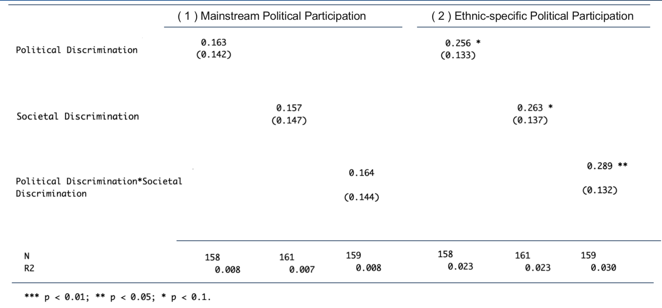

Table 2. The impact of different discrimination on ethnic-specific political participation

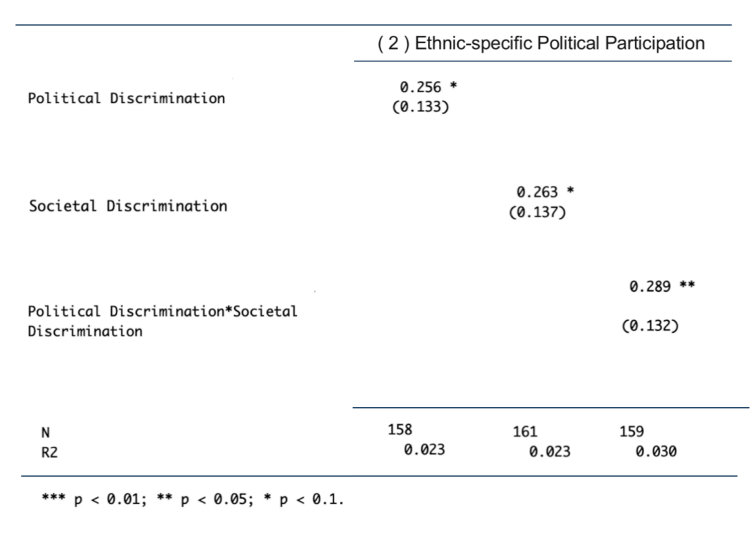

To gain a more nuanced understanding, this analysis constructed box plots to visually assess the real influence of each treatment in Figure 2. These plots shed light on the fact that the effects of each form of discrimination have a minimal impact on Asian Americans’ engagement in mainstream politics. However, the situation differs when it comes to ethnic-specific politics, where the influence of societal discrimination and the combined discrimination treatment is notably stronger compared to political discrimination alone. Nonetheless, it’s important to exercise caution in drawing definitive conclusions at this stage, and it would be premature to reject the third hypothesis outright.

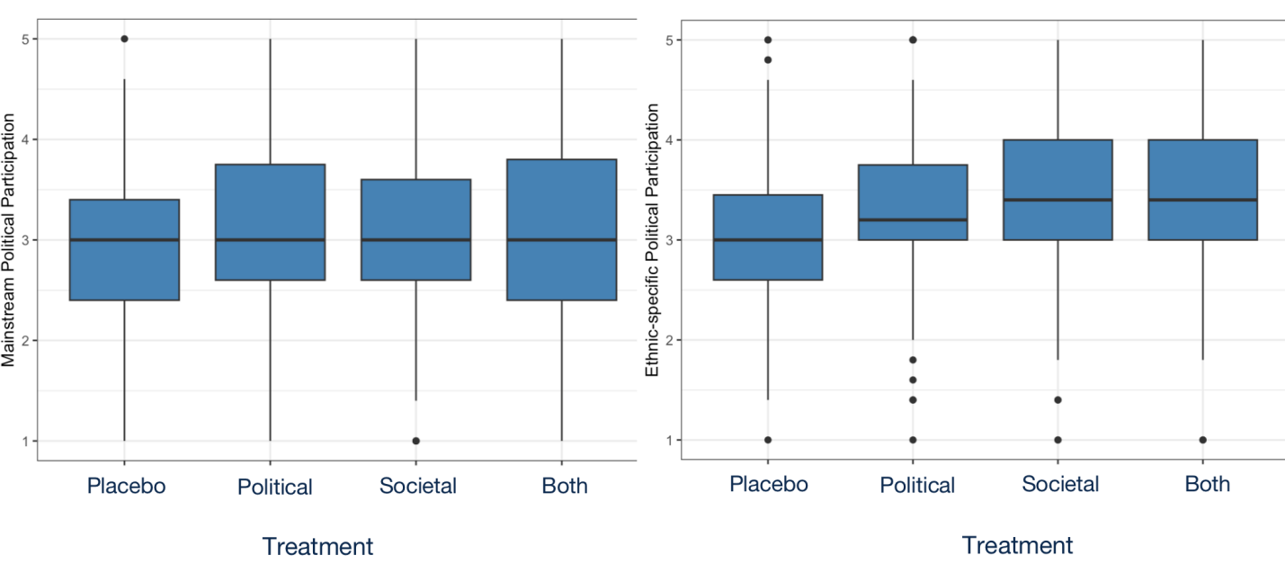

Figure 2. Different impact on treatments

*Propensity Score Matching*

To delve deeper into the analysis, this paper explored potential covariates that could influence the treatment effect and subsequently subsetted the data for a more detailed examination. Notably,two critical factors were considered: ethnicity and participants’ prior experiences with discrimination. These variables were deemed essential to uncover a more comprehensive understanding of the underlying dynamics.

As illustrated in Figure 3, the top six ethnic groups among the participants are Filipino, Chinese (encompassing individuals from Mainland China, Hong Kong, Macau, and Taiwan), Asian Indian, Vietnamese, Japanese, and Korean. These findings align with the national demographic profile as reported by Pew Research Center (2022). To gain a more nuanced perspective, it conducted separate regression analyses for each of these six major Asian origin groups. Interestingly, the results displayed variation across these subgroups, (Table 3 to Table 8). The findings for Chinese and Japanese participants are in line with Oskooii’s previous research, while results for the other groups differ. However, it’s worth noting that many of these results were statistically insignificant, likely attributable to the constraints of small sample sizes.

Previous experiences of discrimination could potentially confound the treatment effects if their influence is stronger and more enduring than that of the vignettes. To investigate this possibility, it started with an initial descriptive analysis, which revealed that slightly more than half of the participants had encountered discrimination in the past three years (as depicted in Figure 4). Among this group, more than one-third reported experiencing discrimination approximately once a month, with another significant portion experiencing discrimination about once a year (as illustrated in Figure 5).

**Match Groups and Level of Participation**

**Conclusion**

Contribution/Summary

Limitation

Future Direction

In an effort to investigate whether the sources of discrimination have an impact on political participation, as argued by Oskooii (2016, 2020), this paper conducted a survey experiment involving over 300 Asian American adults. The study achieved an equal likelihood of exposing participants to political, societal, or both types of discriminatory vignettes. The findings indicate that any source of discrimination serves as a mobilizing factor for various forms of political participation. However, these effects are more pronounced and statistically significant when it comes to co-ethnic participation. Interestingly, the study reveals that societal discrimination does not deter individuals from engaging in mainstream political activities, which contradicts previous research findings. On the other hand, participation specific to one’s ethnicity appears to be more susceptible to the influence of discriminatory experiences. This phenomenon may be attributed to the pressing issue of political representation that participants associate with their specific ethnic backgrounds. Moreover, the study does not uncover any evidence supporting the notion that political discrimination has a stronger mobilizing effect on Asian Americans’ participation in mainstream politics, even when previous experiences of discrimination are taken into account. Consequently, the impact of discrimination from both sources appears to vary depending on the context, and we lack cues indicating whether participants are more exposed to societal or political discrimination and which experience exerts a stronger influence.

This study speaks to the recent finding in Oskooii’s studies and tries to make contributions by test the hypotheses in Asian American group. Theoretically, it seeks to provide a more nuanced understanding of the intricate factors that shape Asian American political engagement by examining the intersectionality of various forms of discrimination. This theoretical contribution is crucial as it sheds light on an overlooked aspect of Asian American political science research, namely how various forms of discrimination affect their political behavior. Methodologically, the research design employs a novel experimental approach that seeks to reveal the explanatory factors of Asian American politics. This methodological innovation is essential since most prior studies on Asian American politics have relied on observational data. By leveraging an experimental design, we can obtain causal inferences and provide more robust evidence to advance the understanding of Asian American politics.

This research does have several inherent limitations that need to be acknowledged. Firstly, the distribution of participant time was not uniform, with one-fourth of participants receiving four vignettes (two from each source) while the remainder only encountered two vignettes. We made an effort to design these vignettes to be concise, each containing fewer than 50 words, in order to minimize participant annoyance during the survey. However, variations in time duration among treatments could introduce self-selection bias among those participants who completed both vignettes. Secondly, the vignettes presented hypothetical situations in which participants were asked to envision themselves reacting to discriminatory experiences they had heard about from friends or colleagues. While this approach was intended to depersonalize the scenarios, it may not accurately capture the intensity of personal experiences. People may have different reactions when confronted with discrimination that happens to their in-group members compared to when they personally experience it. This difference may be influenced by individual levels of empathy and self-identification with their in-group. Participants who possess lower levels of empathy or weaker in-group identification may not be as strongly affected by the discriminatory experiences presented in the vignettes. Furthermore, these limitations are compounded by the issue of pan-ethnicity. There has long been a debate about the extent to which some Asian Americans identify with the broader Asian American pan-ethnicity versus their specific ethnic or origin groups (Yamashita, 2022). Since this study focuses on Asian Americans in general, the vignettes are more likely to trigger their pan-Asian identity rather than their specific ethnic identity. Consequently, participants who feel less aligned with the Asian American pan-ethnicity may not perceive the treatments as having a significant impact.

To delve deeper into this topic, there are several avenues for potential improvement. Firstly, enhancing the treatment effects could involve employing more compelling hypothetical scenarios that closely mirror direct experiences. This approach would foster a stronger sense of connection among participants and provide a clearer causal link. Secondly, narrowing the focus to a specific Asian ethnic group could circumvent the issue of nonalignment with the broader pan-Asian identity. This specificity might yield insights into how different ethnic groups within the Asian American community respond to discriminatory experiences. Lastly, considering the divergence in emotional reactions compared to previous literature, it would be worthwhile to investigate whether particular demographic groups exhibit consistent emotional responses to similar discriminatory experiences. If disparities arise, it becomes essential to explore the underlying reasons behind these variations.

**References:**

Benner, A. D., & Kim, S. Y. (2009). Intergenerational experiences of discrimination in Chinese American families: Influences of socialization and stress. *Journal of Marriage and Family*, 71(4), 862-877.

Bhandari, P. (2022). *Statistical Power and Why It Matters | A Simple Introduction*. Scribbr. https://www.scribbr.com/statistics/statistical-power/.

Blank RM et al. (2004). *Measuring Racial Discrimination.* Washington, DC: National Academies Press.

Campbell, A. L. (2003). Participatory reactions to policy threats: senior citizens and the defense of Social Security and Medicare. *Political Behavior.* 25 (1):29–49.

Chan, N., Nguy, J. H., & Masuoka, N. (2022). The Asian American Vote in 2020: Indicators of Turnout and Vote Choice. *Political Behavior*.

Chandler, J., Rosenzweig, C., Moss, A. J., Robinson, J., & Litman, L. (2019). Online panels in social science research: Expanding sampling methods beyond Mechanical Turk. *Behavior Research Methods*, 51(5), 2022–2038.

Cheah, C. S., Zong, X., Cho, H. S., Ren, H., Wang, S., Xue, X., & Wang, C. (2021). Chinese American adolescents’ experiences of COVID-19 racial discrimination: Risk and protective factors for internalizing difficulties. *Cultural Diversity and Ethnic Minority Psychology*.

Cheng, H. L., Lin, S. P., & Cha, C. H. (2015). Perceived discrimination, intergenerational family conflicts, and depressive symptoms in foreign-born and US-born Asian American emerging adults. *Asian American Journal of Psychology*, 6(2), 107.

Cherry, M. (2021). Political anger. *Philosophy Compass*, *17*(2).

Darling-Hammond, S., Michaels, E. K., Allen, A. M., Chae, D. H., Thomas, M. D., Nguyen, T. D., Mujahid, M. S., & Johnson, R. C. (2020). After “The China Virus” Went Viral: Racially Charged Coronavirus Coverage and Trends in Bias Against Asian Americans. *Health Education & Behavior*, *47*(6), 870–879.

Davidai, S. (2018). Why do Americans believe in economic mobility? Economic inequality, external attributions of wealth and poverty, and the belief in economic mobility. *Journal of Experimental Social Psychology*, 79, 138–148.

Dhanani, L. Y., & Franz, B. (2020). Unexpected public health consequences of the COVID-19 pandemic: a national survey examining anti-Asian attitudes in the USA. *International journal of public health*, 65(6), 747-754.

Gee GC et al. (2009). Racial discrimination and health among Asian Americans: evidence, assessment, and directions for future research. *Epidemiologic Reviews.* 31 (1):130–151.

Gong, S., Wang, K., Li, Y., & Alamian, A. (2019). The influence of immigrant generation on obesity among Asian Americans in California from 2013 to 2014. *PLOS ONE*, *14*(2), e0212740. https://doi.org/10.1371/journal.pone.0212740

Hahm, H.C., Xavier Hall, C.D., Garcia, K.T. et al. (2021). Experiences of COVID-19-related anti-Asian discrimination and affective reactions in a multiple race sample of U.S. young adults. *BMC Public Health*, 21, 1563.

Horse, A. J. Y., Jeung, R., Lim, R., Tang, B., Im, M., Higashiyama, L., ... & Chen, M. (2021). Stop AAPI hate national report. *Stop AAPI Hate*: San Francisco, CA, USA.

Hwang, W. C., & Goto, S. (2008). The impact of perceived racial discrimination on the mental health of Asian American and Latino college students. *Cultural Diversity and Ethnic Minority Psychology*, 14(4), 326.

Joubin, A. (2020). The Roots of Anti-Asian Racism in the U.S.: The Pandemic and ‘Yellow Peril’. Global Social Security Review 2020 Winter Issue Vol. 15. https://www.kihasa.re.kr/en/publish/gss/view?seq=26844&volume=26818

Juang, L. P., & Alvarez, A. A. (2010). Discrimination and adjustment among Chinese American adolescents: Family conflict and family cohesion as vulnerability and protective factors. *American journal of public health*, 100(12), 2403-2409.

Krieger, N. (1999). Embodying inequality: a review of concepts, measures, and methods for studying health consequences of discrimination. *International Journal of Health Services.* 29 (2):295–352.

Lantz, B., & Wenger, M. R. (2022). Anti-Asian xenophobia, hate crime victimization, and fear of victimization during the COVID-19 pandemic. *Journal of interpersonal violence*, 08862605221086651.

Lee, S., & Waters, S. F. (2021). Asians and Asian Americans’ experiences of racial discrimination during the COVID-19 pandemic: Impacts on health outcomes and the buffering role of social support. *Stigma and Health*, 6(1), 70.

 Malik, A. A., McFadden, S. a. M., Elharake, J. A., & Omer, S. B. (2020). Determinants of COVID-19 vaccine acceptance in the US. *EClinicalMedicine*, 26, 100495.

Marcus G.E., Neuman W.R. & MacKuen M. (2000). *Affective Intelligence and Political Judgment*. Chicago, IL: University of Chicago Press.

Miller, J.M. & Krosnick, J.A. (2004). Threat as a motivator of political activism: a field experiment. *Political Psychology.* 25(4):507–523.

Mummolo, J., & Peterson, E. J. (2019). Demand Effects in Survey Experiments: An Empirical Assessment. *American Political Science Review*, *113*(2), 517–529.

Nguyen, L. H., Drew, D. A., Graham, M., Joshi, A., Guo, C. F., Ma, W., Mehta, R. S., Warner, E. T., Sikavi, D., Lo, C. M., Kwon, S., Song, M., Mucci, L. A., Stampfer, M. J., Willett, W. C., Eliassen, A. H., Hart, J. E., Chavarro, J. E., Rich-Edwards, J. W., Zhang, F. (2020). Risk of COVID-19 among front-line health-care workers and the general community: a prospective cohort study. *The Lancet. Public Health*, *5*(9), e475–e483.

Niwa, E. Y., Way, N., & Hughes, D. L. (2014). Trajectories of ethnic‐racial discrimination among ethnically diverse early adolescents: Associations with psychological and social adjustment. *Child Development*, 85(6), 2339-2354.

Ojeda, C. & Pacheco, J. (2017). Health and voting in young adulthood. *British Journal of Political Science*, 1–24.

Ojeda, C. (2015). Depression and political participation. Social Science Quarterly 96 (5):1226–1243.

Oskooii, K. a. R. (2016). How Discrimination Impacts Sociopolitical Behavior: A Multidimensional Perspective. *Political Psychology*, *37*(5), 613–640.

Oskooii, K. a. R. (2020). Perceived Discrimination and Political Behavior. *British Journal of Political Science*, *50*(3), 867–892.

Paradies, Y. (2006). A systematic review of empirical research on self-reported racism and health. *International Journal of Epidemiology*. 35 (4):888–901.

Park, I. J., Schwartz, S. J., Lee, R. M., Kim, M., & Rodriguez, L. (2013). Perceived racial/ethnic discrimination and anti-social behaviors among Asian American college students: testing the moderating roles of ethnic and American identity. *Cultural Diversity and Ethnic Minority Psychology*, 19(2), 166.

Pew Research Center. (2022, October 10). Asian Americans and their origins: Key facts | Pew Research Center. https://www.pewresearch.org/short-reads/2021/04/29/key-facts-about-asian-origin-groups-in-the-u-s/#:~:text=Six%20origin%20groups%20%E2%80%93%20Chinese%2C%20Indian%2C%20Filipino%2C%20Vietnamese%2C,demographic%20characteristics%20of%20the%20overall%20U.S.%20Asian%20population.

Phua, R. (2023). The pandemic emergency may be over, but anti-Asian hate is not. AsAmNews. https://asamnews.com/2023/08/21/anti-asian-hate-underreported-fear-pandemic-xenophobia-racism/

Ramakrishnan, S. K. (2005). *Democracy in Immigrant America: Changing Demographics and Political Participation*. Palo Alto, CA: Stanford University Press.

Ramirez, R. (2013). *Mobilizing Opportunities: The Evolving Latino Electorate and the Future of American Politics*. Charlottesville: University of Virginia Press.

Sue, D. W., Bucceri, J., Lin, A. I., Nadal, K. L., & Torino, G. C. (2009). Racial microaggressions and the Asian American experience.

Tajfel, H. & Turner, J. (1986). The Social Identity Theory of Intergroup Behavior. In Worshel S and Austin W, (eds) *The Psychology of Intergroup Relations*. Chicago, IL: Nelson-Hall, 7–24.

Thai, C. J., Lyons, H. Z., Lee, M. R., & Iwasaki, M. (2017). Microaggressions and self-esteem in emerging Asian American adults: The moderating role of racial socialization. *Asian American Journal of Psychology*, 8(2), 83.

Two Years and Thousands of Voices: National Report (Through March 31, 2022) - *Stop AAPI Hate*. Stop AAPI Hate. https://stopaapihate.org/year-2-report/.

Venkatraman, S. (2021). Anti-Asian hate crimes rose 73% last year, updated FBI data says. *NBC News*. https://www.nbcnews.com/news/asian-america/anti-asian-hate-crimes-rose-73-last-year-updated-fbi-data-says-rcna3741.

Yamashita, L. (2022). “I just couldn’t relate to that Asian American narrative”: How Southeast Asian Americans reconsider panethnicity. *Sociology of Race & Ethnicity*, 8(2), 250–266.

1. U.S. Census Bureau. (2022, May 25). *20.6 Million People in the U.S. Identify as Asian, Native Hawaiian or Pacific Islander*. Census.gov. https://www.census.gov/library/stories/2022/05/aanhpi-population-diverse-geographically-dispersed.html
2. Pew Research Center. (2022, October 10). *Asian Americans and their origins: Key facts | Pew Research Center*. https://www.pewresearch.org/short-reads/2021/04/29/key-facts-about-asian-origin-groups-in-the-u-s/#:~:text=Six%20origin%20groups%20%E2%80%93%20Chinese%2C%20Indian%2C%20Filipino%2C%20Vietnamese%2C,demographic%20characteristics%20of%20the%20overall%20U.S.%20Asian%20population.