FlowSync AI Productivity Assistant

CAPACITI AI-Powered Workplace Productivity Assistant Project
Student: Qiara Ismail
Project Name: FlowSync AI Productivity Assistant
Date: July 2026

1. Project Overview

Introduction
FlowSync AI Productivity Assistant is an AI-powered web application designed to help professionals automate repetitive workplace tasks. The application combines multiple AI tools into a single, easy-to-use platform, enabling users to improve productivity, save time, and streamline daily workflows.
The project was developed using Lovable AI as part of the CAPACITI AI programme to demonstrate practical AI implementation, prompt engineering, and real-world problem solving.

2. Problem Statement
Many professionals spend a significant amount of time completing repetitive tasks such as:
- Writing emails
- Organising daily tasks
- Researching information
These tasks reduce productivity and leave less time for strategic work.
FlowSync addresses this problem by using AI to automate these activities.

3. Project Objectives
The objectives of this project are to:
- Improve workplace productivity.
- Reduce time spent on repetitive tasks.
- Demonstrate practical AI integration.
- Provide an intuitive and modern user interface.
- Showcase prompt engineering techniques.

4. Target Users
FlowSync is designed for:
- Office employees
- Administrative assistants
- Students
- Small business owners
- Project managers
- Remote workers

5. Features

AI Email Generator
Creates professional emails from simple prompts.

AI Task Planner
Organises daily tasks according to priority.

AI Assistant Chat
Allows users to ask workplace-related questions and receive AI-generated responses.

Responsive User Interface
Optimised for desktop and mobile devices.

6. Technologies Used
Technology | Purpose
Lovable AI | Application development
OpenAI | AI functionality
React | Front-end framework
TypeScript | Programming language
Tailwind CSS | Styling
GitHub | Version control
Markdown | Documentation

7. System Workflow
User
↓
Select AI Tool
↓
Enter Prompt
↓
AI Processes Request
↓
Generate Response
↓
Display Result

8. User Interface

Homepage

The homepage serves as the main landing page of FlowSync. It introduces the application and provides quick access to the AI productivity tools. The design uses a monochrome luxury theme with glassmorphism cards to create a modern and professional user experience.

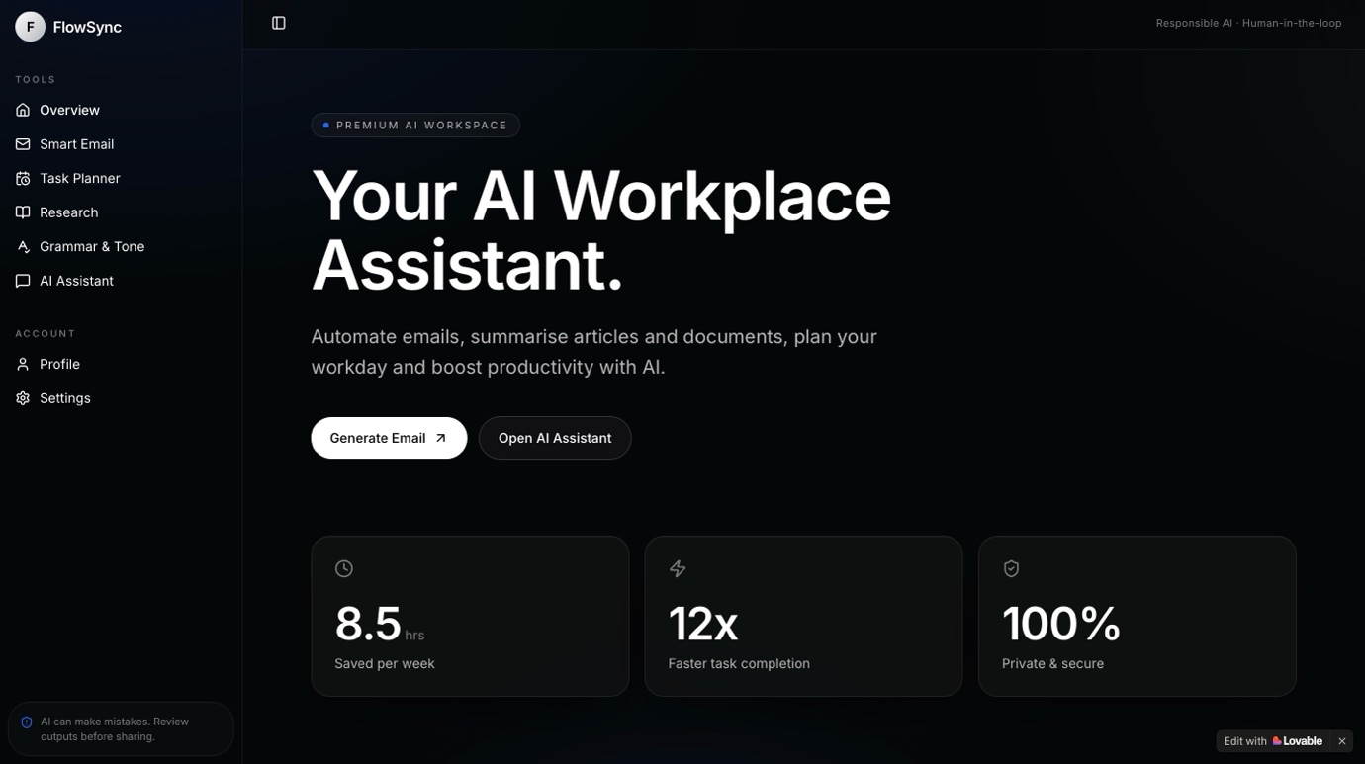

Email Generator

This feature enables users to generate professional workplace emails quickly by providing a prompt.

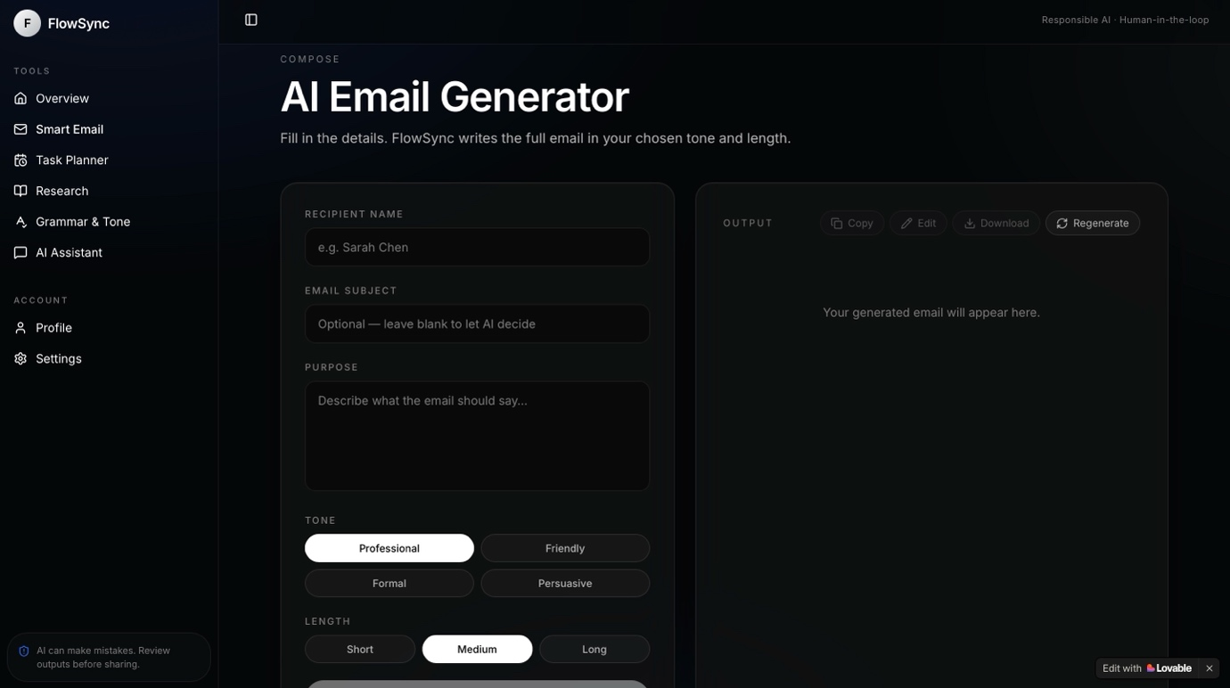

Grammar and Tone Checker
The Grammar and Tone Checker allows users to review written content for grammar, spelling, punctuation, and tone. AI provides suggestions to improve the professionalism and clarity of emails, reports, and other workplace documents.
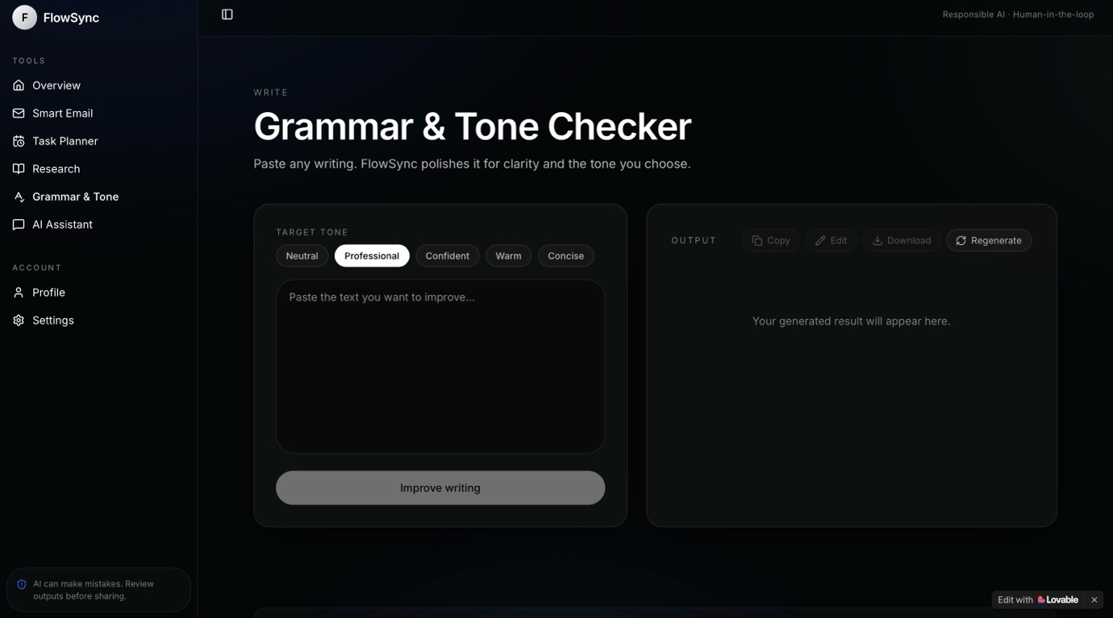

AI Task Planner

The Task Planner helps users organise their workload by prioritising tasks and suggesting efficient schedules.

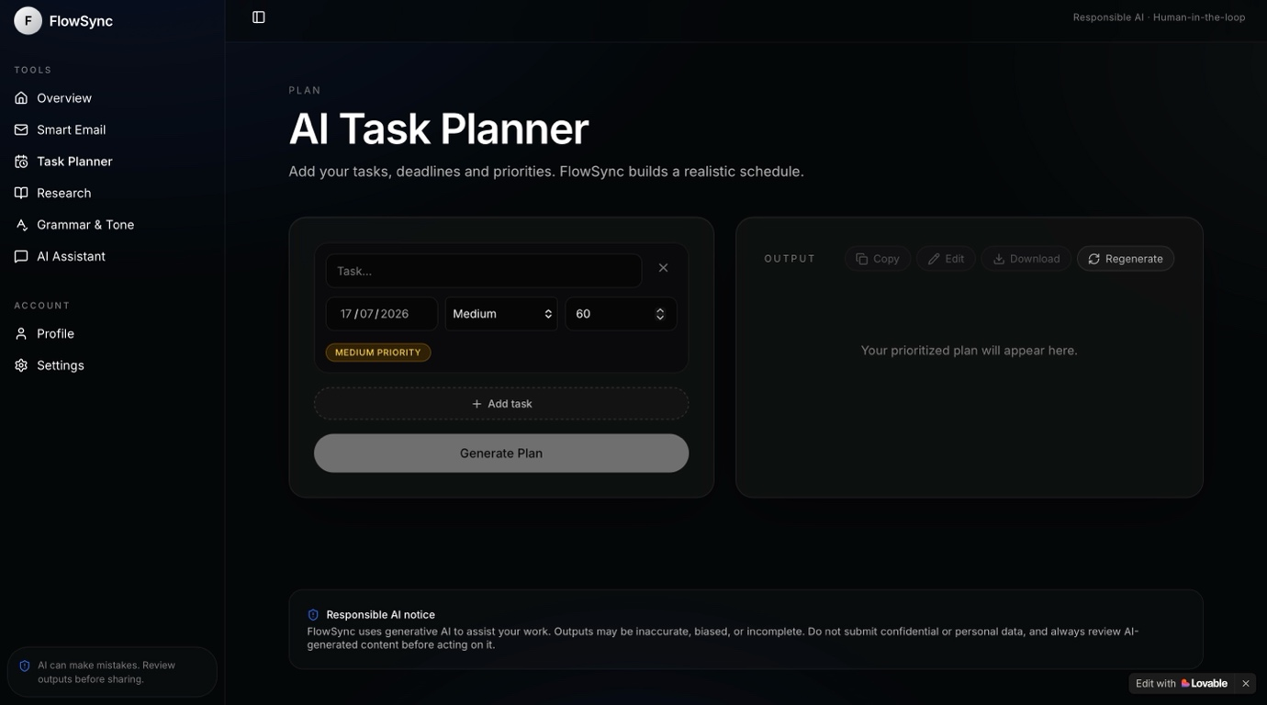

AI Research Assistant

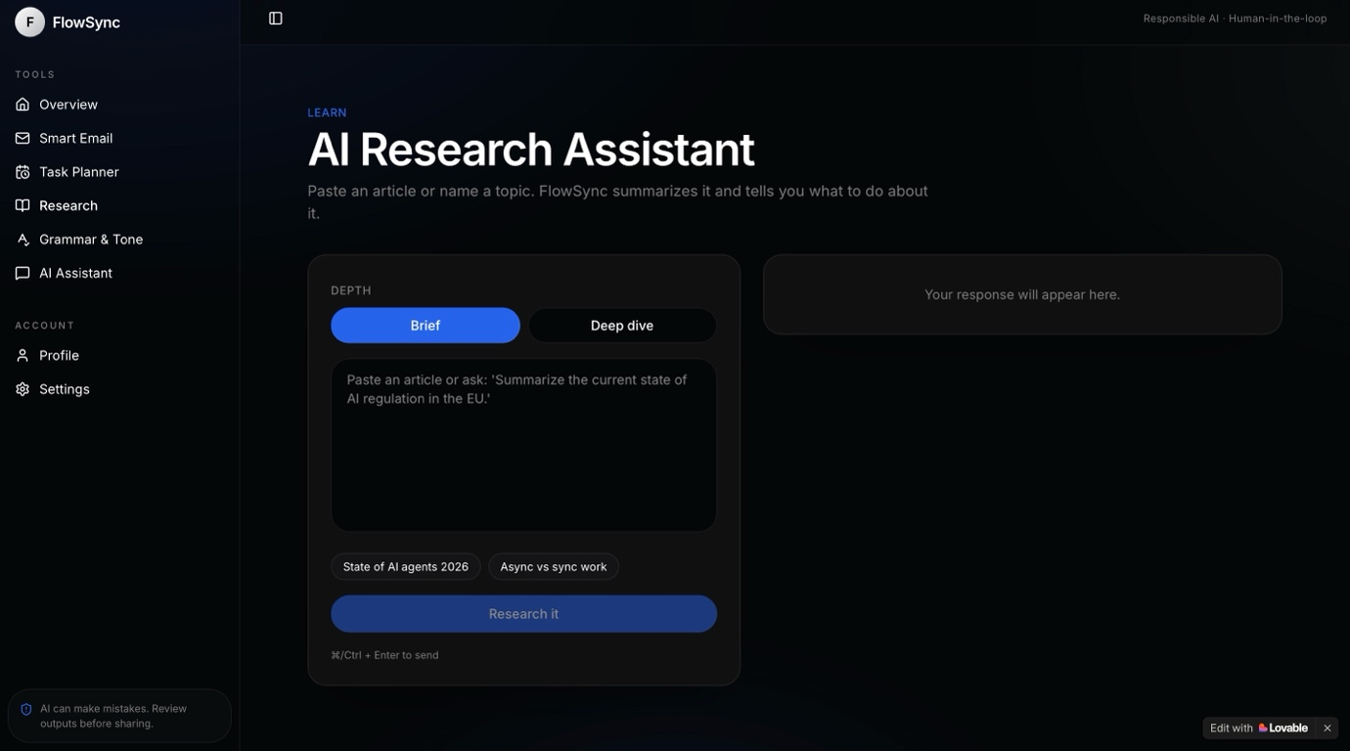
The Research Assistant enables users to explore workplace topics by generating AI-powered summaries and explanations. It helps users quickly understand new concepts, gather information, and support decision-making without leaving the application.

AI Chat Assistant

The AI Chat Assistant allows users to ask workplace-related questions and receive AI-generated responses in real time.

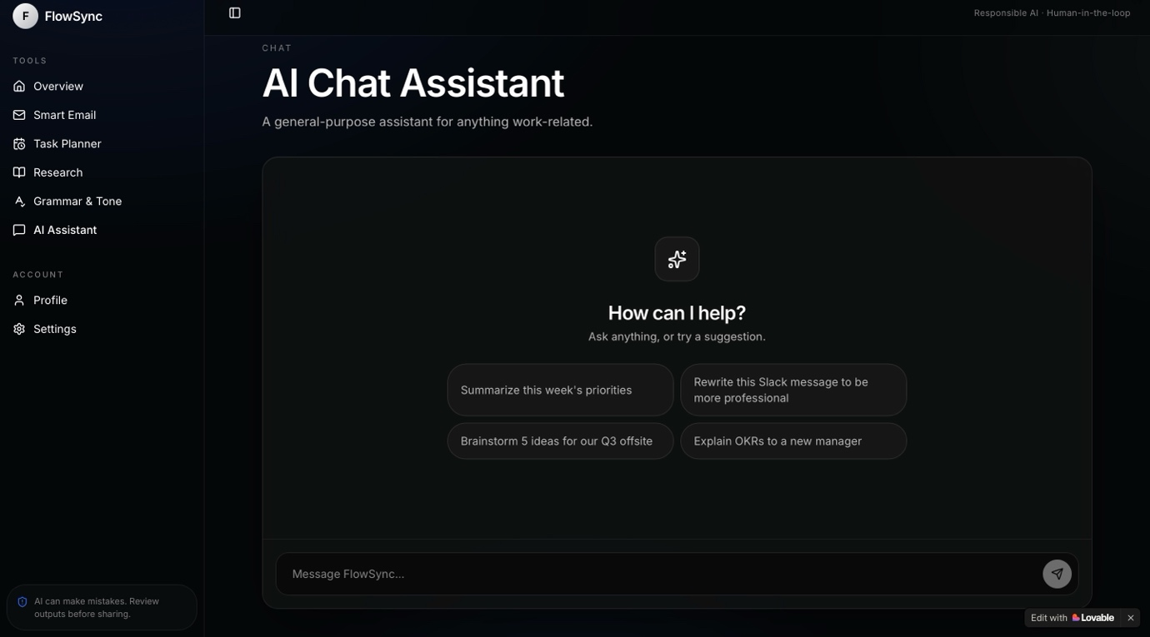

9. Challenges Faced
Some of the challenges encountered during development included:
- Designing a clean and professional user interface.
- Creating effective AI prompts.
- Selecting a suitable colour palette.
- Integrating multiple productivity tools into one application.
- Managing Lovable AI usage credits.

10. Future Improvements
Potential future enhancements include:
- Calendar integration.
- Voice commands.
- File upload support.
- User authentication.
- AI document analysis.
- Dark/light mode.
- Team collaboration features.
- Multi-language support.

11. Conclusion
FlowSync AI Productivity Assistant successfully demonstrates how artificial intelligence can improve workplace productivity by automating repetitive tasks.
The application provides users with an intuitive interface, multiple AI-powered productivity tools, and a modern design, making it suitable for professionals seeking to work more efficiently.

