**INFO 6205**

**Program Structures & Algorithms**

**Fall 2020**

**Assignment No 3**

* **Task**

Step 1:

(a) Implement height-weighted Quick Union with Path Compression. For this, you will flesh out the class UF_HWQUPC. All you have to do is to fill in the sections marked with // TO BE IMPLEMENTED ... // ...END IMPLEMENTATION.

(b) Check that the unit tests for this class all work. You must show "green" test results in your submission (screenshot is OK).

Step 2:

Using your implementation of UF_HWQUPC, develop a UF ("union-find") client that takes an integer value n from the command line to determine the number of "sites." Then generates random pairs of integers between 0 and n-1, calling connected() to determine if they are connected and union() if not. Loop until all sites are connected then print the number of connections generated. Package your program as a static method count() that takes n as the argument and returns the number of connections; and a main() that takes n from the command line, calls count() and prints the returned value. If you prefer, you can create a main program that doesn't require any input and runs the experiment for a fixed set of n values. Show evidence of your run(s).

Step 3:

Determine the relationship between the number of objects (n) and the number of pairs (m) generated to accomplish this (i.e. to reduce the number of components from n to 1). Justify your conclusion.

Don't forget to follow the submission guidelines. And to use sufficient (and sufficiently large) different values of n.

* **Output** (few outputs to prove relationship)

|  |  |
| --- | --- |
| n | m |
| 200 | 476 |
| 400 | 1075 |
| 800 | 2326 |
| 1600 | 5038 |
| 3200 | 11090 |
| 6400 | 23817 |
| 12800 | 51447 |
| 25600 | 109857 |
| 51200 | 234962 |
| 102400 | 497145 |

* **Relationship conclusion and Evidence** (screen shot and/or graph and/or spreadsheet)

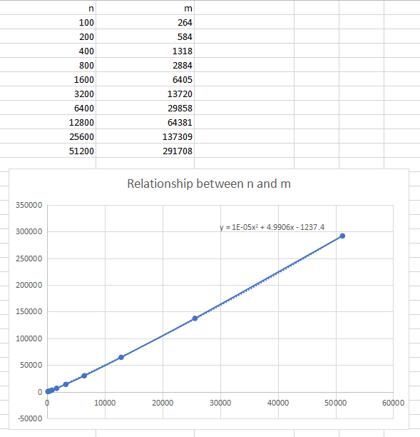

* **Screenshot of Unit test passing**

