**INFO 6205**

**Program Structures & Algorithms**

**Fall 2020**

**Assignment No 4**

* **Task**

1. For weighted quick union, store the depth rather than the size;
2. For weighted quick union with path compression, implement the grandparent fix.

For both of these, code the alternative and benchmark it against the implementation in the repository.

* **Output** (few outputs to prove relationship)

|  |  |  |  |
| --- | --- | --- | --- |
| WQU | | HWQUPC | |
| n | t | n | t |
| 500 | 0.072 | 500 | 0.06 |
| 1000 | 0.11 | 1000 | 0.08 |
| 2000 | 0.244 | 2000 | 0.184 |
| 4000 | 0.53 | 4000 | 0.372 |
| 8000 | 1.178 | 8000 | 0.794 |
| 16000 | 2.704 | 16000 | 1.81 |
| 32000 | 6.042 | 32000 | 3.898 |
| 64000 | 13.938 | 64000 | 8.826 |

* **Relationship conclusion and Evidence** (screen shot and/or graph and/or spreadsheet)

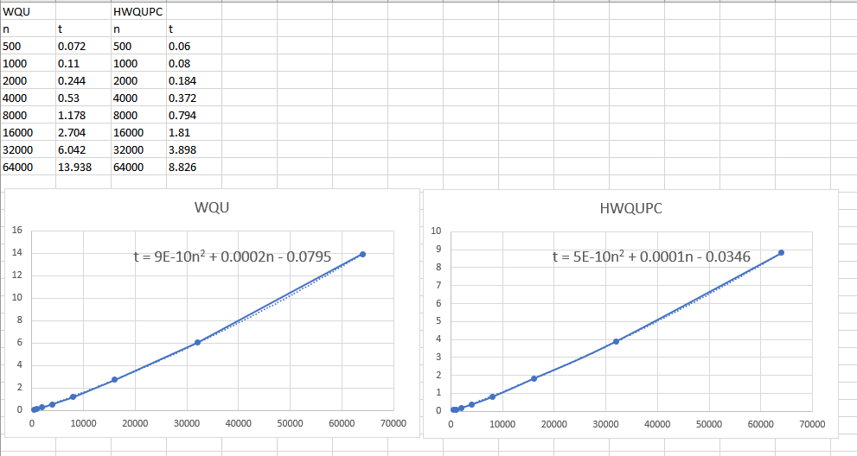

* **Screenshot of Unit test passing**

Test for weighted quick union:

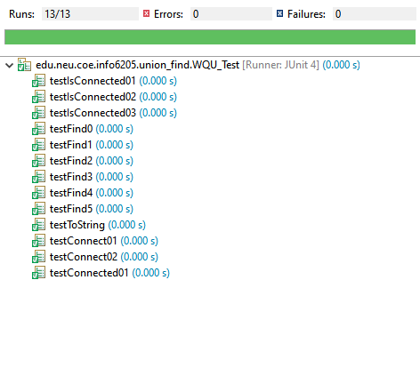

Test for weighted quick union with path compression:

