Qifan Luo(1010945)

**Program Structures & Algorithms**

**Spring 2021**

**Assignment No. 2**

* **Task**
* **Relationship Conclusion:**

**For Best Cases: O(n)**

**For Worst Cases: O(n2)**

**For Average Cases: O(n2)**

**P.S. for partially ordered, I think the time complexity is nearly O(n), while the time is more than order condition.**

* **Evidence to support the conclusion:**
* **Graphical representation:**

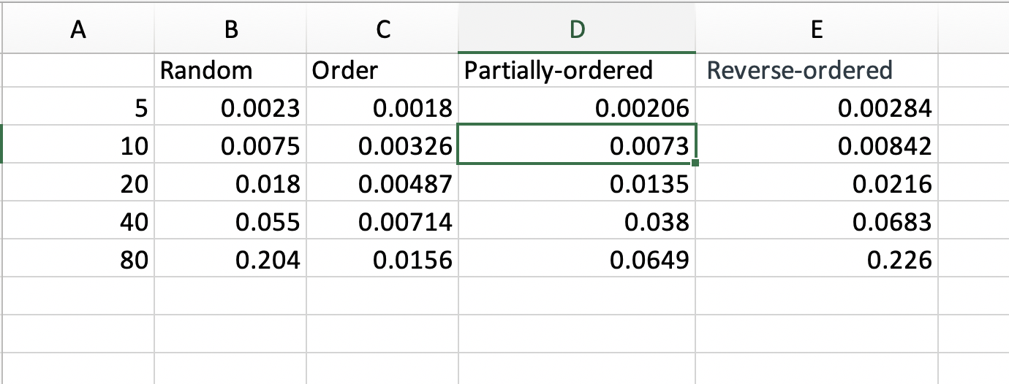

* **Unit tests result:**

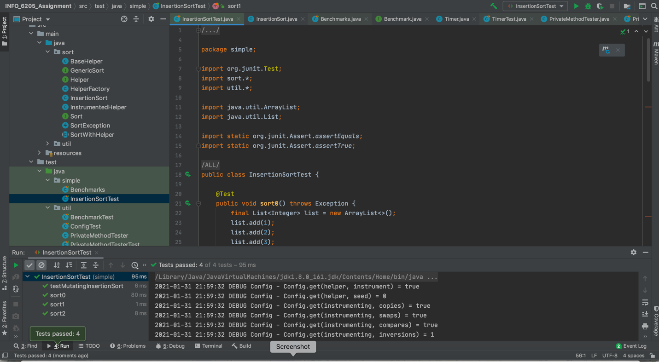

Insertion Sort Unit Test

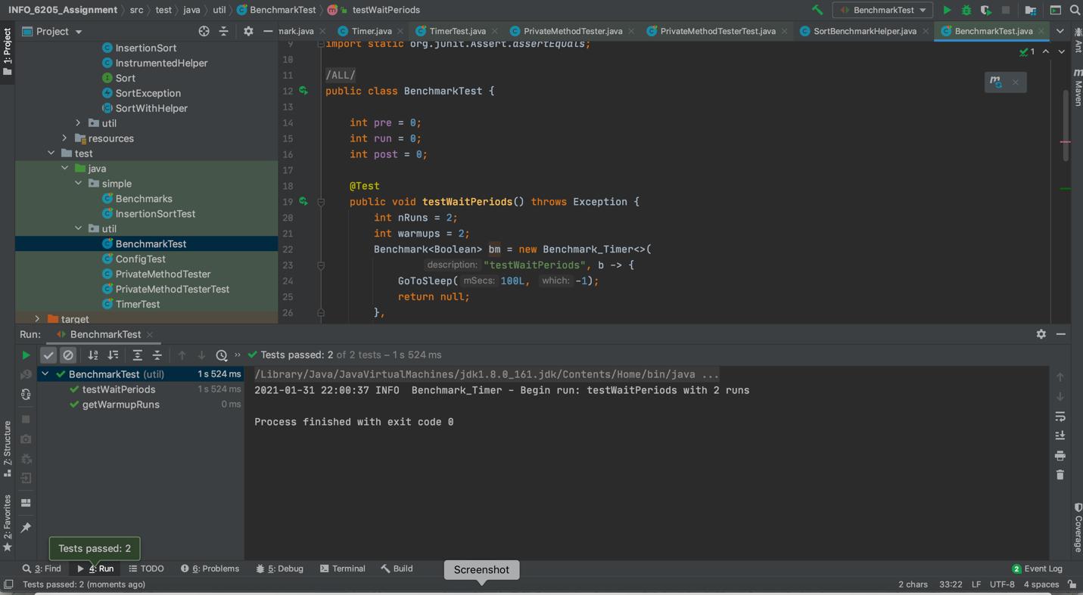

Benchmark Test Picture

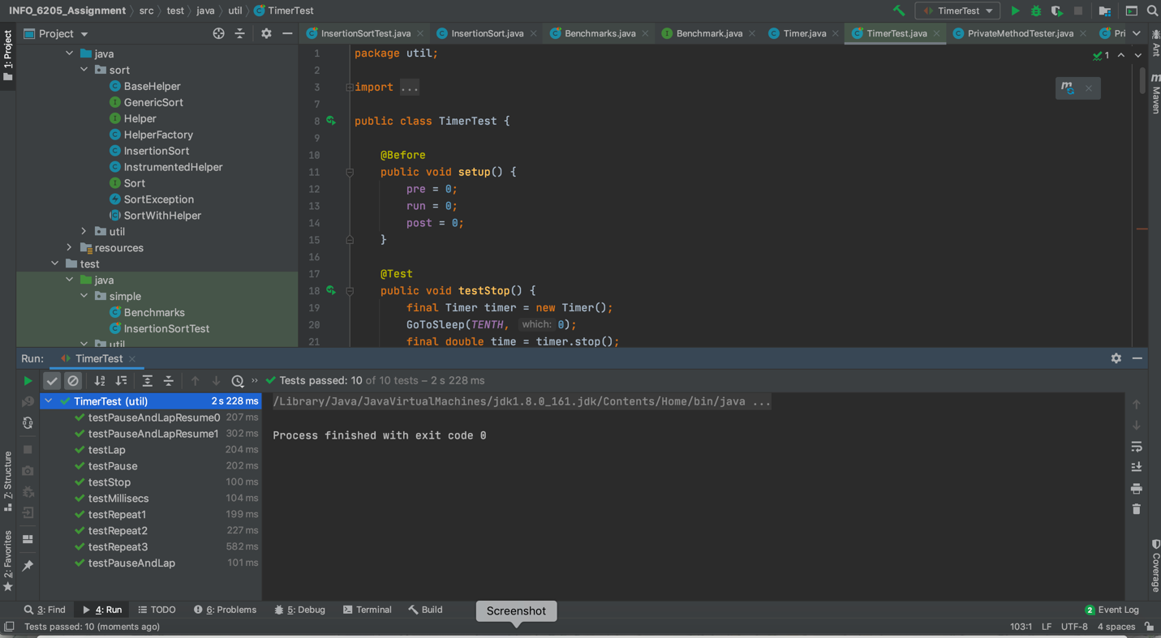

Timer Test Picture