School of Computer Science
Faculty of Engineering and Physical Sciences
Final Report
Short-term Traffic Flow Forecasting Based on Adaptive Graphs and Spatio-Temporal Transformers
Li Qifeng
Submitted in accordance with the requirements for the degree of
BSc Computer Science
2025/26
Final Year Project
Student ID: 2022115988
Supervisor: Zheng Danyang

Deliverables and Declaration
Submitted deliverables.
Items | Format | Recipient(s) and Date
Final Report | DOCX/PDF | Submitted through the university submission system
Code repository | GitHub/local repository | https://github.com/QifengLi/Short-term-Traffic-Speed-Forecasting-Based-on-Adaptive-Graphs-and-Spatio-Temporal-Transformers.git
Experiment outputs | JSON/CSV/NPZ/PNG | Included in the project workspace
The candidate confirms that the work submitted is their own and that appropriate credit has been given where reference has been made to the work of others.
The candidate understands that failure to attribute material obtained from another source may be considered plagiarism.
(Signature of student)
Copyright 2026 The University of Leeds and Li Qifeng.

Summary
Short-term traffic forecasting is a practical machine-learning task in intelligent transportation systems because route guidance, congestion warning and network management depend on accurate near-future traffic estimates. This thesis develops and evaluates AG-STT, an Adaptive Graph Spatio-Temporal Transformer for multi-step traffic forecasting. Although the title uses the conventional term traffic flow forecasting, the prepared PEMSD7-228 and METR-LA benchmark files contain one traffic-state feature per sensor, and the experiments treat that first available speed/flow feature as the prediction target. The work should therefore be understood as short-term traffic-state forecasting under public benchmark constraints, rather than a claim about every possible traffic-flow variable such as volume, occupancy or incident-aware demand.
The model represents each traffic sensor as a graph node, uses twelve five-minute historical observations as input, and predicts the next twelve five-minute steps. Its spatial module fuses a static road graph, a learnable adaptive graph and an input-conditioned dynamic graph. Its temporal module applies self-attention inside spatio-temporal Transformer blocks, with graph diffusion convolution used for graph-aware spatial message passing. The project is implemented in Python and PyTorch with a reproducible pipeline for data preparation, training, evaluation, statistical testing, visualisation and report generation.
Experiments use PEMSD7-228 and METR-LA with Linear, LSTM, STGCN and compact DCRNN-style baselines. Under the standard budget, AG-STT obtains MAE=3.6007 on PEMSD7-228 and MAE=4.3751 on METR-LA. The DCRNN-style baseline remains slightly stronger in MAE on both standard splits, with MAE=3.5898 and MAE=4.3335, while AG-STT is competitive and achieves lower RMSE than that baseline on both datasets. Longer fair-budget experiments and constrained graph-fusion variants provide additional evidence that AG-STT can improve when given more data, more training and stronger graph fusion constraints.
Taken together, the work shows that an adaptive-graph spatio-temporal Transformer can be built and evaluated on public traffic data within the available computing budget. The conclusion is deliberately limited. AG-STT is a credible and competitive approach, but the results in this project do not support a broad claim that it is always better than the DCRNN-style baseline. The main value of the work is the implemented framework and the careful link between saved outputs, reported numbers and final discussion.
Keywords: short-term traffic forecasting; traffic-state prediction; adaptive graph learning; spatio-temporal Transformer; graph neural network; METR-LA; PEMSD7-228; reproducible evaluation.

Acknowledgements
I would like to express my sincere gratitude to my supervisor, Zheng Danyang, for the guidance, feedback and academic advice provided throughout this project. The discussions on research direction, experimental design and report structure were valuable in shaping both the technical work and the final dissertation. I also acknowledge the public datasets, open-source software libraries and published papers that made the experimental comparison possible. This report was completed as an individual project, and external materials used for data, software and research background are identified in the relevant sections and appendices.

Table of Contents
Deliverables and Declaration 2
Summary i
Acknowledgements ii
Table of Contents iii
List of Figures iv
List of Tables v
Chapter 1 Introduction and Background Research 1
1.1 Introduction 1
1.2 Problem Definition and Project Motivation 2
1.3 Literature Review and Related Work 2
1.3.1 Classical, Recurrent and Graph-Based Traffic Forecasting 3
1.3.2 Transformer and Adaptive-Graph Traffic Forecasting 3
1.4 Aims, Objectives and Contributions 4
Chapter 2 Methodology and Model Design 5
2.1 Traffic Forecasting Task Formulation 5
2.2 Dataset and Preprocessing 5
2.3 Static and Adaptive Graph Construction 7
2.3.1 Static and Learnable Graphs 8
2.3.2 Dynamic Graph and Graph Fusion 8
2.4 Spatio-Temporal Transformer Architecture 8
2.4.1 Temporal Representation and Self-Attention 9
2.4.2 Graph Diffusion and Forecasting Head 10
2.5 Training Objective and Optimization 10
2.6 Baseline Models 11
Chapter 3 Implementation and Experimental Setup 12
3.1 Implementation and Reproducibility 12
3.2 Experimental Protocol 13
3.2.1 Standard-Budget Benchmark Setting 13
3.2.2 Fair-Budget and Supplementary Settings 13
3.2.3 Significance and Stability Checks 13
3.3 Evaluation Metrics 13
Chapter 4 Results and Evaluation 15
4.1 Main Forecasting Results 15
4.2 Performance Comparison with Baselines 16
4.3 Ablation Study 17
4.4 Long-Sequence and Fair-Budget Experiments 18
4.5 Statistical Significance and Stability Validation 19
4.5.1 Paired Error Significance Tests 19
4.5.2 Seed-Level and Rolling Stability 20
4.6 Visualisation and Error Analysis 21
4.7 Summary of Results 22
Chapter 5 Discussion and Conclusions 24
5.1 Discussion of Main Findings 24
5.2 Practical Implications 24
5.3 Limitations and Threats to Validity 25
5.4 Conclusions and Future Work 26
References 28
Appendix A Self-appraisal 30
A.1 Critical self-evaluation 30
A.2 Personal reflection and lessons learned 30
A.3 Legal, social, ethical and professional issues 30
A.3.1 Legal issues 30
A.3.2 Social issues 30
A.3.3 Ethical issues 30
A.3.4 Professional issues 31
Appendix B External Material and Reproducibility Notes 32
B.1 Datasets 32
B.2 Software and Libraries 32
B.3 Major Experimental Artefacts 32
B.4 Reproduction Notes 33

List of Figures
Figure 1. Time-ordered train, validation and test split for the standard-budget experiments. 7
Figure 2. AG-STT model architecture showing graph sources, graph fusion, temporal attention, graph diffusion convolution and the forecasting head. 9
Figure 3. Standard-budget MAE comparison across baselines. 16
Figure 4. Horizon-wise MAE across all benchmarked models. 17
Figure 5. Learned adaptive adjacency matrices extracted from saved AG-STT model states. 18
Figure 6. Fair-budget MAE comparison using a larger time slice and eight training epochs. 19
Figure 7. Ground truth, AG-STT and DCRNN curves on difficult selected nodes. 22
Figure 8. AG-STT absolute error distribution on the test predictions. 22

List of Tables
Table 1. Dataset scale, split and graph summary. 6
Table 2. Core model and training hyperparameters. 10
Table 3. Standard-budget benchmark results on both datasets. 15
Table 4. Real-data AG-STT ablation and no-dynamic results. 17
Table 5. Fair-budget comparison with max_timesteps=8064 and epochs=8. 18
Table 6. Paired significance tests comparing standard AG-STT against baselines. 19
Table 7. Seed-level paired comparison between AG-STT fusion constrained v3 and DCRNN. 21

Chapter 1 Introduction and Background Research

1.1 Introduction
Short-term traffic flow forecasting aims to estimate road-network conditions in the next few minutes or hours from recent sensor observations. It is an important part of intelligent transportation systems because decisions such as signal control, congestion warning and route planning are only useful when they are made before congestion fully develops. Unlike long-term demand forecasting, the short-term task is dominated by local temporal variation, road-network interactions and transient disturbances.
Traffic data are not simply independent time series. Sensors placed on nearby roads often influence one another through upstream and downstream propagation, while distant sensors can become correlated through route substitution or shared demand patterns. This makes the task both temporal and spatial. A model that only learns temporal recurrence may miss road-network structure, while a model that only uses a fixed graph may fail to adapt when the effective correlation between road segments changes.
Recent traffic forecasting research has therefore moved from classical statistical models toward graph neural networks and attention-based spatio-temporal models [1, 2]. This project follows that direction by implementing AG-STT, a compact Adaptive Graph Spatio-Temporal Transformer. The design combines graph learning with temporal self-attention while keeping the implementation small enough to run repeated experiments on local hardware.
This project focuses on short-horizon prediction rather than long-term planning. That distinction matters because a long-term planning model can tolerate broader temporal aggregation, while a short-term control model must preserve local peaks, drops and propagation delays. In the five-minute sensor setting used here, a one-hour prediction horizon is long enough for errors to accumulate across multiple future steps but still short enough to be relevant to operational decisions.
A further challenge is that traffic observations contain both repeated daily patterns and irregular deviations. Morning and evening demand cycles may be learnable from recent context, but unusual congestion or abrupt speed changes may not follow the same pattern. The project therefore treats forecasting as a structured sequence problem, where the road graph gives useful prior information but the model must also adapt to data-driven correlations.

1.2 Problem Definition and Project Motivation
The forecasting task is defined as direct multi-step prediction. For each training example, the input tensor is denoted by X, where B is the batch size, T_in is the number of historical steps, N is the number of traffic sensors and F is the number of input features. The model predicts a direct multi-horizon output denoted by Y with a hat in the equations. In the implemented experiments, T_in=12 and T_out=12. Because both prepared benchmark datasets use five-minute sampling, the model uses one hour of historical traffic-state observations and predicts the following one hour.
The motivation for the project is the gap between fixed road topology and dynamic traffic dependency. A provided road graph is useful because physical road connectivity matters. However, real traffic influence is not always identical to that static topology. A learnable graph can capture latent correlations not encoded in the provided adjacency matrix, while a dynamic graph can respond to the current input sequence. The central project question is whether these graph sources can be combined with a temporal Transformer in a reproducible and empirically defensible way.
There is also a practical motivation behind the way the project is reported. A single final score is not enough to judge a forecasting model, especially when the datasets are noisy and the training budget is limited. For that reason, the report records the data slice, split policy, null-value handling, model configuration, random seed, saved model state, prediction arrays and metric summaries. This makes the reported results easier to check.
The project is not designed to prove that a Transformer is always better than a recurrent graph model. Instead, it asks whether a Transformer-based design with adaptive graph fusion can be implemented cleanly and evaluated fairly against strong baselines. This framing is important because DCRNN is a well-matched competitor rather than a weak baseline.

1.3 Literature Review and Related Work
Traffic forecasting has a long research history. Classical approaches, including seasonal ARIMA models, are attractive because they are interpretable and computationally light [3]. However, they require strong assumptions about stationarity and linear structure, which are often unsuitable for nonlinear multi-sensor traffic data. Recurrent neural networks improved sequence modelling, and LSTM and GRU architectures were designed to address vanishing gradients and gated memory control [4, 5]. These models can capture temporal patterns but do not explicitly represent graph-structured spatial dependency unless extra mechanisms are added.
Graph neural networks provide a natural way to model traffic sensors as nodes connected by spatial or learned relations. GCN and GAT established influential message-passing and attention ideas for graph representation learning [7, 8]. In traffic forecasting, STGCN combined temporal convolution with graph convolution [9], while DCRNN used diffusion convolution with recurrent modelling [10]. ASTGCN and GMAN introduced attention into spatio-temporal graph forecasting [11, 13]. Graph WaveNet, AGCRN and MTGNN are especially relevant to this thesis because they show that learned or adaptive graph structure can be useful when a static graph is incomplete or insufficient [12, 14, 15].
Transformer-based forecasting is also relevant because temporal self-attention can model longer-range dependency without recurrence [6]. Informer, Autoformer, FEDformer and PatchTST demonstrate different ways of adapting Transformer ideas to time-series forecasting [17-20]. For traffic forecasting, STTN introduced a spatial-temporal Transformer network [16]. More broadly, recent surveys argue that spatio-temporal graph neural networks remain a strong direction for structured time-series problems [21]. AG-STT is positioned within this line of work, but its contribution is an implemented undergraduate project pipeline rather than a claim of state-of-the-art performance across all benchmarks.
The literature also shows a recurring trade-off between architectural capacity and evaluation reliability. Larger attention models can represent complex interactions, but traffic benchmarks are sensitive to data splits, horizon definitions, missing-value masks and training budgets. This is why the thesis reviews both model families and evaluation practice. A method is only convincing when the comparison setting is clear.
The AG-STT design should therefore be read as a synthesis of several established ideas: graph-based spatial propagation, adaptive adjacency learning, temporal attention and direct multi-horizon forecasting. The novelty within this project is the integration and reproducible implementation of those ideas under local resource constraints, not the invention of an entirely new theoretical mechanism.

1.3.1 Classical, Recurrent and Graph-Based Traffic Forecasting
Classical statistical traffic models normally predict each sensor or route segment from past values and fixed seasonal patterns. Their main strength is transparency, but their weakness is limited capacity for nonlinear interactions. Machine-learning methods can handle nonlinear features better, but many still require manual feature engineering and do not naturally encode road-network propagation.
Graph neural networks address the spatial part of the problem by propagating information across neighbouring or related nodes. DCRNN and STGCN are important baselines because they represent two different graph-time modelling strategies: diffusion recurrent modelling and spatio-temporal convolution. They are therefore stronger baselines than purely node-wise sequence models.

1.3.2 Transformer and Adaptive-Graph Traffic Forecasting
Attention-based models are useful when temporal dependency is not limited to a fixed local window. In this project, temporal self-attention is applied node-wise over the input history, and graph diffusion convolution is used after attention to exchange information across the fused graph. This structure keeps the temporal and spatial roles explicit.
Adaptive graph learning is motivated by the observation that a physical road graph may not capture every predictive dependency. Graph WaveNet and AGCRN showed that learnable adjacency structures can improve traffic forecasting in some settings [12, 14]. AG-STT follows the same principle but keeps the static graph in the model and fuses it with learnable and dynamic graph sources.

1.4 Aims, Objectives and Contributions
The main aim is to build and evaluate a short-term traffic forecasting model based on adaptive graphs and spatio-temporal Transformer blocks. The specific objectives are to implement a reproducible preprocessing and training pipeline, construct static, adaptive and dynamic graph modules, compare AG-STT against Linear, LSTM, STGCN and DCRNN baselines, evaluate using MAE, RMSE and MAPE, run ablation and supplementary fair-budget experiments, and present the work in a final report following the University of Leeds final report structure.
The first contribution is a working AG-STT architecture that combines static road adjacency, learned adaptive adjacency and input-conditioned dynamic adjacency in a compact spatio-temporal Transformer. The second contribution is the project workflow around the model, including data preparation, configuration, training, evaluation, significance testing and figure preparation. The third contribution is a controlled comparison with four baselines on two real traffic datasets. The fourth contribution is a balanced interpretation of the results: AG-STT is reported as competitive, but not as uniformly superior where the data do not support that claim.

Chapter 2 Methodology and Model Design

2.1 Traffic Forecasting Task Formulation
Each training example is generated using a sliding window over a time-ordered traffic tensor. The symbols B, T_in, T_out, N and F denote batch size, input length, output length, number of sensors and number of input features respectively. The current experiments use the first available traffic-state feature as the target variable for both datasets. The same notation is used consistently in the model equations, where a hat denotes a prediction.
$$X ∈ R^\{B×T_\{in\}×N×F\}, Y ∈ R^\{B×T_\{out\}×N×1\}$$
The model learns a function f_theta(X, A) that maps the input sequence and graph information to a direct multi-step prediction. Direct prediction avoids recursive roll-out, where earlier prediction errors become inputs to later steps. The trade-off is that the prediction head must learn horizon-specific behaviour for all twelve future steps at once.
$$Ŷ = f_θ(X, A_f)$$
The direct output shape also simplifies metric computation. Because all horizons are produced together, evaluation can report both an overall metric over all horizons and a per-horizon metric from step 1 to step 12. This is useful because traffic forecasting errors normally grow as the horizon increases. Reporting only the overall value would hide whether a model performs well at short horizons but degrades quickly later.
The formulation assumes that the selected feature is sufficient for the current experiments. This is a limitation, because real traffic systems could benefit from additional variables such as occupancy, volume, weather, incidents and calendar effects. Those inputs are not available in the prepared project files, so the thesis does not claim to model external event causes.

2.2 Dataset and Preprocessing
The project uses two public traffic benchmark datasets. PEMSD7-228 contains 12,672 time steps, 228 sensors and one traffic-state feature, while METR-LA contains 34,272 time steps, 207 sensors and one traffic-state feature. The prepared files include the sensor observations and associated adjacency information used by the graph-based models. In the standard-budget experiments, both datasets use the first 4,032 time steps so that the initial comparison can be run within a controlled local budget. PEMSD7-228 uses a 0.6/0.2/0.2 train, validation and test split, while METR-LA uses 0.7/0.1/0.2.
The public-data setting is important for interpreting the scope of the thesis. The datasets provide useful real traffic benchmark observations, but they do not provide a complete operational view of urban traffic. In particular, the prepared project files do not include weather, incidents, holidays, events, traffic-control actions or roadworks. The model is therefore evaluated as a short-term benchmark forecaster rather than as a full causal traffic management system.
A brief dataset characterisation is also relevant. PEMSD7-228 has a traffic-value range from 3.0 to 82.6 with mean 58.89 and standard deviation 13.48 in the prepared file, while METR-LA has a range from 0.0 to 70.0 with mean 53.72 and standard deviation 20.26. The zero values in METR-LA motivate the null-value mask used during evaluation. These basic statistics help explain why the same architecture can behave differently across the two datasets.
The preprocessing pipeline preserves temporal order. Data are split before sliding windows are generated, and the StandardScaler is fitted only on the training partition. The same scaler is then applied to validation and test partitions. During evaluation, predictions and labels are transformed back to the original scale before metrics are computed. METR-LA uses null_val=0.0 to exclude zero-valued targets from masked metrics, while PEMSD7-228 does not use a null mask. This masking policy is part of the experimental definition rather than a post-hoc adjustment, and the same policy is used in the metric calculation and the paired significance tests.
$$x_tilde = (x - μ_\{train\}) / σ_\{train\}$$
The standard-budget slice is deliberately smaller than the full raw dataset. This was chosen so that multiple baselines, ablations and significance tests could be completed consistently on local hardware. The resulting dataset scale and split policy are reported in Table 1, and Figure 1 visualises the time-ordered split used for the standard-budget experiments. The fair-budget experiment later uses 8,064 time steps to test whether conclusions change when the models receive a larger slice. The two settings are reported separately to avoid mixing budgets.
The adjacency matrices differ substantially in density. The processed PEMS adjacency has a much higher non-zero proportion than METR-LA, while METR-LA is comparatively sparse. This difference is relevant because graph propagation has a different inductive bias in dense and sparse settings. A dense graph can spread information widely but may blur local structure, whereas a sparse graph may preserve locality but miss latent dependency. The datasets also do not contain external explanatory variables such as weather, incidents, holidays or planned events, so sudden traffic changes caused by those factors cannot be modelled directly in this project.
Table 1. Dataset scale, split and graph summary.
Dataset | Raw steps | Used steps | Nodes | Features | Train/Val/Test steps | Adj. density
PEMSD7-228 | 12672 | 4032 | 228 | 1 | 2419/806/807 | 0.3582
METR-LA | 34272 | 4032 | 207 | 1 | 2822/403/807 | 0.0402
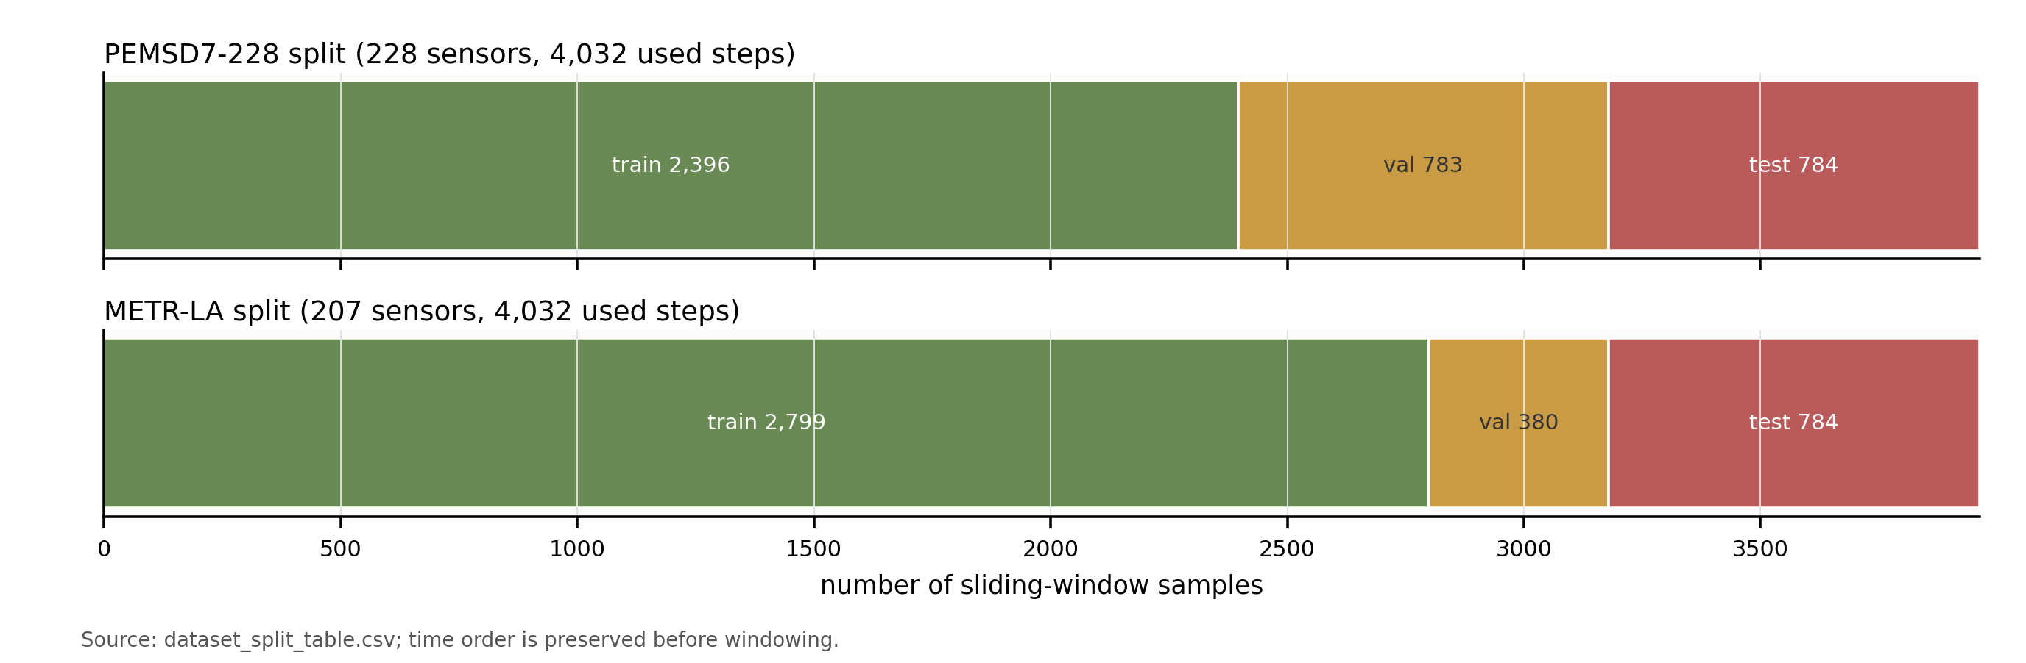
Figure 1. Time-ordered train, validation and test split for the standard-budget experiments.

2.3 Static and Adaptive Graph Construction
The spatial part of the model combines three graph sources. The static graph is loaded from the dataset adjacency matrix, augmented with self-loops and row-normalised. This graph provides a physical or dataset-provided prior over road-sensor connectivity.
The learnable adaptive graph is generated from two node-embedding matrices. The implementation computes ReLU(E1 E2^T) and then applies a row-wise softmax to obtain a directed learned adjacency. This component allows the model to learn latent dependency not captured by the static graph.
The input-conditioned dynamic graph is generated from the current latent input representation. The model averages hidden states over the input time dimension, projects the result into query and key representations, and applies scaled dot-product attention followed by softmax. This makes the graph depend on the current batch input rather than being fixed across all samples.
The three graphs are fused by softmax-normalised learnable weights. The supplementary constrained-fusion setting also applies sparsification and stronger priors on the static graph. This means the full project includes both a basic AG-STT version and a later constrained-fusion variant used as supplementary evidence.
The three graph sources represent different assumptions. The static graph assumes that known road topology is informative. The adaptive graph assumes that persistent correlations can be learned from data. The dynamic graph assumes that the effective relation between sensors can change according to the current input window. None of these assumptions is universally correct, which is why the fusion mechanism is central to the architecture.
A potential risk of adaptive graph learning is that it can overfit correlations in a short training slice. A potential risk of dynamic graph learning is instability, because the graph is produced from the same noisy input that the model is trying to predict from. These risks are not treated as theoretical objections, but they are used to interpret the mixed ablation results in Chapter 4.

2.3.1 Static and Learnable Graphs
The static graph is the row-normalised dataset adjacency matrix. The implementation uses a strict adjacency check so that missing or mismatched graph information cannot silently be replaced by an identity matrix.
$$A_s = D^\{-1\}(A_0 + I), D_\{ii\} = ∑_j (A_0 + I)_\{ij\}$$
The adaptive graph uses trainable node embeddings. It is global across samples and represents persistent latent relationships learned from the training data.
$$A_a = softmax_row(ReLU(E_1 E_2^T))$$

2.3.2 Dynamic Graph and Graph Fusion
The dynamic graph is sample-dependent. It is built from latent input context using query-key similarity. The later ablation results show that this branch is testable but its contribution is mixed under the current budget.
$$A_d(X) = softmax_row(QK^T / √(d_k)), Q = H_bar W_Q, K = H_bar W_K$$
The fusion mechanism applies a softmax over graph-source weights and then normalises the fused adjacency by row. The constrained supplementary configuration keeps the static graph influential while allowing adaptive and dynamic graphs to contribute selectively. This reduces the risk that learned graphs dominate the physical road prior too early in training.
$$α = softmax(w), A_f = RowNorm(α_s A_s + α_a A_a + α_d A_d)$$

2.4 Spatio-Temporal Transformer Architecture
AG-STT first applies a linear input projection from the raw feature dimension to d_model=32 and adds a trainable temporal positional embedding. The projected sequence is passed to the graph generator, which returns a fused adjacency matrix. The hidden states are then processed by two spatio-temporal Transformer blocks. Figure 2 summarises this architecture and the flow from graph construction to temporal attention, graph diffusion and horizon prediction.
Each block contains temporal self-attention, graph diffusion convolution and a feed-forward network. Residual connections, dropout and LayerNorm are used after each submodule. Temporal self-attention is useful because it can compare any pair of time steps within the input window without relying on recurrence, while graph diffusion provides an explicit mechanism for exchanging information across sensor nodes. The readout maps hidden states to one scalar per node and time step, and a horizon projection maps the input sequence length to the twelve-step prediction horizon.
The block order is temporal attention followed by graph diffusion and then a feed-forward network. This means the model first refines each node's temporal representation and then shares information through the fused graph. This separation also makes the architecture easier to interpret, because temporal modelling and spatial propagation are handled by distinct submodules. At the same time, adaptive graph learning introduces risks: a learned dense graph may overfit short training slices, and an input-conditioned graph may be unstable when the current window contains noisy or unusual traffic patterns. These risks are evaluated empirically rather than assumed away.
The architecture is intentionally compact. It uses two blocks, a hidden dimension of 32 and four attention heads. A larger model might improve accuracy, but it would also increase training cost and make repeated baselines harder to complete. For a final-year project, the chosen size is a pragmatic balance between model expressiveness and experiment coverage.
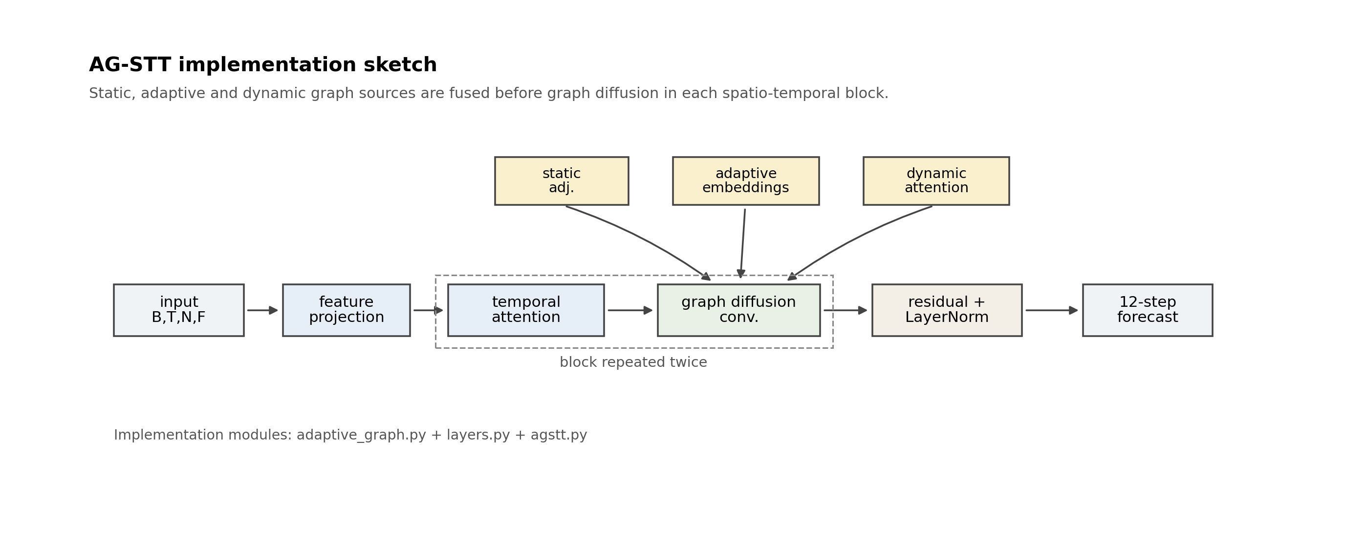
Figure 2. AG-STT model architecture showing graph sources, graph fusion, temporal attention, graph diffusion convolution and the forecasting head.

2.4.1 Temporal Representation and Self-Attention
The input projection is implemented as a linear layer from F to d_model. The positional embedding has shape 1 x T_in x 1 x d_model and is learned during training.
$$H^\{(0)\} = Linear(X) + P$$
Temporal self-attention is applied independently for each node by reshaping the tensor from B x T x N x D to (B x N) x T x D. This focuses the attention operation on temporal dependency while leaving spatial exchange to the graph convolution module.
$$Attention(Q,K,V) = softmax(QK^T / √(d_k)) V$$

2.4.2 Graph Diffusion and Forecasting Head
Graph diffusion convolution repeatedly propagates hidden states through the fused adjacency matrix up to the configured order. The project uses gcn_order=2, so the model can mix information from one-hop and two-hop graph neighbourhoods.
$$Z = ∑_\{k=0\}^\{K_g\} A_f^k H W_k$$
The forecasting head first applies a linear readout from d_model to one scalar and then uses a horizon projection from T_in to T_out. This produces an output tensor with shape B x T_out x N x 1.
$$Ŷ = Proj_T(Readout(H^\{(L)\}))$$

2.5 Training Objective and Optimization
Training minimises masked MAE. For labels y_i and predicted values y_i with a hat over valid positions Omega, the loss is the average absolute error over Omega. If null_val is configured, invalid labels are excluded by a mask that is normalised to keep the loss scale stable.
$$L_\{MAE\} = (1 / |Ω|) ∑_\{i ∈ Ω\} |y_i - ŷ_i|$$
The optimiser is AdamW with learning rate 0.001 and weight decay 0.0001. The standard-budget experiments use batch_size=32 and epochs=6. Gradient norm is clipped at 5.0. The code sets random seeds through the training configuration, and the main experiments use seed 42. Table 2 summarises the core model and training hyperparameters used in the main experiments.
MAE is used as the training loss because it aligns with the primary evaluation metric and is less sensitive to isolated large errors than MSE. RMSE is still reported during evaluation because large errors are operationally important, especially during sharp traffic changes. This separation keeps the optimisation target simple while still exposing large-error behaviour in the results.
The masking implementation normalises the valid mask by its mean. This prevents the loss scale from shrinking when some labels are masked. The detail is especially important for METR-LA because zero-valued targets are treated as invalid under null_val=0.0. Without consistent masking, MAPE and significance results can become misleading.
Table 2. Core model and training hyperparameters.
Setting | Value
Input length | 12 five-minute steps
Prediction length | 12 five-minute steps
AG-STT hidden dimension | 32
Attention heads | 4
Transformer blocks | 2
Feed-forward hidden dimension | 64
Graph diffusion order | 2
Dropout | 0.1
Batch size | 32
Optimiser | AdamW
Learning rate | 0.001
Weight decay | 0.0001
Gradient clipping | 5.0
Standard-budget epochs | 6
Fair-budget epochs | 8
Random seed in main run | 42

2.6 Baseline Models
The baseline set includes Linear, LSTM, STGCN and a compact DCRNN-style graph recurrent baseline. The Linear baseline is a per-node projection from the historical window to the future horizon. The LSTM baseline is a node-wise recurrent model, so it tests whether temporal modelling alone is sufficient under the same data split and training budget. STGCN and the DCRNN-style baseline are graph-aware comparisons and therefore provide stronger tests than purely temporal baselines. The DCRNN-style model is the main reference baseline in this project because it is consistently competitive in the standard-budget results, but it should be interpreted as a controlled project implementation rather than a full reproduction of every mechanism in the original DCRNN paper.

Chapter 3 Implementation and Experimental Setup

3.1 Implementation and Reproducibility
The project is implemented in Python 3.11 using PyTorch for model training and evaluation. NumPy and pandas are used for data processing and result aggregation, PyYAML for configuration, matplotlib for figures, and python-docx for report generation. The codebase separates data loading, graph processing, model definitions, training, evaluation, experiment execution and plotting.
The implementation is organised around separate modules for the AG-STT architecture, adaptive graph construction, common neural-network layers, baseline models, training, evaluation and result aggregation. This separation keeps the experimental workflow reproducible while avoiding duplicated training and metric code across models.
The implementation uses a small factory pattern for model construction. The same training and evaluation workflow can instantiate AG-STT, LSTM, Linear, STGCN or DCRNN from structured experiment settings. This reduces duplicated experiment code and makes the benchmark easier to maintain. The trade-off is that each model must conform to the same input and output tensor contract.
During evaluation, the project saves prediction arrays in NPZ format with both predicted and true values. This is important because later significance testing and error analysis can be checked from the saved outputs without rerunning the model. Using saved predictions improves reproducibility and reduces the risk of accidental changes caused by different checkpoints.
Reproducibility is built into the project through structured configuration files. Each experiment records the dataset source, adjacency source, split ratio, time-slice length, null-value policy, model hyperparameters, training hyperparameters and result destinations. Model states, metrics and prediction arrays are saved so that later analysis can be reproduced without rerunning training.
The evaluation workflow loads saved model states for testing, and the real-data configurations include adjacency-shape checks. The report figures are based on saved metrics, prediction arrays and model states, so the plotted values can be traced back to the experiment outputs rather than copied manually.
The project also records supplementary evidence beyond the main benchmark, including fair-budget summaries, fusion-sweep summaries, robustness summaries, rolling cross-split summaries and seed-level paired significance results. These artefacts are not all used to make the same claim, but they provide context for how stable the model ranking is.
The final report folder includes the key evidence files used to support the reported results, including JSON summaries, table-source CSV files, figures and saved experiment outputs. This makes the submitted materials easier to inspect because the numerical results in the report can be checked against the supporting project evidence in one location.

3.2 Experimental Protocol

3.2.1 Standard-Budget Benchmark Setting
The standard benchmark uses the first 4,032 time steps and six training epochs for each model. This creates a controlled comparison under a modest local training budget. The experiments were designed for a modest local-compute setting rather than a large-scale benchmark environment. The software environment uses Python 3.11 and PyTorch. Training and evaluation were run with the available local compute device, while the exact hardware is not used as a performance claim in this thesis. Instead, reproducibility is supported by saved configurations, model states, prediction arrays and metric files.
The main results are evaluated on the held-out test partition. The statistical significance test uses paired error differences from the saved prediction arrays. PEMS does not apply a null-value mask, while METR-LA uses null_val=0.0, matching the main evaluation configuration.

3.2.2 Fair-Budget and Supplementary Settings
The supplementary fair-budget experiment uses 8,064 time steps and eight epochs for all five models. The standard and fair-budget settings are kept separate in the analysis because a longer data slice and extra training can change model ranking. The same input length, prediction length, split policy, batch size, optimiser settings and epoch count are kept within each budget group.
The baselines are not tuned independently to maximise their best possible performance; instead, they are run under a common controlled protocol suitable for a student project. This should be understood when comparing the results with published benchmark leaderboards.

3.2.3 Significance and Stability Checks
The rolling cross-split experiment gives an additional check against a single lucky or unlucky time segment. It evaluates AG-STT(v3) and DCRNN on three temporal windows. The result is mixed: AG-STT wins some windows and loses others. This supports the thesis argument that model ranking depends on temporal regime and that a single split should not be over-generalised.

3.3 Evaluation Metrics
The report uses MAE, RMSE and MAPE. MAE is the primary metric because it is measured in the original traffic-value scale and is less dominated by extreme errors than RMSE. RMSE is also useful because it penalises larger errors more strongly. MAPE reports percentage error but can be unstable near zero, which is why METR-LA uses the configured null-value mask for zero-valued labels.
$$MAE = (1/n) ∑_i |y_i - ŷ_i|$$
$$RMSE = √((1/n) ∑_i (y_i - ŷ_i)^2)$$
$$MAPE = (100/n) ∑_i |(y_i - ŷ_i) / y_i|$$
MAE is the most directly interpretable metric because it measures the average absolute deviation in the original traffic-value units. RMSE is more sensitive to rare large errors and therefore complements MAE. MAPE is easy to read as a percentage but can be distorted when the true value is close to zero. For that reason, the report treats MAPE as supporting evidence rather than the only decision criterion.
Per-horizon metrics are equally important. A model may be accurate for the next five or ten minutes while losing accuracy at forty-five or sixty minutes. The horizon-wise curves therefore help determine whether performance degradation is gradual and whether AG-STT and DCRNN behave similarly as the horizon extends.
All numerical tables and empirical figures in the report come from saved experiment summaries, metric records, prediction arrays, significance-test results, robustness summaries and model states. The project does not keep a complete training-loss history for every run, so a training-loss curve is not included as a factual thesis figure. This missing item is stated directly instead of being replaced with a reconstructed curve.

Chapter 4 Results and Evaluation

4.1 Main Forecasting Results
Table 3 and Figure 3 summarise the standard-budget benchmark results. Under this setting, AG-STT obtains MAE=3.6007, RMSE=6.8320 and MAPE=9.34% on PEMSD7-228. The DCRNN-style baseline obtains slightly lower MAE=3.5898 and MAPE=8.99%, while AG-STT has lower RMSE=6.8320 compared with DCRNN RMSE=7.0305. This indicates that AG-STT is competitive but not clearly superior on PEMSD7-228 under the standard budget.
On METR-LA, Table 3 shows that AG-STT obtains MAE=4.3751, RMSE=8.8248 and MAPE=12.24%. The DCRNN-style baseline again has slightly lower MAE=4.3335, while AG-STT has lower RMSE. The correct interpretation is therefore that AG-STT is among the strongest models but the graph recurrent baseline remains a difficult comparator.
The standard-budget tables also reveal that different metrics can favour different models. On both datasets DCRNN has the lower MAE, but AG-STT has the lower RMSE. This suggests that AG-STT may reduce some larger errors even when its average absolute error is slightly higher. The report does not overinterpret this difference, but it explains why the model remains competitive despite not leading in MAE.
The gap between AG-STT and DCRNN is small in absolute terms on the standard split, especially on PEMS. However, because the prediction arrays contain many valid points, the paired significance test can still detect a statistically reliable difference. Statistical significance here should therefore be interpreted together with effect size, not as a large practical gap.
Table 3. Standard-budget benchmark results on both datasets.
Dataset | Model | MAE | RMSE | MAPE (%)
PEMSD7-228 | DCRNN | 3.5898 | 7.0305 | 8.99
PEMSD7-228 | AG-STT | 3.6007 | 6.8320 | 9.34
PEMSD7-228 | LSTM | 3.7110 | 7.4007 | 9.25
PEMSD7-228 | STGCN | 4.0883 | 7.3853 | 11.53
PEMSD7-228 | Linear | 4.3167 | 8.1672 | 11.26
METR-LA | DCRNN | 4.3335 | 8.9771 | 11.90
METR-LA | AG-STT | 4.3751 | 8.8248 | 12.24
METR-LA | LSTM | 4.3854 | 8.9903 | 12.16
METR-LA | STGCN | 4.5435 | 8.8454 | 12.62
METR-LA | Linear | 5.1071 | 9.9206 | 13.67
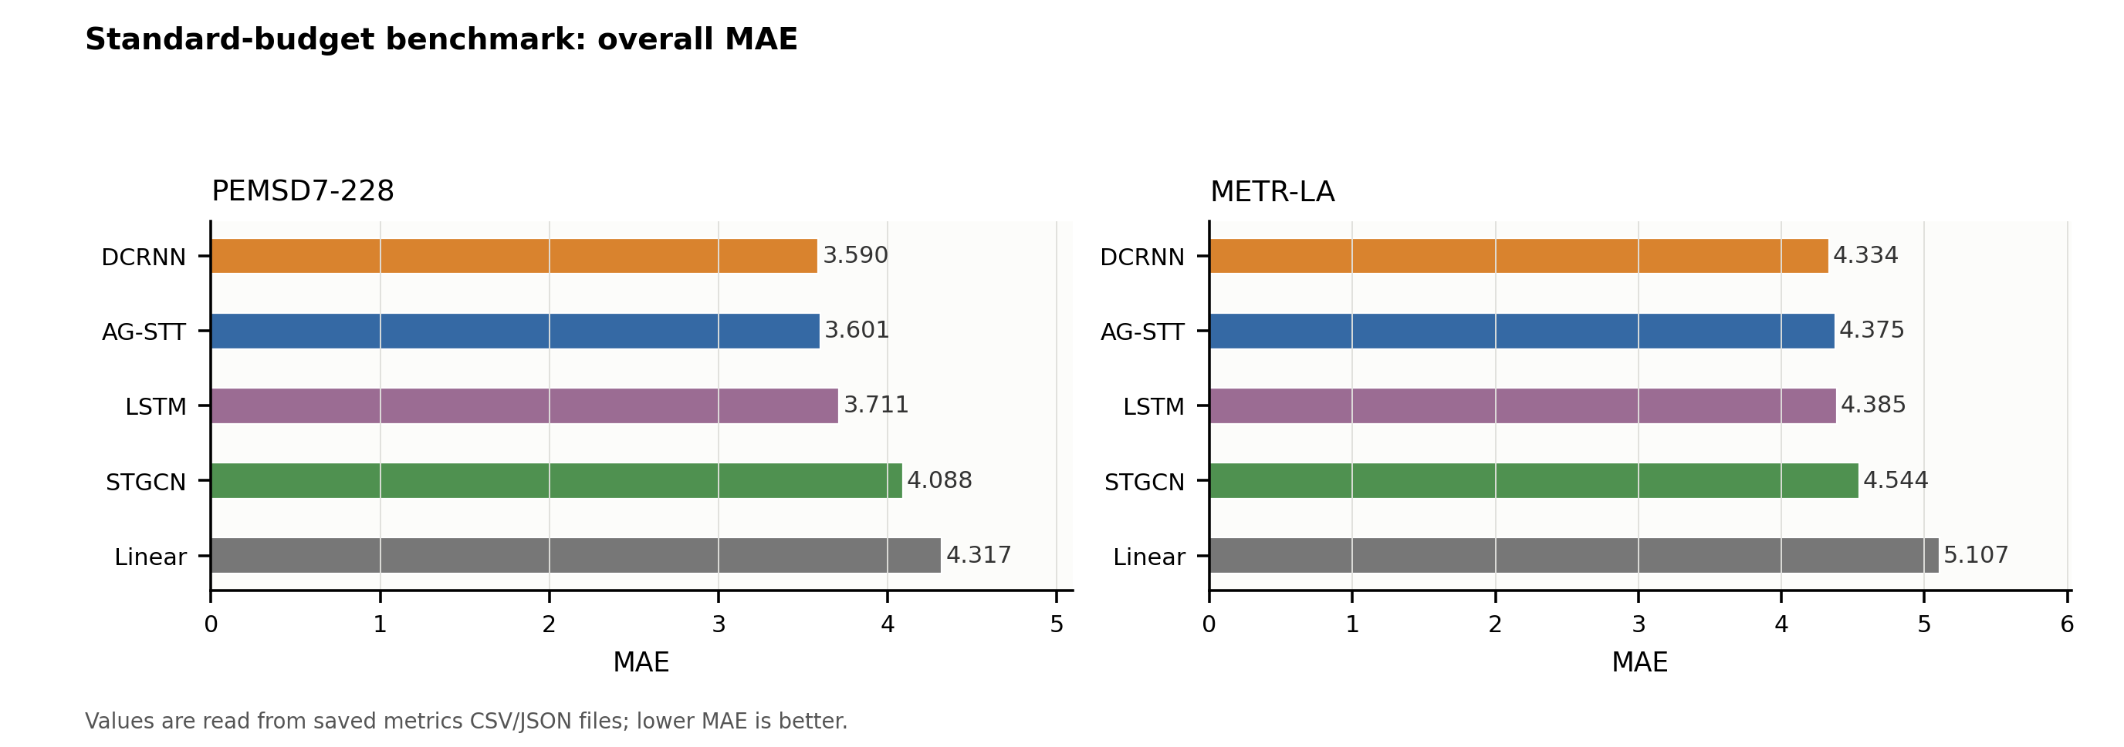
Figure 3. Standard-budget MAE comparison across baselines.

4.2 Performance Comparison with Baselines
AG-STT is consistently stronger than Linear and STGCN in MAE on both datasets. It is also stronger than LSTM on PEMS and very close to LSTM on METR-LA. Figure 4 shows the corresponding horizon-wise MAE curves, which help reveal whether model differences are concentrated at short or long forecast horizons. The results support the usefulness of explicit graph and attention-based modelling, but they also show that a compact DCRNN-style baseline remains highly effective under the same training budget.
The main conclusion should therefore use careful wording. AG-STT is competitive with DCRNN and often improves over simpler baselines. It should not be described as significantly outperforming DCRNN in the standard benchmark because the saved metrics and significance tests show the opposite direction in MAE.
The Linear baseline performs worst on both datasets, which confirms that the task benefits from nonlinear modelling. STGCN improves over Linear but remains behind AG-STT and DCRNN in MAE. LSTM is stronger than STGCN on PEMS and close to AG-STT on METR-LA, showing that temporal modelling alone is a serious baseline even without explicit graph propagation.
The DCRNN-style baseline's strong performance is plausible because graph-aware recurrent modelling is well suited to road networks and can represent sequential dependence with relatively few parameters. This does not invalidate AG-STT; it shows that the proposed model should be compared to strong graph recurrent baselines rather than only to simpler neural networks.
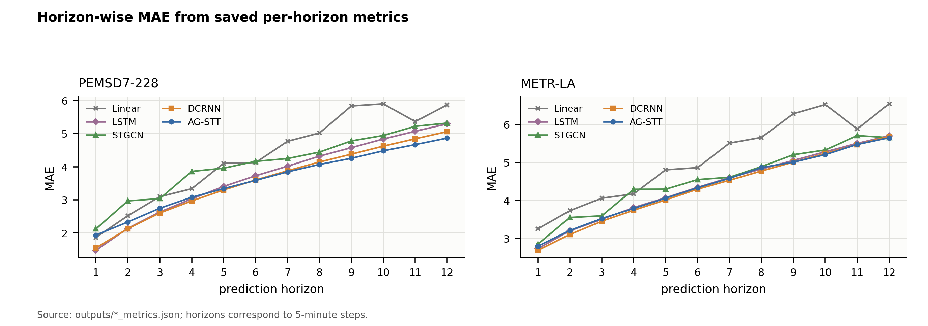
Figure 4. Horizon-wise MAE across all benchmarked models.

4.3 Ablation Study
Table 4 reports the real-data ablation results, comparing the full AG-STT configuration with variants that remove the adaptive graph or the dynamic graph. The results are mixed. On both datasets, the no-adaptive and no-dynamic variants are close to the full model, and in the single-seed standard-budget setting they can even obtain lower MAE than the full version. This suggests that the graph-fusion module is sensitive to budget and configuration.
The completed no-dynamic ablation shows that the input-conditioned dynamic branch is testable but mixed under the current standard budget, so its contribution is interpreted cautiously rather than claimed as uniformly positive.
The constrained fusion sweep gives a more positive picture. The v3 constrained-fusion variant improves the single-run AG-STT MAE to 3.5503 on PEMS and 4.2797 on METR-LA. Figure 5 displays the learned adaptive adjacency matrices extracted from saved AG-STT model states, giving a qualitative check that the adaptive branch learns a non-trivial directed graph. Because the constrained-fusion variant is a later tuned variant, it is treated as supplementary evidence rather than replacing the standard benchmark.
The no-adaptive result is also mixed. Removing the adaptive graph does not always damage single-seed performance, which suggests that the full graph fusion weights may need better constraints or longer training to use the learned graph consistently. The v3 fusion sweep supports this explanation because adding a minimum static coefficient, top-k sparsification and initial fusion weights improves AG-STT performance.
The ablation results are therefore used as diagnostic evidence. They do not show that every component is independently beneficial in the current standard setting. Instead, they show that the graph-fusion design is sensitive and that constrained fusion is a promising refinement.
Table 4. Real-data AG-STT ablation and no-dynamic results.
Dataset | Variant | MAE | RMSE | MAPE (%)
PEMSD7-228 | full AG-STT | 3.6007 | 6.8320 | 9.34
PEMSD7-228 | without adaptive graph | 3.5944 | 6.8087 | 9.53
PEMSD7-228 | without dynamic graph | 3.5444 | 6.8014 | 9.14
METR-LA | full AG-STT | 4.3751 | 8.8248 | 12.24
METR-LA | without adaptive graph | 4.3342 | 8.7500 | 12.38
METR-LA | without dynamic graph | 4.3529 | 8.7726 | 12.62
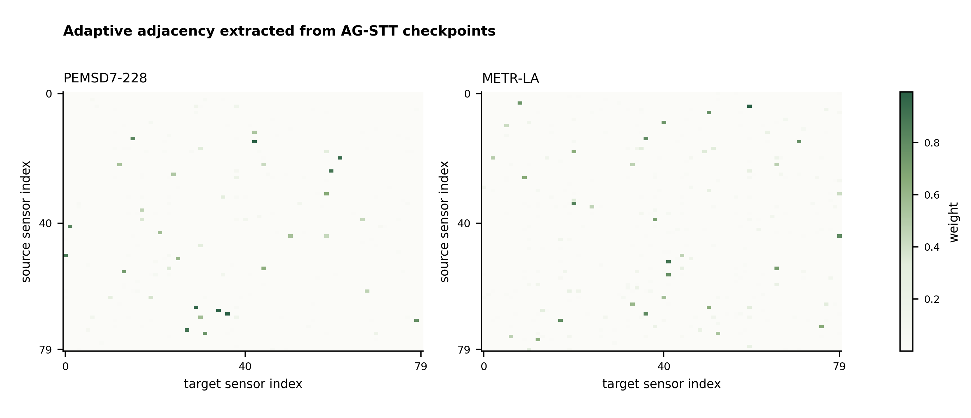
Figure 5. Learned adaptive adjacency matrices extracted from saved AG-STT model states.

4.4 Long-Sequence and Fair-Budget Experiments
Table 5 and Figure 6 report the fair-budget experiments, which use max_timesteps=8064 and epochs=8 for all five models. In this setting AG-STT achieves MAE=3.1828 on PEMS and MAE=3.7914 on METR-LA, ranking first in MAE on both fair-budget tables. This suggests that AG-STT benefits from the longer training slice and additional epochs.
However, the fair-budget results should not be merged with the standard-budget results as if they were the same comparison. They answer a different question: whether the model can improve under a larger but still matched budget. The standard-budget benchmark remains the primary controlled result, while the fair-budget experiment is supporting evidence.
Table 5. Fair-budget comparison with max_timesteps=8064 and epochs=8.
Dataset | Model | MAE | RMSE | MAPE (%)
PEMSD7-228 | AG-STT | 3.1828 | 6.2182 | 8.26
PEMSD7-228 | DCRNN | 3.2543 | 6.4648 | 8.31
PEMSD7-228 | LSTM | 3.3995 | 6.9117 | 8.65
PEMSD7-228 | STGCN | 3.4658 | 6.6517 | 9.03
PEMSD7-228 | Linear | 3.6610 | 7.2538 | 9.41
METR-LA | AG-STT | 3.7914 | 8.2891 | 9.98
METR-LA | STGCN | 3.8832 | 8.3186 | 10.25
METR-LA | DCRNN | 3.8921 | 8.3298 | 9.97
METR-LA | LSTM | 3.9287 | 8.4815 | 10.12
METR-LA | Linear | 4.2371 | 8.8620 | 10.49
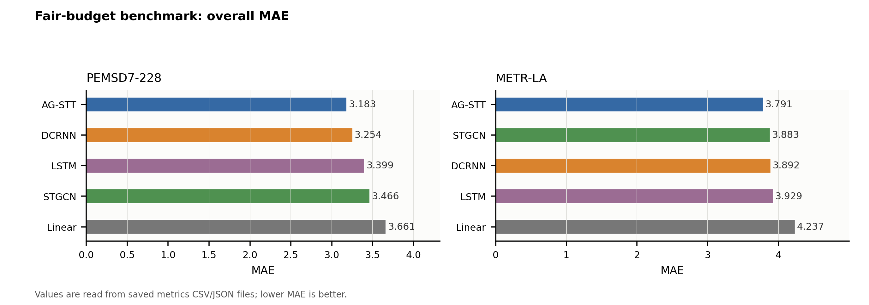
Figure 6. Fair-budget MAE comparison using a larger time slice and eight training epochs.

4.5 Statistical Significance and Stability Validation
This section provides stricter validation evidence beyond the main benchmark table, including paired error tests, seed-level comparisons and rolling split checks. These analyses are reported separately because they answer different questions from the single-run benchmark: whether the observed differences are reliable at the point-error level, whether they remain stable across random initialisations, and whether the conclusions change across temporal windows.

4.5.1 Paired Error Significance Tests
Table 6 compares standard AG-STT with each baseline using the saved prediction arrays. The reported mean difference is defined as AG-STT absolute error minus baseline absolute error. Therefore, a positive value means that the compared baseline has lower error than AG-STT, while a negative value means that AG-STT has lower error. Under this definition, DCRNN is significantly better than standard AG-STT in MAE on both datasets, whereas AG-STT is significantly better than STGCN and Linear. On METR-LA, the significance test uses null_val=0.0, matching the main masked metric calculation.
The validation results are considered in several steps. The standard paired test compares point-wise error differences from the saved test predictions. The seed-level comparison checks whether the improved constrained-fusion variant remains stable across random initialisations. The rolling split check then asks whether the conclusion changes when the temporal window is moved. These tests answer different questions and should not be compressed into a single headline result.
$$d_i = |y_i - ŷ_i^\{AG-STT\}| - |y_i - ŷ_i^\{baseline\}|$$
Table 6. Paired significance tests comparing standard AG-STT against baselines.
Dataset | Comparison | Mean error diff (AG-STT - baseline) | 95% CI | p-value | Interpretation
PEMSD7-228 | AG-STT vs DCRNN | 0.010921 | [0.008310, 0.013673] | 0.000500 | DCRNN lower error
PEMSD7-228 | AG-STT vs LSTM | -0.110263 | [-0.113570, -0.106755] | 0.000500 | AG-STT lower error
PEMSD7-228 | AG-STT vs STGCN | -0.487624 | [-0.491793, -0.483528] | 0.000500 | AG-STT lower error
PEMSD7-228 | AG-STT vs Linear | -0.716047 | [-0.721612, -0.710544] | 0.000500 | AG-STT lower error
METR-LA | AG-STT vs DCRNN | 0.041526 | [0.039173, 0.043960] | 0.000500 | DCRNN lower error
METR-LA | AG-STT vs LSTM | -0.010324 | [-0.012869, -0.007505] | 0.000500 | AG-STT lower error
METR-LA | AG-STT vs STGCN | -0.168449 | [-0.172016, -0.164950] | 0.000500 | AG-STT lower error
METR-LA | AG-STT vs Linear | -0.732066 | [-0.737822, -0.726598] | 0.000500 | AG-STT lower error

4.5.2 Seed-Level and Rolling Stability
Table 7 provides a seed-level comparison between AG-STT fusion constrained v3 and the DCRNN-style baseline. The n=5 robustness summary provides a wider view. Full AG-STT has mean MAE 3.5999 +/- 0.0182 on PEMS and 4.3081 +/- 0.0455 on METR-LA, while the DCRNN-style baseline has 3.6077 +/- 0.0120 and 4.3332 +/- 0.0155 respectively. The v3 seed-level paired test reports 5/5 AG-STT(v3) wins on METR-LA but p=0.0909, and 2/5 wins on PEMS with p=1.0. These results support cautious wording about stability and significance.
The seed-level test has a different scope from the standard significance test. It compares AG-STT(v3) with DCRNN across five seeds rather than comparing standard AG-STT on every test point. Its METR-LA result is directionally favourable to AG-STT(v3), with 5/5 seed wins, but the p-value is not below 0.05 because the seed sample is small. The thesis therefore reports it as stability evidence, not as definitive statistical proof.
The rolling split evidence further limits over-generalisation. On PEMS, AG-STT(v3) wins two of three windows but loses the third by a larger margin. On METR-LA, DCRNN wins two of three windows. These results indicate that temporal regime changes affect both models and that future work should use broader cross-time validation.
Table 7. Seed-level paired comparison between AG-STT fusion constrained v3 and DCRNN.
Dataset | N seeds | Mean error diff (AG-STT(v3) - DCRNN) | 95% CI | p-value | AG-STT(v3) wins
METR-LA | 5 | -0.048122 | [-0.065103, -0.031140] | 0.090909 | 5/5
PEMSD7-228 | 5 | -0.000049 | [-0.029722, 0.033398] | 1.000000 | 2/5

4.6 Visualisation and Error Analysis
Figure 7 compares AG-STT, the DCRNN-style baseline and ground truth on difficult nodes selected by node-level error gap. In these examples, both models follow the broad trend, but sharp changes and local peaks remain challenging. This is consistent with the general behaviour of direct multi-step models trained with averaged point-error losses.
Figure 8 shows that most absolute errors are moderate, but both datasets have a long tail of larger errors. The learned adaptive adjacency heatmap confirms that the adaptive graph is dense and directed after softmax. This does not by itself prove interpretability, but it shows that the saved model state contains a non-trivial learned graph source rather than only using the static adjacency.
The single-node curves are not intended to prove global superiority. Their purpose is to show concrete forecasting behaviour that cannot be seen from aggregate metrics alone. In the selected difficult nodes, the predicted curves are smoother than some ground-truth changes, indicating that abrupt local transitions remain challenging.
The adaptive adjacency heatmap is also interpreted cautiously. A dense learned matrix can show that the model has learned non-static dependencies, but it does not automatically explain traffic causality. Stronger interpretability would require comparing learned edges with road topology, time-of-day regimes and external incidents, which is outside the current project scope.
Compared with post-hoc explanation methods such as feature attribution, the interpretability evidence in this project is mainly structural and diagnostic. The prediction curves show concrete forecast behaviour, the error distribution shows the tail risk of large errors, and the adaptive adjacency heatmap shows that the learned graph source is active. These visualisations support model inspection, but they are not sufficient to prove why a particular road segment changes at a particular time.
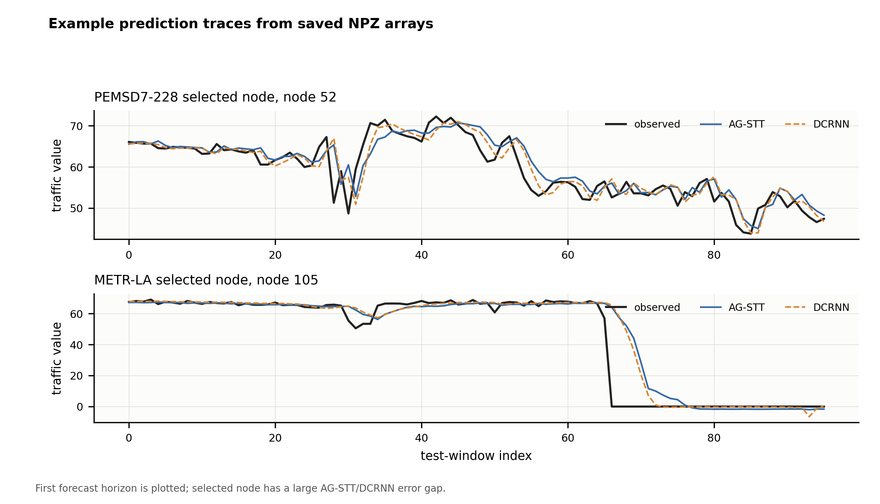
Figure 7. Ground truth, AG-STT and DCRNN curves on difficult selected nodes.
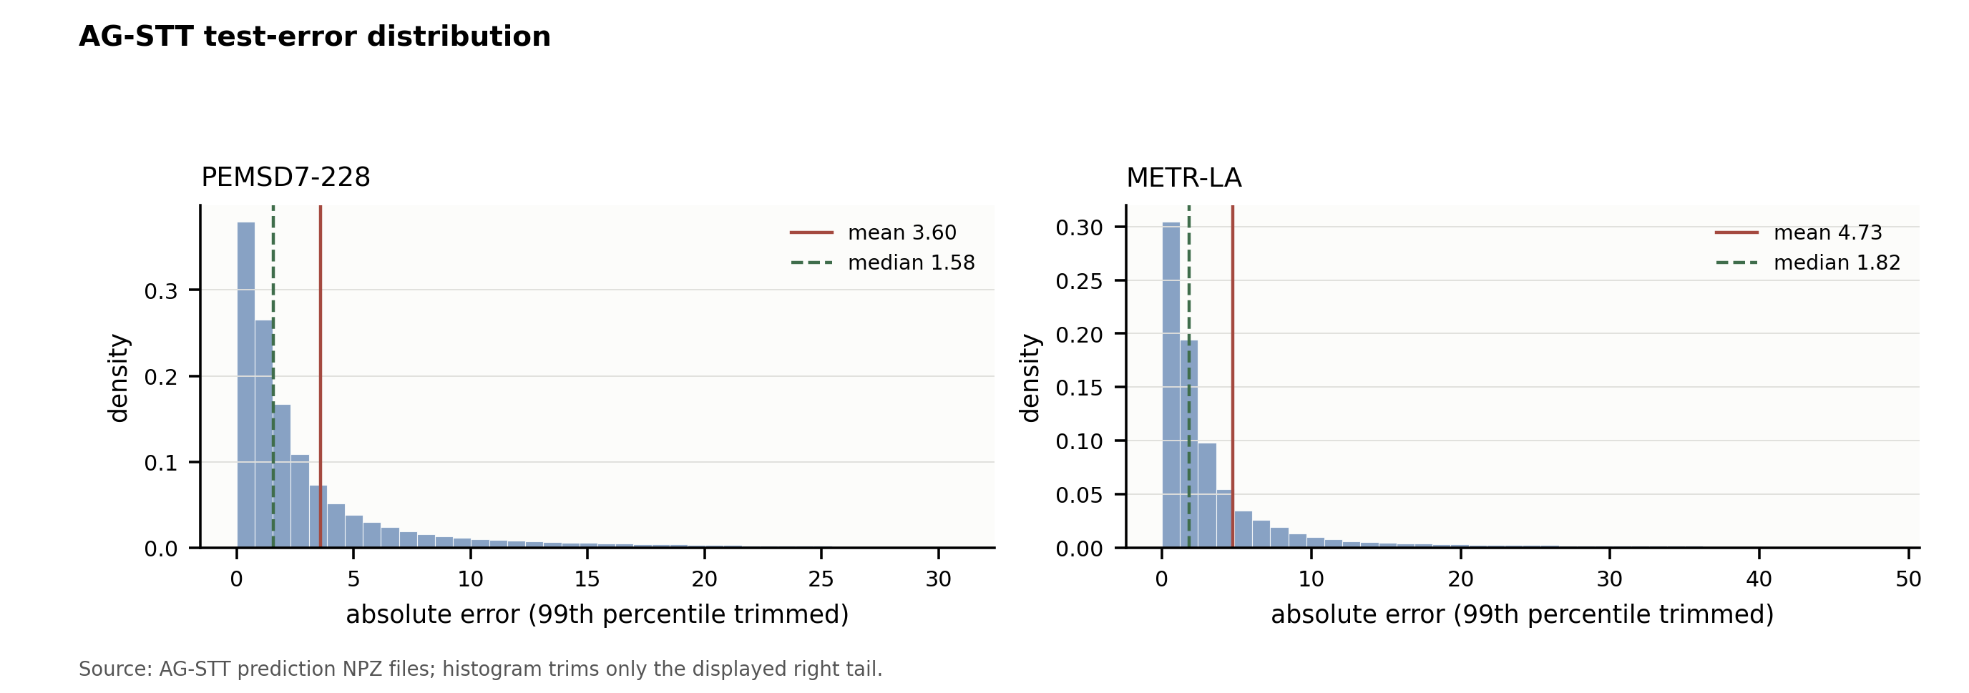
Figure 8. AG-STT absolute error distribution on the test predictions.

4.7 Summary of Results
The empirical findings are balanced. AG-STT is a competitive spatio-temporal forecasting model and clearly improves over weaker baselines in the standard benchmark. However, DCRNN remains slightly stronger in standard-budget MAE. In the fair-budget experiment, AG-STT becomes the best model in MAE under the larger matched training setting. The constrained-fusion sweep also improves AG-STT relative to the basic AG-STT configuration, but it should be treated as supplementary model-refinement evidence rather than a replacement for the standard benchmark. Overall, the adaptive and dynamic graph components are useful design directions, but the ablation results do not justify claiming that every graph branch is uniformly beneficial.

Chapter 5 Discussion and Conclusions

5.1 Discussion of Main Findings
The project supports the idea that adaptive graph learning and spatio-temporal Transformer modelling are feasible for short-term traffic forecasting. The architecture is coherent, the implementation runs on two real datasets, and the reported figures are linked to saved experimental outputs. The strongest result is not that AG-STT defeats every baseline in every setting, but that it remains competitive with a strong graph recurrent baseline while offering a flexible graph-fusion design.
The results also show that architectural complexity does not automatically improve accuracy. The dynamic graph branch is attractive conceptually, but the no-dynamic ablation indicates that its effect is not consistently positive under the current standard budget. This is an important finding because it prevents the thesis from overstating the benefit of dynamic graph learning.
A key lesson from the results is that adaptive graph learning is not a simple switch that always improves performance. It must be combined with a stable fusion strategy and enough training budget. The v3 constrained-fusion experiment is promising because it keeps the static graph influential while allowing adaptive and dynamic relations to contribute.
The results also show why several types of evidence are needed. The standard benchmark checks competitiveness under the fixed local budget. The ablation study examines whether the graph branches are reliable on their own. The fair-budget experiment checks whether the ranking changes under a larger matched budget. The n=5 robustness summaries and rolling-split experiments test stability across random seeds and temporal windows. Together, these results support a careful conclusion: AG-STT is a meaningful and reproducible model design, but its strongest claim is competitiveness and extensibility rather than universal dominance.

5.2 Practical Implications
A model such as AG-STT could support intelligent transportation applications that require hour-ahead estimates, including congestion warning, route guidance, short-term dispatch planning, signal-control support and abnormal sensor monitoring. The direct multi-step output is useful because downstream systems can consume the whole prediction horizon without recursively calling the model. In an operational setting, the model would be most useful as a decision-support component that provides near-future traffic-state estimates to planners or control systems, rather than as an autonomous traffic management system.
Although this project does not implement a real-time deployment system, the results suggest that adaptive graph learning is most useful when sensor relationships cannot be fully captured by a fixed physical adjacency matrix. In practical traffic management systems, this may help model non-local dependencies caused by commuting patterns, road hierarchy and correlated congestion propagation. The mixed ablation results also suggest that such a model should be validated on local data before being used for operational decision support.
For practical use, the model would need additional deployment work. A deployment-oriented workflow would require streaming sensor ingestion, sliding-window feature construction, low-latency inference, missing-sensor handling, prediction monitoring, scheduled retraining and uncertainty estimation. The current project demonstrates an offline research prototype rather than a production traffic management system, so latency, fault tolerance and integration with live traffic-control infrastructure remain outside the submitted implementation.

5.3 Limitations and Threats to Validity
The project has several limitations. First, experiments are limited to two public datasets and a reduced standard time slice. Second, the standard training budget is small, with six epochs, which may favour simpler models. Third, the dynamic graph branch has mixed ablation evidence. Fourth, statistical significance depends on the exact evaluation scope and masking policy, even though the final METR-LA test is aligned with the main null mask. Fifth, the learned graph is only partly interpretable. Finally, the model has not been tested in a real deployment environment. These limitations do not invalidate the project, but they define the boundary of the claims that can be made from the submitted evidence.
Another limitation is that the project does not compare against every recent Transformer or graph forecasting model, such as full published implementations of Graph WaveNet, AGCRN, GMAN or PatchTST-style traffic adaptations. Some of these models are discussed in the literature review but not reproduced as full baselines. The selected baselines are sufficient for the project scope, but not exhaustive.
The project also does not perform hyperparameter optimisation at publication scale. Hidden dimension, layer count, learning rate and graph-fusion settings were kept modest so that the full pipeline could be completed. A larger search could improve both AG-STT and the baselines, so the reported numbers should be interpreted as project results rather than absolute architecture limits.
Internal validity is affected by implementation choices such as temporal splitting, scaling, masking, random seeds and hyperparameters. The project reduces this risk with structured experiment records, strict adjacency checks, saved model states, saved prediction arrays and consistent null-value handling. Construct validity concerns whether MAE, RMSE and MAPE fully measure practical usefulness. They are standard forecasting metrics, but they do not capture uncertainty, downstream decision cost, incident-specific performance or the asymmetric consequences of over-prediction and under-prediction.
External validity is limited because only PEMSD7-228 and METR-LA are used. Results may differ on other cities, sensor layouts, road types, sensor densities or traffic regimes. Statistical conclusion validity is also limited by the number of seeds and by local compute constraints. The report therefore uses cautious language when discussing significance and stability, and it separates standard-budget findings from fair-budget and constrained-fusion evidence.
There is also a reporting-validity threat: once many supplementary experiments exist, it is tempting to highlight only the favourable ones. The report reduces this risk by presenting the standard budget first, explicitly stating that DCRNN is better in MAE there, and only then discussing fair-budget and v3 results as supplementary evidence.
Interpretive validity is a further concern. The learned adaptive adjacency matrix shows that the model has learned non-static dependencies, but it should not be interpreted as a causal map of traffic influence without additional validation against road topology, time-of-day regimes and incident data. A final validity issue is reproducibility across machines. PyTorch versions, CUDA availability and random seeds can produce small numerical differences. The project stores metrics and prediction arrays so that the submitted report does not depend on rerunning experiments during assessment.

5.4 Conclusions and Future Work
This thesis implemented and evaluated AG-STT, an Adaptive Graph Spatio-Temporal Transformer for short-term traffic forecasting. The project covers preprocessing, model training, baseline comparison, significance testing, visualisation and report preparation. The model is evaluated on PEMS and METR-LA against Linear, LSTM, STGCN and a compact DCRNN-style graph recurrent baseline.
The final conclusion is that AG-STT is a credible and competitive approach, especially when graph fusion is constrained and the training budget is increased. Under the standard budget it does not uniformly outperform the DCRNN-style baseline, so the thesis avoids a stronger claim. The main contribution is therefore the implemented framework, reproducible evidence and careful evaluation of adaptive graph spatio-temporal Transformer modelling under realistic public-data and local-compute constraints.
The broader lesson is that a sophisticated architecture is only convincing when its evaluation protocol is equally careful. In this project, the most defensible claim is not that a Transformer-based graph model always wins, but that adaptive graph spatio-temporal modelling can be implemented, audited and evaluated in a way that exposes both its promise and its instability.
Future work should evaluate more public datasets, more temporal splits and more random seeds. A fuller ablation matrix should compare static-only, adaptive-only, dynamic-only and fused variants under the same long-budget setting. External information such as weather, incidents, holidays and events could be added to test whether sudden traffic changes become easier to predict.
Further work should also improve interpretability and deployment readiness. This includes analysing learned graph stability over time, measuring inference latency, adding uncertainty estimates and validating the model in a streaming environment.

References
[1] Yuan, H. and Li, G. (2021) 'A survey of traffic prediction: from spatio-temporal data to intelligent transportation', Data Science and Engineering, 6, pp. 63-85. doi:10.1007/s41019-020-00151-z.
[2] Lee, K., Eo, M., Jung, E., Yoon, Y. and Rhee, W. (2021) 'Short-term traffic prediction with deep neural networks: a survey', IEEE Access, 9, pp. 54739-54756. doi:10.1109/ACCESS.2021.3071174.
[3] Williams, B.M. and Hoel, L.A. (2003) 'Modelling and forecasting vehicular traffic flow as a seasonal ARIMA process', Journal of Transportation Engineering, 129(6), pp. 664-672. doi:10.1061/(ASCE)0733-947X(2003)129:6(664).
[4] Hochreiter, S. and Schmidhuber, J. (1997) 'Long short-term memory', Neural Computation, 9(8), pp. 1735-1780. doi:10.1162/neco.1997.9.8.1735.
[5] Cho, K., van Merrienboer, B., Gulcehre, C., Bahdanau, D., Bougares, F., Schwenk, H. and Bengio, Y. (2014) 'Learning phrase representations using RNN encoder-decoder for statistical machine translation', Proceedings of EMNLP 2014, pp. 1724-1734. doi:10.3115/v1/D14-1179.
[6] Vaswani, A., Shazeer, N., Parmar, N., Uszkoreit, J., Jones, L., Gomez, A.N., Kaiser, L. and Polosukhin, I. (2017) 'Attention is all you need', Advances in Neural Information Processing Systems, 30. Available at: https://papers.nips.cc/paper/7181-attention-is-all-you-need.
[7] Kipf, T.N. and Welling, M. (2017) 'Semi-supervised classification with graph convolutional networks', International Conference on Learning Representations. Available at: https://openreview.net/forum?id=SJU4ayYgl.
[8] Velickovic, P., Cucurull, G., Casanova, A., Romero, A., Lio, P. and Bengio, Y. (2018) 'Graph attention networks', International Conference on Learning Representations. Available at: https://openreview.net/forum?id=rJXMpikCZ.
[9] Yu, B., Yin, H. and Zhu, Z. (2018) 'Spatio-temporal graph convolutional networks: a deep learning framework for traffic forecasting', Proceedings of IJCAI 2018, pp. 3634-3640. doi:10.24963/ijcai.2018/505.
[10] Li, Y., Yu, R., Shahabi, C. and Liu, Y. (2018) 'Diffusion convolutional recurrent neural network: data-driven traffic forecasting', International Conference on Learning Representations. Available at: https://openreview.net/forum?id=SJiHXGWAZ.
[11] Guo, S., Lin, Y., Feng, N., Song, C. and Wan, H. (2019) 'Attention based spatial-temporal graph convolutional networks for traffic flow forecasting', Proceedings of the AAAI Conference on Artificial Intelligence, 33, pp. 922-929. doi:10.1609/aaai.v33i01.3301922.
[12] Wu, Z., Pan, S., Long, G., Jiang, J. and Zhang, C. (2019) 'Graph WaveNet for deep spatial-temporal graph modelling', Proceedings of IJCAI 2019, pp. 1907-1913. doi:10.24963/ijcai.2019/264.
[13] Zheng, C., Fan, X., Wang, C. and Qi, J. (2020) 'GMAN: a graph multi-attention network for traffic prediction', Proceedings of the AAAI Conference on Artificial Intelligence, 34(1), pp. 1234-1241. doi:10.1609/aaai.v34i01.5477.
[14] Bai, L., Yao, L., Li, C., Wang, X. and Wang, C. (2020) 'Adaptive graph convolutional recurrent network for traffic forecasting', Advances in Neural Information Processing Systems, 33. Available at: https://papers.nips.cc/paper/2020/hash/ce1aad92b939420fc17005e5461e6f48-Abstract.html.
[15] Wu, Z., Pan, S., Long, G., Jiang, J., Chang, X. and Zhang, C. (2020) 'Connecting the dots: multivariate time series forecasting with graph neural networks', Proceedings of KDD 2020, pp. 753-763. doi:10.1145/3394486.3403118.
[16] Xu, M., Dai, W., Liu, C., Gao, X., Lin, W., Qi, G.J. and Xiong, H. (2020) 'Spatial-temporal transformer networks for traffic flow forecasting', arXiv:2001.02908. Available at: https://arxiv.org/abs/2001.02908.
[17] Zhou, H., Zhang, S., Peng, J., Zhang, S., Li, J., Xiong, H. and Zhang, W. (2021) 'Informer: beyond efficient transformer for long sequence time-series forecasting', Proceedings of the AAAI Conference on Artificial Intelligence, 35(12), pp. 11106-11115. doi:10.1609/aaai.v35i12.17325.
[18] Wu, H., Xu, J., Wang, J. and Long, M. (2021) 'Autoformer: decomposition transformers with auto-correlation for long-term series forecasting', Advances in Neural Information Processing Systems, 34. Available at: https://papers.nips.cc/paper/2021/hash/bcc0d400288793e8bdcd7c19a8ac0c2b-Abstract.html.
[19] Zhou, T., Ma, Z., Wen, Q., Wang, X., Sun, L. and Jin, R. (2022) 'FEDformer: frequency enhanced decomposed transformer for long-term series forecasting', Proceedings of ICML 2022, PMLR 162, pp. 27268-27286. Available at: https://proceedings.mlr.press/v162/zhou22g.html.
[20] Nie, Y., Nguyen, N.H., Sinthong, P. and Kalagnanam, J. (2023) 'A time series is worth 64 words: long-term forecasting with transformers', International Conference on Learning Representations. Available at: https://openreview.net/forum?id=Jbdc0vTOcol.
[21] Jin, M., Koh, H.Y., Wen, Q., Zambon, D., Alippi, C., Webb, G.I., King, I. and Pan, S. (2024) 'A survey on graph neural networks for time series: forecasting, classification, imputation, and anomaly detection', IEEE Transactions on Pattern Analysis and Machine Intelligence, 46(12), pp. 10466-10485. doi:10.1109/TPAMI.2024.3443141.

Appendix A Self-appraisal

A.1 Critical self-evaluation
The project achieved its main aim: a working adaptive graph spatio-temporal Transformer was built, trained and evaluated on real traffic datasets. The strongest part of the work is the full evidence pipeline. The main weakness is that the standard budget is modest and the dynamic graph branch is not consistently beneficial in ablation. I learned that a credible machine-learning report depends as much on evaluation discipline as on model design.

A.2 Personal reflection and lessons learned
This project improved my ability to connect research reading, engineering implementation and academic writing. The most important lesson was that small evaluation details can change the conclusion. The METR-LA null-value handling and the separation between standard-budget and fair-budget results both forced me to write more carefully and avoid unsupported claims.

A.3 Legal, social, ethical and professional issues
The project does not use personal data collected by the student. It uses public traffic datasets and open-source tools. The main professional responsibility is accurate reporting, reproducibility and clear acknowledgement of external materials.

A.3.1 Legal issues
The data and software libraries are public research or open-source materials. The report cites the datasets, papers and libraries used. No private or identifiable personal data were collected.

A.3.2 Social issues
Traffic forecasting can help reduce congestion and improve planning, but inaccurate predictions could mislead operational decisions. Any deployment should therefore include monitoring and human oversight.

A.3.3 Ethical issues
The ethical risk is low because the data are aggregate traffic sensor observations. The main ethical issue is honesty in reporting performance. The report explicitly avoids claiming that AG-STT significantly outperforms DCRNN under the standard budget.

A.3.4 Professional issues
Professional practice requires maintainable code, reproducible experiments and transparent limitations. The project supports this through structured experiment records, saved experimental artefacts, evidence paths and a validation report.

Appendix B External Material and Reproducibility Notes

B.1 Datasets
The project uses the METR-LA dataset and the PEMSD7-228 traffic dataset with their associated sensor adjacency information.

B.2 Software and Libraries
The project uses Python, PyTorch, NumPy, pandas, PyYAML, scikit-learn, matplotlib and related open-source libraries. Baseline ideas come from Linear forecasting, LSTM, STGCN and DCRNN. Published research used for the literature review is listed in the References.

B.3 Major Experimental Artefacts
The repository recorded in the deliverables contains the AG-STT implementation, data preparation code, training and evaluation components, experiment configurations, result summaries, significance-test outputs and figure materials. The main experimental evidence used in this report is stored with the final report materials, including benchmark summaries, model-level metric files, ablation and fair-budget summaries, paired significance-test outputs, seed-level comparison outputs, rolling-split stability summaries and the CSV files used to prepare the final tables.
The principal evidence files include pemsd7_benchmark_summary.json, metr_la_benchmark_summary.json, current_results_summary.json, fair_budget_benchmark_summary.json, fusion_sweeps_benchmark_summary.json, cross_split_v3_rolling_summary.json, pemsd7_significance_test.json, metr_la_significance_test.json and seed_level_significance_v3_vs_dcrnn.json. The corresponding table-source files include main_benchmark_table.csv, ablation_and_long_budget_table.csv, fair_budget_table.csv, significance_table.csv, seed_level_significance_summary.csv, cross_split_head_to_head.csv and cross_split_per_split.csv.
The report figures are stored in the figure asset directory. They are based on the saved experiment outputs and were formatted for clarity in the final report. The purpose of keeping the evidence files and figure sources alongside the report is to make clear which project artefacts support the numerical claims made in Chapters 3 and 4.

B.4 Reproduction Notes
The main experimental settings are recorded in YAML configuration files in the configs directory. These configurations define the dataset, model, training budget, evaluation settings and output locations used for the reported experiments. The standard and fair-budget settings are represented by separate configuration files so that the comparisons reported in the main text are not mixed across evaluation budgets.
Typical reproduction steps include preparing the METR-LA and PEMSD7-228 datasets, training the configured models, evaluating the saved checkpoints, computing paired significance tests from saved prediction outputs, and comparing the resulting metrics with the evidence files listed in Appendix B.3. Exact file paths may vary by local environment, but the reported tables are based on the saved experimental evidence.

