Reliable LIME under Query Budget Constraints

Qihang Feng | Wonki Byun | Zixi Chai
Department of Electrical and Computer Engineering | Department of Electrical and Computer Engineering | Department of Electrical and Computer Engineering
University of Alberta | University of Alberta | University of Alberta
Edmonton, Canada | Edmonton, Canada | Edmonton, Canada
qfeng5@ualberta.ca | wonki@ualberta.ca | zchai3@ualberta.ca

Abstract—LIME relies on repeated model queries, but real world deployments often impose strict query budgets, which can make explanations unstable. In this work, we build a budget sweep pipeline with stability Jaccard, deletion based faithfulness FaithDropK, weighted MSE fidelity, and runtime cost, enabling systematic numerical comparison under query limits. Additionally, we design a coarse to fine budget allocation strategy with candidate screening and focused perturbations, improving FaithDropK and highlighting key regions under lower budgets compared with original LIME.
Keywords—LIME, query budgets, coarse to fine

Introduction
State the problem, why it matters, what we did

Background

Original LIME Image Workflow
Explain the LIME image workflow, which is our baseline. The 1.1 section in Jupyter Notebook may be helpful.

Motivation
Clarify the definition of budget.
Introduce the limitations of original LIME under limited budgets with visualized examples.

Methodology

Numerical Metrics
Define and explain our four metrics.

Budget Sweep Pipeline
Describe how we systematically evaluate the effect of budget.

Coarse to Fine Budget Allocation
Explain our improvement and algorithm steps.

Experiments and Results

Experiment Setup
We conduct all experiments on a single test image from the scikit-image library (skimage.data.cat()), which is classified as class 285 ("Egyptian cat") by a pretrained ResNet-18 model [4] on ImageNet. The image is segmented into 100 superpixels using the SLIC algorithm with compactness 10 and sigma 1. To ensure consistent comparisons, the segmentation is computed once and shared across all runs.
We evaluate LIME under six query budget levels: N ∈ {200, 500, 1000, 2000, 3000, 5000}. For each budget, we repeat the experiment with 10 random seeds (0–9) to capture variability. The surrogate model is a Ridge regression with regularization parameter α = 1. Pairwise distances between binary perturbation masks are computed using cosine distance, and the exponential kernel with width 0.25 is applied to weight the samples. Each explanation selects the top-10 most important superpixels, and masked regions are filled with black (hide_color = 0).
For the coarse-to-fine method, we use adaptive coarse fraction allocation (50% of budget when N ≤ 500, 30% when N ≤ 2000, and 20% otherwise), candidate_k = 20, exploration ratio ε = 0.2, and batch size 32. All other settings remain identical to the vanilla LIME baseline.

Baseline Results
Table I presents the evaluation metrics of vanilla LIME across different query budgets. As the budget increases from 200 to 5000, all metrics improve consistently: stability (Jaccard) rises from 0.063 to 0.348, fidelity (WMSE × 1000) decreases from 0.770 to 0.163, and faithfulness (Drop-k) increases from −0.056 to 0.193.
TABLE I: Vanilla LIME metrics across query budgets.
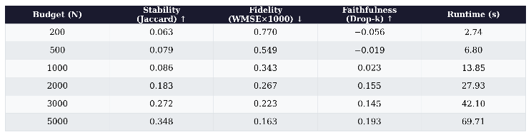
One thing that stands out is that at low budgets (N ≤ 1000), the faithfulness score is near zero or even negative. A negative Drop-k means that removing the superpixels LIME considers "most important" actually increases the model's predicted probability for the target class — in other words, the explanation is pointing to the wrong regions. Stability is also very low (below 0.1) at these budgets, which means running LIME twice with different random seeds gives almost completely different explanations. Together, these numbers show that vanilla LIME is not reliable when the query budget is small.
Fig. 1 provides a visual illustration: at N = 200, the highlighted regions appear scattered and inconsistent, while at N = 5000, the explanation consistently focuses on the cat's facial features (eyes, nose), which are semantically meaningful for the "Egyptian cat" classification.
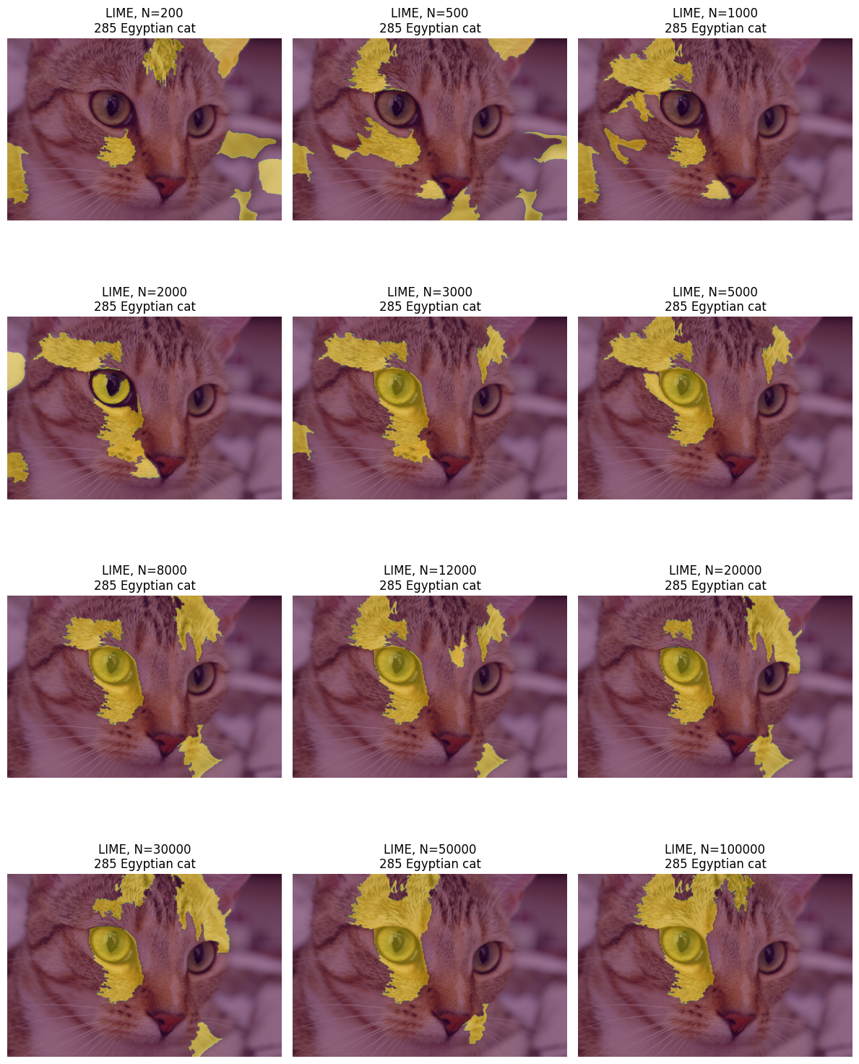

Improvement Results and Discussion
Table II presents the metrics for the coarse-to-fine budget allocation strategy under the same experimental settings.
TABLE II: Coarse-to-fine metrics across query budgets.
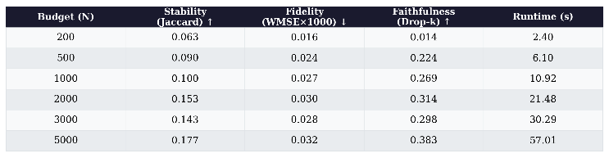
Fig. 2 shows the comparison line charts across all four metrics, and Fig. 3 provides a side-by-side visual comparison of explanation quality.
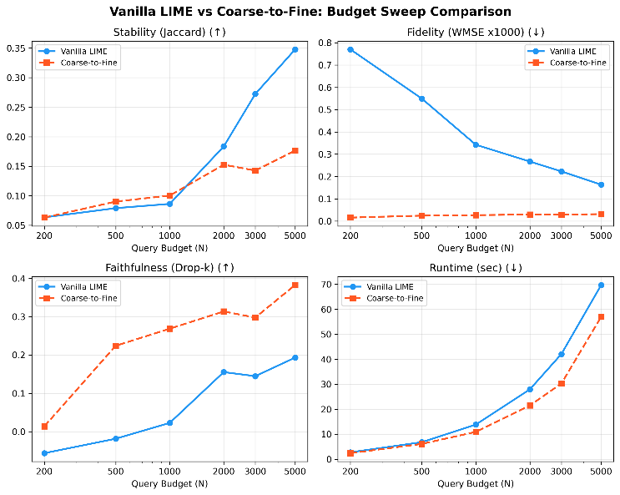
Faithfulness. The biggest improvement we see is in faithfulness. Vanilla LIME gives negative Drop-k scores at N ≤ 500, while coarse-to-fine achieves positive scores at all budgets. For example, at N = 500, faithfulness goes from −0.019 to 0.224. This suggests that the coarse screening stage does a reasonable job at picking out candidate superpixels, and the focused sampling in the fine stage spends the remaining queries more efficiently on refining their importance.
Fidelity. The WMSE values for coarse-to-fine are much lower than vanilla LIME (e.g., 0.016 vs. 0.770 at N = 200). That said, this gap is partly because the focused sampling keeps non-candidate superpixels mostly unchanged, which reduces the effective feature space and makes the Ridge regression easier to fit. So we think WMSE is more useful for tracking how fidelity changes within each method as budget grows, rather than for comparing the two methods directly.
Stability. Coarse-to-fine helps slightly at lower budgets (e.g., 0.090 vs. 0.079 at N = 500), but at higher budgets it actually falls behind vanilla LIME (e.g., 0.177 vs. 0.348 at N = 5000). We believe this happens because when the budget is large enough, vanilla LIME already has plenty of samples to fit well globally. In contrast, coarse-to-fine focuses its sampling on the candidate superpixels selected during the coarse stage, and since different seeds may select slightly different candidates, this can lead to more variation in the final explanations.
Runtime. Both methods have comparable runtime, as the coarse-to-fine strategy does not introduce additional model queries beyond the original budget.
Visual comparison. Looking at Fig. 3, vanilla LIME needs around N = 2000 queries before it starts consistently highlighting the cat's eye region. Coarse-to-fine picks up this region already at N = 500 and also captures other facial features like the whiskers and mouth.

Conclusion and Future Work
We looked at how reliable LIME explanations are for image classification when the number of model queries is limited. We set up a budget sweep pipeline with four metrics — stability (Jaccard), fidelity (WMSE), faithfulness (Drop-k), and runtime — so that we can compare explanation quality at different budget levels in a controlled way. Our experiments show that vanilla LIME becomes unreliable below about N = 1000: the explanations are unstable across seeds and can even point to the wrong regions. We then tried a coarse-to-fine budget allocation strategy, which first uses a portion of the budget to screen for candidate superpixels and then focuses the remaining queries on those candidates. This approach improves faithfulness at all budget levels we tested, and it can highlight meaningful regions with as few as 500 queries.

There are a few things we would like to explore further. Our current experiments only use one test image and one model (ResNet-18), so it would be important to test on more images and different architectures (e.g., VGG, Vision Transformer) to see how well these results generalize. We also noticed that stability does not always improve with coarse-to-fine, especially at higher budgets, so trying other sampling strategies like stratified sampling could help. The hyperparameters we used (coarse fraction, ε, candidate_k) were set manually based on some initial trials — an automatic tuning approach would make the method more practical. Lastly, it would be interesting to apply this budget-aware framework beyond images, to tabular or text data where LIME is also commonly used.

Acknowledgment

References
- ABC.DE
- FG,HG

- K. He, X. Zhang, S. Ren, and J. Sun, "Deep residual learning for image recognition," in Proc. IEEE CVPR, 2016, pp. 770–778.
- If you need to cite other papers, please start the reference numbering from 1 for now. We’ll clean up and organize all references at the end

