Raspberry pi 2 B+ GPU power implication

# Introduction

When we are trying to develop the micro-broad, we are focusing more on the power implication on the board now. For GPU power implication, there is few work done to detail the power consumption of the GPU.

GPU is kind of new for study of the energy consuming, even it is using nearly the same energy as CPU. But I think more effort should be put on the study on GPU, for its multi-core structure can be easily saving a lot of power.

I want to test the power implication of the raspberry pi 2 B+ when it’s using GPU. I am going to use several benchmark and system tool and USB-po3wermeter to measure the GPU power implication on Raspberry pi 2 B+.

# Related work

Desrochers and Paradis and Weaver [1] wrote in his paper that for integrated GPU, is having no way to intercept the input voltage. So they introduced SmallGPU2 as an OpenCL ray-tracer. For the Raspberry Pi, it is having the integrated GPU. But the OpenCL is still not supported, so there is limited method that can look inside the system information.

Abe, Sasaki, Peres, Inoue, Murakami and Kato [2] analysis that system energy can be reduced 28% with decreasing 1% performance by modifying the GPU, and it is trivial for CPU modifying for energy reduction.

Y. Jiao, H. Lin, P. Balaji, W. Feng [3] has investigate that energy saving mechanisms on GPU is totally different from CPU. They has used three different applications with various degrees of compute and memory intensiveness. Their way of saving energy on GPU is leading me for the future work.

# Experimental setup

* Hardware: Raspberry pi 2 B+, 1080p monitor, USB-powermeter, keyboard, mouse, speaker, Ethernet.
  + Raspberry pi 2 B+ has a GPU that is Broadcom VideoCore IV @ 250 MHz. More GPU info: OpenGL ES 2.0 (24 GFLOPS); 1080p30 MPEG-2 and VC-1 decoder (with license); ​1080p30 h.264/MPEG-4 AVC high-profile decoder and encoder.[4]

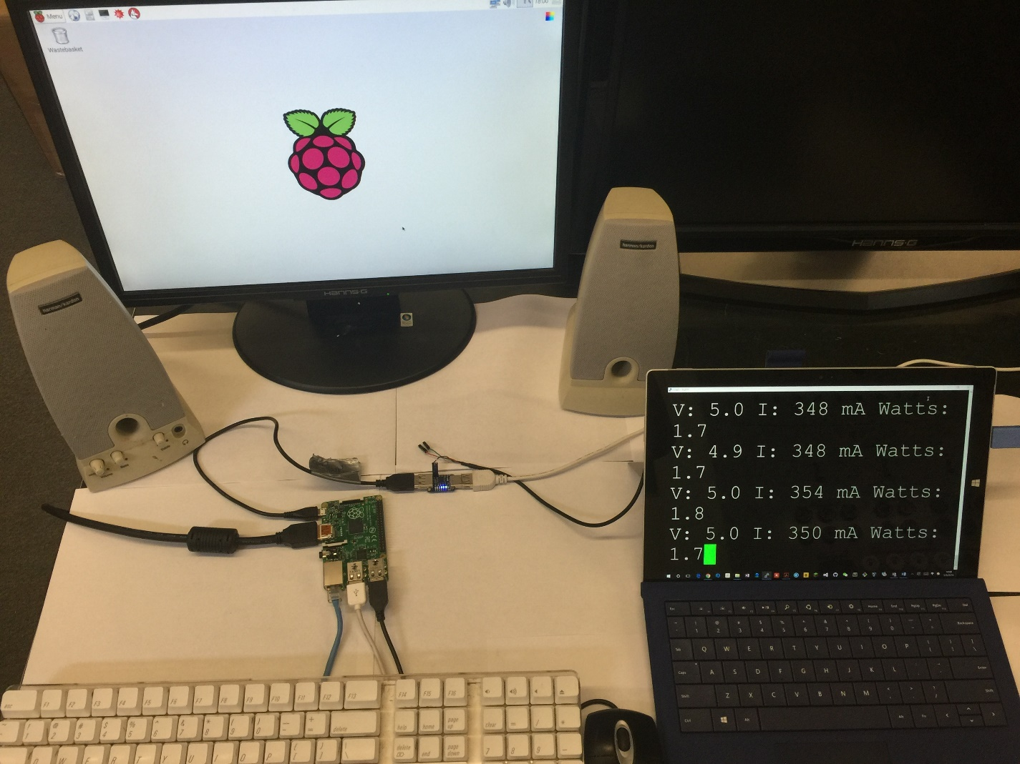

Fig. 1. My instrumented test machine.

* Software:
  + System: Raspbian
  + System tool: PERF, TOP
  + Benchmark: OMXplayer, mplayer, 3D-slash

|  |  |
| --- | --- |
| How to use the benchmark | |
| Play a 1080p movie | Modify a 3d model |
| Use PERF to run   * Omxplayer * Mplayer * Vlc player | Use PERF to run 3d-slash load 3d models |

How to use the USB-powermeter

* Put the USB-powermeter between the power supply and the power port of the raspberry pi and plug the serial USB port to another computer.
* Use the Device manager to find the USB port serial line that are currently used.
* Use PUTTY to read the serial port data from the USB-powermeter.

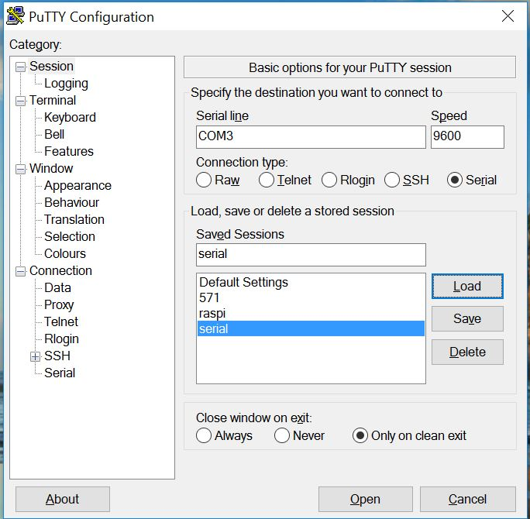

Fig. 2. PUTTY setup for the serial port gathering data.

# Results/analysis

OMXPlayer is a built in basic video player comes with the Raspbian. With the hardware accelerate supported. It is taking little CPU and memory use. It is capable of playing MP4, MP3, MKV. With fast respond speed, and smoothly, it is mostly recommended on the Raspberry pi. OMXplayer is having none feature but to play the movie. Somehow fit the need of playing 1080p.[5]

Mplayer

VLCplayer

3d-slash

Different benchmark performance

|  |  |  |  |  |
| --- | --- | --- | --- | --- |
| **performance** | **Omxplayer** | **Mplayer** | **VLC player** | **3d-slash** |
| Hardware accelerate | Y | N | N | Y |
| 1080p fluency | Y | N, the video is playing at 1 frame/s. | N, the video is playing at 0.01 frame/s |  |
| Audio | Y | N | N |  |
| fluency |  |  |  | Fluent with not HD models  It cannot go detail with HD models |

Table. 1. Different benchmark

Perf measure different benchmark

Fig. 3. Cycles per instructions for different benchmark

The idle and the OMXplayer are having the processor subscalar. But the mplayer, 3D-slash and VLC player are having the processor scalar.

TOP measure different benchmark

Fig. 4. TOP measure CPU and memory use for different benchmark.

Usb-powermeter measure benchmark

Fig. 5. USB-powermeter comparison between different benchmark.

Average power

Fig. 6. Average power comparison between different benchmark

# Conclusion/future work

We are focusing on the power implication of the Raspberry pi 2 B+, but we do not want a lot of performance lost. With the OpenGL support coming out recently, the OMXplayer and 3D-slash performs well.

Thanks to the hardware acceleration from the GPU, the energy consumption is higher than energy usage of the software just use CPU to do graphical work.

# Bibliography/references cited

[1]S. Desrochers and C. Paradis and V. Weaver. ”The first benchmark we look at is SmallptGPU2, an OpenCL ray-tracer.” MEMSYS chapter III F section, p 4, 2016.

[2]Y. Abe H. Sasaki M. Peres K Inoue K. Murakami and S. Kato. “Our analysis on a real system discloses that system energy can be reduced by 28% retaining a decrease in performance within 1% by controlling the voltage and frequency levels of GPUs. We show that energy savings can be achieved when GPU core and memory clock frequencies are appropriately scaled considering the workload characteristics. Another interesting finding is that voltage and frequency scaling of CPUs is trivial for total system energy reduction, and even should not be applied in state-of-the-art GPU-accelerated systems.” Usenix abstract 2012.

[3] Y. Jiao, H. Lin, P. Balaji, W. Feng “In this paper, we systematically characterize the power and energy efficiency of GPU computing. Specifically, using three different applications with various degrees of compute and memory intensiveness, we investigate the correlation between power consumption and different computational patterns under various voltage and frequency levels. Our study revealed that energy saving mechanisms on GPUs behave considerably different than CPUs.” Green Computing and Communications (GreenCom), 2010 IEEE/ACM Int'l Conference on & Int'l Conference on Cyber, Physical and Social Computing (CPSCom) Abstract 18-20 Dec. 2010

[4] J. Brodkin “GPU: Broadcom VideoCore IV @ 250 MHz More GPU info: OpenGL ES 2.0 (24 GFLOPS); 1080p30 MPEG-2 and VC-1 decoder (with license); ​1080p30 h.264/MPEG-4 AVC high-profile decoder and encoder” Raspberry Pi 2 arrives with quad-core CPU, 1GB RAM, same $35 price. Page 1, Feb 2, 2015

[5] J. Yip. “OMXPlayer is a very basic video player which does not have a user interface, but it can play MP4, MP3, MKV, and other file types which I tried with it. It also opens files very quickly, and music and video plays very smoothly without any slowdown problems.” Best Media Player Media Center software for video music playback on Raspberry Pi 2. SEPTEMBER 16, 2015