HW1 – R Output

**Question 3**

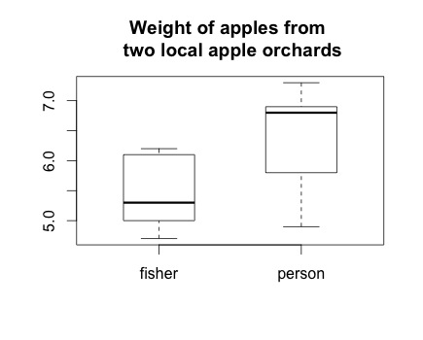

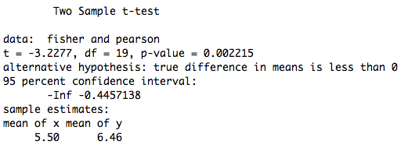

**Question 5**

**a) sample mean and variance using tapply()**

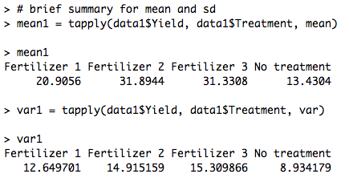

**b) The ratio of largest and smallest variance**

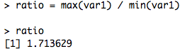

**Given this, I don’t think it is good to assume equal variance across samples.**

**c) ANOVA**

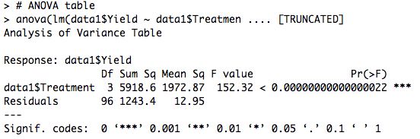

**Questions:**

**Also on Learn@UW is the datatset Yield_Data2.csv. Read this dataset into R and repeat parts a) – c) with this new data. What are the primary differences between the two data sets? Do you believe the two sets of data were drawn from the same population?**

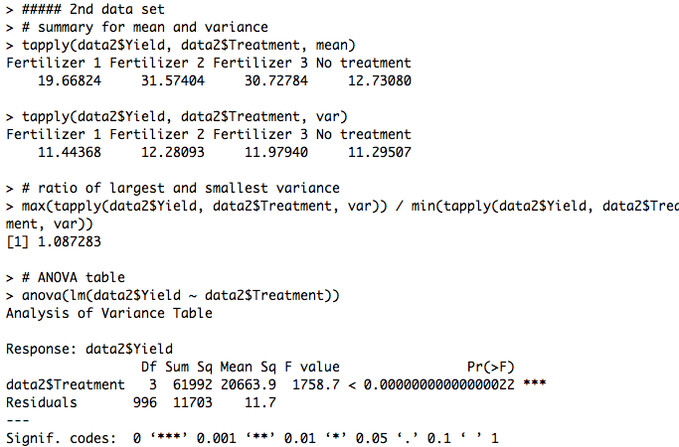

**I do believe these two data sets came from the same population. The primary difference between these two data sets is the sample size. The sample size of the second data set is as ten times as big as the first one. This reduces the error and it becomes more reasonable to assume the variances across treatments are equal. As a natural result, the F value also becomes bigger.**