3.

**Regression line**

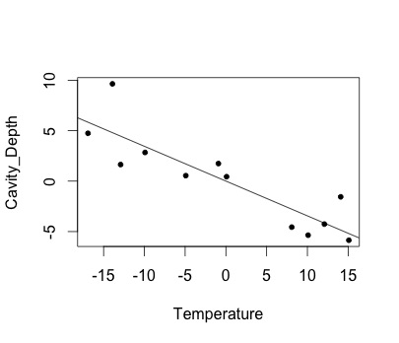

**summary(lm.fit)**

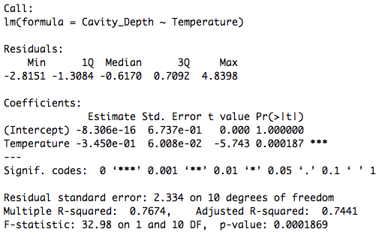

**After centering the model, the intercept of the Y-axis is about 0 (-8.306e-16).**

4.

**Regression line**

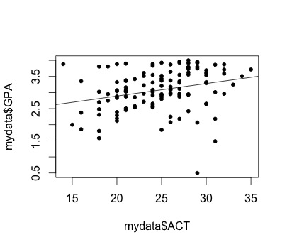

**summary(lm.fit)**

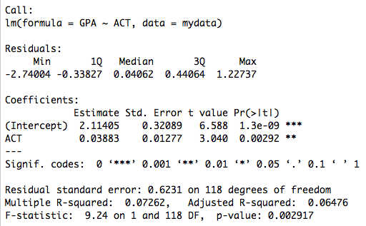

**Answers to the questions on the textbook (1.19):**

1. Obtain the least squares estimates of ß0 & ß1*,* and state the estimated regression function.

**According to the R output, the intercept is 2.11405 and the slope is 0.03883**

**So the regression function is Y = 2.11405 + 0.03883 * X**

1. Plot the estimated regression function and the data. Does the estimated regression function  appear to fit the data well?

**I think the regression function doesn’t fit the data very well, since the R-squared is low (0. 072). Since it shows the variance of depended variable cannot be well explained by the independent variable here.**

1. Obtain a point estimate of the mean freshman GPA for students with ACT test score *X* =30.

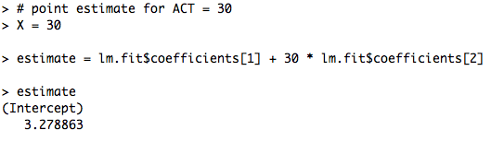

**According to the estimation, the student who had 30 for ACT is likely to get 3.278863 on GPA.**

1. What is the point estimate of the change in the mean response when the entrance test increases by one point?

**When ACT increase by 1 point, the predicted GPA increases by the slope (ß1) of the fitted model, which equals to 0.03883.**

**5.**

**The ANOVA table**

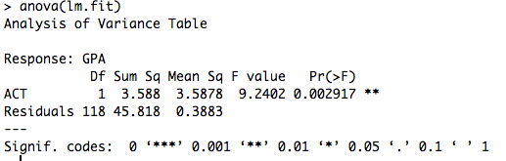

**Answers to the questions on the textbook (1.23):**

a) Obtain the sum of the residuals

**Macintosh HD:Users:Qihong:Desktop:Screen Shot 2015-02-03 at 10.12.50 AM Feb 3.png**

**The sum of the residual is approximately 0.**

b) Estimate population variance and standard deviation.

**Compute the MSE in R:**

