Question 1 – textbook 5.5 – Consumer Finance

Here’re the design matrix X, and the response vector Y

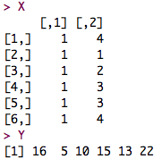

1. Find Y’Y

Macintosh HD:Users:Qihong:Desktop:Screen Shot 2015-03-11 at 12.51.09 PM Mar 11.png

2. Find X’X

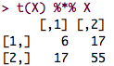

3. Find X’Y

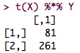

Question 3 – textbook 5.13 – Continuation of Consumer Finance

Find (X’X)-1

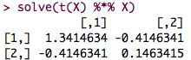

Question 4 – textbook 5.24 – Continuation of Consumer Finance

A.1) Find vector of estimated regression coefficients

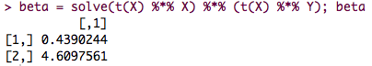

A.2) Vector of residuals

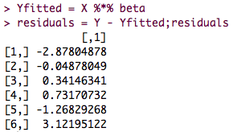

A.3) SSR

Macintosh HD:Users:Qihong:Desktop:Screen Shot 2015-03-11 at 12.55.31 PM Mar 11.png

A.4) SSE

Macintosh HD:Users:Qihong:Desktop:Screen Shot 2015-03-11 at 12.56.27 PM Mar 11.png

A.5) Estimated variance and covariance matrix of b

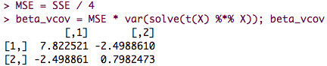

A.6) Point estimate of E(Yhat) when Xhat = 4

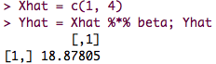

A.7) s2{pred} when Xhat = 4

Macintosh HD:Users:Qihong:Desktop:Screen Shot 2015-03-11 at 12.58.53 PM Mar 11.png

B) Find variance of beta0, beta1, and their covariance

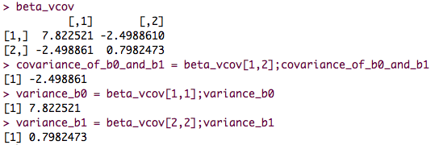

C) Find the hat matrix H

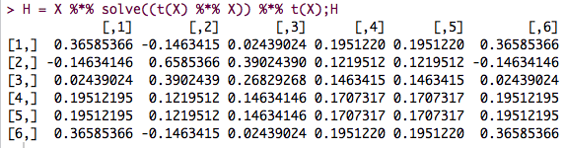

D) Find S2{e}

