SeatForge Ticketing Platform
  - Software Engineering Portfolio
Qihui Pan | September 2026 | Personal project
Public source code / Verified CI results
SeatForge is a full-stack ticket reservation project focused on keeping inventory and orders consistent when buyers compete for the same seat or repeat checkout requests. It combines a Next.js buyer interface, a Spring Boot booking API, and a separate notification worker in a reproducible Docker environment.

The problem
A ticket sale can accept competing requests for a limited seat, lose progress when a hold expires, or duplicate a payment record after a retry. SeatForge makes these state transitions explicit and enforces the booking rules inside PostgreSQL transactions. The result is a working demonstration that reviewers can run locally and inspect through public tests.

What the project delivers
- Buyer journey. Browse events, view seat availability, hold a seat, create an order, simulate payment capture, and download a QR ticket image. Order history and refund APIs complete the lifecycle.
- Catalog and access control. Buyer registration and login, JWT authentication, ownership checks, and organizer APIs for event publishing and session creation.
- Reliable background processing. Transactional outbox publishing, persistent RabbitMQ messages, consumer deduplication, retries, and a dead-letter queue.
- Operational visibility. Prometheus metrics, Grafana configuration, and an optional OpenTelemetry integration linking request logs and metric exemplars to traces.

Technology and implementation scope
Layer | Implementation
Application | Java 21, Spring Boot 3.5, Next.js 16, React 19, TypeScript
Data and messaging | PostgreSQL 17, Flyway, Redis 8, RabbitMQ 4
Quality and delivery | JUnit, Testcontainers, k6, Docker Compose, GitHub Actions, Terraform

The portfolio covers backend transaction design, frontend integration, automated verification, observability, and deployment packaging. The source is public under the MIT License.

Architecture and engineering decisions
A modular monolith keeps the booking transaction in one place. The notification worker runs independently so message handling does not extend checkout latency.
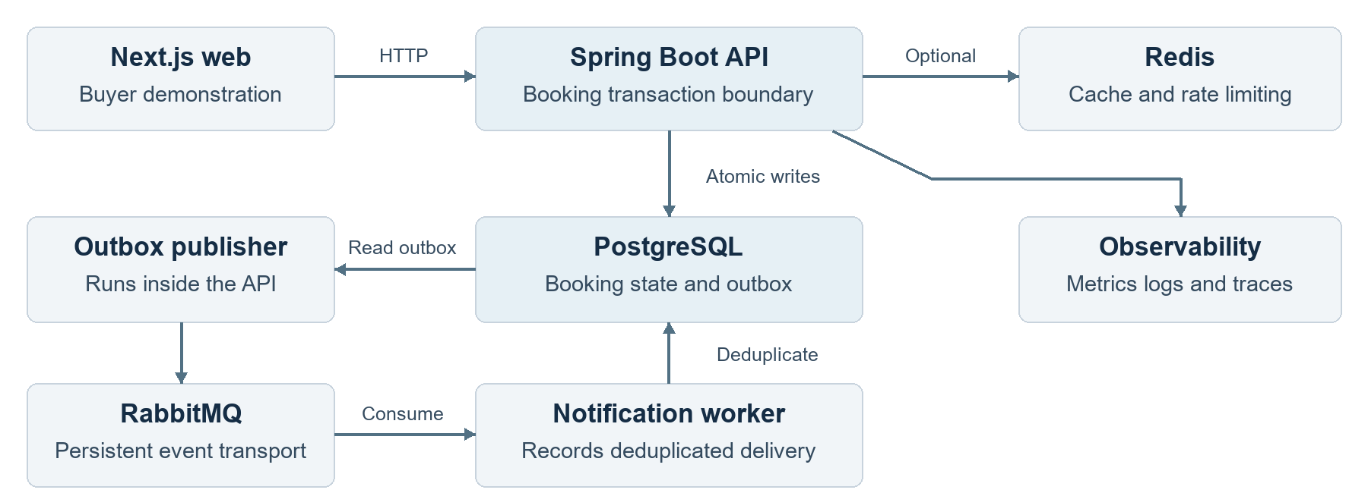
PostgreSQL owns booking correctness. Redis accelerates reads; the outbox moves committed events to RabbitMQ.

Seat ownership under contention
A row lock serializes requests for the same seat. A partial unique index permits only one ACTIVE hold per seat, providing a second correctness check. Holds last five minutes; an expiry job claims batches with SKIP LOCKED so multiple API instances can release expired inventory without claiming the same work.

Checkout retries and atomic state changes
An idempotency key is serialized before the order is locked. The payment record, confirmed order, hold, sold seat, ticket code, audit entry, and outbox event are committed together. Repeating the same request returns the existing payment identifier. Refunds reopen inventory and support repeat requests.

Durable events with explicit deduplication
The API first stores the event in the booking transaction. A publisher sends it to RabbitMQ and waits for confirmation. Redelivery is possible, so the worker uses the event identifier as a unique delivery key. The current worker records delivery deterministically; an external email provider is a future integration.

Cache and observability boundaries
Redis failures fall back to PostgreSQL, and inventory changes invalidate cached availability after commit. Bounded HTTP metric labels avoid user identifiers and raw request paths. The optional OpenTelemetry overlay adds request traces, correlated logs, and Prometheus exemplars without requiring the external observability platform for local startup.

Tradeoff
Keeping the write path together simplifies consistency and deployment. A popular seat remains a serialized database resource, so horizontal API scaling still requires realistic database capacity planning and load measurement.

Verification and project handoff
The public CI run on September 7, 2026 passed for application revision d9577d3. The results below are reproducible test evidence, not production throughput or uptime measurements.
Check | Observed result | Evidence
Seat contention | 100 simultaneous attempts; exactly 1 successful hold | PostgreSQL integration test
Payment retries | 25 concurrent retries; 1 payment identifier and 1 outbox event | PostgreSQL integration test
Backend suite | 10 tests passed; 0 failures, errors, or skipped tests | Maven CI log
Booking smoke test | 19 of 19 checks passed; 0 failed HTTP requests out of 13 | k6 fresh-install CI log
Build and configuration | Web verification, 3 container builds, and Terraform validation passed | GitHub Actions

Run the demonstration
Install Docker with Compose v2, then clone the repository and run the platform-specific helper. The helper creates local configuration, builds the images, and waits for API readiness.
git clone https://github.com/QihuiPan/ticketing-platform.git
cd ticketing-platform
Windows: powershell -ExecutionPolicy Bypass -File .\scripts\quickstart.ps1
macOS / Linux: ./scripts/quickstart.sh
Open http://localhost:3000. The README provides local demo accounts. Run the documented k6 smoke test to verify checkout, payment replay, QR download, refund, and restored availability.

Current delivery scope
The project provides a runnable demonstration with simulated payment capture and recorded notification delivery. AWS Terraform includes a single-node demo and a production infrastructure baseline. Public application hosting and a live deployment URL are not part of this handoff. Real payment and email providers, environment-specific HTTPS and secrets, and production load validation remain deployment work.

Review the implementation
Test results | Concurrency tests | Architecture | Run guide
Portfolio prepared September 11, 2026. Application evidence is pinned to d9577d3; later documentation commits do not change that tested application revision.

