Bigbucks Buy and Sell Test Case

# Buy Test Case

## Buying on Historical Data

1. Ensure you are logged in as a user. If you cannot login, see the test case for registering a user.
2. Navigate to the Transactions page by clicking Transactions in the navigation bar.



1. Where it asks you “which stock do you want to buy,” underneath “Stock Symbol”, type in the stock symbol “msft” to *buy* Microsoft stock.
2. Then underneath “Number of shares” type in “100” to *buy* 100 shares of Microsoft stock.
3. Then underneath “Select the stock’s closing date” type in “01/20/2021” to *buy* 100 shares of Microsoft stock on **January 20th, 2021**. When all the data is typed in correctly, it should look like the below photo.

1. Then click “Buy” to complete the purchase.
2. The purchase will show up in the user’s “Transaction History” on the same page. It should look similar to the photo below, but the “Transaction ID” and the “Date and Time of Transaction” may have different values.



## Buying on Live Data

1. Ensure you are logged in as a user. If you cannot login, see the test case for registering a user.
2. Navigate to the Transactions page by clicking Transactions in the navigation bar.



1. Where it asks you “which stock do you want to buy,” underneath “Stock Symbol”, type in the stock symbol “tsla” to *buy* Tesla stock.
2. Then underneath “Number of shares” type in “100” to *buy* 100 shares of Tesla stock.
3. Then underneath “Select the stock’s closing date” type in the current date to *buy* 100 shares of Tesla stock on **the current date**. When all the data is typed in correctly, it should look like the below photo, but the selected closing date may be different.

1. Then click “Buy” to complete the purchase.
2. The purchase will show up in the user’s “Transaction History” on the same page. It should look similar to the photo below, but some columns may have different values depending on the current date selected. “Stock”, “Stock Symbol”, “Number of Shares Bought or Sold”, and “Transaction Type” should be an exact match.

1. To verify Tesla stock’s current price, follow this link to [Yahoo Finance](https://finance.yahoo.com/quote/TSLA?p=TSLA&.tsrc=fin-srch) to find the live price.

# Sell Test Case

## Selling on Historical Data

1. Ensure you are logged in as a user. If you cannot login, see the test case for registering a user.
2. Navigate to the Transactions page by clicking Transactions in the navigation bar.



1. Where it asks you “which stock do you want to sell,” underneath “Stock Symbol”, type in the stock symbol “msft” to *sell* Microsoft Stock.
2. Then underneath “Number of shares” type in “100” to *sell* 100 shares of Microsoft stock.
3. Then underneath “Select the stock’s closing date” type in “01/27/2021” to *sell* 100 shares of Microsoft stock on **January 27th, 2021**. When all the data is typed in correctly, it should look like the below photo.

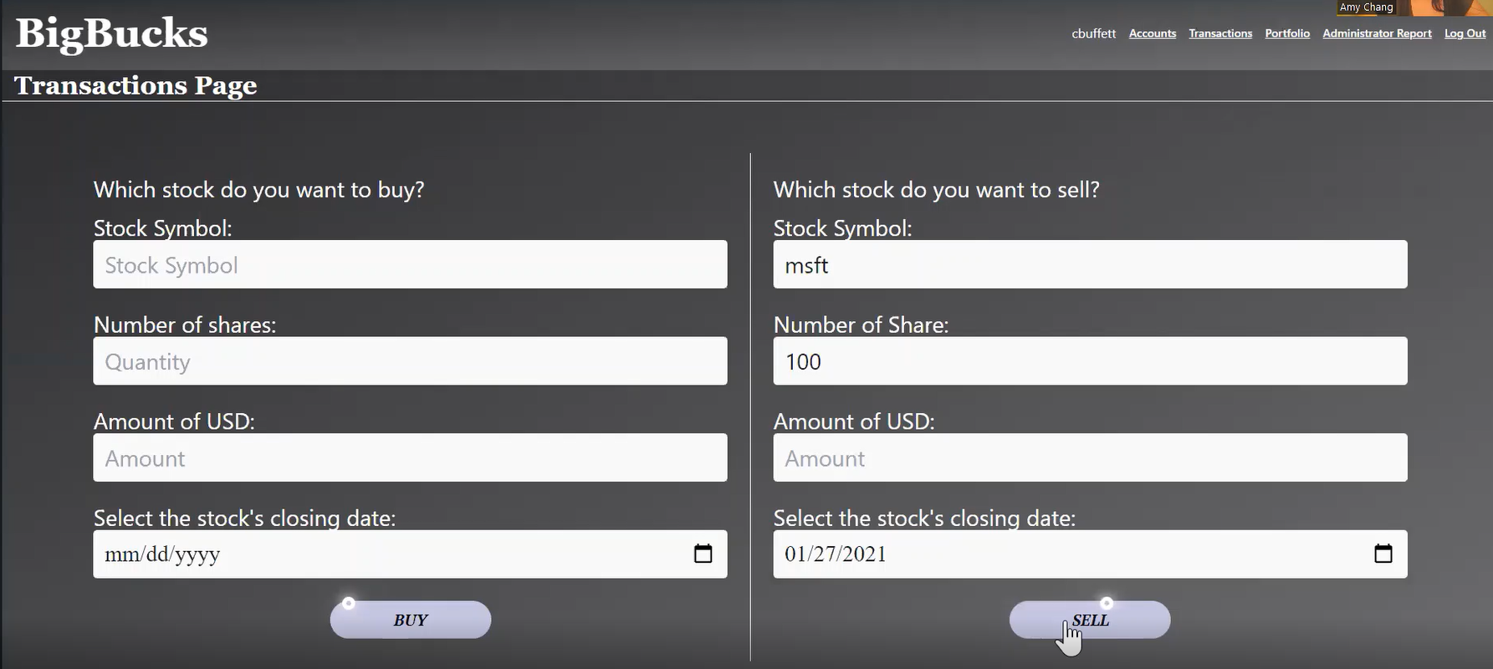

1. Then click “Sell” to complete the transaction.
2. The transaction will show up in the user’s “Transaction History” on the same page. It should look similar to the photo below, but the “Transaction ID” and the “Date and Time of Transaction” may have different values.

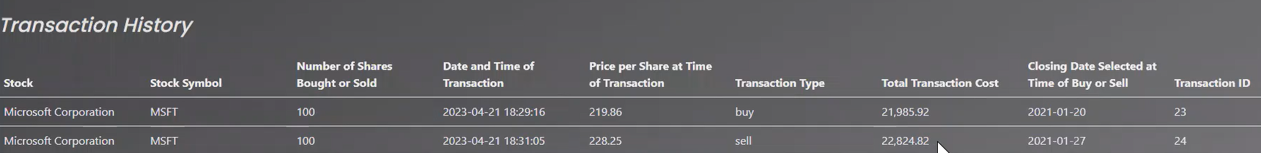

## Selling on Live Data

1. Ensure you are logged in as a user. If you cannot login, see the test case for registering a user.
2. Navigate to the Transactions page by clicking Transactions in the navigation bar.



1. Where it asks you “which stock do you want to sell,” underneath “Stock Symbol”, type in the stock symbol “tsla” to *sell* Tesla stock.
2. Then underneath “Number of shares” type in “50” to *sell* 50 shares of Tesla stock.
3. Then underneath “Select the stock’s closing date” type in the current date to *sell* 50 shares of Tesla stock on **the current date**. When all the data is typed in correctly, it should look like the below photo, but the selected closing date may be different.

1. Then click “sell” to complete the transaction.
2. The transaction will show up in the user’s “Transaction History” on the same page. It should look similar to the photo below, but some columns may have different values depending on the current date selected. “Stock”, “Stock Symbol”, “Number of Shares Bought or Sold”, and “Transaction Type” should be an exact match.

1. To verify Tesla stock’s current price, follow this link to [Yahoo Finance](https://finance.yahoo.com/quote/TSLA?p=TSLA&.tsrc=fin-srch) to find the live price.