**Figure 1. Pre- and Post-bank deregulation Estimation of the Average Treatment Effect**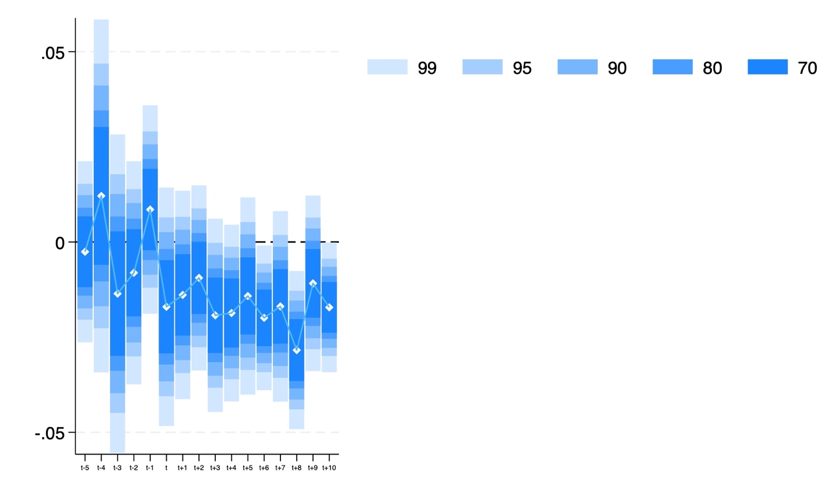

**Note: tvdiff method**

**Figure 2. Pre- and Post-bank deregulation Estimation of the Average Treatment Effect** 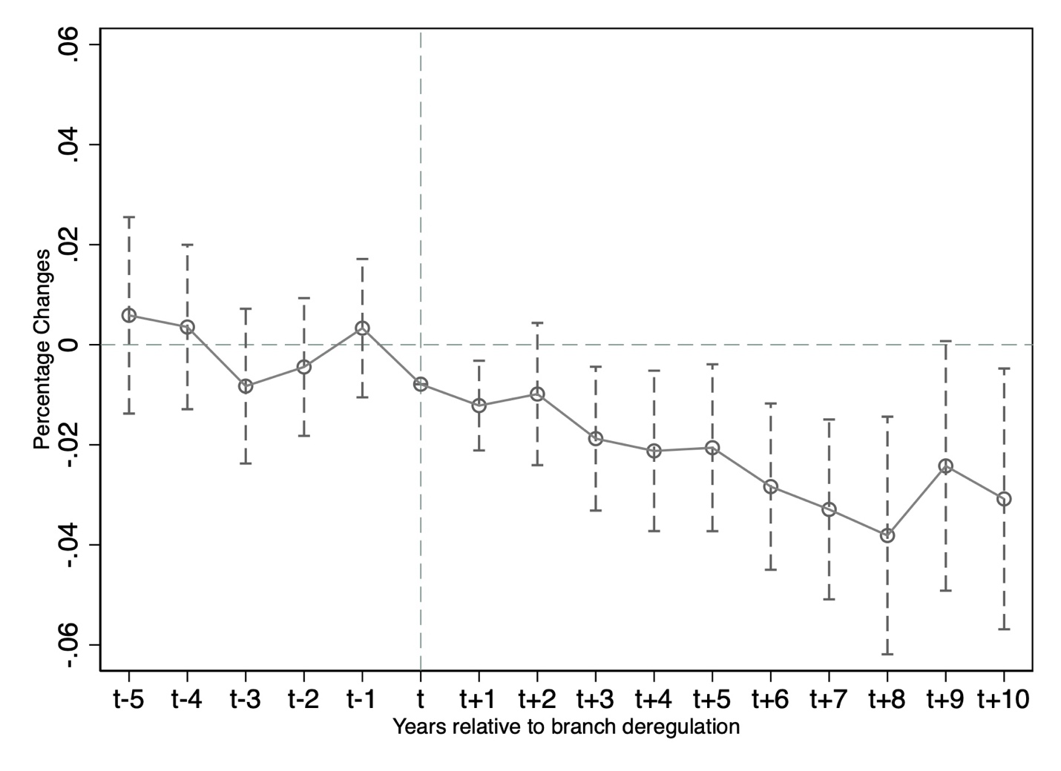

**Note: coefplot method**

**set more off**

**clear all**

**\* ========================================**

**\* -3.1- DID**

**\*\*\* Read in the raw data \*\*\***

**use "/Users/qilinzhou/Desktop/Stata-econometric/StataDemo8/lec3_macro.dta", clear**

**\*\* 【Description】**

**\*\* Beck et al. (2010) is a classic paper using a multi-period DID model published in the Journal of Finance.**

**\*\* The paper examines the impact of bank branch deregulation on income distribution inequality in the U.S. states**

**\*\* that deregulated bank branches at various points during the 1960-1999 period.**

**\*\* The sample consists of 49 U.S. states and 31 years (1976-2006) of balanced panel data, with a total of 1519 observations.**

**\*\* The paper selects four types of indicators, including the Gini coefficient,**

**\*\* as proxies for the inequality of the dependent variable, and only the Gini coefficient is selected**

**\*\* to demonstrate the treatment effect of time-varying DID with inconsistent policy points in time.**

**\*\* The treatment time dummy variable takes a value of 1 after bank branch deregulation in a state,**

**\*\* implying that the state is in the treatment group thereafter.**

**\*\* This time-varying DID model is set up as a two-way fixed effects model,**

**\*\* so individual fixed effects and time fixed effects are controlled for in the model**

**\*\* to produce area dummy variables and time dummy variables, respectively.**

**label var _intra "Bank deregulation" //treatment dummy variable**

**xtset statefip wrkyr //declare the panel data setting**

**tabulate wrkyr, gen(wrkyr_dumm) //generate dummyies of time fixed effects**

**tabulate statefip, gen(state_dumm) //generate dummyies of individual fixed effects**

**replace p10 = 1 if p10==0**

**generate log_gini = log(gini) //as y**

**\*without control variables**

**xtreg log_gini _intra wrkyr_dumm*, fe robust**

**\*define the marco of controls**

**global Xs "gsp_pc_growth prop_blacks prop_dropouts prop_female_headed unemploymentrate"**

**\*with control variables**

**xtreg log_gini _intra $Xs wrkyr_dumm*, fe robust**

**des**

**\*Graph for Parallel-trend tests**

**//Useful user-written commands for DID**

**ssc install coefplot,replace**

**ssc install tvdiff,replace**

**//The first approach: *tvdiff\***

**generate D = (wrkyr - branch_reform == 0)**

**generate y = ln(gini)**

**global X "gsp_pc_growth prop_blacks prop_dropouts"**

**tvdiff y D $X, model(fe) pre(5) post(10) vce(robust) test_tt graph save_graph(mygraph)**

**//The second approach: *coefplot\***

**gen policy = wrkyr - branch_reform**

**replace policy = -5 if policy <= -5**

**replace policy = 10 if policy >= 10**

**gen policy_d = policy + 5**

**xtreg y ib5.policy_d i.wrkyr, fe r**

**///generate the average values of the first 5 periods**

**forvalues i = 0/4{**

**gen b_`i' = _b[`i'.policy_d]**

**}**

**gen avg_coef = (b_0+b_4+b_3+b_2+b_1)/5**

**sum avg_coef**

**coefplot, baselevels ///**

**drop(*.wrkyr _cons policy_d) ///**

**coeflabels(0.policy_d = "t-5" ///**

**1.policy_d = "t-4" ///**

**2.policy_d = "t-3" ///**

**3.policy_d = "t-2" ///**

**4.policy_d = "t-1" ///**

**5.policy_d = "t" ///**

**6.policy_d = "t+1" ///**

**7.policy_d = "t+2" ///**

**8.policy_d = "t+3" ///**

**9.policy_d = "t+4" ///**

**10.policy_d = "t+5" ///**

**11.policy_d = "t+6" ///**

**12.policy_d = "t+7" ///**

**13.policy_d = "t+8" ///**

**14.policy_d = "t+9" ///**

**15.policy_d = "t+10") ///**

**vertical ///**

**yline(0, lwidth(vthin) lpattern(dash) lcolor(teal)) ///**

**ylabel(-0.06(0.02)0.06) ///**

**xline(6, lwidth(vthin) lpattern(dash) lcolor(teal)) ///**

**ytitle("Percentage Changes", size(small)) ///**

**xtitle("Years relative to branch deregulation", size(small)) ///**

**transform(*=@-r(mean)) ///**

**addplot(line @b @at) ///**

**ciopts(lpattern(dash) recast(rcap) msize(medium)) ///**

**msymbol(circle_hollow) ///**

**scheme(s1mono)**