Comparing U.S. household disaster preparedness across natural hazard risks: A Hierarchical Bayesian Item Response Theory (IRT) analysis of protective motivation and sociodemographic factors

1.Introduction and literature review
In an era of intensifying climate-related natural hazards, disasters have become more destructive, economically costly, and complex in their long-term societal impacts (Donatti et al., 2024). According to United Nations Office for Disaster Risk Reduction (UNDRR) and The International Disaster Database (EM-DAT) annual reports, these climate change-related disasters, which affected 93.1 million people and caused more than $ 202.7-million economic damage, are imposing a significant negative impact on global sustainable development initiative and worldwide resilience building (UNDRR, 2023; CRED /UCLouvain, 2024a). Household disaster preparedness, broadly defined as preplanned and pre-implemented actions undertaken by families to mitigate or prevent catastrophic losses, has emerged as a crucial strategy in enhancing societal resilience. For more far-sighted disaster prevention and adaptation, enhancing household disaster preparedness under all possible natural hazard risk backgrounds has been considered a constructive approach for resilience and capacity improvement at all levels.
Household disaster preparedness has long been a central topic in several disaster social science disciplines (Levac et al., 2012; Lindell & Perry, 2000). Scholars have invested considerable attention in disentangling the influencing factors and mechanisms associated with households’ adoption of various preparedness actions. Sociodemographic factors such as gender, race, education, and income are well-documented determinants.
As Tierney, Lindell, and Perry (2001) summarized, households with generally higher socioeconomic status are better prepared for major natural hazard risks. Meanwhile, those marginalized or vulnerable populations are considered to lack sufficient materials and skills for disaster preparedness actions. That is to say, the sociodemographic approach consistently uncovers underlying inequities. For example, scholars have proved that the elderly, medically vulnerable populations, the disabled, and minority immigrants may face insurmountable difficulties in improving preparedness levels. This preliminarily requires support from targeted policy designs and effective social capital increases, especially from the community level (Al-Rousan et al., 2014; Reininger et al., 2013; Bethel et al., 2011; Li et al., 2024). Foreign households’ disaster preparedness actions may also be motivated by social and contextual factors, such as national origin and language proficiency (Green et al., 2021). As for gender, while Hung (2018) proposed that the division of labor and priority setting may explain why males and females hold different opinions on disaster preparedness, Nukpezah and Soujaa’s (2018) research showed that socioeconomic inequity rather than race and gender caused the preparedness divergencies. Besides, higher education and income levels, through boosting risk perception level, comprehension level, and material resource reserve level, could substantially promote household disaster preparedness levels (Donahue et al., 2014; Onuma et al., 2017). Similar mechanisms also explain the diverse preparedness levels between urban and rural households, especially in developing countries (Chai et al., 2021).
However, relying solely on traditional sociodemographic factors to explain disaster preparedness is insufficient. Factors such as knowledge, expertise, ability, mental resilience, and division of labor--many of which stem from sociodemographic characteristics--may offer deeper insight into households’ motivation and decision-making in disaster preparedness. These factors present the dynamic initiatives of general U.S. households in disaster preparedness. Moreover, all households are living in real-time contexts with specific environments and personal life experiences. In this sense, the social-cognitive perspective holds a non-negligible imperative in advancing household disaster preparedness research (Paton, 2003). This not only indicates that disaster preparedness cannot be solely explained by sociodemographic variables but also emphasizes the need for taking more valuable and comprehensive theoretical frameworks into account to extract substantial marginal insights.
Scholars first tried to unravel the effect of previous disaster experiences on household disaster preparedness actions (Sattler et al., 2000). Wide literature confirmed that previous disaster experience could increase household disaster preparedness, regardless of how preparedness is defined or concentrated only on minority populations (Malmin, 2021; Chan et al., 2014). Conversely, Kapucu (2008) used a mail survey in Central Florida to illustrate that previous experience may provoke complacency and no longer positively affect household disaster preparedness. Similar to education and disaster-related knowledge, although most literature emphasizes education and knowledge provision’s important role in fostering rational and sustainable preparedness actions, some also further proposed that the way, content, and delivery of knowledge matter in making an effective difference (Karanci et al., 2005; Heinkel et al., 2022; Nojang & Jensen, 2020). Furthermore, influenced by behavior science and inspired by theoretical frameworks like the Protective Motivation Theory and the Theory of Planned Behavior, through survey data, interviews, focus groups, and other methods, variables including intention, communication, belief, efficacy, place attachment, risk perception and appraisal, information channel, preference, and sensemaking are all found potentially relatable with household disaster preparedness levels (Zaremohzzabieh et al., 2021; Cretikos et al., 2008; Becker et al., 2012; Mishra et al., 2010; Paton et al., 2015). Through these explorations, those contextual and subjective variables brought out remarkable and distinguishing contributions aside from the sociodemographic approach. These enlightening outcomes all revealed the social cognitive perspective’s irreplaceable merits for supporting a more novel understanding of household disaster preparedness actions. However, we may merge all the abovementioned approaches by suggesting the term “resource”. As some extant literature has already used, resources, which could be divided into objective and subjective layers to briefly encompass core factors in social status, personal traits, and community capacity realms, could better provide a holistic understanding of what is materially and mentally driving households to promote their disaster preparedness levels.
Nevertheless, there are still several noteworthy aspects in household disaster preparedness research, namely, preparedness action classification, culture and social background comparison, and the potential discrepancy between types of natural hazards. Beginning with preparedness action classification, Kirschenbaum penetratingly suggested that “preparedness” cannot be simply assumed as an overall concept (Kirschenbaum, 2006). For instance, Sutton and Tierney (2006) constructed six dimensions of household disaster preparedness: hazard knowledge, formal and informal response plans and agreements, life safety protection, property protection, emergency coping and restoration of key functions, and initiation of recovery. Also, household disaster preparedness could surely be classified into survival actions and damage-mitigation actions, or basic preparedness, energy/heat preparedness, and evacuation preparedness following distinct conditions (Spittal et al., 2008; Donahue et al., 2014). These classifications allow for relating various resources with specific actions, which further pave the way to more accurate and grounded results. Natural hazard risks are highly scenario-dependent, with the coupling of geography, climate, social constructs, and psychological pathways. In such a situation, more scholars shed light on household disaster preparedness in developing countries in Asia and Africa, where vulnerability and climate change may pose an obvious and urgent passive effect (Kapucu, 2008; Karanci et al., 2005; Cretikos et al., 2008). More importantly, such research could fill critical gaps and embody equality while propelling valuable worldwide comparisons. Lastly, when reviewing related literature, single scenarios are the scholars’ unanimous choice for most research. Among them, earthquakes and floods stand out (Atreya et al, 2017; Becker et al., 2012). This hinders scholars from considering the distinct and complex natures of natural hazard risks and purely treating them as parallel or similar backgrounds. Especially when considering the characteristics, formation mechanisms, and consequences of natural hazards like wildfire and hurricanes are apparently different.
In addition, the community’s supporting role in strengthening household disaster preparedness is verified (Heller et al., 2005), while some scholars claim that community disaster preparedness is far more vital than the household level (Uscher-Pines et al., 2013). While valuable, household disaster preparedness alone cannot ensure successful disaster risk reduction (DRR); adopting preparedness cannot certainly guarantee ideal outcomes like impregnable prevention or mitigation (Clay et al., 2020). At the same time, some scholars have already critically reflected on the conventional thinking of household disaster preparedness by proposing an informal household preparedness approach that is subconsciously rooted in our everyday lives (Heidenstrøm, 2020). But for now, the problem is seldom about whether we should encourage and promote household disaster preparedness, but rather seek consensus toward inclusive and feasible household disaster preparedness research and practice.
This study mainly investigates one predominant concern: household disaster preparedness in different natural hazard risk contexts. Currently, scarce literature has explored household disaster preparedness in multi-hazard contexts in specific cities in Chile (Cisternas et al., 2024; Bronfman et al., 2019). These results preliminarily indicate that households treat different natural hazards differently in their preparedness action choices, specifically earthquake over flood. Correspondingly, we proposed the following research questions: Are there significant household disaster preparedness differences in various natural hazard risk contexts? Are there diverse influencing mechanisms in different natural hazard risks? To conclude, this study’s latent contributions are: (1) connect household disaster preparedness with different natural hazard risk contexts on a more solid theoretical basis; (2) systematically examine the mechanisms and extend our understanding between household disaster preparedness and natural hazard risks with a vaster and more deliberate national dataset in the U.S. context.
The remainder of this article is structured as follows. Section 2 introduces the theoretical background and hypotheses, including a typology framework to capture the characteristics of natural hazard risks and the Protective Motivation Theory. Section 3 presents the data and method. Specifically, we introduced the FEMA dataset we used and the Hierarchical Bayesian IRT modelling process. Section 4 presents the results of the analysis. Section 5 discusses the results with existing findings, highlighting the limitations of the study. Section 6 draws conclusions.

2.Theoretical background and hypotheses

2.1 Typology framework of natural hazard risks: predictability-destructiveness
As universally acknowledged, natural hazard risks, while sharing similar geophysical agents and processes, exhibit apparent discrepancies when considering their potential impact and consequences on human society. Robert Kates (1971) creatively purported that the frequency of occurrence, the magnitude of energy release, the suddenness of onset, and the coupling with specific sites are critical features of natural hazards, especially when linking them with socioeconomic impacts. Subsequently, scholars further discussed features such as the spatial and temporal scales, predictability, and expected future increase or decrease to augment understanding of the nature of natural hazard risks (Plapp & Werner, 2006; Gill & Malamud, 2014). For example, natural hazard risks like earthquakes, which are long-existing, highly unpredictable, largely unavoidable, and often destructive on large scales with huge energy releases may manifest their massive influence on human society. Regardless of the exact terms they used, the imperative of such exploration is to clarify the intrinsic differences between natural hazard risk types and the correspondingly divergent or diversified influence mechanisms for human society. In Caldera and Wirasinghe’s (2022) study, they developed a universal severity classification of natural hazards, which partially guided our framework. Drawing upon these valuable insights to schematically connect multiple types of natural hazard risks with household preparedness, we prefer using predictability and destructiveness to construct a 2*2 typology framework for outlining natural hazard risks’ core features in Figure 1.
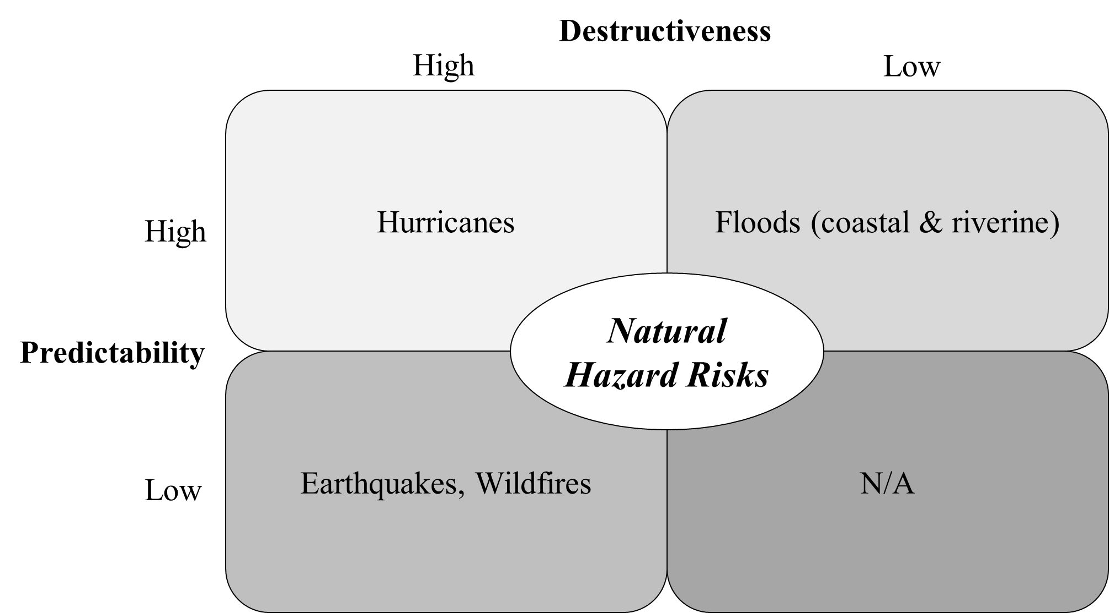
Figure 1
For this study, we will elaborate on this typology framework in the U.S. context. Foremost, considering the countless technical details and arguments within, we need to stress that the divisions of predictability and destructiveness in this typology framework are all relative rather than absolute. These classifications mainly reflect past disaster experiences, which strongly influence how people perceive different types of risks.
Based on this, referring to open data of attributes including economic losses, casualties, social disruption, and geographical scales from EM-DAT, National Oceanic and Atmospheric Administration (NOAA), and FEMA risk map products (CRED/UCLouvain, 2024b; FEMA, 2024a; NOAA, 2024), all major types of natural hazard risks are divided into the four quadrants of the framework: (1) the high predictability- destructiveness quadrant: hurricanes; (2) the low predictability-high destructiveness quadrant: earthquakes and wildfires; (3) the high predictability-low destructiveness quadrant: coastal floods and riverine floods; (4) the low predictability- destructiveness quadrant: no major natural hazard risks in this quadrant. We are fully aware that, according to The Fifth National Climate Assessment, highly climate-change-related natural hazard risks like floods and wildfires are becoming more challenging and severe than ever (Crimmins et al., 2023). However, there are never unanimous thresholds for assessing the destructiveness. In this regard, the classifications of this study present a tentatively conventional stance, which relies most on historical events and empirical judgements. All the abovementioned classifications could shift due to climate change’s uneven influence.
This typology framework is established for the following reasons. First, the predictability of specific natural hazard risks may affect households’ willingness to invest time and material in preparedness. The unpredictable risks, which often can only be mitigated, may generally trigger households’ extra attention and actions. For example, mitigating earthquakes requires anti-seismic construction, sufficient knowledge and awareness, and other pre-implemented actions; however, losses can mostly be relieved only after their occurrence (Freddi et al., 2021). Second, it’s evident that natural hazard risks with potential high destructiveness could better induce households’ preparedness actions. For instance, households in Florida focus more on preparing for hurricanes (Hung, 2018). Meanwhile, households with insufficient resources may adopt comparatively more lacking preparedness actions for those risks with seemingly less destructiveness. This may eventually reinforce their vulnerabilities and enlarge social inequity. Third, the predictability and destructiveness dimensions are complementary when relating natural hazard risks with household disaster preparedness actions. Predictability shapes risk perception, while destructiveness affects resource investment, reflecting socioeconomic capacity (Slovic, 1987). The combination of these two dimensions not only states several pivotal discrepancies between natural hazard risks but also presents the fundamental characteristics of natural hazard risks for the U.S. households’ disaster preparedness decision-making.
Under this typology framework, the distinct characteristics of natural hazard risks would eventually be reflected in households’ actions. Sociodemographic factors remain essential in explaining household preparedness actions, particularly when examined across distinct hazard types. We shall not deliberately deny their potential and attempt to further explore their diversity based on this framework. Therefore, we would like to propose the following hypotheses.
H1 Household disaster preparedness may fluctuate in response to the degree of unpredictability and expected destructiveness associated with specific risk types.
H2 Sociodemographic factors may influence households’ disaster preparedness levels in different natural hazard risk contexts.

2.2 Protection Motivation Theory (PMT)
Originating in 1975, the Protection Motivation Theory (PMT) was initially proposed to postulate the mechanism of crucial components of fear appeal and cognitive mediating processes for individual attitude change from the psychological stance (Rogers, 1975). Later, threat appraisal and coping appraisal, two comparatively independent cognitive evaluation processes, were prescribed in the modified and widely accepted version of PMT. This version of PMT further stressed the influence of threat information or signals in driving individual response behaviors (Rogers, 1983). Specifically, threat appraisal refers to individuals’ estimation and evaluation of the possibility, vulnerability, and severity of certain negative situations. Meanwhile, threat appraisal involves internal and external motivational factors such as satisfaction and social recognition. Coping appraisal consists of individual self-evaluation on self-efficacy, response efficacy, and response costs, which indicates the subjective perception, expectation, and capacity to take measures for DRR.
Through threat appraisal and coping appraisal, individuals and households may implement positive responses regardless of whether they are disposable, repeated, or multiple, or directly avoid adopting any substantial responses. PMT ultimately proposed that, while coping appraisal influences individual and households’ adaptive responses, threat appraisal may influence individuals’ maladaptive responses. Briefly, adaptive responses unfold the positive and pragmatic side of risk confrontation, and maladaptive responses represent the pessimistic and impractical side. Excessive or amplified threat appraisal may provoke maladaptive responses. Individuals and households’ actual response actions is the result of both adaptive responses and maladaptive responses (Duval & Mulilis, 1999). Through the above illustration, PMT can well account for why individuals and households undertake disaster preparedness actions and offer evidence-based suggestions.
The current application of PMT has already far beyond its original scope of personal health threats (Li et al., 2024; Chai et al., 2021). It has been a mainstream analytical model in the worldwide disaster social sciences research community. As for household disaster preparedness, PMT serves as a favorable analytical tool to disentangle household disaster preparedness under different natural hazard risk contexts. If the typology framework we proposed represents the objective side of natural hazard risks, the PMT could supplement a necessary subjective perspective.
Specifically, predictability and destructiveness, as defined previously in the typology framework, may first influence threat appraisals. Furthermore, predictability and destructiveness may influence households’ self-efficacy and response efficacy through psychological approaches. For example, in unpredictable natural hazard types like earthquakes, threat appraisal may stand out. Potentially, highly unpredictable natural hazard risks may impair households’ coping efficacy since their preparedness may prove useless; highly destructive natural hazard risks may arouse households’ efficacy, considering their advanced coping may pay off on a large scale. However, overload unpredictability and destructiveness may conversely traverse psychological thresholds of threat appraisal and lead to passive or void disaster preparedness. Therefore, empirical evidence is needed to disentangle such analytical gaps.
Accordingly, we concluded this section with H3. So far, the objective, subjective, and household-inherent influencing factors within the disaster preparedness research realm are illustrated accordingly.
H3 Threat appraisal and coping appraisal may not be consistently significant in different types of natural hazard risks.

3.Data and Method

3.1 FEMA Dataset
Data from the FEMA 2023 National Household Survey (NHS) on Disaster Preparedness is used for this study. According to the FEMA official website, FEMA administrates this annual survey via landline and mobile phones, using a random sampling of approximately 5000 adult respondents in English and Spanish to track household disaster preparedness progress among the general U.S. public. Every year, besides nationally representative samples, the NHS also managed to include different risk-specific groups to illuminate specific preparedness status quo in the U.S (FEMA, 2024b). This reflects FEMA’s growing emphasis on community-level preparedness. With available raw open data since 2017, the NHS provides a comprehensive and nationally representative dataset on household disaster preparedness.
Referring to the public summary of the 2023 NHS, there are a total of 7604 valid respondents who participated in the survey, which also includes risk-specific samples in Coastal Flood (n=507), Earthquake (n=502), Hurricane (n=501), Riverine Flood (n=505), and Wildfire (n=509). The duration of the survey is from February 1st to March 14th. In the 2023 NHS, all respondents were asked general disaster and pandemic preparedness questions. The overall response rate is 17%. These risk-specific groups all finished the risk-specific module. Meanwhile, owing to the efforts of FEMA, these risk-specific samples are adjusted and calibrated by key demographic variables to reflect the composition of the general U.S. public, which makes it possible to carry out the subsequent analysis. Besides demographic information, the NHS questionnaire involves “Disaster Risk Perception”, “Preparedness Efficacy”, “Disaster Experience”, and other preparedness action influencing sections, which implicitly echo the PMT. Limited by length, we will not further introduce their dedicated survey design, survey administration, data cleaning and manipulation, and careful analytical approach recommendations. Hitherto, the 2023 NHS data, especially the risk-specific data that encompassed representative major natural hazard risks including hurricanes, earthquakes, riverine flood, coastal flood, and wildfire for the first time, provides us the scarce opportunity to probe into the research question proposed earlier.

3.2 Eligibility and Geographical Distribution of Risk-specific Samples
The 2023 NHS risk-specific samples are collected based on the potential respondents’ geographic locations. Briefly, FEMA managed to include sufficient respondents who reside in multiple constrained counties with high natural hazard risk. Overseas territory samples are excluded from this study. Those respondents were required to finish the extra risk-specific modules beyond the general questionnaires. The eligible counties are the top 50 generated through FEMA’s National Risk Index for each natural hazard risk type, with ranking by a series of calculated risk scores. FEMA did not reveal much about the quantification process of deciding these eligible counties and their rankings. The geographic distribution of these risk-specific samples eligible counties is presented in Figure 2.
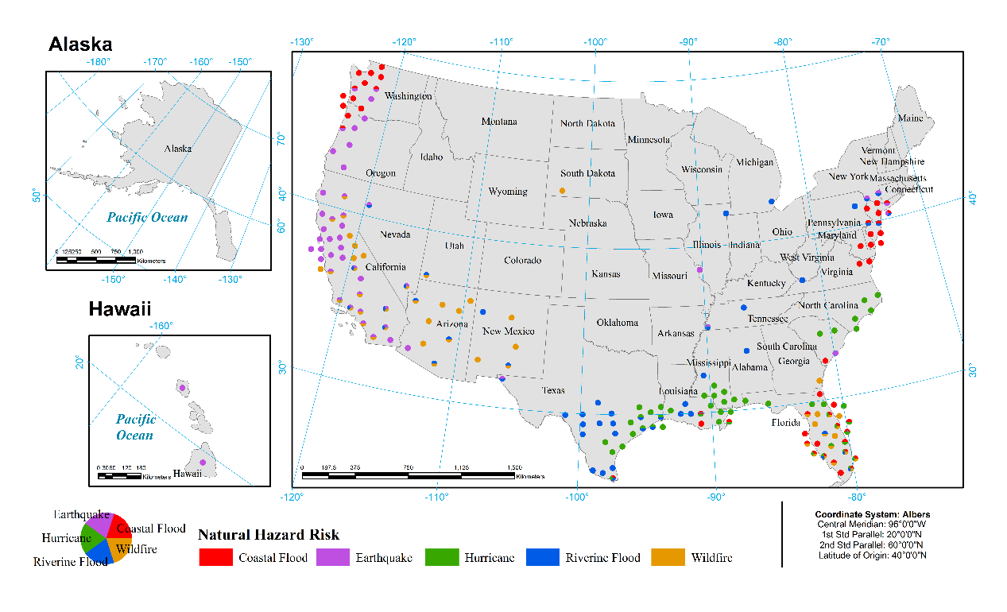
Figure 2
This overall geographic distribution is in line with the conventional cognition of each natural hazard risk type. With 50 California counties and 54 Florida counties on the lists, these two states emerged, considering their widely known natural hazard threats. Meanwhile, Miami-Dade, Lee, Palm Beach, and Orange, all in Florida, occurred 4 times in the list, indicating their shared high and complex natural hazard risk status in coastal flood, riverine flood, hurricane, and wildfire. Particularly, Miami-Dade ranks 2nd for coastal flood and riverine flood, 8th for hurricane, and 11th for wildfire. This manifests the geographically uneven tendency of natural hazard risk distribution in the U.S., which conversely, reinforces the necessity and importance of risk-specific data. Also, under such circumstances, the relationship between distinct types of natural hazard risks and household disaster preparedness may vary when these risks are compounded and intervened with specific socioeconomic contexts.

3.3 Variables
3.3.1 Independent Variables
The core independent variables in this study are based on PMT. For measuring threat appraisal, the “risk perception” variable is selected to indicate the perceived risk threat. The NHS designed a question asking how likely would a disaster impact the respondents for measuring risk perception levels. However, no other applicable variables for threat appraisal are found in the NHS due to the second-hand nature. For coping appraisal, self-efficacy and response efficacy are measured separately. Self-efficacy is measured by asking about the self-confidence respondents hold in taking actions to prepare for a disaster, response efficacy is measured by asking the question “How much would taking steps to prepare help you get through a disaster in your area?”. These two items both adopted 5-point-Likert scales. These measurements are accepted and proved appropriate in previous literature for similar purposes (Li et al., 2024; Rivera, 2021).
Sociodemographic variables are widely applied in previous research. The fundamental ones are: (1) gender; (2) age; (3) ethnicity & race; (4) income; (5) education. Other binary sociodemographic variables are rurality, disability, and homeownership. The number of children in the household is a special numerical sociodemographic variable since children are often more vulnerable and may trigger more household preparedness actions. Detailed questionnaires and corresponding illustrations are available at the FEMA official website (FEMA, 2024b).
3.3.2 Dependent Variables
Disaster preparedness is the dependent variable of this study. In the NHS questionnaire, disaster preparedness is measured in the “Preparedness Actions” section, “What have you done to prepare for a disaster or emergency in the last year? (Select all that apply)”. Twelve preparedness action types, including assembling or updating supplies, learning my evacuation plans, making a plan, practicing emergency drills or habits, and signing up for alerts and warnings, etc., are provided as options. These action types are all binary variables (0= ‘No’, 1= ‘Yes’).

3.4 Model Specification
As we previously indicated, the dependent variable we measure is the “Preparedness Actions” section of the NHS questionnaire. However, simply adding up these actions introduces the major measurement weaknesses: different preparedness actions may have varying levels of latent difficulty. Under this assumption, households who complete more difficult actions may demonstrate a higher level of preparedness.
To capture these latent considerations and model individual disaster preparedness levels across multiple natural hazard risk types while avoiding parameter explosion, we partially follow the approach of Martin and Quinn (2002) and employ a fixed-effects adjustment within a one-parameter logistic item response theory (1PL-IRT) framework, where the probability of a household providing a correct response (coded as 1 for preparedness) is modeled as a function of their actual latent ability and a demographic-related fixed-effect component (Lang & Tay, 2021). Due to the linear specification of the latent trait θ, our model introduces only the item difficulty parameter b as the core IRT parameter. Nevertheless, this simplified one-parameter logistic model offers advantages over Classical Test Theory (CTT). Unlike CTT, which conceptualizes measurement error as a fixed property of the test and assumes it is uniform across all individuals, IRT provides respondent-specific estimates of measurement precision by calculating standard errors for each response pattern. These standard errors vary depending on how closely item difficulties align with a respondent’s latent ability. As a result, IRT captures differences in precision across individuals and flags inconsistencies in response actions, such as unexpected incorrect answers to easy items or correct responses to difficult ones. Furthermore, IRT allows for a more intuitive and empirically grounded assessment of test reliability by averaging the standard errors across respondents, offering a person-centered alternative to the sample-level reliability estimates in CTT.
To measure the ability of each subject, in our model, we first assume that each household (denoted as i) participates in the preparedness actions (denoted as j) as:
$Y_{ij}\sim Bernoulli\left(p_{ij}\right)$ (1)
The $p_{ij}$ follows the general format of the 1PL-IRT:
$\left.p_{ij}=\frac{1}{1+exp\left(-\left(θ_{i}-b_{j}\right)\right)}\right.$ (2)
Where i = 1, ..., N index individuals, j = 1, ..., j index preparedness actions (items), and $d_{i}$∈ {1, 2, 3, 4, 5} denote the risk type (e.g., hurricanes, earthquakes, etc.) associated with household i. Each household has an unobserved latent preparedness ability $θ_{i}$. Meanwhile, $b_{j}$ represents the baseline difficulty of preparedness action j.
We depart from the traditional IRT formulation by modeling household ability $θ_{j}$as a linear function of observed covariates.
The model assumes that the heterogeneity in latent ability can be sufficiently captured by background characteristics such as age, education, and income. In doing so, we conceptualize “ability” as a structured function of sociodemographic predictors, thereby focusing our model on explainable variation in item responses rather than unobserved individual differences.
Thus, the latent ability $θ_{i}$ is assumed to be generated by a linear regression model incorporating the independent variables and natural hazard risk type indicators:
$θ_{i}\sim N\left(μ_{i},σ^{2}\right)$ (3)
With
$μ_{i}=β_{0}+\sum_{k=1}^{K}{β_{k}X_{ik}}+\sum_{d=2}^{5}{η_{d}I(d_{i}=d)}$ (4)
Here, $β_{0}$is the intercept corresponding to the baseline risk type, and $η_{d}$ captures the fixed effect associated with risk type d.
Based on the analysis above, the complete joint likelihood function for the observed data could be written as:
$L\left(Y,θ| b,β,γ,σ^{2}\right)=\left[\prod_{i=1}^{N}{\prod_{j=1}^{J}{{p_{ij}}^{Y_{ij}}{\left(1-p_{ij}\right)}^{1-Y_{ij}}}}\right]×\left[\prod_{i=1}^{N}{\frac{1}{\sqrt{2πσ^{2}}}exp\left(-\frac{{\left(θ_{i}-μ_{i}\right)}^{2}}{2σ^{2}}\right)}\right]$ (5)
We adopt a Bayesian framework for model estimation due to the complex hierarchical structure of the proposed specification. The model simultaneously estimates household latent preparedness abilities, item baseline difficulties, risk-specific item difficulty adjustments, and the effects of multiple covariates, all under conditions of partial observability and strong inter-parameter dependence. Bayesian inference is particularly well suited for this context: it naturally incorporates uncertainty at all levels of the model, supports principled regularization through the specification of prior distributions, and enables full posterior estimation without the need for marginalization over latent variables, which would be computationally prohibitive under a frequentist approach. Estimation is carried out using the No-U-Turn Sampler (NUTS), an adaptive variant of Hamiltonian Monte Carlo (HMC) that efficiently explores high-dimensional posterior spaces by leveraging gradient information (Hoffman & Gelman, 2014). Unlike traditional Markov Chain Monte Carlo (MCMC) methods that rely on random-walk proposals and are prone to slow convergence in hierarchical settings, NUTS dynamically adjusts trajectory lengths to avoid redundant sampling paths and facilitates large, informed transitions through the posterior landscape. This enhances sampling efficiency, reduces autocorrelation, and ensures robust convergence diagnostics.
In our Hierarchical Bayesian IRT model, the posterior distribution of our parameter shown as:
$p\left(θ,b,β,η,σ^{2}\right|Y)∝ L\left(Y|θ, b\right)∙p\left(θ|β,η,σ^{2}\right)∙p\left(b\right)∙p\left(β\right)∙p\left(η\right)∙p\left(σ^{2}\right)$ (6)
This modeling approach preserves risk-specific variations in item difficulties while ensuring model parsimony, effectively preventing parameter proliferation as the number of natural hazard risk types grows.

4.Results

4.1 Cross-risk Comparison
We begin by presenting our estimated item difficulty results, which are schematically visualized in Figure 3. This Figure measured Estimated Difficulty (denoted as b_{j}) in points with 95% credible intervals (CIs). Higher scores represent more “difficulty” in taking actual actions. Among 12 prescribed types of household disaster preparedness actions in 2023 NHS, “Assembled or updated supplies” and “Made a plan” are the two most “difficult” ones. “Got involved in my community” and “Planned with neighbors” are the “easiest” ones. Other preparedness actions are all distributed on either side around 0. More importantly, the obvious differences in action difficulty reaffirmed the potential inaccuracy of simply adopting the additive approach in measuring the preparedness levels. In other words, U.S. households face divergent levels of challenges and constraints when taking different disaster preparedness actions, and different actions may bring different outcomes. The incorporation of Hierarchical Bayesian IRT model in this study is an effective tool in reaching measurement equivalence of scores when making group comparisons, which are between all risk groups in this study (Lang & Tay, 2021).
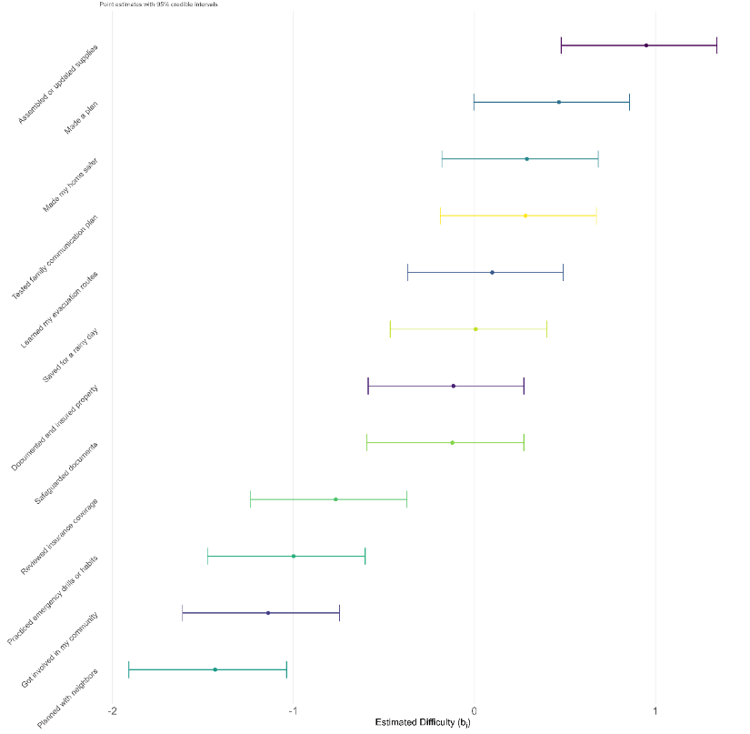
Figure 3
Adjusted by the “difficulty”, the preparedness level distribution (denoted as θ) of each risk-specific group and the national samples are displayed in Figure 4. This indicates that the preparedness levels in all these groups are quite similar, which further proves that whether typical natural hazard risk exists did not significantly contribute to the increase in household preparedness levels. This is the opposite of the conventional addictive approach (see Figure 5), which largely confirmed the significant cross-risk differences (see the ANOVA results in the Appendix A). Compared to traditional statistical regressions, Bayesian models offer richer interpretable probabilistic inferences (Dunson, 2001). Insofar, H1 is not supported using the 2023 NHS dataset, which hints that the cross-risk divergencies of U.S. household disaster preparedness are not as apparent as we expected.
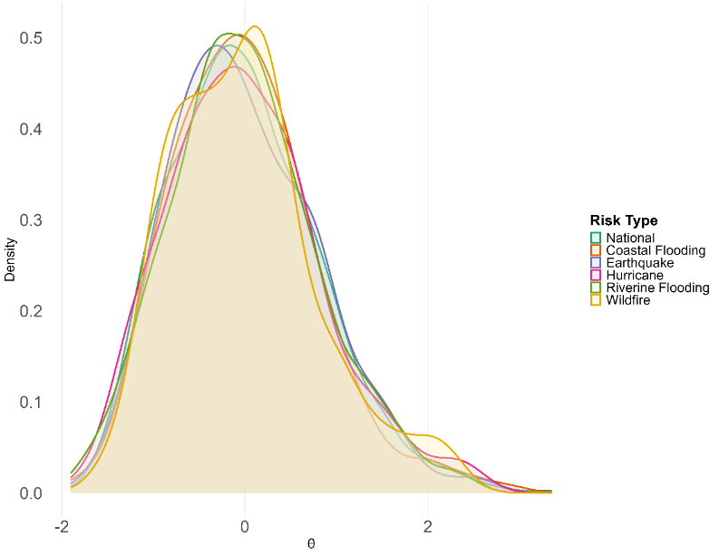
Figure 4

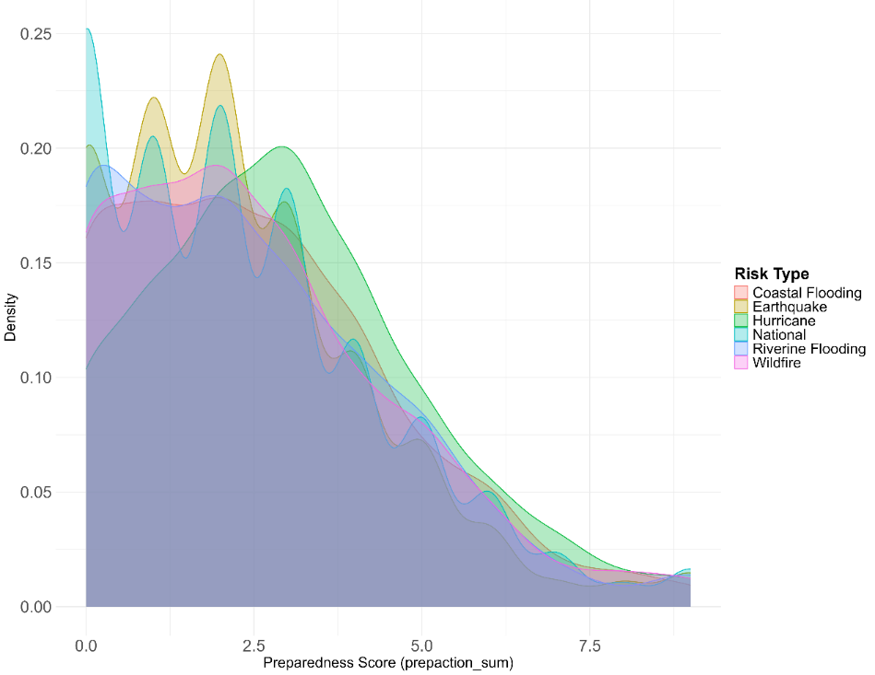
Figure 5

4.2 Effects of PMT and sociodemographic factors
As for the predictive model, which focuses on the marginal effects of PMT and sociodemographic variables in each risk context compared with national samples, the results are summarized in Table 1. Compared to the conventional reporting of standard error and p-values, in our Bayesian model, 95% credible intervals and posterior probability of direction (PD) serve a similar function to indicate statistical significance (Makowski et al., 2019). The equivalence relationship between conventional p-value and PD in the Bayesian model is demonstrated in existing literature (Shi & Yin, 2021). When the CIs are on either side of 0, more certain effect directions could be reflected. In this study, PDs are our primary concerns. Strictly relying on the 95% CIs and PD>0.95, for PMT variables, coping appraisal holds a consistent positive effect on promoting household disaster preparedness levels; threat appraisal only positively correlates with Coastal Flood and Earthquakes. Even if we slightly loosen the threshold to 90% CI and PD>0.90, there is still not enough evidence for relating wildfire to threat appraisal. However, wildfires are characterized as destructive and hard to predict. Therefore, threat appraisal’s influence on U.S. household disaster preparedness is rather limited. These results support our H3, which further suggests that coping appraisal’s primary role in promoting household disaster preparedness.
Table 1 Predictive model results
Risk Type | Estimate | 95% CI Lower | 95% CI Upper | Posterior Probability of Direction (PD) | Variable
Coastal Flood | 0.03 | -0.05 | 0.12 | 0.76 | Age
Hurricanes | 0.01 | -0.07 | 0.10 | 0.62 | Age
Earthquakes | 0.03 | -0.06 | 0.12 | 0.77 | Age
Wildfire | -0.02 | -0.14 | 0.03 | 0.12 | Age
Riverine Flood | 0.03 | -0.05 | 0.12 | 0.78 | Age
Coastal Flood | -0.10 | -0.41 | 0.21 | 0.25 | Gender (ref. Male)
Earthquakes | -0.06 | -0.37 | 0.25 | 0.36 | Gender (ref. Male)
Hurricanes | -0.30 | -0.61 | 0.01 | 0.03 | Gender (ref. Male)
Riverine Flood | 0.18 | -0.13 | 0.49 | 0.87 | Gender (ref. Male)
Wildfire | 0.01 | -0.31 | 0.32 | 0.52 | Gender (ref. Male)
Coastal Flood | -0.55 | -1.45 | 0.36 | 0.12 | Gender (ref. Non-binary/third gender)
Earthquakes | -0.09 | -1.18 | 1.00 | 0.43 | Gender (ref. Non-binary/third gender)
Hurricanes | -0.36 | -1.39 | 0.67 | 0.25 | Gender (ref. Non-binary/third gender)
Riverine Flood | -0.12 | -1.02 | 0.78 | 0.39 | Gender (ref. Non-binary/third gender)
Wildfire | -0.14 | -1.10 | 0.83 | 0.39 | Gender (ref. Non-binary/third gender)
Coastal Flood | 0.62 | -0.21 | 1.45 | 0.93^{c} | Ethnicity & race (ref. Two or more races) ª
Earthquakes | 0.14 | -0.57 | 0.87 | 0.65 | Ethnicity & race (ref. Two or more races) ª
Hurricanes | -0.20 | -0.59 | 0.98 | 0.69 | Ethnicity & race (ref. Two or more races) ª
Riverine Flood | -0.16 | -0.92 | 0.60 | 0.34 | Ethnicity & race (ref. Two or more races) ª
Wildfire | 0.04 | -0.77 | 0.84 | 0.55 | Ethnicity & race (ref. Two or more races) ª
Coastal Flood | 0.09 | -0.03 | 0.20 | 0.92^{c} | Education
Hurricanes | -0.01 | -0.11 | 0.09 | 0.43 | Education
Earthquakes | -0.01 | -0.13 | 0.11 | 0.44 | Education
Wildfire | -0.01 | -0.14 | 0.11 | 0.41 | Education
Riverine Flood | 0.11 | -0.01 | 0.22 | 0.96^{b} | Education
Coastal Flood | 0.05 | -0.03 | 0.13 | 0.88 | Income
Hurricanes | 0.04 | -0.03 | 0.12 | 0.87 | Income
Earthquakes | 0.03 | -0.04 | 0.11 | 0.80 | Income
Wildfire | 0.07 | -0.01 | 0.15 | 0.97^{b} | Income
Riverine Flood | 0.01 | -0.08 | 0.09 | 0.55 | Income
Coastal Flood | 0.18 | -0.16 | 0.51 | 0.85 | Houseownership
Earthquakes | -0.24 | -0.58 | 0.11 | 0.09 | Houseownership
Hurricanes | -0.04 | -0.36 | 0.28 | 0.41 | Houseownership
Riverine Flood | -0.15 | -0.51 | 0.21 | 0.21 | Houseownership
Wildfire | -0.04 | -0.37 | 0.28 | 0.41 | Houseownership
Coastal Flood | -0.32 | -0.68 | 0.04 | 0.04 | Disability
Earthquakes | -0.08 | -0.44 | 0.28 | 0.34 | Disability
Hurricanes | -0.06 | -0.43 | 0.31 | 0.38 | Disability
Riverine Flood | -0.18 | -0.54 | 0.18 | 0.17 | Disability
Wildfire | -0.23 | -0.57 | 0.11 | 0.10 | Disability
Coastal Flood | -0.06 | -0.73 | 0.61 | 0.44 | Rurality
Earthquakes | 0.26 | -0.48 | 1.02 | 0.75 | Rurality
Hurricanes | 0.35 | -0.26 | 0.97 | 0.87 | Rurality
Riverine Flood | -0.19 | -0.90 | 0.53 | 0.30 | Rurality
Wildfire | -0.09 | -0.74 | 0.57 | 0.40 | Rurality
Coastal Flood | 0.06 | -0.10 | 0.21 | 0.78 | Number of children
Hurricanes | 0.07 | -0.07 | 0.21 | 0.82 | Number of children
Earthquakes | -0.06 | -0.25 | 0.12 | 0.25 | Number of children
Wildfire | 0.02 | -0.13 | 0.16 | 0.58 | Number of children
Riverine Flood | 0.03 | -0.13 | 0.19 | 0.66 | Number of children
Coastal Flood | 0.33 | 0.24 | 0.43 | 1.00^{b} | Coping appraisal
Hurricanes | 0.28 | 0.19 | 0.38 | 1.00^{b} | Coping appraisal
Earthquakes | 0.25 | 0.15 | 0.35 | 1.00^{b} | Coping appraisal
Wildfire | 0.38 | 0.27 | 0.48 | 1.00^{b} | Coping appraisal
Riverine Flood | 0.31 | 0.22 | 0.41 | 1.00^{b} | Coping appraisal
Coastal Flood | 0.32 | 0.09 | 0.56 | 1.00^{b} | Threat appraisal
Hurricanes | 0.21 | -0.04 | 0.46 | 0.95^{b} | Threat appraisal
Earthquakes | 0.34 | 0.11 | 0.59 | 1.00^{b} | Threat appraisal
Wildfire | 0.09 | -0.15 | 0.33 | 0.77 | Threat appraisal
Riverine Flood | 0.18 | -0.07 | 0.41 | 0.93^{c} | Threat appraisal
Note: Coefficient estimates are median posterior values
a. Ethnicity & race results are partially omitted due to table length; b. PD>0.95; c. PD>0.90
For sociodemographic variables, the positive effects of education in Riverine Flood, income in Wildfire are identified. Relying on PD>0.90, the roles of education and race in Coastal Flood are identified. However, for sociodemographic variables including gender, houseownership, disability, rurality, and number of children, no noteworthy effects are found. Also, no promising sociodemographic factors are identified in earthquake and hurricane contexts. Lastly, interaction effects (see Appendix B) suggest that males may perform better in riverine flood contexts (PD > 0.95). Additional interaction effects were observed in homeownership, disability, and age under coastal flood context, and in age and education under hurricanes, wildfires, and earthquakes (PD > 0.90). These findings highlight the heterogeneity across natural hazard contexts. All these results support H2 by specifically emphasizing the outstanding roles of education and income in understanding U.S. household disaster preparedness. But in general, the abovementioned results present sociodemographic factors’ contextual, yet inconsistent effects. In conclusion, these classical sociodemographic variables still reveal that households that hold sufficient intellectual and material resources are more likely to be better prepared for natural hazard risks to a more limited extent.

5.Discussion
The core of this study is to understand the U.S. household disaster preparedness for different natural hazard risk contexts. The results of this study positively supported H2 and H3 with more details, while H1 did not. We would like to address the following discussion based on the proposed framework, theory background, and statistical results throughout the whole study.

5.1 Characteristics of Natural Hazard Risks
The characteristics of natural hazard risks, as the objective foundation for understanding household disaster preparedness, require contextual consideration. Recent research has echoed our predictability-destructiveness topology by examining that tornadoes and damaging winds, which are unpredictable and concentrated with extreme damage, would negatively influence county-level income growth in the U.S (Huesler, 2024). These two types of natural hazards share similar characteristics with hurricanes, which suggests that the characteristics of natural hazard risks are closely related to their various socioeconomic impacts. However, in this study, by introducing the Hierarchical Bayesian IRT model, the expected fluctuations between all risk-specific groups are not supported. Intuitively, this illustrates that the geographical rise or accumulation of natural hazard risks could not account for the improvement of household disaster preparedness. However, we think there are still underlying issues that require clarification.
For example, previous research concluded that U.S. households tend to prepare for “mega” natural hazard risks with massive scales and in-depth social constructs like hurricanes (Helsloot et al., 2012). Hurricanes Katrina and Hurricane Andrew, etc., all manifested their nonnegligible impact on U.S. social cognition, economy, urban planning, and politics, along with extensive dialogue and reflection between scholars, practitioners, and local communities (Petterson et al., 2006). In vast literature, the preparedness level increase after major hurricanes is also observed (Baker, 2011). Nevertheless, why these effects vanished in a nationwide survey? First, this may be attributed that FEMA chose the top counties where specific risk accumulates. In these counties, the existence of certain natural hazard risks is more obvious. Under such circumstances, this may result in similar mindsets and priorities in attention and resource investment for preparedness in these counties. This may indicate that household preparedness is driven less by the theoretical characteristics of risks and more by an intuitive response simply to the tangibility of risks.
Second, we propose that the way of measuring household disaster preparedness levels matters. As discussed before, the validity of forming certain disaster preparedness action indexes is always challenging and complex (Simpson, 2008; Jamieson, 2016). In the majority literature focusing on single natural hazard risk contexts, the importance of such issue has not been fully discovered. As we already mentioned, how to define the preparedness action spectrum has long been a diversified topic. In other words, there is seldom acknowledged criteria to precisely set the desirable width and depth of household disaster preparedness action realms. In the 2023 NHS questionnaire, preparedness levels are measured in 12 binary variables without contextual consideration. For example, “Signed up for alert and warnings” carry unequal significance in predictable risks like hurricanes and unpredictable risks like earthquakes. Or, what dose “Got involved in my community” specifically contain? Moreover, these measurements may ignore local or innovative disaster preparedness attempts. These latent drawbacks constitute substantial concerns about the reliability of such overgeneralized measurements. Context-sensitivity, multidimensionality, and inclusiveness are helpful in improving their qualities. We think that understanding the context through qualitative and heuristic ways is becoming more indispensable for such survey designs.
Therefore, we think the results generated form NHS are not effective enough to claim that the characteristics of natural hazard risk are never important. By comparing disaster preparedness levels in each risk-specific group, the seemingly insufficient differences in their levels suggest that scholars and practitioners should reversely not dwell on the broad growth of general average preparedness levels. As scholars have suggested avoiding using the vague term “natural disaster” with more accurate expressions, we need to point out that natural hazard risks should be treated more prudently (Chmutina & Von Meding, 2019). By applying more well-rounded designs, we reckon that the characteristics of natural hazard risks would still possess certain influences on U.S. household disaster preparedness. Ultimately, how we measure household disaster preparedness matters. For example, the lack of critical preparedness actions may intensify the loss, even if they are considered comparatively less critical in other risk contexts. We have to acknowledge that such situations are possible. Emphasizing both the unique and shared characteristics, swiftly evolving trends, and coupling processes with socioeconomic contexts of each type of natural hazard risk are indispensable for generating more sustainable solutions. The predictability-destructiveness typology in this study could also be further discussed and revised.

5.2 PMT and sociodemographic Factors
5.2.1 PMT Factors
PMT and sociodemographic factors are helpful but not ultimate in understanding household preparedness actions in the U.S. As our results suggested, coping appraisal is consistently significant, while threat appraisal is not. This is validated and discussed in the previous research in the non-U.S. contexts (Hu et al., 2022). In addition, there is also competing research that claims the dominance of threat appraisal in shaping adaptive behaviors (Huntsman et al, 2021).
Our findings suggest that PMT’s applicability may be context-dependent. Concentrated on this phenomenon, in the beginning, the essentiality of coping appraisal should be confirmed since this provides the positive-going momentum in fostering household disaster preparedness actions. This reinforces the importance of self-efficacy as a driver of U.S. household preparedness. As for threat appraisal, this inconsistency may be attributed to the exact time and location, questionnaire design, and even social information dissemination environment which could skew or constrain accurate risk perception, especially at present. In the current digital society, accurate and moderate threat appraisals seem even harder to form and evaluate. Under such circumstances, the potential effects of threat appraisal should not be crudely denied; on the contrary, we should reflect and improve the way we measure it. At the same time, these abovementioned findings may imply revising and advancing the existing structure within PMT. Specifically, this may require appropriate theoretical extension and revision of PMT to include more constructive elements since much effort has been invested both domestically and internationally on DRR along with the enriching process of the active protective action spectrum (Westcott et al., 2017).
5.2.2 Sociodemographic Factors
Sociodemographic factors present inconsistent mechanisms toward household disaster preparedness, which may imply deep inequities and social capital building from certain contextual angles. In this study’s results, income, education, and race are all related to the U.S. household preparedness levels in different risk contexts. Above that, interaction effects better support and advance our findings by presenting more detailed sociodemographic heterogeneities within natural hazard risk contexts. This, on the one hand, is harmonized with previous studies which posited that higher socioeconomic status may bring higher preparedness levels (Perry et al., 2001); on the other hand, this also latently reveals that socioeconomic status is not changeless across natural hazard risk contexts. The significance of income and education together probably illustrates that the fulfillment of well-rounded household disaster preparedness could not be accomplished purely out of active willingness but also knowledge and material resources. Moreover, the interaction effects may underpin that hidden inequities in specific contexts require more focus. Moreover, these sociodemographic differences are previously denoted towards different preparedness domains (Castañeda et al., 2020). Our results preliminarily presented the diversified sociodemographic mechanisms across risk contexts.
Aside from this, the geographical distribution of the research area (e.g., hurricane counties are extremely concentrated in Florida) may provide more specific space-time conditions for interpreting the influence of sociodemographic factors. Generally, both PMT and sociodemographic factors could still provide insights into unresolved areas, especially for revealing inequity and insufficiency. However, these factors could not be taken as terminal determinants. Socioeconomic status should not be immutable. For households within and outside the U.S., it’s more important to focus on those who do not inexorably accept the socioeconomic effects but positively utilize their initiatives for improving preparedness levels. Therefore, we need to be more conscious of the complexity between natural hazard risks and social status, and probe into the short-term and long-term evolution of such inequity and insufficiency. This is also imperative for the worldwide DRR progress, which calls for strengthening the vulnerable groups and closing the gaps in collective efforts.

5.3 Policy Implications
Targeted policymaking needs to be better undergirded for more resilient household disaster preparedness building. Previous research introduced and used the enlightening term “social vulnerability” (Cutter et al., 2003). In this study, our results further prove that social vulnerability is a dynamic construct in different natural hazard risk contexts and from different angles. Therefore, this study calls for a more deliberate and comprehensive policy design for nudging household disaster preparedness actions especially for public managers and related practitioners. As mentioned in the review section, as an example, the way and delivery of disaster-related knowledge matter (Heinkel et al., 2022; Nojang et al., 2020). This certified that more attention should be paid to integrating policy with specific natural hazard risk contexts.
From the government side, based on this study, the focal points are not limited to: (1) flexible and risk-oriented resource and attention input according to the nature, status, and trend of each major natural hazard risk and their potential impact on all groups of people; (2) Encouraging the long-term engagement of representative households in incorporating their genuine need and experience into local policy agenda and practice; (3) Promoting the application of new technologies and frameworks to sustain and empower more advanced disaster preparedness actions through forming interdisciplinary boards. These principles should be reflected in the budgeting and planning protocols, the development of public risk products (e.g., mobile APPs), and the institutionalization of wider and more agile feedback mechanisms.
From the community and household side, the directions are not limited to: (1) generating accurate and scientific risk perception and preparedness mindset through long-term effective knowledge coproduction; (2) transforming disaster preparedness into an annual routine with incremental resource investment under guidance; (3) collaborating with multiple stakeholders like NGOs and academic institutions for continuous capacity accumulation toward resilience that adapts to local conditions. These are all fundamental countermeasures concerning the sophistication of natural hazard risks. Community level disaster preparedness is a unique kind of public service, where coproduction also works. Initiatives like co-developing preparedness checklists, co-design workshops, co-implementation incentives, and annual drills as co-assessment will be beneficial in the long run (Dudau et al., 2019).

5.4 Limitations
In summary, household disaster preparedness in the U.S. is influenced by the complex coupling of both objective characteristics and subjective drivers. Therefore, we tried to avoid overgeneralization by taking a rather prudent stance.
This study has the following limitations. (1) This study is potentially limited due to the second-hand nature of the FEMA dataset since we could only accept its established structure and content as it is. This limits theoretical scope and omits other key factors such as political context and risk communication (Mulligan et al., 2019; Blanchard-Coehm, 1998). As a study derived from a typical self-reporting questionnaire design, potential bias may still exist in measurement credibility and reliability. (2) The characteristics of natural hazard risks, proposed as a typological framework, are incorporated into the analysis in a categorical way. This may also impair the overall quality of this study since we could not determine the “turning points” of risk thresholds. (3) This study used cross-sectional data, which lacks longitudinal observation, especially considering the diverse local policy frameworks and social norms among different states. More combinations with case studies may extend the current exploration of the mechanisms behind. (4) Anchoring at more general conclusions, the U.S. household samples may not represent the worldwide disaster preparedness and DRR progress or universal concerns.
Also, we still need to acknowledge that PMT is never a flawless or always-effective theory for understanding public disaster preparedness actions. Fundamentally, PMT is widely adopted considering its unremitting focus on threat and coping, which are largely pivotal elements for understanding human behavior under severe and uncertain conditions. We chose PMT because of its conciseness and pertinence, and also out of its accordance with the structure of the second-hand dataset we used as well.

6.Conclusion
This study investigates whether natural hazard risk heterogeneity shapes U.S. household disaster preparedness, using FEMA’s NHS survey data. Our results proposed a more intriguing question: how to measure disaster preparedness in more appropriate ways? The results of this study also show that households present divergent vulnerabilities and preparedness requirements in different natural hazard risk contexts, and PMT is not the “golden rule” for understanding and predicting household actions in diversified contexts. These findings highlight the need for more evidence-based, and inclusive policy design and intervention in nudging appropriate household disaster preparedness actions. Hopefully, this study provides solid insights for supporting such governance visions.
For scholars in relating realms, we sincerely call for constructing larger and more systematic first-hand datasets, especially from the global south and other underrepresented regions. There are still challenges in designing and conducting effective disaster preparedness surveys accustomed to diverse backgrounds. By comparing cross-national and long-term observation, we may obtain more valuable and accurate insights for human society. Concurrently, scholars should acknowledge more of the potential “glass ceiling” effect of relying on traditional self-report questionnaires and apply multiple methods, such as quick response and behavioral experiments, to deepen and broaden our understanding of household disaster preparedness from both the macro and micro perspectives (Oulahen et al., 2020). Lastly, cross-disciplinary theories and frameworks should be encouraged and incorporated to perpetuate the creativity and novelty of this realm. After the whole study, we eventually conclude that more attention should be paid to disentangling the relation and mechanisms between natural hazard risk characteristics, preparedness actions, and multidimensional contexts for a more resilient future.

Reference
Al-Rousan, T. M., Rubenstein, L. M., & Wallace, R. B. (2014). Preparedness for natural disasters among older US adults: a nationwide survey. American journal of public health, 104(3), 506-511.
Atreya, A., Czajkowski, J., Botzen, W., Bustamante, G., Campbell, K., Collier, B., ... & Montgomery, M. (2017). Adoption of flood preparedness actions: A household level study in rural communities in Tabasco, Mexico. International Journal of Disaster Risk Reduction, 24, 428-438.
Baker, E. J. (2011). Household preparedness for the aftermath of hurricanes in Florida. Applied Geography, 31(1), 46-52.
Becker, J. S., Paton, D., Johnston, D. M., & Ronan, K. R. (2012). A model of household preparedness for earthquakes: how individuals make meaning of earthquake information and how this influences preparedness. Natural hazards, 64, 107-137.
Bethel, J. W., Foreman, A. N., & Burke, S. C. (2011). Disaster preparedness among medically vulnerable populations. American journal of preventive medicine, 40(2), 139-143.
Blanchard-Coehm, R. D. (1998). Understanding public response to increased risk from natural hazards: Application of the hazards risk communication framework. International Journal of Mass Emergencies & Disasters, 16(3), 247-278.
Bronfman, N. C., Cisternas, P. C., Repetto, P. B., & Castañeda, J. V. (2019). Natural disaster preparedness in a multi-hazard environment: Characterizing the sociodemographic profile of those better (worse) prepared. PloS one, 14(4), e0214249.
Caldera, H. J., & Wirasinghe, S. C. (2022). A universal severity classification for natural disasters. Natural hazards, 111(2), 1533-1573.
Castañeda, J. V., Bronfman, N. C., Cisternas, P. C., & Repetto, P. B. (2020). Understanding the culture of natural disaster preparedness: exploring the effect of experience and sociodemographic predictors. Natural Hazards, 103, 1881-1904.
Chai, L., Han, Y., Han, Z., Wei, J., & Zhao, Y. (2021). Differences in disaster preparedness between urban and rural communities in China. International Journal of Disaster Risk Reduction, 53, 102020.
Chan, E. Y., Kim, J. H., Lin, C., Cheung, E. Y., & Lee, P. P. (2014). Is previous disaster experience a good predictor for disaster preparedness in extreme poverty households in remote muslim minority based community in China?. Journal of immigrant and minority health, 16, 466-472.
Chmutina, K., & Von Meding, J. (2019). A dilemma of language:“Natural disasters” in academic literature. International Journal of Disaster Risk Science, 10, 283-292.
Cisternas, P. C., Cifuentes, L. A., Bronfman, N. C., Repetto, P. B., & Castañeda, J. V. (2024). Household preparedness for multi-natural hazards in coastal communities. International Journal of Disaster Risk Reduction, 109, 104584.
Clay, L. A., Goetschius, J. B., Papas, M. A., Trainor, J., Martins, N., & Kendra, J. M. (2020). Does preparedness matter? The influence of household preparedness on disaster outcomes during superstorm sandy. Disaster medicine and public health preparedness, 14(1), 71-79.
CRED/UCLouvain. (2024). Disaster Year in Review 2023. EM-DAT, files.emdat.be/2024/04/CredCrunch74.pdf. Accessed 22 Nov. 2024.
CRED/UCLouvain. (2024). Public Em-Dat Platform. Public EM-DAT Platform, public.emdat.be/.
Cretikos, M., Eastwood, K., Dalton, C., Merritt, T., Tuyl, F., Winn, L., & Durrheim, D. (2008). Household disaster preparedness and information sources: Rapid cluster survey after a storm in New South Wales, Australia. BMC public health, 8, 1-9.
Crimmins, Allison R., et al. (2023). Fifth national climate assessment. https://doi.org/10.7930/NCA5.2023
Cutter, S. L., Boruff, B. J., & Shirley, W. L. (2003). Social vulnerability to environmental hazards. Social science quarterly, 84(2), 242-261.
Donahue, A. K., Eckel, C. C., & Wilson, R. K. (2014). Ready or not? How citizens and public officials perceive risk and preparedness. The American Review of Public Administration, 44(4_suppl), 89S-111S.
Donatti, C. I., Nicholas, K., Fedele, G., Delforge, D., Speybroeck, N., Moraga, P., ... & Zvoleff, A. (2024). Global hotspots of climate-related disasters. International Journal of Disaster Risk Reduction, 108, 104488.
Dudau, A., Glennon, R., & Verschuere, B. (2019). Following the yellow brick road?(Dis) enchantment with co-design, co-production and value co-creation in public services. Public management review, 21(11), 1577-1594.
Dunson, D. B. (2001). Commentary: practical advantages of Bayesian analysis of epidemiologic data. American journal of Epidemiology, 153(12), 1222-1226.
Duval, T. S., & Mulilis, J. P. (1999). A Person‐Relative‐to‐Event (PrE) Approach to Negative Threat Appeals and Earthquake Preparedness: A Field Study. Journal of applied social psychology, 29(3), 495-516.
FEMA. (2024). National Household Survey. FEMA.Gov, https://www.fema.gov/about/openfema/data-sets/national-household-survey.
FEMA. (2024). Risk Mapping, Assessment and Planning (Risk Map). FEMA.Gov, www.fema.gov/flood-maps/tools-resources/risk-map.
Freddi, F., Galasso, C., Cremen, G., Dall’Asta, A., Di Sarno, L., Giaralis, A., ... & Woo, G. (2021). Innovations in earthquake risk reduction for resilience: Recent advances and challenges. International Journal of Disaster Risk Reduction, 60, 102267.
Gill, J. C., & Malamud, B. D. (2014). Reviewing and visualizing the interactions of natural hazards. Reviews of geophysics, 52(4), 680-722.
Green, D., Linley, M., Whitney, J., & Sano, Y. (2021). Factors affecting household disaster preparedness among foreign residents in Japan. Social Science Japan Journal, 24(1), 185-208.
Heidenstrøm, N. (2020). Informal household preparedness: methodological approaches to everyday practices. Journal of Risk Research, 23(3), 379-397.
Heinkel, S. B., Thiebes, B., Than, Z. M., Aung, T., Kyi, T. T., Mar, W. L., ... & Kraas, F. (2022). Disaster preparedness and resilience at household level in Yangon, Myanmar. Natural hazards, 112(2), 1273-1294.
Heller, K., Alexander, D. B., Gatz, M., Knight, B. G., & Rose, T. (2005). Social and personal factors as predictors of earthquake preparation: the role of support provision, network discussion, negative affect, age, and education. Journal of Applied Social Psychology, 35(2), 399-422.
Helsloot, I., Boin, A., Jacobs, B., & Comfort, L. K. (2012). Mega-crises: Understanding the prospects, nature, characteristics, and the effects of cataclysmic events. Charles C Thomas Publisher.
Hoffman, M. D., & Gelman, A. (2014). The No-U-Turn sampler: adaptively setting path lengths in Hamiltonian Monte Carlo. J. Mach. Learn. Res., 15(1), 1593-1623.
Hu, S. Y., Yu, M., Que, T., Fan, G., & Xing, H. G. (2022). Individual willingness to prepare for disasters in a geological hazard risk area: an empirical study based on the protection motivation theory. Natural hazards, 1-25.
Huesler, J. (2024). The Impact of Tornadoes and Damaging Winds on County-Level Income Growth in the United States. International Journal of Disaster Risk Science, 15(6), 906-918.
Hung, L. S. (2018). Gender, intra-household dynamics, and household hurricane preparedness: an exploratory study employing a dyadic interview approach. International Journal of Disaster Risk Science, 9, 16-27.
Huntsman, D., Wu, H. C., & Greer, A. (2021). What matters? Exploring drivers of basic and complex adjustments to tornadoes among college students. Weather, Climate, and Society, 13(3), 665-676.
Jamieson, T. (2016). Disastrous measures: Conceptualizing and measuring disaster risk reduction. International Journal of Disaster Risk Reduction, 19, 399-412.
Kapucu, N. (2008). Culture of preparedness: household disaster preparedness. Disaster Prevention and Management: An International Journal, 17(4), 526-535.
Karanci, A. N., Aksit, B., & Dirik, G. (2005). Impact of a community disaster awareness training program in Turkey: Does it influence hazard-related cognitions and preparedness behaviors. Social Behavior and Personality: an international journal, 33(3), 243-258.
Kates, R. W. (1971). Natural hazard in human ecological perspective: hypotheses and models. Economic Geography, 47(3), 438-451.
Kirschenbaum, A. (2006). Families and disaster behavior: a reassessment of family preparedness. International Journal of Mass Emergencies & Disasters, 24(1), 111-143.
Lang, J. W., & Tay, L. (2021). The science and practice of item response theory in organizations. Annual Review of Organizational Psychology and Organizational Behavior, 8(1), 311-338.
Levac, J., Toal-Sullivan, D., & OSullivan, T. L. (2012). Household emergency preparedness: a literature review. Journal of community health, 37, 725-733.
Li, Y., Chen, Y. F., Wang, Z., & Han, Z. (2024). Risk perception, efficacies and disaster preparedness: A comparison between people with and without disability. Journal of Contingencies and Crisis Management, 32(3), e12597.
Lindell, M. K., & Perry, R. W. (2000). Household adjustment to earthquake hazard: A review of research. Environment and behavior, 32(4), 461-501.
Makowski, D., Ben-Shachar, M. S., Chen, S. A., & Lüdecke, D. (2019). Indices of effect existence and significance in the Bayesian framework. Frontiers in psychology, 10, 2767.
Malmin, N. P. (2021). Historical disaster exposure and household preparedness across the United States. Disaster medicine and public health preparedness, 15(1), 58-64.
Martin, A. D., & Quinn, K. M. (2002). Dynamic ideal point estimation via Markov chain Monte Carlo for the US Supreme Court, 1953–1999. Political analysis, 10(2), 134-153.
Mishra, S., Mazumdar, S., & Suar, D. (2010). Place attachment and flood preparedness. Journal of environmental psychology, 30(2), 187-197.
Mulligan, T. D., Taylor, K., & DeLeo, R. A. (2019). Politics and policies for managing natural hazards. In Oxford Research Encyclopedia of Natural Hazard Science.
National Oceanic and Atmospheric Administration. (2024). National Weather Service. NOAA.Gov, https://www.weather.gov/.
Nojang, E. N., & Jensen, J. (2020). Conceptualizing individual and household disaster preparedness: the perspective from Cameroon. International Journal of Disaster Risk Science, 11, 333-346.
Nukpezah, J. A., & Soujaa, I. (2018). Creating emergency prepared households—What really are the determinants of household emergency preparedness?. Risk, hazards & crisis in public policy, 9(4), 480-504.
Onuma, H., Shin, K. J., & Managi, S. (2017). Household preparedness for natural disasters: Impact of disaster experience and implications for future disaster risks in Japan. International journal of disaster risk reduction, 21, 148-158.
Oulahen, G., Vogel, B., & Gouett-Hanna, C. (2020). Quick response disaster research: Opportunities and challenges for a new funding program. International Journal of Disaster Risk Science, 11, 568-577.
Paton, D. (2003). Disaster preparedness: a social‐cognitive perspective. Disaster Prevention and Management: An International Journal, 12(3), 210-216.
Paton, D., Anderson, E., Becker, J., & Petersen, J. (2015). Developing a comprehensive model of hazard preparedness: lessons from the Christchurch earthquake. International Journal of Disaster Risk Reduction, 14, 37-45.
Perry, R. W., Lindell, M. K., & Tierney, K. J. (Eds.). (2001). Facing the unexpected: Disaster preparedness and response in the United States. Joseph Henry Press.
Petterson, J. S., Stanley, L. D., Glazier, E., & Philipp, J. (2006). A preliminary assessment of social and economic impacts associated with Hurricane Katrina. American Anthropologist, 108(4), 643-670.
Plapp, T., & Werner, U. (2006). Understanding risk perception from natural hazards: examples from Germany. In RISK21-coping with risks due to natural hazards in the 21st century (pp. 111-118). CRC Press.
Reininger, B. M., Rahbar, M. H., Lee, M., Chen, Z., Alam, S. R., Pope, J., & Adams, B. (2013). Social capital and disaster preparedness among low income Mexican Americans in a disaster prone area. Social science & medicine, 83, 50-60.
Rivera, J. D. (2021). Factors influencing individual disaster preparedness information seeking behavior: Analysis of US households. Natural Hazards Review, 22(4), 04021042.
Rogers, R. W. (1975). A protection motivation theory of fear appeals and attitude change. The journal of psychology, 91(1), 93-114.
Rogers, R. W. (1983). Cognitive and physiological processes in fear appeals and attitude change: A revised theory of protection motivation. Social psychology: A source book, 153-176.
Sattler, D. N., Kaiser, C. F., & Hittner, J. B. (2000). Disaster preparedness: Relationships among prior experience, personal characteristics, and distress 1. Journal of applied social psychology, 30(7), 1396-1420.
Shi, H., & Yin, G. (2021). Reconnecting p-value and posterior probability under one-and two-sided tests. The American Statistician, 75(3), 265-275.
Simpson, D. M. (2008). Disaster preparedness measures: a test case development and application. Disaster Prevention and Management: An International Journal, 17(5), 645-661.
Slovic, P. (1987). Perception of risk. science, 236(4799), 280-285.
Spittal, M. J., McClure, J., Siegert, R. J., & Walkey, F. H. (2008). Predictors of two types of earthquake preparation: survival activities and mitigation activities. Environment and behavior, 40(6), 798-817.
Sutton, J., & Tierney, K. (2006). Disaster preparedness: Concepts, guidance, and research. Colorado: University of Colorado, 3(1), 3-12.
UNDRR. (2023). GAR Special Report 2023: Mapping Resilience for the Sustainable Development Goals. UNDRR-Homepage, www.undrr.org/gar/gar2023-special-report.
Uscher-Pines, L., Chandra, A., & Acosta, J. (2013). Household preparedness is not enough: the challenges and opportunities in assessing community readiness for disasters. Journal of public health management and practice, 19, S70-S76.
Westcott, R., Ronan, K., Bambrick, H., & Taylor, M. (2017). Expanding protection motivation theory: investigating an application to animal owners and emergency responders in bushfire emergencies. BMC psychology, 5, 1-14.
Zaremohzzabieh, Z., Samah, A. A., Roslan, S., Shaffril, H. A. M., D'Silva, J. L., Kamarudin, S., & Ahrari, S. (2021). Household preparedness for future earthquake disaster risk using an extended theory of planned behavior. International Journal of Disaster Risk Reduction, 65, 102533.

Religious belief may serve a vital and complex role in disaster preparedness, predictability, and risk perception. But the data of this study does not contain such exploration. More information can be found at Sun, Lei, and Wenhua Qi. “Tibetan Buddhist belief and disaster resilience: a qualitative exploration of the Yushu area, China.” Disasters 47.3 (2023): 788-805.
Radiological Emergency samples (n=505) are eliminated since this is not a natural hazard risk.
More information is available in the “2023 National Household Survey on Disaster Preparedness Methodology Report”.
Ibid
More discussion can be seen at: Witte, Kim. “Putting the fear back into fear appeals: The extended parallel process model.” Communications Monographs 59.4 (1992): 329-349.

