**计网平时作业**

**第二次作业**

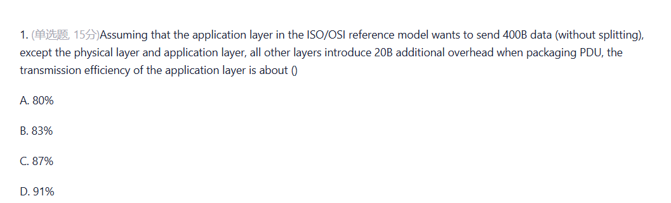

ISO/OSI共七层，选A

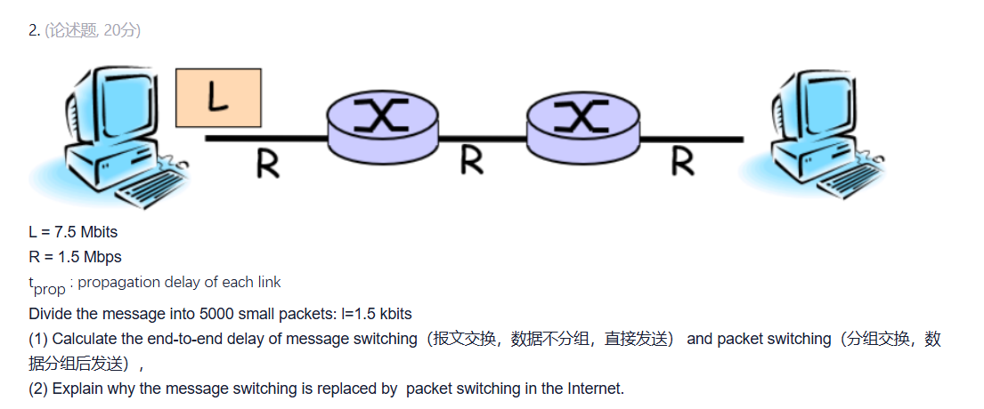

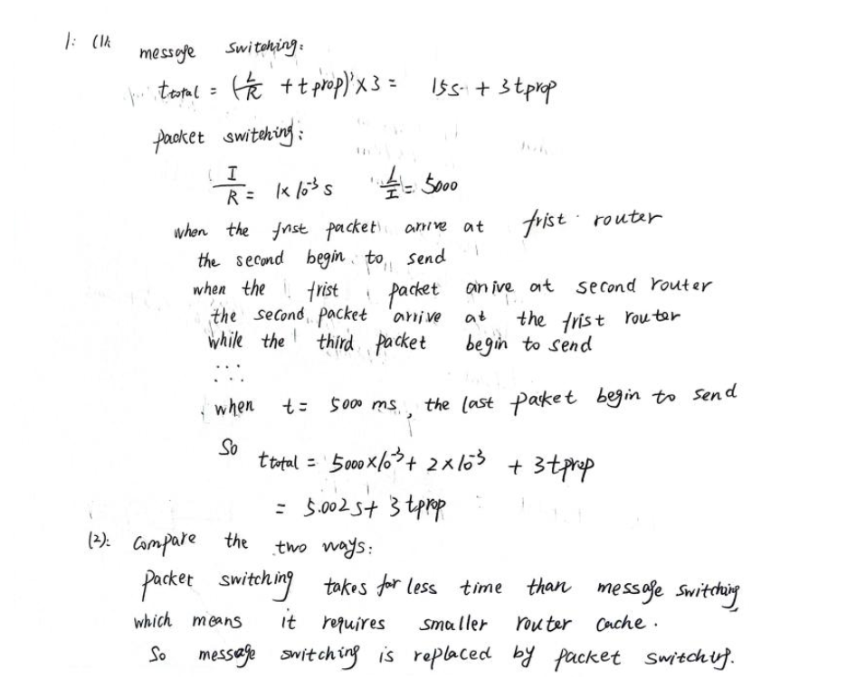

分组交换可以大幅减少发送时延

3. The message to be sent is **X** (bits) in total. There are **K** links from the source to the destination. The propagation delay of each link is **D**(s) and the bandwidth is **R**(bps). In circuit switching, the circuit establishment time is **S**(s). In packet switching, the message can be divided into several packets with **P**(bits) length. It is assumed that the processing time and queuing time of the message/packets at each node are ignored.

Q: under what conditions is the end-to-end delay of circuit switching greater than that of packet switching?

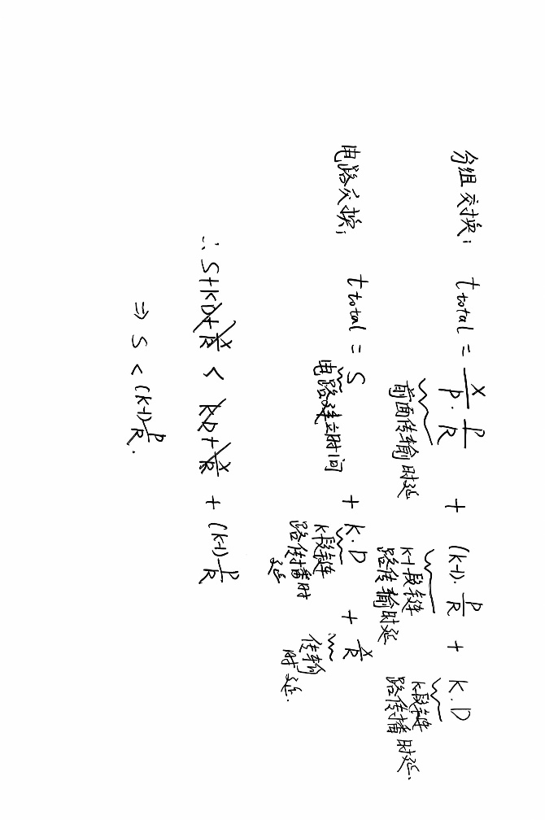

4 What can the five layers’ principal responsibilities of each of these layers?

应用层：支持各类网络应用程序

传输层：提供端到端（进程到进程）的可靠数据传输

网络层：数据报的路由和转发

数据链路层：保证数据在相邻节点的可靠传输

物理层：完成相邻节点链路上比特流的透明传输

5

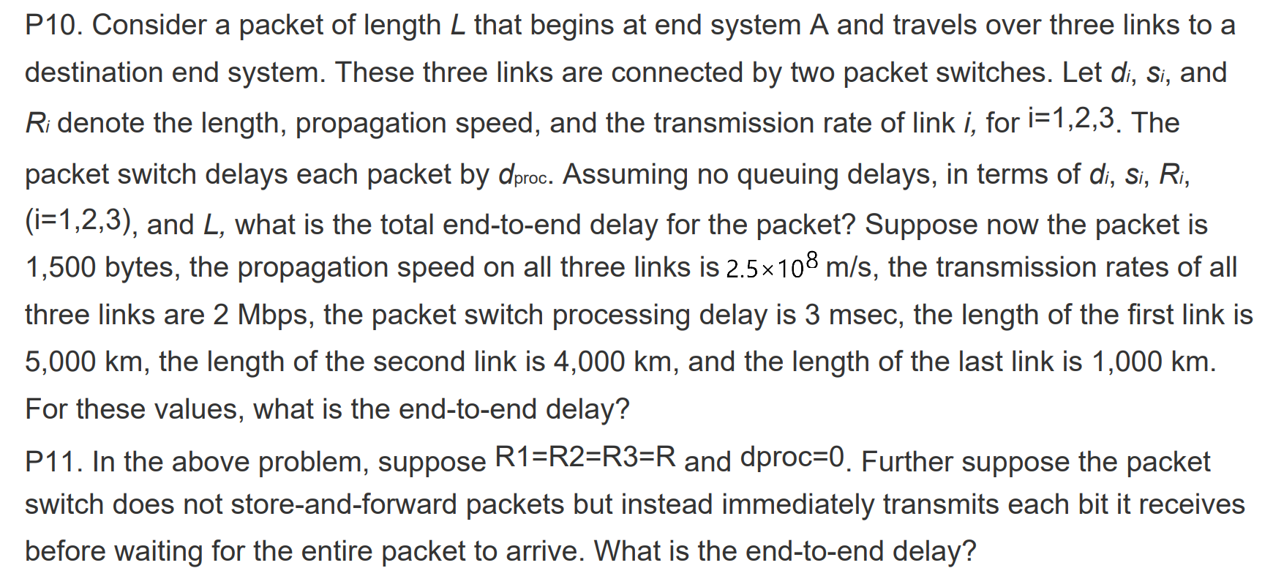

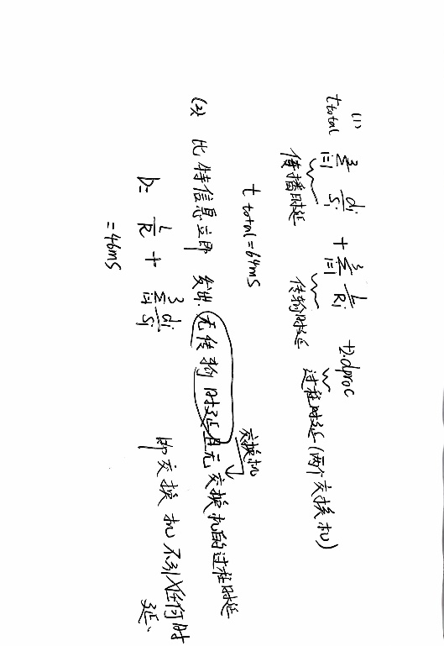

**第三次作业**

1 In the physical layer interface characteristics, the time sequence used to describe the completion of each function is（D）

A. Mechanical （机械）Characteristics

B. Electrical （电气）Characteristics

C. Functional （功能）Characteristics

D. Procedural（规程） Characteristic

机械特性：指定物理连接中使用的连接器的大小、引脚的数量和排列

电气特性：指定传输二进制位时的传输模式、电压电平、编码、阻抗匹配、传输速率和距离限制

功能特性：定义每条物理线路的功能，指示线路上出现的特殊电压的平均值；线路功能分为四类：数据、控制、定时、电源

规程特性：定义每条物理线路的**工作规则**和时序关系；信号传输：单工、半双工、全双工

2 Among the following options, that do not belong to the definition scope of physical layer interface specification is（C）

A. interface shape

B. pin function

C. physical address

D. signal level

物理地址即MAC地址，属于数据链路层

3 Under the condition of no noise, if the frequency bandwidth of a communication link is 3kHz and QAM modulation technology with 4 phases and 4 amplitudes in each phase is adopted, the maximum data transmission rate of the communication link is ( B )

A.12kbps B.24kbps C.48kbps D.96kbps



4 If the data transmission rate of a communication link is 2400bps and 4-phase modulation is adopted, the baud rate of the link is（B）

A 600 baud B 1200 baud C 4800 baud D 9600 baud

四相位的调制需要2bit，因此波特率＝比特率/比特数=1200baud

5 If the frequency bandwidth connecting R2 and R3 link is 8kHz and the signal-to-noise ratio is 30dB, and the actual data transmission rate of the link is about 50% of the maximum data transmission rate, the actual data transmission rate of the link is about（C）

A. 8kbps

B. 20kbps

C. 40kbps

D. 80kbps

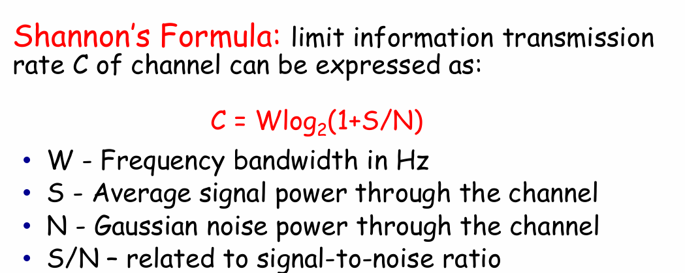

香农格式，记住**信噪比是比率，若是分贝得转换**

6 Among the following factors, which will not affect the channel data transmission rate is ( D)

A. signal to noise ratio

B. frequency bandwidth

C. symbol speed

D. signal propagation speed

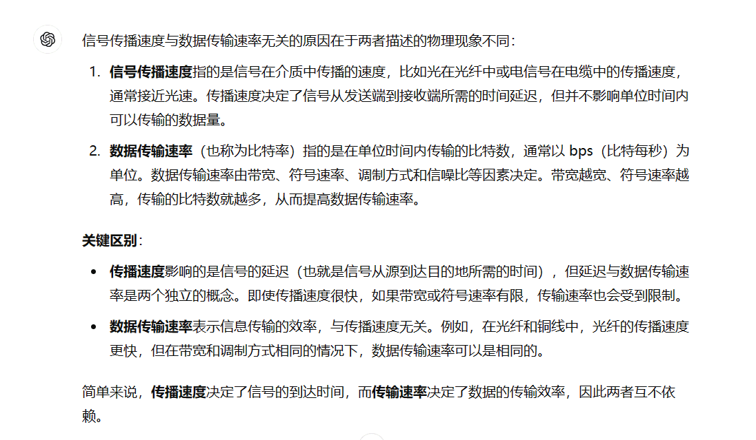

8 Under the condition **of no noise,** if the frequency bandwidth of a communication link is 6kHz and QAM modulation technology with 4 phases and 2 amplitudes in each phase is adopted, What is the maximum data transmission rate of the communication link?

9 Please draw the signal waveform of 00110110 with NRZ-L, Manchester Coding, and Differential Manchester Coding.

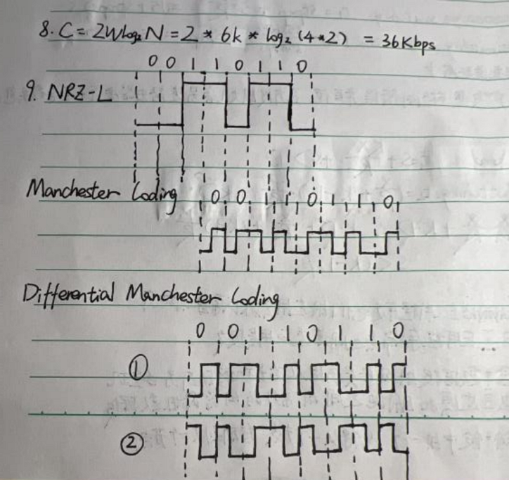

**第四次作业**

1. The data link layer uses the GBN protocol, and the sender has sent frames numbered 0 ~ 7. When the timer expires, if the sender only receives the acknowledgement of frames 0, 2 and 3, the number of frames to be retransmitted by the sender is ？

GBN是顺序收发，若接收方已经发送了3的ACK，证明前面（0,1,2,3）都已收到，因此发送方只需要重传4

### Considering GBN protocol and SR protocol, assuming that the length of sequence number space is n, what is the maximum allowed sender window?

GBN：n-1

SR：n/2

### [GBN和SR的窗口最大尺寸 - 知乎](https://zhuanlan.zhihu.com/p/450499911)

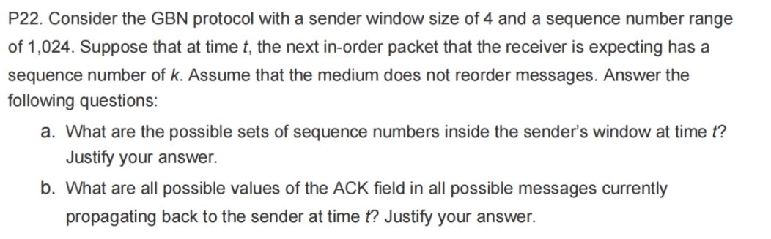

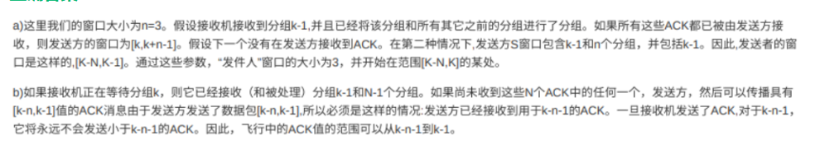

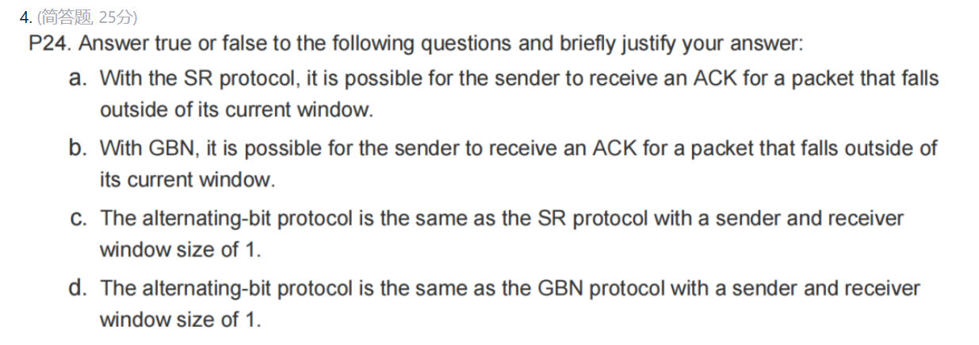

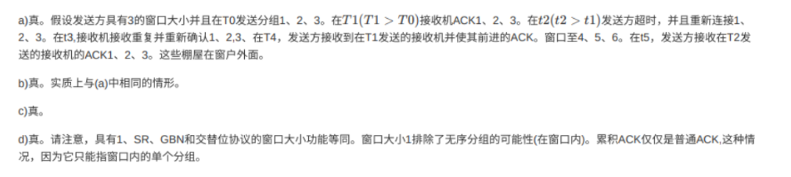

**第五次作业**

### A LAN adopts CSMA/CD protocol to realize the media access control. The data transmission rate is 10Mbps, the distance between host A and host B is 2km, and the signal propagation speed is 200000km/s. If there is a conflict when two hosts send data, how long will it take from the time when they start sending data to the time when both hosts detect the conflict? ( 需要回答的问题是：What is the minimum and maximum duration?)

### 

### 第六次作业

1. In a LAN using CSMA / CD protocol, the transmission medium is a complete cable, the transmission rate is 1Gbps, and the signal propagation rate in the cable is 200000 km / s. if the minimum data frame length is reduced by 800 bits, the distance between the farthest two stations needs to be at least（D）
2. increased by 160m

B. increased by 80m

1. reduced by 160m
2. reduced by 80m

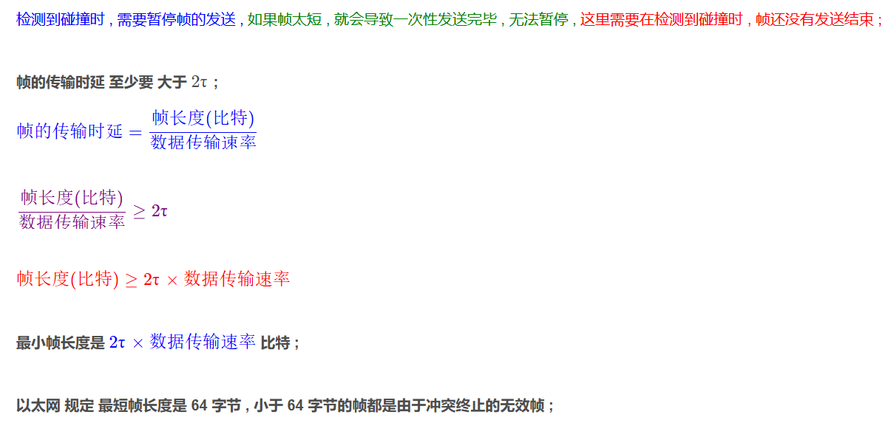

传输时延要大于2倍传播时延

1. What does it mean for a wireless network to be operating in “infrastructure mode”? If the network is not in infrastructure mode, what mode of operation is it in, and what is the difference between that mode of operation and infrastructure mode?

在基础架构模式下，每个无线主机都通过基站连接到较大的网络；若未处于基础架构模式，则网络处于临时模式。在自组织模式下，结点仅能传输到链路覆盖范围内的其他结点

1. Why are acknowledgments used in 802.11 but not in wired Ethernet?

无线网络中不能进行冲突检测，因此需要通过确认帧来判断数据是否发送成功，有线网络中可以通过冲突检测机制判断数据是否发送成功，且出错概率小，所以不需要确认帧。

1. Why does collision occur in CSMA, if all nodes perform carrier sensing before transmission?

在CSMA（载波监听多路访问）协议中，碰撞（collision）可能发生，即使所有节点在传输前都进行了载波监听，原因如下：

由于网络存在传播延时，其他节点需要一定时间后才能感知某个节点是否在发送数据，所以即使采用CSMA，仍然会产生冲突。

1. Ethernet is by far the most prevalent wired LAN technology, and it is likely to remain so for the foreseeable future. Ethernet uses CSMA/CD (载波监听/冲突检测) multiple access protocol with binary exponential backoff to address the collision problem in a shared broadcast link.

a) In a network using CSMA/CD protocol, the transmission medium is a complete cable, the transmission rate is 1Gbps, and the speed of signal propagation in the cable is 200000km/s. If the minimum length of the data frame is 1000 bits, what should be the distance between the farthest two nodes? (m)

b) According to the binary exponential backoff algorithm (二进制指数退避算法), after the 11th collision, what is the probability that a node chooses K=5? The result K=5 corresponds to a delay of how many seconds on a 10Mbps Ethernet?

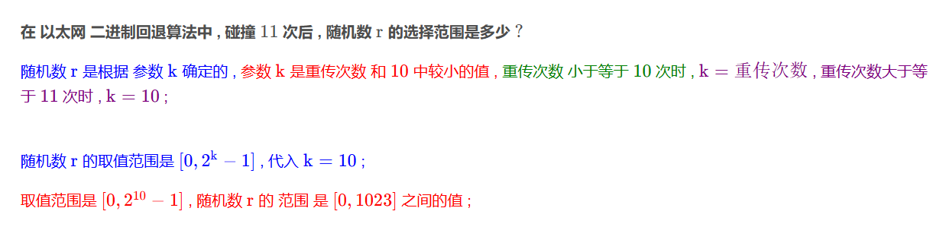

范围是[0,1023]，所以选中k=5的概率是1/1024

延时是

c) For 802.11 wireless LANs, the CSMA with collision avoidance mechanism (CSMA/CA, 载波监听/冲突避免) is used instead of using collision detection in Ethernet. Please briefly describe how 802.11 implements the collision avoidance.

发送前：载波监听，若信道忙，则等待帧间间隔后再尝试

发送中：若信道空闲，进行发送；发生冲突后则以随机二进制指数回退进行退避

发送后：接收方会发送一个确认帧（ACK）给发送方，以确认数据已正确接收。

**第七次作业**

Consider the following network. With the indicated link costs, please use Dijkstra’s shortest-path algorithm to compute the shortest path from **x** to all network nodes, give out the shortest-path tree and the forwarding table from **x** to all network nodes.

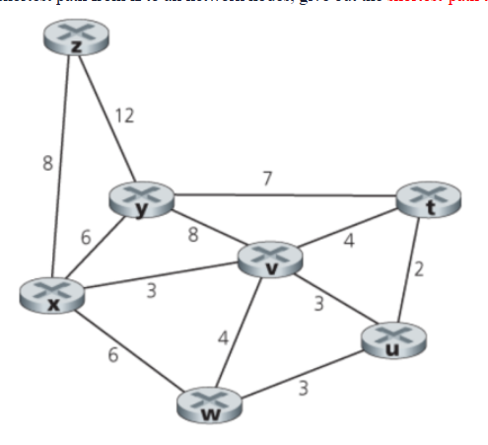

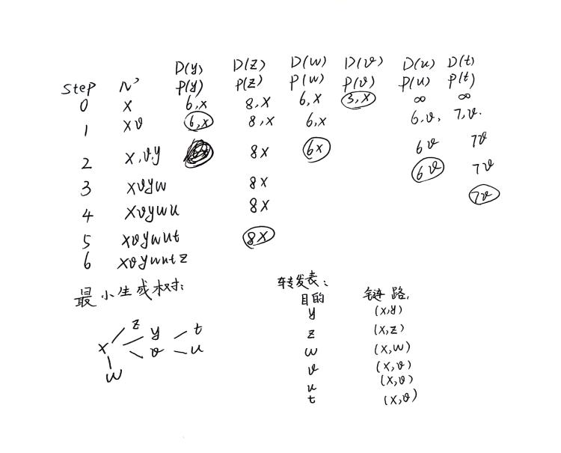

**第八次作业**

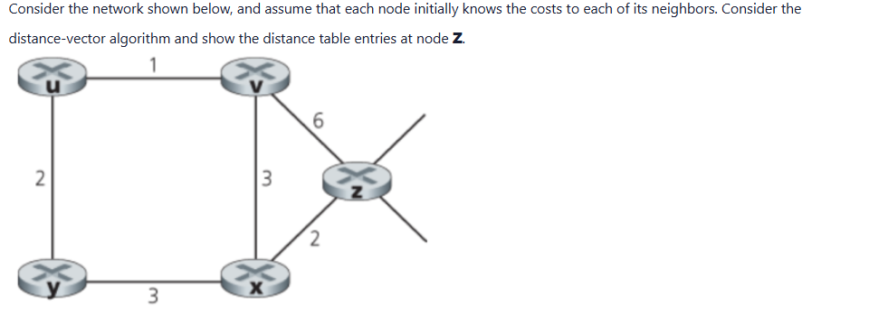

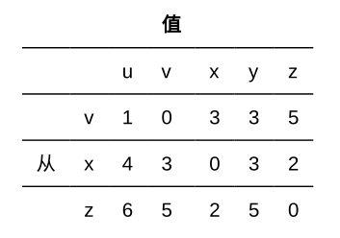

Consider a three-node topology shown below. If the DV routing algorithm is used in the network, what problem will· happen when c(Y,X)· changes· from· 4· to 40?· In order to solve this problem, after the self-update, what distance vector table does the router Y tell its neighbors?

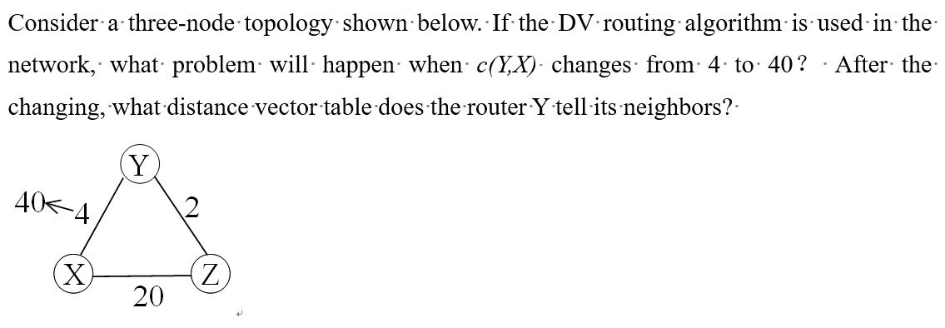

(1):当c(Y,X)从4变到40，Z的距离向量不会立即更新，其告诉Y自己到X的cost是6，那样Y就会经由Z到X。此时迭代比较慢，即**无穷计数问题**

(2)：采用毒性反转，由于Z到X的距离向量是经过Y的，于是在Y告诉Z它到X的距离应该设为无穷；而Y告诉X它到X的距离即为22。

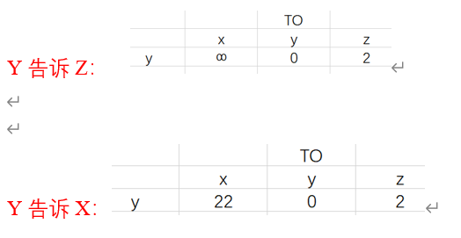

**第九次作业**

1. Figure 1 shows the network topology, and Figure 2 shows the hex-content of the first 80 bytes of an Ethernet frame of the host for a Web request.(1) What is the IP address of the Web server? What is the MAC address of the default gateway of this host?(2) When the IP packet encapsulated in this frame is forwarded through router R, which fields in the IP packet need to be modified？

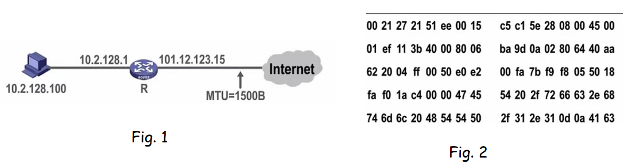

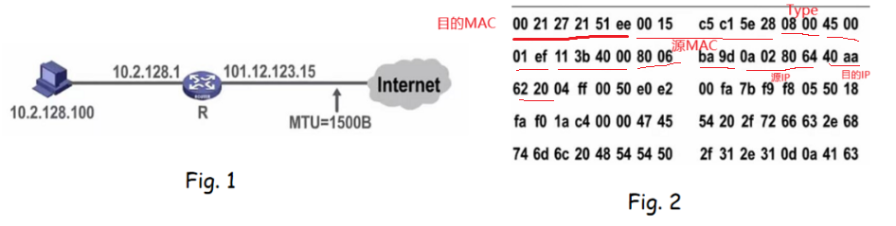

(1)64.170.98.32; 00-21-27-21-51-ee(2) TTL字段，首部校验和重新计算（某些字段：生存时间、片偏移、标识字段可能发生变化），总长字段若大于MTU，则总长字段、标志字段、片偏移字段都需要修改

1. One University owns the block of IP addresses of the form: 103.46.112.0 /20.

Suppose it wants to create four subnets from this block, with each-block having the same number of IP addresses. Please complete the following list.

|  |  |
| --- | --- |
| The block of IP4address | 103.46.112.0 /20 |
| The prefixes (of form a.b.c.d/x) for the **lst** subnet | 103.46.112.0 /22 |
| the prefixes (of form a.b.c.d/x)for the **3rd** subnet | 103.46.120.0 /22 |
| The directed broadcast address of the **2nd** subnet | 103.46.119.255 |
| Loop back test address (local host IP address) | 127.0.0.1 |

1. Consider sending a 1600-byte datagram into a link that has an MTU of 500 bytes. Assuming a 20-byte IP header and the original datagram is stamped with the identification number 345. Please complete the fragmentation for the large datagram. Give the specific values of the fields related to fragmentation.

[(1600-20)/480] = 4

第一个分片：长度为480+20=500，ID为345，偏移字段为0，flag为1

第二个分片：长度为480+20=500，ID为345，偏移字段为480//8=60，flag为1

第三个分片：长度为480+20=500，ID为345，偏移字段为120，flag为1

第四个分片：长度为(1580-480*3)+20=160，ID为345，偏移字段为180，flag为0

1. What is the principal responsibility of a router? 路由和转发
2. MTU means 最大传输单元 ，it relates to the 数据报分段 field in the header of an IP datagram.
3. There are two levels for the routing protocols in the Internet: intra-autonomous system routing protocol and inter-autonomous system routing protocol. OSPF 、  **RIP** routing protocols are widely used for intra-AS routing. And all ASs run a same inter-AS routing protocol: BGP .
4. A IPv6 address with zero compression is 1A00::C057:50:8:15/60, the full expression of this address with colon hexadecimal notation is 1A00:0000:0000:0000:C057:0050:0008:0015/60 .
5. What aspects of the IPv6 protocol has been improved to speed up the IP forwarding speed within the network? The analysis can be combined with the IPv6 and IPv4 datagram formats?

1）简化头部格式，固定头部长度 2）移除checksum字段 3）IPv6 不允许在中间路由器上进行分片与重新组装

1. What two types of ICMP messages are received at the sending host executing the Traceroute program?

Type 11 code 0 TTL过期

Type3 code 3 目的端口不可达

1. When does the NAT (Network Address Translation) protocol need? How does it work?

内网主机与外网主机进行数据传输时，NAT将内网地址转换成公网IP地址，并通过端口号区分不同内网主机。

NAT使用NAT路由器上的NAT转换表记录公网IP地址+端口号与内网IP+端口号的对应关系。

**第十次作业**

1. Host A sends a TCP segment (SYN=1,seq=11220) to host B and expects to establish a TCP connection with host B. if host B accepts the connection request, the correct TCP segment sent by host B to host A may be ( C)

A. SYN=0,ACK=0,seq=11221,ack=11221

B.SYN=1,ACK=1,seq=11220,ack=11220

C.SYN=1,ACK=1,seq=11221,ack=11221

D. SYN=0,ACK=0,seq=11220,ack=11220

ACK=1表示收到建立连接的请求

1. A TCP connection has been established between host A and host B. host A sends three consecutive TCP segments to host B, including 300 bytes, 400 bytes and 500 bytes payload respectively. The sequence number of the third segment is 900. If host B receives only the first and third segments correctly, the confirmation sequence number sent by host B to host A is(B )

A. 300

B. 500

C. 1200

D. 1400

第一段的seq是900-400-300=200

只收到了第一段和第三段，所以只发送第一段的ACK，即为200+299+1=500

