**Supporting materials**

**Table S1** The column names, definition, unit and format for the input variables table required in rTRIPLEXSIF package.（21 input variables）

|  |  |  |  |
| --- | --- | --- | --- |
| Column names | Definition | Unit | format |
| DATE | Date | - | 2019/1/1 0:00 |
| Vms | Wind speed at measured height | m s-1 | Numeric |
| Ta | Air temperature | ℃ | Numeric |
| RH | Relative humidity | % | Numeric |
| VPD | Vapor pressure deficit | hPa | Numeric |
| SVWC30cm | Soil volumetric moisture at depth of 30 cm | % | Numeric |
| Rn | Net radiation at the canopy surface | W m-2 | Numeric |
| PPFD | Photosynthetic photon flux density | μmol m-2 s-1 | Numeric |
| Rainfall | Rainfall | mm | Numeric |
| Month | The sequence of month | - | 1 for January |
| Day | Day of month | - | Numeric |
| year | Studied year | - | 2019 |
| time | The time of day at 30 min scale | h | 0.5, 1, 1.5,… |
| DOY | Day of year | - | Numeric |
| Cof | Carbon dioxide concentration in the atmosphere | ppm | Numeric |
| G | Soil heat flux | W m-2 | Numeric |
| GPP | Observed gross primary productivity at 30 min scale | mg CO2 m-2 s-1 | Numeric |
| LE | Observed latent heat at 30 min scale | W m-2 | Numeric |
| SIF | Solar induced chlorophyll fluorescence | m W m-2 nm-1 sr-1 | Numeric |
| NIRv | Near- infrared reflectance of vegetation | - | Numeric |
| fPAR | Fraction of absorbed photosynthetically active radiation | - | Numeric |

**Table S2** The column names, definition, unit for the input parameters table required in rTRIPLEXCWFlux package. The formats of all data are numeric.（模型参数31个）

|  |  |  |  |
| --- | --- | --- | --- |
| Column names | Definition | Unit | Values |
| Hw | The height at wind measurement | m | 29 |
| hc | The average canopy height | m | 10 |
| N | Leaf nitrogen content | % | 1.4 |
| Nm | Maximum nitrogen content | % | 1.7 |
| m | Coefficient | - | 8.5 |
| g0 | Initial stomatal conductance | m mol m-2 s-1 | 15 |
| Vm25 | Maximum carboxylation rate at 25℃ | μmol m-2 s-1 | 52.1 |
| Rgas | Molar gas constant | m3 Pa mol-1 K-1 | 8.314 |
| O2 | Oxygen concentration in the atmosphere | Pa | 21000 |
| Ls | Standard longitude of time zone | - | 120 |
| Le | Local longitude | ° | 115.59 |
| latitude | Local latitude | ° | 31.12 |
| LAI | Leaf area index of canopy | m2 m-2 | 6.3 |
| SWCs | Saturated soil volumetric moisture content at depth of 30 cm | % | 25.5 |
| SWCw | Wilting soil volumetric moisture content at depth of 30 cm | % | 11.2 |
| VPD_close | The VPD at stomatal closure | kPa | 2 |
| VPD_open | The VPD at stomatal opening | kPa | 0.2 |
| Mf | Biomass density of for leaf | kg C m-2 day-1 | 0.12 |
| Ms | Biomass density of for sapwood | kg C m-2 day-1 | 0.83 |
| Mr | Biomass density of for root | kg C m-2 day-1 | 0.36 |
| rmf | Maintenance respiration coefficient for leaf | - | 0.002 |
| rms | Maintenance respiration coefficient for stem | - | 0.001 |
| rmr | Maintenance respiration coefficient for root | - | 0.001 |
| rgf | Growth respiration coefficient for leaf | - | 0.25 |
| rgs | Growth respiration coefficient for sapwood | - | 0.25 |
| rgr | Growth respiration coefficient for root | - | 0.25 |
| raf | Carbon allocation fraction for leaf | - | 0.09 |
| ras | Carbon allocation fraction for sapwood | - | 0.54 |
| rar | Carbon allocation fraction for root | - | 0.24 |
| Q10 | Temperature sensitivity factor | - | 1.64 |
| Tref | Base temperature for Q10 | ℃ | 20 |
| fPSII | Ration of PSII SIF to total SIF | - | 0.6 |
| Kdf | Ratio of kd (the rate constant for constitutive heat loss) to kf (the rate constant for fluorescence emission) | - | 9 |

**Table S3** The column names, definition, unit and format for model output in rTRIPLEXCWFlux package.（输出数据24个）

|  |  |  |  |
| --- | --- | --- | --- |
| Column names | Definition | Unit | format |
| DATE | Date | - | 2019/1/1 0:00 |
| Vms | Wind speed at measured height | m s-1 | Numeric |
| Ta | Air temperature | ℃ | Numeric |
| RH | Relative humidity | % | Numeric |
| VPD | Vapor pressure deficit | hPa | Numeric |
| SVWC30cm | Soil volumetric moisture at depth of 30 cm | % | Numeric |
| Rn | Net radiation at the canopy surface | W m-2 | Numeric |
| PPFD | Photosynthetic photon flux density | μmol m-2 s-1 | Numeric |
| Rainfall | Rainfall | mm | Numeric |
| Month | The sequence of month | - | 1 for January, 2 for February… |
| Day | Day of month | - | Numeric |
| year | Studied year | - | 2019 |
| time | The time of day at 30 min scale | h | 0.5, 1, 1.5,… |
| DOY | Day of year | - | Numeric |
| Cof | Carbon dioxide concentration in the atmosphere | ppm | Numeric |
| G | Soil heat flux | W m-2 | Numeric |
| NEE | Observed net ecosystem productivity at 30 min scale | mg CO2 m-2 s-1 | Numeric |
| LE | Observed latent heat at 30 min scale | W m-2 | Numeric |
| ObserveNEE30 | Observed net ecosystem production | gC m-2 30 min-1 | Numeric |
| OETS | Observed evapotranspiration | mm 30 min-1 | Numeric |
| NEP30min | Net ecosystem production | gC m-2 30 min-1 | Numeric |
| ETS | Evapotranspiration | mm 30 min-1 | Numeric |
| GPP30min | Gross primary production | gC m-2 30 min-1 | Numeric |
| Re30min | Ecosystem respiration | gC m-2 30 min-1 | Numeric |

**Table S4** Parameters and their values, units for carbon and water coupled model used in case study.

|  |  |  |  |  |
| --- | --- | --- | --- | --- |
| Parameters | Definition | Units | Value | Source |
| g0 | Initial stomatal conductance | m mol m-2 s-1 | 15 | (Lai *et al.*, 2000) |
| hc | average canopy height | m | 18.9 | This study |
| LAI | Leaf area index | m2 m-2 | 6.3 | This study |
| latitude | Local latitude | ° | 26.86 | Studied site |
| Le | Local longitude | ° | 109.71 | Studied site |
| Ls | Standard longitude of time zone | ° | 120 | Studied site |
| m | coefficient | - | 7.5 | Optimized |
| Mf | Biomass of leaf | kg C m-2 day-1 | 0.12 | (Wei, 2019) |
| Mr | Biomass of root | kg C m-2 day-1 | 0.36 | (Wei, 2019) |
| Ms | Biomass of sapwood | kg C m-2 day-1 | 0.83 | (Wei, 2019) |
| N | Leaf nitrogen content | % | 1.4 | (Wang, 2019) |
| Nm | Maximum nitrogen content | % | 1.7 | (Wang, 2019) |
| O2 | Oxygen concentration in the atmosphere | Pa | 21000 | (Chen *et al.*, 1999) |
| Q10 | Temperature sensitivity factor | - | 1.64 | (Huang *et al.*, 2009) |
| raf | Carbon allocation fraction for leaf | - | 0.09 | (Wu, 2019) |
| rar | Carbon allocation fraction for root | - | 0.24 | (Wu, 2019) |
| ras | Carbon allocation fraction for stem | - | 0.54 | (Wu, 2019) |
| Rgas | Molar gas constant | m3 Pa mol-1 K-1 | 8.314 | (Chen *et al.*, 1999) |
| rgf | Growth respiration coefficient for leaf | - | 0.25 | (Ryan, 1991) |
| rgr | Growth respiration coefficient for root | - | 0.25 | (Ryan, 1991) |
| rgs | Growth respiration coefficient for stem | - | 0.25 | (Ryan, 1991) |
| rmf | Maintenance respiration coefficient for leaf | - | 0.002 | (Kimball *et al.*, 1997) |
| rmr | Maintenance respiration coefficient for root | - | 0.001 | (Kimball *et al.*, 1997) |
| rms | Maintenance respiration coefficient for stem | - | 0.001 | (Kimball *et al.*, 1997) |
| SWCs | saturated soil volumetric water content | % | 25.5 | (Goldberg, *et al.*, 1976) |
| SWCw | Wilting soil volumetric water content | % | 11.2 | (Goldberg, *et al.*, 1976) |
| Vm25 | Maximum carboxylation rate at 25℃ | μmol m-2 s-1 | 52.1 | (Wu *et al.*, 2021) |
| VPD_close | Vapour pressure deficit at stomatal closure | kpa | 2 | (Dang *et al.*, 1997) |
| VPD_open | Vapour pressure deficit at stomatal opening | kpa | 0.2 | (Dang *et al.*, 1997) |
| Z(Hw) | the height at wind measurement | m | 32.5 | This study |

**Figure captions**

**Figure S1** Comparison of (a) net ecosystem productivity (NEP) at 30 min time scale and (b) evapotranspiration (ET) values simulated by TRIPLEX-CW-Flux model with the corresponding observed values by the eddy covariance (EC) method in a Chinese fir plantation during the period from 2016 to 2018.

**Figure S2** Comparison of net ecosystem productivity (NEP) values at 30 min scale simulated by the TRIPLEX-CW-Flux model and observed by the eddy covariance (EC) method in a Chinese fir plantation in 2019. The red line represents simulated values, the black point represents observed values.

**Figure S3** Comparison of net ecosystem productivity (NEP) values at 30 min scale simulated by the TRIPLEX-CW-Flux model and observed by the eddy covariance (EC) method in a Chinese fir plantation in 2020. The red line represents simulated values, the black point represents observed values.

**Figure S4** Comparison of evapotranspiration (ET) values at 30 min scale simulated by the TRIPLEX-CW-Flux model and observed by the eddy covariance (EC) method in a Chinese fir plantation in 2019. The red line represents simulated values, the black point represents observed values.

**Figure S5** Comparison of evapotranspiration (ET) values at 30 min scale simulated by the TRIPLEX-CW-Flux model and observed by the eddy covariance (EC) method in a Chinese fir plantation in 2020. The red line represents simulated values, the black point represents observed values.

**Figure S6** Comparison of simulated net ecosystem productivity (NEP) by TRIPLEX-CW-Flux model (red line) and TRIPLEX-Flux (blue line) at 30 min scale verse observed value by the eddy covariance (EC) method in (a) spring (March, April, and May), (b) summer (June, July, and August), (c) autumn (September, October, and November), and (d) winter (December, January and February) in a Chinese fir plantation from 2019 to 2020.

**Figure S7** Comparison of simulated evapotranspiration (ET) by TRIPLEX-CW-Flux model (red line) and TRIPLEX-Flux (blue line) at 30 min scale verse observed value by the eddy covariance (EC) method in (a) spring (March, April, and May), (b) summer (June, July, and August), (c) autumn (September, October, and November), and (d) winter (December, January and February) in a Chinese fir plantation from 2019 to 2020.

**Figure S1**



**Figure S2**



**Figure S3**



**Figure S4**



**Figure S5**



**Figure S6**

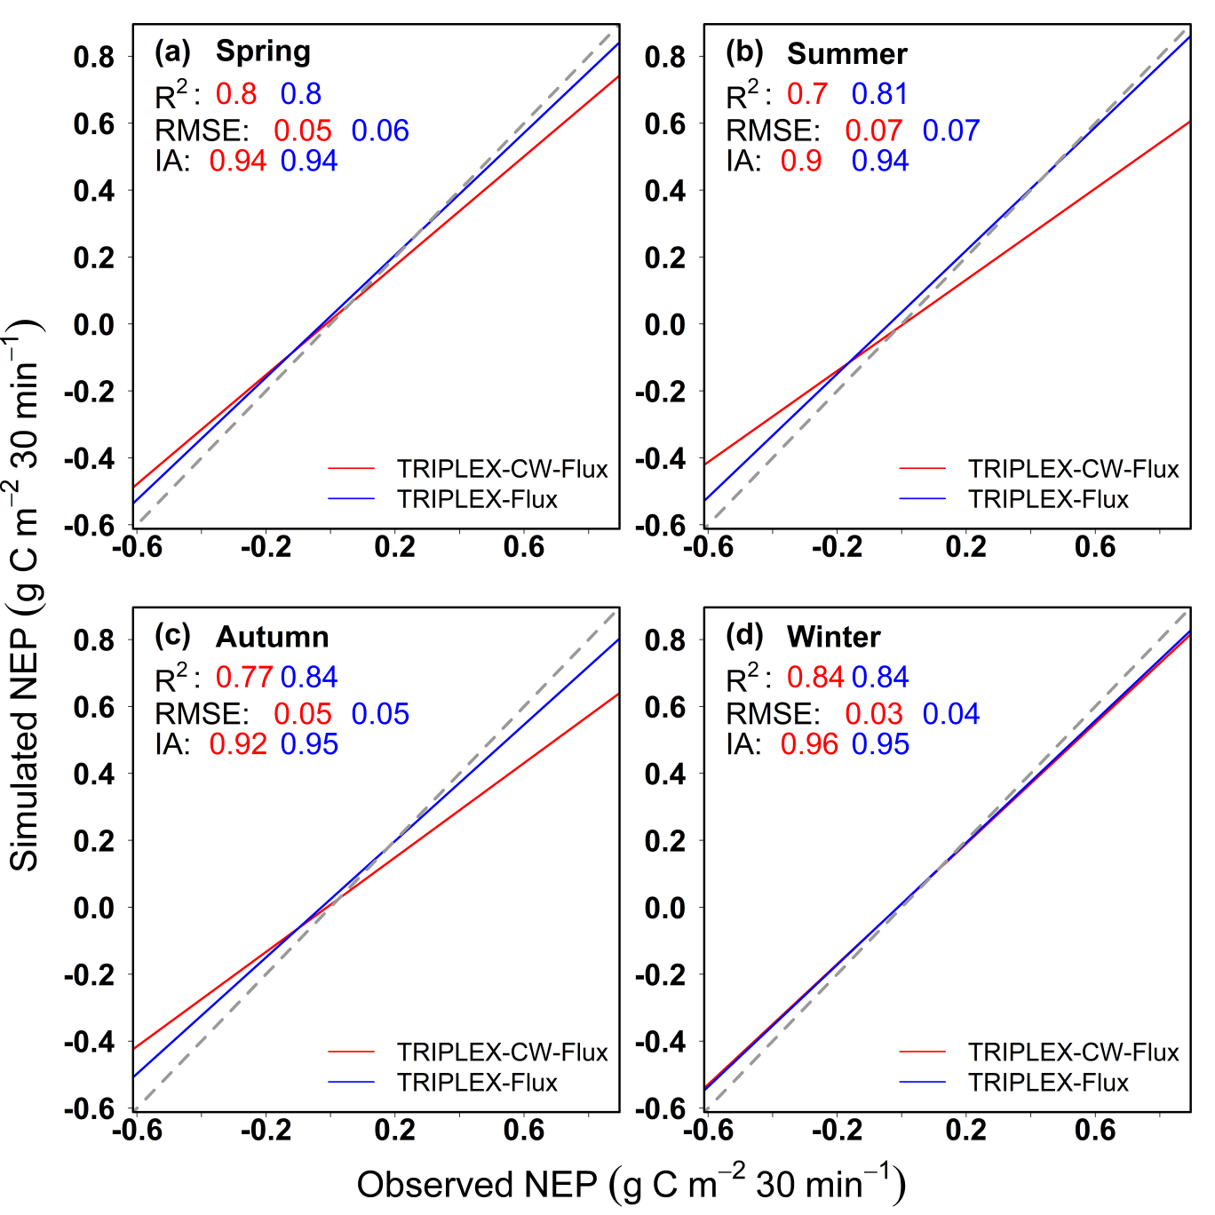

**Figure S7**



**References**

Chen, J.M., Liu, J., Cihlar, J., & Goulden, M.L. (1999). Daily canopy photosynthesis model through temporal and spatial scaling for remote sensing applications. Ecological Modelling, 124(2-3), 99-119.

Dang, Q.L., Margolis, H.A., Coyea, M.R., Sy, M., & Collatz, G.J. (1997). Regulation of branch-level gas exchange of boreal trees: roles of shoot water potential and vapor pressure difference. Tree Physiology, 17(8-9), 521-535.

Goldberg, D., Gornat, B., & Rimon, D. (1976). Drip irrigation: principles, design and agricultural practices. Drip Irrigation Principles Design & Agricultural Practices.

Huang, H., Yang, Y.S., Gao, R., Yang, Z.J., & Wei, G.J. (2009). Relationships between diurnal patterns of soil respiration and soil temperature of *Cunninghamia lanceolata* (Lamb) Hook. and *Phoebe bournei* in Subtropical China, Journal of Fujian Normal University (Natural Science Edition), 25(02):113-118.

Kimball, J.S., Thornton, P.E., White, M.A., & Running, S.W. (1997). Simulating forest productivity and surface–atmosphere carbon exchange in the BOREAS study region. Tree physiology, 17(8-9), 589-599.

Lai, C.T., Katul, G., Oren, R., Ellsworth, D., & Schäfer, K. (2000). Modeling CO2 and water vapor turbulent flux distributions within a forest canopy. Journal of Geophysical Research: Atmospheres, 105(D21), 26333-26351.

Ryan, M.G. (1991). A simple method for estimating gross carbon budgets for vegetation in forest ecosystems. Tree physiology, 9(1-2), 255-266.

Wang, H.L. (2019). Dynamics of nutrient content in different ages of *Cunninghamia lanceolata* Plantation in Huitong, Hunan Province. Master Thesis of Central South University of Forestry and Technology, P.R. China (in Chinese).

Wei, X.C. (2019). Biomass & nutrient accumulation and distribution of Chenshan Red-heart Chinese-fir. Master Thesis of Central South University of Forestry and Technology, P.R. China (in Chinese).

Wu, H.L. (2019). Phosphorus bioavailability mechanism and cycling characteristics in Chinese fir plantations with stand age. PhD Thesis of Central South University of Forestry and Technology, P.R. China (in Chinese).

Wu Q.L., Song, C.H., Song J.L., Wang, J.D., Chen, S.Y., Yang, L., Xiang, W.H., Zhao, Z.H., & Jiang, J. (2021). Effects of leaf age and canopy structure on gross ecosystem production in a subtropical evergreen Chinese fir forest. Agricultural and Forest Meteorology, 310(15):108618.