Adaptive Mobility During Hurricanes Helene and Milton: A Comparative Analysis of Coastal and Inland Populations

Abstract
County-level mobility disruption and recovery dynamics following Hurricanes Helene and Milton in 2024 were examined using high-resolution origin-destination mobility data. We decomposed mobility into within-region, inflow, and outflow components, estimated SARIMAX counterfactual baselines, and quantified recovery time via a Theil-Sen trend-based method. Pooled OLS regression across both hurricanes identified insurance coverage as protective across within-region metrics, predicting smaller drops, faster recovery, and less total disruption. Higher-income counties had greater evacuation outflow but slower within-region recovery, and coastal location was the strongest single predictor of evacuation surge. Hurricane severity explained the largest share of variance in disruption magnitude. Milton-specific analysis of 21 counties yielded no significant socioeconomic effects, with recovery times uniform across income quartiles (4.1–6.2 days). Spatial diagnostics confirmed that outflow clustering reflects evacuation zone geography rather than income gradients. Insurance coverage, more than income or vehicle access, is the most consistent socioeconomic correlate of hurricane mobility resilience.

Introduction
Climate change has profoundly affected human societies, notably through the increased frequency and severity of natural disasters that endanger public health and disrupt economic activity. Hurricanes and other tropical cyclones are among the most harmful of these events, with devastating effects on mortality, infrastructure, and population displacement [1,2]. In the United States alone, tropical cyclones caused over $1.3 trillion in damages between 1980 and 2024, with losses accelerating in recent decades [3]. Understanding how communities respond to and recover from hurricane impacts is essential for effective disaster preparedness and climate adaptation planning.
Human mobility, which is the movement of people through space and time, provides a uniquely sensitive window into community functioning before, during, and after hurricane landfall. The availability of high-resolution mobility data derived from mobile devices has opened new opportunities to study population dynamics during climate-related disasters with unprecedented spatial and temporal detail [4,5]. Prior work has characterized evacuation behaviors [6], pre-landfall mobility surges [7,8], and post-disaster recovery trajectories [9,10] across a range of hurricane events. A growing body of research has examined sociodemographic disparities in these responses: wealthy white residents are more likely to evacuate ahead of hurricanes than low-income, Black, or Hispanic residents [11,12], and transportation infrastructure, particularly vehicle access, further shapes both the decision and ability to leave [13,14]. Beyond individual factors, population density, social connectivity, and prior disaster experience have all been shown to influence adaptive mobility behaviors [15,16].
Despite this progress, most existing studies focus on a single dimension of mobility response- typically evacuation- and on coastal regions with high historical hurricane exposure. The dynamics of post-disaster recovery remain comparatively understudied, as does the question of how socioeconomic factors shape recovery heterogeneity across counties with varying levels of exposure and resources. Furthermore, most studies analyze mobility in aggregate, without distinguishing how different functional activities- work, healthcare, retail, education- are differentially disrupted and recover at different rates. This functional heterogeneity may have direct implications for health outcomes, economic continuity, and the equitable distribution of disaster impacts.
In fall 2024, Hurricanes Helene and Milton struck the southeastern United States within two weeks of each other, together representing one of the most destructive back-to-back hurricane sequences in recent US history. On September 26th, Helene (Category 4 at landfall) made landfall near Perry, Florida before tracking inland, producing historic rainfall and catastrophic flooding across Georgia, South Carolina, North Carolina, Tennessee, and Virginia, resulting in an estimated 219 deaths and $78.7 billion in losses [3]. The storm’s inland trajectory brought it into regions with little historical hurricane exposure, where flood-related fatalities dominated and many counties received Federal Emergency Management Agency (FEMA) Major Disaster Declarations [17]. Two weeks later, on October 9th, Milton (Category 5 at peak intensity, Category 3 at landfall) struck near Siesta Key, Florida, passing through the densely populated and hurricane-experienced central Florida corridor and causing an estimated 32 deaths and $34.3 billion in losses [3]. Together the two storms affected 24.4 million residents across 292 counties within 50 miles of their respective storm tracks [18]. Yao et al. [18] documented that Milton triggered a 29.2% surge in out-region visits and a 29.6% drop in within-region visits on the day of landfall alone, while Helene’s mobility changes were largely within the range of natural variation which is a contrast they attributed to differences in historical hurricane exposure and adaptive capacity between coastal and inland populations. However, that analysis focused on regional-level aggregate mobility and did not examine recovery dynamics, functional category-level disruption, or the county-level socioeconomic predictors of disruption magnitude and recovery speed. These questions are central to understanding how populations respond to hurricanes, which communities are most vulnerable to prolonged disruption, and what structural factors drive that vulnerability.

Results (do numbers ltr)

Mobility pattern changes

Definition of the affected regions, xx population is covered for Helene and Milton respectively. Flow type xx. Mobility categories

Baseline definitions (move some of basics from the discussion)

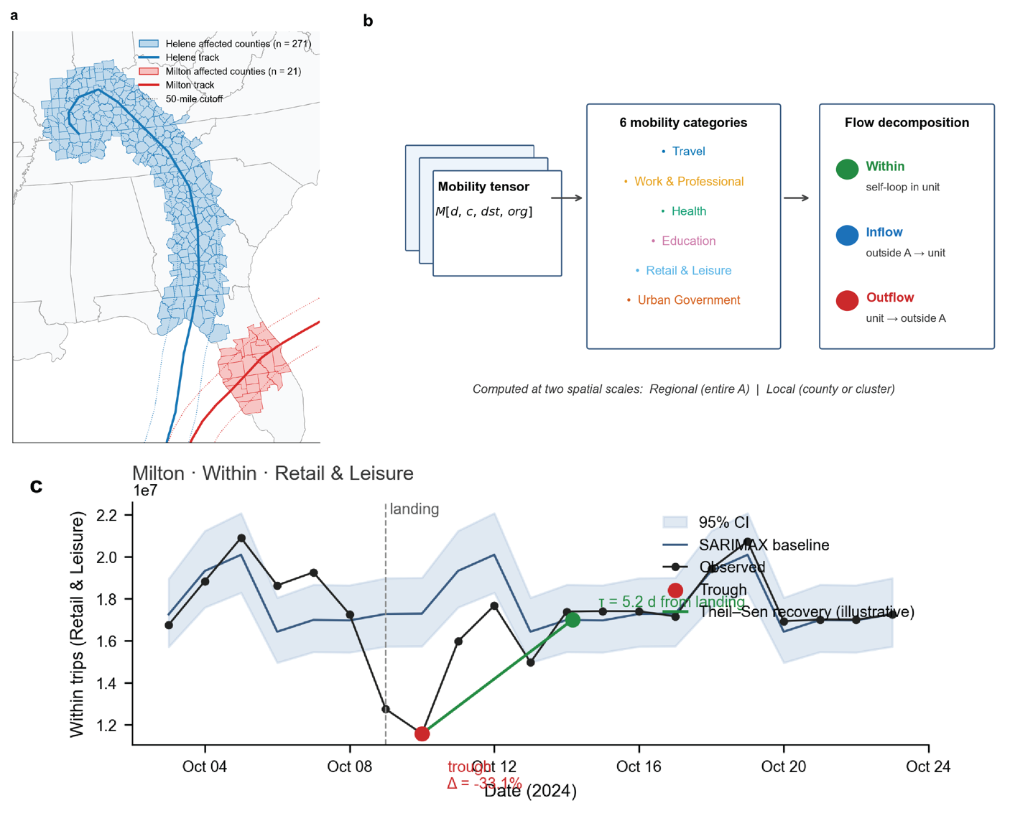

For the mobility volume analysis

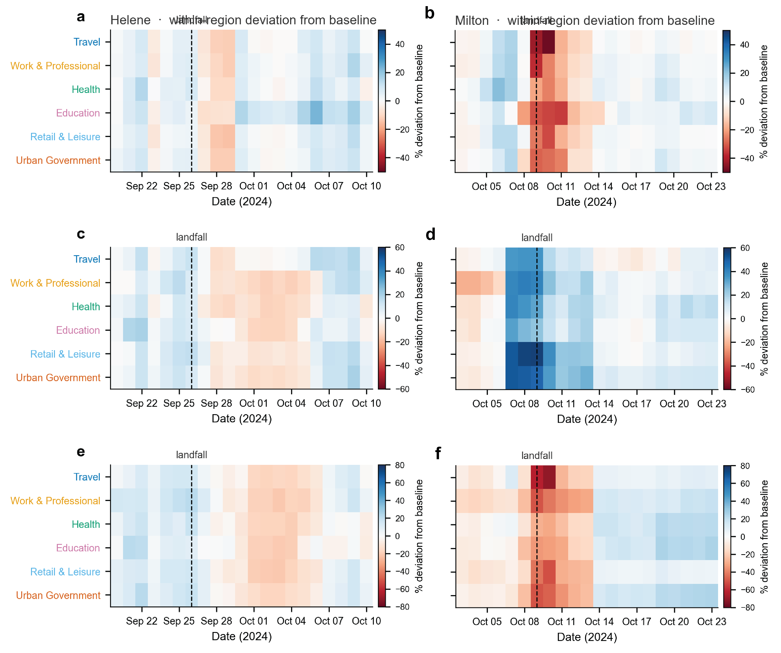

(a) (b) within region, (c) (d) outflow (e) (f) inflow

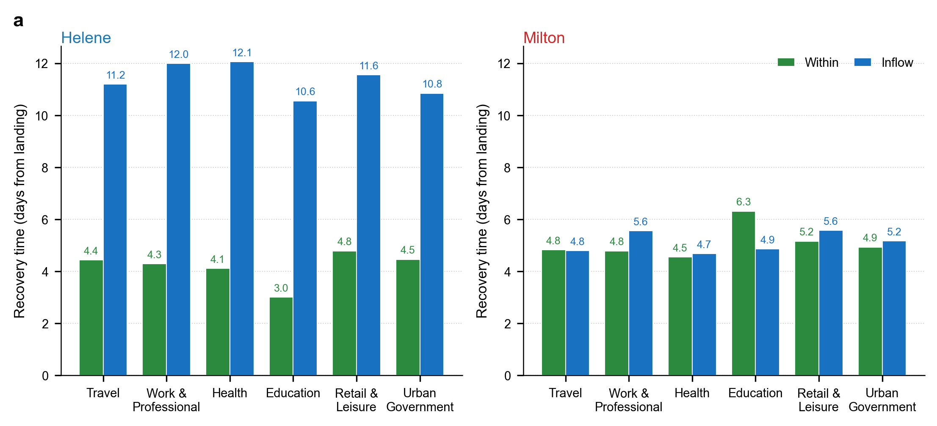

Recovery time analysis

Pooled regression: model fit
Pooled OLS across both hurricanes (N = 292 counties) yielded significant models for the majority of mobility outcomes. Within-region largest drop was the best-fitting model (adj. R2 = 0.728, F p < 0.001), followed by total within-region disruption, defined as the product of recovery time and absolute drop (adj. R2 = 0.523, F p < 0.001). Models for inflow largest drop (adj. R2 = 0.388, F p < 0.001) and outflow surge (adj. R2 = 0.341, F p < 0.001) also reached significance. Recovery time models were weaker: adj. R2 = 0.148 (p = 0.056) for within-region recovery and 0.192 (p = 0.036) for inflow recovery. The total inflow disruption model did not reach significance (adj. R2 = 0.098, p = 0.156).
The hurricane indicator (is Milton) was the strongest predictor in every significant model. Controlling for all other covariates, Milton-affected counties had within-region drops 17.3 percentage points larger than Helene-affected counties (p < 0.001), total within-region disruption scores 107 units higher (p < 0.001), and inflow drops 15.4 percentage points larger (p = 0.009), reflecting both Milton’s greater intensity at landfall and the higher pre-landfall mobility response of coastal Florida populations.

Socioeconomic predictors of disruption and recovery
Health insurance coverage was the most consistent socioeconomic predictor across all within-region outcomes. Counties with higher insurance coverage had smaller within-region drops (coefficient = +1.98, p = 0.044), faster within-region recovery (coefficient = −0.68, p = 0.016), and lower total within-region disruption (coefficient = −28.4, p = 0.002). The consistency of this effect across three distinct metrics suggests that insurance coverage captures a broader dimension of community resilience rather than acting through a single pathway, plausibly reflecting access to healthcare, financial buffers, and housing stability that collectively facilitate faster return to normal functioning.
Median household income showed a more differentiated pattern depending on flow type. Higher-income counties had significantly larger outflow surges (coefficient = +17.4, p = 0.002), consistent with greater access to transportation and financial resources enabling evacuation ahead of landfall. At the same time, higher income predicted slower within-region recovery (coefficient = +0.90, p = 0.017), suggesting that counties that evacuated more heavily also took longer to return to baseline mobility, as displaced residents remained away for longer. Income also approached significance as a predictor of inflow drop (coefficient = −4.25, p = 0.083), with higher-income counties losing more inflow post-landfall, consistent with a larger evacuated population generating fewer local visits upon return.
Coastal location was the strongest single predictor of evacuation behavior, independently adding 38.8 percentage points to outflow surge (p < 0.001) after controlling for income, insurance coverage, and distance to track. This effect reflects direct storm surge exposure, established evacuation zone infrastructure in coastal Florida, and greater familiarity with evacuation procedures among coastal populations. Vehicle access and total population did not reach significance in any model.
The proportion of white residents was associated with slower inflow recovery (coefficient = +4.4, p = 0.015) and greater total inflow disruption (coefficient = +116, p = 0.020). These counties tend to be more rural and less densely connected, and the findings are consistent with reduced access to external support networks and lower volumes of incoming aid-related mobility in the post-landfall period.
Distance to the hurricane track produced a counterintuitive result across within-region outcomes: counties farther from the track experienced larger drops (coefficient = −1.84, p = 0.039), slower recovery (coefficient = +0.51, p = 0.044), and greater total disruption (coefficient = +22.9, p = 0.005), while showing less outflow surge (coefficient = −7.1, p = 0.052). The reduced outflow for more distant counties is expected, as mandatory evacuation orders concentrate near the track. The greater within-region disruption at distance, however, is attributable to the composition of the Helene-affected region: inland Appalachian counties in North Carolina and Tennessee experienced catastrophic flooding and landslides despite lying far from the wind track, making geodesic distance to the storm track a poor proxy for actual physical impact in this sample.

Milton county-level analysis
No OLS model for Milton’s 21 counties reached statistical significance across any dependent variable or predictor combination. Adjusted R2 values were near zero or negative for within-region largest drop (adj. R2 = −0.198, F p = 0.948), recovery time (adj. R2= 0.136, F p = 0.180), and outflow surge (adj. R2 = −0.114, F p = 0.745). This null result held across all specifications tested, including models with distance to track, interaction terms, and subsets excluding outlier counties.
An apparent significant association between insurance coverage and recovery time in the full sample (p = 0.032) was entirely driven by Okeechobee County, which had the longest recovery at 6.2 days against a sample mean of 4.8 days. Removing Okeechobee reduced the insurance effect to non-significance (p = 0.599). After residualizing all outcomes against distance to track, partial correlations between income and each dependent variable remained near zero and non-significant (partial r ranging from −0.043 to +0.255, all p > 0.27). Kruskal-Wallis tests across income quartiles, both raw and distance-adjusted, were non-significant for all outcomes (all p > 0.40). These results confirm that neither the income-distance correlation in the sample (Spearman ρ = −0.295, p = 0.19) nor any other spatial confound accounts for the null findings.
Within-region recovery time was notably uniform across Milton’s 21 counties, ranging from 4.1 to 6.2 days, with median recovery nearly identical across income quartiles (4.77 to 4.84 days). Disruption magnitude and recovery speed were decoupled: Charlotte County had the largest drop at −47% but recovered in 4.5 days, while Okeechobee had a more moderate drop of −36% but the slowest recovery at 6.2 days. This uniformity likely reflects Milton’s well-forecast track enabling consistent preparedness across the region regardless of income, together with the relatively strong emergency management infrastructure across the affected Florida counties. Formal inference is reserved for the pooled analysis; Milton findings are presented as descriptive given the sample size.

Milton spatial diagnostics
Moran’s, I tests on OLS residuals identified spatial autocorrelation for two of the four outcomes. Outflow surge showed strong clustering under both Queen contiguity (Moran’s I = 0.327, p = 0.006) and k-nearest-neighbor weights (Moran’s I = 0.408, p = 0.0004). This clustering reflects the geography of Florida’s evacuation zones rather than any socioeconomic gradient. Within-region, the largest drop showed weaker but significant clustering under Queen weights only (Moran’s I = 0.223, p = 0.046), concentrated among the coastal counties most directly exposed to landfall near Siesta Key. Recovery time showed no spatial autocorrelation under either weight matrix (Queen: Moran’s I = 0.005, p = 0.691; KNN: Moran’s I = 0.015, p = 0.617), consistent with its near-uniform distribution across counties.
Residuals were not significantly correlated with distance to track for any outcome (all p > 0.20), indicating that the spatial clustering in outflow and largest drop is neighborhood-based rather than a gradient from the storm track. These diagnostics confirm that the null socioeconomic findings for Milton are not an artifact of spatial confounding, and that the spatial structure present in evacuation behavior is better explained by evacuation zone geography than by county-level socioeconomic characteristics.

Discussion
This study extends Yao et al. (2025) by introducing a quantitative framework for measuring mobility disruption and recovery across Hurricanes Helene and Milton and by examining the county-level socioeconomic factors that shape those outcomes. Using a SARIMAX-based counterfactual, Theil-Sen trend-based recovery estimation, and distance-band spatial aggregation, we produced disruption and recovery metrics that go beyond single-week comparisons to capture the full temporal arc of each hurricane’s impact. Pooled regression across 292 affected counties identified several consistent predictors, while Milton-specific spatial diagnostics characterized the limits of inference at small sample sizes.
Health insurance coverage was the most consistent socioeconomic predictor across the pooled sample. Counties with higher insurance coverage had smaller within-region drops, faster recovery, and less total disruption, and this held after controlling for income, distance to track, and coastal status. Health insurance may therefore serve as a useful population-level indicator of community capacity to recover from extreme weather rather than simply being a proxy for wealth. Income showed a different pattern: higher-income counties evacuated more heavily before landfall but also took longer to return to baseline mobility afterward. Evacuation capacity and recovery speed are thus distinct dimensions of disaster response that do not move together, and policies targeting recovery should not assume that the ability to evacuate implies broader resilience. The finding that counties farther from the hurricane track had greater within-region disruption is primarily a reflection of the Helene-affected inland Appalachian counties, where flooding and landslide damage was severe despite distance from the wind track. This points to a limitation of track-distance as an exposure measure for events where inland flooding is the primary hazard.
The spatial diagnostics for Milton confirm that its null socioeconomic findings are not a result of spatial confounding. The clustering observed in outflow surge and within-region drop reflects evacuation zone geography, and recovery time showed no spatial autocorrelation. The near-uniform recovery times across Milton’s counties regardless of income quartile suggest that for a well-forecast hurricane striking a prepared coastal population, the acute disruption phase may not vary meaningfully with socioeconomic characteristics within the affected region. There are several limitations to note. The mobility data may underrepresent lower-income populations with lower mobile device penetration, the cross-sectional design does not support causal inference, and the analysis covers only the acute recovery period through October 2024. The GWR analysis for Helene, which will allow spatially varying coefficient estimates across 271 counties, is ongoing and will provide a more detailed account of how socioeconomic effects on disruption and recovery differ across the affected region.
These findings build on the published analysis by identifying specific socioeconomic characteristics that predict the depth and duration of mobility disruption. Insurance coverage and income are associated with evacuation and recovery in different and sometimes opposing ways, coastal geography shapes evacuation behavior independently of socioeconomic status, and the spatial structure of disruption reflects evacuation zone policy as much as the physical footprint of the storm. Targeting preparedness resources toward communities with low insurance coverage may improve recovery outcomes more effectively than targeting by income alone, and planners should account for the possibility that higher-income communities evacuate readily but do not necessarily recover faster.

Methods
We extend the analysis of Yao et al. (2025), which used 3.56 billion foot-traffic records from mobile devices to examine within-region and out-region mobility during Hurricanes Helene and Milton, comparing changes against a single reference week. Here, we introduce a SARIMAX-based counterfactual, a finer decomposition of flow types, quantitative disruption and recovery metrics, distance-band spatial aggregation, and regression analysis linking mobility outcomes to county-level socioeconomic characteristics. The affected regions are defined identically: counties whose geographic centroids fall within 50 miles of each storm’s IBTrACS track, yielding 271 counties for Helene and 21 for Milton.

Counterfactual baseline
Rather than comparing observed mobility to a fixed reference week, we fit a SARIMAX model to construct a dynamic counterfactual for each flow series. The model is an AR(1) specification with exogenous dummy variables for day of week, calendar month, and year, trained on data from July to October 2023 and July 2024 through seven days before each hurricane’s landfall. Mobility is log-transformed prior to fitting, y_{t} = log(1 + M_{t}), and predictions are back-transformed as M̂_{t} = exp(ŷ_{t}) − 1, where M_{t} is the observed daily visit count for a given flow series on day t and M̂_{t} is the model-predicted value representing expected mobility absent any hurricane disruption. The 2023 training window captures seasonal patterns in a year without hurricane impacts; the 2024 window captures any year-over-year trends up to the pre-landfall period.

2.2 Disruption metrics
For within-region and inflow series, disruption is quantified as the largest relative drop from the counterfactual baseline within the landing week [t_{L}, t_{L} + 6], where t_{L} is the landfall date:
Δ_{min} = min_{t} ∈ [t_{L}, t_{L} + 6] (M_{t} − M̂_{t}) / M̂_{t} × 100
For outflow, the evacuation surge is the largest positive deviation above baseline in the window [t_{L} − 3, t_{L} + 6]:
Δ_{max} = max_{t} ∈ [t_{L} − 3, t_{L} + 6] (M_{t} − M̂_{t}) / M̂_{t} × 100
The three-day pre-landfall window reflects the typical lead time for mandatory evacuation orders.

2.3 Disruption metrics
Recovery time τ is the number of days from landfall until mobility returns to the counterfactual baseline. For each series, we first compute the relative deviation rd_{t} = (M_{t} − M̂_{t}) / M̂_{t} and smooth it with a centred 3-day moving average. The trough t_{trough} is identified as the most negative smoothed value within 7 days of landfall. From there, we extract the monotonic recovery segment by retaining the initial non-decreasing run forward from the trough, and fit a Theil-Sen median slope r̂d(t) = α + βt on that segment. Recovery time is then:
τ = (t_{trough} − t_{L}) + (−α / β)
where the first term is the days from landfall to the trough and −α/β is the projected days from the trough to the zero-crossing of the fitted line, i.e., when mobility is estimated to return to baseline. Theil-Sen is used in place of OLS because it is resistant to outliers in the post-trough window, which can be noisy for low-volume series.

2.4 Distance band aggregation
County-level SARIMAX baselines are unreliable for rural and low-population counties with sparse mobility volumes. To address this, we aggregate counties into three concentric bands based on minimum geodesic distance from each county centroid to the hurricane track: 0 to 10 miles (direct track corridor), 10 to 25 miles (near-track), and 25 to 50 miles (peripheral). Within-region flow is summed across all counties in each band before baseline fitting and metric computation, yielding one time series per band per mobility category. This produces a spatial gradient of disruption and recovery with respect to storm track proximity while maintaining a stable enough time series for reliable SARIMAX estimation.

2.5 Distance band aggregation
To examine socioeconomic predictors of disruption and recovery, we fit pooled OLS regressions across both hurricanes with a hurricane indicator (isMilton = 1 for Milton-affected counties). County-level predictors were drawn from the American Community Survey 2022 five-year estimates: total population (B01003), median household income (B19013), percent of households without a vehicle (B08201), and percent of residents with health insurance coverage (B27010). Additional covariates were a coastal indicator (county centroid within 50 miles of the US coastline) and minimum distance to the hurricane track d_{i}. Dependent variables were Δ_{min} and τ for within-region and inflow series, and Δ_{max} for outflow. Predictors were standardized before entry. Model diagnostics included variance inflation factors, the Breusch-Pagan test for heteroscedasticity, and the Shapiro-Wilk test for residual normality.
For Milton (N = 21), the sample is too small for reliable inference. We ran spatial diagnostics to characterize the data prior to modelling: LOWESS scatter plots colored by d_{i} to assess nonlinearity; Moran’s I on OLS residuals under Queen contiguity and k-nearest-neighbor (k = 4) weights to test for spatial autocorrelation; and Spearman rank correlation between residuals and d_{i} to determine whether proximity to the track is a missing predictor. These diagnostics jointly inform model selection: non-spatial nonlinearity points toward a GAM, spatially structured residuals toward a distance-interaction or spatial error model. Milton findings are presented descriptively.
For Helene (N = 271), we apply geographically weighted regression (GWR), which estimates a separate coefficient vector for each county i by kernel-weighted least squares:
β̂(u_{i}, v_{i}) = (X^{T} W_{i} X)⁻¹ X^{T} W_{i} y
where (u_{i}, v_{i}) are the spatial coordinates of county i and W_{i} is a diagonal matrix of spatial weights. Rather than the standard inter-centroid Euclidean kernel, we weight by distance to the hurricane track: w_{ij} = K(d_{j} / h), where d_{j} is the minimum geodesic distance from county j to the track, h is the bandwidth, and K(·) is a bisquare kernel. This aligns the weighting scheme with the physical gradient of hurricane impact rather than arbitrary geographic proximity between counties. The bandwidth h is selected by minimizing AIC_{c}.

Acknowledgements
- Talk later, data provider, etc.

Reorganize the GitHub code, some things are unnecessary
- Use my GitHub and organize something and make it more consistent
  - Get rid of a lot of unnecessary things
  - Make it public
  - Revise on my github later on after we organize in this current github

