数据仓库物理模型

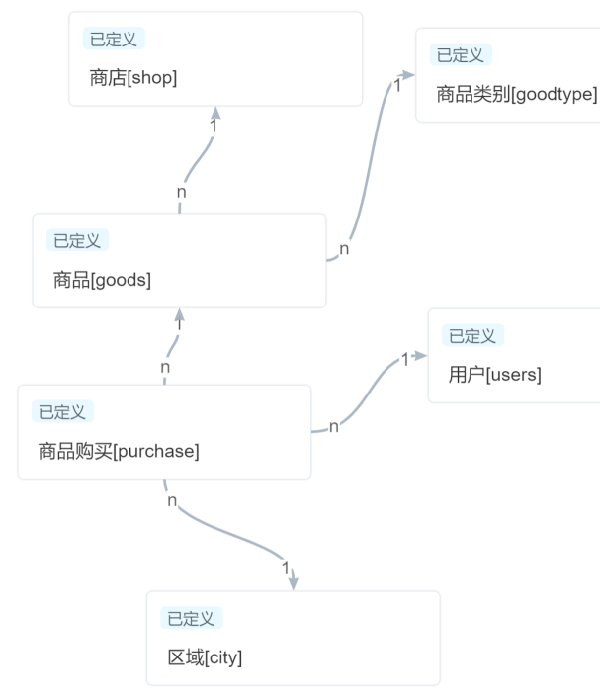

DWDM物理模型

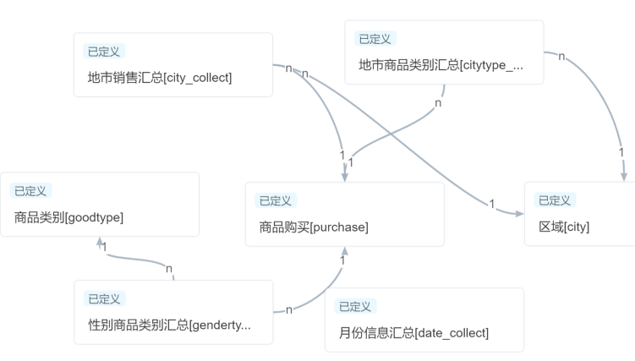

根据月份查看销售数量和新注册数量

select a.month as month, COALESCE(price,0) as turnover,COALESCE(nums,0) from  
((select sum(cast(price as decimal))as price,purchase_date as month from  
homework.purchase group by month)a  
left join  
(select count(*) as nums,register_date as month from homework.users group by  
month)b on a.month=b.month)  
union  
select b.month as month,COALESCE(price,0) as turnover,COALESCE(nums,0) from  
((select sum(cast(price as decimal))as price,purchase_date as month from  
homework.purchase group by month)a  
right join  
(select count(*) as nums,register_date as month from homework.users group by  
month)b on a.month=b.month)

按月份查看收货地址销售数量

select sum(cast(price as decimal))as turnover,address_name as address,purchase_date as  
month from(  
homework.purchase a left join homework.address b on a.receive_address=b.address_code  
)group by month,b.address_name

根据月份查看地址和商品类别的销售数量

select sum(cast(a.price as decimal))as turnover,address_name as address,good_name as  
goods,purchase_date as month from(  
homework.purchase a left join homework.address b on a.receive_address=b.address_code left join  
homework.goods c on a.good_id=c.good_id  
)group by month,b.address_name,goods

正则表达式对邮箱，年龄，手机号码检查

