**12.25悬索桥模型多点分布式监测实验**

赵庆安

一.仪器布置

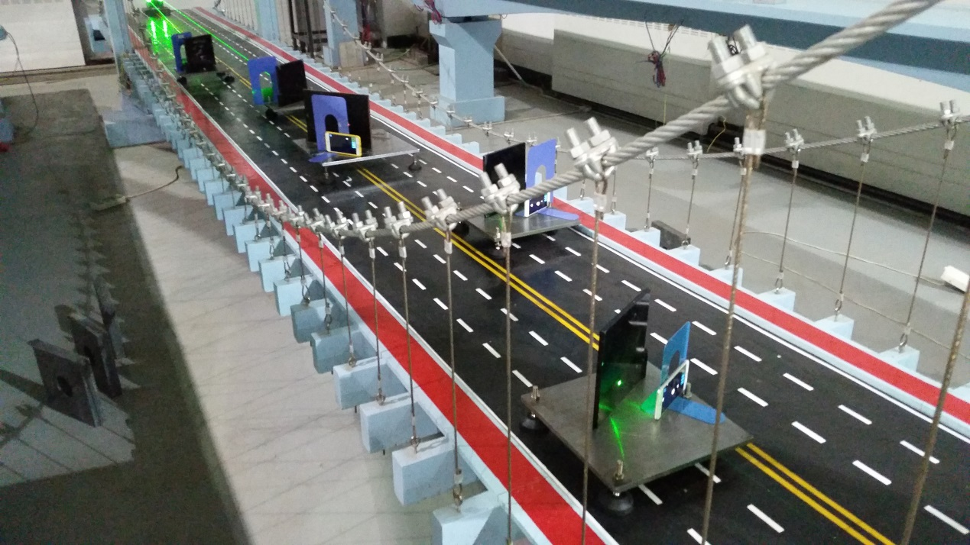

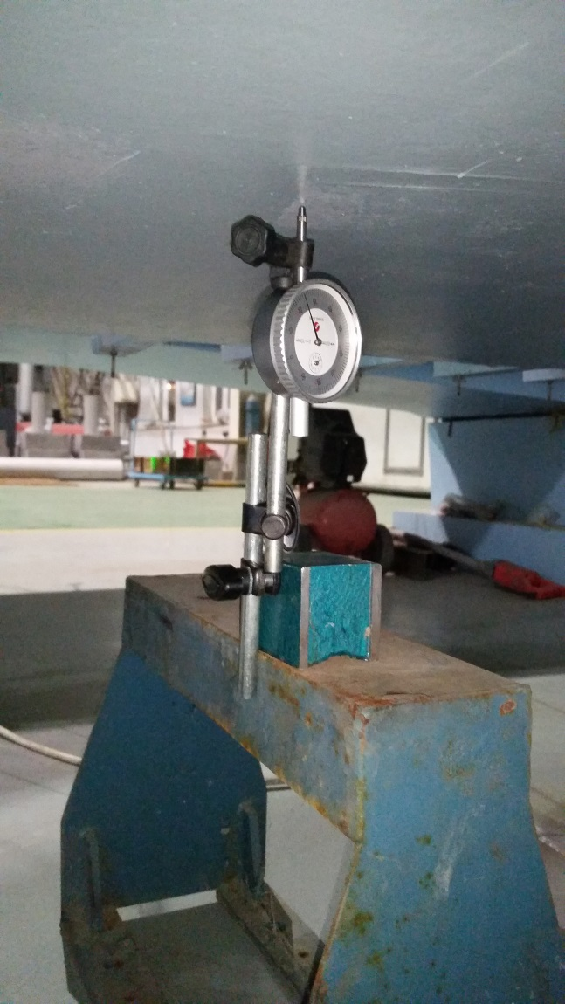

**测点（1~5）：两测点间距107m；1,5分别距桥墩轴线143cm；桥面上架设手机桥下假设百分表。**

**激光（4,5）**

**激光（1~3）**

**1**

**2**

**3**

**4**

**5**

二.加载方式

采用17.8kg砝码在悬索桥模型跨中处（3号测点）分级加载，每次加载为桥面轴线方向两侧各加一块，流程为加载-加载-卸载-卸载。

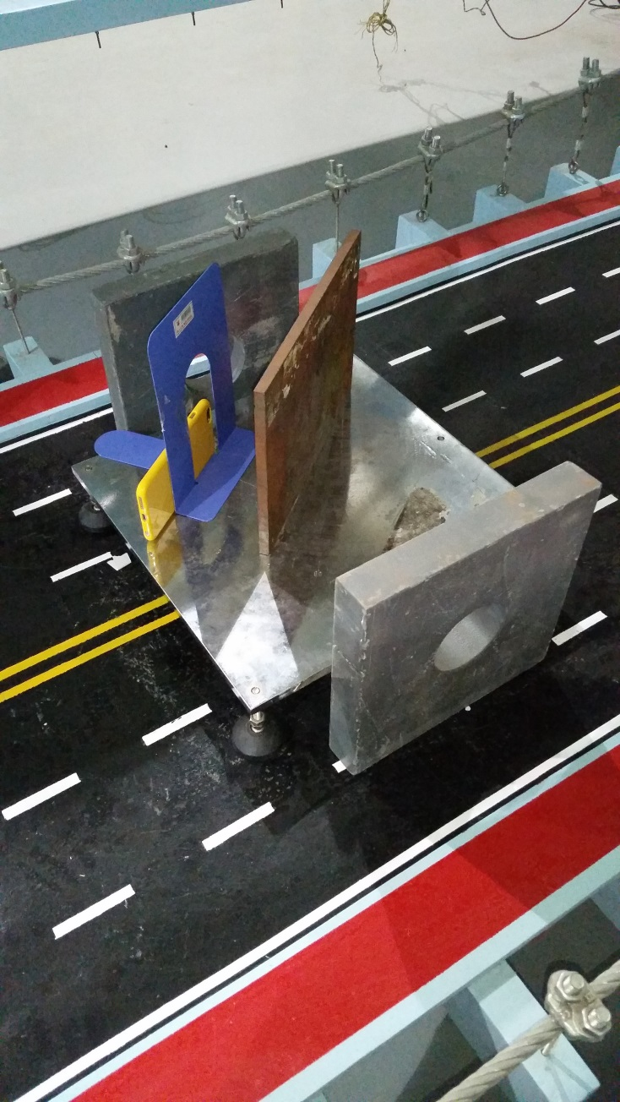

三.实验结果

第一次

测点1

|  |  |  |  |  |  |
| --- | --- | --- | --- | --- | --- |
| 状态 | 加载前 | 加载 | 加载 | 卸载 | 卸载 |
| 手机平均度数(mm) | 0 | 0.237 | 0.396 | 0.259 | 0.010 |
| 百分表度数(mm) | 0 | 0.232 | 0.380 | 0.250 | 0.010 |
| 相对误差(%) | - | 2.16 | 4.21 | 3.60 | 0 |

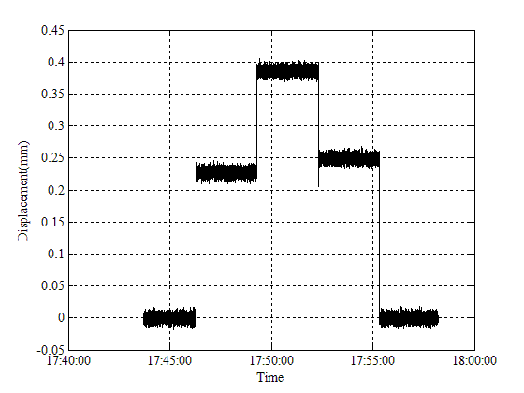

测点2

|  |  |  |  |  |  |
| --- | --- | --- | --- | --- | --- |
| 状态 | 加载前 | 加载 | 加载 | 卸载 | 卸载 |
| 手机平均度数(mm) | 0 | 0.536 | 1.070 | 0.596 | 0.046 |
| 百分表度数(mm) | 0 | 0.515 | 1.040 | 0.580 | 0.045 |
| 相对误差(%) | - | 4.08 | 2.88 | 2.76 | 2.22 |

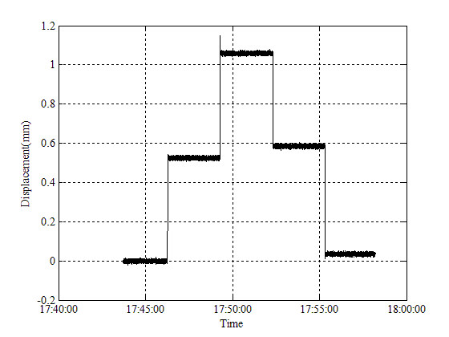

测点3

|  |  |  |  |  |  |
| --- | --- | --- | --- | --- | --- |
| 状态 | 加载前 | 加载 | 加载 | 卸载 | 卸载 |
| 手机平均度数(mm) | 0 | 0.739 | 1.486 | 0.850 | 0.069 |
| 百分表度数(mm) | 0 | 0.715 | 1.440 | 0.815 | 0.065 |
| 相对误差(%) | - | 3.36 | 3.28 | 4.29 | 6.15 |

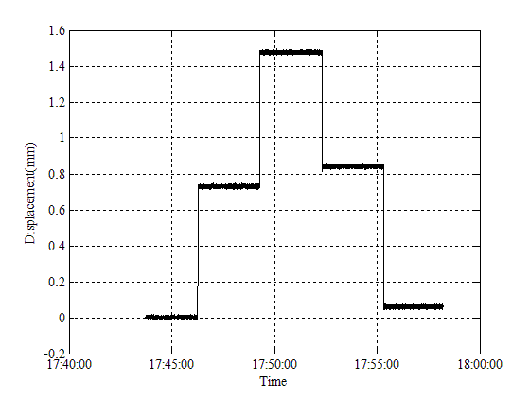

测点4

|  |  |  |  |  |  |
| --- | --- | --- | --- | --- | --- |
| 状态 | 加载前 | 加载 | 加载 | 卸载 | 卸载 |
| 手机平均度数(mm) | 0 | 0.506 | 1.026 | 0.578 | 0.057 |
| 百分表度数(mm) | 0 | 0.500 | 1.010 | 0.560 | 0.055 |
| 相对误差(%) | - | 1.20 | 1.58 | 3.21 | 3.63 |

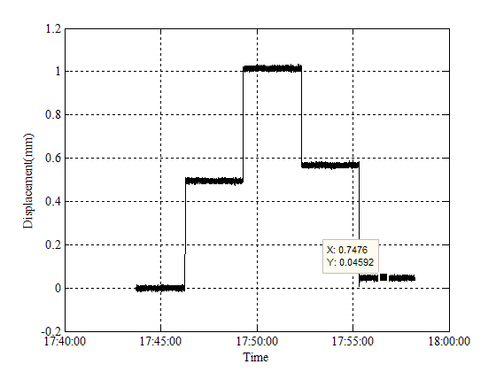

测点5

|  |  |  |  |  |  |
| --- | --- | --- | --- | --- | --- |
| 状态 | 加载前 | 加载 | 加载 | 卸载 | 卸载 |
| 手机平均度数(mm) | 0 | 0.229 | 0.455 | 0.244 | 0.031 |
| 百分表度数(mm) | 0 | 0.220 | 0.440 | 0.240 | 0.030 |
| 相对误差(%) | - | 4.09 | 3.41 | 1.67 | 3.33 |

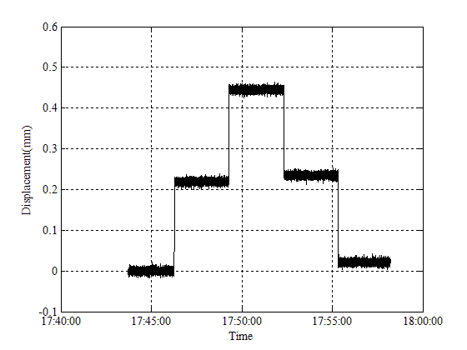

合并图像

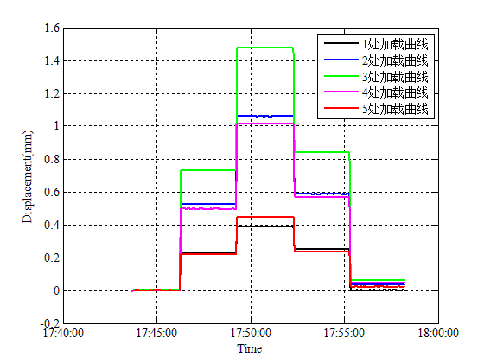

第二次

测点1

|  |  |  |  |  |  |
| --- | --- | --- | --- | --- | --- |
| 状态 | 加载前 | 加载 | 加载 | 卸载 | 卸载 |
| 手机平均度数(mm) | 0 | 0.241 | 0.447 | 0.259 | 0.005 |
| 百分表度数(mm) | 0 | 0.230 | 0.430 | 0.250 | 0.005 |
| 相对误差(%) | - | 4.78 | 3.95 | 3.60 | 0 |

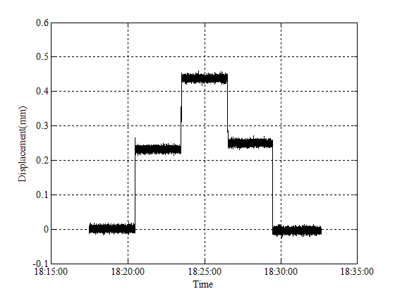

测点2

|  |  |  |  |  |  |
| --- | --- | --- | --- | --- | --- |
| 状态 | 加载前 | 加载 | 加载 | 卸载 | 卸载 |
| 手机平均度数(mm) | 0 | 0.542 | 1.084 | 0.593 | 0.054 |
| 百分表度数(mm) | 0 | 0.525 | 1.050 | 0.585 | 0.050 |
| 相对误差(%) | - | 3.24 | 3.24 | 1.37 | 8.00 |

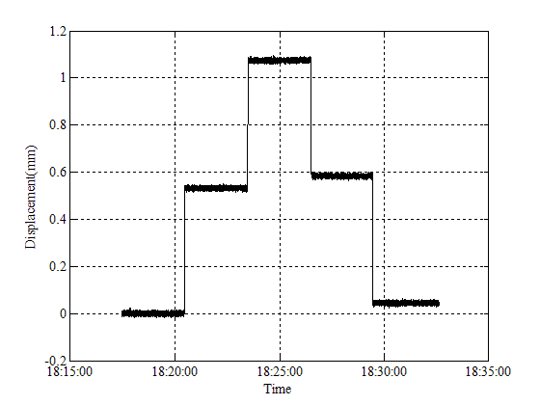

测点3

|  |  |  |  |  |  |
| --- | --- | --- | --- | --- | --- |
| 状态 | 加载前 | 加载 | 加载 | 卸载 | 卸载 |
| 手机平均度数(mm) | 0 | 0.744 | 1.469 | 0.826 | 0.063 |
| 百分表度数(mm) | 0 | 0.720 | 1.450 | 0.800 | 0.060 |
| 相对误差(%) | - | 3.33 | 1.31 | 3.25 | 5.00 |

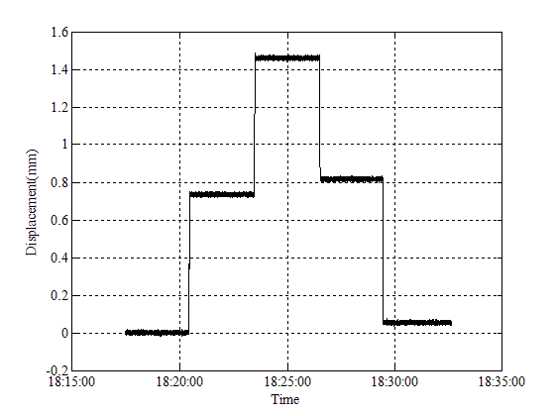

测点4

|  |  |  |  |  |  |
| --- | --- | --- | --- | --- | --- |
| 状态 | 加载前 | 加载 | 加载 | 卸载 | 卸载 |
| 手机平均度数(mm) | 0 | 0.503 | 1.037 | 0.562 | 0.048 |
| 百分表度数(mm) | 0 | 0.490 | 1.000 | 0.545 | 0.045 |
| 相对误差(%) | - | 2.65 | 3.70 | 3.12 | 6.67 |

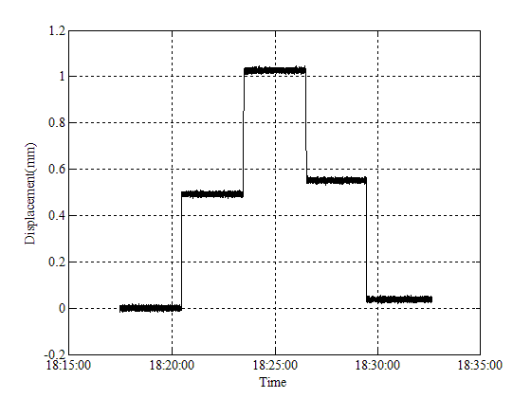

测点5

|  |  |  |  |  |  |
| --- | --- | --- | --- | --- | --- |
| 状态 | 加载前 | 加载 | 加载 | 卸载 | 卸载 |
| 手机平均度数(mm) | 0 | 0.208 | 0.429 | 0.230 | 0.010 |
| 百分表度数(mm) | 0 | 0.205 | 0.420 | 0.220 | 0.010 |
| 相对误差(%) | - | 1.46 | 2.14 | 4.55 | 0 |

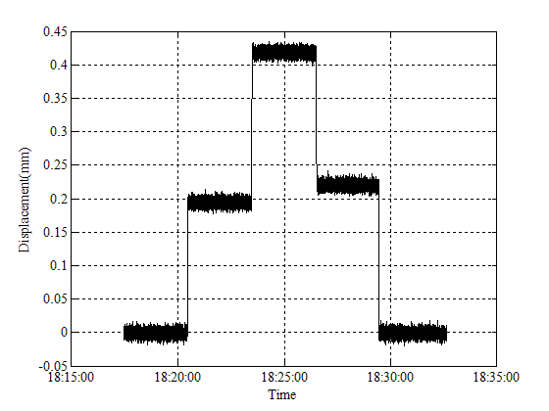

合并图像

