Surgical Innovation

Individual Write-Up

By Qingbo Kang (kangqingbokb@gmail.com)

# What I have learned so far

Innovation refers to the existing thinking mode is different from the conventional or ordinary people's ideas for the guidance of the use of existing knowledge and material in an environment, in the ideal needs or to meet the needs of the community, and improve or create new things, methods, elements, paths, the environment, and get a certain beneficial behavior.

As a computer science student, and worked in the industry for 5 years as a software development engineer, I had little knowledge of the medical field, through this period of surgical innovation course learning, I gradually realized the importance of innovation in the medical field, and cross-cutting cooperation in the medical field. Cross-cutting cooperation refers to people who learn different subjects and have different background come together and work together in the form of teamwork to solve problems, the advantage of this cooperation is that everyone from a different point of view to look at the same problem and try to solve the problem. The most ideal team work is to complement each team according to their strengths and weaknesses, which is conducive to teamwork, and helps to solve problems and achieve innovation.

Specific to the field of medical innovation, medical students may not be particularly aware of the engineering or commercial parts, vice versa. Everyone may be experts in their field, but the problem in surgery field more often is not a purely surgical problem, sometimes maybe engineering related, when the results of innovation began to market, without exception, will encounter business problems. In my own case, I used to work in the company and responsible for the Research & Development department, more specifically, I was in charge of the research and development of computer algorithms, but a complete software project can not only contain technical problems, more is related to the filed which your software is trying to solve, when it comes to business section, the methods of selling our products, intellectual property and other issues, so cross-cutting cooperation is very important. In addition, students with different backgrounds and different disciplines come to the surgical field, when they encounter with one problem, they may have different views and discoveries compare to the medical students, that is, some medical students are not aware whereas the other areas of people may be aware of, so this can bring more opportunities for innovation.

Another point which I was impressed is that if we need to solve a specific problem, we must go to the front line to investigate, sort out the demand, the so-called no investigation there is no right to speak. Specific to the field of surgical innovation, as the teacher said in the classroom, the ideal situation is to live directly to the hospital, all the time to observe the work of doctors and nurses, observe the patient's condition, observe the process of surgery, observe everything, everyone. So that more detailed needs can be found. In the field of software engineering, requirement analysis is also a crucial step in the software life cycle. The goal of the requirement analysis is to analyze and collate the user's "request" or "need" of the software, confirm the formation of a document that describes the integrity, clarity and specification, and determine what functions the software needs to do and what to do. This part is pretty similar to the first part of the course.

# What areas I am interested in

Although the hospital visit did not give me a chance to specifically understand more about medical images, but due to my previous work experience (image processing algorithm) and my current research areas (image processing and pattern recognition) to make me have a great interest to medical image processing. Since the X-ray application in medical diagnosis, UI, CT, MRI, CR, PET, MI and other medical imaging equipment has been emerged, making the traditional medical diagnosis has undergone a revolutionary change. The technology of computerized image processing of medical image equipment is called medical image processing and analysis technology. With the development of modern computer science and technology, medical image processing and analysis are paid more and more attention, and has been widely used in clinical, assisted doctors to clear and accurate diagnosis and differential diagnosis. For medical image processing and analysis, the algorithm is the source of its development. Nowadays, because of the rapid development of machine learning, especially deep learning, how to use the available mass medical image data to update and make a development of our existing algorithm is a particularly interesting direction for me.

Through the hospital visit, may be my previous working experience or my research interests, I am much interested in the medical informatization side. I noticed that at MUCH, current patient can only make a phone call or face to face to make an appointment of doctor, I personally feel very inconvenient and inefficient. With the popularity of the Internet and smart phones, I think more people will tend to make an online appointment or use an APP in smartphone to make an appointment, which will save more time and are more friendly ways for the patient. I come from China and in China's big cities, basically you can make an appointment through the Internet and mobile APP (WeChat, Alipay or the APP developed by hospital), pay fees, etc., it’s very convenient. At the same time, for the older or who are less exposed to the Internet or smart phones, there will be some automatic appointment machine at the hospital, you can just insert the chip card can choose doctors to make an appointment. But at MUCH, it seems I do not see something like that.

In conclusion, due to my own background and interests, I am more interested in the field of medical image processing and analysis, and also the field of hospital or medical informatization.

# General needs/ideas I have identified

1. Appointment via online or smartphone APP.
2. A way to recognize the handwritten prescription by doctors (much similar to OCR).
3. An automatic delivery system that can deliver cleaned materials to the destination area or case cart.
4. Some unsolved problem in medical image processing field.

# Photos of my observation notebook

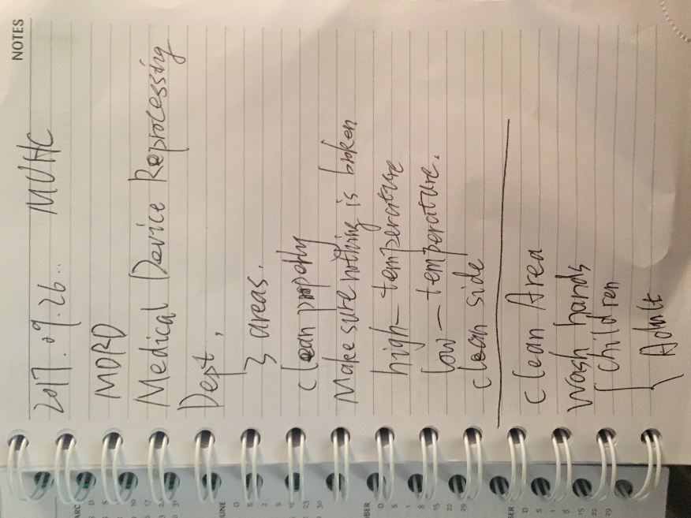

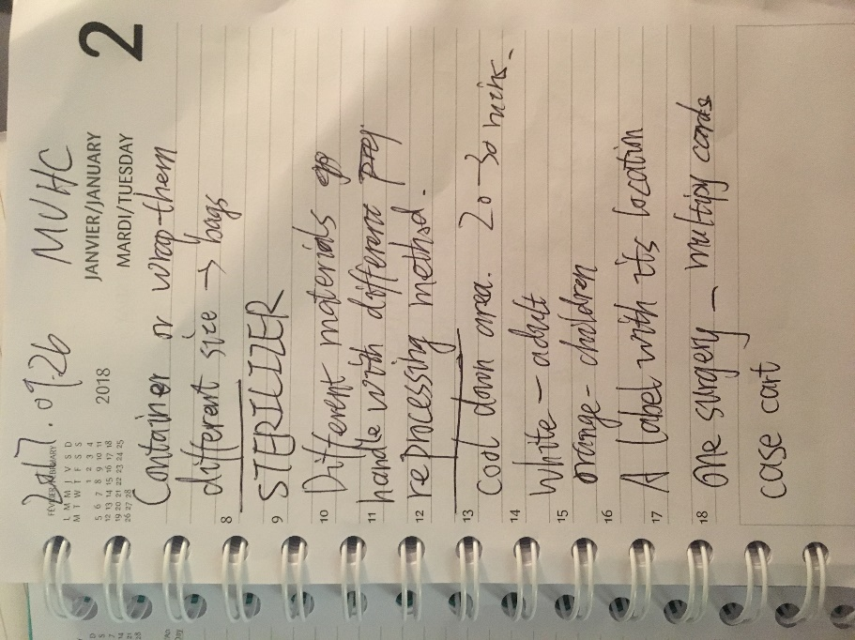

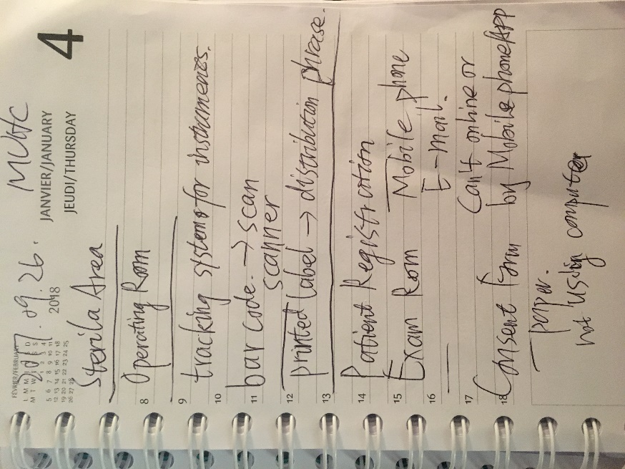

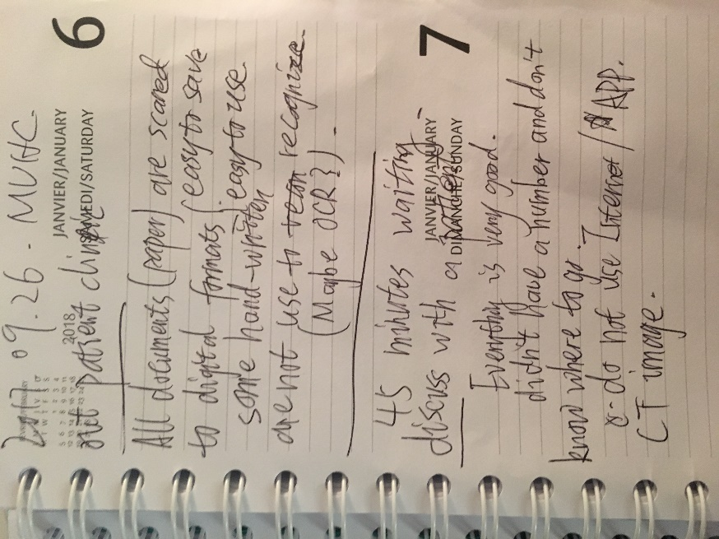

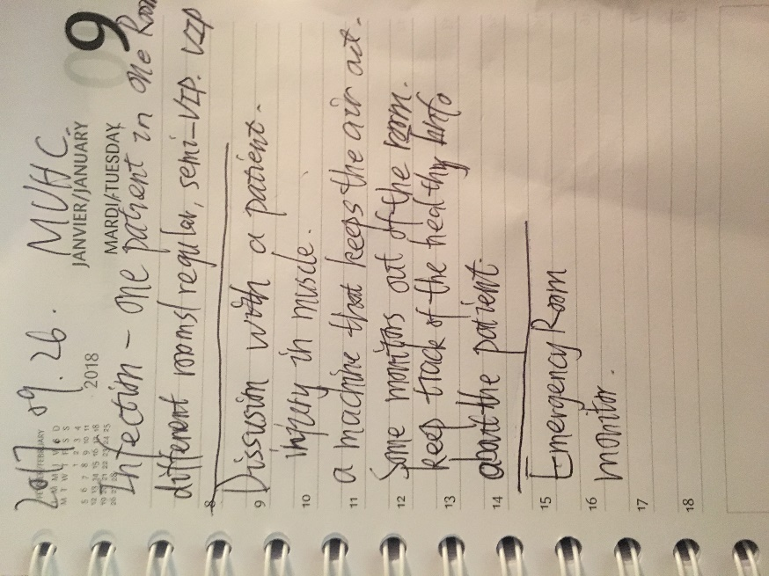

My Personal Type: ISFJ