**COMP 478/6771 Image Processing**

**Solutions to Assignment 1**

**Student: Qingbo Kang Student ID: 40058122**

Part I: Theoretical questions

1. Nonlinear. An operator that computes the median of a set of pixels of a sub-image area which acts like media filter is nonlinear.

The example is given below:

Suppose , , ,

Apply that operator, with symmetrically extended at the boundaries:

, , , 

It clearly can be seen that:



So by this example, the operator that computes the median of a set of pixels of a sub-image area is nonlinear.

1. a) The histogram image shows below:

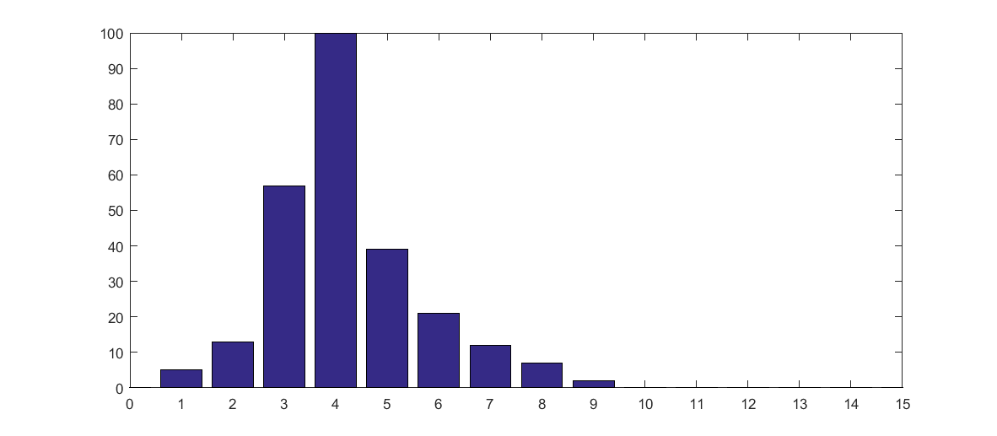

b)

i) First, from the table, the image is a 4-bit image, L = 16, image size = 256, intensity levels [0, 15].

Calculate , , :

|  |  |  |  |  |  |
| --- | --- | --- | --- | --- | --- |
|  |  |  |  |  |  |
|  | 0 | 0 |  | 7 | 0.0273 |
|  | 5 | 0.0195 |  | 2 | 0.0078 |
|  | 13 | 0.0508 |  | 0 | 0 |
|  | 57 | 0.2227 |  | 0 | 0 |
|  | 100 | 0.3906 |  | 0 | 0 |
|  | 39 | 0.1523 |  | 0 | 0 |
|  | 21 | 0.0820 |  | 0 | 0 |
|  | 12 | 0.0469 |  | 0 | 0 |

Since , therefore:

, , , , ,

,

,

,

,

.

Because the gray levels are integers, so the values of  are:

, , , , , , , , .

ii) First, computing :

, , , , ，, .

The below shows the figure of :

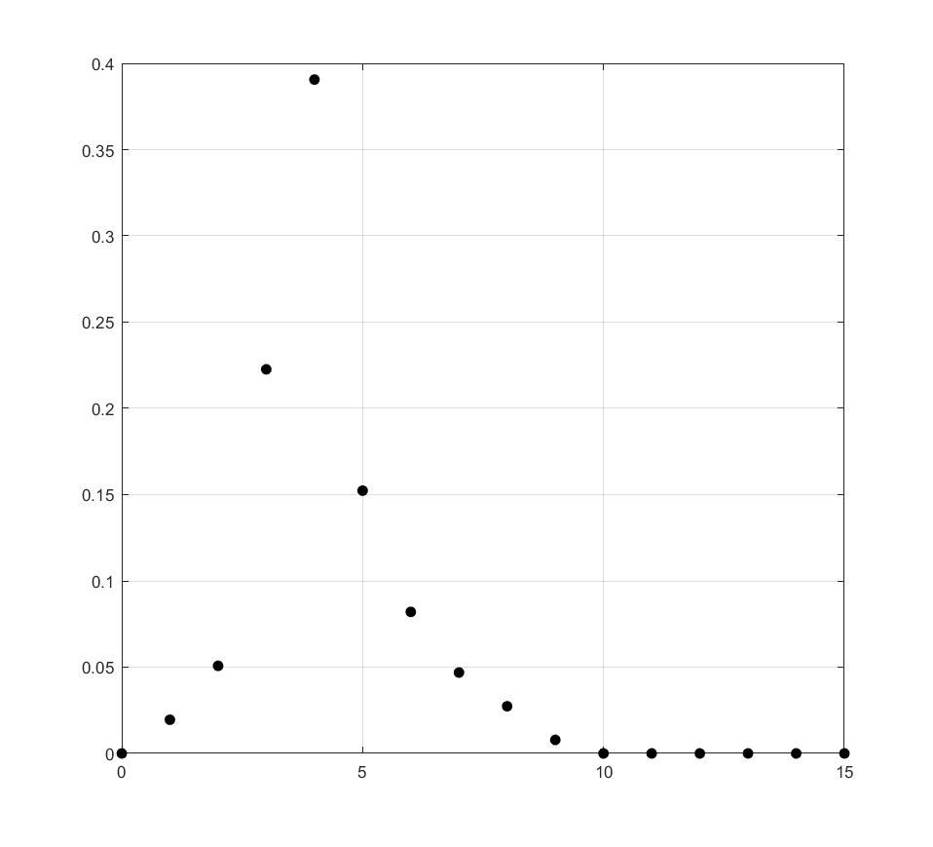

The below shows the figure of :

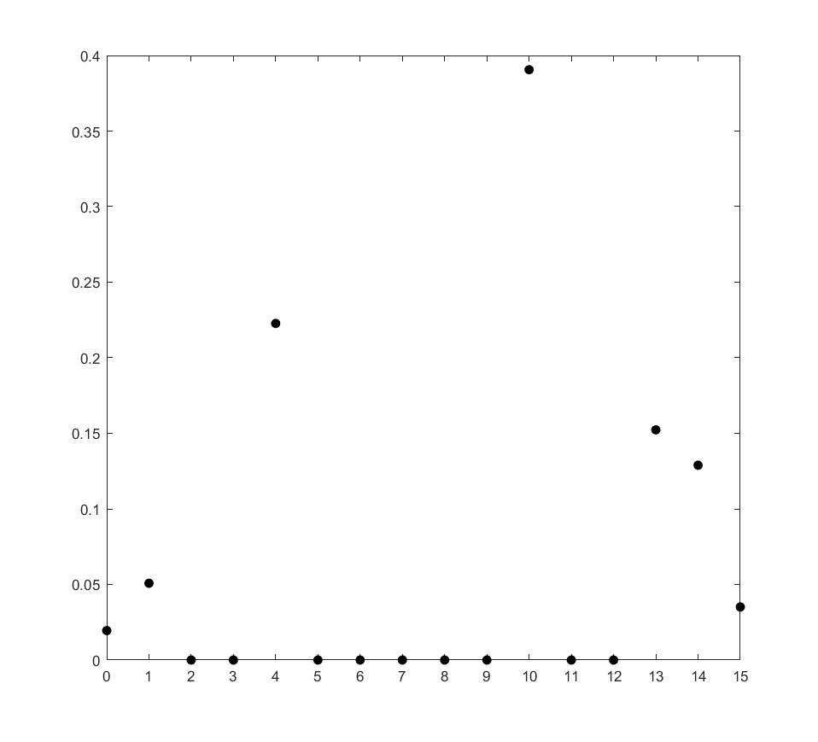

c) The below shows the new histogram after performing the histogram equalization:

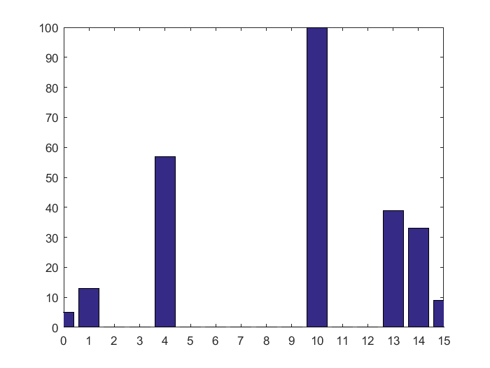

d) Because the original histogram have a peak level which means this gray level have a relatively large amount of pixels (in this example, the gray level is 4, nearly 40% pixels are at this gray level), and the histogram equalization technique just mapping one gray level to another one, it’s a is single valued and monotonically increasing transformation.

e) The same. A second pass of histogram equalization (on the histogram-equalized image) produce the same result as the first pass.

Explanation: Suppose  is the total number of pixels and  is the number of pixels in the image with intensity value . According to the histogram equalization transformation:



Since every pixel with value  is mapped to value . Then we have,



A second pass of histogram equalization:



and , so we get:



And it means a second pass of histogram equalization produce the same result as the first pass.

1. First, apply the histogram equalization:



And for the second diagram:

,

Let , then



Finally, because the intensity levels are all positive numbers, so



Part Ⅱ: Programming question

1. See code file Solution_1.m.

Below shows the running figure:

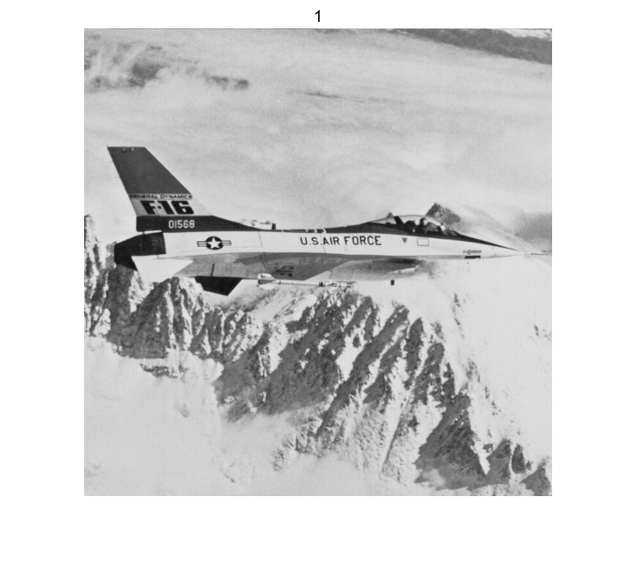

1. See code file Solution_1.m.

Below shows the running figure:

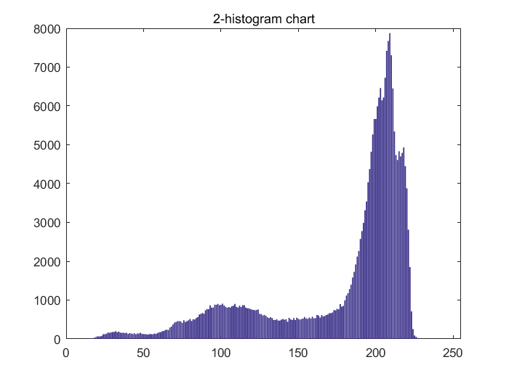

1. See code file Solution_1.m.

Below shows the running figure:

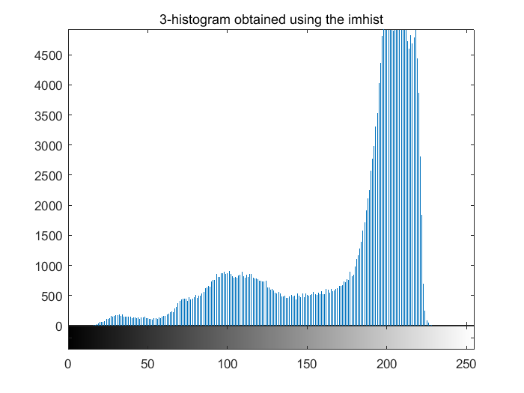

1. See code file Solution_1.m.

Below shows the running figure:

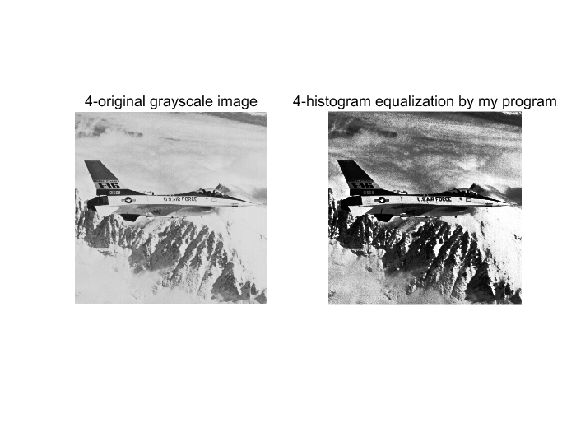

1. See code file Solution_1.m.

Below shows the running figure:

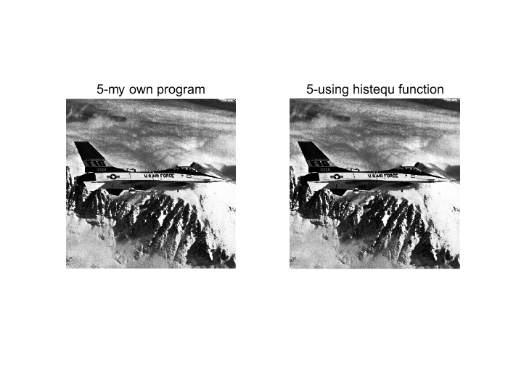

1. See code file imhiststretch.m.

Below shows the running figure:

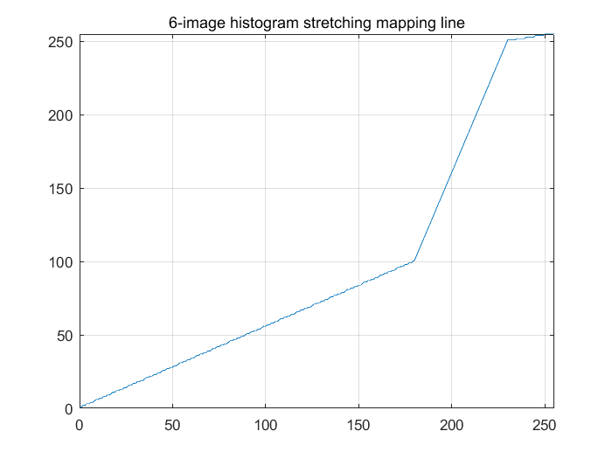

1. See code file Solution_1.m.

By inspecting the input image and its histogram, I observed that a majority of pixels fall into the range [180, 230], and in order to achieve the best quality which means stretch the image contrast, I decided to expand this range to a much wider range, so I choose [100, 250] range. I map input range [180, 230] to output range [100, 250].

1. See code file Solution_1.m.

Below shows the running figure:

