Sharing your Vivli-Microsoft Datathon solutions

A key principle of the Innovation Challenge is that “The spirit of the Innovation Challenge is to encourage innovation and collaboration.” To support this principle, one expectation is that “All IP produced during the Innovation Challenge is required to be registered in the public domain under an open source license without residual rights to the IP and available for public use” as we have outlined in our prior materials.

To facilitate public sharing of all solutions, we will take advantage of GitHub – this will also be the mechanism for submitting your solution to the judges.

To enable this, we will ask you to:

* Create a GitHub account, if you do not already have one.
* Create a public repository for the work you will do for the datathon. (Note that public repositories are readable by anyone but only individuals that you explicitly list as collaborators can modify the contents)
* Share the URL of the repository with [contact@vivli.org](mailto:contact@vivli.org) (do this early so that the judges may find and access your solution)
* Post all solution materials that are to be evaluated into the repository. For the purpose of judging, if your submission is primarily code, we ask you to additionally provide a document called “**Overview**” that provides a summary description of your solution, including the objective, approach, and any algorithms.

When Vivli publishes the results of the Datathon, we will include a list of all of the participating teams and the URLs for each of the repositories.

If you are new to GitHub – see the following section for a very brief introduction to the essentials.

# QuickStart for GitHub novices:

Point your browser to <https://github.com/> and fill in the Sign up form

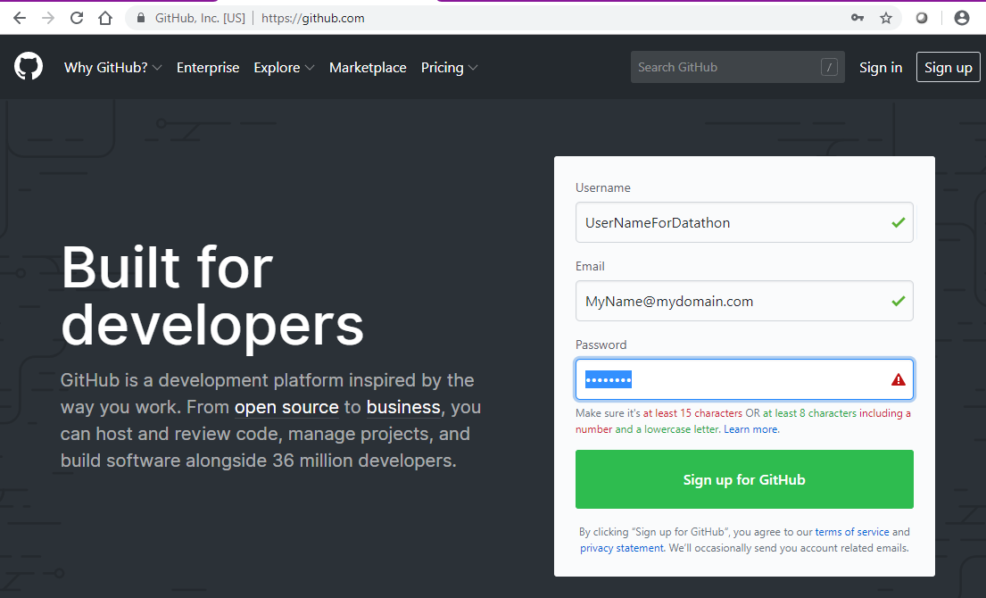

Note that your username may only contain alphanumeric characters or single hyphens, and cannot begin or end with a hyphen, and that the system will send a verification email to the email address you provide.

Once you have opened an account, create a repository – click “New” on the upper left of the screen:

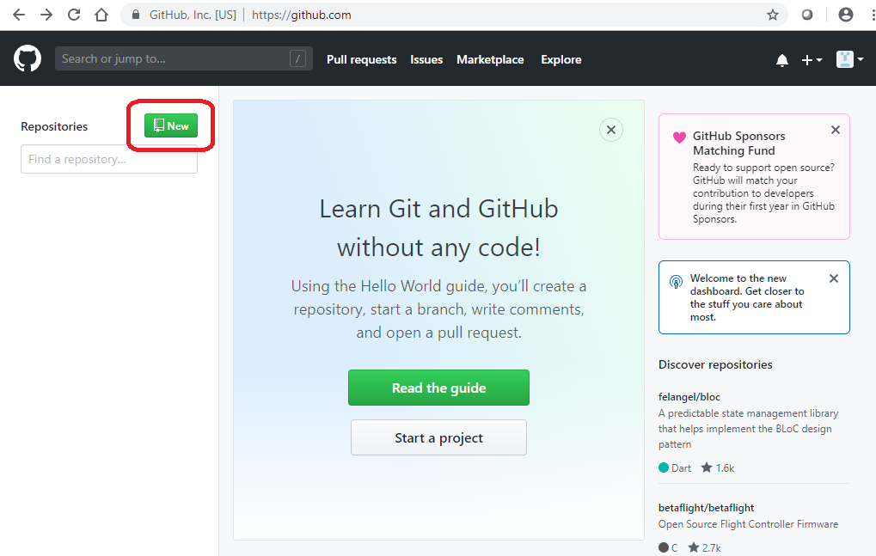

In the resulting form, fill in the Repository Name, the Description, Accept the default choice of Public (that one is important for sharing), and check “Initialize this repository with a README”:

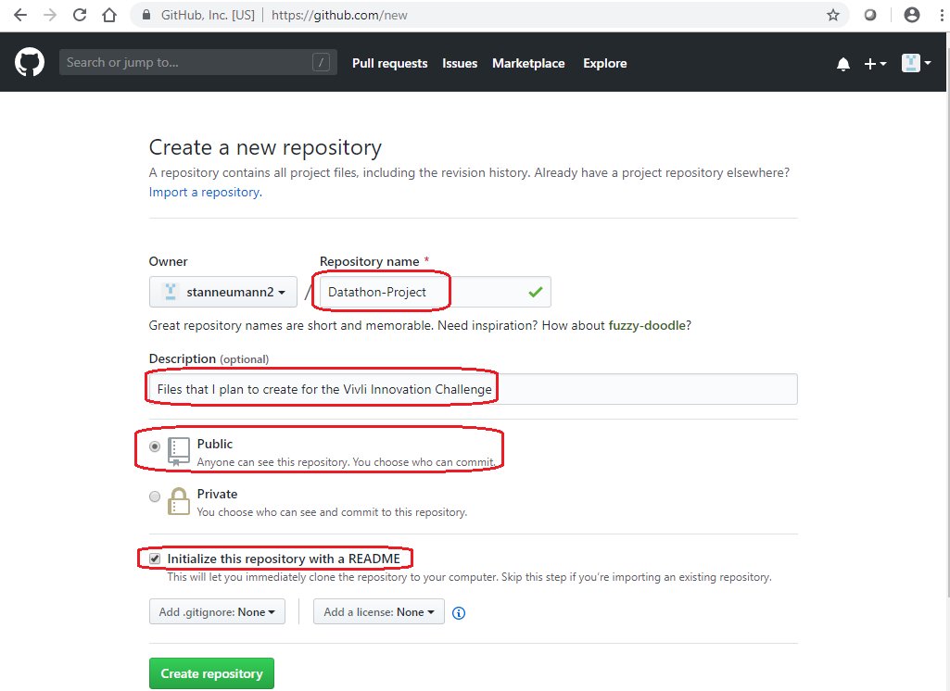

The repository is pre-loaded with a Readme file – to add other files, such as the requested “Overview” document, click on “Upload Files”:

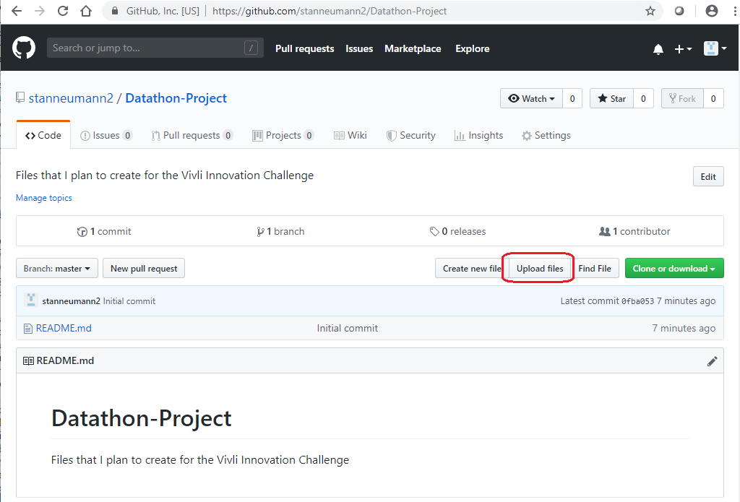

Github will display a page allowing you to drag and drop files, or browse (“Choose your files”):

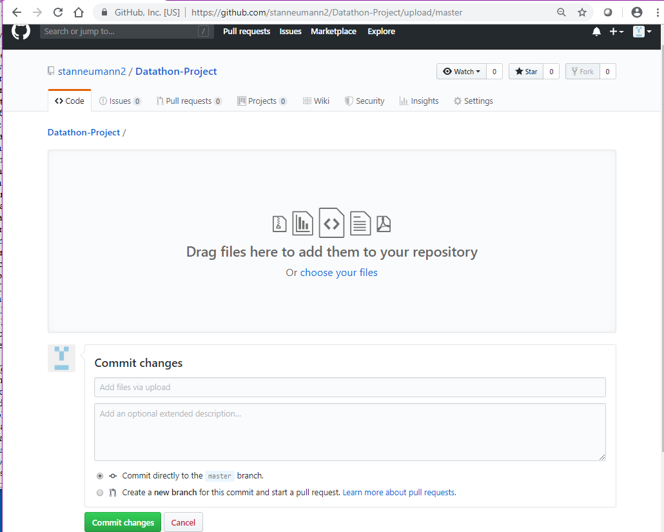

Files that you drag onto the screen will be listed below the drag target. When you have selected all of the files you want to upload, click on “Commit Changes”

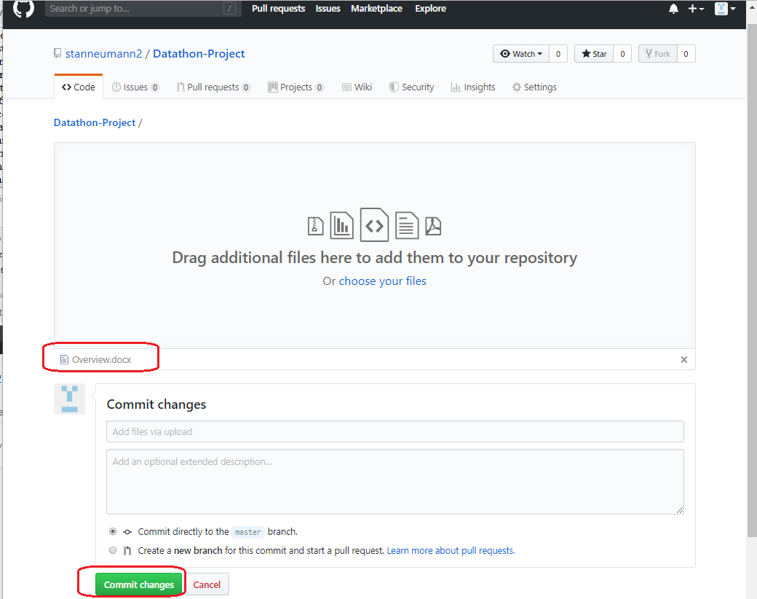

Back at the main repository screen; your added files will be listed:

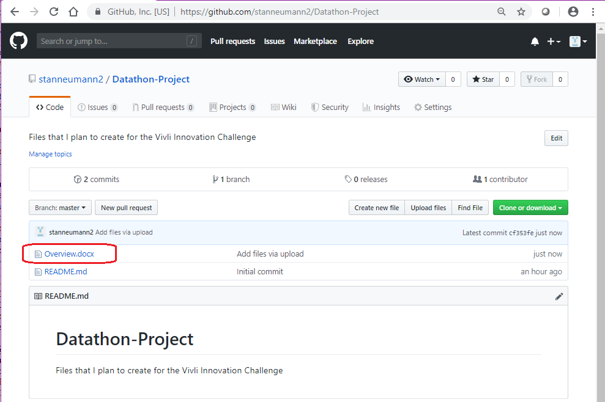

If you want to update the file, simply re-upload it, and the new version of the file will replace the earlier version.

Note that the URL of the repository is in the browser URL field: it will be of the form:

[https://github.com/<YourAccount>/<YourRepository](https://github.com/%3cYourAccount%3e/%3cYourRepository)>

This URL is what we ask you to share with Vivli (to Contact@vivli.org), so that we can provide it to the judges, to help them find your submission, and later to the public.