**Distinct contributions of anterior and posterior orbitofrontal cortex to adaptive decision-making**

## **Abstract**

The lateral orbitofrontal cortex (OFC) is critical for flexibly adjusting choices when outcome values change. This requires representations of stimulus-outcome associations and inferring the updated value of outcomes, but whether and how different parts of OFC contribute to these functions has remained unclear. Here we used transcranial magnetic stimulation (TMS) to disrupt activity in functional networks centered on the anterior (aOFC) and posterior (pOFC) lateral OFC. Participants (n=48) received aOFC or pOFC network-targeted TMS either before learning associations between visual stimuli and sweet or savory food odor rewards, or, on the next day, before a meal to selectively devalue one of these rewards. TMS targeting pOFC before the meal disrupted goal-directed behavior, as measured by choices of stimuli predicting non-sated rewards in a probe test, whereas disrupting aOFC before learning stimulus-outcome associations similarly impaired choices in the probe test. These findings demonstrate distinct contributions of different OFC subregions to goal-directed behavior.

## **Introduction**

Humans and animals effortlessly adapt to changing environments by flexibly adjusting their behavior. This adaptability relies on outcome-guided decision-making, where individuals can re-evaluate their choices in real time, simulating potential outcomes based on changes in outcome value1 rather than defaulting to habitual responses. For example, a restaurant chef might anticipate that a guest could experience an allergic reaction to certain ingredients and adjust the dish accordingly before an issue arises. To enable this flexibility, a detailed representation of the environment—commonly referred to as a cognitive map or model-based representation-is essential2. A chef with a thorough understanding of ingredient composition and suitable substitutes can efficiently modify recipes to accommodate allergies without compromising the dish. The orbitofrontal cortex (OFC) plays a central role in both processes, supporting adaptive behaviors through the formation of cognitive maps3,4 and use the map to simulate potential outcomes5,6.

Across species, the OFC is known as a heterogeneous region, comprising subregions with varying anatomical and functional properties along both mediolateral and anterior-posterior gradients7-15. In humans, studies on value-based decision-making have primarily focused on the functional distinctions between the medial and lateral OFC8,9,13. However, the anterior-posterior gradient has received less attention, despite anatomical studies in humans and non-human primates revealing a cytoarchitectural progression from granular to agranular cortex along this axis7,8,14,15.

This study aims to identify the distinct roles of anterior-posterior subregions within the lateral OFC in supporting different aspects of adaptive behaviors in an outcome devaluation task3,5,16-27. We examine responses to predictive cues after the selective devaluation of the associated outcome, demonstrating the ability to align actions with updated goals and contexts. Different views exist on the computational roles of the OFC in outcome devaluation task, such as the ability to use the current value of stimuli to control response selection18,19, extending to using mental simulations to update values of outcome-predicting stimuli3,19, or as a cognitive cartographer to create and modify the relevant cognitive map28. In the current work, we seek for a unified explanation of those assumed mechanisms in the same computational framework.

We hypothesize that disrupting OFC activity during different phases of the outcome devaluation task causes distinct effects on behavior. Specifically, we expect that disrupting the anterior portion of the central/lateral OFC will impair the acquisition of specific stimulus-outcome associations and disrupting the posterior portion will impair retrieving and using these associations to guide choices.

To test this, we applied network-targeted transcranial magnetic stimulation (TMS) with continuous theta burst stimulation (cTBS) in a within-participant study across multiple sessions. This approach allowed us to modulate the anterior and posterior portions of the central/lateral OFC network selectively during the learning and testing phases. We also developed computational models that implement devaluation behaviors by mechanism of updating outcome value and/or behavioral control, while also capturing different mechanisms through which TMS might influence devaluation.

Our findings reveal distinct roles for the anterior and posterior lateral OFC in goal-directed behavior. Disruption of the posterior lateral OFC before testing impaired outcome devaluation, whereas disruption of the anterior lateral OFC before learning similarly impaired subsequent devaluation. Additionally, cTBS targeting either region disrupted value acquisition, but only during the first session of the within-participant study. Together, these results suggest that anterior and posterior lateral orbitofrontal cortex networks play complementary roles, supporting the acquisition and use of outcome-specific stimulus-reward associations essential for goal-directed behaviors.

## **Results**

### **Experimental design and outcome devaluation task.**

This study follows a within-participant, multiple-session design, with 48 healthy human participants completing a two-day experiment, repeated across three separate sessions (spaced at least one week apart; **Fig. 1A**). Each session involves the delivery of either continuous theta burst stimulation (cTBS) on one day and sham TMS on the other, or sham TMS on both days (**Fig. 1D**), resulting in three conditions (Day 1-Day 2: cTBS-sham, sham-cTBS, sham-sham, order counterbalanced). On Day 1, participants learned to discriminate pairs of visual stimuli associated with desirable food odors (sweet or savory, equally valued based on pre-task ratings; **Fig. 1E**) and odorless air (**Fig. 1B**). They were asked to select the stimulus associated with any odor, meaning they were not required to encode the specific stimulus-outcome identity associations to perform the discrimination task. On Day 2, participants chose between stimuli based on odor preferences, making choices between stimuli predicting sweet and savory odors, or between stimuli predicting odor and air. A pre-meal test was followed by a meal, then by a post-meal test. Participants received the odors during the Day 1 discrimination task and the Day 2 pre-meal test. No odors were delivered during Day 2 post-meal test. Participants also reported how much they liked each odor before and after the meal. To explore the potentially distinct functional roles of OFC subregions in this task, TMS was administered at two different time points—either before the discrimination task on Day 1 or before the meal on Day 2 (**Fig. 1A**) —and targeted either the anterior or posterior portions of the lateral OFC in different groups of subjects.

We aimed to selectively modulate neural activity in the anterior (aOFC) and posterior (pOFC) portions of the lateral OFC network (**Fig. 2A**). Stimulation targets were defined using MNI coordinates in the right hemisphere: aOFC at [34, 54, -14] and pOFC at [28, 38, -16]. Each target showed strong functional connectivity with isolated lateral prefrontal cortex (LPFC) clusters (referred to as aOFC-connected and pOFC-connected LPFC clusters, respectively). Based on resting-state fMRI data from Day 0, we individually selected LPFC stimulation sites with the highest connectivity to the respective aOFC or pOFC targets (**Fig. 2B**). We confirmed the functional separation of these networks across all resting-state fMRI sessions: the aOFC-connected LPFC showed stronger connectivity with the aOFC than the pOFC (W = 988, p = 1.567e-5, Wilcoxon signed rank test, two-sided), and the pOFC-connected LPFC showed stronger connectivity with the pOFC than the aOFC (W = 936, p = 2.234e-4) (**Fig. 2C**).

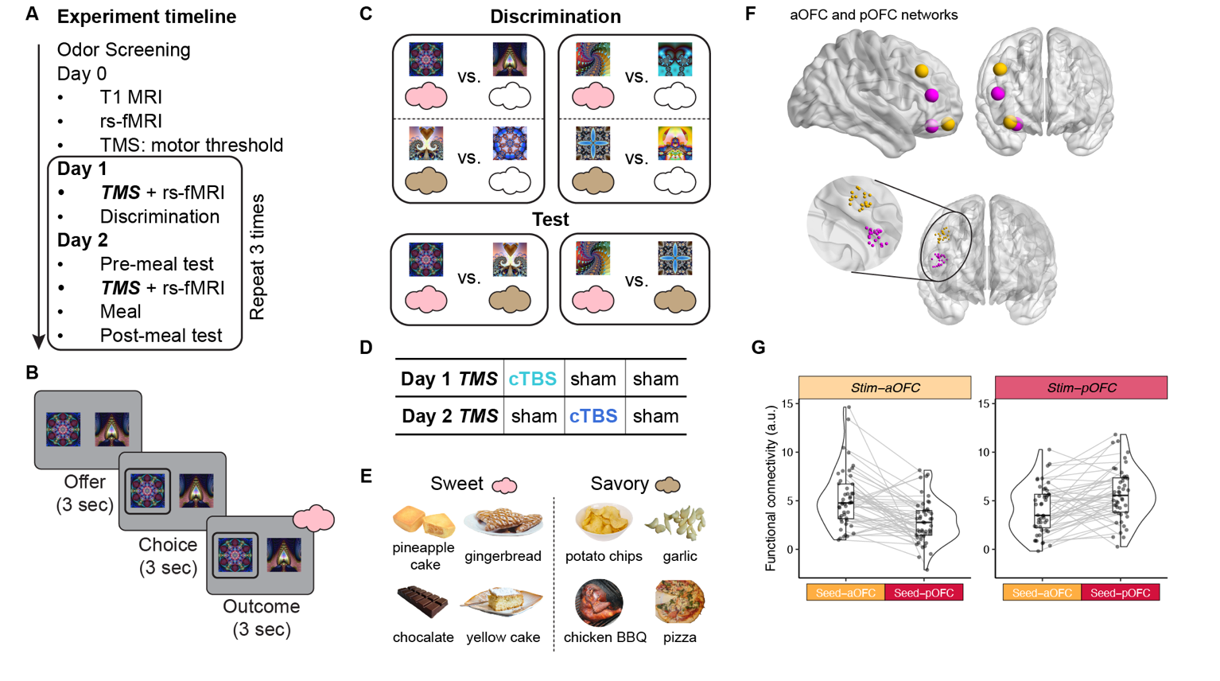

**Fig. 1. Experimental design and outcome devaluation task.** **A. Experiment timeline.** Following an odor screening session, Day 0 includes T1 MRI, resting-state fMRI, and motor threshold determination via TMS. On Day 1, participants received either continuous theta burst stimulation (cTBS) or sham TMS before performing an discrimination task. On Day 2, participants performed a pre-meal test, received TMS (cTBS or sham), consumed a meal, and then completed a post-meal test. **B. Trial structure of discrimination task and choice task.** Each trial started with an offer phase (3 seconds), where participants were presented with two visual stimuli paired with different outcomes. This was followed by a choice phase (maximum 3 seconds), where participants selected one of the stimuli, and finally, an outcome phase (3 seconds), where the predicted outcome was delivered (odor or no odor). **C. Associative structure for the discrimination and test tasks.** During the discrimination task, participants learned which stimuli predicted odors (indicated by colored clouds) and which predicted non-odor outcomes (i.e. clean air). In the test phase, participants were required to select stimuli based on their learned odor associations, without odor delivery. Tests also contained choices between odor-predictive stimuli and air-predictive stimuli (not shown). **D. TMS conditions.** Three conditions counterbalanced across three sessions: cTBS on Day 1 followed by sham TMS on Day 2 (cTBS-sham), sham TMS on Day 1 followed by cTBS on Day 2 (sham-cTBS), and sham TMS on both days (sham-sham). **E. Odor stimuli.** A set of eight food-related odors, divided into savory (e.g., potato chips, pizza) and sweet (e.g., pineapple cake, chocolate). For each participant, one savory and one sweet odor was selected based on individual pleasantness ratings to ensure they were as similarly pleasant as possible. **F.** Visualization of the OFC and LPFC ROIs, showing two pairs of the OFC-LPFC network (yellow: aOFC; magenta: pOFC). Individual stimulation coordinates, with each point representing the site of stimulation for each participant. These coordinates were chosen to maximize functional connectivity with either the aOFC or pOFC seed regions. **G.** Functional connectivity estimates for the aOFC and pOFC networks. The half-violin plots indicate the distribution of functional connectivity values between the stimulated OFC regions and their respective seed regions in the LPFC. Each dot corresponds to an individual participant’s connectivity estimate. Functional connectivity was calculated by using the aOFC or pOFC seed regions and extracted from the LPFC ROIs.

### ***Choices on stimuli are influenced by learned stimulus values and selective satiation effects***

Before examining the effects of cTBS, we first set out to examine the factors that might influence participants’ choices on savory-sweet pairs on Day 2, where participants had not been trained in making these decisions. We presumed that these choices were influenced by both the learned value of each stimulus and participants’ satiation status on Day 2. The following results support this assumption.

The learning outcome from Day 1 influenced Day 2 choices showing that learned value weights affected choices collapsing across all participants and sessions (**Fig. 4A**). These weights were estimated using the fitted learning model from the Day 1 discrimination task. Dot size represents the number of trials per value combination (log scale), with missing dots indicating unobserved combinations. The data revealed a pattern: the probability of selecting the sated option was highest with high SA and low NS values (bottom-right quadrant) and lowest with low SA and high NS values (top-left quadrant), following a gradient from top-left to bottom-right. We further plotted the probability of selecting the sated option against the value difference between sated and non-sated options, showing a significant increase in probability with value difference (Pearson’s r = 0.923, p = 3.49 × 10⁻¹⁰; **Fig. 4B**).

Participants’ odor ratings on Day 2 indicated that the selective satiation procedure significantly reduced odor pleasantness across sessions and participants (p = 2.75e-13, **Fig. 4C**). This reduction was consistent regardless of TMS condition (sham/cTBS), TMS targeted location (aOFC/pOFC), session number (1st, 2nd, 3rd), or sated odor type (savory/sweet) (all p > 0.05), suggesting that odor devaluation after the meal was robust (**Extended Data Fig. 2**). We also calculated a selective satiation measure by determining the change in odor pleasantness before and after the meal (post-meal minus pre-meal) for both sated and non-sated odors, then subtracting the change for non-sated odors from the change for sated odors.

To assess the satiation effect on choices, we used the pre-meal average choice as a session baseline and subtracted it from the post-meal choices. The results collapsing across all three sessions showed that post-meal choices of sated odors were significantly lower than the baseline in both the aOFC (Wilcoxon signed rank test, one-sided, p = 0.024) and pOFC (p = 2.3e-3) stimulating groups (**Fig. 5A**), suggesting the effect of selective satiation on stimulus selection.

Sated odor choices were significantly correlated with the pleasantness difference between sated and non-sated odors both before and after the meal (**Fig. 4D, E**). Additionally, changes in sated odor choices were significantly correlated with changes in pleasantness difference (Pearson’s r = 0.46, p = 8.3e-4; **Fig. 4F**).

When evaluating cTBS effects (Day 1 or Day 2) on Day 2 choices, we included the difference in learned value weights and the selective satiation index as regressors. This approach was necessary because Day 1 cTBS might influence both value learning and identity learning. However, by incorporating these regressors, we effectively accounted for potential deficits in value learning.

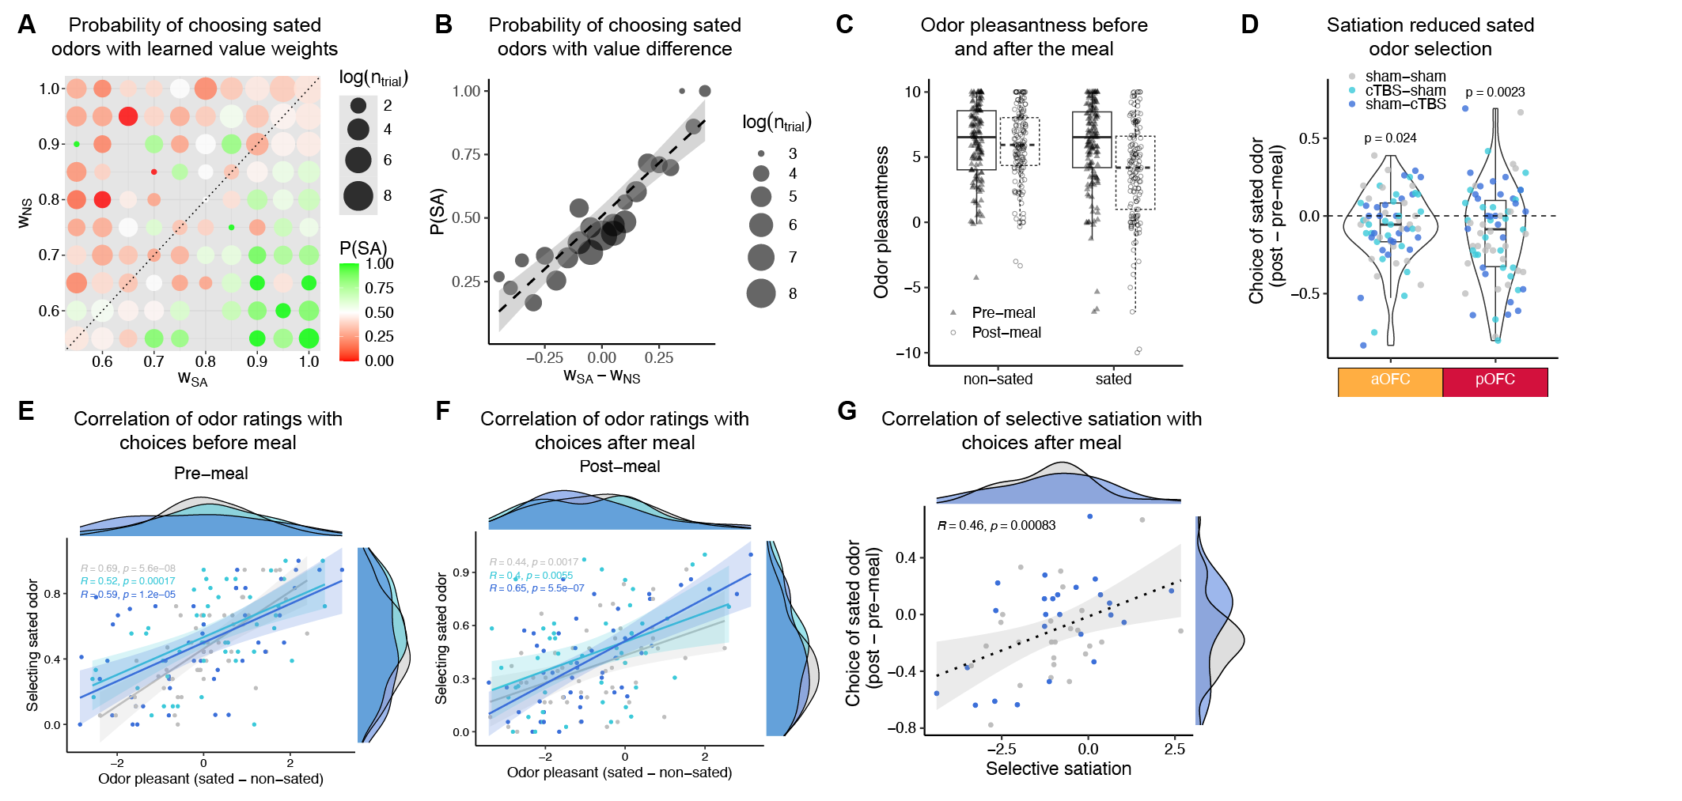

**Fig. 2.** **Choices are influenced by both learned values and selective satiation effects. A.** Change of rated odor pleasantness before and after the meal, for sated and non-sated odors. **B.** Choice of sated odors options associated with each of the learned weight of the combination of sated and non-sated options. **C**. Choice of sated odors options with value difference. **D.** Choice of sated odors in sweet-savory choices for sham-sham and sham-cTBS conditions, under aOFC-targeted and pOFC-targeted cTBS. **E.** Scatter plots showing high correlations between the choice of sated odors and odor preference before and after the meal, separated by the three TMS conditions. **F.** Scatter plot showing the change in the choice of sated odors against the change of odor pleasantness difference after eating the meal. **G.** Correlation between baseline odor preferences identified from savory-sweet odor choices and odor-air choices, separated by the three TMS conditions.

### **Posterior, but not anterior, OFC-targeted cTBS before the choice test impairs outcome devaluation**

To examine the role of the aOFC and pOFC in outcome devaluation, we analyzed participants’ choices for stimuli predicting sweet and savory odors (**Fig. 5A, B**) and choices for stimuli included one odor and one clean air.

To investigate the effects of TMS targeting aOFC and pOFC during the test phase, we focused on the “sham-sham” and “sham-cTBS” stimulating conditions. We identified found a significant interaction between stimulation location (aOFC-targeting, pOFC-targeting) and TMS condition (sham, cTBS) in sated-odor predicting choices (p = 0.0326), according to logistic mixed-effects models on post-meal choices of sated odors, with the session baseline and the value difference accounted for. We then analyzed the two stimulation locations separately (**Fig. 5B**), and we found significant cTBS effect for the pOFC group (p = 0.00115), but not for the aOFC group (p = 0.977), indicating that pOFC-, but not aOFC-targeted cTBS impaired choices between stimuli predicting sweet and savory (i.e., devalued and non-devalued) outcomes. In addition, the pOFC-targeted cTBS effect on sated choice selection was robust regardless of session order (**Extended Data Fig. 3B**).

Note that the Day 2 cTBS effect we observed on sated odor choices was after accounting for value differences. **Fig. 5E** shows the probability of selecting sated odors across various stimulus value combinations for each targeted stimulation condition. For the aOFC group, both sham and cTBS conditions exhibited a clear gradient from top-left to bottom-right, with a higher probability of selecting sated odors as value differences increased. This is further illustrated in **Fig. 5F**, where the positive relationship between sated odor choices and value difference remained intact under Day 2 cTBS. In contrast, the pOFC group showed a strikingly different pattern. Under cTBS, green dots in **Fig. 5E** appeared more dispersed across the value space, and the positive relationship between the choice probability and value difference was disrupted under Day 2 cTBS in **Fig. 5F,** indicating that pOFC-targeted cTBS impaired value-based choices.

We conducted additional analyses to examine factors that might influence choice behaviors. Our results showed that Day 2 cTBS had no effect on the correlations between pleasantness ratings and sated odor choices (all p > 0.05; **Fig. 4D, E, F**). Moreover, there were no significant correlations between perceived TMS discomfort or intensity and changes in sated odor choices, except in the aOFC group, where a positive correlation was observed between TMS perception and choice of sated odor (**Extended Data Fig. 4A**). While no correlation was found between the difference in conditions (cTBS vs. sham) for the pOFC group, a significant positive correlation was identified in the aOFC group (Pearson’s r = 0.7, p = 7.9e-8; **Extended Data Fig. 4B**). Incorporating TMS ratings into the mixed-effects models did not alter the above conclusions.

In addition to savory-sweet odor choices, we examined choices between an odor and clean air, previously learned during the Day 1 discrimination task. Participants generally preferred odors over clean air (**Fig. 5C**). However, after the meal, preference for sated odors decreased, while choices for non-sated odors remained unchanged. This decrease in sated odor selection was significantly stronger after sham stimulation (Wilcoxon signed-rank test, p = 0.018, two-sided) but not after cTBS on Day 2 (p = 0.91; **Extended Data Fig. 3F**). Choices for sated odors were marginally lower after sham compared to cTBS but only with pOFC targeting (p = 0.06) and not aOFC (p = 0.43; **Fig. 5D**). These findings align with results from savory-sweet choices, indicating that pOFC-targeted cTBS on Day 2 impaired choice updating for non-sated odors. This suggests that the critical role of pOFC for goal-directed decision-making, even in previously trained trials.

Together, this suggests that pOFC-targeted cTBS before the choice test impaired outcome devaluation, as indicated by an increase of selecting sated odor-predicting stimuli. In contrast, aOFC-targeted cTBS had no such effect. This replicates previous results from our lab5 and further highlights the specificity of the pOFC involvement in goal-directed behavior.

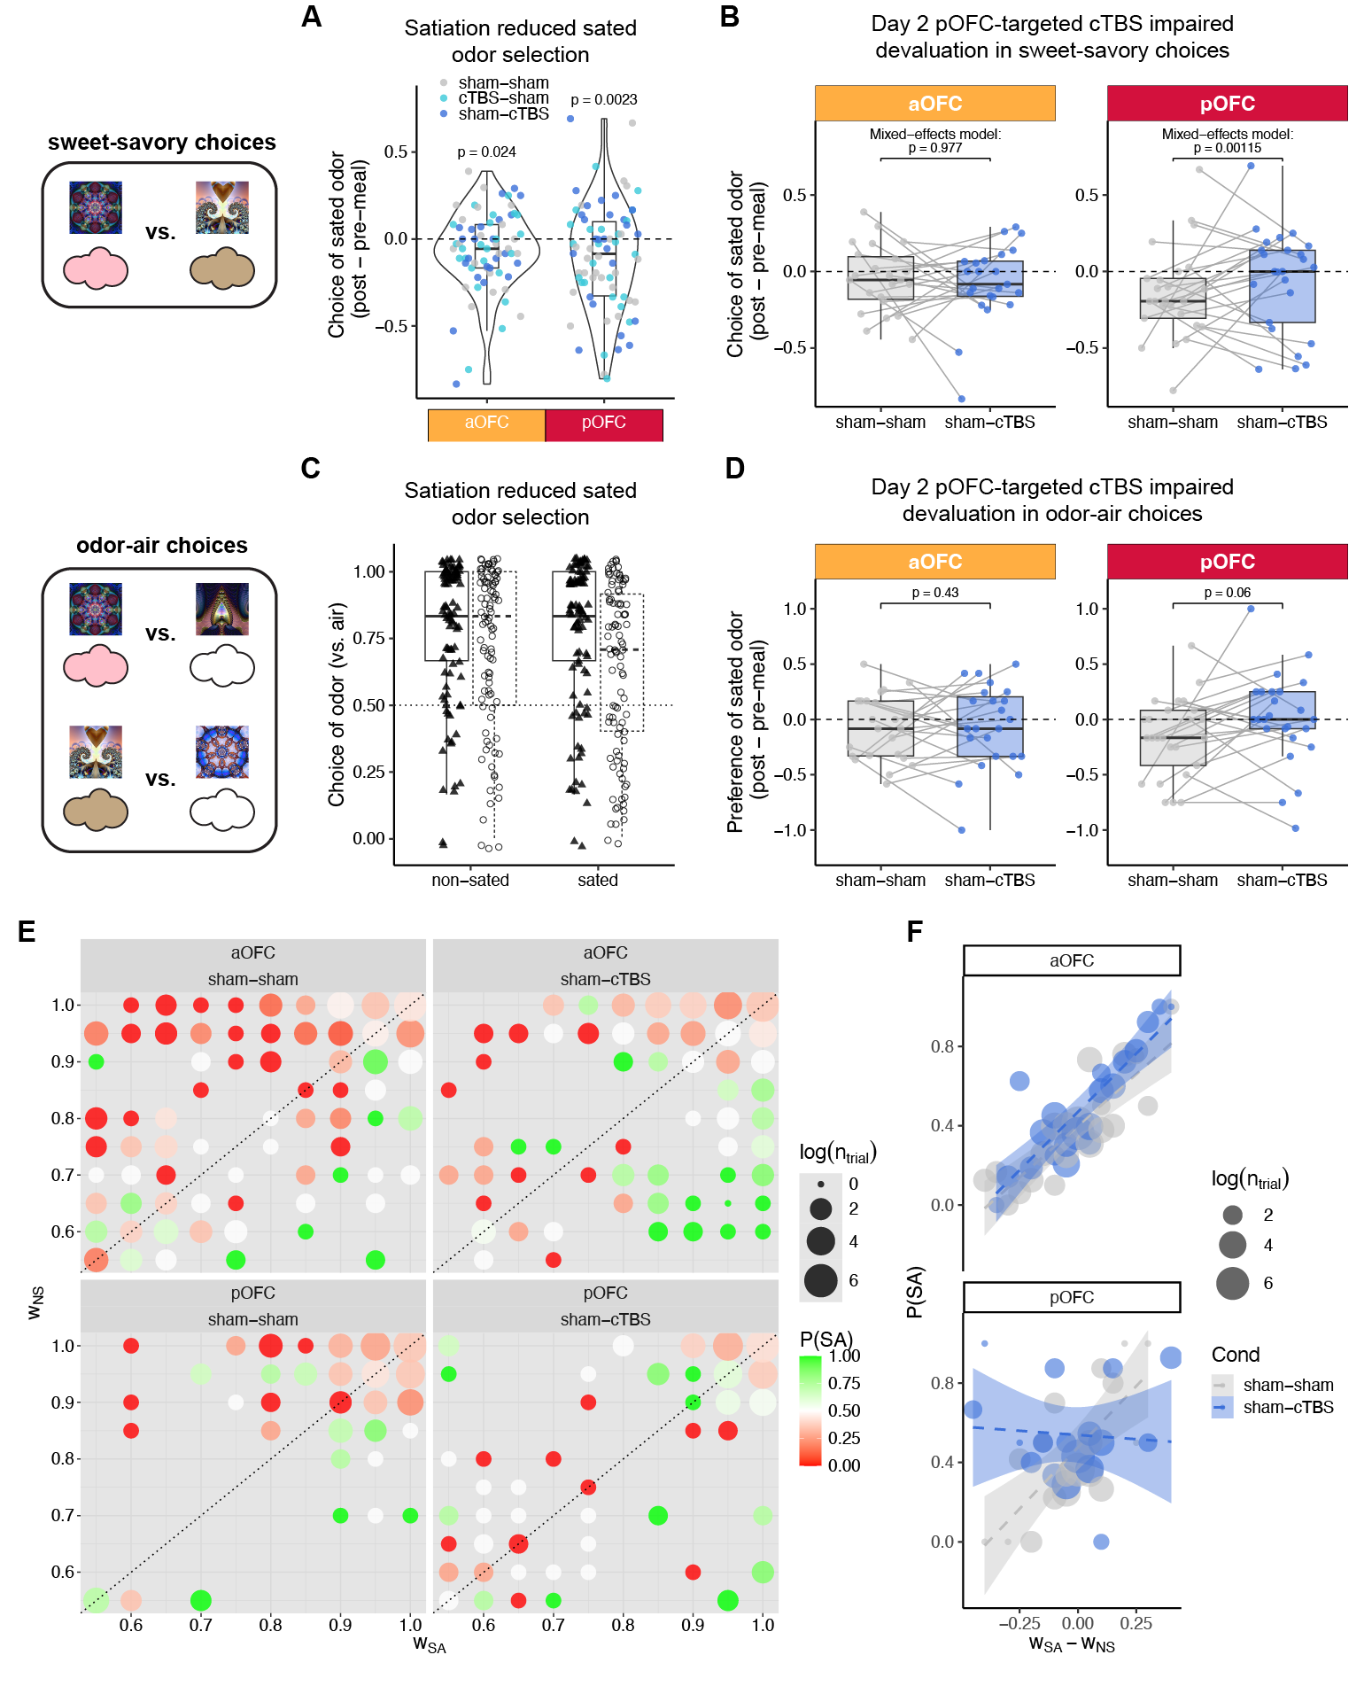

**Fig. 5. Posterior, but not anterior, OFC-targeted cTBS on Day 2 impaired outcome devaluation**. **A.** Change of choice of sated odors in sweet-savory choices from pre-meal to post-meal test. **C.** Choice of odors vs. clean air, for sated odors and non-sated odors, pre-meal and post-meal. **D.** Change of preference of sated odors relative to non-sated odors, by comparing odor choices between odor vs. clean air. **E.** Choice of sated odors options associated with each of the learned weight of the combination of sated and non-sated options, separated by stimulation targeted locations and conditions. **F**. Choice of sated odors options with value difference, separated by locations and conditions.

### ***Anterior, but not posterior, OFC targeted cTBS before discrimination learning impaired subsequent outcome devaluation***

We then explored whether cTBS targeting aOFC and pOFC before learning could affect outcome devaluation measured on Day 2, as would be expected if cTBS disrupted the learning of stimulus-reward identity. We predicted that aOFC-targeted cTBS disrupts the latent learning of reward identity on Day 1.

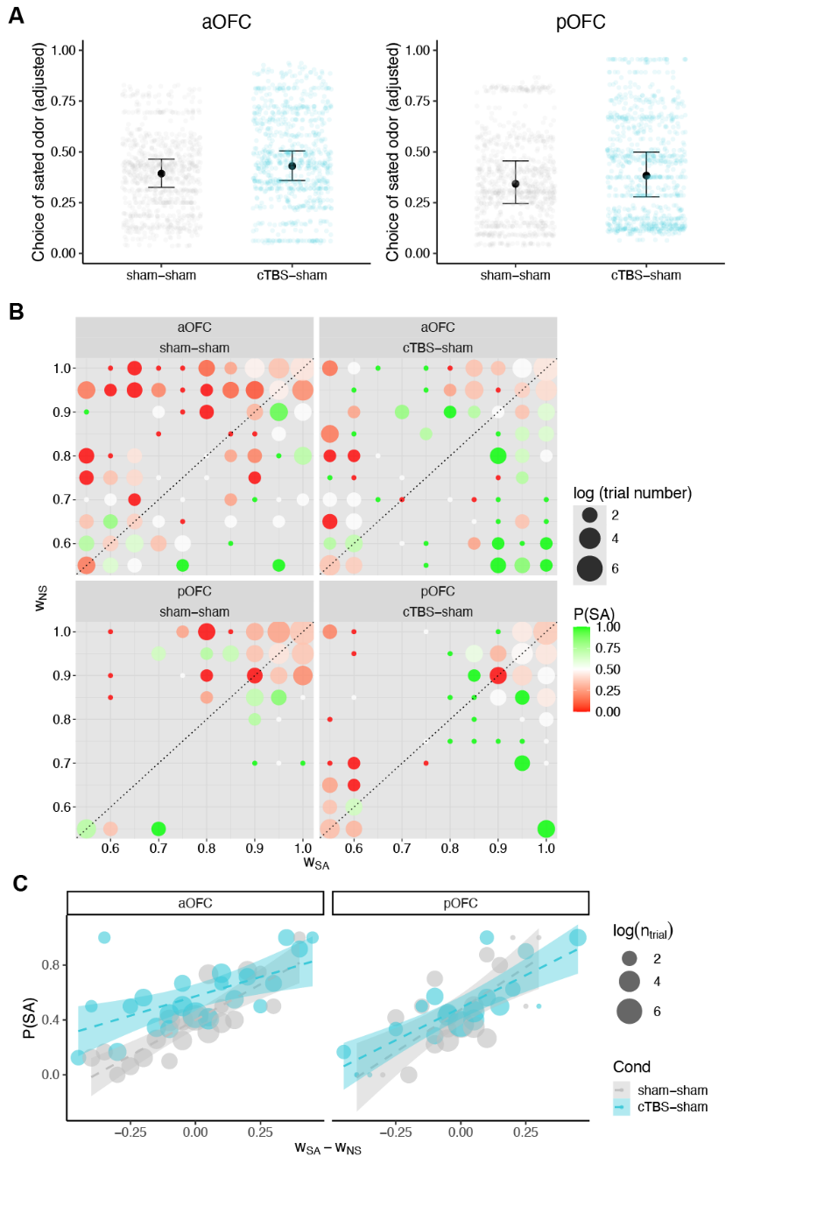

**Fig. 6.** **Anterior, but not posterior, OFC-targeted cTBS on Day 1 impaired subsequent devaluation behaviors. A.** Probability of sated odor selection after the meal, after adjusting modeled contributions of value difference, selective satiation effects, pre-meal odor preference, compared between sham-sham and cTBS-sham sessions. Overlayed points are the model fitted values of the sated odor selection for each trial collapsing across participants. **B.** Probability of choosing the sated odor across value pair combinations, separated by stimulation locations and conditions. **C.** Choice of sated odors options associated with each of the learned weight of the combination of sated and non-sated options, separated by stimulation locations and conditions.

To assess Day 1 cTBS effect on post-meal choices of sated odors on sweet-savory choices, we focused on “sham-sham” and “cTBS-sham” conditions and used logistic mixed-effects models with covariates including session-wise selective satiation index, estimated value difference, and pre-meal odor preference. For the aOFC group, both TMS condition and session number significantly influenced post-meal sated odor choices, with a significant interaction between the two. Specifically, the cTBS-sham condition significantly increased the selection of sated odors (**Fig. 6A**; beta = 1.527, SE = 0.625, p=0.0146), and this effect diminished over sessions (beta = -0.657, SE = 0.290, p=0.0236). Choices also increased with session number (β = 0.550, SE = 0.165, p=0.000085). Additional covariates, including selective satiation index, value difference, and pre-meal odor preference, were significant predictors. Overall, aOFC-targeted cTBS on Day 1 increased post-meal choices of stimuli predicting sated odors, with the effect moderated by session number. For the pOFC group, similar analyses revealed no significant difference between the sham-sham and cTBS-sham stimulation conditions, regardless of whether session numbers were considered as a covariate (**Fig. 6A**; all p>0.05). However, pre-meal odor preference and value difference were significant predictors of post-meal choices, while the selective satiation index was not (p>0.05).

Accounting for value difference was important to correctly interpret the day 1 cTBS effect. **Figure 6B** illustrates the impact of Day 1 aOFC-targeted cTBS on sated odor choices, showing the probability of choosing the sated odor across value pair combinations. For the aOFC group, the top-right quadrant of the cTBS-sham plot reveals increased sated odor choices for pairs with high values for both options. In the top-left quadrant, a clear shift is observed: red dots, indicating lower probabilities of choosing the sated odor, are replaced by green dots, which represent higher probabilities. This shift suggests that Day 1 cTBS increased sated odor choices, contradicting predictions based solely on value differences and explaining the significant cTBS effect observed. This can also be observed in **Fig. 6C** where the correlation between sated odor choices and value difference was elevated by Day 1 cTBS. In contrast, the pOFC group shows a different pattern. While the top-right diagonal of the cTBS-sham plot indicates increased sated odor choices, the bottom-right quadrant also shows more green dots. These changes, however, align with predictions based on value differences, potentially explaining the lack of a significant cTBS effect after accounting for value differences. This can be viewed by **Fig. 6C** where the correlation between sated odor choices and value difference was similar between sham and cTBS conditions. Overall, the plot highlights distinct patterns in how Day 1 cTBS influences choices in the aOFC and pOFC groups, with the aOFC-targeted cTBS leading to choice patterns that diverge from value-based expectations.

These findings support our hypothesis that the aOFC plays a critical role in specific stimulus-outcome learning on Day 1, even when the task does not require it. Notably, this result is independent of the Day 2 TMS effect, emphasizing the aOFC’s importance in constructing cognitive maps that are later used to guide behavior. Furthermore, the differing effects of aOFC-targeted cTBS and pOFC-targeted cTBS on odor identity learning, compared to their similar effects on odor value learning, suggest that value and identity learning rely on distinct neural substrates.

### **Posterior, or anterior, OFC-targeted cTBS disrupted value acquisition, only when administered during the first session**

The discrimination task on Day 1 required participants to select the stimulus predicting desirable food odors (vs. odorless air) from a pair of stimuli, reflecting a process of value acquisition. To account for individual and trial-wise variability, logistic mixed-effects models were applied with participants as random factor to predict choices on each trial. Over five runs, participants significantly improved in selecting odor-predictive stimuli (p < 2.2e-16), with this improvement affected by both the TMS condition applied before the task (p = 1.27e-07) and the session number (p = 1.71e-11; 1st, 2nd, 3rd session) (Line plot and error bar; **Fig. 3A**). There was also a significant interaction between the TMS condition and the session number (p = 1.93e-05). Response times decreased significantly across runs (p < 2.2e-16), where this decrease was affected by session number (p < 2.2e-16, Extended Data **Fig. 1A**) but was not by TMS condition (p = 0.541), according to linear mixed-effects models with participants as random factor.

Given that TMS condition and session number were correlated in the within-participant design, we grouped participants by the session number in which they received cTBS or sham on Day 1 (**Fig. 3B**). This analysis revealed that the impairment in discrimination performance was not an overall effect but was only observable when cTBS was applied to participants’ first session (p < 2.2e-16). In all analyses, we also explored whether the effect of cTBS was influenced by anterior or posterior OFC-targeted stimulation. However, there was no evidence of a differential impact based on the targeted location on discrimination performance (all p > 0.05).

To better quantify and compare the learning process, we fitted a Rescorla-Wagner model to the discrimination task choices across the five runs using a hierarchical Bayesian approach29 (see Supplementary Note for details). We compared three models: one with condition-specific learning rates, one with session-specific learning rates, and one with fixed learning rates across sessions/conditions. Model comparison showed that the session-specific learning rate model provided the best fit (deviance information criterion30; DIC; session-specific learning rates = 13161.95, condition-specific learning rates = 13544.84, fixed learning rates = 14045.46). The winning model captured the data well, as illustrated by the shaded fit overlaid on the experimental data (**Fig. 3A, B**).

We examined the estimated learning rates from the winning model and compared them across TMS conditions for each participant group. Wilcoxon signed-rank tests revealed that learning rates were significantly lower after cTBS compared to sham, but only for participants who received cTBS during their first session (p = 0.0027**; Extended Data Fig. 1B**). We explored if the low learning rates in this group were correlated with perceived TMS discomfort and intensity reported by the participants (Extended Data **Fig. 1C**) but found no significant correlation (r = -0.12, p = 0.65).

Overall, cTBS targeting both posterior and anterior OFC impaired value acquisition in the discrimination task, but only when applied during the first session. This likely reflects participants’ initial difficulty in performing the task due to cTBS. As noted in the earlier sections of the results, we included the difference in learned value weights as regressors when assessing the effects of cTBS (Day 1 or Day 2) on Day 2 choices to account for any potential deficits in value learning caused by cTBS.

**Fig.X. Posterior or anterior OFC-targeted cTBS disrupted value acquisition, when administered during the first session.** **A**. Discrimination accuracy across runs, plotted by TMS conditions (cTBS, sham), and session numbers (1st, 2nd, 3rd), separated by different OFC targeted locations (aOFC, pOFC). Error bars display the experimental data while the shade displays the 95% confidence interval of simulated accuracy using the posterior estimates of learning rates. **C.** Discrimination accuracy across runs, separated by session numbers and the order of Day 1 TMS.

## **Discussion**

In this study, we used a three-session times two-day design with network-targeted TMS to selectively modulate activity in anterior and posterior subregions of the OFC. Using an outcome devaluation task requiring adaptive decision-making based on learned stimulus-outcome identity associations, we found that TMS targeting the pOFC (but not the aOFC) prior to the meal disrupted adaptive behavior, as evidenced by increased choices of stimuli predicting non-sated rewards in the probe test. Conversely, disrupting the aOFC (but not the pOFC) before learning stimulus-outcome associations impaired behavior in the probe test on the following day. These findings demonstrate that the aOFC facilitates adaptive decision-making by supporting the acquisition of stimulus-outcome associations, while the pOFC supports their use.

The current work draws direct inspiration from previous work in non-human primates that examined the different roles of OFC subregions in flexible behaviors19, where they showed that the anterior OFC (area 11) was more involved in goal selection during choice, whereas the posterior OFC (area 13) primarily supported the updating of outcome values. However, the temporal resolution of TMS does not allow us to effectively disentangle these mechanisms. Instead, we investigated the potential different involvement of OFC subregions in representing stimulus-outcome associations and using those representations to guide flexible behaviors. Our findings are consistent with a diverse collection of studies that highlight distinct roles for OFC subregions by using a variety of tasks, including goal-directed choices with outcome devaluation, two-choice probabilistic task31, and different information encoding in the OFC32, and different roles of subregions of central OFC in economic choices11. While precise cross-species mapping of our defined anterior and posterior OFC regions onto animals remains challenging due to anatomical and methodological differences, our study represents the first human investigation, to our knowledge, that attempts to differentiate the functional roles of OFC along anterior-posterior gradient in goal-directed and flexible decision-making. Understanding the functional differences among OFC subregions is important to avoid oversampling or undersampling specific areas when evaluating the OFC’s role in learning and decision-making processes. In human research, this distinction is especially significant for neuroimaging studies and increasingly important for emerging neuromodulation studies targeting the OFC.

Our findings suggest that the anterior OFC plays a key role in learning specific stimulus-outcome structures (e.g., associating visual stimuli with specific odors) even when the current task did not explicitly require it. This aligns with prior work indicating that the OFC represents the current state in a state space3,33. However, our study has some nuanced conceptual difference as the stimulus-outcome associations were directly observable, contrasting with partially observable problems where states cannot be directly observed from perceptual features in the task environment, and often require using retained information in the memory or inferred (e.g. 34,35). The cognitive map representation function of the posterior OFC identified here bear more resemblance to previous research indicating that both humans and animals are driven by curiosity to explore and learn about the environment, known as latent learning4,36, constructing a representation of the world even in the absence of direct rewards4,37,38. Such cognitive maps, once formed, provide a foundation for guiding goal-directed behaviors2,36. In that sense, this work draws important parallel with the rodent study where it shows that chemogenetic inhibition of lateral OFC caused a deficit in credit assignment during map construction28. Notably, our findings highlight the specific and causal role of the anterior lateral OFC among large area of the OFC in supporting this map formation process.

This work is also in line with recent studies in both rodents and humans that suggest that the lateral OFC plays a specific role in learning the identity of rewards associated with stimuli28,39-43. Notably, our recent findings demonstrated that OFC-targeted cTBS impaired the ability to predict correct odor identity information41. However, the current study offers a novel and unique contribution by showing that aOFC remains essential even when individuals are not explicitly tasked with encoding such identity information. Moreover, when identity encoding is impaired, the deficit extends to later stages, where the encoded information is crucial for adaptive decision making.

We also found that, on Day 2, the posterior OFC plays a critical role in goal-directed behaviors. Without an intact posterior OFC, individuals exhibit deficits in updating their stimulus choices following outcome satiation. This finding suggests that the posterior OFC contributes to the use of the cognitive map. Specifically, this impairment may stem from difficulties in either accessing the content of the cognitive map or using its content to guide behavior. These possibilities require further investigation in future studies to clarify the underlying mechanisms.

Although not part of our initial hypothesis, we found that cTBS targeting both the anterior (aOFC) and posterior OFC (pOFC) disrupted discrimination task performance, but only during the first session, not in later sessions. This challenges the common view of the OFC as not essential for simple Pavlovian acquisition behaviors44,45. However, some rodent studies also suggest that the role of the OFC in Pavlovian acquisition may be more nuanced than previously thought46. Our within-participant design adds complexity to interpreting this result, as the deficit was only observed in the first session. This deficit likely reflects participants’ difficulty in initially grasping the task’s basic structure – understanding that one stimulus in a pair leads to a reward while another does not and pressing corresponding keys to receive the rewarding odor outcome. Once the fundamental task structure is learned, it can be reused or generalized in subsequent sessions with different stimulus sets2,47. This may explain why an intact lateral OFC becomes less critical to perform the discrimination task in the second or third sessions.

One limitation of this study is the use of a within-participant design, which, while increasing statistical power, may introduce interpretive challenges. For instance, participants completing the first session might infer that the stimulus-outcome identity associations learned on Day 1 would be relevant for the Day 2 task, potentially altering their approach to processing odor identity information on Day 1. To address this, we compared groups of participants based on the order of cTBS and sham stimulation. Importantly, none of our findings were driven by a particular stimulation order, speaking to the robustness of our results. However, the relatively small sample size within each stimulation order group may limit the ability to detect subtle order effects, leaving this confound unresolved. Another potential limitation is the difference in perceived TMS discomfort and intensity between cTBS and sham conditions as reported in our previous work41. However, our analyses found no differences in these ratings between anterior and posterior stimulation sites, and these ratings did not account for the observed behavioral effects. In particular, the learning deficit from cTBS on the discrimination task observed only in the first session might arise from discomfort or the novelty of the initial TMS experience. However, no correlations supporting this explanation were identified.

In conclusion, we identified the critical and distinct roles of the anterior and posterior OFC in the formation of a cognitive map and its use based on an outcome devaluation task in humans. These findings have broad implications, potentially extending to other tasks that require the formation and application of task representations, such as sensory preconditioning and outcome overprediction. Furthermore, this work may provide valuable insights for studies in rodents and non-human primates, enhancing our understanding of the neural mechanisms underlying adaptive decision making across species.

## **Methods**

#### **Participants**

Eighty-eight healthy, right-handed participants (ages 18-40) with no history of psychiatric or neurological disease provided informed written consent to participate in this study. Of these, 48 participants (16 males; ages 18-40, mean = 25.17, SD = 4.14) completed all sessions. For one participant, behavioral data from the cTBS-sham session were unavailable due to a technical error, but data from the other two sessions were included in the analysis when appropriate. MRI data for five resting-state scans were not obtained and were excluded from analysis. All participants fasted for at least 4 hours before each study visit.

#### **Study design**

The study consisted of eight visits (Fig. 1A, D), with Day 1 and Day 2 occurring consecutively and repeated over three sessions. Sessions were spaced by at least 1 week, with a median gap of 13.5 days, a mean of 18.02 days (SD = 9.09), and a range of 7 to 63 days. On each Day 1 and Day 2, participants received either continuous theta-burst stimulation (cTBS, labeled C) or sham stimulation (S). Across the three sessions, they experienced three TMS conditions: cTBS-sham (CS), sham-cTBS (SC), and sham-sham (SS). The order of these conditions was counterbalanced, with 9 participants experiencing CS-SC-SS, 7 experiencing CS-SS-SC, and 8 in the remaining participants experiencing one of the other four possible orders.

To prevent differences in stimulation location from affecting participants’ experience across sessions, each participant consistently received TMS targeting either the anterior or posterior portion of the lateral OFC in all three sessions. Of the participants, 16 of 32 females and 9 of 16 males received TMS targeted to the posterior portion. We also counterbalanced the order of satiation, with half the participants receiving a sweet meal in the first session and the other half receiving a savory meal. The sated odor type alternated for each participant across the three sessions (e.g., savory-sweet-savory or sweet-savory-sweet).

#### **Screening session**

After providing informed consent and completing eligibility screening, participants rated the pleasantness of eight food odors. These odors, supplied by International Flavors and Fragrances (New York, NY), included four savory (garlic, potato chip, pizza, barbecue) and four sweet (chocolate, yellow cake, pineapple cake, gingerbread) odors.

In each trial, participants smelled a food odor for 2 seconds and rated their liking on a visual analog scale ranging from “Most Disliked Sensation Imaginable” to “Most Liked Sensation Imaginable.” Ratings were made using a scroll wheel and keyboard press. Each odor was presented three times in a pseudo-randomized order, and ratings were averaged per odor. Based on these ratings, two odors (one savory, one sweet) that were pleasant (above neutral) and closely matched were selected for the discrimination and choice tasks. These odors were used across all three sessions. Participants were excluded if no suitable odors were identified.

A custom-built, computer-controlled olfactometer was used to deliver the odors with precise timing to nasal masks worn by participants. The olfactometer directed medical-grade air through the headspace of amber bottles containing the odor solutions at a constant flow rate of 3.2 L/min. Using two independent mass flow controllers (Alicat, Tucson, AZ), the device enabled precise dilution of the odorized air with odorless air. Throughout the experiment, a constant stream of odorless air was delivered, and odorized air was mixed in at specific time points without altering the overall flow rate or causing somatosensory stimulation.

#### **Day 0: Scan & Motor threshold**

We acquired a T1-weighted structural MRI scan to assist with TMS neuronavigation and an 8 min multi-echo resting-state fMRI scan (310 volumes, TR = 1.5s) to individually define the OFC-targeted cTBS coordinates (see below). The same scanning parameters were used for other resting-state scans. We then measured resting motor threshold (rMT) by administering single TMS pulses to the hand area of the left motor cortex. rMT was defined as the lowest percentage of stimulator output required to evoke 5 visible thumb movements from 10 pulses.

#### **Day 1: Discrimination task**

Participants first underwent a TMS session (cTBS or sham, see below), followed by a resting-state scan. Then they completed five runs of a discrimination task. In each trial, participants chose between two fractal stimuli: one associated with a savory or sweet odor, and the other with clean air. Stimuli were displayed for 3 seconds, followed by a choice phase (maximum 3 seconds). If participants selected a stimulus leading to an odor, the odor was delivered for 2 seconds. The inter-trial interval ranged from 4 to 8 seconds. Each run consisted of 24 trials, using four groups of stimulus pairs: two sets (A and B) crossed with sweet/savory odors. Each combination had three non-overlapping stimulus pairs, resulting in 24 distinct fractals. Each pair was presented twice to counterbalance left and right positions. Choice and response times were recorded for each trial, and different fractals were used across the three sessions.

#### **Day 2: Meal consumption and choice task**

Day 2 started with an odor pleasantness rating followed by a choice task (pre-meal) where participants selected between pairs of stimuli. Afterwards, participants underwent a TMS session and then had a meal carefully matched in flavor to either the sweet or savory food odor used in their task. Following the meal, participants completed another set of odor pleasantness ratings and a second choice task (post-meal). Both pre-meal and post-meal choice tasks instructed participants to choose based on their current odor preferences. In the pre-meal choice task, participants received the odor associated with their selected stimulus. In the post-meal choice task, no odors were delivered immediately, but participants were told that five randomly selected trials would result in odor delivery at the end of all trials.

The pre-meal choice task included 30 trials, all from set A, consisting of 3 sweet vs. clean air pairs, 3 savory vs. clean air pairs, and 9 savory vs. sweet pairs. Note that participants did not encounter the savory vs. sweet pairs of stimuli during the Day 1 discrimination task. Each pair was presented twice to counterbalance left and right positions. The post-meal choice task included 60 trials from both sets A and B. We obtained the pre-meal odor preference baseline from set A.

Pre- and post-meal choices for both set A and set B stimuli were highly correlated (Extended Data Fig. **3A**), indicating consistent choices across sets based on odor preferences. Thus, to assess the satiation effect on choices, we used the pre-meal average choice from set A as a session baseline and subtracted it from the post-meal choices for both sets.

In both pre- and post-meal choice tasks, similar to the discrimination task, every trial began with a pair of stimuli presented for 3 seconds, followed by a decision phase of up to 3 seconds. In the pre-meal choice task, if participants selected a stimulus linked to an odor, the odor was delivered for 2 seconds after their choices. In the post-meal choice task, five odors were delivered, each for 2 seconds, after all trials were completed. The inter-trial interval ranged from 4 to 8 seconds, and choice and response times were recorded from all trials.

#### **MRI data acquisition**

Each TMS session on Day 1 and Day 2 was immediately followed by a resting-state MRI scan. MRI data were acquired on a Siemens 3T PRISMA system equipped with a 64-channel head-neck coil. Resting-state fMRI data were collected across all seven sessions with the same multi-echo sequence (310 volumes; TR = 1.5s; TE1-TE3 = 14.60ms, 39.04ms, 63.48ms). The short TE of the first echo is beneficial to mitigate signal dropout near the OFC, as demonstrated in previous studies using both resting-state and task-based fMRI48-51. Other scanning parameters included: flip angle, 72°, slice thickness, 2mm (no gap), multi-band acceleration factor 4, 60 slices with interleaved acquisition, matrix size 104 x 104 voxels, and field of view 208mm x 208mm. A 1mm isotropic T1-weighted structural scan was acquired on Day 0 session for neuronavigation during TMS and to aid spatial normalization.

#### **Coordination selection for network-targeted TMS**

The stimulation coordinates were computed based on the multi-echo resting-state MRI data collected from the Day 0 session. We defined our stimulation targets in the right hemisphere’s aOFC and pOFC using MNI coordinates: aOFC [34, 54, -14] and pOFC [28, 38, -16]. The pOFC coordinates were identical to those used in our previous network-targeted TMS studies5,41,52,53, which have been found to correlate with the identity of reward outcomes5,52. Each targeted coordinate in the aOFC and pOFC exhibited strong functional connectivity with separate LPFC clusters with peak coordinate of [44, 28, 38] and [46, 38, 14], respectively. This functional connectivity was determined based on a meta-analysis from Neurosynth.org involving a sample of 1,000 subjects. We first generated spherical masks of 8-mm radius around these four coordinates in MNI space, each inclusively masked by the gray matter tissue probability map provided by SPM12 (thresholded at > 0.1). We then transformed these four masks to each subject’s native space using the inverse deformation field generated during the normalization of the T1 anatomical image. We then specified two resting-state fMRI functional connectivity analyses (one per region) for each subject, using individual OFC masks as the seed region and motion parameters from the realignment of the first echo as regressors of no interest. Finally, stimulation coordinates were defined as the voxels within the right LPFC masks with the strongest functional connectivity to the right aOFC and pOFC seed regions, respectively. We used infrared MRI-guided stereotactic neuronavigation (LOCALITE) to apply stimulation to these two individual LPFC coordinates.

#### **Transcranial magnetic stimulation**

Similar to our previous work, the target coordinates were defined as the locations in the right LPFC with the strongest functional connectivity with the right OFC seed regions (see details above). The Fig.-of-eight coil was tilted so that its long axis was approximately perpendicular to the long axis of the middle frontal gyrus. Whereas cTBS was delivered by positioning the active side of the A/P coil to modulate neural tissue, sham cTBS was applied with the placebo side of the A/P coil, producing similar somatosensory and auditory experiences for the subject without modulating neural tissue. Electrodes were placed on subjects’ forehead and direct current stimulation was applied in synchrony with the TMS pulses to mask TMS effects and enhance the similarity between cTBS and sham sessions.

Subjects were informed about potential muscle twitches in the face, eyes, and jaw during the simulation. To test for tolerability, two single pulses were applied over the stimulation coordinates before administering cTBS. We assessed subjects’ discomfort and perceived stimulation intensity after each TMS session. The cTBS session was generally perceived as more uncomfortable and intense compared to the sham session. On a scale from 0 (not uncomfortable at all) to 10 (extremely uncomfortable), the mean discomfort ratings were 3.38 for sham and 5.8 for cTBS sessions (*p* = 2.2e-16, linear mixed effects model). Similarly, on a scale from 0 (not strong at all) to 10 (extremely strong), the mean intensity ratings were 3.79 for sham and 6.23 for cTBS sessions (*p* = 2.2e–16, linear mixed effects model). Neither discomfort nor intensity ratings differed between aOFC or pOFC-targeted cTBS (all p > 0.6). In analyses involving cTBS effects (Day 1 or Day 2 TMS), we used standardized discomfort and intensity ratings to correlate or regress against other variables to determine if the observed cTBS effects were driven by subjective discomfort or perceived TMS intensity.

We compared participants’ motion during the resting-state scan after different types of TMS (sham vs. cTBS) and stimulation locations (anterior vs. posterior OFC). Specifically, we computed the framewise displacement (FD) per volume and summed that across volumes54. No significant differences were found between TMS types or stimulation locations (all p > 0.8). FD for cTBS was 38.3mm (±10.8mm) at the anterior OFC and 41.3mm (±17.8mm) at the posterior OFC. For sham, FD was 41.0mm (±16.7mm) at the anterior OFC and 39.6mm (±15.8mm) at the posterior OFC.

#### **Meal consumption**

On Day 2, participants were asked to eat a meal after the TMS session to selectively satiate one of the two food odors. Food items were chosen to closely match the corresponding food odors, and water was provided. Participants were instructed to eat as much as they could until they felt very full and were then left alone for 15 minutes. After the meal, participants immediately rated the pleasantness of the odors and proceeded to the post-meal choice task.

On average, participants consumed 669.89 ± 44.16 calories (SEM) during the meal. To examine the relationship between these ratings and task behavior, we standardized the ratings for each participant.

#### **Modeling value learning process**

We used a standard Rescorla-Wagner model to describe the learning process during the discrimination task. In this task, participants selected between two stimuli, one leading to an odor and the other to odorless air. Since no stimuli were shared across pairs, we modeled learning at the level of each stimulus pair rather than individual stimuli, with the weight of each pair (w) representing how well it is learned. This way, we could derive a measure of how well each stimulus pair is learned after the Day 1 discrimination task.

The model updates the weight w for each pair based on prediction error, calculated as the difference between the actual strength (S=1) and the expected strength on each trial. The learning rate (α) determines the rate at which w is adjusted across trials. Initially, S is set to 0.5, and S = 1 indicates that the stimulus pair is perfectly learned. Discrimination choices were modeled using a Bernoulli process, with w as the probability parameter.

The details of how the learning model was specified and estimated should go to **supplementary text 1.**

#### **Multi-echo MRI data processing**

Preprocessing of the multi-echo resting-state fMRI data involved several steps. First, all functional images from the smallest echo across all rs-fMRI runs were realigned to the first volume of the first echo, and the resulting voxel-to-world mapping matrix was applied to the other two echoes, volume by volume. All functional images were then resliced for each echo. Next, the images in each echo were combined using temporal signal-to-noise ratio (tSNR) weighting, following parallel-acquired inhomogeneity desensitized (PAID) approach49. Specifically, voxel-wise tSNR maps were computed for each echo, multiplied by the echo time (TE), and normalized across the three echoes to generate weight maps. These weight maps were then used to combine the resliced images by multiplying each volume by its respective weight map. Lastly, the combined data underwent coregistration, normalization, and smoothing using a 6 mm FWHM Gaussian kernel.

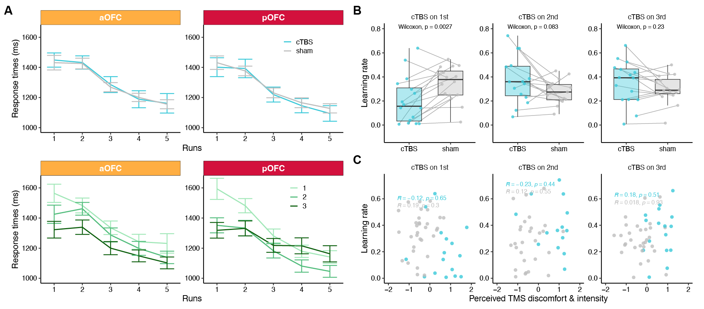

**Extended Data Fig. 1. Supplementary results on cTBS effect on discrimination learning.** **A.** Change of response times across runs. **B.** Effect of cTBS on estimated learning rates, separated by Day 1 TMS order. **C.** Scatter plots showing the relationship between estimated learning rates and perceived TMS discomfort/intensity, separated by Day 1 TMS order.

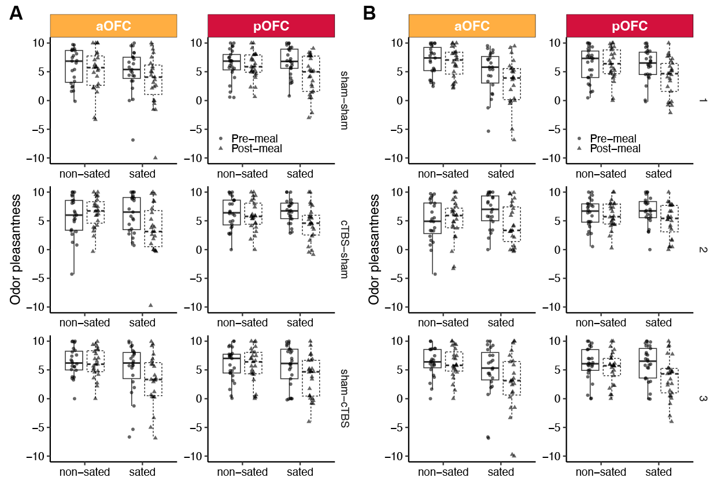

**Extended Data Fig. 2. Supplementary results on odor pleasantness ratings.** **A.** Odor pleasantness ratings separated by TMS conditions and stimulation locations. **B.** Odor pleasantness ratings separated by session numbers and stimulation locations.

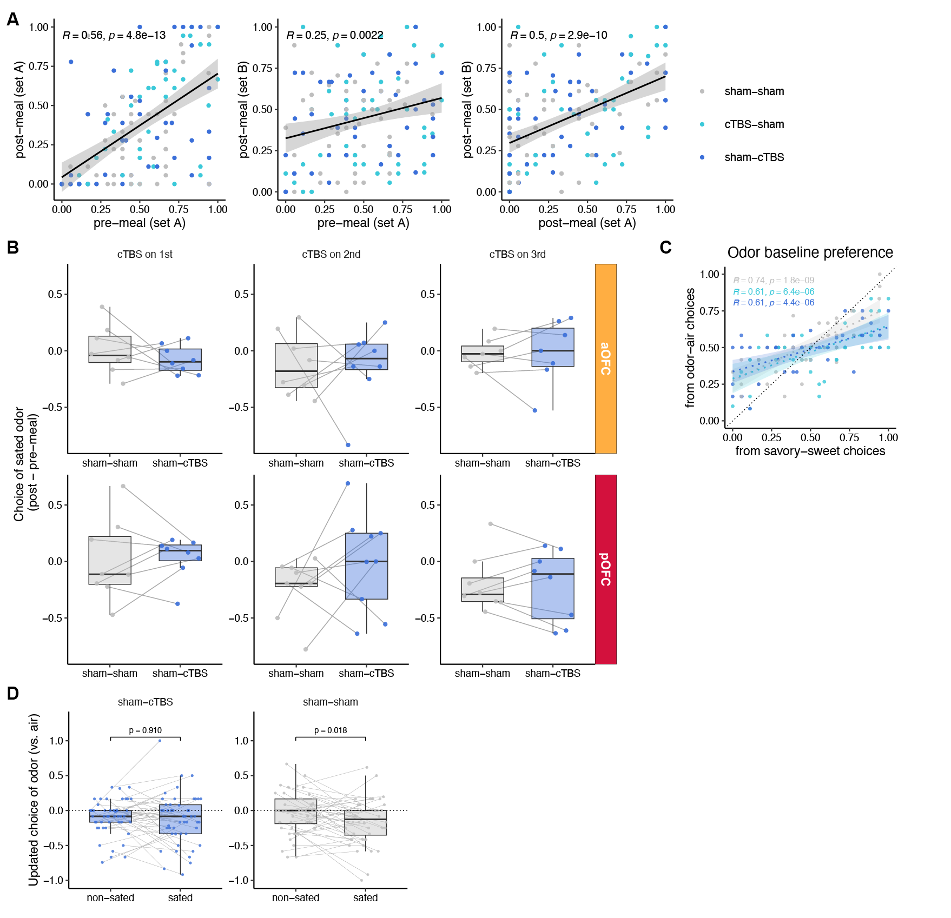

**Extended Data Fig. 3. Supplementary results of Day 2 cTBS effect. A.** Scatter plots showing high correlations of the choice for selecting sated odors across post-meal, pre-meal, set A and set B. **B.** Choice of sated odors for participants experiencing different Day 2 TMS orders within each stimulation location group (aOFC and pOFC). **C.** Correlation of the baseline odor preference. **D.** Change in the choice of odors during odor-air choices, separated by sham-cTBS and sham-sham TMS conditions and sated/non-sated odors.

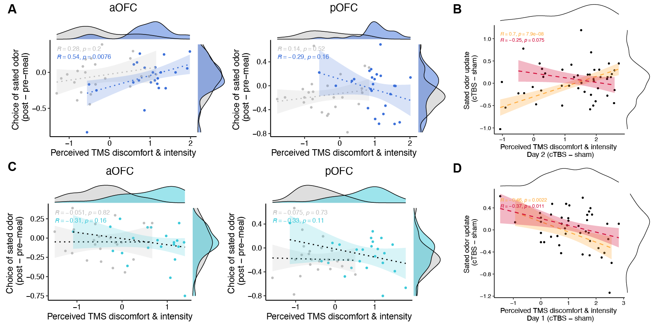

**Extended Data Fig. 4. Correlations between TMS effect on choice behaviors and perceived TMS discomfort and intensity. A.** Scatter plot showing the relationship between the choice of sated odors and perceived TMS discomfort/intensity, separated by Day 2 TMS conditions and cTBS targeted locations (aOFC, pOFC). **B.** Scatter plot showing the relationship between the condition-wise difference of choice of sated odors and condition-wise difference of perceived TMS discomfort/intensity from Day 2 TMS. **C.** Scatter plot showing the relationship between the choice of sated odors and perceived TMS discomfort/intensity, separated by Day 1 TMS conditions and cTBS targeted locations (aOFC, pOFC). D. Scatter plot showing the relationship between the condition-wise difference of choice of sated odors and condition-wise difference of perceived TMS discomfort/intensity from Day 1 TMS.

#### **References**

1 Daw, N. D., Niv, Y. & Dayan, P. Uncertainty-based competition between prefrontal and dorsolateral striatal systems for behavioral control. *Nat Neurosci* **8**, 1704-1711 (2005).

2 Behrens, T. E. *et al.* What is a cognitive map? Organizing knowledge for flexible behavior. *Neuron* **100**, 490-509 (2018).

3 Wilson, R. C., Takahashi, Y. K., Schoenbaum, G. & Niv, Y. Orbitofrontal cortex as a cognitive map of task space. *Neuron* **81**, 267-279 (2014).

4 Wang, M. Z. & Hayden, B. Y. Latent learning, cognitive maps, and curiosity. *Curr Opin Behav Sci* **38**, 1-7 (2021). <https://doi.org/10.1016/j.cobeha.2020.06.003>

5 Howard, J. D. *et al.* Targeted Stimulation of Human Orbitofrontal Networks Disrupts Outcome-Guided Behavior. *Current Biology* **30**, 490-498.e494 (2020). <https://doi.org/10.1016/j.cub.2019.12.007>

6 Rudebeck, Peter H. & Murray, Elisabeth A. The Orbitofrontal Oracle: Cortical Mechanisms for the Prediction and Evaluation of Specific Behavioral Outcomes. *Neuron* **84**, 1143-1156 (2014). <https://doi.org/10.1016/j.neuron.2014.10.049>

7 Price, J. L. Definition of the orbital cortex in relation to specific connections with limbic and visceral structures and other cortical regions. *Annals of the New York Academy of Sciences* **1121**, 54-71 (2007).

8 Wallis, J. D. Cross-species studies of orbitofrontal cortex and value-based decision-making. *Nat Neurosci* **15**, 13-19 (2012).

9 Kahnt, T., Chang, L. J., Park, S. Q., Heinzle, J. & Haynes, J.-D. Connectivity-based parcellation of the human orbitofrontal cortex. *Journal of Neuroscience* **32**, 6240-6250 (2012).

10 Izquierdo, A. Functional heterogeneity within rat orbitofrontal cortex in reward learning and decision making. *Journal of Neuroscience* **37**, 10529-10540 (2017).

11 Wang, M. Z., Hayden, B. Y. & Heilbronner, S. R. A structural and functional subdivision in central orbitofrontal cortex. *Nat Commun* **13**, 3623 (2022). <https://doi.org/10.1038/s41467-022-31273-9>

12 Heilbronner, S. R., Rodriguez-Romaguera, J., Quirk, G. J., Groenewegen, H. J. & Haber, S. N. Circuit-based corticostriatal homologies between rat and primate. *Biological psychiatry* **80**, 509-521 (2016).

13 Walton, M. E., Behrens, T. E., Noonan, M. P. & Rushworth, M. F. Giving credit where credit is due: orbitofrontal cortex and valuation in an uncertain world. *Annals of the New York Academy of Sciences* **1239**, 14-24 (2011).

14 Mackey, S. & Petrides, M. Quantitative demonstration of comparable architectonic areas within the ventromedial and lateral orbital frontal cortex in the human and the macaque monkey brains. *Eur J Neurosci* **32**, 1940-1950 (2010). <https://doi.org/10.1111/j.1460-9568.2010.07465.x>

15 Kringelbach, M. L. & Rolls, E. T. The functional neuroanatomy of the human orbitofrontal cortex: evidence from neuroimaging and neuropsychology. *Prog Neurobiol* **72**, 341-372 (2004). <https://doi.org/10.1016/j.pneurobio.2004.03.006>

16 Colwill, R. M. & Rescorla, R. A. Postconditioning devaluation of a reinforcer affects instrumental responding. *Journal of experimental psychology: animal behavior processes* **11**, 120 (1985).

17 Balleine, B. W. & Dickinson, A. Goal-directed instrumental action: contingency and incentive learning and their cortical substrates. *Neuropharmacology* **37**, 407-419 (1998).

18 Baxter, M. G., Parker, A., Lindner, C. C., Izquierdo, A. D. & Murray, E. A. Control of response selection by reinforcer value requires interaction of amygdala and orbital prefrontal cortex. *Journal of Neuroscience* **20**, 4311-4319 (2000).

19 Murray, E. A., Moylan, E. J., Saleem, K. S., Basile, B. M. & Turchi, J. Specialized areas for value updating and goal selection in the primate orbitofrontal cortex. *elife* **4**, e11695 (2015).

20 Critchley, H. D. & Rolls, E. T. Hunger and satiety modify the responses of olfactory and visual neurons in the primate orbitofrontal cortex. *Journal of Neurophysiology* **75**, 1673-1686 (1996).

21 O'doherty, J. *et al.* Sensory-specific satiety-related olfactory activation of the human orbitofrontal cortex. *Neuroreport* **11**, 893-897 (2000).

22 Gottfried, J. A., O'Doherty, J. & Dolan, R. J. Encoding predictive reward value in human amygdala and orbitofrontal cortex. *Science* **301**, 1104-1107 (2003). <https://doi.org/10.1126/science.1087919>

23 Howard, J. D. & Kahnt, T. Identity-Specific Reward Representations in Orbitofrontal Cortex Are Modulated by Selective Devaluation. *J. Neurosci.* **37**, 2627-2638 (2017). <https://doi.org/10.1523/JNEUROSCI.3473-16.2017>

24 Howard, J. D. & Kahnt, T. Causal investigations into orbitofrontal control of human decision making. *Current Opinion in Behavioral Sciences* **38**, 14-19 (2021).

25 Gallagher, M., McMahan, R. W. & Schoenbaum, G. Orbitofrontal cortex and representation of incentive value in associative learning. *Journal of Neuroscience* **19**, 6610-6614 (1999).

26 Pickens, C. L. *et al.* Different roles for orbitofrontal cortex and basolateral amygdala in a reinforcer devaluation task. *Journal of Neuroscience* **23**, 11078-11084 (2003).

27 Ostlund, S. B. & Balleine, B. W. Orbitofrontal cortex mediates outcome encoding in Pavlovian but not instrumental conditioning. *Journal of Neuroscience* **27**, 4819-4825 (2007).

28 Costa, K. M. *et al.* The role of the lateral orbitofrontal cortex in creating cognitive maps. *Nat Neurosci* **26**, 107-115 (2023).

29 Myung, J. I., Karabatsos, G. & Iverson, G. J. A Bayesian approach to testing decision making axioms. *Journal of Mathematical Psychology* **49**, 205-225 (2005).

30 Spiegelhalter, D. J., Best, N. G., Carlin, B. P. & Van Der Linde, A. Bayesian measures of model complexity and fit. *Journal of the royal statistical society: Series b (statistical methodology)* **64**, 583-639 (2002).

31 Stoll, F. M. & Rudebeck, P. H. Dissociable representations of decision variables within subdivisions of macaque orbitofrontal and ventrolateral frontal cortex. *bioRxiv* (2024).

32 Rich, E. L. & Wallis, J. D. Spatiotemporal dynamics of information encoding revealed in orbitofrontal high-gamma. *Nat Commun* **8**, 1139 (2017).

33 Vaidya, A. R. & Badre, D. Abstract task representations for inference and control. *Trends in Cognitive Sciences* **26**, 484-498 (2022).

34 Zhou, J. *et al.* Complementary task structure representations in hippocampus and orbitofrontal cortex during an odor sequence task. *Current Biology* **29**, 3402-3409. e3403 (2019).

35 Schuck, N. W., Cai, M. B., Wilson, R. C. & Niv, Y. Human orbitofrontal cortex represents a cognitive map of state space. *Neuron* **91**, 1402-1412 (2016).

36 Tolman, E. C. Cognitive maps in rats and men. *Psychological Review* **55**, 189 (1948).

37 O'keefe, J. & Nadel, L. *The hippocampus as a cognitive map*. (Oxford university press, 1978).

38 Kidd, C. & Hayden, B. Y. The Psychology and Neuroscience of Curiosity. *Neuron* **88**, 449-460 (2015). <https://doi.org/10.1016/j.neuron.2015.09.010>

39 Howard, J. D., Gottfried, J. A., Tobler, P. N. & Kahnt, T. Identity-specific coding of future rewards in the human orbitofrontal cortex. *Proceedings of the National Academy of Sciences* **112**, 5195-5200 (2015). <https://doi.org/10.1073/pnas.1503550112>

40 Howard, J. D. & Kahnt, T. Identity prediction errors in the human midbrain update reward-identity expectations in the orbitofrontal cortex. *Nat Commun* **9**, 1611 (2018). <https://doi.org/10.1038/s41467-018-04055-5>

41 Liu, Q. *et al.* Midbrain signaling of identity prediction errors depends on orbitofrontal cortex networks. *Nat Commun* **15**, 1704 (2024). <https://doi.org/10.1038/s41467-024-45880-1>

42 McDannald, M. A. *et al.* Orbitofrontal neurons acquire responses to ‘valueless’ Pavlovian cues during unblocking. *Elife* **3**, e02653 (2014).

43 Namboodiri, V. M. K. *et al.* Single-cell activity tracking reveals that orbitofrontal neurons acquire and maintain a long-term memory to guide behavioral adaptation. *Nat Neurosci* **22**, 1110-1121 (2019).

44 Murray, E. A., O'Doherty, J. P. & Schoenbaum, G. What we know and do not know about the functions of the orbitofrontal cortex after 20 years of cross-species studies. *Journal of Neuroscience* **27**, 8166-8169 (2007).

45 Delamater, A. R. The Role of the Orbitofrontal Cortex in Sensory-Specific Encoding of Associations in Pavlovian and Instrumental Conditioning. *Annals of the New York Academy of Sciences* **1121**, 152-173 (2007). <https://doi.org/10.1196/annals.1401.030>

46 Panayi, M. C. & Killcross, S. The role of the rodent lateral orbitofrontal cortex in simple Pavlovian cue-outcome learning depends on training experience. *Cerebral Cortex Communications* **2**, tgab010 (2021).

47 Harlow, H. F. The formation of learning sets. *Psychol Rev* **56**, 51-65 (1949). <https://doi.org/10.1037/h0062474>

48 Fernandez, B., Leuchs, L., Samann, P. G., Czisch, M. & Spoormaker, V. I. Multi-echo EPI of human fear conditioning reveals improved BOLD detection in ventromedial prefrontal cortex. *NeuroImage* **156**, 65-77 (2017). <https://doi.org/10.1016/j.neuroimage.2017.05.005>

49 Poser, B. A., Versluis, M. J., Hoogduin, J. M. & Norris, D. G. BOLD contrast sensitivity enhancement and artifact reduction with multiecho EPI: parallel-acquired inhomogeneity-desensitized fMRI. *Magn Reson Med* **55**, 1227-1235 (2006). <https://doi.org/10.1002/mrm.20900>

50 Kirilina, E., Lutti, A., Poser, B. A., Blankenburg, F. & Weiskopf, N. The quest for the best: The impact of different EPI sequences on the sensitivity of random effect fMRI group analyses. *NeuroImage* **126**, 49-59 (2016). <https://doi.org/10.1016/j.neuroimage.2015.10.071>

51 Zhao, L. S., Raithel, C. U., Tisdall, D., Detre, J. A. & Gottfried, J. A. Leveraging Multi-echo EPI to Enhance BOLD Sensitivity in Task-based Olfactory fMRI. *bioRxiv*, 2024.2001. 2015.575530 (2024).

52 Wang, F., Howard, J. D., Voss, J. L., Schoenbaum, G. & Kahnt, T. Targeted Stimulation of an Orbitofrontal Network Disrupts Decisions Based on Inferred, Not Experienced Outcomes. *J. Neurosci.* **40**, 8726-8733 (2020). <https://doi.org/10.1523/JNEUROSCI.1680-20.2020>

53 Tegelbeckers, J., Porter, D. B., Voss, J. L., Schoenbaum, G. & Kahnt, T. Lateral orbitofrontal cortex integrates predictive information across multiple cues to guide behavior. *Current Biology* **33**, 4496-4504. e4495 (2023).

54 Power, J. D., Barnes, K. A., Snyder, A. Z., Schlaggar, B. L. & Petersen, S. E. Spurious but systematic correlations in functional connectivity MRI networks arise from subject motion. *NeuroImage* **59**, 2142-2154 (2012). <https://doi.org/10.1016/j.neuroimage.2011.10.018>