Distinct contributions of anterior and posterior orbitofrontal cortex to outcome-guided behavior

Qingfang Liu1, Daria Porter2, Hadeel Damra2, Yao Zhao3, Joel L. Voss4, Geoffrey Schoenbaum1, Thorsten Kahnt1*

1*National Institute on Drug Abuse Intramural Research Program, Baltimore, 21224, MD, USA.

2Feinberg School of Medicine, Northwestern University, Chicago, 60611, IL, USA.

3Department of Psychology, University of Pennsylvania, Philadelphia, 19104, PA, USA.

4Department of Neurology, The University of Chicago, Chicago, 60611, IL, USA.

*Corresponding author(s). E-mail(s): thorsten.kahnt@nih.gov;

**Abstract**

The lateral orbitofrontal cortex (OFC) is critical for flexibly adjusting choices when outcome values change. Anterior and posterior parts of the human lateral OFC differ in cytoarchitecture and connectivity, but whether these subregions make differential contributions to outcome-guided (i.e., goal-directed) behavior remains unclear. Outcome-guided behavior requires (a) representations of stimulus–outcome associations and (b) inferring the current value of outcomes when making decisions. Here, we test whether these two functions are differentially supported by the posterior (pOFC) and anterior (aOFC) parts of the lateral OFC, using transcranial magnetic stimulation (TMS) to selectively disrupt activity in functional networks centered on the pOFC and aOFC during a two-day outcome devaluation task. Participants (n = 48) received pOFC- or aOFC network-targeted TMS either on day 1 before learning associations between visual stimuli and sweet or savory food odor rewards, or on day 2 before a meal that selectively devalued one of these rewards, followed by a probe choice test. TMS targeting pOFC, but not aOFC, before the meal on day 2 disrupted outcome guided behavior, as measured by choices of stimuli predicting non-sated rewards in the probe test. In contrast, TMS targeting aOFC, but not pOFC, before learning on day 1 similarly impaired choices in the probe test on day 2. These findings demonstrate that anterior and posterior parts of the lateral OFC make distinct contributions to outcome-guided behavior by supporting the learning of stimulus–outcome associations and the inference of current outcome values, respectively.

**Keywords:** outcome-guided behavior, goal-directed behavior, cognitive map, orbitofrontal cortex

# 1 Introduction

Humans and animals effortlessly adapt to changing environments by flexibly adjusting their behavior. This adaptability relies on outcome-guided (i.e., goal-directed) decision-making, where individuals can re-evaluate their choices in real time, simulating potential outcomes based on changes in outcome value [1] rather than defaulting to habitual responses. For example, a restaurant chef might anticipate that a guest could experience an allergic reaction to certain ingredients and adjust the dish accordingly before an issue arises. To enable this flexibility, a detailed representation of the environment—commonly referred to as a cognitive map or model—is essential [2]. A chef with full knowledge of ingredients and associated allergies can efficiently modify recipes to accommodate allergies without compromising the dish. The orbitofrontal cortex (OFC) plays a central role in both processes, supporting adaptive behaviors through the formation of cognitive maps [3–5] as well as their use to simulate potential outcomes [6, 7].

The OFC is a heterogeneous region, comprising multiple subregions with varying anatomical and functional properties along both mediolateral and anterior-posterior axes [8–17]. In humans, studies on value-based decision-making have primarily focused on the functional distinctions between the medial and lateral OFC [9, 10, 14, 16, 18–20], whereas the anterior-posterior axis has received comparatively less attention.

The current study aims to identify the distinct roles of anterior and posterior subregions within the lateral OFC in supporting adaptive behavior in an outcome devaluation task [4, 6, 21–32]. Outcome devaluation assesses responses to predictive cues following the selective devaluation of their associated outcomes, thereby revealing the capacity to align choices with updated goals and contexts. In outcome-specific versions of this task, different stimuli are first associated with different but equally preferred rewards. Next, one of the outcomes is selectively devalued (for instance by feeding it to satiety), and then choices between stimuli are assessed in a probe test. While earlier theories emphasized the role of the OFC in signaling the current value of stimuli to guide response selection [23], more recent accounts propose two complementary roles: one in using mental simulations to infer or update the value of outcome-predicting stimuli [4, 6, 24], and another in forming the specific associations that link predictive stimuli to outcomes during initial learning [3, 33]. In the current work, we focus on these latter two mechanisms, proposing a unified framework that integrates them within the lateral OFC and empirically testing for functional specialization across subregions.

Previous studies in non-human primates suggest that anterior and posterior regions of the OFC support distinct functions in outcome-guided behavior [24]. Our earlier work further demonstrated that the posterior OFC is critical for retrieving and using stimulus–outcome associations [6]. Building on these findings, we hypothesized that the anterior and posterior lateral OFC subregions are differentially involved in separate phases of the outcome devaluation task: the anterior OFC during acquisition of stimulus–outcome associations, and the posterior OFC during their retrieval and use in guiding choices. To test this, we applied network-targeted transcranial magnetic stimulation (TMS) with continuous theta burst stimulation (cTBS) either before intial training or before the probe test, in a multi-session within-participant study. This approach allowed us to test the specific roles of anterior and posterior portions of the lateral OFC network for learning associative structures and guiding choices based on current values.

Our findings reveal distinct roles for the anterior and posterior lateral OFC networks in outcome-guided behavior. Disruption of the posterior but not anterior lateral OFC network before the probe test impaired adaptive choices, whereas disruption of the anterior but not posterior lateral OFC before initial learning similarly impaired subsequent outcome-guided choices in the probe test. Additionally, cTBS targeting either region disrupted value acquisition, but only during the first session. Together, these results suggest that anterior and posterior lateral OFC networks play complementary roles for outcome-guided behavior, supporting the acquisition and use of outcome-specific stimulus-reward associations, respectively.

# 2 Results

**2.1 Experimental design and outcome devaluation task.**

This study follows a within-participant, multiple-session design, with 48 healthy human participants completing a two-day experiment, repeated across three separate sessions (spaced at least one week apart; Figure 1A). Each session involves the delivery of either cTBS on one day and sham TMS on the other, or sham TMS on both days, resulting in three conditions (Day 1-Day 2: cTBS-sham, sham-cTBS, sham-sham, order counterbalanced; Figure 1D).

On Day 1, participants learned to discriminate pairs of visual stimuli associated with desirable food odors (sweet or savory, equally valued based on pre-task ratings; Figure 1E) and clean air. They were asked to select the stimulus associated with any odor, meaning they were not required to encode the specific stimulus-outcome identity associations to perform the discrimination task (Figure 1B, C). On Day 2, participants chose between stimuli based on odor preferences, making choices between stimuli predicting sweet and savory odors, or between stimuli predicting odor and air. A pre-meal free choice task was followed by a meal, then by a post-meal free choice task. Participants received the odors during the Day 1 discrimination task and the Day 2 pre-meal free choice task. No odors were delivered during Day 2 post-meal free choice task. Participants also reported how much they liked each odor before and after the meal.

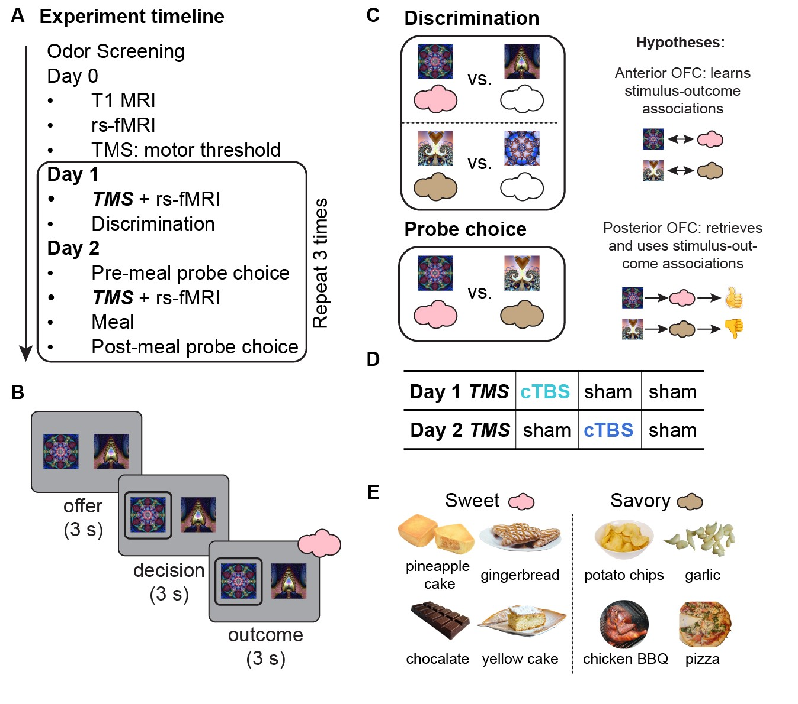

**Fig. 1**: **Experimental design and outcome devaluation task. A. Experiment timeline.** Following odor screening, participants completed T1 MRI, resting-state fMRI, and TMS motor threshold determination on Day 0. On Day 1, they received either continuous theta burst stimulation (cTBS) or sham TMS before a discrimination task. On Day 2, they performed a pre-meal free choice task, received TMS (cTBS or sham), consumed a meal, and then completed a post-meal free choice task. **B. Trial structure of discrimination and choice tasks.** Each trial started with an offer phase (3 s), presenting two visual stimuli paired with different outcomes, followed by a decision phase (maximum 3 s) where participants selected one stimulus. In the discrimination task, the trial concluded with an outcome phase (3 s) where participants received an odor or no odor, depending on their choice. **C. Task structure.** In the discrimination task, participants learned which stimuli predicted odors (colored clouds) versus non-odor (i.e., clean air, empty clouds) outcomes. In the free choice task, participants selected stimuli based on learned odor associations and their odor preference, but without immediate odor delivery. The free choice task also included trials comparing odor-predictive and non-odor-predictive stimuli, similar to the discrimination task. **D. TMS conditions.** Participants were assigned to one of three counterbalanced conditions: (1) cTBS on Day 1, sham on Day 2 (cTBS-sham), (2) sham on Day 1, cTBS on Day 2 (sham-cTBS), and (3) sham on both days (shamsham). **E. Odor stimuli.** Eight food-related odors (savory and sweet). One savory and one sweet odor was selected per participant to match pleasantness ratings.

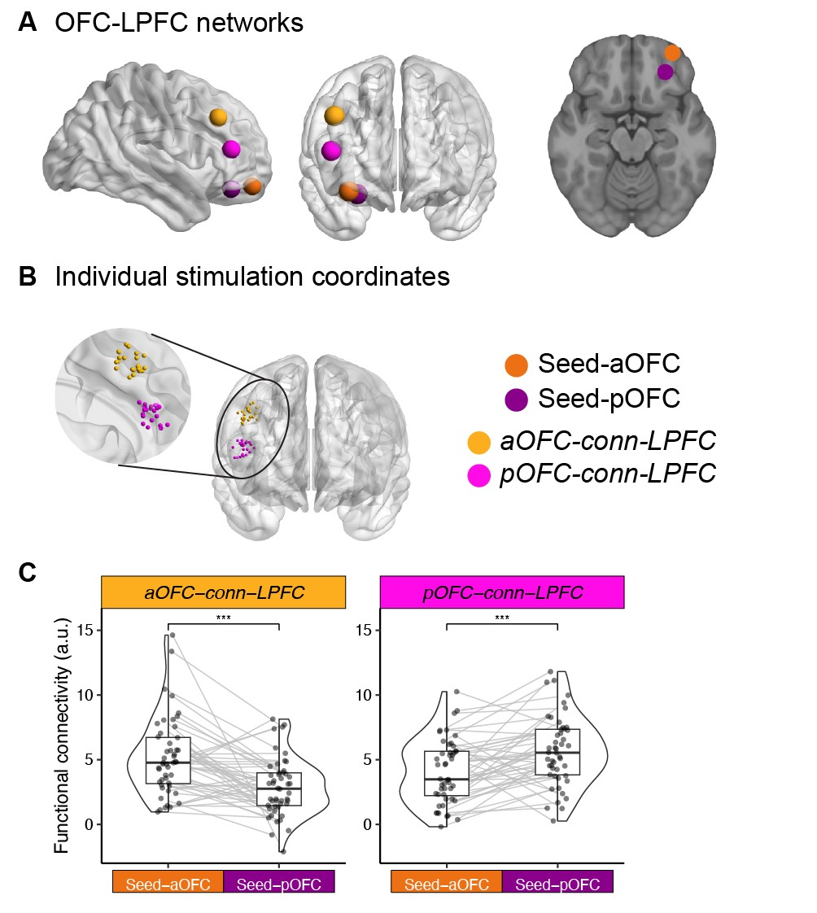

**Fig. 2**: **Network-targeted cTBS. A. OFC-LPFC networks.** Seed regions in the anterior (aOFC; tangerine, MNI coordinates: [34, 54, –14]) and posterior OFC (pOFC; magenta, MNI coordinates: [28, 38, –16]), along with their corresponding connectivitybased target regions in the lateral prefrontal cortex (LPFC), are shown on cortical surface renderings. Brain visualizations were generated using BrainNet Viewer [34], and the axial slice corresponds to *z* = −16 in MNI space. **B. Individual stimulation coordinates.** LPFC stimulation sites were individually selected to maximize functional connectivity with either the aOFC or pOFC seed region. The zoomed view shows the distribution of stimulation coordinates across participants, color-coded by group. **C. Functional connectivity estimates.** Half-violin plots depict the distribution of resting-state functional connectivity between LPFC stimulation sites and each OFC seed region. Each dot represents an individual participant’s connectivity estimate, and gray lines connect paired within-subject values across seed regions. Boxplots indicate the median and interquartile range. Asterisks denote significant differences between connectivity patterns (***p *<* 0.001).

To explore the potentially distinct functional roles of OFC subregions in this task, TMS was administered at two different time points—either before the discrimination task on Day 1 or before the meal on Day 2 (Figure 1A)—and targeted either the anterior (aOFC) or posterior (pOFC) portions of the lateral OFC in different groups of subjects (Figure 2A). Stimulation targets were defined using MNI coordinates in the right hemisphere: aOFC at [34, 54, -14] and pOFC at [28, 38, -16]. Each target showed strong functional connectivity with isolated lateral prefrontal cortex (LPFC) ROIs (referred to as aOFC-conn-LPFC and pOFC-conn-LPFC, respectively). Based on resting-state fMRI data collected on Day 0, we individually selected LPFC stimulation sites with the highest connectivity to the respective aOFC or pOFC targets (Figure 2B). We confirmed the functional separation of these networks across all resting-state fMRI sessions: the aOFC-conn-LPFC showed stronger connectivity with the aOFC than the pOFC (*W* = 988, *p* = 1*.*57*e* − 5, Wilcoxon signed rank test, twosided), and the pOFC-conn-LPFC showed stronger connectivity with the pOFC than the aOFC (*W* = 936, *p* = 2*.*23*e* − 4) (Figure 2C).

**2.2 Discrimination learning and selective satiation effects.**

On Day 1, participants completed a discrimination task in which they selected, from pairs of stimuli, the one associated with desirable food odors (vs. clean air). Over five runs, participants in both aOFC and pOFC groups showed significant improvement in choosing odor-predictive stimuli, indicating successful value acquisition (Figure 3A; *p <* 2*.*2 × 10−16).

To evaluate the effectiveness of selective satiation—induced by feeding participants an odor-matched meal on Day 2—we first examined changes in rated odor pleasantness from before to after the meal. There was a robust effect of selective satiation on the change in odor pleasantness ratings (post-meal minus pre-meal) (*p* = 2*.*75*e* − 13, Figure 3B). Specifically, sated odors showed a larger decrease in pleasantness compared to non-sated ones. This reduction was unaffected by TMS condition (sham vs. cTBS, Day 2), stimulation target (aOFC vs. pOFC), session number (1st, 2nd, 3rd), or sated odor type (savory/sweet) (all *p >* 0*.*05; Figure S1). Consistent with previous findings [6, 35, 36], these results suggest that OFC lesions or disrupting OFC function with TMS did not impair participants’ ability to update the value of reward outcomes.

We then assessed whether selective satiation changed task behavior by analyzing choices between stimuli predictive of sated (SA) and non-sated (NS) odors in novel savory-sweet stimulus pairs not used during Day 1 training. Collapsing across sessions, participants made significantly fewer SA choices post-meal compared to pre-meal, both in the aOFC (Wilcoxon signed rank test, one-sided, *p* = 0*.*024) and in the pOFC (*p* = 2*.*3*e*−3) groups (Figure 3C), confirming an effect of selective satiation on probe choices. SA choices were significantly correlated with the pleasantness difference between sated and non-sated odors, both before and after the meal (Figure S2A, B), indicating that choices reflected relative odor preferences as expected.

To quantify the behavioral impact of subjective value changes, we computed a “selective satiation index” by subtracting the change in pleasantness ratings for non-sated odors from those for sated odors (post-meal minus pre-meal). This index was significantly correlated with the corresponding change in SA choices (Pearson’s

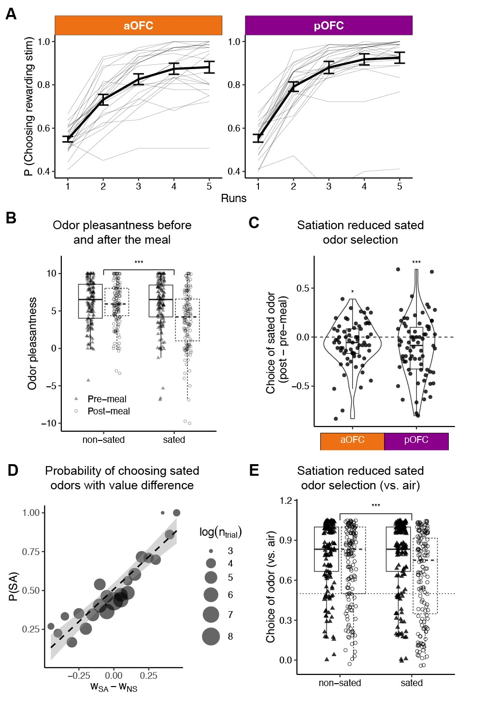

**Fig. 3**: **Discrimination learning and selective satiation effects. A**. Participants learned to select odor-predictive stimuli over five runs of the Day 1 discrimination task, shown separately for the aOFC and pOFC groups. Thin gray lines represent the average learning trajectories of individual participants. **B**. Rated pleasantness of sated and non-sated odors before and after the meal. Pleasantness decreased significantly for sated odors post-meal, consistent with selective satiation. **C.** Change in choice proportion for sated odors in sweet–savory trials from pre- to post-meal, across three sessions, for both aOFC- and pOFC-targeted stimulation. **D.** Probability of choosing the sated odor stimulus as a function of the estimated value difference between the sated and non-sated options (*wSA* − *wNS*). Dot size reflects the number of trials (log-scaled) at each value bin. **E.** Choice between odors and clean air, for sated and non-sated odors, before and after the meal. The p-value reflects a likelihood ratio test evaluating the interaction between odor type (sated vs. non-sated) and meal timing (pre vs. post), based on a trial-wise mixed-effects model.

*r* = 0*.*46, *p* = 8*.*3 × 10−4; Figure S2C), further supporting a link between subjective devaluation and behavioral change.

Although not part of our original hypothesis—and rarely examined in outcome devaluation studies—we found that individual choices were also influenced by the learned value of each stimulus. Because learning on Day 1 was not perfect and likely varied across participants, sessions, and stimuli, we used a Rescorla-Wagner model to estimate individual stimulus values to capture this variability (see Section 2.5 for details). The probability of choosing the SA over the NS option increased significantly with the value difference between the two stimuli (*wSA* − *wNS*) (Pearson’s *r* = 0*.*92, *p* = 3*.*49*e* − 10; Figure 3D, Figure S2B). Accordingly, when evaluating the effects of cTBS (applied on Day 1 or Day 2) on SA choices during Day 2, we included both the learned value difference (*wSA* − *wNS*) and the selective satiation index as regressors to account for factors influencing behavior beyond the effects of TMS.

Finally, we analyzed choices between stimuli where one predicted an odor and the other predicted clean air—pairings learned during the Day 1 discrimination task. Across sessions, participants showed a significant post-meal reduction in choosing odor-predictive stimuli (*p <* 2*.*2*e*−16), with a significantly greater reduction for stimuli predictive of the sated versus non-sated odor (*p* = 1*.*187*e* − 6) (Figure 3E).

## 2.3 Posterior, but not anterior, OFC-targeted cTBS before the free choice impairs outcome devaluation

To examine the role of the aOFC and pOFC in outcome devaluation during the test phase, we focused on the “sham-sham” and “sham-cTBS” TMS conditions. We found a significant interaction between stimulation target (aOFC vs. pOFC) and TMS condition (sham vs. cTBS on Day 2, Day 1 fixed at sham) in predicting SA choices (*p* = 0*.*00548), according to mixed-effects logistic models on post-meal SA choices, with the session odor preference baseline, satiation status, and the value difference (*wSA* − *wNS*) accounted for. We further separately analyzed the aOFC and pOFC group (Figure 4B) and found that cTBS significantly increased SA choices — indicating poorer adaptation to the updated value of the outcomes — only in the pOFC group (*p* = 0*.*00034), but not in the aOFC group (*p* = 0*.*655). Additionally, we confirmed that the effect of pOFC-targeted cTBS on SA choices remained robust regardless of session order.

We conducted additional analyses to assess whether the effect of TMS on SA choices was driven by other factors, such as satiation status or perceived TMS discomfort or intensity. The across-participant correlations between pleasantness ratings and SA choices were unchanged by Day 2 cTBS (all *p >* 0*.*05; Figure S2C), suggesting that the effect of Day 2 cTBS on SA choices was not modulated by satiation status. Moreover, the changes in SA choices induced by cTBS could not be explained by perceived TMS discomfort or intensity, as incorporating TMS ratings into the regression models did not alter any of the findings (Figure S4). We also examined participants’ choices between an odor and clean air to assess potential TMS effects, but found no significant effects in either the aOFC or pOFC group.

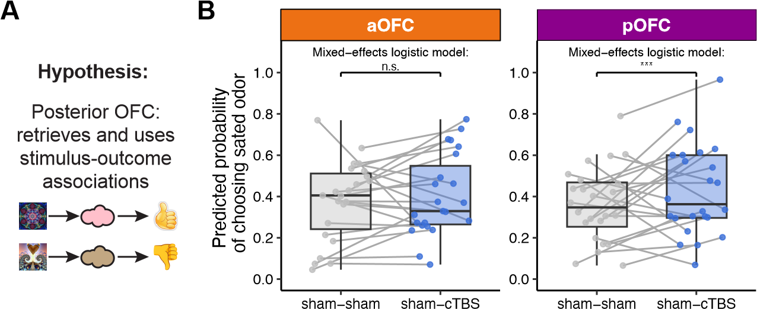

**Fig. 4**: **Posterior, but not anterior, OFC-targeted cTBS before the free choice impaired outcome devaluation**. **A**. Hypothesis: the posterior OFC (pOFC) is involved in retrieving and using stimulus–outcome associations to guide choices. **B**. Predicted probability of choosing the sated odors under sham–sham and sham–cTBS conditions, shown separately for anterior (aOFC, tangerine) and posterior (pOFC, magenta) OFC-targeting groups. Each dot represents a participant’s average predicted probability, and gray lines connect values from the same participant across conditions. Box plots show group-level distributions of fitted values. Statistical comparisons were conducted using trial-wise mixed-effects logistic regression controlling for baseline odor preference, satiation status, and value difference between sated and non-sated options (*wSA* − *wNS*). A significant increase in sated odor choice was observed following Day 2 pOFC cTBS (***), but no effect in the aOFC group (n.s.).

Together, this suggests that pOFC-targeted cTBS before the free choice phase impaired outcome devaluation, as indicated by the continued selection of sated odorpredicting stimuli. In contrast, aOFC-targeted cTBS had no such effect, highlighting the specificity of the pOFC involvement.

## 2.4 Anterior, but not posterior, OFC targeted cTBS before discrimination learning impaired subsequent outcome devaluation

We explored whether cTBS targeting aOFC and pOFC before learning could affect outcome devaluation measured on Day 2, as would be expected if cTBS disrupted the latent learning of stimulus-reward identity associated during discrimination training (Figure 5A).

To assess Day 1 cTBS effect on post-meal choices of sated odors on sweet-savory choices, we focused on “sham-sham” and “cTBS-sham” conditions. For the aOFC group, both TMS condition and session number significantly influenced post-meal sated odor choices, with a significant interaction between the two. Specifically, the cTBS-sham condition significantly increased the selection of sated odors (Figure 5B; *β*ˆ = 1*.*527, SE = 0.625, *p* = 0*.*015), and this effect diminished over sessions (*β*ˆ = −0*.*657, SE = 0.290, *p* = 0*.*024). Choices also increased with session number (*β*ˆ =

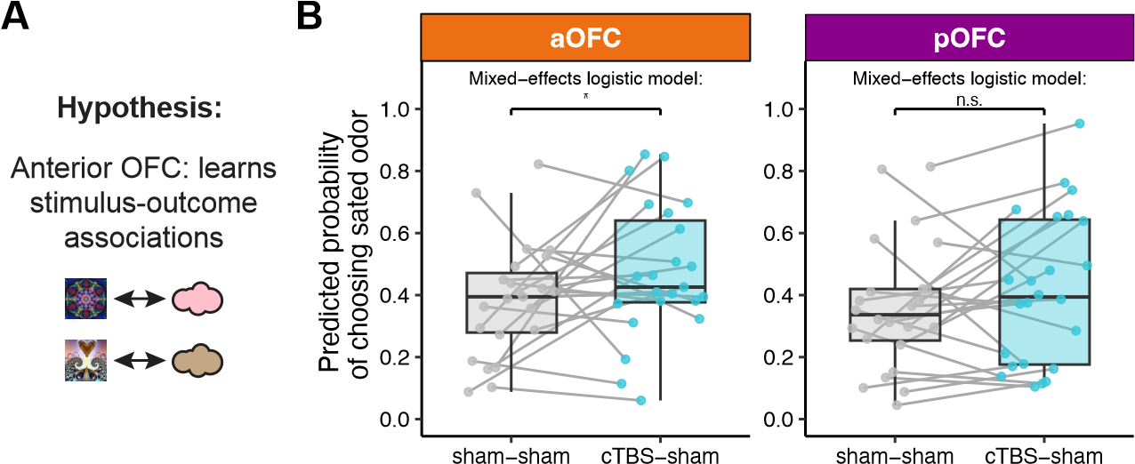

**Fig. 5**: **Anterior, but not posterior, OFC-targeted cTBS on Day 1 impaired subsequent outcome devaluation**. **A**. Hypothesis: the anterior OFC (aOFC) is involved in learning stimulus–outcome associations. **B**. Predicted probability of choosing the sated odor in the post-meal test, compared between sham–sham and cTBS–sham sessions, separately for anterior (aOFC, tangerine) and posterior (pOFC, magenta) targeting groups. Each dot represents a participant’s average predicted probability, with gray lines connecting values from the same participant across conditions. Box plots indicate the group-level distribution of fitted values. Statistical comparisons were conducted using trial-wise mixed-effects logistic regression, controlling for value difference, pre-meal odor preference, and selective satiation effects. A significant increase in sated odor choice was observed following Day 1 aOFC cTBS (*), but no effect in the pOFC group (n.s.).

0*.*550, SE = 0.165, *p* = 8*.*5*e*−5). Similar to how we examined Day 2 effect, these effects were with the session odor preference baseline, satiation status, and the value difference (*wSA* −*wNS*) accounted for, and those covariates were significant predictors. Overall, aOFC-targeted cTBS on Day 1 increased post-meal choices of stimuli predicting sated odors, with the effect moderated by session number.

In contrast, similar analyses in the pOFC group revealed no significant difference between the sham-sham and cTBS-sham stimulation conditions (Figure 5B; *p* = 0*.*24). Pre-meal odor preference and value difference were significant predictors of post-meal choices, while the selective satiation index was not (*p >* 0*.*05). Additionally, no interaction between stimulation targeted location (aOFC vs. pOFC) and TMS condition (sham-sham vs. cTBS-sham) was identified (*p* = 0*.*37).

These findings support our hypothesis that the aOFC plays a critical role in learning the specific stimulus-outcome associations on Day 1, even when the task does not explicitly require it (i.e., latent learning). Notably, this result is independent of the Day 2 TMS, emphasizing the aOFC’s importance in constructing cognitive maps that are later used to guide behavior.

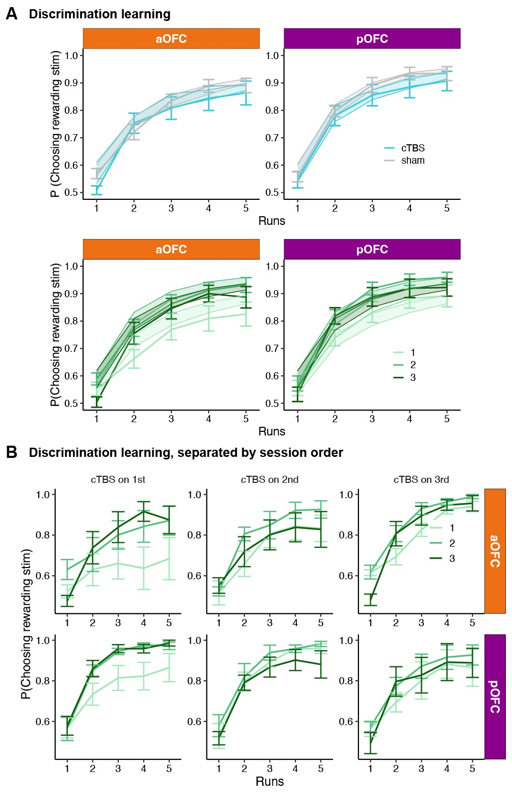

**Fig. 6**: **Posterior or anterior OFC-targeted cTBS disrupted value acquisition during the first session. A.** Discrimination accuracy over five runs during the Day 1 task, plotted by TMS condition (cTBS vs. sham), session number (1st, 2nd, 3rd), and stimulation target (aOFC vs. pOFC). **B.** Discrimination accuracy across runs, separated by session number and the session order of cTBS administration—that is, whether cTBS was applied during the 1st, 2nd, or 3rd session of the three-session experiment.

## 2.5 Posterior and anterior, OFC-targeted cTBS disrupted value acquisition during the first session

As noted in section 2.2, participants showed significant improvement in selecting odorpredictive stimuli over the five runs of the discrimination task on Day 1. A more detailed analysis revealed that this improvement was influenced by the TMS condition applied prior to the task (cTBS vs. sham; *p* = 1*.*27 × 10−7), session number (1st, 2nd, 3rd; *p* = 1*.*71 × 10−11), and their interaction (*p* = 1*.*93 × 10−5), based on logistic mixed-effects models with participant as a random effect (see line plot with error bars in Figure 6A).

To further examine the effects of TMS and session number on discrimination learning, we grouped participants based on the session in which they received cTBS or sham stimulation on Day 1 (Figure 6B). This analysis revealed that the impairment in discrimination due to cTBS was evident only when cTBS was administered during the first session (*p <* 2*.*2×10−16). We also tested whether the effect differed by stimulation target (anterior vs. posterior OFC) but found no significant interaction or main effect related to target location (all *p >* 0*.*05).

To quantify and compare the learning process, we fitted a Rescorla–Wagner model to participants’ discrimination behavior using a hierarchical Bayesian framework [37] (see **Supplementary Text** for details). We evaluated three model variants: one with condition-specific learning rates (based on TMS condition: sham vs. cTBS on Day 1), one with session-specific learning rates (sessions 1, 2, and 3), and one with a fixed learning rate across all sessions and conditions. Model comparison using the deviance information criterion (DIC) [38] indicated that the session-specific model provided the best fit (DIC: session-specific = 13,161.95; condition-specific = 13,544.84; fixed = 14,045.46). This model closely captured the observed data, as shown by the shaded fits in Figure 6A.

Overall, cTBS targeting both posterior and anterior OFC impaired value acquisition in the discrimination task, but only when applied during the first session. This suggests a general disruptive effect of cTBS on participants’ ability to perform the discrimination task when administered early. As noted in section 2.2, to account for these effects, we incorporated the estimated difference in learned values as regressors when assessing the effects of Day 1 or Day 2 cTBS on sated odor (SA) choices during Day 2.

# 3 Discussion

In this study, we used a three-session times two-day design with network-targeted TMS to selectively modulate activity in anterior and posterior subregions of the human lateral OFC. Using an outcome devaluation task, we found that TMS targeting the pOFC (but not the aOFC) prior to the meal disrupted outcome-guided behavior, as evidenced by continued choices of stimuli predicting sated rewards in the probe test. Conversely, disrupting the aOFC (but not the pOFC) before learning stimulusoutcome associations on Day 1 also impaired behavior in the probe test on the following day. These findings demonstrate that the aOFC facilitates outcome-guided behavior by supporting the acquisition of stimulus-outcome associations, while the pOFC supports their use for inferring the current value of choice options.

Our findings suggest that the anterior OFC plays a key role in enabling individuals to learn specific stimulus-outcome structures (e.g., associating visual stimuli with specific odors) even when the current task does not explicitly require it. This aligns with prior work indicating that the OFC represents the current task state [4, 39]. However, stimulus-outcome associations in our study were directly observable, contrasting with only partially observable problems where states have to be inferred or retained in memory [e.g. 40, 41]. The function of the anterior OFC in cognitive map construction identified here bears more resemblance to previous research indicating that both humans and animals are driven by curiosity to explore and learn about the environment, known as latent learning [5, 42], constructing a representation of the world even in the absence of direct rewards [5, 43, 44]. Such cognitive maps, once formed, provide a foundation for guiding outcome-guided behaviors [2, 42]. Importantly, although discrimination training in our task involved reward, learning the specific identity of the reward was not required or reinforced. In that sense, our work parallels a previous study in rats showing that chemogenetic inhibition of lateral OFC caused a deficit in credit assignment during map construction [3]. Notably, our findings highlight the specific and causal role of the anterior part of the lateral OFC in forming cognitive maps. This work is also in line with recent studies in both rodents and humans suggesting that the lateral OFC supports learning the identity of rewards associated with stimuli [3, 19, 45–48]. However, the current study offers a novel and unique contribution by showing that aOFC remains essential even when individuals are not explicitly tasked with encoding such identity information. Moreover, the effect of disrupting learning of reward identity can be revealed in later stages, when the encoded information becomes crucial for outcome-guided behavior. This provides important information on the specific roles of different OFC subregions and highlights the regional specificity of network-targeted TMS more generally.

Consistent with previous work [6], we found that the posterior part of the lateral OFC is critical for outcome-guided behavior during the probe test. Without an intact posterior OFC, individuals fail to change their choices after selective satiation, continuing to choose stimuli predicting devalued outcomes. This suggests that the posterior OFC may support retrieving and applying the cognitive map to guide current behavior. Importantly, our findings show that this effect is specific for the posterior OFC network and does not occur when stimulating a network centered on the adjacent anterior OFC.

Our findings align with a range of studies demonstrating distinct roles of OFC subregions across various tasks and across species, including outcome-guided choices with outcome devaluation [24], two-choice probabilistic tasks [49], differential information encoding in the OFC [50], and the specific contributions of lateral OFC subregions to economic decision-making [12]. Particularly relevant is work in non-human primates examining the differential roles of OFC subregions in flexible behavior [24], demonstrating that the anterior OFC (area 11) is more involved in goal selection during choice, while the posterior OFC (area 13) primarily supports outcome value updating. In contrast to [24], our study focused on the differential involvement of lateral OFC subregions in learning and using stimulus-outcome identity associations to guide outcome-guided behavior. While a precise cross-species mapping of our defined anterior and posterior OFC regions to animal models remains challenging, our study is, to our knowledge, the first causal investigation to differentiate the functional roles of the human OFC along the anterior-posterior gradient. Recognizing these functional differences represents a substantial advance in our understanding of this brain area and will help guide future studies assessing the role of OFC in learning and decision-making. In human subjects research, this distinction is particularly important for neuroimaging studies and neuromodulation approaches targeting the OFC [6, 29, 46, 51–53].

Although not part of our initial hypothesis, we found that cTBS targeting both the anterior and posterior OFC disrupted discrimination learning on Day 1, but only during the first session, with no impact in later sessions. This challenges the view that OFC is not important for simple Pavlovian acquisition [54–56], in line with recent rodent studies suggesting that OFC’s role in Pavlovian acquisition may be more nuanced than previously thought [57]. Interpreting this result is further complicated by our within-participant design, as the deficit emerged only in the first session. This initial impairment likely reflects difficulty in grasping the basic task structure. Once this fundamental task structure was learned, it could be reused in subsequent sessions with different stimulus sets [2, 58], potentially explaining why TMS had no effect on discrimination learning in later sessions. To account for these effects, we included the stimulus-level learned values of each option in the analysis of SA choices, instead of simply assuming “perfect” learning during the discrimination task [6, 24].

In this regard, one limitation of this study is the within-participant design, which enhances statistical power but may introduce interpretive challenges. For instance, participants completing the first session could learn that odor identity would be relevant for the Day 2 task, potentially altering their approach to processing odor identity in later sessions. To test this possibility, we compared groups of participants based on the order of cTBS and sham stimulation. Importantly, our findings were not driven by stimulation order, speaking to the robustness of our results. However, the small sample size within each session-order group may limit the ability to detect subtle order effects. Another limitation is the difference in perceived TMS discomfort and intensity between cTBS and sham conditions as reported in the current work and our previous work [46]. However, we found no differences in these ratings between anterior and posterior sites, and individual differences did not account for the observed behavioral effects.

In conclusion, our study reveals distinct roles of the anterior and posterior OFC network in cognitive map formation and its use for outcome-guided behavior in humans. These findings contribute to a better understanding of the functional role of OFC subregions in outcome-guided behavior. Additionally, this work offers valuable insights for research in rodents and non-human primates, advancing our understanding of the neural mechanisms underlying outcome-guided behavior across species.

# 4 Methods

## 4.1 Participants

Eighty-eight healthy, right-handed participants (ages 18-40) with no history of psychiatric or neurological disease provided written informed consent to participate in this study. Of these, 48 participants (16 males; ages 18-40, mean = 25.17, SD = 4.14) completed all sessions. Due to a technical error, behavioral data from the cTBSsham session were unavailable for one participant in the posterior targeting group (see section 4.2); however, data from the other two sessions were included in the analysis where applicable. MRI data for five resting-state scans were not acquired and excluded from analysis. All participants fasted for at least four hours before each study visit.

## 4.2 Study design

The study consisted of eight visits (Figure 1A, D), with Day 1 and Day 2 occurring on consecutive days. The two-day experiment was repeated across three sessions. Sessions were spaced at least one week apart, with a median interval of 13.5 days, a mean of 18.02 days (SD = 9.09), and a range of 7 to 63 days. On each Day 1 and Day

2, participants received either continuous theta-burst stimulation (cTBS, labeled C) or sham stimulation (S). Over the three sessions, they experienced three TMS conditions: cTBS-sham (CS), sham-cTBS (SC), and sham-sham (SS). The order of these conditions was counterbalanced, with 9 participants receiving CS-SC-SS, 7 receiving CS-SS-SC, and the remaining 32 equally assigned to one of the other four possible sequences (SC-CS-SS, SC-SS-CS, SS-CS-SC, and SS-SC-CS).

To prevent differences in stimulation location from affecting participants’ experience across sessions, each participant received TMS targeting either the anterior or posterior portion of the lateral OFC throughout all three sessions. Among the participants, 16 of 32 females and 9 of 16 males received TMS targeted to the posterior portion. Additionally, the order of satiation conditions was counterbalanced: half of the participants received a sweet meal in their first session, while the other half received a savory meal. The sated odor type alternated for each participant across the three sessions (e.g., savory-sweet-savory or sweet-savory-sweet).

## 4.3 Screening session

After providing informed consent and completing eligibility screening, participants rated the pleasantness of eight food odors. These odors, supplied by International Flavors and Fragrances (New York, NY), included four savory (garlic, potato chip, pizza, barbecue) and four sweet (chocolate, yellow cake, pineapple cake, gingerbread) odors. In each trial, participants smelled a food odor for 2 seconds and rated their liking on a visual analog scale ranging from “Most Disliked Sensation Imaginable” to “Most Liked Sensation Imaginable.” Ratings were made using a scroll wheel and keyboard press. Each odor was presented three times in a pseudo-randomized order, and ratings were averaged per odor. Based on these ratings, two odors (one savory, one sweet) that were pleasant (above neutral) and closely matched were selected for the discrimination and choice tasks. These odors were used across all three sessions. Participants were excluded if no suitable odors were identified.

A custom-built, computer-controlled olfactometer was used to deliver the odors with precise timing to nasal masks worn by participants. The olfactometer directed medical-grade air through the headspace of amber bottles containing the odor solutions at a constant flow rate of 3.2L/min. Using two independent mass flow controllers (Alicat, Tucson, AZ), the device enabled precise dilution of the odorized air with odorless air. Throughout the experiment, a constant stream of odorless air was delivered, and odorized air was mixed in at specific time points without altering the overall flow rate or causing somatosensory stimulation.

## 4.4 Day 0: Scan & Motor threshold

We acquired a T1-weighted structural MRI scan to assist with TMS neuronavigation and an 8 min multi-echo resting-state fMRI scan (310 volumes, TR = 1.5s) to individually define the OFC-targeted cTBS coordinates (see section 4.8). The same scanning parameters were used for other resting-state scans. We then measured resting motor threshold (rMT) by administering single TMS pulses to the hand area of the left motor cortex. rMT was defined as the lowest stimulator output required to evoke 5 visible thumb movements from 10 pulses.

## 4.5 Day 1: Discrimination task

Participants first underwent a TMS session (cTBS or sham, see section 4.9) followed by a resting-state scan. Then they completed five runs of a discrimination task. In each trial, participants chose between two fractal stimuli: one associated with a savory or sweet odor, and the other with clean air. Stimuli were displayed for 3 seconds, followed by a choice phase (maximum 3 seconds). If participants selected a stimulus leading to an odor, the odor was delivered for 2 seconds. The inter-trial interval ranged from 4 to 8 seconds. Each run consisted of 24 trials, using four groups of stimulus pairs: two sets (A and B) crossed with sweet/savory odors. Each combination had three nonoverlapping stimulus pairs, resulting in 24 distinct fractals. Each pair was presented twice to counterbalance left and right positions on the screen. Choice and response times were recorded for each trial, and different fractals were used across the three sessions.

## 4.6 Day 2: Meal consumption and free choice task

Day 2 started with an odor pleasantness rating followed by a choice task (pre-meal) where participants selected between pairs of stimuli. Afterwards, participants underwent a TMS session and then had a meal carefully matched in flavor to either the sweet or savory food odor used in their task. Following the meal, participants completed another set of odor pleasantness ratings and the post-meal free choice task. Both pre-meal and post-meal choice tasks instructed participants to choose based on their current odor preferences.

The pre-meal free choice task included 30 trials, all from set A, consisting of 3 sweet vs. clean air pairs, 3 savory vs. clean air pairs, and 9 savory vs. sweet pairs. Each pair was presented twice to counterbalance left and right positions on the screen. The post-meal choice task included 60 trials from both sets A and B. In both pre- and post-meal choice tasks, similar to the discrimination task, every trial began with a pair of stimuli presented for 3 seconds, followed by a decision phase of up to 3 seconds. In the pre-meal free choice task, if participants selected a stimulus linked to an odor, the odor was delivered for 2 seconds after their choices. No odors were delivered during the post-meal free choice task. Participants received the odors chosen in five randomly selected trials at the end of the task. The inter-trial interval ranged from 4 to 8 seconds, and choice and response times were recorded from all trials. Pre- and post-meal free choices for both set A and set B stimuli were highly correlated (Figure S3), indicating consistent choices across sets based on odor preferences. Thus, to assess the satiation effect on choices, we used the pre-meal average choice from set A as a session-wise odor preference baseline and compared it with the post-meal choices.

## 4.7 MRI data acquisition

MRI data were acquired on a Siemens 3T PRISMA system equipped with a 64-channel head-neck coil. Each TMS session on Day 1 and Day 2 was immediately followed by a resting-state MRI scan. Resting-state fMRI data were collected across all seven sessions with the same multi-echo sequence (310 volumes; TR = 1.5s; TE1-TE3 = 14.60ms, 39.04ms, 63.48ms). The short TE of the first echo is beneficial to mitigate signal dropout near the OFC, as demonstrated in previous studies using both resting-state and task-based fMRI [59–62]. Other scanning parameters included: flip angle, 72°, slice thickness, 2mm (no gap), multi-band acceleration factor 4, 60 slices with interleaved acquisition, matrix size 104 x 104 voxels, and field of view 208mm x 208mm. A 1mm isotropic T1-weighted structural scan was acquired on Day 0 session for neuronavigation during TMS and to aid spatial normalization.

## 4.8 Coordination selection for network-targeted TMS

The stimulation coordinates were computed based on the multi-echo resting-state MRI data collected from the Day 0 session. We defined our stimulation targets in the right hemisphere’s aOFC and pOFC using MNI coordinates: aOFC [34, 54, -14] and pOFC [28, 38, -16]. The pOFC coordinates were identical to those used in our previous network-targeted TMS studies [6, 46, 51, 52]. Each targeted coordinate in the aOFC and pOFC exhibited strong functional connectivity with isolated clusters in the LPFC with peak coordinates of [44, 28, 38] and [46, 38, 14], respectively, as determined in data from Neurosynth.org involving a sample of 1,000 subjects.

We first generated spherical masks of 8-mm radius around these four coordinates in MNI space, each inclusively masked by the gray matter tissue probability map provided by SPM12 (thresholded at *>* 0.1). We then transformed these four masks to each subject’s native space using the inverse deformation field generated during the normalization of the T1 anatomical image. We then specified two resting-state fMRI functional connectivity analyses (one per region) for each subject, using individual aOFC and pOFC masks as the seed regions and motion parameters from the realignment of the first echo as regressors of no interest. Finally, stimulation coordinates were defined as the voxels within the right LPFC masks with the strongest functional connectivity to the right aOFC and pOFC seed regions, respectively. We used infrared MRI-guided stereotactic neuronavigation (LOCALITE) to apply stimulation to these two individual LPFC coordinates.

## 4.9 Transcranial magnetic stimulation

Similar to our previous work, the target coordinates were defined as the locations in the right LPFC with the strongest functional connectivity with the corresponding right OFC seed regions (see details above). The Figure-eight coil was tilted so that its long axis was approximately perpendicular to the long axis of the middle frontal gyrus. TMS was administered at 80% of the rMT using a cTBS protocol. This protocol involved delivering bursts of three pulses at 50 Hz every 200 ms (5 Hz) for a total of 600 pulses over approximately 40 seconds. Stimulation was applied using a MagPro X100 stimulator equipped with a MagPro Cool-B65 A/P butterfly coil (MagVenture). Previous work has demonstrated that this cTBS protocol at 80% MT has inhibitory aftereffects which persist for 50–60 min over primary motor cortex [63]. Whereas cTBS was delivered by positioning the active side of the A/P coil to modulate neural tissue, sham cTBS was applied with the placebo side of the A/P coil, producing similar somatosensory and auditory experiences for the participant without modulating neural tissue. Electrodes were placed on participants’ forehead and direct current stimulation was applied in synchrony with the TMS pulses to mask TMS effects and enhance the similarity between cTBS and sham sessions.

Participants were informed about potential muscle twitches in the face, eyes, and jaw during simulation. To assess tolerability, two single pulses were applied over the stimulation coordinates before administering cTBS. Discomfort and perceived stimulation intensity were evaluated after each TMS session. The cTBS sessions were generally rated as more uncomfortable and intense compared to the sham sessions. On a scale from 0 (not uncomfortable at all) to 10 (extremely uncomfortable), mean discomfort ratings were 3.38 for sham and 5.8 for cTBS sessions (*p* = 2*.*2*e* − 16, linear mixed effects model). Similarly, on a scale from 0 (not strong at all) to 10 (extremely strong), mean intensity ratings were 3.79 for sham and 6.23 for cTBS sessions (*p* = 2*.*2*e* − 16, linear mixed effects model). Discomfort and intensity ratings did not differ between aOFC- or pOFC-targeted cTBS (all *p >* 0.6). For analyses involving cTBS effects (Day 1 or Day 2 TMS), standardized discomfort and intensity ratings were used to examine correlations or regressions against other variables, assessing if the observed cTBS effects were driven by subjective discomfort or perceived TMS intensity, but none of the effects can be explained by those ratings (see Figure S4).

## 4.10 Meal consumption

On Day 2, participants consumed a meal following the TMS session to selectively satiate one of the two food odors. The meal items were carefully chosen to closely match the corresponding food odors, and water was provided. Participants were instructed to eat until they felt very full and were then left alone for 15 minutes. Immediately afterward, they rated the pleasantness of the odors and proceeded to the post-meal choice task. On average, participants consumed 669.89 ± 44.16 calories (SEM). Before analyzing the relationship between odor ratings and task behavior, we standardized the ratings within each participant across sessions.

## 4.11 Multi-echo MRI data processing

Preprocessing of the multi-echo resting-state fMRI data involved several steps. First, all functional images from the smallest echo across all rs-fMRI runs were realigned to the first volume of the first echo, and the resulting voxel-to-world mapping matrix was applied to the other two echoes, volume by volume. All functional images were then resliced for each echo. Next, the images across the three echoes were combined using temporal signal-to-noise ratio (tSNR) weighting, following parallel-acquired inhomogeneity desensitized (PAID) approach [60]. Specifically, voxel-wise tSNR maps were computed for each echo, multiplied by the echo time (TE), and normalized across the three echoes to generate weight maps. These weight maps were then used to combine the resliced images by multiplying each volume by its respective weight map. Lastly, the combined data underwent coregistration, normalization, and smoothing using a 6 mm FWHM Gaussian kernel.

## 4.12 Analysis of odor pleasantness rating

Odor pleasantness ratings (Figure 3A) were collected on a raw scale from –10 to 10. For statistical analyses, ratings were z-scored within each participant to account for individual differences in scale use. To evaluate whether selective satiation specifically reduced the pleasantness of the sated odor, we calculated the change in pleasantness (PleasantChange, defined as post-meal minus pre-meal) for each odor and session. We then fit two linear mixed-effects models with random intercepts for participants. The null model (MPC0) included only a random intercept, while the full model (MPC1) included an additional fixed effect of (IsSated), a binary variable indicating whether the odor was the sated one. Model comparison was performed using a likelihood ratio test.

MPC0 <- lmer(PleasantChange ˜ (1 | Ppt), data = pc_data) MPC1 <- lmer(PleasantChange ˜ IsSated + (1 | Ppt), data = pc_data)

We then computed a session-wise index of the selective satiation effect, SatIdx, defined as the difference in PleasantChange between sated and non-sated odors. To explore whether this effect was influenced by additional factors — such as TMS condition (Day 2; sham vs. cTBS), TMS target site (aOFC vs. pOFC), session number (1st, 2nd, 3rd), or sated odor type (savory/sweet) — we fit a second set of linear mixedeffects models. Each model included one of these predictors and was compared against the same null model MSatIdx0. For example, to test the influence of TMS condition (TMScond), we fit and compared the following models:

MSatIdx0 <- lmer(SatIdx ˜ (1 | Ppt), data = SatIdxDat)

MSatIdx1 <- lmer(SatIdx ˜ TMScond + (1 | Ppt), data = SatIdxDat) All mixed-effects models were fit using the lme4 package in R.

## 4.13 Analysis of Day 2 probe choices

We analyzed the Day 2 probe choice data on sweet–savory choices, and split these analyses by TMS target site (aOFC and pOFC groups). As noted in Section 4.6, we used the pre-meal average choice for each session as a baseline measure of odor preference BasePref. Post-meal choices were baseline-corrected, and a one-sided Wilcoxon signed-rank test was performed, collapsed across sessions, to test for an overall reduction in preference for the sated odor due to selective satiation (Figure 3B).

To assess the effect of Day 2 TMScond (Day 2; sham vs. cTBS) on choices involving the sated odor, we analyzed the trial-wise data using logistic mixed-effects modeling. The models included the following covariates: (1) BasePref, the pre-meal baseline preference; (2) SatIdx, the session-wise reduction in pleasantness of the sated odor; and (3) ValueDiff, the value difference between the two choice options on each trial, reflecting discrimination learning from Day 1 (see Section 4.14). For each target group (aOFC and pOFC), we compared a full model (Mchoice1) that included the TMS condition (TMScond) with a reduced model (Mchoice0) that did not:

Mchoice1 <- glmer(Choice ˜ TMScond + ValueDiff + SatIdx + BasePref

+ (1|Ppt), data = ChoiceDat, family = ’binomial’)

Mchoice0 <- glmer(Choice ˜ ValueDiff + SatIdx + BasePref + (1|Ppt), data = ChoiceDat, family = ’binomial’)

In these models, Choice was a binary outcome indicating whether the participant chose the sated odor (1) or the non-sated odor (0). To further examine whether the effect of TMS condition varied by stimulation site, we tested an additional model that included an interaction term between TMScond and TMStarget. We used the fitted function in R to extract trial-level predicted choices based on the best-fitting model for each group. These predicted values were then averaged within each participant to estimate the model-derived probability of choosing the sated odor, as shown in Figure 4. The Day 1 TMS effect was analyzed in a similar manner, using the contrast between Day 1 sham and cTBS while holding Day 2 TMS constant at sham, as shown in Figure 5.

## 4.14 Analysis and modeling of discrimination learning

We examined whether participants improved their performance across runs by fitting the following mixed-effects logistic regression models:

Mdisc1 <- glmer(OdorChosen ˜ Run + (1|Ppt), data = disc_dat, family = ’binomial’)

Mdisc0 <- glmer(OdorChosen ˜ (1|Ppt), data = disc_dat, family = ’binomial’)

In these models, OdorChosen indicates whether the odor-predictive stimulus was selected (yes = 1), and Run ranges from 1 to 5. To assess learning across runs, we compared a full model (Mdisc1) that included Run as a fixed effect with a reduced model (Mdisc0) that did not.

To further characterize learning, we employed a standard Rescorla-Wagner model [64] to describe how participants acquired associations in the discrimination task. On each trial, participants chose between two stimuli: one predictive of an odor and the other predictive of clean air. Because stimulus pairs did not overlap across trials, we assumed that learning was primarily driven by the odor-predictive stimulus.

Accordingly, we modeled the learned value *w* of the odor-predictive stimulus across trials. The model updated this value based on the prediction error, defined as the difference between the actual outcome (*w* = 1) and the expected value. The stimulus-specific learning rate determined how quickly *w* was adjusted. All values were initialized at *w* = 0*.*5, with *w* = 1 indicating complete acquisition.

For a given stimulus pair, when it was presented on trial *i*, the value *w* was updated as follows:

*wi*+1 = *wi* + *α* · (1 − *wi*)*,*

where *α* denotes the learning rate for the stimulus pair presented on the current trial. We estimated a separate learning rate for each odor-predictive stimulus using a hierarchical Bayesian framework [37], with session-wise or condition-wise priors. This approach enabled us to derive individualized value trajectories for each odor-predictive stimulus, which were subsequently used in the analysis of probe choices on Day 2. Further details on model specification and estimation procedures are provided in the **Supplementary Text**. Hierarchical Bayesian modeling was implemented in R using the Rjags package.

## Acknowledgements

This work was supported by National Institute on Deafness and Other Communication Disorders grant R01DC015426 (to T.K.) and the Intramural Research Program at the National Institute on Drug Abuse (ZIA DA000642, to T.K.). The opinions expressed in this work are the authors’ own and do not reflect the view of the NIH/DHHS.

# 5 Supplementary Figures References

1. Daw, N. D., Niv, Y. & Dayan, P. Uncertainty-based competition between prefrontal and dorsolateral striatal systems for behavioral control. *Nature neuroscience* **8**, 1704–1711 (2005).
2. Behrens, T. E. *et al.* What is a cognitive map? organizing knowledge for flexible behavior. *Neuron* **100**, 490–509 (2018).
3. Costa, K. M. *et al.* The role of the lateral orbitofrontal cortex in creating cognitive maps. *Nature neuroscience* **26**, 107–115 (2023).
4. Wilson, R. C., Takahashi, Y. K., Schoenbaum, G. & Niv, Y. Orbitofrontal cortex as a cognitive map of task space. *Neuron* **81**, 267–279 (2014).
5. Wang, M. Z. & Hayden, B. Y. Latent learning, cognitive maps, and curiosity. *Current Opinion in Behavioral Sciences* **38**, 1–7 (2021).
6. Howard, J. D. *et al.* Targeted stimulation of human orbitofrontal networks disrupts outcome-guided behavior. *Current Biology* **30**, 490–498 (2020).
7. Rudebeck, P. H. & Murray, E. A. The orbitofrontal oracle: cortical mechanisms for the prediction and evaluation of specific behavioral outcomes. *Neuron* **84**, 1143–1156 (2014).
8. Price, J. L. Definition of the orbital cortex in relation to specific connections with limbic and visceral structures and other cortical regions. *Annals of the New York Academy of Sciences* **1121**, 54–71 (2007).
9. Wallis, J. D. Cross-species studies of orbitofrontal cortex and value-based decision-making. *Nature neuroscience* **15**, 13–19 (2012).
10. Kahnt, T., Chang, L. J., Park, S. Q., Heinzle, J. & Haynes, J.-D. Connectivitybased parcellation of the human orbitofrontal cortex. *Journal of Neuroscience* **32**, 6240–6250 (2012).
11. Izquierdo, A. Functional heterogeneity within rat orbitofrontal cortex in reward learning and decision making. *Journal of Neuroscience* **37**, 10529–10540 (2017).
12. Wang, M. Z., Hayden, B. Y. & Heilbronner, S. R. A structural and functional subdivision in central orbitofrontal cortex. *Nature communications* **13**, 3623 (2022).
13. Heilbronner, S. R., Rodriguez-Romaguera, J., Quirk, G. J., Groenewegen, H. J. & Haber, S. N. Circuit-based corticostriatal homologies between rat and primate. *Biological psychiatry* **80**, 509–521 (2016).
14. Walton, M. E., Behrens, T. E., Noonan, M. P. & Rushworth, M. F. Giving credit where credit is due: orbitofrontal cortex and valuation in an uncertain world. *Annals of the New York Academy of Sciences* **1239**, 14–24 (2011).
15. Mackey, S. & Petrides, M. Quantitative demonstration of comparable architectonic areas within the ventromedial and lateral orbital frontal cortex in the human and the macaque monkey brains. *European Journal of Neuroscience* **32**, 1940–1950 (2010).
16. Kringelbach, M. L. & Rolls, E. T. The functional neuroanatomy of the human orbitofrontal cortex: evidence from neuroimaging and neuropsychology. *Progress in neurobiology* **72**, 341–372 (2004).
17. Neubert, F.-X., Mars, R. B., Sallet, J. & Rushworth, M. F. Connectivity reveals relationship of brain areas for reward-guided learning and decision making in human and monkey frontal cortex. *Proceedings of the national academy of sciences* **112**, E2695–E2704 (2015).
18. McNamee, D., Rangel, A. & O’doherty, J. P. Category-dependent and categoryindependent goal-value codes in human ventromedial prefrontal cortex. *Nature neuroscience* **16**, 479–485 (2013).
19. Howard, J. D., Gottfried, J. A., Tobler, P. N. & Kahnt, T. Identity-specific coding of future rewards in the human orbitofrontal cortex. *Proceedings of the National Academy of Sciences* **112**, 5195–5200 (2015).
20. O’Doherty, J., Kringelbach, M. L., Rolls, E. T., Hornak, J. & Andrews, C. Abstract reward and punishment representations in the human orbitofrontal cortex. *Nature neuroscience* **4**, 95–102 (2001).
21. Colwill, R. M. & Rescorla, R. A. Postconditioning devaluation of a reinforcer affects instrumental responding. *Journal of experimental psychology: animal behavior processes* **11**, 120 (1985).
22. Balleine, B. W. & Dickinson, A. Goal-directed instrumental action: contingency and incentive learning and their cortical substrates. *Neuropharmacology* **37**, 407– 419 (1998).
23. Baxter, M. G., Parker, A., Lindner, C. C., Izquierdo, A. D. & Murray, E. A. Control of response selection by reinforcer value requires interaction of amygdala and orbital prefrontal cortex. *Journal of Neuroscience* **20**, 4311–4319 (2000).
24. Murray, E. A., Moylan, E. J., Saleem, K. S., Basile, B. M. & Turchi, J. Specialized areas for value updating and goal selection in the primate orbitofrontal cortex. *elife* **4**, e11695 (2015).
25. Critchley, H. D. & Rolls, E. T. Hunger and satiety modify the responses of olfactory and visual neurons in the primate orbitofrontal cortex. *Journal of neurophysiology* **75**, 1673–1686 (1996).
26. O’doherty, J. *et al.* Sensory-specific satiety-related olfactory activation of the human orbitofrontal cortex. *Neuroreport* **11**, 893–897 (2000).
27. Gottfried, J. A., O’Doherty, J. & Dolan, R. J. Encoding predictive reward value in human amygdala and orbitofrontal cortex. *Science* **301**, 1104–1107 (2003).
28. Howard, J. D. & Kahnt, T. Identity-specific reward representations in orbitofrontal cortex are modulated by selective devaluation. *Journal of Neuroscience* **37**, 2627–2638 (2017).
29. Howard, J. D. & Kahnt, T. Causal investigations into orbitofrontal control of human decision making. *Current opinion in behavioral sciences* **38**, 14–19 (2021).
30. Gallagher, M., McMahan, R. W. & Schoenbaum, G. Orbitofrontal cortex and representation of incentive value in associative learning. *Journal of Neuroscience*

**19**, 6610–6614 (1999).

1. Pickens, C. L. *et al.* Different roles for orbitofrontal cortex and basolateral amygdala in a reinforcer devaluation task. *Journal of Neuroscience* **23**, 11078–11084 (2003).
2. Ostlund, S. B. & Balleine, B. W. Orbitofrontal cortex mediates outcome encoding in pavlovian but not instrumental conditioning. *Journal of Neuroscience* **27**, 4819–4825 (2007).
3. Gardner, M. P. & Schoenbaum, G. The orbitofrontal cartographer. *Behavioral neuroscience* **135**, 267 (2021).
4. Xia, M., Wang, J. & He, Y. Brainnet viewer: a network visualization tool for human brain connectomics. *PloS one* **8**, e68910 (2013).
5. Izquierdo, A., Suda, R. K. & Murray, E. A. Bilateral orbital prefrontal cortex lesions in rhesus monkeys disrupt choices guided by both reward value and reward contingency. *Journal of Neuroscience* **24**, 7540–7548 (2004).
6. Rhodes, S. E. & Murray, E. A. Differential effects of amygdala, orbital prefrontal cortex, and prelimbic cortex lesions on goal-directed behavior in rhesus macaques. *Journal of Neuroscience* **33**, 3380–3389 (2013).
7. Myung, J. I., Karabatsos, G. & Iverson, G. J. A bayesian approach to testing decision making axioms. *Journal of Mathematical Psychology* **49**, 205–225 (2005).
8. Spiegelhalter, D. J., Best, N. G., Carlin, B. P. & Van Der Linde, A. Bayesian measures of model complexity and fit. *Journal of the royal statistical society: Series b (statistical methodology)* **64**, 583–639 (2002).
9. Vaidya, A. R. & Badre, D. Abstract task representations for inference and control. *Trends in cognitive sciences* **26**, 484–498 (2022).
10. Zhou, J. *et al.* Complementary task structure representations in hippocampus and orbitofrontal cortex during an odor sequence task. *Current Biology* **29**, 3402–3409. e3 (2019).
11. Schuck, N. W., Cai, M. B., Wilson, R. C. & Niv, Y. Human orbitofrontal cortex represents a cognitive map of state space. *Neuron* **91**, 1402–1412 (2016).
12. Tolman, E. C. Cognitive maps in rats and men. *Psychological review* **55**, 189

(1948).

1. O’keefe, J. & Nadel, L. *The hippocampus as a cognitive map* (Oxford university press, 1978).
2. Kidd, C. & Hayden, B. Y. The psychology and neuroscience of curiosity. *Neuron* **88**, 449–460 (2015).
3. Howard, J. D. & Kahnt, T. Identity prediction errors in the human midbrain update reward-identity expectations in the orbitofrontal cortex. *Nature communications* **9**, 1611 (2018).
4. Liu, Q. *et al.* Midbrain signaling of identity prediction errors depends on orbitofrontal cortex networks. *Nature Communications* **15**, 1704 (2024).
5. McDannald, M. A. *et al.* Orbitofrontal neurons acquire responses to ‘valueless’ pavlovian cues during unblocking. *Elife* **3**, e02653 (2014).
6. Namboodiri, V. M. K. *et al.* Single-cell activity tracking reveals that orbitofrontal neurons acquire and maintain a long-term memory to guide behavioral adaptation. *Nature neuroscience* **22**, 1110–1121 (2019).
7. Stoll, F. M. & Rudebeck, P. H. Dissociable representations of decision variables within subdivisions of the macaque orbital and ventrolateral frontal cortex. *Journal of Neuroscience* **44** (2024).
8. Rich, E. L. & Wallis, J. D. Spatiotemporal dynamics of information encoding revealed in orbitofrontal high-gamma. *Nature Communications* **8**, 1139 (2017).
9. Wang, F., Howard, J. D., Voss, J. L., Schoenbaum, G. & Kahnt, T. Targeted stimulation of an orbitofrontal network disrupts decisions based on inferred, not experienced outcomes. *Journal of Neuroscience* **40**, 8726–8733 (2020).
10. Tegelbeckers, J., Porter, D. B., Voss, J. L., Schoenbaum, G. & Kahnt, T. Lateral orbitofrontal cortex integrates predictive information across multiple cues to guide behavior. *Current Biology* **33**, 4496–4504. e5 (2023).
11. Ouellet, J. *et al.* Enhancing decision-making and cognitive impulse control with transcranial direct current stimulation (tdcs) applied over the orbitofrontal cortex (ofc): a randomized and sham-controlled exploratory study. *Journal of psychiatric research* **69**, 27–34 (2015).
12. Murray, E. A., O’Doherty, J. P. & Schoenbaum, G. What we know and do not know about the functions of the orbitofrontal cortex after 20 years of cross-species studies. *Journal of Neuroscience* **27**, 8166–8169 (2007).
13. Delamater, A. R. The role of the orbitofrontal cortex in sensory-specific encoding of associations in pavlovian and instrumental conditioning. *Annals of the New York Academy of Sciences* **1121**, 152–173 (2007).
14. Stalnaker, T. A. *et al.* Orbitofrontal neurons infer the value and identity of predicted outcomes. *Nature communications* **5**, 3926 (2014).
15. Panayi, M. C. & Killcross, S. The role of the rodent lateral orbitofrontal cortex in simple pavlovian cue-outcome learning depends on training experience. *Cerebral Cortex Communications* **2**, tgab010 (2021).
16. Harlow, H. F. The formation of learning sets. *Psychological review* **56**, 51 (1949).
17. Fernandez, B., Leuchs, L., S¨amann, P. G., Czisch, M. & Spoormaker, V. I. Multi-echo epi of human fear conditioning reveals improved bold detection in ventromedial prefrontal cortex. *Neuroimage* **156**, 65–77 (2017).
18. Poser, B. A., Versluis, M. J., Hoogduin, J. M. & Norris, D. G. Bold contrast sensitivity enhancement and artifact reduction with multiecho epi: parallel-acquired inhomogeneity-desensitized fmri. *Magnetic Resonance in Medicine: An Official Journal of the International Society for Magnetic Resonance in Medicine* **55**, 1227–1235 (2006).
19. Kirilina, E., Lutti, A., Poser, B. A., Blankenburg, F. & Weiskopf, N. The quest for the best: The impact of different epi sequences on the sensitivity of random effect fmri group analyses. *Neuroimage* **126**, 49–59 (2016).
20. Zhao, L. S., Raithel, C. U., Tisdall, M. D., Detre, J. A. & Gottfried, J. A. Leveraging multi-echo epi to enhance bold sensitivity in task-based olfactory fmri. *Imaging Neuroscience* **2**, 1–15 (2024).
21. Huang, Y.-Z., Edwards, M. J., Rounis, E., Bhatia, K. P. & Rothwell, J. C. Theta burst stimulation of the human motor cortex. *Neuron* **45**, 201–206 (2005).
22. Rizley, R. C. & Rescorla, R. A. Associations in second-order conditioning and sensory preconditioning. *Journal of comparative and physiological psychology* **81**, 1 (1972).

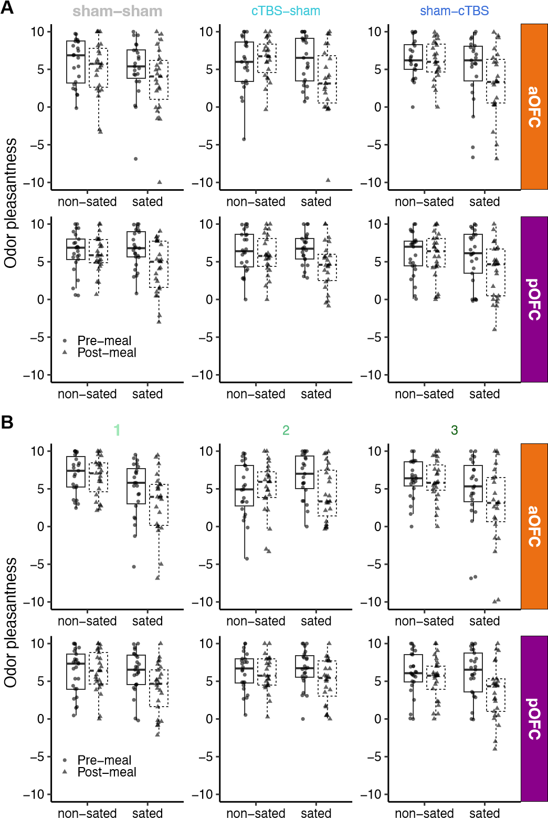

**Fig. S1**: **Supplementary results on odor pleasantness ratings across stimulation conditions and sessions. A.** Odor pleasantness ratings separated by TMS condition (sham–sham, cTBS–sham, sham–cTBS), stimulation target (aOFC vs. pOFC), and odor type (sated vs. non-sated), displayed for pre- and post-meal timepoints. These ratings confirm that selective satiation effects were robust across TMS conditions within each target group. **B.** Odor pleasantness ratings by session number (1, 2, 3), stimulation target, and odor type, again separated into pre- and post-meal measurements. This panel examines potential habituation or learning effects across repeated exposures. No evidence of habituation was observed, and satiation effects remained consistent across sessions within each target group.

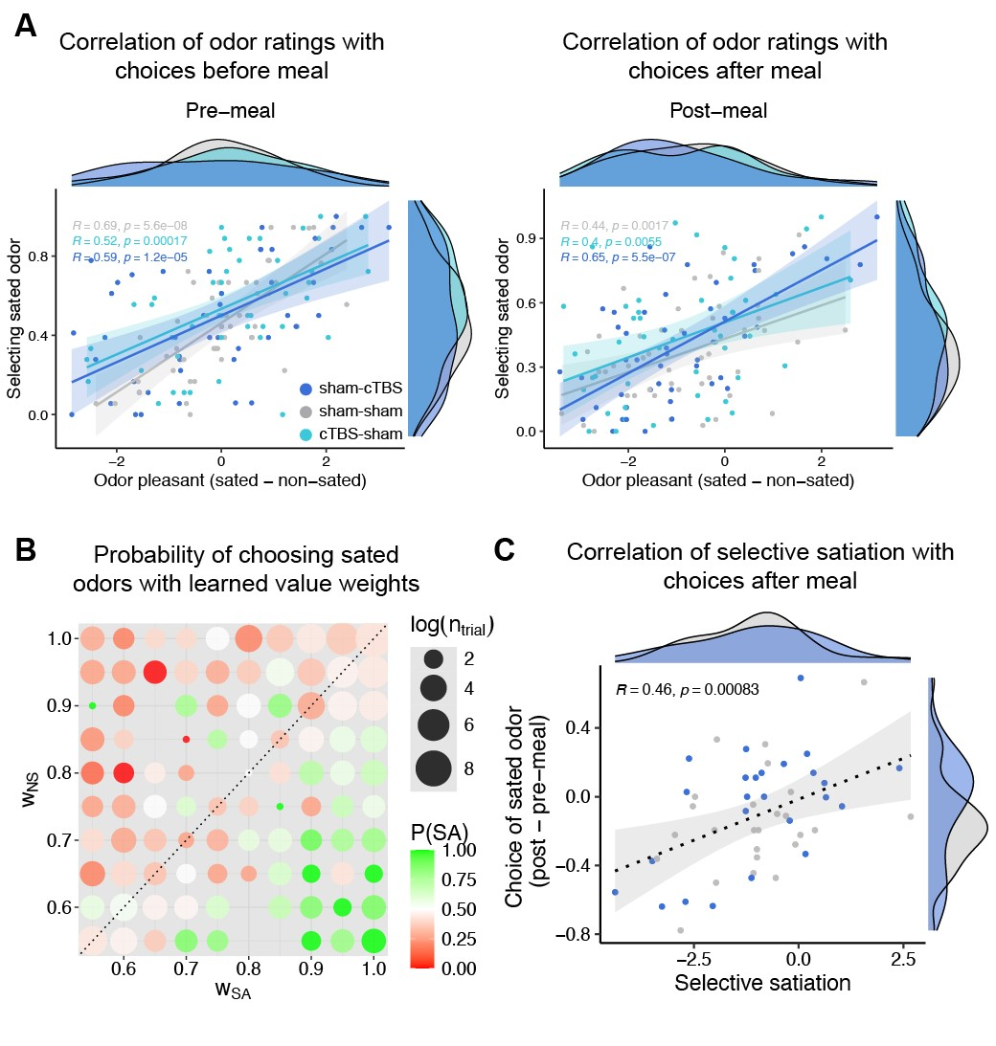

**Fig. S2**: **Probe choices are influenced by learned stimulus values and selective satiation effects. A.** Scatter plots showing correlations between the choice of stimuli predicting sated odors and odor pleasantness ratings of sated minius non-sated odors before (left) and after the meal (right), separated by the three TMS conditions. **B.** Choice of sated odors options associated with each of the learned weight of the combination of sated and non-sated options. Dot size represents the number of trials per value combination (log-scaled), with missing dots indicating unobserved combinations. **C.** Scatter plots showing correlations between selective satiation effect and choices of sated odor.

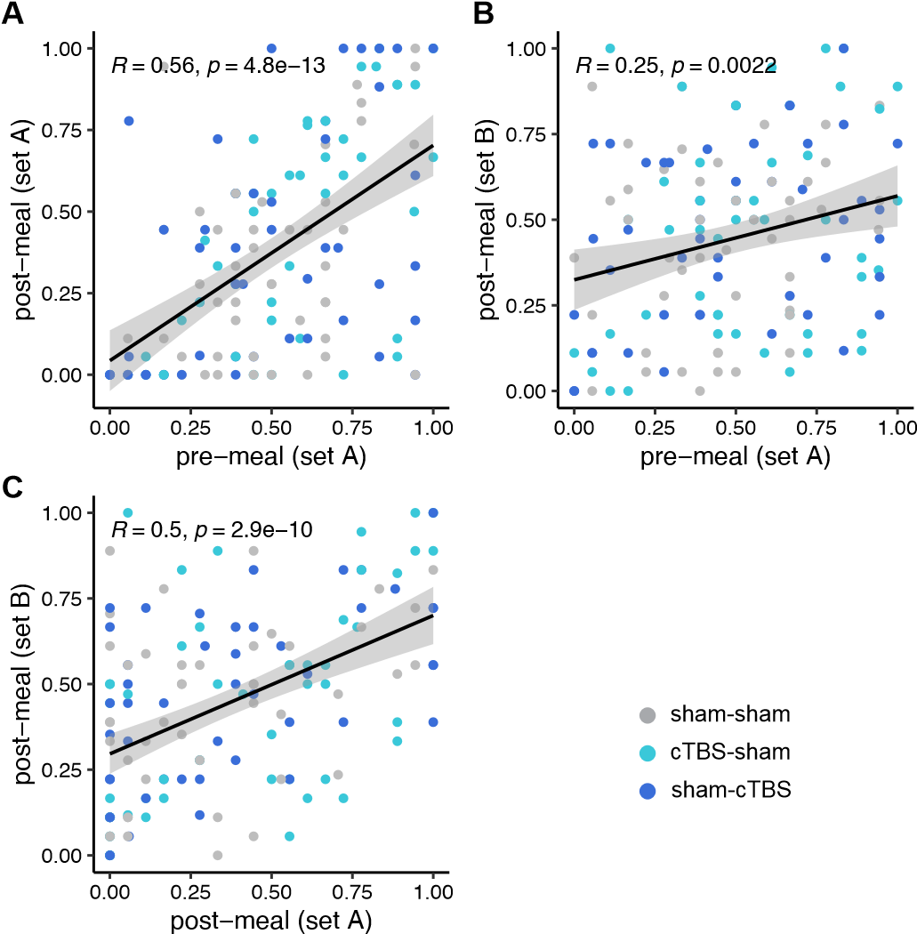

**Fig. S3**: **Scatter plots showing correlations in the proportion of sated odor choices across different sessions and odor sets. A.** Correlation between pre-meal and post-meal choices for odors in Set A. **B.** Correlation between pre-meal choices for Set A and post-meal choices for Set B. **C.** Correlation between post-meal choices for Set A and Set B. Each dot represents a participant. Reported Pearson’s *R* and *p* values are calculated across all participants, collapsing across TMS conditions due to the absence of significant differences. These correlations reflect stable individual patterns in sated odor choice behavior across TMS conditions and stimulus sets.

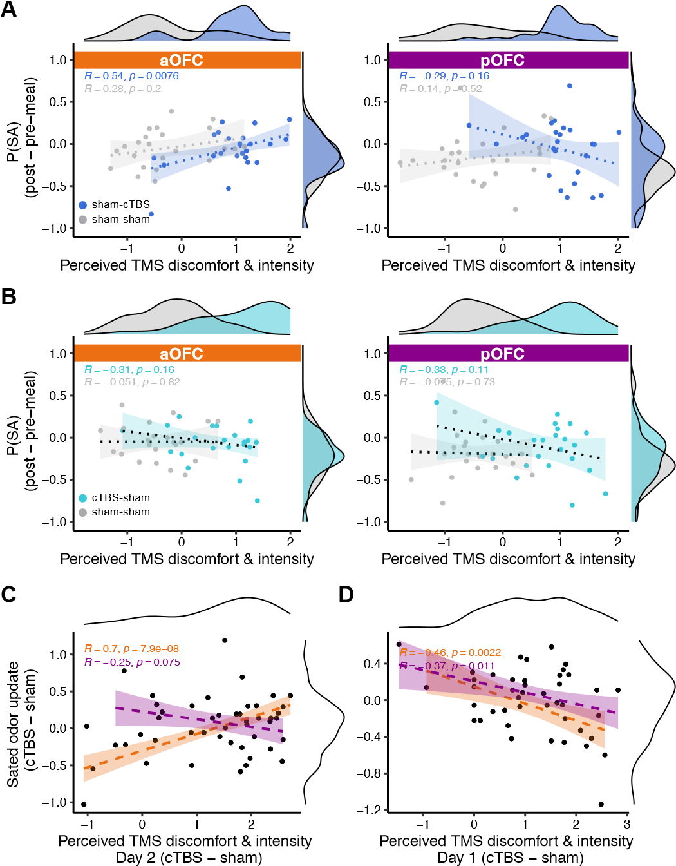

**Fig. S4**: **Relationship between perceived TMS discomfort and intensity and sated odor (SA) choices. A.** Correlation between SA choices and TMS ratings, separated by Day 2 TMS conditions (sham-cTBS vs. sham-sham) and TMS targeted regions (aOFC, pOFC). A positive correlation was observed between TMS ratings and SA choices in the aOFC group, but including ratings of TMS perception into the regression models did not alter the observed TMS effects on SA choices. **B.** Same as **A**, but focus on Day 1 TMS effect (sham-sham vs. cTBS-sham). **C.** Scatter plot showing the relationship between the condition-wise difference (sham-cTBS vs. sham-sham) of SA choices and condition-wise difference of TMS ratings from Day 2 TMS. There was a significant positive correlation in the aOFC group (Pearson’s *r* = 0*.*7, *p* = 7*.*9*e*−8) **D.** Same as **B**, but focus on Day 1 TMS effect (sham-sham vs. cTBS-sham). Shaded areas represent 95% confidence intervals estimated using robust linear regression. Marginal distributions are shown on the top and right axes. Pearson correlation coefficients (R) and p-values are reported for each TMS condition.