**Multifaceted Mechanisms of Outcome Devaluation: The Crucial Role of the Posterior Lateral OFC in Goal-Directed Choices**

## **Introduction**

Humans and animals effortlessly adapt to changing environments, adjusting their behavior in response to shifting contexts. The outcome devaluation paradigm offers a valuable framework for studying the cognitive mechanisms that underlie these adaptive behaviors. In this paradigm, responses to a predictive cue are evaluated after the selective devaluation of the associated outcome. Outcome devaluation is a key marker of goal-directed behavior, demonstrating the ability to align actions with updated goals and contexts rather than relying on habitual responses.

Studies in humans, rodents, and non-human primates have consistently shown that activity in the orbitofrontal cortex (OFC) is linked to processing of devalued outcomes and the stimuli associated with them1-4. Inactivating the OFC across species results in continued responding to Pavlovian cues, even after the outcome has been devalued, indicating an impaired ability to adjust behavior based on the updated outcome value5-7.

The OFC’s role in outcome devaluation has traditionally been interpreted as selectively updating the value of a stimulus that predicts a specific outcome, or as part of a broader behavioral control process5. However, recent studies in both rodents and humans suggest that the lateral OFC is specifically involved in learning the identity of the reward associated with stimuli9-12. If this association learning is disrupted due to dysfunction in the OFC, this could, in theory, disrupt the ability to adjust choices based on stimuli that predict different outcome identities. However, whether the OFC’s role in association learning directly influences outcome devaluation in humans remains unexplored. In addition, the OFC is a heterogeneous region composed of distinct subregions with differing anatomical and functional properties8, leaving it unclear whether all OFC subregions contribute uniformly to outcome devaluation or if certain portions play a more dominant role.

Given the complexity of the outcome devaluation process, which likely engages multiple cognitive components—such as value updating, behavioral inhibition, and stimulus-identity learning and retrieval—we aimed to investigate these mechanisms within a single experiment. We hypothesized that disrupting OFC activity during different phases of the outcome devaluation task could have varying effects on behavior. To test this, we applied network-targeted transcranial magnetic stimulation (TMS) with continuous theta burst stimulation (cTBS) in a within-participant study across multiple sessions. This approach was aimed to modulate the anterior and posterior portions of the lateral OFC network during the learning and testing phases. We found that: (1) both posterior and anterior OFC-targeted cTBS disrupted value acquisition, but only when administered during the first session; (2) posterior, but not anterior, OFC-targeted cTBS before testing impaired outcome devaluation; and (3) posterior, but not anterior, OFC disruption before learning impaired subsequent outcome devaluation. These results highlight the multifaced role of the posterior portion of the lateral OFC in outcome devaluation.

## **Results**

### **Outcome devaluation experiment design.**

This study follows a within-participant, multiple-session design, with 48 healthy human participants completing a two-day experiment across three separate sessions (spaced at least one week apart; **Figure 1A**). Each session involves the delivery of either continuous theta burst stimulation (cTBS) or sham TMS on both days (**Figure 1D**), with three counterbalanced conditions (Day 1-Day 2: cTBS-sham, sham-cTBS, sham-sham). On Day 1, participants learned to discriminate stimuli associated with desirable food odors (sweet or savory, equally valued based on pre-task ratings; **Figure 1E**) and odorless air (**Figure 1B**). They were asked to select the stimulus associated with any odor, meaning they were not required to encode the specific stimulus-identity associations to correctly perform the discrimination task. On Day 2, participants chose between stimuli based on odor preferences. A pre-meal test was followed by a meal, then by a post-meal test. Participants received the odors during the Day 1 discrimination task and the Day 2 pre-meal test. No odors were delivered during Day 2 post-meal test. Participants also reported how much they liked each odor before and after the meal.

To explore the potentially distinct functional roles of OFC subregions in this task, TMS was administered at two different time points—either before the discrimination task on Day 1 or before the meal on Day 2 (**Figure 1A**) —and targeted either the anterior or posterior portions of the lateral OFC. To differentiate the effects of cTBS applied in different phases, we used two distinct sets of stimuli: set A and set B (**Figure 1C**). Set A is used to indicate a baseline preference for the two odors during the pre-meal test, while set B is used to assess any impairments from Day 1 cTBS without the influence of relearning during the pre-meal test. Thus, the effects of cTBS on Day 2 can be observed in both sets, whereas the effects of Day 1 cTBS are only detectable in set B.

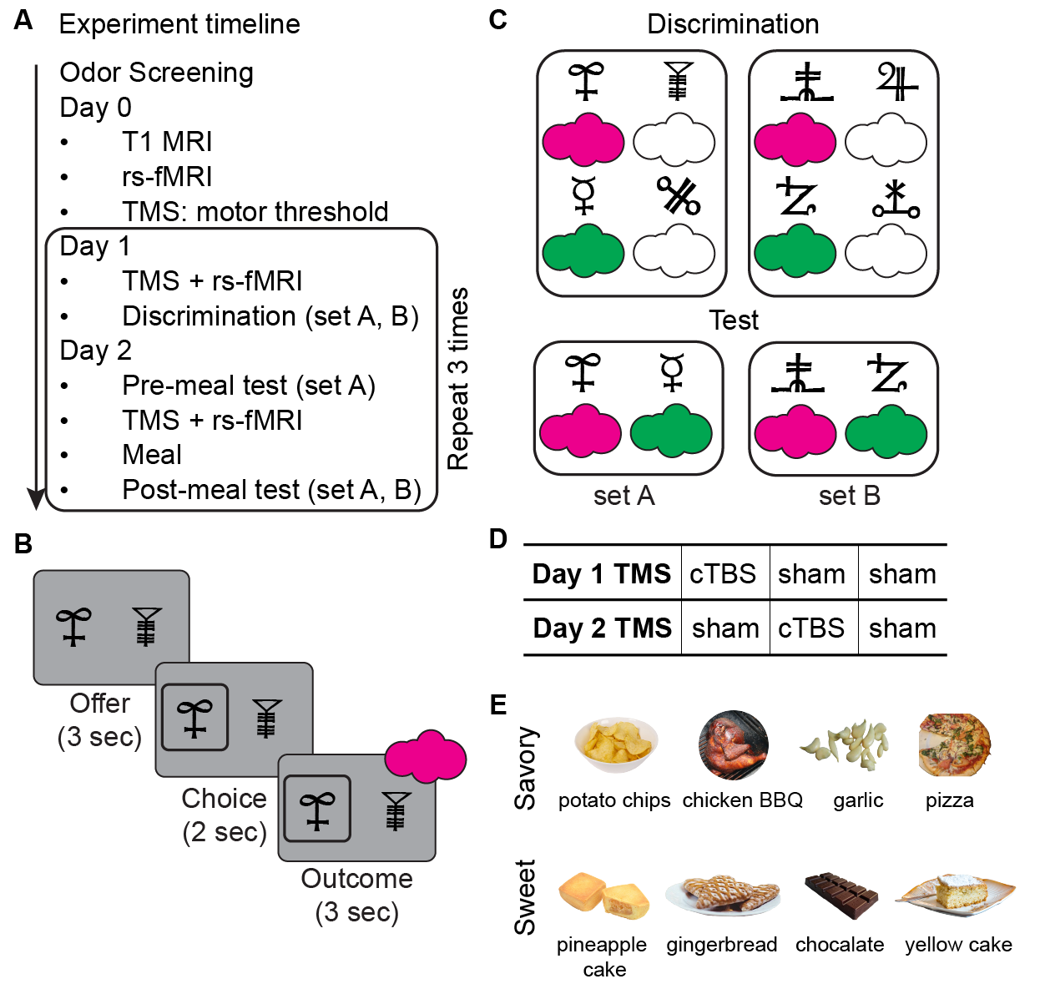

**Figure 1. Outcome devaluation experiment design.** **A. Experiment timeline.** The study follows a within-subject, multiple-session design. Participants underwent a two-day (Day1, Day2) experiment repeated across three separate sessions, spaced at least one week apart. Following odor screening session, Day 0 includes T1 MRI, resting-state fMRI, and motor threshold determination via TMS. On Day 1, participants received either continuous theta burst stimulation (cTBS) or sham TMS before performing an odor discrimination task. On Day 2, participants performed a pre-meal test (set A), received TMS (cTBS or sham), consumed a meal, and then completed a post-meal test (sets A and B). **B. Trial structure of discrimination task and tests.** Each trial started with an offer phase (3 seconds), where participants were presented with two visual stimuli paired with different outcomes. This was followed by a choice phase (2 seconds), where participants selected one of the stimuli, and finally, an outcome phase (3 seconds), where the predicted outcome was delivered (odor or no odor). **C. Associative structure for the discrimination and test tasks.** During the discrimination task, participants learned which stimuli predicted odors (indicated by colored clouds) and which predicted non-odor outcomes. In the test phase, participants were required to select stimuli based on their learned odor associations, without odor delivery. **D. TMS conditions.** Three counterbalanced conditions across three sessions: cTBS on Day 1 followed by sham TMS on Day 2 (cTBS-sham), sham TMS on Day 1 followed by cTBS on Day 2 (sham-cTBS), and sham TMS on both days (sham-sham). **E. Odor stimuli.** A set of eight food-related odors, divided into savory (e.g., potato chips, pizza) and sweet (e.g., pineapple cake, chocolate). For each participant, one savory and one sweet odor were pre-selected based on their pleasantness ratings to ensure they were as similarly pleasant as possible.

**Network-targeted TMS on anterior and posterior portions of the lateral OFC network.**

We aimed to selectively modulate neural activity in the anterior (aOFC) and posterior (pOFC) portions of the lateral OFC network (**Figure 2A**). Stimulation targets were defined using MNI coordinates in the right hemisphere: aOFC at [34, 54, -14] and pOFC at [28, 38, -16]. Each target showed strong functional connectivity with isolated lateral prefrontal cortex (LPFC) clusters (referred to as aOFC-connected and pOFC-connected LPFC clusters, respectively). Based on resting-state fMRI data from Day 0, we individually selected LPFC stimulation sites with the highest connectivity to the respective aOFC or pOFC targets (**Figure 2B**). We confirmed the functional separation of these networks across all resting-state fMRI sessions: the aOFC-connected LPFC showed stronger connectivity with the aOFC than the pOFC (W = 988, p = 1.567e-5, Wilcoxon signed rank test, two-sided), and the pOFC-connected LPFC showed stronger connectivity with the pOFC than the aOFC (W = 936, p = 2.234e-4) (**Figure 2C**).

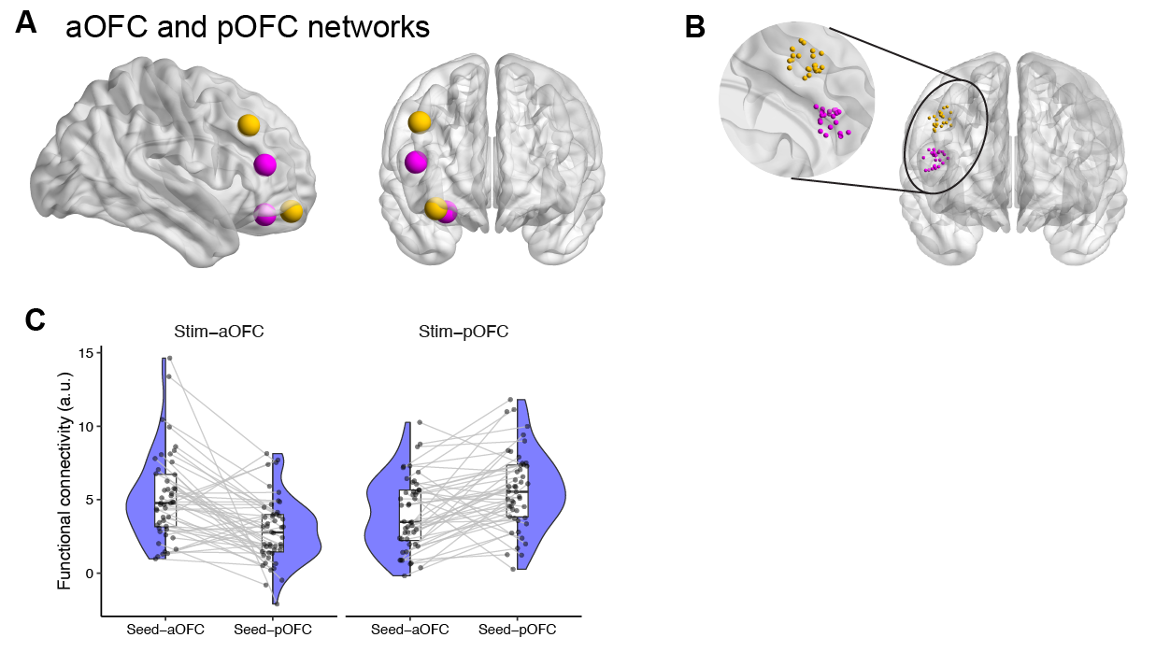

**Figure 2. Network-targeted TMS on anterior and posterior portions of the lateral OFC network. A.** Visualization of the OFC and LPFC networks, showing two pairs of the OFC-LPFC network (yellow: aOFC; magenta: pOFC). **B.** Individual stimulation coordinates, with each point representing the site of stimulation for each participant. These coordinates were chosen to maximize functional connectivity with either the aOFC or pOFC seed regions. **C.** Functional connectivity values for the aOFC and pOFC networks. The half-violin plots indicate the distribution of functional connectivity values between the stimulated OFC regions and their respective seed regions in the LPFC. Each dot corresponds to an individual participant’s connectivity value. Functional connectivity was calculated by using the aOFC or pOFC seed and extracted from the LPFC ROIs.

### **Posterior or anterior OFC-targeted cTBS disrupted value acquisition, only when administered during the first session**

The discrimination task on Day 1 required participants to select the stimulus predicting desirable food odors (vs. odorless air) from a pair of stimuli, reflecting a process of value acquisition. To account for individual and trial-wise variability, logistic mixed-effects models were applied with participants as random factor to predict choices on each trial. Over five runs, participants significantly improved in selecting odor-predictive stimuli (p < 2.2e-16), with this improvement affected by both the TMS condition applied before the task (p = 1.27e-07) and the session number (p = 1.71e-11; 1st, 2nd, 3rd session) (Line plot and error bar; **Figure 3A**). There was also a significant interaction between the TMS condition and the session number (p = 1.93e-05). Response times decreased significantly across runs (p < 2.2e-16), where this decrease was affected by session number (p < 2.2e-16, **Figure 3B**) but was not by TMS condition (p = 0.541), according to linear mixed-effects models with participants as random factor. Given that TMS condition and session number were confounded in the within-participant design, we grouped participants by the session number in which they received cTBS or sham on Day 1 (**Figure 3C**). This analysis revealed that the impairment in discrimination performance was not an overall effect but was only observable when cTBS was applied to participants’ first session (p < 2.2e-16). In all analyses, we also explored whether the effect of cTBS was influenced by anterior or posterior OFC-targeted stimulation. However, there was no evidence of a differential impact based on the targeted location on discrimination performance (all p > 0.05).

To better quantify and compare the learning process, we fitted a Rescorla-Wagner model to the discrimination task choices across the five runs using a hierarchical Bayesian approach15. We compared three models: one with condition-specific learning rates, one with condition-specific learning rates, and one with fixed learning rates across sessions/conditions. Model comparison showed that the session-specific learning rate model provided the best fit (deviance information criterion16; DIC; session-specific learning rates = 13161.95, condition-specific learning rates = 13544.84, fixed learning rates = 14045.46). The winning model captured the data well, as illustrated by the shaded fit overlaid on the experimental data (**Figure 3A**).

We examined the estimated learning rates from the winning model and compared them across TMS conditions for each participant group. Wilcoxon signed-rank tests revealed that learning rates were significantly lower after cTBS compared to sham, but only for participants who received cTBS during their first session (p = 0.0027**; Figure 3D**). We explored if the low learning rates in this group were correlated with perceived TMS discomfort and intensity reported by the participants (**Figure 3E**). While no significant correlation was found, participants with lower learning rates tended to report higher overall TMS discomfort and intensity (r = -0.12, p = 0.65).

Overall, posterior and anterior OFC-targeted cTBS impaired value acquisition in the discrimination task, but only when cTBS was applied during the first session. This effect likely reflects participants’ difficulty in learning the task structure or the potential discomfort or surprise caused by their initial TMS experience, which may have negatively impacted their behavior.

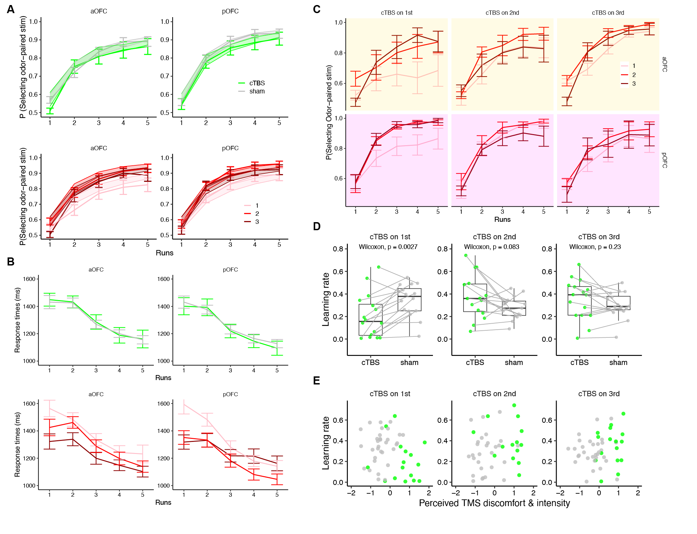

**Figure 3. Posterior or anterior OFC-targeted cTBS disrupted value acquisition, only when administered during the first session.** **A**. Discrimination accuracy across runs, plotted by TMS conditions (cTBS, sham), and session numbers (1st, 2nd, 3rd), separated by different OFC targeted locations (aOFC, pOFC). Error bars display the experimental data while the shade displays the 95% confidence interval of simulated accuracy using the posterior estimates of learning rates. **B.** Change of response times across runs. **C.** Discrimination accuracy across runs, separated by session numbers and the order of Day 1 TMS. **D.** Effect of cTBS on estimated learning rates, separated by Day 1 TMS order. **E.** Scatter plots showing the relationship between estimated learning rates and perceived TMS discomfort/intensity, separated by Day 1 TMS order.

### **Posterior, but not anterior, OFC-targeted cTBS on Day 2 impaired outcome devaluation**

Participants’ odor ratings on Day 2 indicated that the selective satiation procedure significantly reduced odor pleasantness across sessions and participants (p = 2.75e-13, **Figure 4A**). This effect was not influenced by TMS condition (sham/cTBS), TMS targeted location (aOFC/pOFC), session number (1st, 2nd, 3rd), or sated odor type (savory/sweet) (all p > 0.05), suggesting participants devalued the odor consistent after consuming the meal. To examine the role of the aOFC or the pOFC in outcome devaluation, we analyzed participants’ choices for stimuli predicting the sated odors before and after the meal. Pre- and post-meal choices for both set A and set B stimuli were highly correlated (**Figure 4B**), indicating consistent choices across sets based on odor preferences. To assess the satiation effect, we used the pre-meal average choice from set A as a session baseline and subtracted it from the post-meal choices for both sets. The results across sessions showed that post-meal choices of sated odors were significantly lower than the baseline in both the aOFC (Wilcoxon signed rank test, one-sided, p = 0.024) and pOFC (p = 0.0023) stimulation groups, suggesting the effect of selective satiation on stimulus selection.

To investigate the Day 2 TMS effect while avoiding potential disruption from Day 1 TMS, we focused on the ‘sham-sham’ and ‘sham-cTBS’ conditions. Using logistic mixed-effects models on post-meal choices of sated odors, with the session baseline as a regressor, we found a significant interaction between stimulation location and TMS condition in predicting sated-odor choices (p = 0.030). When analyzing the two stimulation locations separately (**Figure 4C**), adding the TMS condition significantly improved model fit for the pOFC group (p = 0.000419), but not for the aOFC group (p = 0.77). We also examined potential Day 2 TMS order effects on sated odor choices in the pOFC-targeted cTBS group, but no significant order effects were observed (**Figure 4D**).

We also explored whether changes in choice behavior before and after the meal were driven by the selective satiation effect. To quantify this, we created a session-wise selective satiation measure (see Methods), where more negative values indicate a stronger satiation effect. The change in sated odor choices was significantly correlated with the selective satiation measure (Pearson’s r = 0.46, p = 0.00083; **Figure 4E**). However, this correlation was not influenced by TMS condition (p = 0.9173), implying that cTBS was not likely to affect people to make choices according to the values. Additionally, we found no significant correlation between perceived TMS discomfort and intensity and changes in sated odor choice (Pearson’s r = 0.14, p = 0.18; Figure 4F), nor the difference of them between cTBS and sham conditions on Day 2 (Pearson’s r = 0.22, p = 0.14; Figure 4G).

Together, it suggests that pOFC-targeted cTBS impaired outcome devaluation, while aOFC-targeted cTBS had no such effect. This replicates previous results from our lab7 and further highlights the specificity of the pOFC involvement during the meal and test phase for outcome devaluation.

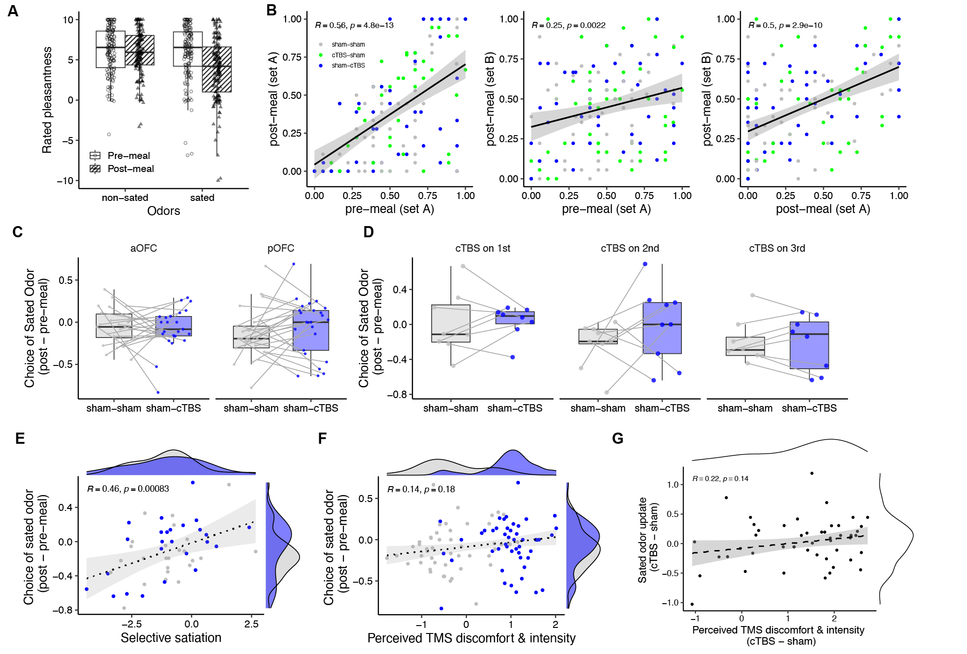

**Figure 4. Posterior, but not anterior, OFC-targeted cTBS on Day 2 impaired outcome devaluation**. **A.** Change of rated odor pleasantness before and after the meal, for sated and non-sated odors. **B.** Scatter plots showing Pearson’s correlation coefficients of choice of selecting sated odors among post-meal, pre-meal, set A and set B. **C.** Choice of sated odors for sham-sham and sham-cTBS conditions, under aOFC-targeted and pOFC-targeted cTBS. **D.** Choice of sated odors for participants of each Day 2 TMS stimulation order. **E.** Scatter plots showing the relationship between the choice of sated odors and selective satiation effect, separated by Day 2 TMS conditions. **F.** Scatter plot showing the relationship between the choice of sated odors and perceived TMS discomfort/intensity, separated by Day 2 TMS conditions. **G.** Scatter plot showing the relationship between the condition-wise difference of choice of sated odors and condition-wise difference of perceived TMS discomfort/intensity.

### ***Posterior, but not anterior, targeted-OFC disruption on Day 1 impaired subsequent outcome devaluation.***

We also explored whether Day 1 OFC-targeted cTBS affected outcome devaluation, as it might disrupt stimulus-outcome identity learning, which could, in turn, influence devaluation behavior observed on Day 2. Specifically, we focused on choices from set B stimuli to assess potential impairments. Set A stimuli were relearned at the beginning of Day 2, which would negate any effects of Day 1 TMS on set A, even if such effects had occurred. A differential pattern of cTBS effects between set A and set B would support the notion that OFC-targeted cTBS impairs stimulus-outcome identity learning.

For this analysis, we focused on the comparison between sham-sham and cTBS-sham conditions, assessing whether the TMS targeted location (aOFC vs. pOFC) moderated the effect of Day 1 TMS. We applied logistic mixed-effects models that accounted for baseline odor preferences in each session, as well as individual and trial-to-trial variability. The results revealed a significant interaction between the Day 1 TMS condition and the TMS targeted location on set B stimuli (β = 0.532, SE = 0.215, *p* = 0.013). Post-hoc examination showed that participants who received pOFC-targeted cTBS were more likely to select the sated odor compared to the sham (*p* = 0.031), indicating a significant impairment in outcome devaluation only following pOFC-targeted cTBS. In contrast, for set A stimuli, the interaction between Day 1 TMS and TMS targeted location was in the opposite direction ( = -0.599, SE = 0.266, p = 0.024), suggesting that the impairment observed for set B was not present for set A stimuli.

To verify how well the logistic mixed-effects models captured the experimental data, we used the fitted mixed-effects models to predict participants’ choices and compared these predictions to the actual experimental data. The predicted choices were highly correlated with the actual data in both aOFC-targeted (r = 0.53, p = 0.00015) and pOFC-targeted (r = 0.74, p = 2.4e-9) groups, suggesting that the model successfully captured the key patterns in the data. Lastly, we confirmed that the effect of cTBS on set B was not driven by a particular order in which participants received cTBS on Day 1 (**Figure 5C**). We also explored the relationship between the perceived TMS discomfort and intensity and their Day 2 choices across sets and stimulation sites (aOFC and pOFC) (Figure 5D). A negative, but not, correlation was found between the update in post-meal sated odor choices and perceived TMS effects, only for set B (r = -0.41, p = 0.045), suggesting that the cTBS effect on increased sated choices was unlikely to be driven by any TMS-related discomfort.

These findings support our hypothesis that pOFC-targeted cTBS on Day 1 impaired outcome devaluation on Day 2, whereas aOFC-targeted cTBS had no such effect. Importantly, this result is separated from the Day 2 TMS effect and aligns with previous research highlighting the pOFC’s critical role in representing reward identity during learning. This further underscores the specific involvement of the pOFC during association learning for outcome devaluation.

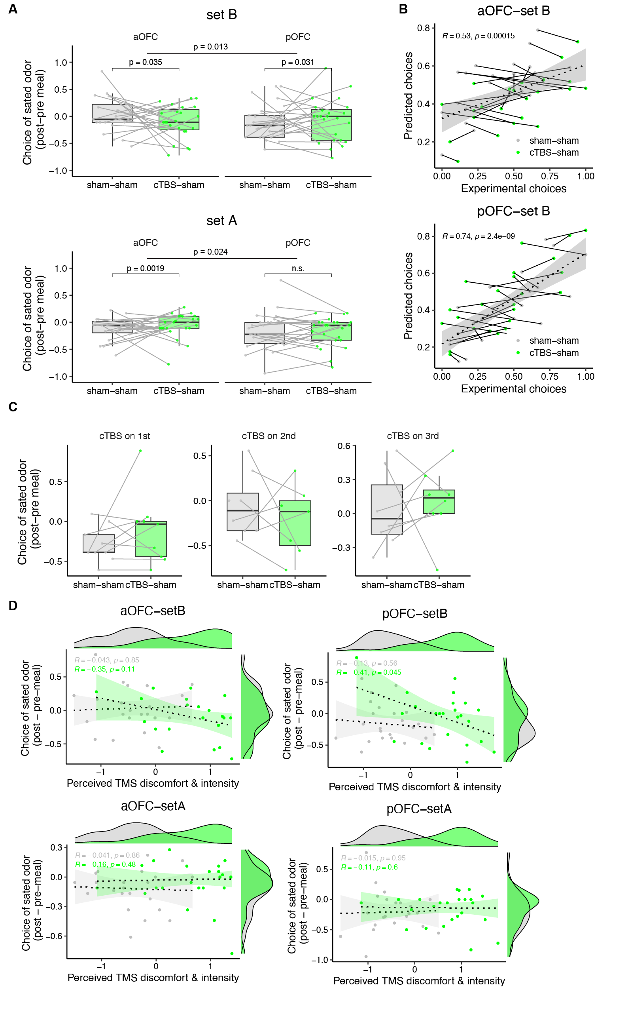

**Figure 5.** **Posterior, but not anterior, OFC-targeted cTBS before discrimination task on Day 1 impaired subsequent outcome devaluation**. **A.** Probability of selecting the sated odor (post-meal minus pre-meal) in set A and set B stimuli, compared between sham-sham and cTBS-sham sessions. The effect of Day 1 cTBS was assessed using set B stimuli, which reveals potential impairments in stimulus-identity association. A logistic mixed-effect model identified a significant interaction between Day 1 TMS (sham, cTBS) and TMS targeted location (aOFC, pOFC) on the probability of selecting the sated odor for set B stimuli ( = 0.532, SE = 0.215, p = 0.013). Specifically, Participants who received cTBS targeting the pOFC during the cTBS-sham condition were significantly more likely to choose the sated odor compared to the sham-sham condition, indicating impaired outcome devaluation following pOFC stimulation. In contrast, for set A stimuli, the interaction between Day 1 TMS and TMS targeted was in the opposite direction ( = -0.599, SE = 0.266, p = 0.024), suggesting that the impairment observed for set B was not present for set A stimuli. **B.** Scatter plots showing the correlation between predicted and experimental choices for set B stimuli, across participants and Day 1 TMS conditions, in both aOFC-targeted (r = 0.53, p = 0.00015) and pOFC-targeted (r = 0.74, p = 2.4e-9) groups. The dotted line represents the regression fit, with the shaded area representing the 95% confidence interval. **C.** The effect of Day 1 cTBS on outcome devaluation was not driven by a particular order in which participants received Day 1 cTBS. **D.** Relationship between perceived TMS discomfort and intensity and the change in sated odor choices on Day 2. Scatter plots show the correlation between perceived TMS discomfort/intensity and their post-meal sated odor choice across two sets (set A and set B) and two TMS-targeted locations (aOFC and pOFC).

## **Methods**

#### **Participants**

Eighty-eight healthy, right-handed participants (ages 18-40) with no history of psychiatric or neurological disease provided informed written consent to participate in this study. Of these, 48 participants (16 males; ages 18-40, mean = 25.17, SD = 4.14) completed all sessions. For one participant, behavioral data from the cTBS-sham session were unavailable due to a technical error, but data from the other two sessions were included in the analysis when appropriate. MRI data for five resting-state scans were not obtained and were excluded from analysis. All participants fasted for at least 4 hours before each study visit.

#### **Study design**

The study consisted of eight visits (Figure 1A, D), with Day 1 and Day 2 occurring consecutively and repeated over three sessions. Sessions were spaced by at least 1 week, with a median gap of 13.5 days, a mean of 18.02 days (SD = 9.09), and a range of 7 to 63 days. On each Day 1 and Day 2, participants received either continuous theta-burst stimulation (cTBS, labeled C) or sham stimulation (S). Across the three sessions, they experienced three TMS conditions: cTBS-sham (CS), sham-cTBS (SC), and sham-sham (SS). The order of these conditions was counterbalanced, with 9 participants experiencing CS-SC-SS, 7 experiencing CS-SS-SC, and 8 in the remaining participants experiencing one of the other four possible orders.

To prevent differences in stimulation location from affecting participants’ experience across sessions, each participant consistently received TMS targeting either the anterior or posterior portion of the lateral OFC in all three sessions. Of the participants, 16 of 32 females and 9 of 16 males received TMS targeted to the posterior portion. We also counterbalanced the order of satiation, with half the participants receiving a sweet meal in the first session and the other half receiving a savory meal. The sated odor type alternated for each participant across the three sessions (e.g., savory-sweet- savory or sweet-savory-sweet).

#### **Screening session**

After providing informed consent and completing eligibility screening, participants rated the pleasantness of eight food odors. These odors, supplied by International Flavors and Fragrances (New York, NY), included four savory (garlic, potato chip, pizza, barbecue) and four sweet (chocolate, yellow cake, pineapple cake, gingerbread) odors.

In each trial, participants smelled a food odor for 2 seconds and rated their liking on a visual analog scale ranging from “Most Disliked Sensation Imaginable” to “Most Liked Sensation Imaginable.” Ratings were made using a scroll wheel and keyboard press. Each odor was presented three times in a pseudo-randomized order, and ratings were averaged per odor. Based on these ratings, two odors (one savory, one sweet) that were pleasant (above neutral) and closely matched were selected for the discrimination and choice tasks. These odors were used across all three sessions. Participants were excluded if no suitable odors were identified.

A custom-built, computer-controlled olfactometer was used to deliver the odors with precise timing to nasal masks worn by participants. The olfactometer directed medical-grade air through the headspace of amber bottles containing the odor solutions at a constant flow rate of 3.2 L/min. Using two independent mass flow controllers (Alicat, Tucson, AZ), the device enabled precise dilution of the odorized air with odorless air. Throughout the experiment, a constant stream of odorless air was delivered, and odorized air was mixed in at specific time points without altering the overall flow rate or causing somatosensory stimulation.

##### ***Day 0: Scan & Motor threshold***

We acquired a T1-weighted structural MRI scan to assist with TMS neuronavigation and an 8 min multi-echo resting-state fMRI scan (310 volumes, TR = 1.5s) to individually define the OFC-targeted cTBS coordinates (see below). The same scanning parameters were used for other resting-state scans. We then measured resting motor threshold (rMT) by administering single TMS pulses to the hand area of the left motor cortex. rMT was defined as the lowest percentage of stimulator output required to evoke 5 visible thumb movements from 10 pulses.

##### ***Day 1: Discrimination task***

Participants first underwent a TMS session (cTBS or sham, see below), followed by a resting-state scan. Then they completed five runs of a discrimination task. In each trial, participants chose between two stimuli: one associated with a savory or sweet odor, and the other with clean air. Stimuli were displayed for 3 seconds, followed by a decision phase (maximum 3 seconds). If participants selected a stimulus leading to an odor, the odor was delivered for 2 seconds. The inter-trial interval ranged from 4 to 8 seconds. Each run consisted of 24 trials, using four groups of stimulus pairs: two sets (A and B) crossed with sweet/savory odors. Each combination had three non-overlapping stimulus pairs, resulting in 24 distinct stimuli. Each pair was presented twice to counterbalance left and right positions. Choice and response times were recorded for each trial, and different visual stimuli were used across the three sessions.

##### ***Day 2: Meal consumption and choice task***

Day 2 started with an odor pleasantness rating followed by a choice task (pre-meal) where participants selected between pairs of stimuli. Afterwards, participants underwent a TMS session and then had a meal carefully matched in flavor to either the sweet or savory food odor used in their task. Following the meal, participants completed another set of odor pleasantness ratings and a second choice task (post-meal). Both pre-meal and post-meal choice tasks instructed participants to choose based on their current odor preferences. In the pre-meal choice task, participants received the odor associated with their selected stimulus. In the post-meal choice task, no odors were delivered immediately, but participants were told that five randomly selected trials would result in odor delivery at the end of all trials.

The pre-meal choice task included 30 trials, all from set A, consisting of 3 sweet vs. clean air pairs, 3 savory vs. clean air pairs, and 9 savory vs. sweet pairs. Note that participants did not encounter the savory vs. sweet pairs of stimuli during the Day 1 discrimination task. Each pair was presented twice to counterbalance left and right positions. The post-meal choice task included 60 trials, from both sets A and B. The purpose of using two sets was to obtain a baseline preference for the odors from set A in the pre-meal test and to use set B to assess any impairment in odor identity learning from the Day 1 cTBS session.

In both tasks, every trial began with a pair of stimuli presented for 3 seconds, followed by a decision phase of up to 3 seconds. In the pre-meal choice task, if participants selected a stimulus linked to an odor, the odor was delivered for 2 seconds after their choices. In the post-meal choice task, five odors were delivered, each for 2 seconds, after all trials were completed. The inter-trial interval ranged from 4 to 8 seconds, and choice and response times were recorded for all trials.

#### **MRI data acquisition**

Each TMS session on Day 1 and Day 2 was immediately followed by a resting-state MRI scan. MRI data were acquired on a Siemens 3T PRISMA system equipped with a 64-channel head-neck coil. Resting-state fMRI data were collected across all seven sessions with the same multi-echo sequence (310 volumes; TR = 1.5s; TE1-TE3 = 14.60ms, 39.04ms, 63.48ms). The short TE of the first echo is beneficial to mitigate signal dropout near the OFC, as demonstrated in previous studies using both resting-state and task-based fMRI17-20. Other scanning parameters included: flip angle, 72°, slice thickness, 2mm (no gap), multi-band acceleration factor 4, 60 slices with interleaved acquisition, matrix size 104 x 104 voxels, and field of view 208mm x 208mm. A 1mm isotropic T1-weighted structural scan was acquired on Day 0 session for neuronavigation during TMS and to aid spatial normalization.

#### **Coordination selection for network-targeted TMS**

The stimulation coordinates were computed based on the multi-echo resting-state MRI data collected from the Day 0 session. We defined our stimulation targets in the right hemisphere’s aOFC and pOFC using MNI coordinates: aOFC [34, 54, -14] and pOFC [28, 38, -16]. The pOFC coordinates were identical to those used in our previous network-targeted TMS studies7,12-14, which have been found to correlate with the identity of reward outcomes7,13. Each targeted coordinate in the aOFC and pOFC exhibited strong functional connectivity with separate LPFC clusters with peak coordinate of [44, 28, 38] and [46, 38, 14], respectively. This functional connectivity was determined based on a meta-analysis from Neurosynth.org involving a sample of 1,000 subjects. We first generated spherical masks of 8-mm radius around these four coordinates in MNI space, each inclusively masked by the gray matter tissue probability map provided by SPM12 (thresholded at > 0.1). We then transformed these four masks to each subject’s native space using the inverse deformation field generated during the normalization of the T1 anatomical image. We then specified two resting-state fMRI functional connectivity analyses (one per region) for each subject, using individual OFC masks as the seed region and motion parameters from the realignment of the first echo as regressors of no interest. Finally, stimulation coordinates were defined as the voxels within the right LPFC masks with the strongest functional connectivity to the right aOFC and pOFC seed regions, respectively. We used infrared MRI-guided stereotactic neuronavigation (LOCALITE) to apply stimulation to these two individual LPFC coordinates.

#### **Transcranial magnetic stimulation**

Similar to our previous work, the target coordinates were defined as the locations in the right LPFC with the strongest functional connectivity with the right OFC seed regions (see details above). The figure-of-eight coil was tilted so that its long axis was approximately perpendicular to the long axis of the middle frontal gyrus. Whereas cTBS was delivered by positioning the active side of the A/P coil to modulate neural tissue, sham cTBS was applied with the placebo side of the A/P coil, producing similar somatosensory and auditory experiences for the subject without modulating neural tissue. Electrodes were placed on subjects’ forehead and direct current stimulation was applied in synchrony with the TMS pulses to mask TMS effects and enhance the similarity between cTBS and sham sessions.

Subjects were informed about potential muscle twitches in the face, eyes, and jaw during the simulation. To test for tolerability, two single pulses were applied over the stimulation coordinates before administering cTBS. We assessed subjects’ discomfort and perceived stimulation intensity after each TMS session. The cTBS session was generally perceived as more uncomfortable and intense compared to the sham session. On a scale from 0 (not uncomfortable at all) to 10 (extremely uncomfortable), the mean discomfort ratings were 3.38 for sham and 5.8 for cTBS sessions (*p* = 2.2e-16, linear mixed effects model). Similarly, on a scale from 0 (not strong at all) to 10 (extremely strong), the mean intensity ratings were 3.79 for sham and 6.23 for cTBS sessions (*p* = 2.2e–16, linear mixed effects model). Neither discomfort nor intensity ratings differed between aOFC or pOFC-targeted cTBS (all p > 0.6). In analyses involving cTBS effects (Day 1 or Day 2 TMS), we used standardized discomfort and intensity ratings to correlate or regress against other variables to determine if the observed cTBS effects were driven by subjective discomfort or perceived TMS intensity.

#### **Meal consumption**

On Day 2, participants were asked to eat a meal after the TMS session to selectively satiate one of the two food odors. Food items were chosen to closely match the corresponding food odors, and water was provided. Participants were instructed to eat as much as they could until they felt very full and were then left alone for 15 minutes. After the meal, participants immediately rated the pleasantness of the odors and proceeded to the post-meal choice task.

On average, participants consumed 669.89 ± 44.16 calories (SEM) during the meal. To examine the relationship between these ratings and task behavior, we standardized the ratings for each participant and calculated a selective satiation measure by determining the change in odor pleasantness before and after the meal (post-meal minus pre-meal) for both sated and non-sated odors, then subtracting the change for non-sated odors from the change for sated odors.

#### **Modeling learning process**

We used a Rescorla-Wagner model to describe the learning process during the discrimination task. In this task, participants selected between two stimuli, one leading to an odor and the other to odorless air. Since no stimuli were shared across pairs, we modeled learning at the level of each stimulus pair rather than individual stimuli, with the strength of each pair (S) representing how well it is learned.

The model updates the strength S for each pair based on prediction error, calculated as the difference between the actual strength (S=1) and the expected strength on each trial. The learning rate (α) determines the rate at which S is adjusted across trials. Initially, S is set to 0.5, and S = 1 indicates that the stimulus pair is perfectly learned. Discrimination choices were modeled using a Bernoulli process, with S as the probability parameter.

#### **Multi-echo MRI data processing**

Preprocessing of the multi-echo resting-state fMRI data involved several steps. First, all functional images from the smallest echo across all rs-fMRI runs were realigned to the first volume of the first echo, and the resulting voxel-to-world mapping matrix was applied to the other two echoes, volume by volume. All functional images were then resliced for each echo. Next, the images in each echo were combined using temporal signal-to-noise ratio (tSNR) weighting, following parallel-acquired inhomogeneity desensitized (PAID) approach18. Specifically, voxel-wise tSNR maps were computed for each echo, multiplied by the echo time (TE), and normalized across the three echoes to generate weight maps. These weight maps were then used to combine the resliced images by multiplying each volume by its respective weight map. Lastly, the combined data underwent coregistration, normalization, and smoothing using a 6 mm FWHM Gaussian kernel.

#### **References**

1 Critchley, H. D. & Rolls, E. T. Hunger and satiety modify the responses of olfactory and visual neurons in the primate orbitofrontal cortex. *Journal of Neurophysiology* **75**, 1673-1686 (1996).

2 O'doherty, J. *et al.* Sensory-specific satiety-related olfactory activation of the human orbitofrontal cortex. *Neuroreport* **11**, 893-897 (2000).

3 Gottfried, J. A., O'Doherty, J. & Dolan, R. J. Encoding predictive reward value in human amygdala and orbitofrontal cortex. *Science* **301**, 1104-1107 (2003). <https://doi.org/10.1126/science.1087919>

4 Howard, J. D. & Kahnt, T. Identity-Specific Reward Representations in Orbitofrontal Cortex Are Modulated by Selective Devaluation. *J. Neurosci.* **37**, 2627-2638 (2017). <https://doi.org/10.1523/JNEUROSCI.3473-16.2017>

5 Murray, E. A., Moylan, E. J., Saleem, K. S., Basile, B. M. & Turchi, J. Specialized areas for value updating and goal selection in the primate orbitofrontal cortex. *elife* **4**, e11695 (2015).

6 Howard, J. D. & Kahnt, T. Causal investigations into orbitofrontal control of human decision making. *Current Opinion in Behavioral Sciences* **38**, 14-19 (2021).

7 Howard, J. D. *et al.* Targeted Stimulation of Human Orbitofrontal Networks Disrupts Outcome-Guided Behavior. *Current Biology* **30**, 490-498.e494 (2020). <https://doi.org/10.1016/j.cub.2019.12.007>

8 Wang, M. Z., Hayden, B. Y. & Heilbronner, S. R. A structural and functional subdivision in central orbitofrontal cortex. *Nat Commun* **13**, 3623 (2022). <https://doi.org/10.1038/s41467-022-31273-9>

9 Howard, J. D., Gottfried, J. A., Tobler, P. N. & Kahnt, T. Identity-specific coding of future rewards in the human orbitofrontal cortex. *Proceedings of the National Academy of Sciences* **112**, 5195-5200 (2015). <https://doi.org/10.1073/pnas.1503550112>

10 Howard, J. D. & Kahnt, T. Identity prediction errors in the human midbrain update reward-identity expectations in the orbitofrontal cortex. *Nat Commun* **9**, 1611 (2018). <https://doi.org/10.1038/s41467-018-04055-5>

11 Costa, K. M. *et al.* The role of the lateral orbitofrontal cortex in creating cognitive maps. *Nat Neurosci* **26**, 107-115 (2023).

12 Liu, Q. *et al.* Midbrain signaling of identity prediction errors depends on orbitofrontal cortex networks. *Nat Commun* **15**, 1704 (2024). <https://doi.org/10.1038/s41467-024-45880-1>

13 Wang, F., Howard, J. D., Voss, J. L., Schoenbaum, G. & Kahnt, T. Targeted Stimulation of an Orbitofrontal Network Disrupts Decisions Based on Inferred, Not Experienced Outcomes. *J. Neurosci.* **40**, 8726-8733 (2020). <https://doi.org/10.1523/JNEUROSCI.1680-20.2020>

14 Tegelbeckers, J., Porter, D. B., Voss, J. L., Schoenbaum, G. & Kahnt, T. Lateral orbitofrontal cortex integrates predictive information across multiple cues to guide behavior. *Current Biology* **33**, 4496-4504. e4495 (2023).

15 Myung, J. I., Karabatsos, G. & Iverson, G. J. A Bayesian approach to testing decision making axioms. *Journal of Mathematical Psychology* **49**, 205-225 (2005).

16 Spiegelhalter, D. J., Best, N. G., Carlin, B. P. & Van Der Linde, A. Bayesian measures of model complexity and fit. *Journal of the royal statistical society: Series b (statistical methodology)* **64**, 583-639 (2002).

17 Fernandez, B., Leuchs, L., Samann, P. G., Czisch, M. & Spoormaker, V. I. Multi-echo EPI of human fear conditioning reveals improved BOLD detection in ventromedial prefrontal cortex. *NeuroImage* **156**, 65-77 (2017). <https://doi.org/10.1016/j.neuroimage.2017.05.005>

18 Poser, B. A., Versluis, M. J., Hoogduin, J. M. & Norris, D. G. BOLD contrast sensitivity enhancement and artifact reduction with multiecho EPI: parallel-acquired inhomogeneity-desensitized fMRI. *Magn Reson Med* **55**, 1227-1235 (2006). <https://doi.org/10.1002/mrm.20900>

19 Kirilina, E., Lutti, A., Poser, B. A., Blankenburg, F. & Weiskopf, N. The quest for the best: The impact of different EPI sequences on the sensitivity of random effect fMRI group analyses. *NeuroImage* **126**, 49-59 (2016). <https://doi.org/10.1016/j.neuroimage.2015.10.071>

20 Zhao, L. S., Raithel, C. U., Tisdall, D., Detre, J. A. & Gottfried, J. A. Leveraging Multi-echo EPI to Enhance BOLD Sensitivity in Task-based Olfactory fMRI. *bioRxiv*, 2024.2001. 2015.575530 (2024).