Supporting Information
Model-based inference of reward identity in the lateral orbitofrontal cortex
Qingfang Liu, Yao Zhao, Taaseen Khan, Nicole Moussa, Geoffrey Schoenbaum, and Thorsten Kahnt
Correspondence: Thorsten Kahnt. E-mail: thorsten.kahnt@nih.gov

Supplementary Methods

Study participants
Thirty-five healthy, right-handed participants with no history of major psychiatric or neurological disorders provided written informed consent to participate in the study. One participant withdrew due to scheduling constraints, leaving 34 individuals who completed all experimental sessions. All participants fasted for approximately 2–4 hours before each study visit. Two participants were excluded from data analysis because they did not demonstrate learning during the conditioning task, rendering their data unsuitable for further analyses. One additional participant was excluded because the post-task interview indicated that they had misunderstood the probe choice instructions. The final sample comprised 31 participants (11 males, 20 females; ages 21–42, M = 28.58, SD = 6.03). The study protocol was approved by the NIDA-IRP Institutional Review Board (Study #001156) and registered on ClinicalTrials.gov (NCT05707806).

Experimental design
This study used a modified sensory preconditioning task combined with outcome devaluation. Participants first completed a preconditioning phase, during which they learned associations between pairs of visual cues (A1-B1, A2-B2, and C-D). The assignment of places and cartoon characters to preconditioned cues (A1, A2, and C) and conditioned cues (B1, B2, and D) was counterbalanced across participants. There were two sets of cue pairs, and each set comprised two A-B pairs (A1-B1 and A2-B2) and one C-D pair (Table S1). This was followed by a conditioning phase, where participants learned associations between the second cue in each pair and a non-devalued (B1) or subsequently devalued (B2) food odor, or clean air (D). The assignment of sweet and savory odors to B1 and B2 was counterbalanced across participants. Finally, participants completed a probe task in which they made choices among both conditioned and preconditioned cues, reflecting their preferences for the associated odors. The probe task was administered twice: once before and once after participants consumed a meal that was matched to either the sweet or the savory food odor (counterbalanced across participants).
Table S1. Cue–outcome mappings for preconditioned cues, conditioned cues, and their associated odor outcomes. In this illustration, the sweet odor is paired with A1 and B1 for consistency with main-text Fig. 1; in the actual experiment, the sweet–savory assignment was counterbalanced across participants.
Cue set Preconditioned cue Conditioned cue |  |  | Outcome
Set 1 | A1₁ | B1₁ | sweet odor
Set 1 | A2₁ | B2₁ | savory odor
Set 1 | C₁ | D₁ | clean air
Set 2 | A1₂ | B1₂ | sweet odor
Set 2 | A2₂ | B2₂ | savory odor
Set 2 | C₂ | D₂ | clean air

Study sessions
The study comprised three sessions: a stimulus selection session, Day 1, and Day 2. During the stimulus selection session, participants rated the images and odors. Day 1 included an MRI localizer scan followed by preconditioning training. Day 2 began with a brief preconditioning refresher (outside the scanner), followed by the conditioning task (three runs, inside the scanner) and two probe tasks (three runs each, inside the scanner), separated by the meal. Immediately before and after the meal, participants rated odor pleasantness and self-reported satiation. Day 2 concluded with a recognition memory task outside the scanner, followed by a post-task interview. In the final sample (n = 31), the interval between the stimulus selection session and Day 1 was 7.42 ± 10.75 days, and the interval between Day 1 and Day 2 was 7.42 ± 5.14 days (mean ± SD).
Stimulus selection session In the stimulus selection session, participants first completed an image rating task outside the scanner, in which they evaluated a series of character images followed by place images, indicating how much they liked each one. The purpose of this task was to identify images with neutral—or as similar as possible—liking ratings so that these images could be used as visual cues, ensuring that subsequent preference-based choices would primarily reflect preferences for the associated odors rather than any preexisting preferences for particular visual stimuli. Participants rated each image three times, and we selected eight character images and eight place images based on their average ratings.
Next, participants completed an odor rating and selection procedure in which they evaluated the pleasantness and intensity of ten food odors. We used five savory (potato chip, garlic, cheddar, pizza, tuna) and five sweet food odors (strawberry, chocolate, apple cinnamon, peach, vanilla). On each trial, participants smelled one odor for 2 s and then rated how much they liked it using a visual analog scale ranging from “Most Disliked Sensation Imaginable” to “Most Liked Sensation Imaginable.” Ratings were made by positioning a cursor along the scale. Each odor was presented three times in a pseudo-randomized order, and the three ratings for each odor were averaged. Based on these averaged ratings, two odors—one savory and one sweet—were selected for each participant. We selected odors that were rated above neutral and as closely matched in pleasantness as possible, and at least medium in perceived intensity. These individualized food odors served as the reward outcomes for the remainder of the experiment.
Study day 1 – Localizer (fMRI) On study day 1, participants completed a series of fMRI localizer scans designed to obtain neural responses to all visual and olfactory stimuli before any associative learning occurred. The session included two odor localizer runs, four character localizer runs, and four place localizer runs.
Odor localizer.
Participants completed two runs of the odor localizer, in which each trial consisted of a 2s sniff cue followed by 2s of odor delivery (one of the two participant-specific food odors or clean air), separated by a jittered 9–13s ITI. Each run contained 30 trials (3 odor types × 10 repetitions). Participants were instructed to inhale through their noses at the sniff cue while minimizing head and body movement.
Study day 1 – Preconditioning training On Day 1, following the localizer MRI scans, participants completed preconditioning training outside the scanner. During this phase, they learned six deterministic associations comprising six cue pairs: two A1–B1 pairs, two A2–B2 pairs, and two C–D pairs. In one counterbalanced assignment, the A1, A2, and C cues were places, whereas the B1, B2, and D cues were characters; the reverse category assignment was used for other participants. Participants were instructed to learn and remember which place was associated with each character. Instead of a passive viewing paradigm, we implemented a choice-based design to facilitate active engagement and promote more robust encoding of the paired associations (Bunsey and Eichenbaum, 1996).
Each trial began with a 3s presentation of the first cue (e.g., A1), followed by a 0.3s gap and then a 3s presentation of two possible second cues, one of which was the correct associate (e.g., B1), whereas the incorrect cue was from one of the other cue pairs within the same cue set (i.e., B2 or D). During this 3s choice period, participants indicated which of the two cues was associated with the preceding cue A1 by pressing left or right arrow key. Trials were separated by a jittered 3–8s inter-trial interval. Feedback (correct, incorrect) was provided after each choice. Whether the character or the place served as cue A1 and B1 (appeared first and second) was counterbalanced across participants.
Each run comprised 24 trials (6 cue pairs × 2 incorrect alternatives drawn from the same cue set × left/right balancing). Participants completed 3–5 runs in total, with the task terminating early if they achieved ≥ 90% accuracy after the third or fourth run.
Preconditioning refresher Day 2 began with a brief preconditioning refresher outside the scanner to reinforce the character–place associations learned on Day 1. Participants were allowed up to three refresher runs; those who achieved greater than 90% accuracy after the first or second run skipped the remaining runs. The structure of each run was identical to the preconditioning training on Day 1. Of the 31 participants in the final sample, 29 met the accuracy threshold after one run, whereas two participants required a second run.
Conditioning task In the conditioning task, participants viewed the second cue of each pair (i.e., B1, B2, and D) and predicted which odor (or clean air) would follow. Cues B1 and B2 predicted the non-devalued and subsequently devalued food odors, respectively, with sweet/savory identity counterbalanced across participants; cues D predicted clean air. To encourage retrieval of the associated, absent preconditioned cues (A1, A2 and C), participants were provided with a cover story instructing them to think about the related cue while making their predictions. Each trial began with a 2s presentation of a conditioned cue, followed by a 3s prediction period during which the cue remained on the screen and three odor abbreviations were displayed. Participants indicated which odor they expected. After a 4s delay following the prediction period, the associated odor (or clean air) was delivered for 2s. If no response was made, no odor was delivered and a “too slow” message appeared. Trials concluded with a jittered 4–10s inter-trial interval. Each of the three runs comprised 36 trials (6 cues × 6 possible orderings of odor names on the response screen).
Probe task (pre-meal and post-meal) In the probe task, administered once before and once after the meal, participants made choices between two sequentially presented cues based on which associated odor (or clean air) they preferred to smell. The two sequentially presented cues could either be two conditioned cues (i.e., B1 vs. B2, B1 vs. D, or B2 vs.
D) or two preconditioned cues (i.e., A1 vs. A2, A1 vs. C, or A2 vs. C). Participants were informed that no odors would be delivered during the task; instead, five trials would be randomly selected and the odor corresponding to their choice would be delivered at the end of the experiment.
Each trial began with a 3s presentation of the first cue (cue1), followed by a jittered 4–10s interval before the second cue (cue2) appeared for 3s. Participants then had 2s to indicate their choice, after which the trial ended with a jittered 4–10s inter-trial interval. Each of the six (3 pre-meal, 3 post-meal) runs comprised 24 trials (6 pairwise choice pairs × 2 cue sets × left/right balancing).
Meal consumption Between the pre- and post-meal probe tasks, participants left the scanner and consumed a meal matched to one of the two food odors (sweet or savory, counterbalanced across participants). The ten odor–food pairings are listed in Table S2. Participants were given 15minutes and instructed to eat until they felt very full. Food items were chosen to match the target odor as closely as possible, and water was provided. In the final sample, participants in the savory group (n = 15) consumed 711.8 ± 320.7 kcal, whereas those in the sweet group (n = 16) consumed 705.0 ± 232.2 kcal (mean ± SD). Caloric intake did not differ significantly between groups (two-sided independent-samples t-test: t(29) = 0.07, p = 0.95).
Table S2. Food odors and matching foods used for outcome devaluation.
Odor | Matching food(s)
Potato chip | Potato chips
Garlic | Minced garlic and naan
Cheddar | Macaroni and cheese, Goldfish crackers, Cheeze-  Its
Pizza | Frozen pizza and tomato sauce
Tuna | Canned tuna and crackers
Strawberry | Strawberry strudels
Chocolate | Clif bars
Apple cinnamon | Nutrigrain bars and apple crisps
Peach | Fruit cups and peach strudels
Vanilla | Vanilla cookies
Odor pleasantness ratings Participants rated the pleasantness of each food odor and clean air before and after the meal using a horizontal slider ranging from –4 (very unpleasant) to +4 (very pleasant) in 0.5-point increments. Each stimulus was rated three times, and the average of the three ratings was used in subsequent analyses. Because of an operational error, pleasantness, hunger, and satiety ratings were unavailable for one participant, leaving 30 participants for these analyses.
Self-reported hunger and satiety Participants also rated hunger and satiety before and after the meal by responding to three questions: “How would you rate your current level of hunger?”, “How would you rate your current level of satiety (feeling full)?”, and “How would you rate your current desire to eat?”. Ratings were made using the same horizontal slider scale as the odor pleasantness ratings.
Recognition memory task During the recognition memory task, participants judged whether specific character–place pairs had been encountered during preconditioning. Each trial consisted of a 3s presentation of the first cue (cue1), followed by a 0.3s blank interval and a 3s presentation of a second cue (cue2). Participants then indicated whether the pair was “old” or a recombined foil. No corrective feedback was provided. Trials were separated by a jittered 3–8s inter-trial interval. The task comprised 36 trials in total (6 cue pairs × old/foil × 3 repetitions). Foil pairs were constructed by randomly pairing each first cue (A1, A2 or C) with a second cue (B1, B2 or D) that had not been associated with it during pre-conditioning.
Post-task interview After completing all tasks, participants took part in a brief post-task interview designed to assess awareness, subjective experience, and task compliance.

Task stimuli
Visual stimuli We used two categories of visual stimuli—cartoon characters and landmark places. The visual stimulus set comprised 30 familiar cartoon characters (e.g., Jerry Mouse, Snoopy, Charmander) and 30 commonly recognizable places (e.g., office buildings, university campuses, bridges). Images were selected to avoid strong positive or negative affective content and to minimize any real-world associations with specific odors. For cartoon characters, we also excluded images with pronounced lateral gaze directions to prevent potential biases in participants’ left–right choices during the task. All images were converted to grayscale to reduce visual saliency and to ensure that any differences in preference or neural representation were not driven by low-level perceptual features.
Odor stimuli and delivery Food odors were sourced from several commercial suppliers:
Takasago International Corporation (Tokyo, Japan), International Flavors & Fragrances (New York, NY), The Flaming Candle (Strongsville, OH), The Candlemaker’s Store (Butler County, OH), and the Midwest Sea Salt Company (West Chester, OH).
We used a custom-built computer-controlled olfactometer to deliver food odors with precise timing directly to nasal masks worn by subjects. This olfactometer directed medical-grade air through the headspace of amber bottles containing liquid solutions of food odors, maintaining a constant flow rate of 3.2 L/min. Using two independent mass flow controllers (Alicat, Tucson, AZ), the olfactometer enabled the dilution of odorized air with odorless air. Throughout the experiment, a constant stream of odorless air was delivered to subjects’ noses. Odorized air was mixed into this airstream at specific time points, while ensuring no impact on the overall flow rate and preventing any alteration in somatosensory stimulation.

MRI data acquisition
MRI data were acquired on a Siemens 3T Prisma-Fit system using a 32-channel head coil.
Functional images were collected with a multi-echo gradient-echo EPI sequence (TR =
1.5s; TE₁–TE₄ = 12.60, 29.16, 45.72, and 62.28ms; flip angle = 67∘; in-plane voxel size = 2.51 × 2.51mm; slice thickness = 2.5mm (no gap); matrix size = 86 × 86 voxels; field of view = 216 × 216mm; 60 axial slices acquired in an interleaved order; multiband acceleration factor = 4). The short first echo time helps reduce susceptibility-induced signal dropout in orbitofrontal cortex, as demonstrated in previous resting-state and task-based fMRI studies (Fernandez et al., 2017; Kirilina et al., 2016; Poser et al., 2006; Zhao et al., 2024). High-resolution T1-weighted structural images (1mm isotropic) were acquired on Day 1 to facilitate spatial normalization.
Across the two study days, functional MRI runs varied in length depending on the task. On Day 1, the odor localizer scan comprised 320 volumes, and each character and place localizer run comprised 244 volumes. On Day 2, the odor prediction task consisted of 404 volumes per run, and each pre- and post-meal probe run contained 372 volumes.

Multi-echo MRI data processing
Preprocessing of the multi-echo fMRI data followed the procedures described in our recent work (Liu et al., 2025). First, all functional images from the shortest echo across all fMRI runs were realigned to the first volume of the first echo using SPM12, and the resulting voxel-to-world mapping matrix was applied to the other three echoes, volume by volume. All functional images were then resliced for each echo. Next, the images across the four echoes were combined using temporal signal-to-noise ratio (tSNR) weighting, following parallel-acquired inhomogeneity desensitized (PAID) approach (Poser et al., 2006). Specifically, voxel-wise tSNR maps were computed for each echo, multiplied by the echo time (TE), and normalized across the four echoes to generate weight maps. These weight maps were then used to combine the resliced images by multiplying each volume by its respective weight map. Finally, the combined multi-echo data were coregistered, normalized to MNI space, resampled to 2 mm isotropic resolution, and smoothed with a 2mm full-width at half-maximum (FWHM) Gaussian kernel, all using SPM12.

Sniff recording and analysis
We measured subjects’ nasal airflow (i.e., sniffing) directly at the nose using a nasal mask connected to a respiratory flow head and spirometer. Nasal airflow was recorded with PowerLab equipment (ADInstruments, Dunedin, New Zealand) at a sampling rate of 1kHz. Airflow traces for each fMRI run were preprocessed by smoothing with a 250ms moving window, down-sampling to 10Hz, applying a high-pass filter (50s cutoff) to remove slow drifts, normalizing each run by subtracting the mean and dividing by the standard deviation, and finally down-sampling to match the fMRI repetition time of 1.5s (TR). Sniff volume was computed as the integral of the nasal airflow. Nasal airflow, sniff volume, and their squared terms were included as nuisance regressors in the fMRI GLM analyses. Additional nuisance regressors accounting for head motion and image artifacts are described under Single-presentation GLMs below.

Behavioral data analysis
We analyzed behavior during the preconditioning task, the conditioning task, as well as the pre- and post-meal probe tasks. We excluded data from two participants whose run-wise accuracies in the conditioning task were consistently below 0.40.
Preconditioning and conditioning performance were quantified as the proportion of correct responses within each run. For comparisons among preconditioning cue-pair types, accuracy from the final Day 2 refresher run was calculated separately for each cue pair and then averaged across the two stimulus sets with equal weighting. Conditioning accuracy was compared among the three outcome-associated cue types in the final conditioning run, pooling across stimulus sets. Differences among cue pairs or cue types were assessed using Friedman tests.
No-response trials were counted as incorrect when calculating run-wise learning accuracy. For the final-run conditioning comparison among cue types, trials with missing response times were excluded.
For each probe test session, choice proportions were calculated separately for each participant and pairwise cue comparison, pooling valid trials across runs and stimulus sets. Proportions represented selection of the cue named first in each comparison, irrespective of its presentation position. Trials with missing responses were excluded. Changes in choice proportions and odor pleasantness were calculated as post-meal minus pre-meal values. Changes were tested against zero using two-sided Wilcoxon signed-rank tests, with an uncorrected significance threshold of p < 0.05.
To assess selective devaluation while accounting for changes common to both conditions over time, we compared participants’ pre- to post-meal changes using one-sided Wilcoxon signed-rank tests. For odor pleasantness, we compared changes for the devalued and non-devalued odors (n = 30). For choices, we compared changes for B2 > D versus B1 > D and, separately, A2 > C versus A1 > C (n = 31 for each comparison). The directional hypothesis was that the devalued condition would show a greater decrease than the non-devalued condition. Changes were defined as post-meal minus pre-meal values, and contrasts were oriented as devalued minus non-devalued changes. Tests assessed whether these paired contrasts were shifted below zero. Contrasts were rounded to 12 decimal places before ranking to preserve numerical ties, and zero contrasts were excluded from ranking. The reported W statistic is the sum of ranks for positive contrasts. These comparisons used an uncorrected significance threshold of p < 0.05.
Recognition memory accuracy was calculated after excluding trials with missing responses or response times. Accuracy was first averaged within each of the six cue pairs. Cue-pair-type accuracies equally averaged the two pairs in each type and were compared using a Friedman test. Overall recognition accuracy equally averaged all six cue pairs within each participant and was compared with chance (0.5) using a two-sided Wilcoxon signed-rank test, with an uncorrected significance threshold of p < 0.05. Differences from chance were rounded to 12 decimal places before ranking to preserve numerical ties. The test used a tie-corrected normal approximation without continuity correction; zero differences were excluded from ranking, and W was the smaller of the positive and negative rank sums.

Single-presentation GLMs
Nuisance regressors Nuisance regressors were constructed following procedures used in our previous work (Liu et al., 2024, 2025). Each run included six rigid-body motion parameters, their first temporal differences, and the squared terms of both, yielding 24 motion regressors, together with the respiratory regressors described under Sniff recording and analysis. To capture image artifacts from within-volume head motion, two additional measures were calculated from the unprocessed shortest-echo images: the difference in mean signal between odd- and even-numbered slices and the variance of mean signal across slices. Each measure was expressed as an absolute standardized deviation using its mean and standard deviation across all runs within each participant. These two time series, their first temporal differences, and their squared temporal differences were included as nuisance regressors. Volumes exceeding four standard deviations on either measure were modeled using separate indicator regressors. All nuisance regressors were z-scored within each run before inclusion in the GLMs.
Probe and odor-localizer models We estimated single-presentation GLMs for the premeal and postmeal probe tasks using the least-squares-separate approach (Mumford et al., 2012). A separate GLM was fitted for each cue presentation, modeling the target cue at its onset with a duration of 3 s and pooling all other cue presentations within the same run into a second regressor. Both cue positions were estimated, yielding two GLMs per trial. Each model additionally included decision periods, modeled with a duration of 2 s; separate left- and right-hand button-press regressors, modeled as zero-duration events; and the nuisance regressors described above. Models were estimated on resliced, coregistered, normalized functional EPIs smoothed with a 2 mm FWHM Gaussian kernel. A high-pass filter with a cutoff of 128 s was applied.
Single-trial beta estimates were also obtained from the passive odor localizer using the least-squares-separate approach. A separate GLM was fitted for each odor presentation, with the target presentation modeled as a zero-duration event at sniff-cue onset and all remaining presentations within the same run pooled into a second regressor. Models used the same preprocessed functional images and nuisance regressors described above, with a high-pass filter cutoff of 128 s. Beta estimates for the two food odors were used to train the cross-task decoder.

Representational similarity analysis
We conducted a region-of-interest (ROI)-based representational similarity analysis (RSA) examining if cue-evoked fMRI responses in the premeal probe task (i.e., before devaluation could introduce confounding changes in odor value) reflected the identity of the odors associated with the cues. Analyses used the two bilateral orbitofrontal cortex (OFC) ROIs defined below.
Single-image beta estimates were selected for the first cue presentation of each trial. Conditioned and preconditioned cues were analyzed separately, each comprising four odor-predictive cue identities across the two stimulus sets. Cues associated with clean air were excluded. Individual presentation patterns were retained without averaging across trials or runs. Each cue subset ordinarily contained 24 samples across three runs, with two presentations of each cue per run. One participant contributed only 16 samples from two runs.
Within each ROI and cue subset, voxels with nonfinite values in any selected sample were removed. Each voxel’s responses were mean-centered across the selected samples within each run. Neural representational dissimilarity matrices were constructed using one minus the Pearson correlation between activity patterns. We created an odor-identity model representational dissimilarity matrix (RDM) by assigning zeros to trial pairs associated with the same odor and one to trial pairs associated with different odors. Correspondence between neural and model dissimilarities was assessed using Spearman correlation, retaining only trial pairs from different runs. Group-level inference used one-sided one-sample t tests of participant-level Spearman coefficients against zero.
Within each OFC ROI, participant-level odor-identity RSA coefficients for conditioned and preconditioned cues were correlated across participants using Spearman rank correlation. Negative associations were assessed using one-sided tests, with an uncorrected significance threshold of p < 0.05.

Cross-task decoding of odor identity
We tested whether multivoxel representations of perceived odor identity generalized to odor-associated visual cues. Analyses used the same two bilateral OFC regions as the RSA.
For each participant and ROI, a linear support vector machine with a fixed regularization parameter of C = 1 was trained to distinguish single-trial beta patterns from the passive odor task (conducted before associative learning) corresponding to different food odors.
Training included 40 odor presentations across two runs, with 20 presentations per odor. Clean-air trials were excluded.
The classifier was subsequently tested on single-image beta patterns from the premeal probe task, during which no odors were delivered. Only the first cue presentation in each trial was included. Conditioned and preconditioned cues were evaluated separately, retaining four odor-predictive cue identities per subset across the two stimulus sets. Each subset ordinarily contained 24 samples across three runs; one participant contributed only 16 samples from two runs. Test labels indicated the odor associated with each cue.
For each participant, ROI, and cue subset, voxels with nonfinite values in any training or test sample were excluded. Voxel responses were z-scored across samples separately within each run and task, with the two stimulus sets pooled within each probe run. Normalization statistics were calculated independently for the passive odor and probe datasets. The classifier was fitted using both passive odor runs and applied to the probe patterns without further fitting or hyperparameter selection. Decoding accuracy was calculated as the mean proportion of correct classifications across the two odor identities. One-sided one-sample t tests assessed whether participant-level decoding accuracy exceeded the chance level of 50%.

Region-of-interest definition
Analyses used two independently defined bilateral orbitofrontal cortex (OFC) regions from the connectivity-based K = 2 parcellation atlas: medial/posterior-lateral OFC (hereafter medial OFC) and central/anterior-lateral OFC (hereafter lateral OFC) (Kahnt et al., 2012). The parcellation map was resampled to the 2 mm isotropic analysis grid using nearest-neighbor interpolation. Each region was then intersected with a gray-matter mask derived from the SPM12 gray-matter tissue probability map thresholded at probability
> 0.1. The same ROI definitions were used for odor-identity RSA and cross-task decoding.

Searchlight RSA of subjective odor value
We examined subjective odor-value representations by combining single-image beta estimates from the premeal and postmeal probe tasks in a searchlight-based multiple-regression RSA. Both cue positions and all cues were included, including cues associated with clean air. We used spherical searchlights with an 8mm radius. Within each run, each voxel’s responses were mean-centered across cue presentations before neural RDMs were constructed. Neural dissimilarity was defined as one minus the Pearson correlation between activity patterns. Model fitting retained only trial pairs from different runs, with premeal and postmeal runs assigned distinct identifiers so that cross-phase pairs were included.
For each participant, the three outcome pleasantness ratings from each phase were jointly z-scored across the six phase-by-outcome values. Each cue presentation was assigned its associated outcome’s rating from the corresponding phase. The odor-value model RDM contained absolute differences between these assigned values. Neural dissimilarities were regressed on odor-value dissimilarity together with cue type (conditioned versus preconditioned), image identity, button presence, and button side model RDMs, using ordinary least squares with an intercept. Image identity was defined independently of first versus second presentation position. Button labels were assigned to second-cue presentations, whereas first-cue presentations were labeled as having no response. Separate odor-identity and phase model RDMs were not included in this regression.
Additional analyses used only the first or second cue presentation from each trial, retaining all cues and combining premeal and postmeal data. The first-cue analysis used the same cue-associated outcome-value model, omitting the button RDMs because they had no variance. For the second-cue analysis, each trial was assigned the signed difference between the standardized outcome values associated with the second and first cues (V₂ − V₁); the value RDM contained absolute pairwise differences in this trial-level variable. This model was fitted together with cue type, second-cue image identity, and button RDMs, omitting button RDMs with no variance.
Participant-level odor-value coefficient maps were smoothed with a 6mm FWHM Gaussian kernel and entered into a one-sided one-sample t test against zero in SPM12, using a gray-matter mask thresholded at probability > 0.1. Small-volume correction was applied separately within the independently defined bilateral medial and lateral OFC connectivity-based masks used for the odor-identity analyses (Kahnt et al., 2012). The medial and lateral OFC masks contained 5,500 and 4,445 voxels at 2mm isotropic resolution, respectively, all of which overlapped the analysis search volume. Peak-level inference controlled family-wise error (FWE) at p < 0.05 within each ROI, using the smoothness estimated from the group model.

Baseline outcome-identity retrieval success
The main-text model defines computational value as a_{i} = (1 − p_{i})D_{i}, where p_{i} is the probability of correctly retrieving the outcome identity before allocating representational resource r_{i}, and D_{i} > 0 is the behavioral cost of an identity error. Thus, at zero resource, expected decision loss is L_{i}(0) = (1 − p_{i})D_{i}. These baseline probabilities describe the associative retrieval process; they are not estimates of behavioral accuracy or fMRI decoding accuracy.
Let A denote successful retrieval of the correct conditioned associate from a preconditioned cue, and B denote successful retrieval of the correct outcome from that associate. We assume that recovering the correct outcome through the indirect route requires both steps to succeed. By the probability chain rule, indirect retrieval success is
p_{P} = Pr(A∩B) = Pr(A)Pr(B | A). Define p_{PC} = Pr(A) and assume that Pr(B | A) = p_{CO}, where p_{CO} is also the success probability for retrieving the outcome directly from a conditioned cue. This shared-reliability assumption gives p_{C} = p_{CO} and p_{P} = p_{PC}p_{CO} without requiring independence between the two retrieval events. It excludes successful recovery through alternative routes or compensating errors after an incorrect first retrieval.
For 0 < p_{PC},p_{CO} < 1, p_{P} < p_{C}. With equal behavioral error costs, D_{P} = D_{C} = D > 0, the computational-value ratio is
aP (1 − pP )D 1 − pPCpCO
= = > 1. a_{C} (1 − p_{C})D 1 − p_{CO}
The two associations need not have equal success probabilities. The ordering follows from the additional required retrieval step and the assumed common reliability of the C → O step across routes.

Optimal allocation of representational resources
We derive the allocation that minimizes the total decision loss in the resource-limited model. Let P and C denote preconditioned and directly conditioned cue classes, respectively. The computational values a_{P} ,a_{C} > 0 are held fixed during optimization. Representational resources are nonnegative and share a fixed budget r_{P} + r_{C} = R, with R > 0. Substituting r_{C} = R − r_{P} expresses total loss as a function of one allocation:
L(rP ) = aP e−rP + aCe−(R−rP), 0 ≤ rP ≤ R. (S1)
Differentiating with respect to r_{P} gives
^{dL} −r_{P} −(R−r_{P})
= −a_{P} e + a_{C}e . (S2)
dr_{P}
At an interior optimum, this derivative equals zero. Thus, the marginal reduction in loss from assigning additional resource to the preconditioned cue class equals the marginal increase in loss from removing that resource from the conditioned cue class:
a_{P} e^{−rP} = a_{C}e^{−rC} =⇒ r_{P} − r_{C} = log(a_{P} /a_{C}). (S3)
Here, log denotes the natural logarithm. Combining this equality with the budget

constraint yields the interior solution:
- R + log(aP /a_{C}) r_{P} = ,
2
- R − log(aP /aC)
rC = . (S4)
2

The second derivative is strictly positive:
^{d}2^{L} −r_{P} −(R−r_{P})
= a
dr_{P}2 _{P} e + a_{C}e > 0. (S5)
Therefore, total loss is strictly convex, and the stationary point is the unique global minimum whenever it lies within the feasible interval. If it lies outside that interval, the constrained minimum occurs at the nearest boundary. The general solution is
(︃ )︃
- R + log(aP /aC) * *
r_{P} = clip ,0,R , r_{C} = R − r_{P} , (S6)
2
where clip(x,0,R) = min{R,max{0,x}}. The solution is interior when
−R < log(a_{P} /a_{C}) < R. All resources are assigned to the preconditioned cue class when log(a_{P} /a_{C}) ≥ R, and to the conditioned cue class when log(a_{P} /a_{C}) ≤ −R. If R = 0, both allocations are zero.
For an interior solution, a_{P} > a_{C} implies r_{P}* > r_{C}* : outcome identities receive more resources when representing them has greater computational value. For the illustrative parameters in main-text Figure 5B (R = 4, a_{P} = 4, and a_{C} = 1), the solution is r_{P}* = 2.69 and r_{C}* = 1.31.

Simulation of the representational trade-off
To illustrate the shared-budget prediction in main-text Figure 5D, we simulated 100 participants with a common representational budget R = 4. For participant j, we fixed a_{C,j} = 1 and sampled the log computational-value ratio z_{j} = log(a_{P,j}/a_{C,j}) from a normal distribution conditional on a positive value:
z_{j} ∼ 𝒩(log4,1.2²) conditional on z_{j} > 0, a_{P,j} = e^{zj}. (S7)
The mean log4 and standard deviation 1.2 specify the underlying, untruncated normal distribution. Sampling from its positive tail, rather than clipping negative draws to zero, ensures a_{P,j} > a_{C,j} for every simulated participant, consistent with lower baseline retrieval success for preconditioned cues and equal behavioral error costs. We sampled computational-value ratios directly, rather than individual retrieval probabilities; the success-probability formulation motivates their ordering but does not specify their distribution. We used SciPy’s truncated-normal sampler with NumPy’s default random-number generator initialized with seed 20261023. Main-text Figure 5C shows the general allocation rule across both orderings of computational value; the participant simulation in Figure 5D is restricted to a_{P} > a_{C}.
For each draw, we calculated the constrained optimum using Eq. S6. The resulting latent allocations were nonnegative, summed to R, and assigned more resources to preconditioned than conditioned outcome identities. To obtain illustrative measurements of representational strength, we then added independent, zero-mean Gaussian noise to the two allocations:
xj = rC,j* + C,j, yj = rP,j* + P,j, C,j,P,j ∼ 𝒩(0,0.752). (S8)
Noise was drawn independently across participants and cue classes using the same generator after sampling the computational-value ratios. Noisy measurements were not clipped; they are expressed in arbitrary resource units and are not simulated RSA coefficients. At fixed R, the latent allocations obey r_{P,j}* = R − r_{C,j}* and therefore have a Spearman correlation of −1 when they vary across participants. Independent measurement noise attenuated this relationship, yielding a Spearman correlation of −0.324 between x_{j} and y_{j} in the illustrated sample. The line in Figure 5D shows a descriptive ordinary least-squares fit, with a pointwise 95% confidence interval for the fitted mean. All simulation parameters are illustrative and were not fitted to the empirical fMRI correlation; the simulation demonstrates a possible consequence of a shared budget rather than an estimate of its empirical magnitude.

Supplementary Results
Self-reported hunger and satiety. Ratings showed the expected shifts in hunger, satiety, and desire to eat after the meal (n = 30; Fig. S1). Mean hunger ratings decreased from 1.40 before the meal to −2.77 afterward. Mean satiety ratings increased from −1.40 to 1.88, and mean desire-to-eat ratings decreased from 1.58 to −2.43. All three changes were significant (two-sided Wilcoxon signed-rank tests, all p < 0.001, uncorrected).
Recognition memory. Recognition accuracy was well above chance (mean ± SD:
93.37% ± 14.19%; n = 31; two-sided Wilcoxon signed-rank test against 50%: W = 2.0, p < 0.001, uncorrected) and did not differ significantly across the three cue-pair types (Friedman test: χ²(2) = 1.60, p = 0.449; Fig. S2).
Choice preference and odor pleasantness. We examined the relationship between probe choices and odor pleasantness in participants with complete pleasantness data (n = 30). Meal-related changes in choice proportions were positively correlated with relative changes in outcome pleasantness for A2>A1 (r = 0.43, p = 0.018), B2>B1 (r = 0.41, p = 0.023), and B2>D (r = 0.42, p = 0.019; Fig. S3). Correlations for the remaining three comparisons were positive but nonsignificant (all p ≥ 0.096).
Choice proportions were also positively correlated with the pleasantness difference between the associated outcomes for all six comparisons, both before the meal (r = 0.43–0.77, all p ≤ 0.018) and after the meal (r = 0.42–0.81, all p ≤ 0.020; Fig. S4). All choice–pleasantness tests were two-sided Pearson correlations, uncorrected for multiple comparisons.
Representation of subjective outcome value. Separate analyses of conditioned and preconditioned cues revealed no significant value-related peaks in medial OFC
(conditioned: t(29) = 3.73, p_{FWE} = .134; preconditioned: t(29) = 2.11, p_{FWE} = .938; peak-level FWE correction within the medial OFC mask). These nonsignificant results may partly reflect reduced statistical power when analyzing each cue class separately.
The first-cue-only analysis revealed no significant outcome-value-related peak in medial OFC (t(29) = 2.54, p_{FWE} = .748). An analysis of second-cue responses using the signed value difference between the second and first cues likewise revealed no significant peak in medial OFC (t(29) = 3.81, p_{FWE} = .124; peak-level small-volume correction).
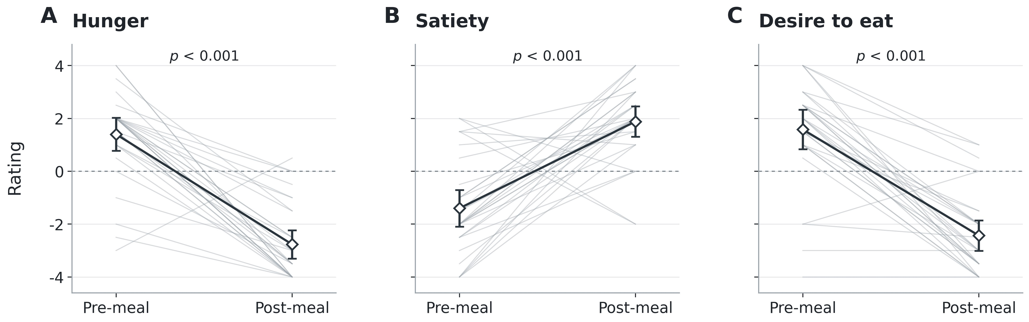

Figure S1. Change in self-reported hunger, satiety, and desire to eat. Panels
A–C show hunger, satiety, and desire-to-eat ratings, respectively, before and after the meal. Gray lines connect measurements from individual participants (n = 30). Open diamonds indicate group means, with t-based 95% confidence intervals. Horizontal dashed lines mark zero on the rating scale. Hunger and desire-to-eat ratings decreased, whereas satiety ratings increased (two-sided Wilcoxon signed-rank tests, all p < 0.001, uncorrected for multiple comparisons).
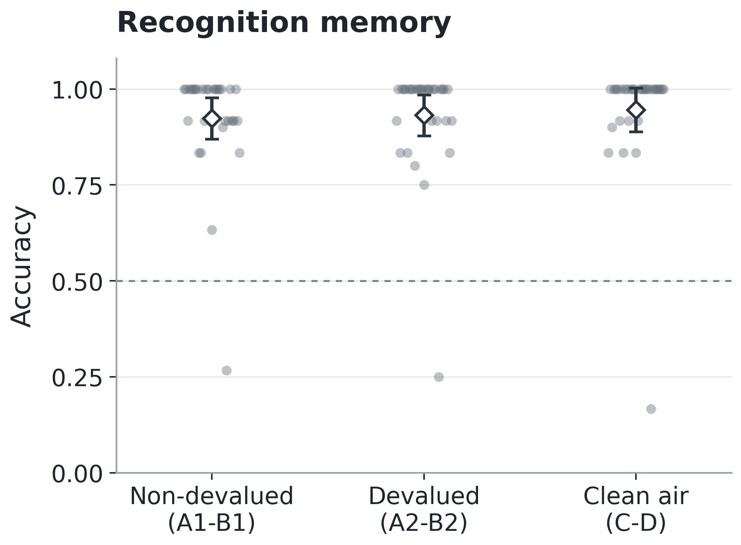
Figure S2. Recognition memory accuracy across cue-pair types. Points show individual participants’ mean recognition accuracy for each cue-pair group (n = 31). Accuracy was averaged within each cue pair and then equally across the two pairs in each group. Open diamonds indicate group means, with t-based 95% confidence intervals. The horizontal dashed line marks chance-level performance (0.5). Recognition accuracy did not differ significantly across cue-pair types (Friedman test: χ²(2) = 1.60, p = 0.449).
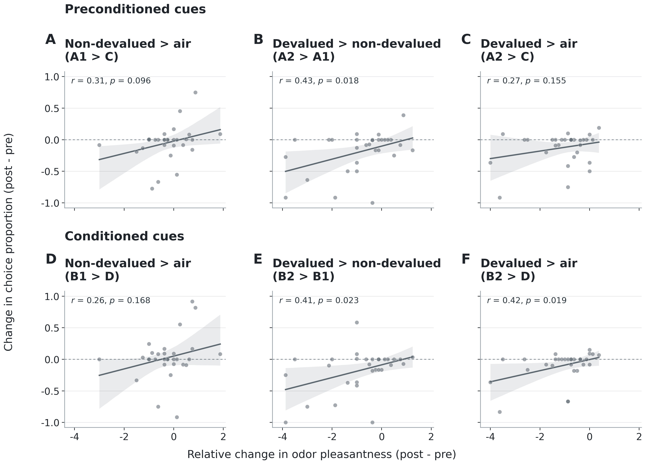
Figure S3. Changes in choices correlate with relative changes in odor pleasantness. Panels A–C show preconditioned cues, and panels D–F show conditioned cues. Each point represents one participant (n = 30). Choice changes were calculated as post-meal minus pre-meal proportions of choosing the first cue in each comparison. Relative pleasantness change was calculated as the difference between the associated outcomes’ post-minus-pre changes in pleasantness ratings, ordered as first cue minus second cue. Lines show ordinary least-squares fits; shaded regions indicate pointwise 95% bootstrap confidence intervals for the fitted mean. Horizontal dashed lines indicate zero choice change. Positive correlations were significant for A2>A1 (r = 0.43, p = 0.018), B2>B1 (r = 0.41, p = 0.023), and B2>D (r = 0.42, p = 0.019). Correlations were positive but nonsignificant for A1>C (r = 0.31, p = 0.096), A2>C (r = 0.27, p = 0.155), and B1>D (r = 0.26, p = 0.168). All tests were two-sided Pearson correlations, uncorrected for multiple comparisons.
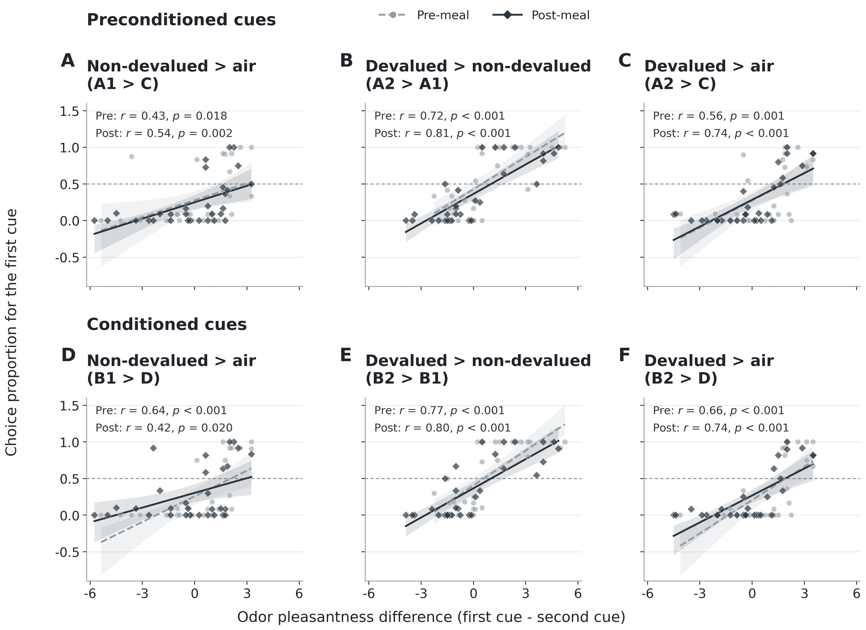
Figure S4. Choices correlate with odor pleasantness before and after the meal. Panels A–C show preconditioned cues, and panels D–F show conditioned cues. Each point represents one participant (n = 30). Choice proportions for the first cue in each comparison are plotted against the pleasantness difference between the associated outcomes, ordered as first cue minus second cue. Light-gray circles and dashed regression lines represent pre-meal measurements; dark diamonds and solid regression lines represent post-meal measurements. Lines show ordinary least-squares fits; shaded regions indicate pointwise 95% bootstrap confidence intervals for the fitted mean. Horizontal dashed lines indicate chance choice (0.5). Positive correlations were significant in both phases for all six comparisons: A1>C (pre: r = 0.43, p = 0.018; post: r = 0.54, p = 0.002), A2>A1 (pre: r = 0.72, p < 0.001; post: r = 0.81, p < 0.001), A2>C (pre: r = 0.56, p = 0.001; post: r = 0.74, p < 0.001), B1>D (pre: r = 0.64, p < 0.001; post: r = 0.42, p = 0.020), B2>B1 (pre: r = 0.77, p < 0.001; post: r = 0.80, p < 0.001), and B2>D (pre: r = 0.66, p < 0.001; post: r = 0.74, p < 0.001). All tests were two-sided Pearson correlations, uncorrected for multiple comparisons.
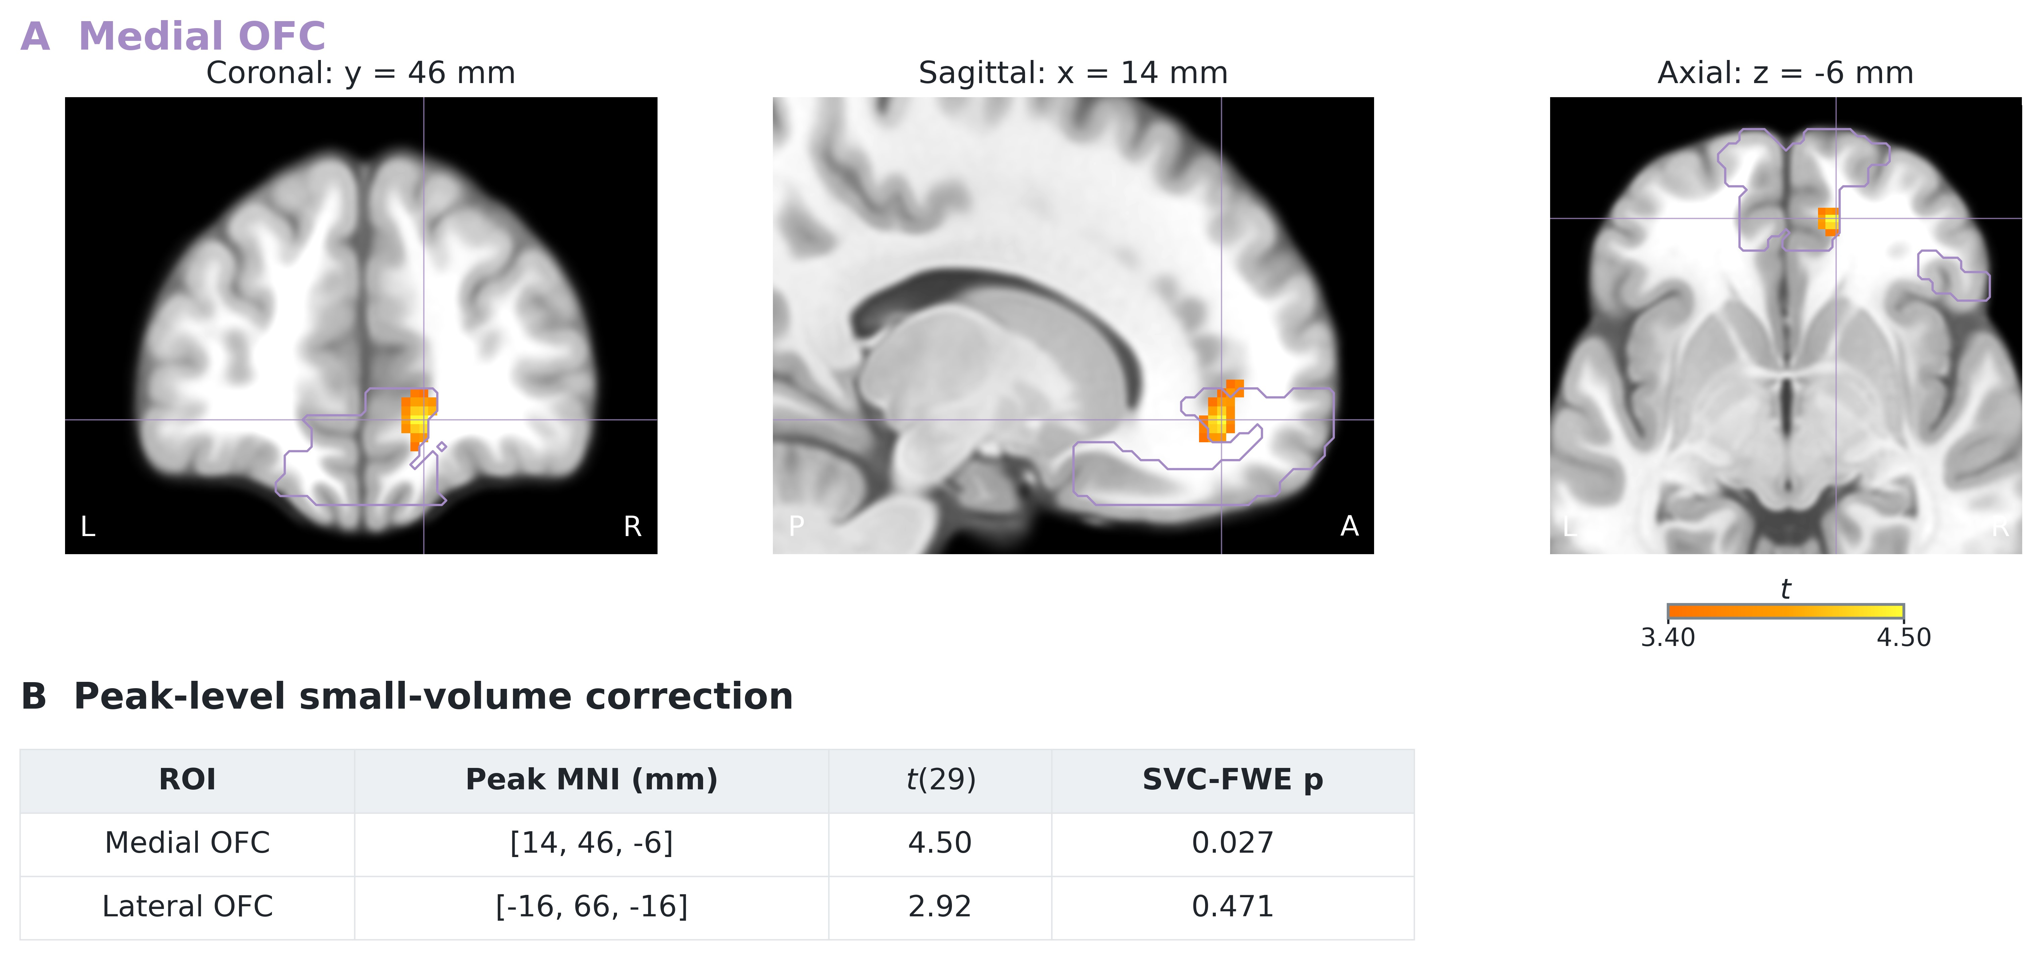
Figure S5. Searchlight RSA of subjective value. A. Medial OFC peak. Coronal (y = 46), sagittal (x = 14), and axial (z = −6) views intersect at MNI [14,46,−6]. Views show the positive group-level odor-value RSA t map from the combined pre-meal and post-meal probe analysis (n = 30), overlaid on the SPM-normalized ICBM152NLin2009 anatomical reference distributed with MRIcroGL. Views focus on frontal regions. Purple contours delineate the independently defined medial OFC connectivity-based mask (Kahnt et al., 2012); matching crosshairs mark the regional peak. Colored voxels show the whole-brain map at p < 0.001, uncorrected, with no extent threshold, for visualization; native 2mm statistical voxels are displayed without interpolation. The color bar indicates t values. Coronal and axial views use neurological orientation (left hemisphere shown on the left). B. Regional peak statistics. Peak-level p values control family-wise error within each independently defined OFC ROI, using the smoothness estimated from the group model. The medial OFC peak survived correction within its mask. Lateral OFC did not contain a significant peak and had no voxels above the display threshold.

References
Micheal Bunsey and Howard Eichenbaum. Conservation of hippocampal memory function in rats and humans. Nature, 379(6562):255–257, 1996.
Brice Fernandez, Laura Leuchs, Philipp G Sämann, Michael Czisch, and Victor I Spoormaker. Multi-echo epi of human fear conditioning reveals improved bold detection in ventromedial prefrontal cortex. Neuroimage, 156:65–77, 2017. ISSN 1053-8119.
Thorsten Kahnt, Luke J Chang, Soyoung Q Park, Jakob Heinzle, and John-Dylan Haynes. Connectivity-based parcellation of the human orbitofrontal cortex. The Journal of Neuroscience, 32(18):6240–6250, 2012.
Evgeniya Kirilina, Antoine Lutti, Benedikt A Poser, Felix Blankenburg, and Nikolaus Weiskopf. The quest for the best: The impact of different epi sequences on the sensitivity of random effect fmri group analyses. Neuroimage, 126:49–59, 2016.
Qingfang Liu, Yao Zhao, Sumedha Attanti, Joel L Voss, Geoffrey Schoenbaum, and Thorsten Kahnt. Midbrain signaling of identity prediction errors depends on orbitofrontal cortex networks. Nature Communications, 15(1):1704, 2024.
Qingfang Liu, Daria Porter, Hadeel Damra, Yao Zhao, Joel L Voss, Geoffrey Schoenbaum, and Thorsten Kahnt. Distinct contributions of anterior and posterior orbitofrontal cortex to outcome-guided behavior. Current Biology, 35(22):5549–5559, 2025.
Jeanette A Mumford, Benjamin O Turner, F Gregory Ashby, and Russell A Poldrack.
Deconvolving bold activation in event-related designs for multivoxel pattern classification analyses. Neuroimage, 59(3):2636–2643, 2012.
Benedikt A Poser, Maarten J Versluis, Johannes M Hoogduin, and David G Norris. Bold contrast sensitivity enhancement and artifact reduction with multiecho epi:
parallel-acquired inhomogeneity-desensitized fmri. Magnetic Resonance in Medicine: An Official Journal of the International Society for Magnetic Resonance in Medicine, 55(6): 1227–1235, 2006.
Ludwig Sichen Zhao, Clara U Raithel, M Dylan Tisdall, John A Detre, and Jay A
Gottfried. Leveraging multi-echo epi to enhance bold sensitivity in task-based olfactory fmri. Imaging Neuroscience, 2:1–15, 2024.

