导航部分

启动导航
配置navigation 2参数,把默认的nav2参数复制到工作空间
cp /opt/ros/humble/share/nav2_bringup/params/nav2_params.yaml src/student_starter_kit/config/
launch文件中使用nav2_bringup里的启动文件，会加快我们的导航启动速度
(ros2) airsim@AIPhy:/home/qinghe/ros2_ws$ cd /opt/ros/humble/share/nav2_bringup/rviz/
(ros2) airsim@AIPhy:/opt/ros/humble/share/nav2_bringup/rviz$ ls -l
total 32
-rw-r--r-- 1 root root 18303 Nov 18 01:56 nav2_default_view.rviz
-rw-r--r-- 1 root root 12002 Nov 18 01:56 nav2_namespaced_view.rviz
在launch文件中修改：
nav2_bringup_dir = get_package_share_directory('nav2_bringup')
rviz_config_dir = os.path.join(
nav2_bringup_dir, 'rviz', 'nav2_default_view.rviz')
......
launch.actions.IncludeLaunchDescription(
PythonLaunchDescriptionSource(
[nav2_bringup_dir, '/launch', '/bringup_launch.py']),
启动导航
conda activate ros2
cd /ros2-demo_ws
source install/setup.sh
ros2 launch student_starter_kit navigation.launch.py
全局代价地图开关
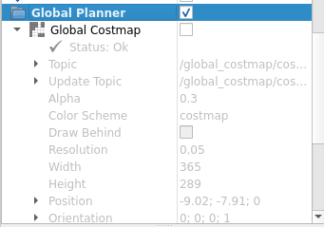

没开
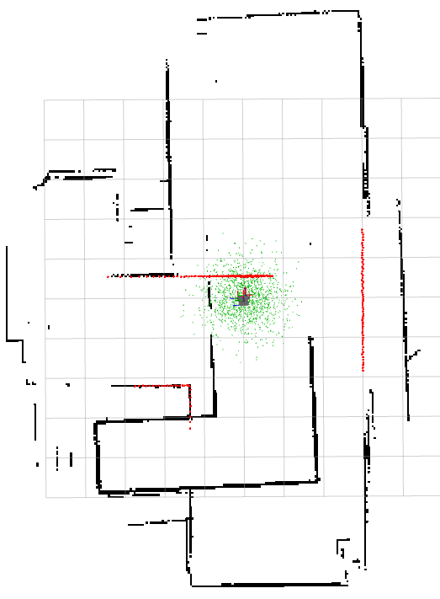

开了
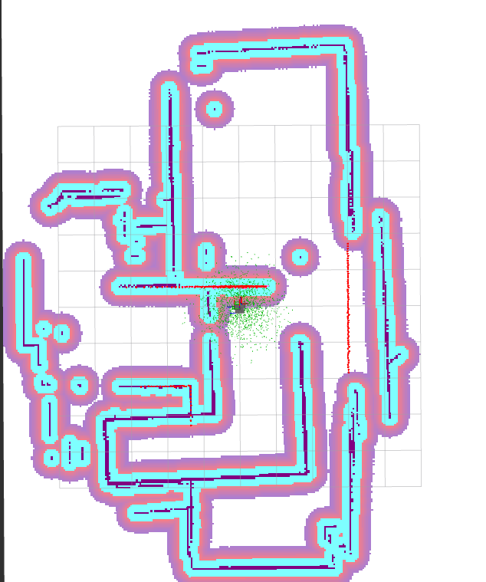

局部代价地图开关
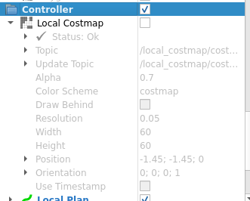

没开
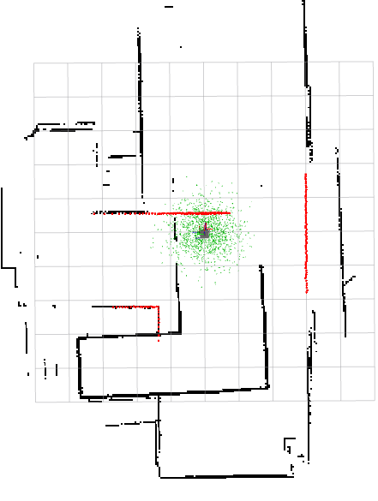

开了
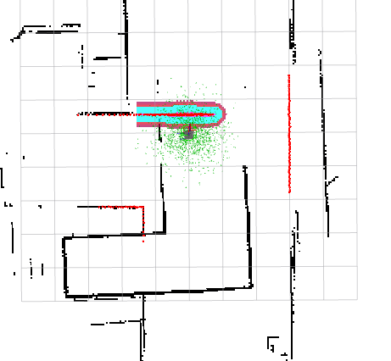

一开始会报tf错误
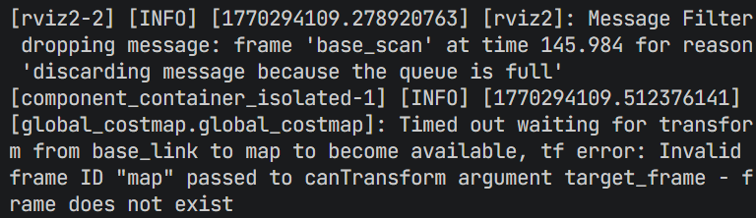

需要给机器人一个大概的位置，amcl会基于这个位置做大概的估计
在rviz中，选择2D Pose Estimate来标定位置
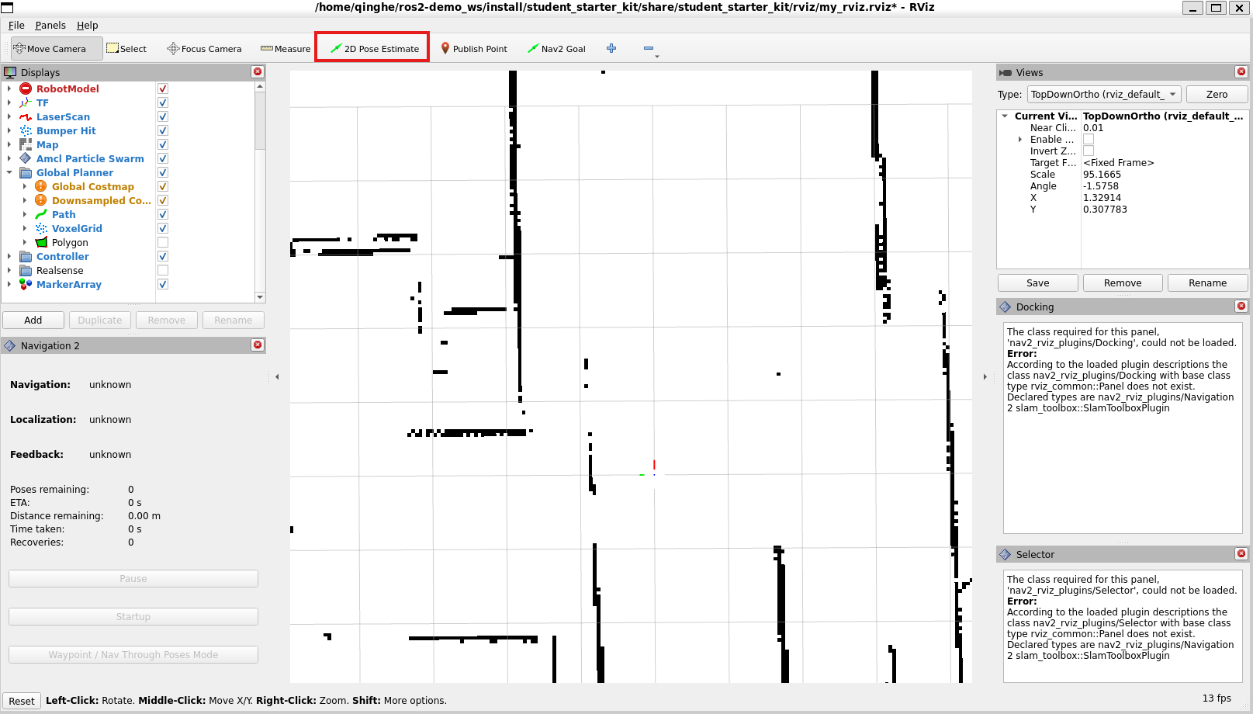

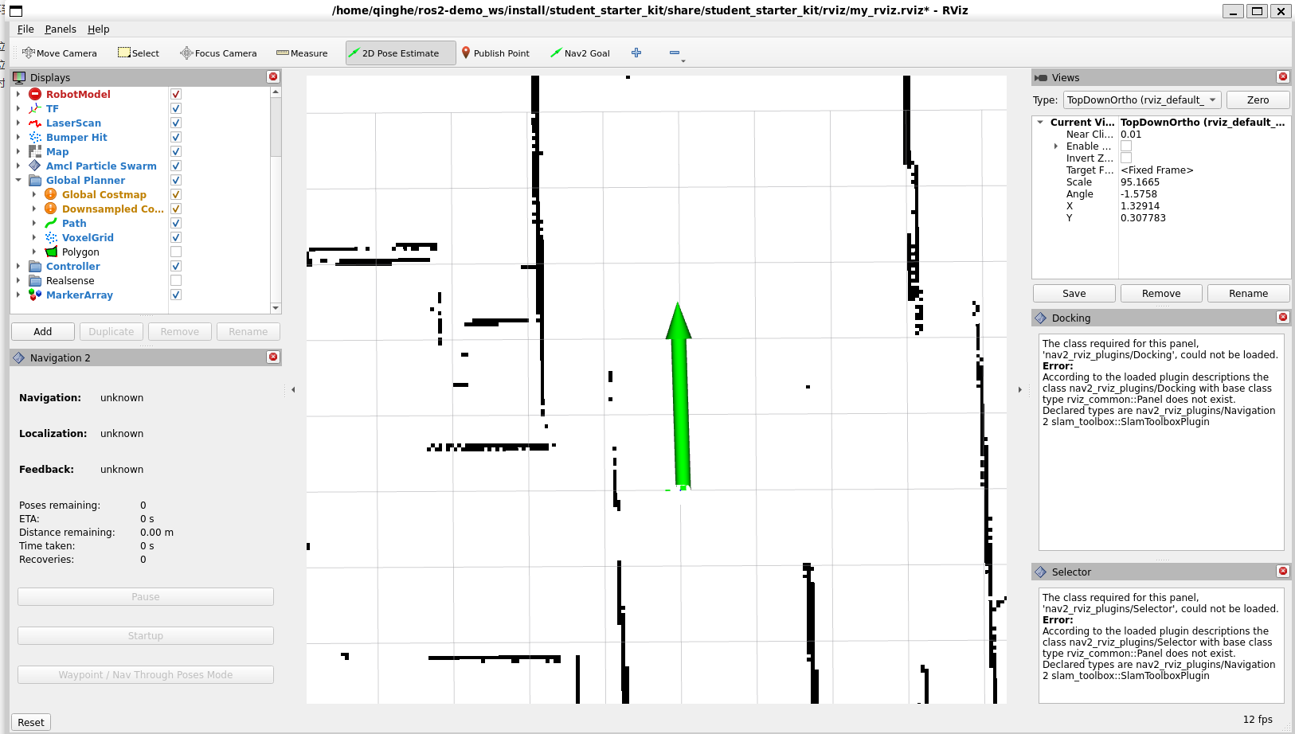

在RViz中导航

单点导航
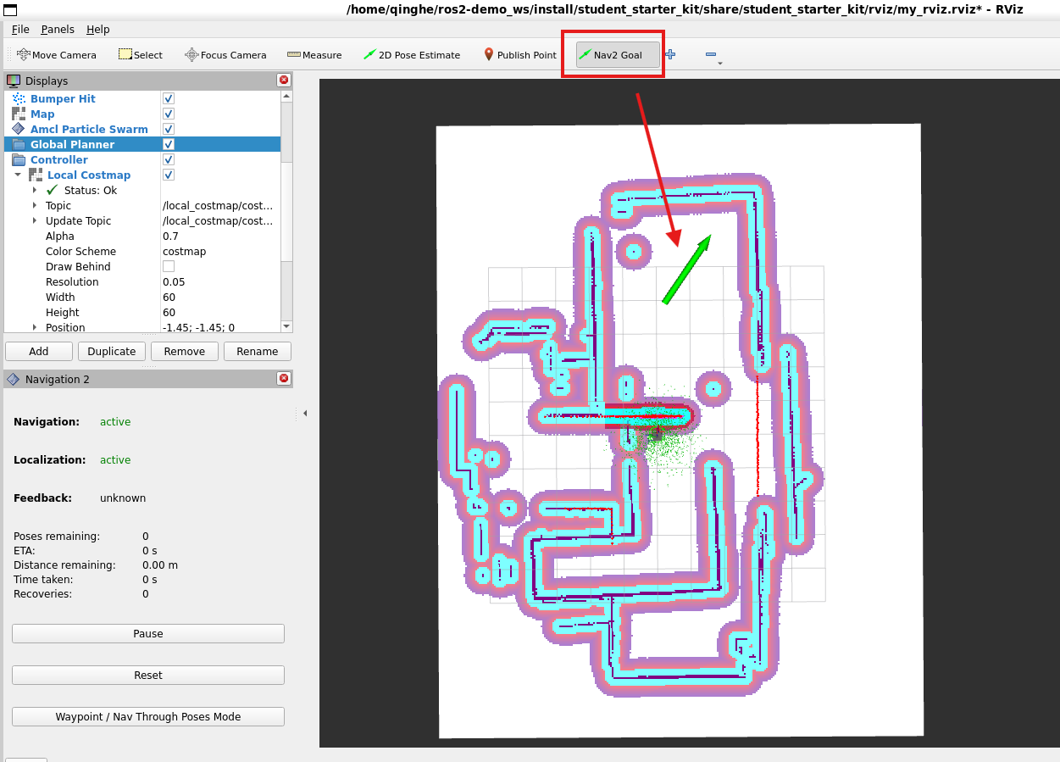

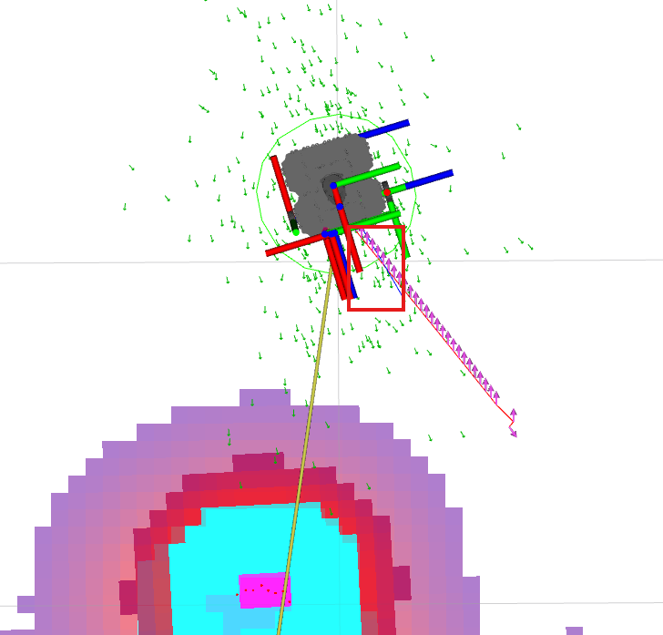

其中，蓝色的线是局部规划路径

多点导航
通过这个插件可以取消导航任务，也可以设置多个目标点的导航，点击最下面的 Waypoint/Nav Through Poses Mode ，接着使用 Nav2 Goal 依次设置多个路点，比如下图中设置了五个路点，让机器人绕过咖啡桌再到左前方的目标点。
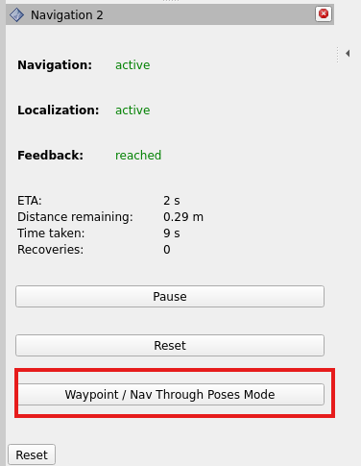

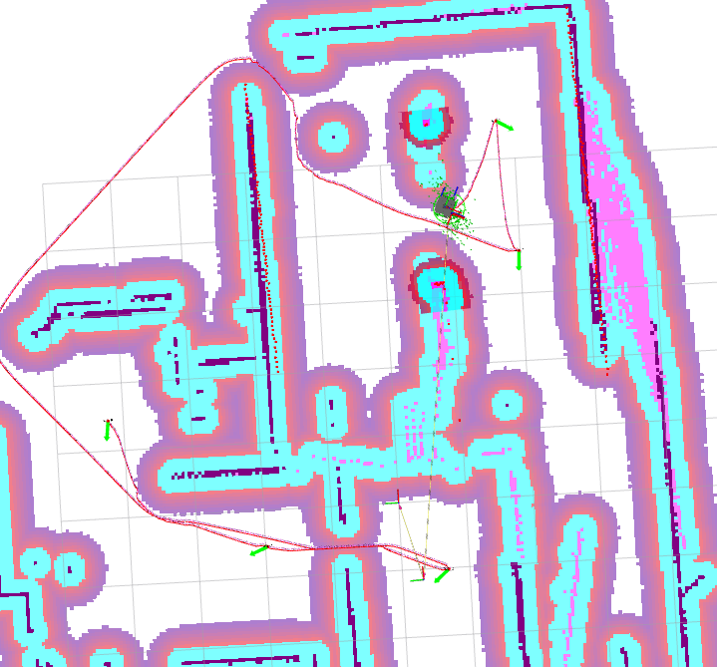

动态避障
在gazebo中放置一个圆柱，机器人导航的过程中，看到方块会动态规划路径。
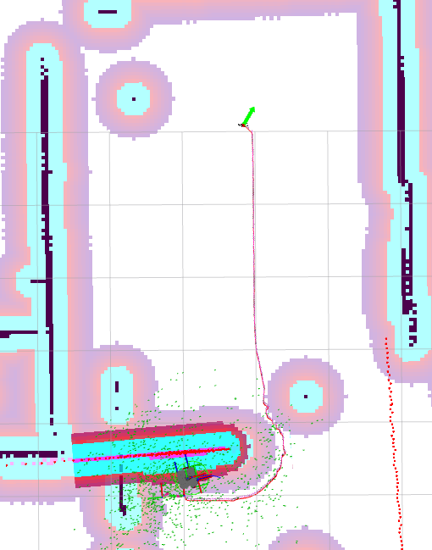

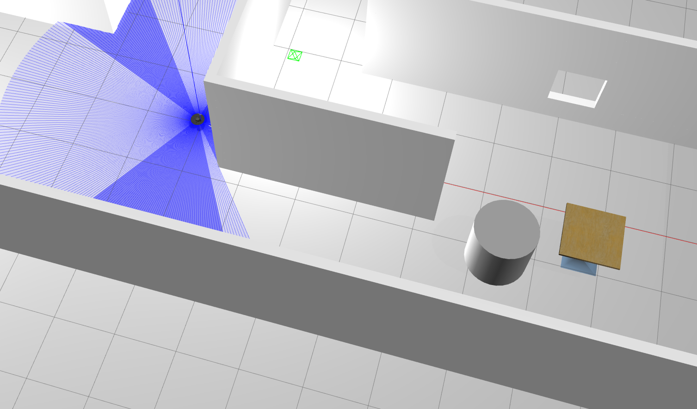

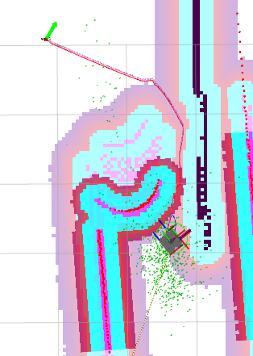

路线变了

使用话题初始化机器人的位置信息
查看节点
ros2 node info /amcl
/amcl
Subscribers:
/bond: bond/msg/Status
/clock: rosgraph_msgs/msg/Clock
/initialpose: geometry_msgs/msg/PoseWithCovarianceStamped # # 用于接受初始化未知的信息，直接向这个话题发布数据
/map: nav_msgs/msg/OccupancyGrid
/parameter_events: rcl_interfaces/msg/ParameterEvent
/scan: sensor_msgs/msg/LaserScan
Publishers:
/amcl/transition_event: lifecycle_msgs/msg/TransitionEvent
/amcl_pose: geometry_msgs/msg/PoseWithCovarianceStamped
/bond: bond/msg/Status
/parameter_events: rcl_interfaces/msg/ParameterEvent
/particle_cloud: nav2_msgs/msg/ParticleCloud
/rosout: rcl_interfaces/msg/Log
/tf: tf2_msgs/msg/TFMessage
Service Servers:
/amcl/change_state: lifecycle_msgs/srv/ChangeState
/amcl/describe_parameters: rcl_interfaces/srv/DescribeParameters
/amcl/get_available_states: lifecycle_msgs/srv/GetAvailableStates
/amcl/get_available_transitions: lifecycle_msgs/srv/GetAvailableTransitions
/amcl/get_parameter_types: rcl_interfaces/srv/GetParameterTypes
/amcl/get_parameters: rcl_interfaces/srv/GetParameters
/amcl/get_state: lifecycle_msgs/srv/GetState
/amcl/get_transition_graph: lifecycle_msgs/srv/GetAvailableTransitions
/amcl/list_parameters: rcl_interfaces/srv/ListParameters
/amcl/set_parameters: rcl_interfaces/srv/SetParameters
/amcl/set_parameters_atomically: rcl_interfaces/srv/SetParametersAtomically
/reinitialize_global_localization: std_srvs/srv/Empty
/request_nomotion_update: std_srvs/srv/Empty
/set_initial_pose: nav2_msgs/srv/SetInitialPose
Service Clients:
Action Servers:
Action Clients:
在gazebo中，查看机器人在物理坐标系的位置
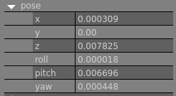

使用命令行发布数据
ros2 topic pub /initialpose geometry_msgs/msg/PoseWithCovarianceStamped "{header: {frame_id: 'map'}}" --once
##usage
--once 代表只发布一次
发布结果
ros2 topic pub /initialpose geometry_msgs/msg/PoseWithCovarianceStamped "{header: {frame_id: 'map'}}" --once
publisher: beginning loop
publishing #1: geometry_msgs.msg.PoseWithCovarianceStamped(header=std_msgs.msg.Header(stamp=builtin_interfaces.msg.Time(sec=0, nanosec=0), frame_id='map'), pose=geometry_msgs.msg.PoseWithCovariance(pose=geometry_msgs.msg.Pose(position=geometry_msgs.msg.Point(x=0.0, y=0.0, z=0.0), orientation=geometry_msgs.msg.Quaternion(x=0.0, y=0.0, z=0.0, w=1.0)), covariance=array([0., 0., 0., 0., 0., 0., 0., 0., 0., 0., 0., 0., 0., 0., 0., 0., 0.,
0., 0., 0., 0., 0., 0., 0., 0., 0., 0., 0., 0., 0., 0., 0., 0., 0.,
0., 0.])))
打开rviz，发现机器人已经初始化完成
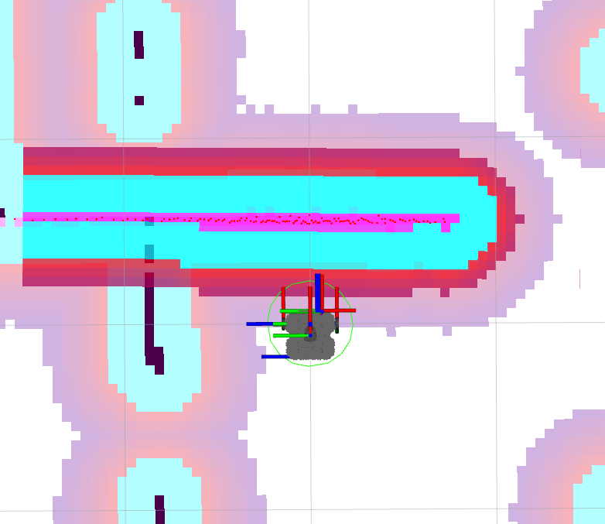

使用话题初始化机器人位姿
编写init_pose.py
from geometry_msgs.msg import PoseStamped
from nav2_simple_commander.robot_navigator import BasicNavigator
import rclpy
def main():
rclpy.init()
navigator = BasicNavigator()
initial_pose = PoseStamped()
initial_pose.header.frame_id = 'map'
initial_pose.header.stamp = navigator.get_clock().now().to_msg()
initial_pose.pose.position.x = 0.0
initial_pose.pose.position.y = 0.0
initial_pose.pose.orientation.w = 1.0
navigator.setInitialPose(initial_pose)
navigator.waitUntilNav2Active()
rclpy.spin(navigator)
rclpy.shutdown()
if __name__ == '__main__':
main()
在setup.py中添加可执行文件
entry_points={
'console_scripts': [
'init_pose = app.init_pose:main',
],
},
启动
conda activate ros2
cd /ros2-demo_ws
source install/setup.sh
ros2 run student_starter_kit init_pose
部分日志
ros2 run student_starter_kit init_pose
[INFO] [1773736514.389364959] [basic_navigator]: Publishing Initial Pose
[INFO] [1773736516.121607050] [basic_navigator]: Setting initial pose
[INFO] [1773736516.122061410] [basic_navigator]: Publishing Initial Pose
[INFO] [1773736516.122383543] [basic_navigator]: Waiting for amcl_pose to be received
[INFO] [1773736516.122963912] [basic_navigator]: Setting initial pose
[INFO] [1773736516.123241642] [basic_navigator]: Publishing Initial Pose
[INFO] [1773736516.123587113] [basic_navigator]: Waiting for amcl_pose to be received
[INFO] [1773736516.123821928] [basic_navigator]: Setting initial pose
[INFO] [1773736516.124081713] [basic_navigator]: Publishing Initial Pose
[INFO] [1773736516.124345021] [basic_navigator]: Waiting for amcl_pose to be received
[INFO] [1773736518.131357781] [basic_navigator]: Nav2 is ready for use!

使用TF获取机器人的实时位置
编写get_pose.py
import rclpy
from rclpy.node import Node
from tf2_ros import TransformListener, Buffer
from tf_transformations import euler_from_quaternion
class TFListener(Node):
def __init__(self):
super().__init__('tf2_listener')
self.buffer = Buffer()
self.listener = TransformListener(self.buffer, self)
self.timer = self.create_timer(1, self.get_transform)
def get_transform(self):
try:
tf = self.buffer.lookup_transform(
'map', 'base_footprint', rclpy.time.Time(seconds=0), rclpy.time.Duration(seconds=1))
transform = tf.transform
rotation_euler = euler_from_quaternion([
transform.rotation.x,
transform.rotation.y,
transform.rotation.z,
transform.rotation.w
])
self.get_logger().info(
f'平移:{transform.translation},旋转四元数:{transform.rotation}:旋转欧拉角:{rotation_euler}\n')
except Exception as e:
self.get_logger().warn(f'不能够获取坐标变换，原因: {str(e)}')
def main():
rclpy.init()
node = TFListener()
rclpy.spin(node)
rclpy.shutdown()
if __name__ == '__main__':
main()
启动
ros2 run student_starter_kit get_pose
结果
ros2 run student_starter_kit get_pose
[WARN] [1773736610.233588849] [tf2_listener]: 不能够获取坐标变换，原因: "map" passed to lookupTransform argument target_frame does not exist.
[WARN] [1773736611.252465321] [tf2_listener]: 不能够获取坐标变换，原因: "map" passed to lookupTransform argument target_frame does not exist.
[INFO] [1773736614.297043216] [tf2_listener]: 平移:geometry_msgs.msg.Vector3(x=0.002508296625350322, y=6.255069366564888e-06, z=1.2909499452040674e-05),旋转四元数:geometry_msgs.msg.Quaternion(x=-1.089724180507742e-05, y=-2.846339711850197e-06, z=0.002349842724179158, w=0.9999972390523486):旋转欧拉角:(-2.180780034012696e-05, -5.641450097801871e-06, 0.00469968983527079)
[INFO] [1773736615.195006376] [tf2_listener]: 平移:geometry_msgs.msg.Vector3(x=0.0026094278580411946, y=6.6639958904479485e-06, z=3.0285999815653566e-05),旋转四元数:geometry_msgs.msg.Quaternion(x=-7.295575604177853e-06, y=1.612088964502082e-06, z=0.0024447753563787344, w=0.9999970115043507):旋转欧拉角:(-1.4583225212612784e-05, 3.2598403804636087e-06, 0.004889555559885128)
此时tf树如下：
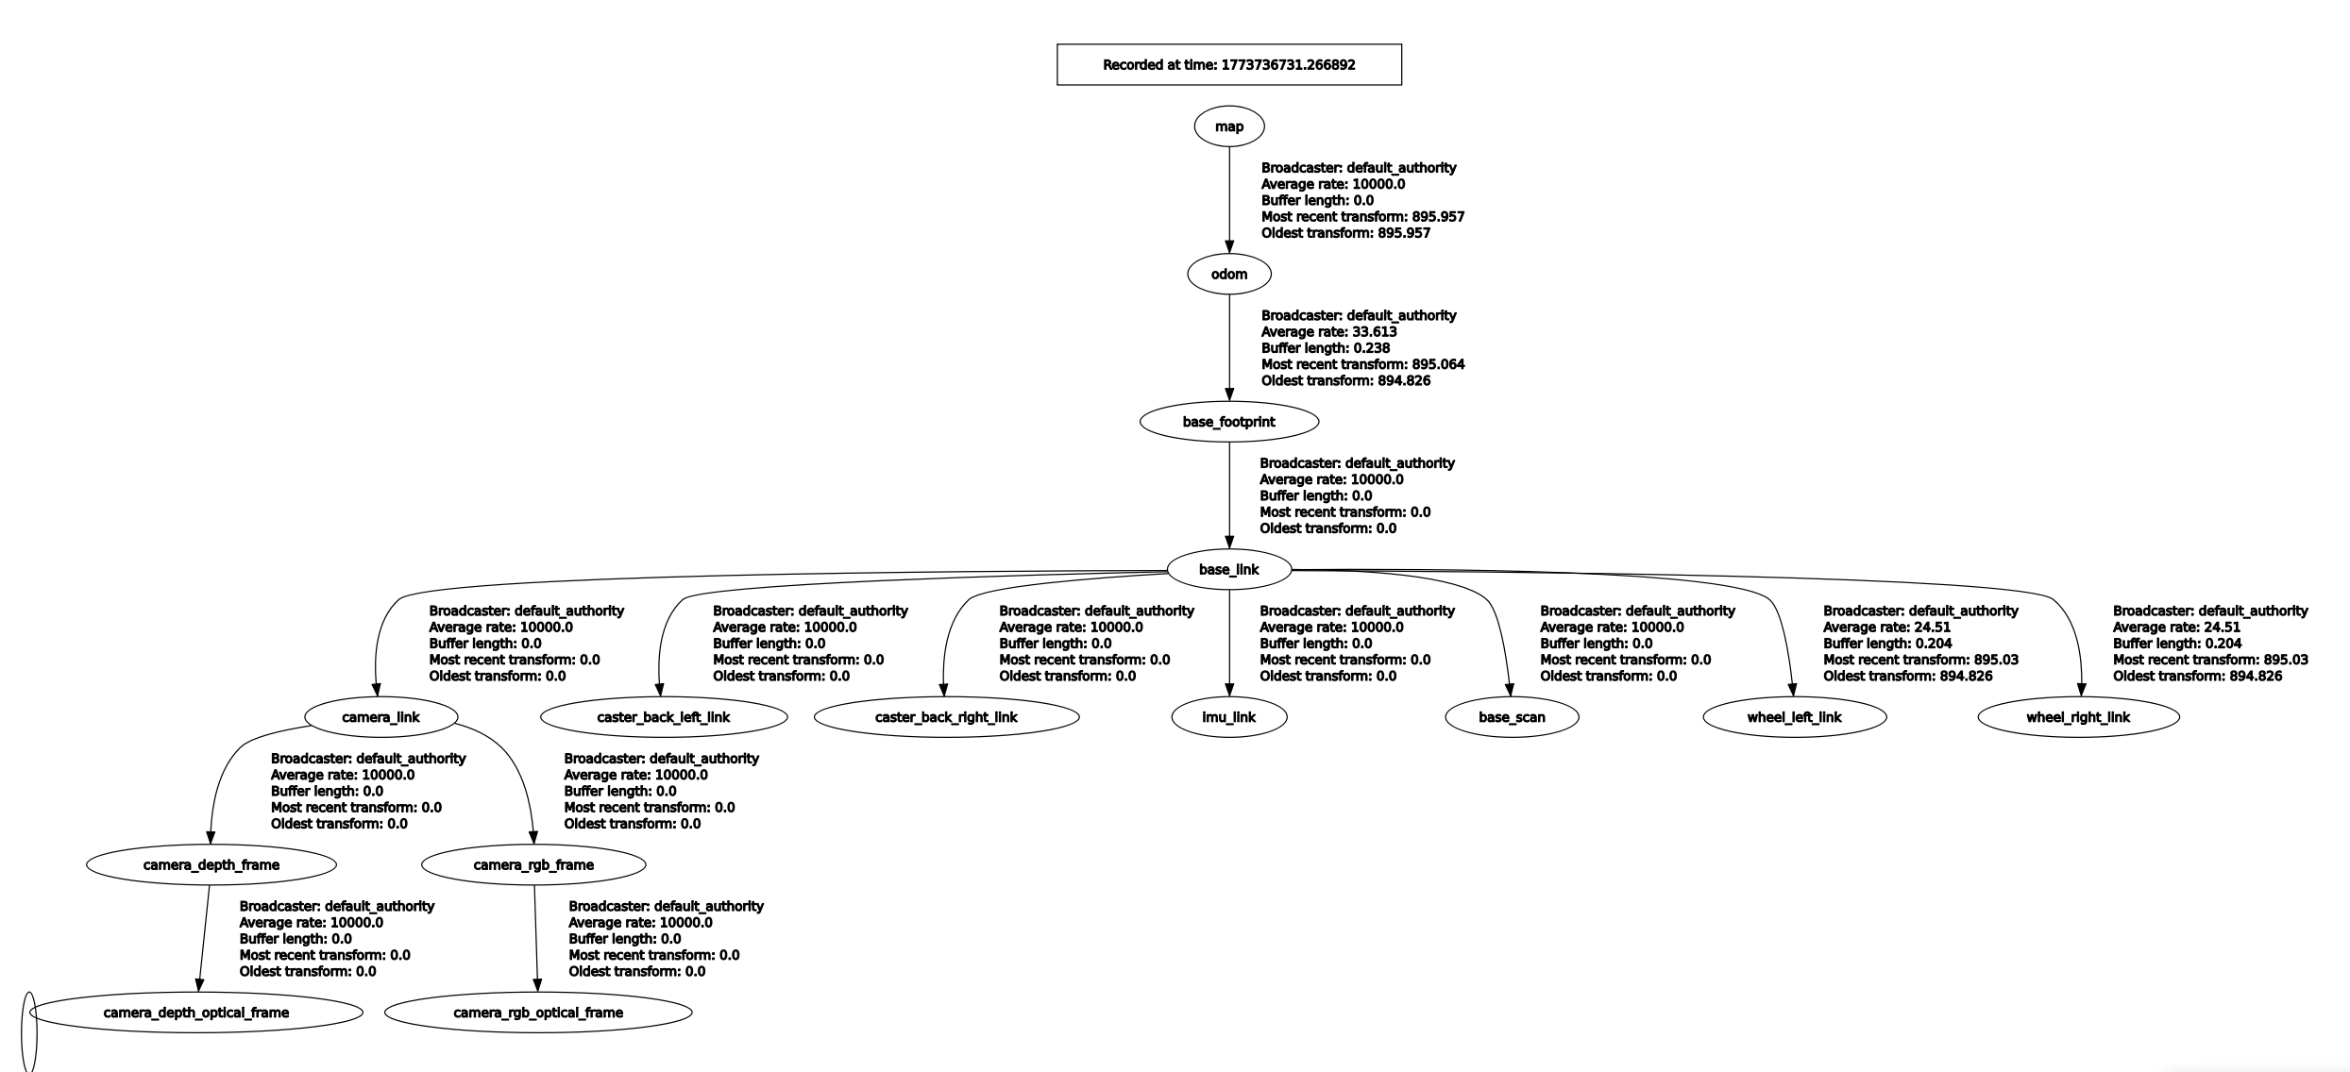

调用接口进行单点导航
查看动作节点
ros2 action list -t
/assisted_teleop [nav2_msgs/action/AssistedTeleop]
/backup [nav2_msgs/action/BackUp]
/compute_path_through_poses [nav2_msgs/action/ComputePathThroughPoses]
/compute_path_to_pose [nav2_msgs/action/ComputePathToPose]
/drive_on_heading [nav2_msgs/action/DriveOnHeading]
/follow_path [nav2_msgs/action/FollowPath]
/follow_waypoints [nav2_msgs/action/FollowWaypoints]
/navigate_through_poses [nav2_msgs/action/NavigateThroughPoses]
/navigate_to_pose [nav2_msgs/action/NavigateToPose] ## 此服务用于处理导航到点的请求
/smooth_path [nav2_msgs/action/SmoothPath]
/spin [nav2_msgs/action/Spin]
/wait [nav2_msgs/action/Wait]
查看nav2_msgs/action/NavigateToPose接口的内容
ros2 interface show nav2_msgs/action/NavigateToPose
详细信息如下
ros2 interface show nav2_msgs/action/NavigateToPose
#goal definition 客户端发给服务端的目标
geometry_msgs/PoseStamped pose
std_msgs/Header header
builtin_interfaces/Time stamp
int32 sec
uint32 nanosec
string frame_id
Pose pose
Point position
float64 x
float64 y
float64 z
Quaternion orientation
float64 x 0
float64 y 0
float64 z 0
float64 w 1
string behavior_tree
---
#result definition
std_msgs/Empty result
---
#feedback definition 服务端给客户端的反馈
geometry_msgs/PoseStamped current_pose
std_msgs/Header header
builtin_interfaces/Time stamp
int32 sec
uint32 nanosec
string frame_id
Pose pose
Point position
float64 x
float64 y
float64 z
Quaternion orientation
float64 x 0
float64 y 0
float64 z 0
float64 w 1
builtin_interfaces/Duration navigation_time
int32 sec
uint32 nanosec
builtin_interfaces/Duration estimated_time_remaining
int32 sec
uint32 nanosec
int16 number_of_recoveries
float32 distance_remaining
发送一个动作请求给动作服务器
ros2 action send_goal /navigate_to_pose nav2_msgs/action/NavigateToPose "{pose: {header: {frame_id: map}, pose: {position: {x: 2.0, y: 1.0, z: 0.0}, orientation: {x: 0.0, y: 0.0, z: 0.0, w: 1.0}}}}" --feedback
机器人会前往x=2.0,y=1.0的导航点
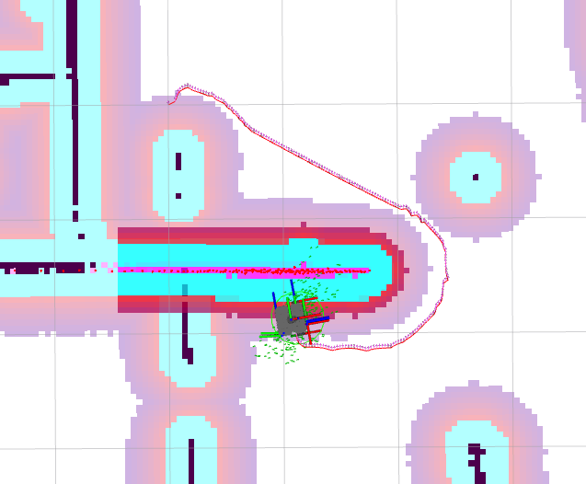

反馈信息如下：
Feedback:
current_pose:
header:
stamp:
sec: 1138
nanosec: 538000000
frame_id: map
pose:
position:
x: 2.180823310769019
y: 1.1390269773260406
z: 0.009952321305022507
orientation:
x: 0.002579772630933317
y: 0.0024296646375585027
z: 0.10424760824741153
w: 0.9945450606571912
navigation_time:
sec: 75
nanosec: 300000000
estimated_time_remaining:
sec: 8
nanosec: 523652104
number_of_recoveries: 7
distance_remaining: 0.23250165581703186
Result:
result: {}
Goal finished with status: SUCCEEDED
编写nav2pose.py实现上述功能
from geometry_msgs.msg import PoseStamped
from nav2_simple_commander.robot_navigator import BasicNavigator, TaskResult
import rclpy
from rclpy.duration import Duration
def main():
# 节点初始化
rclpy.init()
navigator = BasicNavigator()
# 等待导航启动完成
navigator.waitUntilNav2Active()
# 设置目标点坐标
goal_pose = PoseStamped()
goal_pose.header.frame_id = 'map'
goal_pose.header.stamp = navigator.get_clock().now().to_msg()
goal_pose.pose.position.x = 3.0
goal_pose.pose.position.y = 2.0
goal_pose.pose.orientation.w = 1.0
# 发送目标接收反馈结果
navigator.goToPose(goal_pose)
# 等待导航完成
while not navigator.isTaskComplete():
feedback = navigator.getFeedback()# 获取导航反馈
navigator.get_logger().info(
f'预计: {Duration.from_msg(feedback.estimated_time_remaining).nanoseconds / 1e9} s 后到达')
# 超时自动取消
if Duration.from_msg(feedback.navigation_time) > Duration(seconds=600.0):
navigator.cancelTask()
# 最终结果判断
result = navigator.getResult()
if result == TaskResult.SUCCEEDED:
navigator.get_logger().info('导航结果：成功')
elif result == TaskResult.CANCELED:
navigator.get_logger().warn('导航结果：被取消')
elif result == TaskResult.FAILED:
navigator.get_logger().error('导航结果：失败')
else:
navigator.get_logger().error('导航结果：返回状态无效')
if __name__ == '__main__':
main()
启动
conda activate ros2
cd /ros2-demo_ws
source install/setup.sh
ros2 launch student_starter_kit navigation.launch.py
ros2 run student_starter_kit nav2pose
结果如下：
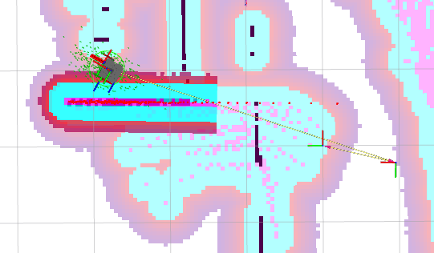

部分日志：
[INFO] [1773737573.664222752] [basic_navigator]: 预计: 1.318686697 s 后到达
[INFO] [1773737573.765987282] [basic_navigator]: 预计: 1.259035095 s 后到达
[INFO] [1773737573.874539279] [basic_navigator]: 预计: 1.197913984 s 后到达
[INFO] [1773737573.976352857] [basic_navigator]: 预计: 1.11724876 s 后到达
[INFO] [1773737574.077409597] [basic_navigator]: 预计: 1.647775979 s 后到达
[INFO] [1773737574.178246084] [basic_navigator]: 预计: 1.727459794 s 后到达
[INFO] [1773737574.280125692] [basic_navigator]: 预计: 1.767611774 s 后到达
[INFO] [1773737574.382734081] [basic_navigator]: 预计: 1.617185275 s 后到达
[INFO] [1773737574.484329352] [basic_navigator]: 预计: 1.606351261 s 后到达
[INFO] [1773737574.585864575] [basic_navigator]: 预计: 1.465992454 s 后到达
[INFO] [1773737574.688029634] [basic_navigator]: 预计: 1.187373139 s 后到达
[INFO] [1773737574.789140956] [basic_navigator]: 预计: 1.278589147 s 后到达
[INFO] [1773737574.890445458] [basic_navigator]: 预计: 1.106264801 s 后到达
[INFO] [1773737574.991524834] [basic_navigator]: 预计: 0.884877308 s 后到达
[INFO] [1773737575.046459844] [basic_navigator]: 导航结果：成功

使用接口完成多点导航
查看动作信息
ros2 action info /follow_waypoints -t
详细信息如下：
ros2 action info /follow_waypoints -t
Action: /follow_waypoints
Action clients: 1
/rviz_navigation_dialog_action_client [nav2_msgs/action/FollowWaypoints]
Action servers: 1
/waypoint_follower [nav2_msgs/action/FollowWaypoints]
查看这个消息接口的内容
ros2 interface show nav2_msgs/action/FollowWaypoints
内容如下
ros2 interface show nav2_msgs/action/FollowWaypoints
#goal definition
geometry_msgs/PoseStamped[] poses
std_msgs/Header header
builtin_interfaces/Time stamp
int32 sec
uint32 nanosec
string frame_id
Pose pose
Point position
float64 x
float64 y
float64 z
Quaternion orientation
float64 x 0
float64 y 0
float64 z 0
float64 w 1
---
#result definition
int32[] missed_waypoints
---
#feedback definition
uint32 current_waypoint
编写waypoint_flollow.py
from geometry_msgs.msg import PoseStamped
from nav2_simple_commander.robot_navigator import BasicNavigator, TaskResult
import rclpy
from rclpy.duration import Duration
def main():
# 节点初始化
rclpy.init()
navigator = BasicNavigator()
navigator.waitUntilNav2Active()
# 创建点集
goal_poses = []
# 添加第一个点
goal_pose1 = PoseStamped()
goal_pose1.header.frame_id = 'map'
goal_pose1.header.stamp = navigator.get_clock().now().to_msg()
goal_pose1.pose.position.x = 1.0
goal_pose1.pose.position.y = 1.0
goal_pose1.pose.orientation.w = 1.0
goal_poses.append(goal_pose1)
# 添加第二个点
goal_pose2 = PoseStamped()
goal_pose2.header.frame_id = 'map'
goal_pose2.header.stamp = navigator.get_clock().now().to_msg()
goal_pose2.pose.position.x = 2.0
goal_pose2.pose.position.y = 0.0
goal_pose2.pose.orientation.w = 1.0
goal_poses.append(goal_pose2)
# 添加第三个点
goal_pose3 = PoseStamped()
goal_pose3.header.frame_id = 'map'
goal_pose3.header.stamp = navigator.get_clock().now().to_msg()
goal_pose3.pose.position.x = 2.0
goal_pose3.pose.position.y = 2.0
goal_pose3.pose.orientation.w = 1.0
goal_poses.append(goal_pose3)
# 调用路点导航服务
navigator.followWaypoints(goal_poses)
# 判断结束及获取反馈
while not navigator.isTaskComplete():
feedback = navigator.getFeedback()
navigator.get_logger().info(
f'当前目标编号：{feedback.current_waypoint}')
# 最终结果判断
result = navigator.getResult()
if result == TaskResult.SUCCEEDED:
navigator.get_logger().info('导航结果：成功')
elif result == TaskResult.CANCELED:
navigator.get_logger().warn('导航结果：被取消')
elif result == TaskResult.FAILED:
navigator.get_logger().error('导航结果：失败')
else:
navigator.get_logger().error('导航结果：返回状态无效')
if __name__ == '__main__':
main()
启动
conda activate ros2
cd /ros2-demo_ws
source install/setup.sh
ros2 launch student_starter_kit navigation.launch.py
ros2 run student_starter_kit waypoint_flollow

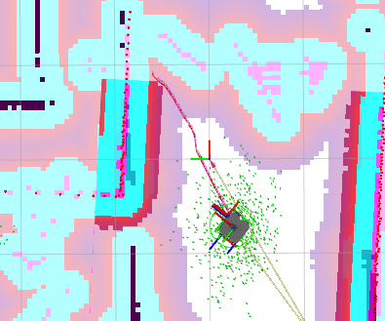

部分日志
[INFO] [1773739184.596055529] [basic_navigator]: 当前目标编号：2
[INFO] [1773739184.698319741] [basic_navigator]: 当前目标编号：2
[INFO] [1773739184.802513304] [basic_navigator]: 当前目标编号：2
[INFO] [1773739184.903708819] [basic_navigator]: 当前目标编号：2
[INFO] [1773739185.004697381] [basic_navigator]: 当前目标编号：2
[INFO] [1773739185.113900115] [basic_navigator]: 当前目标编号：2
[INFO] [1773739185.215075024] [basic_navigator]: 当前目标编号：2
[INFO] [1773739185.316069064] [basic_navigator]: 当前目标编号：2
[INFO] [1773739185.417033145] [basic_navigator]: 当前目标编号：2
[INFO] [1773739185.518776618] [basic_navigator]: 当前目标编号：2
[INFO] [1773739185.620295066] [basic_navigator]: 当前目标编号：2
[INFO] [1773739185.704334584] [basic_navigator]: 导航结果：成功
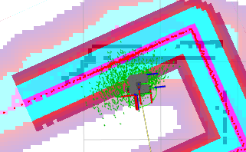

编写巡检控制节点
创建功能包
ros2 pkg create autopartol --build-type ament_python --dependencies rclpy nav2_simple_commander
语音合成和图像相关功能包
sudo apt install python3-pip -y
sudo apt install espeak-ng -y
sudo pip3 install espeakng
sudo apt install ros-$ROS_DISTRO-tf-transformations
sudo pip3 install transforms3d
删除包中的include和src文件夹，创建srv文件夹
创建Speech.srv文件，此文件声明语音播报消息服务接口
string text # 合成文字
---
bool result # 合成结果

修改CMakelists.txt文件
# find dependencies
find_package(ament_cmake REQUIRED)
find_package(rosidl_default_generators REQUIRED)
rosidl_default_generators(${PROJECT_NAME}
"srv/Speech.srv"
)
修改package.xml,声明功能包，大概在最后几行
<export>
<build_type>ament_cmake</build_type>
</export>
<member_of_group>rosidl_interface_packages</member_of_group>
</package>
编写语音合成服务节点
编写speaker.py
import rclpy
from rclpy.node import Node
from autopartol_interfaces.srv import Speech
import espeakng
class Speaker(Node):
def __init__(self, node_name):
super().__init__(node_name)
# 创建服务端，服务类型为Speech，服务名称为'speech'，回调函数为self.speak_callback
self.speech_service = self.create_service(
Speech, 'speech', self.speak_callback)
# 创建espeakng对象，设置语音为中文
self.speaker = espeakng.Speaker()
self.speaker.voice = 'zh'
# 日志提示服务端已启动
self.get_logger().info('服务端已启动，等待客户端请求')
# 服务回调函数，用于处理客户端请求
def speak_callback(self, request, response):
self.get_logger().info('正在朗读 %s' % request.text)
self.speaker.say(request.text)# 朗读请求中的文本
self.speaker.wait()
response.result = True
return response
def main(args=None):
rclpy.init(args=args)
node = Speaker('speaker')# 创建节点，节点名称为'speaker'
rclpy.spin(node)
rclpy.shutdown()
启动
conda activate ros2
cd /ros2-demo_ws
source install/setup.sh
ros2 launch student_starter_kit navigation.launch.py
ros2 run autopartol speaker
查看服务列表，是否有Speech的服务
ros2 service list
部分服务如下
/speaker/get_parameter_types
/speaker/get_parameters
/speaker/list_parameters
/speaker/set_parameters
/speaker/set_parameters_atomically
/speech
调用speech服务
ros2 service call /speech autopartol_interfaces/srv/Speech "{text: 你好}"
另一个终端显示
ros2 run autopartol speaker
[INFO] [1773794443.500154625] [speaker]: 服务端已启动，等待客户端请求
[INFO] [1773794594.905329895] [speaker]: 正在朗读 你好
['espeak-ng', '-v', 'zh', '-s', '175', '-p', '50', '-a', '100', '-g', '0', '你好']

编写partol_node.py
import rclpy
from geometry_msgs.msg import PoseStamped, Pose
from nav2_simple_commander.robot_navigator import BasicNavigator, TaskResult
from tf2_ros import TransformListener, Buffer
from tf_transformations import euler_from_quaternion, quaternion_from_euler
from rclpy.duration import Duration
# 添加服务接口
from autopatrol_interfaces.srv import SpeachText
from sensor_msgs.msg import Image
from cv_bridge import CvBridge
import cv2
class PatrolNode(BasicNavigator):
def __init__(self, node_name='patrol_node'):
super().__init__(node_name)
# 导航相关定义
self.declare_parameter('initial_point', [0.0, 0.0, 0.0]) # 初始位置
self.declare_parameter('target_points', [0.0, 0.0, 0.0, 1.0, 1.0, 1.57]) # 目标位置
self.initial_point_ = self.get_parameter('initial_point').value
self.target_points_ = self.get_parameter('target_points').value
# 实时位置获取 TF 相关定义
self.buffer_ = Buffer()
self.listener_ = TransformListener(self.buffer_, self)
self.speach_client_ = self.create_client(SpeachText, 'speech_text')
# 订阅与保存图像相关定义
self.declare_parameter('image_save_path', '')
self.image_save_path = self.get_parameter('image_save_path').value
self.bridge = CvBridge()
self.latest_image = None
self.subscription_image = self.create_subscription(
Image, '/camera_sensor/image_raw', self.image_callback, 10)
def image_callback(self, msg):
"""
将最新的消息放到 latest_image 中
"""
self.latest_image = msg
def record_image(self):
"""
记录图像
"""
if self.latest_image is not None:
pose = self.get_current_pose()
cv_image = self.bridge.imgmsg_to_cv2(self.latest_image)
cv2.imwrite(f'{self.image_save_path}image_{pose.translation.x:3.2f}_{pose.translation.y:3.2f}.png', cv_image)
def speach_text(self, text):
"""
调用服务播放语音
"""
while not self.speach_client_.wait_for_service(timeout_sec=1.0):
self.get_logger().info('语合成服务未上线，等待中。。。')
request = SpeachText.Request()
request.text = text
future = self.speach_client_.call_async(request)
rclpy.spin_until_future_complete(self, future)
if future.result() is not None:
result = future.result().result
if result:
self.get_logger().info(f'语音合成成功：{text}')
else:
self.get_logger().warn(f'语音合成失败：{text}')
else:
self.get_logger().warn('语音合成服务请求失败')
def get_pose_by_xyyaw(self, x, y, yaw):
"""
通过 x,y,yaw 合成 PoseStamped
"""
pose = PoseStamped() # 创建位姿消息
pose.header.frame_id = 'map' # 位姿参考坐标系
pose.pose.position.x = x # 位姿 x 坐标
pose.pose.position.y = y # 位姿 y 坐标
# 欧拉角转换为四元数
rotation_quat = quaternion_from_euler(0, 0, yaw)
pose.pose.orientation.x = rotation_quat[0]
pose.pose.orientation.y = rotation_quat[1]
pose.pose.orientation.z = rotation_quat[2]
pose.pose.orientation.w = rotation_quat[3]
return pose # 返回位姿
def init_robot_pose(self):
"""
初始化机器人位姿
"""
# 从参数获取初始化点
self.initial_point_ = self.get_parameter('initial_point').value
# 合成位姿并进行初始化
self.setInitialPose(self.get_pose_by_xyyaw(
self.initial_point_[0], self.initial_point_[1], self.initial_point_[2]))
# 等待直到导航激活
self.waitUntilNav2Active()
def get_target_points(self):
"""
通过参数值获取目标点集合
"""
points = []
self.target_points_ = self.get_parameter('target_points').value
for index in range(int(len(self.target_points_)/3)):
x = self.target_points_[index*3]
y = self.target_points_[index*3+1]
yaw = self.target_points_[index*3+2]
points.append([x, y, yaw])
self.get_logger().info(f'获取到目标点: {index}->({x},{y},{yaw})')
return points
def nav_to_pose(self, target_pose):
"""
导航到指定位姿
"""
self.waitUntilNav2Active()
result = self.goToPose(target_pose)
while not self.isTaskComplete():
feedback = self.getFeedback()
if feedback:
self.get_logger().info(f'预计: {Duration.from_msg(feedback.estimated_time_remaining).nanoseconds / 1e9} s 后到达')
# 最终结果判断
result = self.getResult()
if result == TaskResult.SUCCEEDED:
self.get_logger().info('导航结果：成功')
elif result == TaskResult.CANCELED:
self.get_logger().warn('导航结果：被取消')
elif result == TaskResult.FAILED:
self.get_logger().error('导航结果：失败')
else:
self.get_logger().error('导航结果：返回状态无效')
def get_current_pose(self):
"""
通过TF获取当前位姿
"""
while rclpy.ok():
try:
tf = self.buffer_.lookup_transform(
'map', 'base_footprint', rclpy.time.Time(seconds=0), rclpy.time.Duration(seconds=1))
transform = tf.transform
rotation_euler = euler_from_quaternion([
transform.rotation.x,
transform.rotation.y,
transform.rotation.z,
transform.rotation.w
])
self.get_logger().info(
f'平移:{transform.translation},旋转四元数:{transform.rotation}:旋转欧拉角:{rotation_euler}')
return transform
except Exception as e:
self.get_logger().warn(f'不能够获取坐标变换，原因: {str(e)}')
def main():
rclpy.init()
patrol = PatrolNode()
patrol.speach_text(text='正在初始化位置')
patrol.init_robot_pose()
patrol.speach_text(text='位置初始化完成')
while rclpy.ok():
for point in patrol.get_target_points():
x, y, yaw = point[0], point[1], point[2]
# 导航到目标点
target_pose = patrol.get_pose_by_xyyaw(x, y, yaw)
patrol.speach_text(text=f'准备前往目标点{x},{y}')
patrol.nav_to_pose(target_pose)
patrol.speach_text(text=f"已到达目标点{x},{y},准备记录图像")
patrol.record_image()
patrol.speach_text(text=f"图像记录完成")
rclpy.shutdown()
if __name__ == '__main__':
main()
自动生成配置文件
ros2 param dump /partol_node
修改配置文件，设置导航点
patrol_node:
ros__parameters:
initial_point: [0.0, 0.0, 0.0]
target_points: [
0.0, 0.0, 0.0,
1.0, 0.0, 3.14,
1.0, 1.0, 1.57,
0.0, 0.0, 1.57,
1.5, 1.5, 3.14
]
启动
conda activate ros2
cd /ros2-demo_ws
source install/setup.sh
ros2 launch student_starter_kit navigation.launch.py
ros2 run autopartol speaker
ros2 run autopartol partol_node --ros-args --param-file /home/qinghe/ros2-demo_ws/src/autopartol/config/partol_config.yaml
部分日志
(ros2) airsim@AIPhy:/home/qinghe/ros2-demo_ws$ ros2 run autopartol partol_node --ros-args --param-file /home/qinghe/ros2-demo_ws/src/autopartol/config/partol_config.yaml
[INFO] [1773795139.190924142] [patrol_node]: 加载参数文件：/home/qinghe/ros2-demo_ws/src/autopartol/config/partol_config.yaml
[INFO] [1773795139.192327421] [patrol_node]: 加载参数：initial_point = [0.0, 0.0, 0.0]
[INFO] [1773795139.192773951] [patrol_node]: 加载参数：target_points = [0.0, 0.0, 0.0, 1.0, 0.0, 3.14, 1.0, 1.0, 1.57, 0.0, 0.0, 1.57, 1.5, 1.5, 3.14]
[INFO] [1773795169.095008254] [patrol_node]: 语音合成成功：正在初始化位置
[INFO] [1773795169.095306154] [patrol_node]: 初始位置：[0.0, 0.0, 0.0]
[INFO] [1773795169.095937303] [patrol_node]: Publishing Initial Pose
[INFO] [1773795175.209751863] [patrol_node]: Nav2 is ready for use!
[INFO] [1773795175.210094845] [patrol_node]: Nav2 已激活
[INFO] [1773795204.228291894] [patrol_node]: 语音合成成功：位置初始化完成
[INFO] [1773795204.229060280] [patrol_node]: 目标点 0: (0.0, 0.0, 0.00 rad)
[INFO] [1773795204.230369055] [patrol_node]: 目标点 1: (1.0, 0.0, 3.14 rad)
[INFO] [1773795204.230631439] [patrol_node]: 目标点 2: (1.0, 1.0, 1.57 rad)
[INFO] [1773795204.231551844] [patrol_node]: 目标点 3: (0.0, 0.0, 1.57 rad)
[INFO] [1773795204.231795019] [patrol_node]: 目标点 4: (1.5, 1.5, 3.14 rad)
[INFO] [1773795233.273167606] [patrol_node]: 语音合成成功：准备前往目标点 0.0, 0.0
[INFO] [1773795237.291013788] [patrol_node]: Nav2 is ready for use!
[INFO] [1773795237.291715775] [patrol_node]: Navigating to goal: 0.0 0.0...
[INFO] [1773795237.377997353] [patrol_node]: 导航结果：成功
编写autopartol.launch.py
import os
import launch
import launch_ros
from ament_index_python.packages import get_package_share_directory
from launch.launch_description_sources import PythonLaunchDescriptionSource
def generate_launch_description():
# 获取与拼接默认路径
autopartol_dir = get_package_share_directory(
'autopartol')
patrol_config_path = os.path.join(
autopartol_dir, 'config', 'partol_config.yaml')
action_node_turtle_control = launch_ros.actions.Node(
package='autopartol',
executable='partol_node',
parameters=[patrol_config_path]
)
action_node_patrol_client = launch_ros.actions.Node(
package='autopartol',
executable='speaker',
)
return launch.LaunchDescription([
action_node_turtle_control,
action_node_patrol_client,
])
修改setup.py
data_files=[
('share/ament_index/resource_index/packages',
['resource/' + package_name]),
('share/' + package_name, ['package.xml']),
('share/' + package_name + '/config', ['config/partol_config.yaml']),
('share/' + package_name + '/launch', glob.glob('launch/*.launch.py')),
],
启动
ros2 launch autopartol autopartol.launch.py
安装图片相关包
sudo apt install ros-$ROS_DISTRO-tf-transformations
sudo pip3 install transforms3d

调整导航参数
对nav2_params.yaml中部分参数进行调整

对路径跟踪参数进行调整
搜索controller_server:
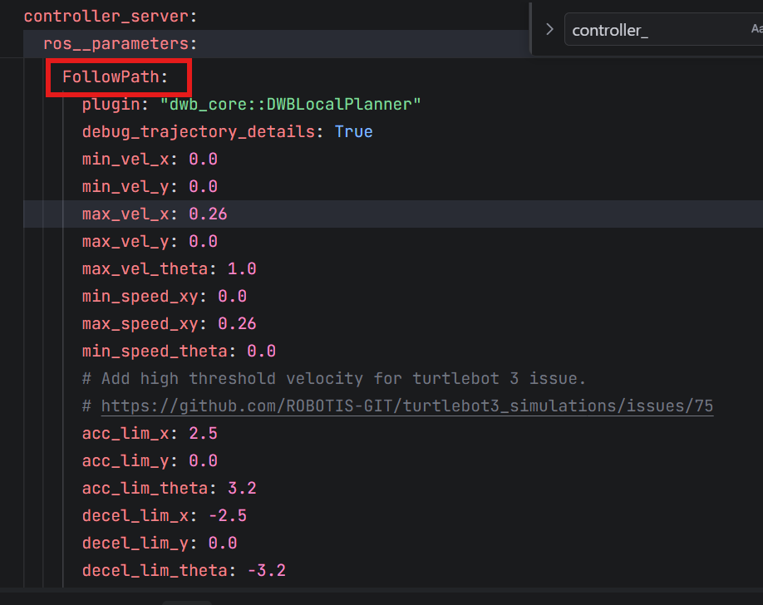

修改max_vel_theta和acc_lim_theta
FollowPath:
plugin: "dwb_core::DWBLocalPlanner"
debug_trajectory_details: True
min_vel_x: 0.0
min_vel_y: 0.0
max_vel_x: 0.26
max_vel_y: 0.0
max_vel_theta: 0.8 #最大旋转速度
min_speed_xy: 0.0
max_speed_xy: 0.26
min_speed_theta: 0.0
# Add high threshold velocity for turtlebot 3 issue.
# https://github.com/ROBOTIS-GIT/turtlebot3_simulations/issues/75
acc_lim_x: 2.5
acc_lim_y: 0.0
acc_lim_theta: 2.0 #最大旋转加速度
decel_lim_x: -2.5
decel_lim_y: 0.0
decel_lim_theta: -3.2
vx_samples: 20
vy_samples: 5
vtheta_samples: 20
sim_time: 1.7
启动
conda activate ros2
cd /ros2-demo_ws
source install/setup.sh
ros2 launch student_starter_kit navigation.launch.py
ros2 topic echo /cmd_vel
根据输出日志，可以发现最大角速度限制到-0.8-0.8
linear:
x: 0.26
y: 0.0
z: 0.0
angular:
x: 0.0
y: 0.0
z: -0.631578947368421
---
linear:
x: 0.26
y: 0.0
z: 0.0
angular:
x: 0.0
y: 0.0
z: -0.631578947368421

调整膨胀半径
在rviz中，可以看到机器人几乎要碰壁了
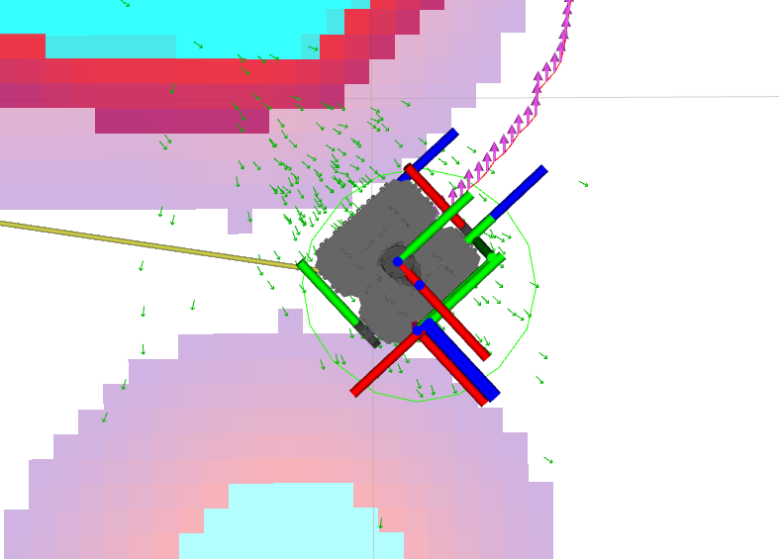

但是在gazebo中，其实机器人和墙壁还有一段很宽的距离
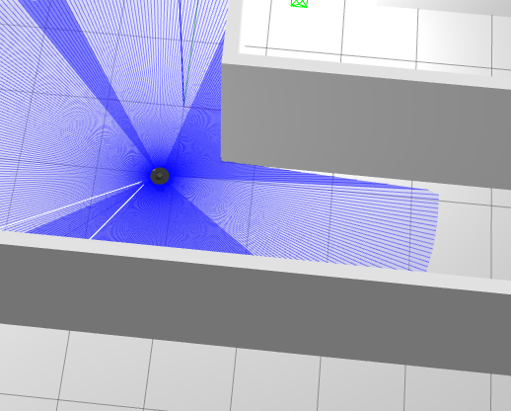

这时候需要调整膨胀半径,搜索local_costmap和 ，修改inflation_radius为0.2
local_costmap:
local_costmap:
ros__parameters:
update_frequency: 5.0
publish_frequency: 2.0
global_frame: odom
robot_base_frame: base_link
use_sim_time: True
rolling_window: true
width: 3
height: 3
resolution: 0.05
robot_radius: 0.22
plugins: ["voxel_layer", "inflation_layer"]
inflation_layer:
plugin: "nav2_costmap_2d::InflationLayer"
cost_scaling_factor: 3.0
inflation_radius: 0.2 #膨胀半径
global_costmap:
global_costmap:
ros__parameters:
update_frequency: 1.0
publish_frequency: 1.0
global_frame: map
robot_base_frame: base_link
use_sim_time: True
robot_radius: 0.22
resolution: 0.05
track_unknown_space: true
plugins: ["static_layer", "obstacle_layer", "inflation_layer"]
obstacle_layer:
plugin: "nav2_costmap_2d::ObstacleLayer"
enabled: True
observation_sources: scan
scan:
topic: /scan
max_obstacle_height: 2.0
clearing: True
marking: True
data_type: "LaserScan"
raytrace_max_range: 3.0
raytrace_min_range: 0.0
obstacle_max_range: 2.5
obstacle_min_range: 0.0
static_layer:
plugin: "nav2_costmap_2d::StaticLayer"
map_subscribe_transient_local: True
inflation_layer:
plugin: "nav2_costmap_2d::InflationLayer"
cost_scaling_factor: 3.0
inflation_radius: 0.2 #膨胀半径
always_send_full_costmap: True
启动
conda activate ros2
cd /ros2-demo_ws
source install/setup.sh
ros2 launch student_starter_kit navigation.launch.py
结果为
