**Position paper: Towards a codelet-based runtime for**

ing between threads; typically the operating system (OS)

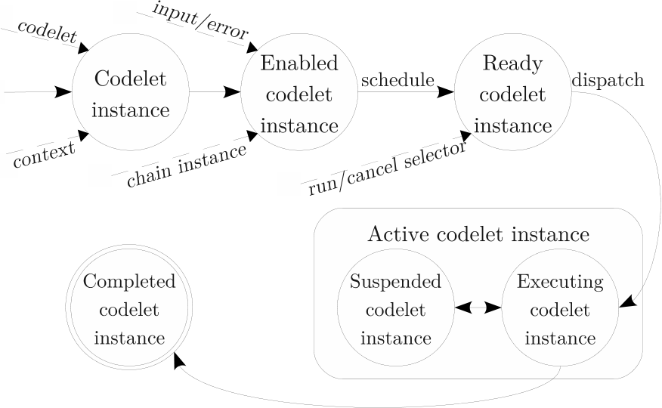

The chain instance passed into a codelet complex is typ-

|  |  |  |
| --- | --- | --- |
| codelet as a return value, and if canceled, the error can be |  |  |
|  |  |

stances have been run (a roughly FIFO ordering). Sched-

as an implementation; the codelet runtime described in this