**Extreme-scaling applications**

reduced time to solution (

**Table 1: 2016 Extreme Scaling Workshop code characteristics. Compiler and main programming languages**

|  |  |  |  |  |  |  |  |  |  |  |
| --- | --- | --- | --- | --- | --- | --- | --- | --- | --- | --- |
| cases writing output and in some cases reading input files | | |  |  |  |  |  |  |  |  |
|  |  |  |  |  |  |  |  |  |  |  |
|  |  |  |  |  |  |  |  |  |  |  |
|  |  |  |  |  |  |  |  |  |  |  |
|  |  |  |  |  |  |  |  |  |  |  |
|  |  |  |  |  |  |  |  |  |  |  |
|  |  |  |  |  |  |  |  |  |  |  |
|  |  |  |  |  |  |  |  |  |  |  |
|  |  |  |  |  |  |  |  |  |  |  |
|  |  |  |  |  |  |  |  |  |  |  |
|  |  |  |  |  |  |  |  |  |  |  |
|  |  |  |  |  |  |  |  |  |  |  |
|  |  |  |  |  |  |  |  |  |  |  |
|  |  |  |  |  |  |  |  |  |  |  |
|  |  |  |  |  |  |  |  |  |  |  |
|  |  |  |  |  |  |  |  |  |  |  |
|  |  |  |  |  |  |  |  |  |  |  |
|  |  |  |  |  |  |  |  |  |  |  |
|  |  |  |  |  |  |  |  |  |  |  |
|  |  |  |  |  |  |  |  |  |  |  |
|  |  |  |  |  |  |  |  |  |  |  |
|  |  |  |  |  |  |  |  |  |  |  |
|  |  |  |  |  |  |  |  |  |  |  |

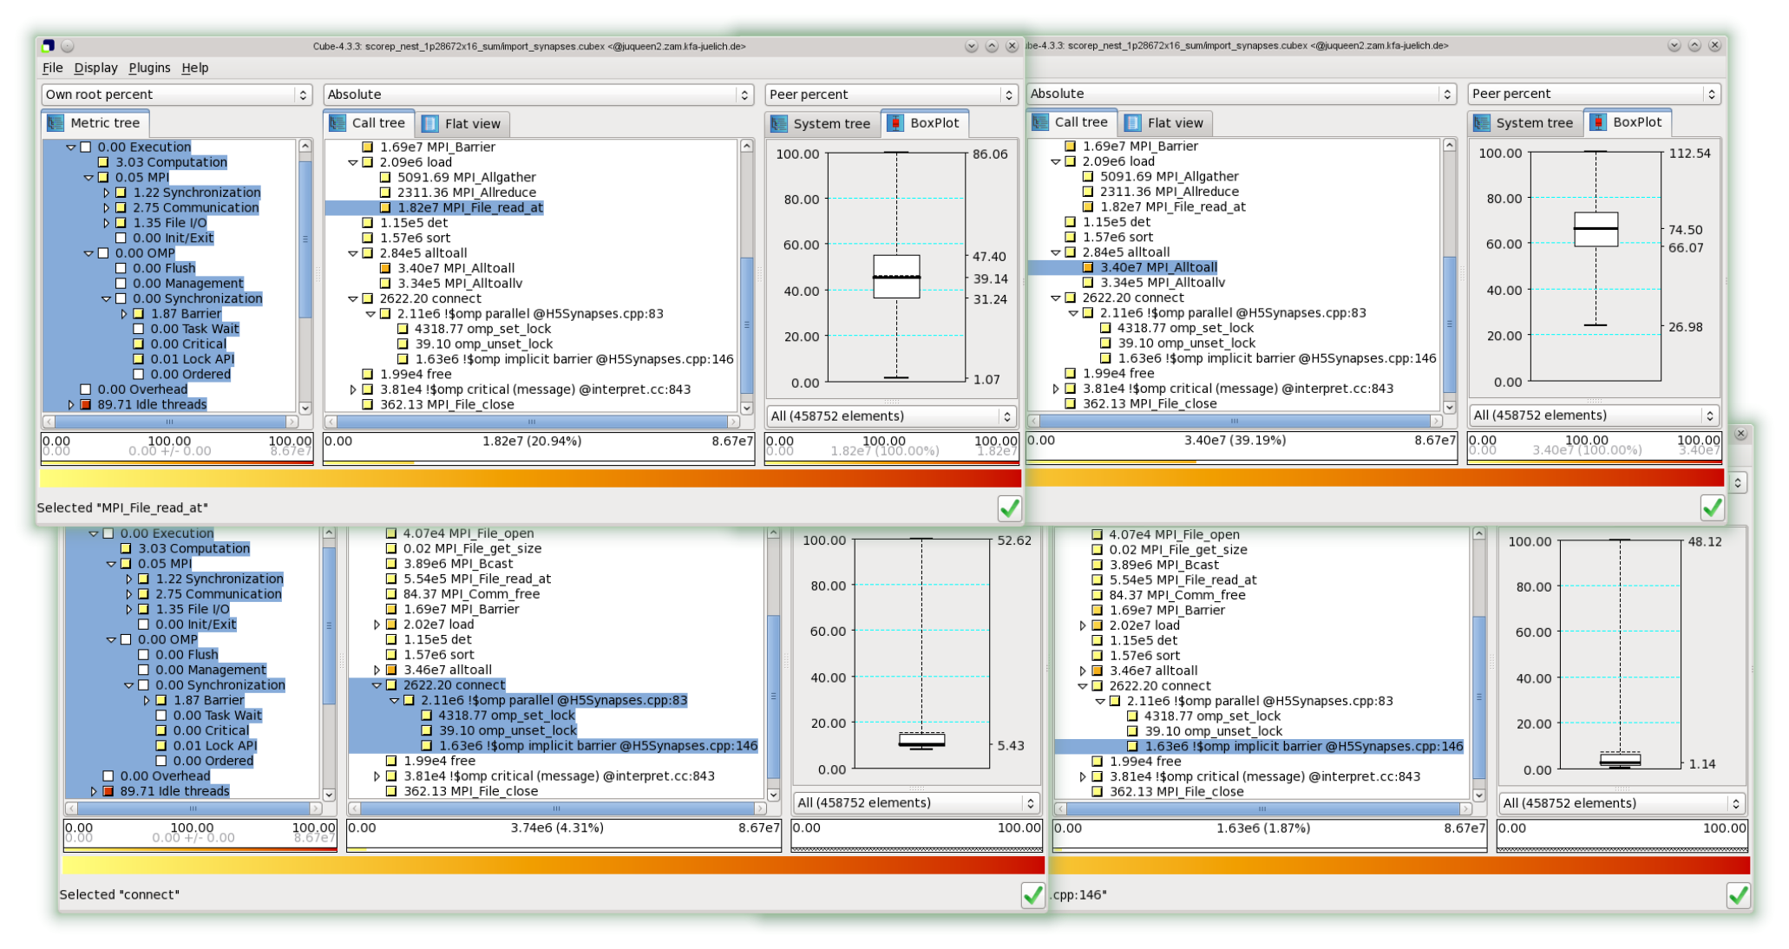

**Figure 5: Scalasca analysis report explorer views of**

|  |  |  |
| --- | --- | --- |
| aggregate the output into a single file for subsequent use. |  |  |

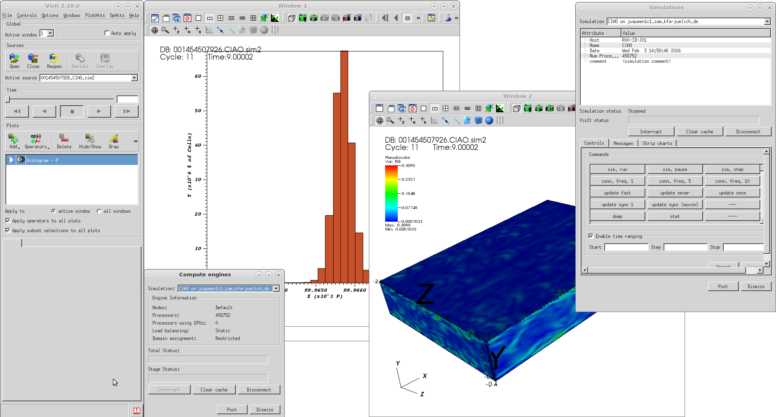

**Figure 6: VisIt interactive visualization client coupled via JUSITU to**

|  |  |  |
| --- | --- | --- |
| proving and improving the ability of applications to exploit |  |  |

[14] Mathis Bode, Jens Henrik G¨obbert, Heinz Pitsch,

**Table 2: High-Q Club member application code characteristics. Compiler and main programming languages**