**Descriptive Epidemiology of Neonatal Mortality in Gowa**

included residing in Gowa district in 2015 and willing to be

**Table 4. Distribution of respondent based parity in Gowa**

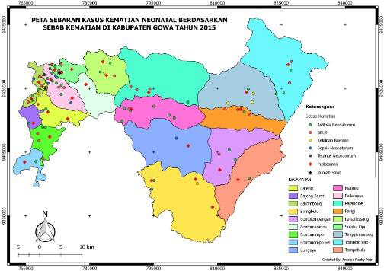

**Figure 7. Coverage map of neonatal mortality cases based on**

|  |  |  |  |
| --- | --- | --- | --- |
| Neonatal MOrtality |  |  |  |
|  |  |  |
|  |  |  |
|  |  |  |
|  |  |  |
|  |  |  |

[9]