**On Celebrity, Epidemiology and the Internet**

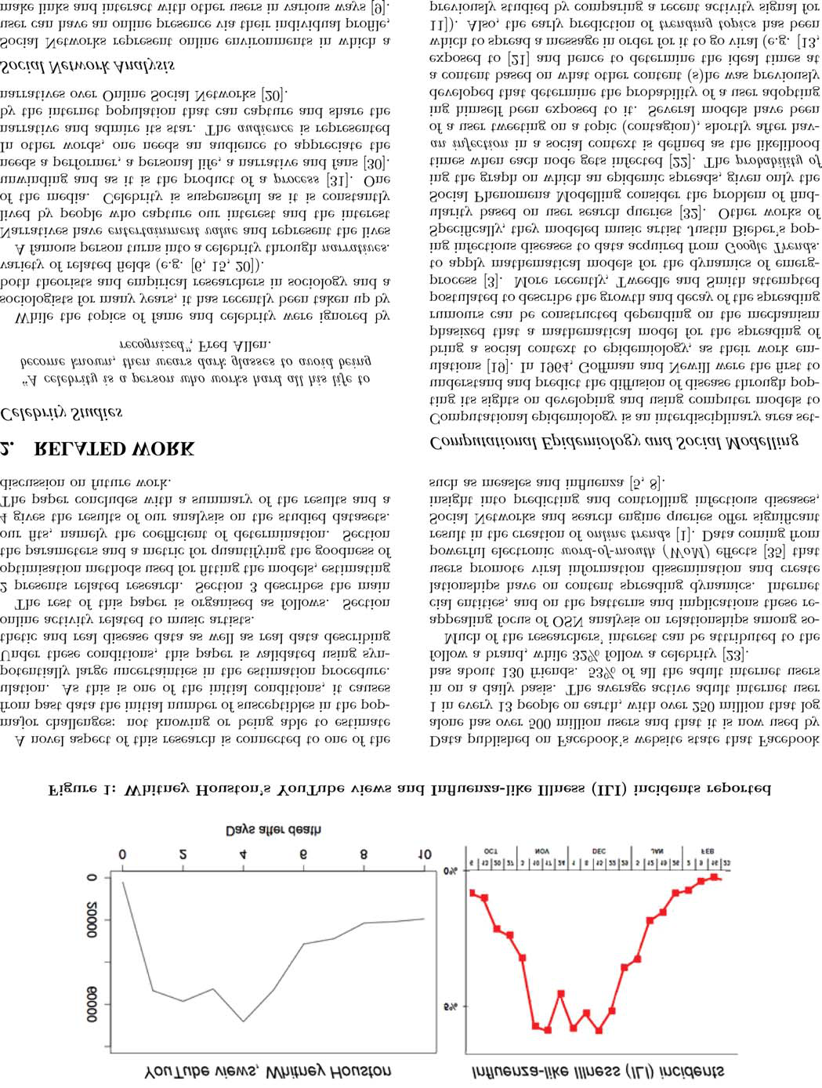

a topic to a large collection of historical activity signals for

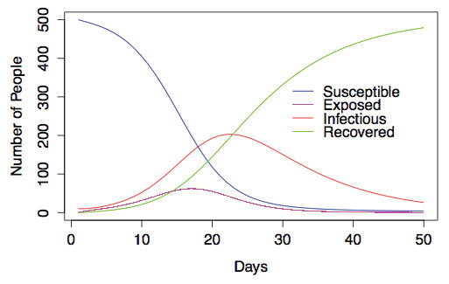

Figure 4: Sample run of the SEIR model with pa-

and

|  |  |  |  |  |  |  |  |  |  |  |  |  |  |  |  |  |  |  |  |  |  |
| --- | --- | --- | --- | --- | --- | --- | --- | --- | --- | --- | --- | --- | --- | --- | --- | --- | --- | --- | --- | --- | --- |
| 250 |  |  |  |  |  |  |  |  |  |  |  |  |  |  |  |  |  |  |  |  |  |
|  |  |  |  |  |  |  |  |  |  |  |  |  |  |  |  |  |  |  |  |  |
|  |  |  |  |  |  |  |  |  |  |  |  |  |  |  |  |  |  |  |  |  |
|  |  |  |  |  |  |  |  |  |  |  |  |  |  |  |  |  |  |  |  |  |
|  |  |  |  |  |  |  |  |  |  |  |  |  |  |  |  |  |  |  |  |  |  |
|  |  |  |  |  |  |  |  |  |  |  |  |  |  |  |  |  |  |  |  |  |  |
|  |  |  |  |  |  |  |  |  |  |  |  |  |  |  |  |  |  |  |  |  |  |
|  |  |  |  |  |  |  |  |  |  |  |  |  |  |  |  |  |  |  |  |  |  |
|  |  |  |  |  |  |  |  |  |  |  |  |  |  |  |  |  |  |  |  |  |  |
|  |  |  |  |  |  |  |  |  |  |  |  |  |  |  |  |  |  |  |  |  |  |
|  |  |  |  |  |  |  |  |  |  |  |  |  |  |  |  |  |  |  |  |  |  |
|  |  |  |  |  |  |  |  |  |  |  |  |  |  |  |  |  |  |  |  |  |  |
|  |  |  |  |  |  |  |  |  |  |  |  |  |  |  |  |  |  |  |  |  |  |
|  |  |  |  |  |  |  |  |  |  |  |  |  |  |  |  |  |  |  |  |  |  |
|  |  |  |  |  |  |  |  |  |  |  |  |  |  |  |  |  |  |  |  |  |  |
|  |  |  |  |  |  |  |  |  |  |  |  |  |  |  |  |  |  |  |  |  |  |
|  |  |  |  |  |  |  |  |  |  |  |  |  |  |  |  |  |  |  |  |  |  |
|  |  |  |  |  |  |  |  |  |  |  |  |  |  |  |  |  |  |  |  |  |  |
|  |  |  |  |  |  |  |  |  |  |  |  |  |  |  |  |  |  |  |  |  |  |

|  |  |  |
| --- | --- | --- |
| 4.3 |  |  |

[18] H. Li, H. Wang, J. Liu, and K. Xu. Video sharing in