**Nitrogen Concentration Prediction in Waste Water Study**

**(Math 571 Project Final Report)**

**Submitted to:**

Prof. Adam McElhinney Department of Data Science Illinois Institute of Technology

**Report Prepared By:**

Travis Boltz

A20389533

Yitao Ma

A20380311

Yuqing Zhao

A20392575

Yue Ning

A20282614

April 15, 201

**Table of Content**

## Executive summary ………………………………………………… i

## 1 Introduction ………………………………………………………. 4

## 2 Data Processing…...………………………………………………. xx

## Basic summary statistics ………………………………………….. xx

## Analysis of Demographic and Avova Test..………………………. xx

## Exploratory Regression Models ………………………………….. xx

## Evaluations of Models…………………………… ………………. xx

## Results and Discussion……………………...……………………… xx

## 8 References ……………………………………………………….. xx

## Appendix: R code…………….………………………………………. xx

**Executive Summary**

This report summarizes the statistical modeling and analysis results associated with the Nitrogen concentration prediction in waste water study. The purpose of this report is to document both the implemented sampling design and all corresponding data modeling and inference techniques used during the subsequent statistical analyses.

The development of the sampling protocol, including both the data source and data cleaning strategy are discussed in Section 2.

The basic statistics that summarize the contamination data associated with the analyzed compounds are given in Section 3. A total of 9 variables were analyzed for eight locations for this study. Five compounds concentration measurements include BOD5, TKN, NH3.N, P.TOT, SS. Two variables factors analyzed in this study include FLOW and Rainfall. The statistics summary and several plots were performed in this study.

Section 4 presents the analysis of the demographic, based on the 8 waste water treatment plants where data were acquired. ANOVA-test p-value approach were used to compare data for TKN (target variable) to see if the means are equal.

Regression models and Algorithm background are discussed in Section 5; both the baseline-linear regression and PCA may also be present; Additionally, Linear regression with variable selection and linear regression with regularization were used to XXXX.

Section 6 introduces model evaluations.

Finally, in section 7, discussion and conclusion are given.

**1.0 Introduction**

Sewage is an essential consideration for every part of the world. It is a water-carried waste, the water leftover after its use in numerous application such as industrial, agricultural, municipal, domestic and on. It had become a significant problem for the environment, especially when untreated sewage discharged into the body of water such as stream, river, lake, bay or ocean [1]. The ecosystem cannot breakdown such massive amount of human waste; sewage can contaminate water and harm vast amounts of wildlife. Sewage with no treatment unbalances the natural nutrient cycle by loading large concentrations of a complex mixture of chemicals with many distinctive chemical characteristics, like ammonium, nitrate, nitrogen, phosphorus and high dissolved solids into the water. Particularly phosphorus and nitrogen cause increased the growth of algae and green plants in the water. As more algae and plants grow, others die. The dead organic matter becomes bacteria’s food, with the increasing of food, the bacteria increase in number and use up the dissolved oxygen in the water, which results in a dead area [2]. A harmful algal blooms (HABs) is dangerous for the environment and human health and usually necessitates the shut-down of water treatment plants used for drinking water, which has massive consequences for the local economy and the sustainability of natural ecosystems. One of the ways to prevent these algae blooms is to understand better how much oxygen is used as microbes breathe as they eat the contaminants in wastewater. Just as we breathe, microbes also breathe, they consume oxygen when they breathe. The more contaminants in wastewater, the more contaminants in the wastewater, the more oxygen is needed. So a high BOD indicates high concentration of contaminants in the wastewater that the microbes have eaten [3]. BOD5 stands for “5-day Biochemical Oxygen Demand”. The “5-day” means that the oxygen content is measured when the test starts, and again at the end of 5 days. The difference in the oxygen content on the first day and on the last day is used to calculate the Biochemical Oxygen Demand of the wastewater. If we can forecast the BOD5 on day 1 using same-day measurements of the SS, TKN, T.POT, Flow, Rainfall, and Location, the wastewater plants can know the BOD5 of the current waste water in the system 4 days ahead of time, take corrective action and save time. The metric used to measure the total amount of nitrogen in the water is called Total Kjeldahl Nitrogen (TKN). TKN is the U.S. EPA-approved parameter used to measure organic nitrogen and ammonia. The TKN content of influent municipal wastewater is typically between 35 and 60 mg/L. Organic nitrogen compounds in wastewater undergo microbial conversion to NH3 and ammonium ion NH4+ [4]. TKN is a required parameter for regulatory reporting at many wastewater treatment plants for monitoring plants operations. We use TKN as one of our variables.

**2.0 Data Processing**

**3.0 Basic Summary Statistics**

In this study, 20376 observations of 7 variables were acquired from 8 wastewater treatment plants locations. Each sample was analyzed for the following compound: BOD5(5-day Biochemical Oxygen Demand), TKN(Total Kjeldahl Nitrogen), NH3.N(ammonia), P.TOT(Total of Phosphorus), SS(Suspended Solids). Flow (MGD: million of gallons of water used per day) and Rainfall (1mm/hour) data were collected for each sample. Table 1.0 lists the overview statistic summary for each variable.

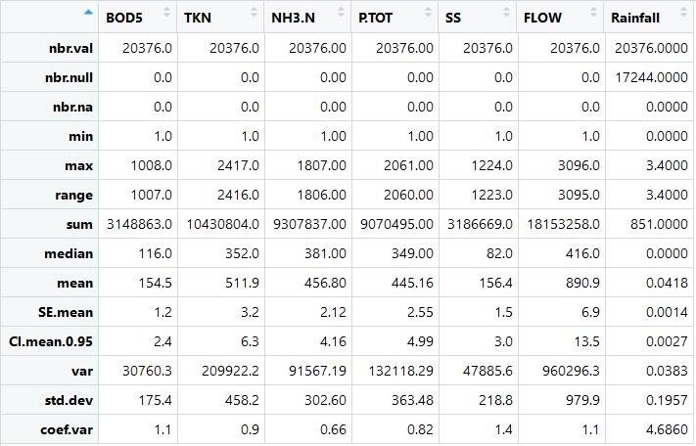

Table 1.0 An overview statistic summary for each variable

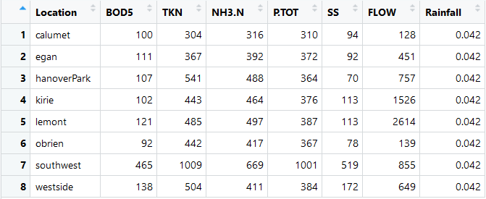

Table 2.0 mean of each variable in each location

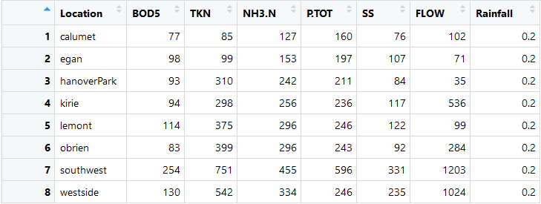

Table 2.1 sd of each variable in each location

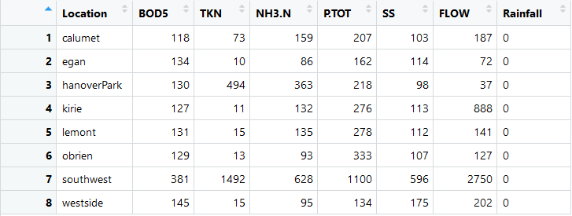

Table 2.2 IQR of each variable in each location

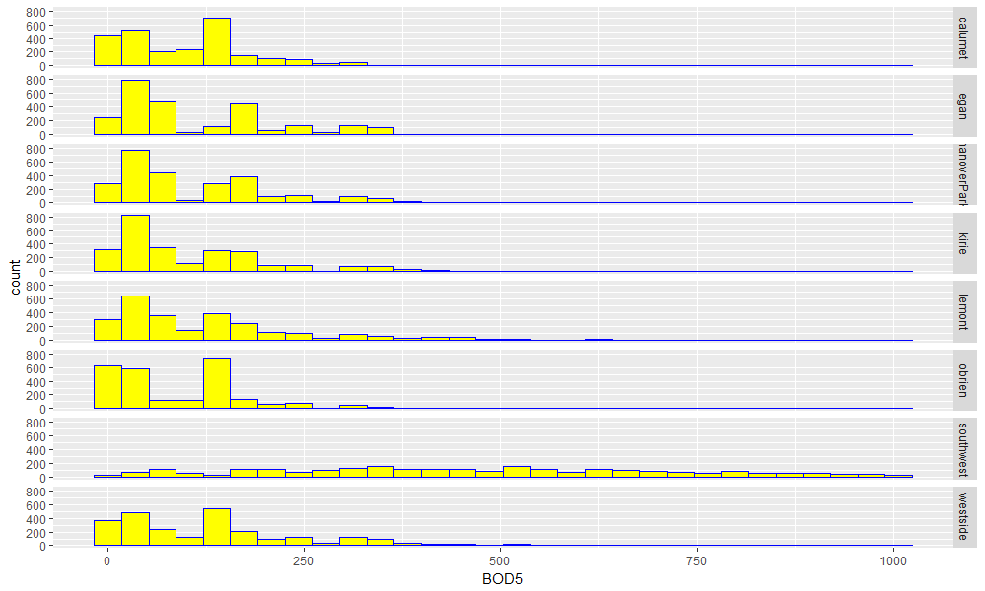

Table 3.0 Histogram of BOD5 in each location

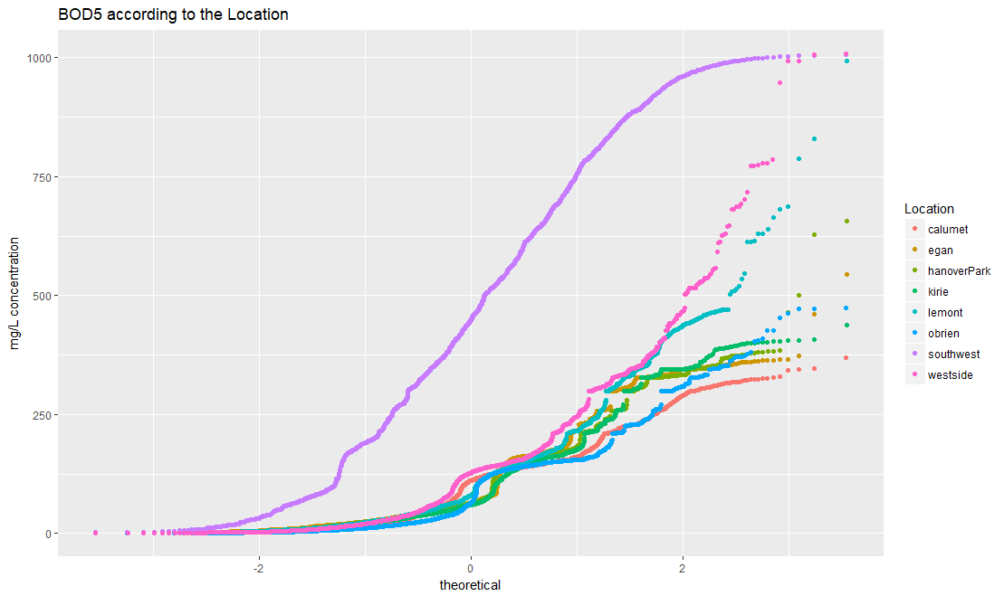

Table 3.1 QQplot of BOD5 in each location

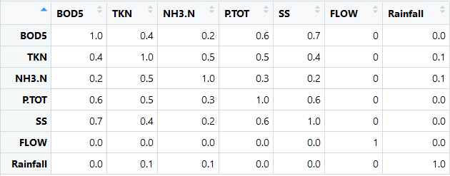

Table 3.2 Correlation matrix

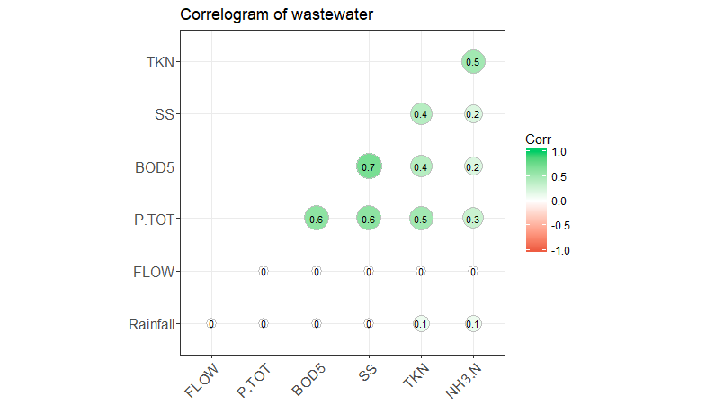

Table 3.3 Correlogram of wastewater

Strong correlations were observed between BOD5 and P.TOT, BOD5 and SS, P.TOT and SS.

Moderate correlations were observed between TKN and P.TOT, TKN and NH3.N, TKN and BOD5, TKN and SS.

Weak correlations were observed for some of the relationships between NH3.N and SS, BOD5, P.TOT.

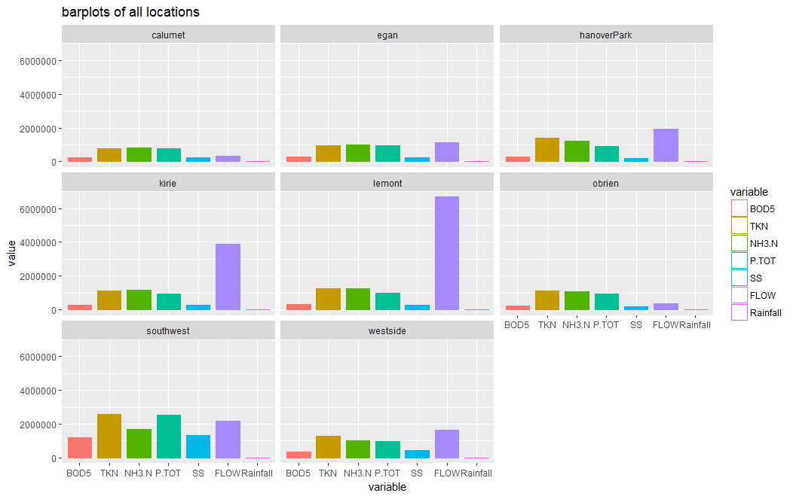

Table 3.4 barplots for each variable of all locations.

**4.0 Analysis of Demographic and Avova Test**

# 5.0 Exploratory Regression Models

**6.0 Evaluations of Models**

**7.0 Results and Discussion**

**8.0 References**

[1] <https://en.wikipedia.org/wiki/Sewage>

[2] <https://www.sciencedaily.com/terms/algal_bloom.htm>

[3] https://en.wikipedia.org/wiki/Biochemical_oxygen_demand

[4] OI Analytical Method Abstract, Publication # 39040712 Analysis of TKN and Ammonia in NPDES Wastewater Samples by In-line Gas Diffusion

**Appendix: R Code**

(for performing all data analyses described in Report)