Portfolio

Reading 38

LOS 38.a

A diversified portfolio produces reduced risk for a given level of expected return, compared to investing in an individual security. Modern portfolio theory concludes that investors that do not take a portfolio perspective bear risk that is not rewarded with greater expected return.

LOS 38.b

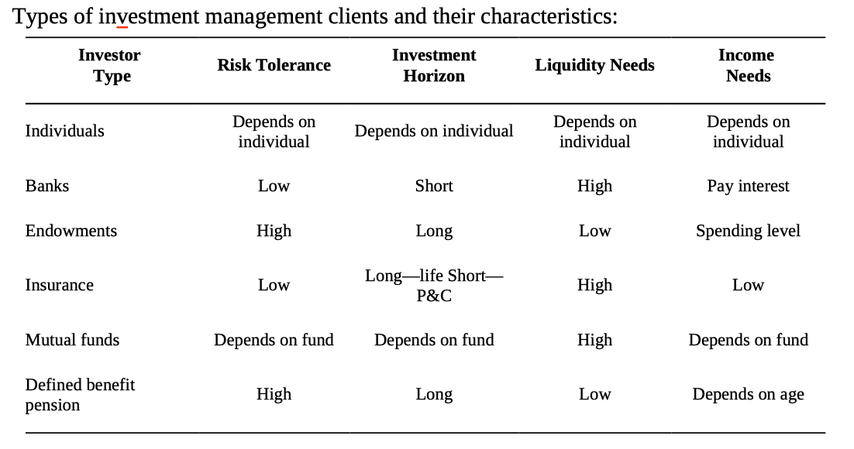

LOS 38.c

In a defined contribution plan, the employer contributes a certain sum each period to the employee’s retirement account. The employer makes no promise regarding the future value of the plan assets; thus, the employee assumes all of the investment risk.

In a defined benefit plan, the employer promises to make periodic payments to the employee after retirement. Because the employee’s future benefit is defined, the employer assumes the investment risk.

LOS 38.d

The three steps in the portfolio management process are:

1. Planning: Determine client needs and circumstances, including the client’s return objectives, risk tolerance, constraints, and preferences. Create, and then periodically review and update, an investment policy statement (IPS) that spells out these needs and circumstances.

2. Execution: Construct the client portfolio by determining suitable allocations to various asset classes based on the IPS and on expectations about macroeconomic variables such as inflation, interest rates, and GDP growth (top-down analysis). Identify attractively priced securities within an asset class for client portfolios based on valuation estimates from security analysts (bottom-up analysis).

3. Feedback: Monitor and rebalance the portfolio to adjust asset class allocations and securities holdings in response to market performance. Measure and report performance relative to the performance benchmark specified in the IPS.

LOS 38.e

Mutual funds combine funds from many investors into a single portfolio that is invested in a specified class of securities or to match a specific index. Many varieties exist, including money market funds, bond funds, stock funds, and balanced (hybrid) funds. Open-ended shares can be bought or sold at the net asset value. Closed-ended funds have a fixed number of shares that trade at a price determined by the market.

Exchange-traded funds are similar to mutual funds, but investors can buy and sell ETF shares in the same way as shares of stock. Management fees are generally low, though trading ETFs results in brokerage costs.

Separately managed accounts are portfolios managed for individual investors who have substantial assets. In return for an annual fee based on assets, the investor receives personalized investment advice.

Hedge funds are available only to accredited investors and are exempt from most reporting requirements. Many different hedge fund strategies exist. A typical annual fee structure is 20% of excess performance plus 2% of assets under management.

Buyout funds involve taking a company private by buying all available shares, usually funded by issuing debt. The company is then restructured to increase cash flow. Investors typically exit the investment within three to five years.

Venture capital funds are similar to buyout funds, except that the companies purchased are in the start-up phase. Venture capital funds, like buyout funds, also provide advice and expertise to the start-ups.

Reading 39 Portfolio Risk and Return: Part 1

LOS 39.a

Holding period return is used to measure an investment’s return over a specific period. Arithmetic mean return is the simple average of a series of periodic returns. Geometric mean return is a compound annual rate.

Money-weighted rate of return is the IRR calculated using periodic cash flows into and out of an account and is the discount rate that makes the present value of cash inflows equal to the present value of cash outflows.

Gross return is total return after deducting commissions on trades and other costs necessary to generate the returns, but before deducting fees for the management and administration of the investment account. Net return is the return after management and administration fees have been deducted.

Pretax nominal return is the numerical percentage return of an investment, without considering the effects of taxes and inflation. After-tax nominal return is the numerical return after the tax liability is deducted, without adjusting for inflation. Real return is the increase in an investor’s purchasing power, roughly equal to nominal return minus inflation. Leveraged return is the gain or loss on an investment as a percentage of an investor’s cash investment.

LOS 39.b

As predicted by theory, asset classes with the greatest average returns have also had the highest risk.

Some of the major asset classes that investors consider when building a diversified portfolio include small-capitalization stocks, large-capitalization stocks, long-term corporate bonds, long-term Treasury bonds, and Treasury bills.

In addition to risk and return, when analyzing investments, investors also take into consideration an investment’s liquidity, as well as non-normal characteristics such as skewness and kurtosis.

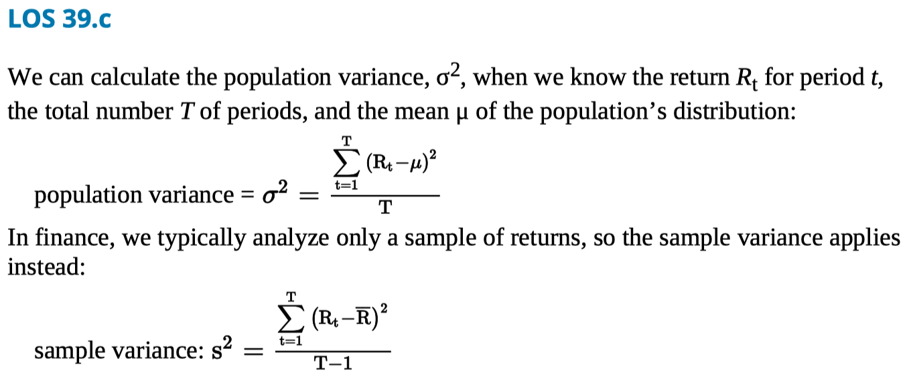

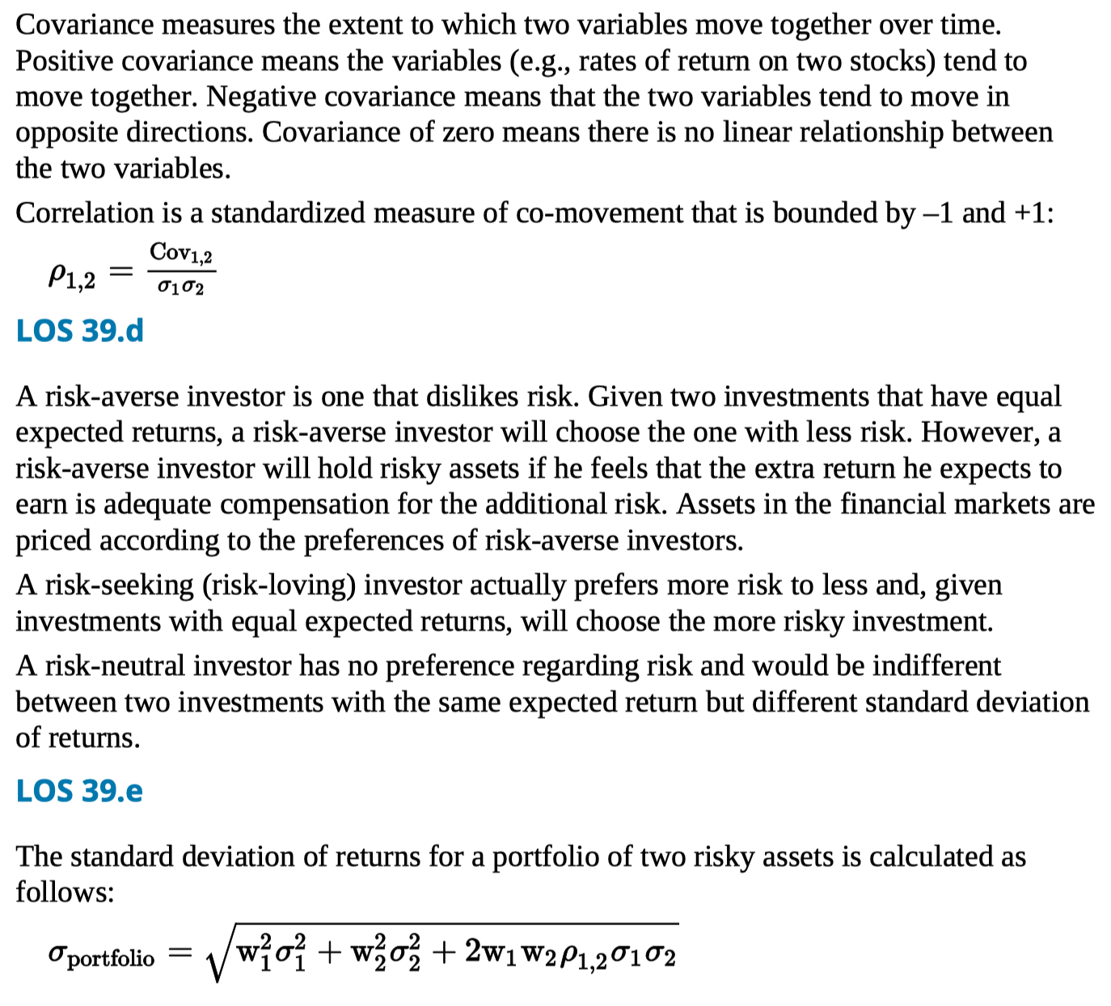

LOS 39.f

The greatest portfolio risk will result when the asset returns are perfectly positively correlated. As the correlation decreases from +1 to –1, portfolio risk decreases. The lower the correlation of asset returns, the greater the risk reduction (diversification) benefit of combining assets in a portfolio.

LOS 39.g

For each level of expected portfolio return, the portfolio that has the least risk is known as a minimum-variance portfolio. Taken together, these portfolios form a line called the minimum-variance frontier.

On a risk versus return graph, the one risky portfolio that is farthest to the left (has the least risk) is known as the global minimum-variance portfolio.

Those portfolios that have the greatest expected return for each level of risk make up the efficient frontier. The efficient frontier coincides with the top portion of the minimum variance frontier. Risk-averse investors would only choose a portfolio that lies on the efficient frontier.

LOS 39.h

An indifference curve plots combinations of risk and expected return that an investor finds equally acceptable. Indifference curves generally slope upward because risk- averse investors will only take on more risk if they are compensated with greater expected returns. A more risk-averse investor will have steeper indifference curves.

Flatter indifference curves (less risk aversion) result in an optimal portfolio with higher risk and higher expected return. An investor who is less risk averse will optimally choose a portfolio with more invested in the risky asset portfolio and less invested in the risk-free asset.

Reading 40 Portfolio Risk and Return Part2

LOS 40.a

The availability of a risk-free asset allows investors to build portfolios with superior risk-return properties. By combining a risk-free asset with a portfolio of risky assets, the overall risk and return can be adjusted to appeal to investors with various degrees of risk aversion.

LOS 40.b

On a graph of return versus risk, the various combinations of a risky asset and the risk- free asset form the capital allocation line (CAL). In the specific case where the risky asset is the market portfolio, the combinations of the risky asset and the risk-free asset form the capital market line (CML).

LOS 40.c

Systematic (market) risk is due to factors, such as GDP growth and interest rate changes, that affect the values of all risky securities. Systematic risk cannot be reduced by diversification. Unsystematic (firm-specific) risk can be reduced by portfolio diversification.

Because one of the assumptions underlying the CAPM is that portfolio diversification to eliminate unsystematic risk is costless, investors cannot increase expected equilibrium portfolio returns by taking on unsystematic risk.

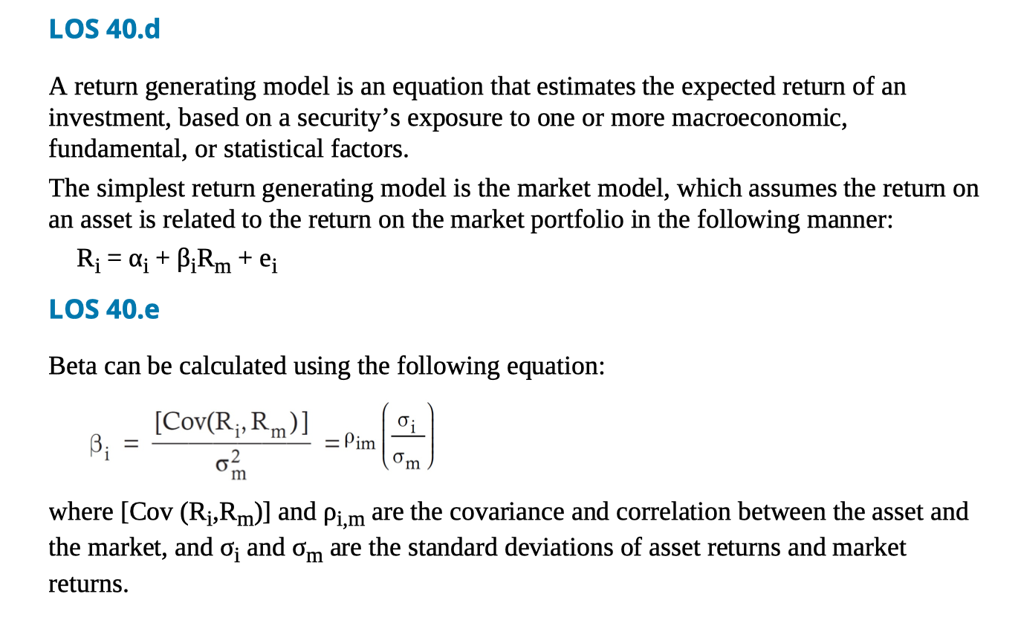

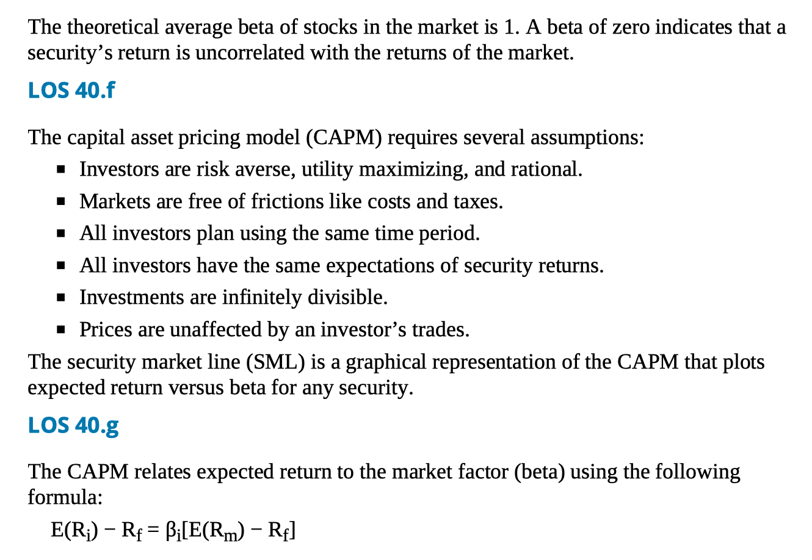

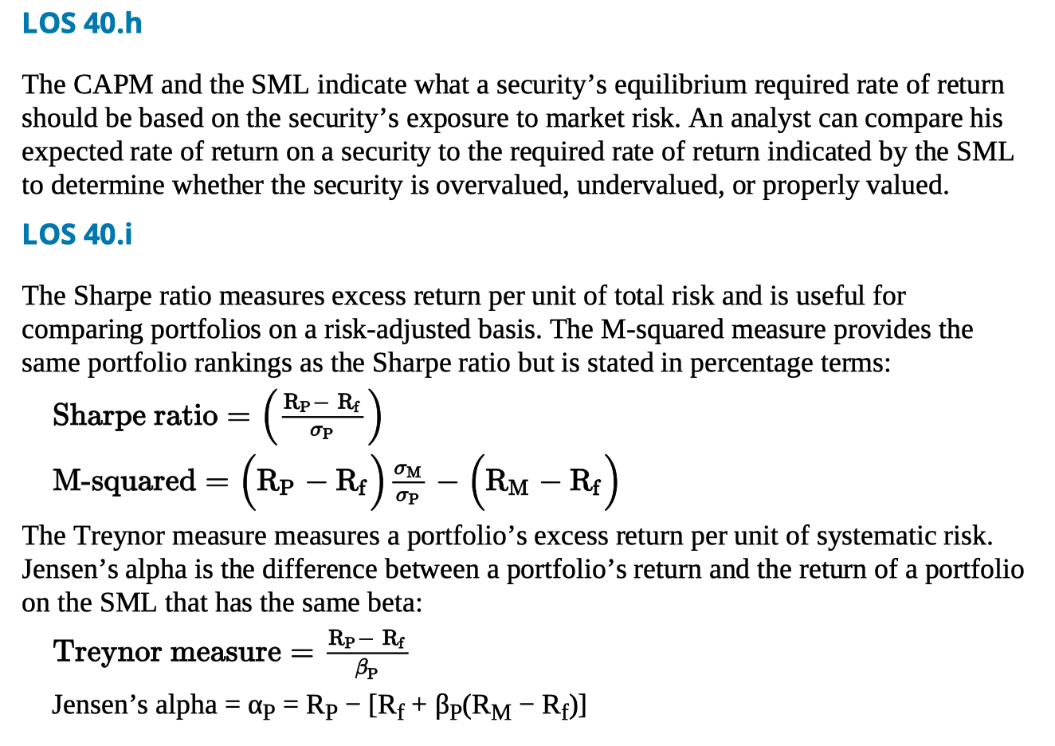

Reading 41: Basics of Portfolio Planning and Construction

LOS 41.a

A written investment policy statement, the first step in the portfolio management process, is a plan for achieving investment success. An IPS forces investment discipline and ensures that goals are realistic by requiring investors to articulate their circumstances, objectives, and constraints.

LOS 41.b

Many IPS include the following sections:

Introduction—Describes the client.

Statement of Purpose—The intentions of the IPS.

Statement of Duties and Responsibilities—Of the client, the asset custodian, and the investment managers.

Procedures—Related to keeping the IPS updated and responding to unforeseen events.

Investment Objectives—The client’s investment needs, specified in terms of required return and risk tolerance.

Investment Constraints—Factors that may hinder the ability to meet investment objectives; typically categorized as time horizon, taxes, liquidity, legal and regulatory, and unique needs.

Investment Guidelines—For example, whether leverage, derivatives, or specific kinds of assets are allowed.

Evaluation and Review—Related to feedback on investment results.

Appendices—May specify the portfolio’s strategic asset allocation (policy portfolio) or the portfolio’s rebalancing policy.

LOS 41.c

Risk objectives are specifications for portfolio risk that are developed to embody a client’s risk tolerance. Risk objectives can be either absolute (e.g., no losses greater than 10% in any year) or relative (e.g., annual return will be within 2% of FTSE return).

Return objectives are typically based on an investor’s desire to meet a future financial goal, such as a particular level of income in retirement. Return objectives can be absolute (e.g., 9% annual return) or relative (e.g., outperform the S&P 500 by 2% per year).

The achievability of an investor’s return expectations may be hindered by the investor’s risk objectives.

LOS 41.d

Willingness to take financial risk is related to an investor’s psychological factors, such as personality type and level of financial knowledge.

Ability or capacity to take risk depends on financial factors, such as wealth relative to liabilities, income stability, and time horizon.

A client’s overall risk tolerance depends on both his ability to take risk and his willingness to take risk. A willingness greater than ability, or vice versa, is typically resolved by choosing the more conservative of the two and counseling the client.

LOS 41.e

Investment constraints include:

Liquidity—The need to draw cash from the portfolio for anticipated or unexpected future spending needs. High liquidity needs often translate to a high portfolio allocation to bonds or cash.

Time horizon—Often the period over which assets are accumulated and before withdrawals begin. Risky or illiquid investments may be inappropriate for an investor with a short time horizon.

Tax considerations—Concerns the tax treatments of the investor’s various accounts, the relative tax treatment of capital gains and income, and the investor’s marginal tax bracket.

Legal and regulatory—Constraints such as government restrictions on portfolio contents or laws against insider trading.

Unique circumstances—Restrictions due to investor preferences (religious, ethical, etc.) or other factors not already considered.

LOS 41.f

An asset class is a group of securities with similar risk and performance characteristics. Examples of major asset classes include equity, fixed income, cash, and real estate. Portfolio managers also use more narrowly defined asset classes, such as large-cap U.S. equities or speculative international bonds, and alternative asset classes, such as commodities or investments in hedge funds.

LOS 41.g

Strategic asset allocation is a set of percentage allocations to various asset classes that is designed to meet the investor’s objectives. The strategic asset allocation is developed by combining the objectives and constraints in the IPS with the performance expectations of the various asset classes. The strategic asset allocation provides the basic structure of a portfolio.

Tactical asset allocation refers to an allocation that deviates from the baseline (strategic) allocation in order to profit from a forecast of shorter-term opportunities in specific asset classes.

Reading 42 Risk Management

LOS 42.a

Risk management is the process of identifying and measuring the risks an organization (or portfolio manager or individual) faces, determining an acceptable level of overall risk (establishing risk tolerance), deciding which risks should be taken and which risks should be reduced or avoided, and putting the structure in place to maintain the bundle of risks that is expected to best achieve the goals of the organization.

LOS 42.b

An overall risk management framework should address the following activities:

Identifying and measuring existing risks.

Determining the organization’s overall risk tolerance.

Establishing the processes and policies for risk governance.

Managing and mitigating risks to achieve the optimal bundle of risks.

Monitoring risk exposures over time.

Communicating across the organization.

Performing strategic risk analysis.

LOS 42.c

Risk governance refers to senior management’s determination of the risk tolerance of the organization, the elements of its optimal risk exposure strategy, and the framework for oversight of the risk management function.

LOS 42.d

The risk tolerance for an organization is the overall amount of risk it will take in pursuing its goals and is determined by top management.

LOS 42.e

Risk budgeting is the process of allocating the total risk the firm will take (risk tolerance) to assets or investments by considering the risk characteristics of each and how they can be combined to best meet the organization’s goals. The budget can be a single risk measure or the sum of various risk factors.

LOS 42.f

Financial risks are those that arise from exposure to financial markets, including credit risk, liquidity risk, and market risk. Non-financial risks are the risks from the operation of the organization and from sources external to the organization. Individuals face mortality and longevity risk, in addition to financial risks.

Interactions among risks are frequent and can be especially significant during periods of stress in financial markets.

LOS 42.g

Risk of assets is measured by standard deviation, beta, or duration. Derivatives risk measures include delta, gamma, vega, and rho. Tail risk is measured with value at risk (VaR) or Conditional VaR. Some risks must be measured subjectively.

An organization may decide to bear a risk (self-insurance), avoid or take steps to prevent a risk, efficiently manage a risk through diversification, transfer a risk with insurance or a surety bond, or shift a risk (change the distribution of uncertain outcomes) with derivatives.

Organizations may use multiple methods of risk modification after considering the costs and benefits of the various methods. The end result is a risk profile that matches the organization’s risk tolerance and includes the risks that top management has determined match the organization’s goals.

Reading 43 Fintech in Investment Management

LOS 43.a

Fintech refers to developments in technology that can be applied to the financial services industry. Companies that develop technologies for the finance industry are referred to as fintech companies.

LOS 43.b

Big Data refers to the potentially useful information that is generated in the economy, including data from traditional and non-traditional sources. Characteristics of Big Data include its volume, velocity, and variety.

Artificial intelligence refers to computer systems that can be programmed to simulate human cognition. Neural networks are an example of artificial intelligence.

Machine learning is programming that gives a computer system the ability to improve its performance of a task over time and is often used to detect patterns in large sets of data.

LOS 43.c

Applications of fintech to investment management include text analytics, natural language processing, risk analysis, algorithmic trading, and robo-advisory services.

Text analytics refers to analyzing unstructured data in text or voice forms. Natural language processing is the use of computers and artificial intelligence to interpret human language. Algorithmic trading refers to computerized securities trading based on predetermined rules.

Robo-advisors are online platforms that provide automated investment advice based on a customer’s answers to survey questions. The primary advantage of robo-advisors is their low cost to customers. A disadvantage is that the reasoning behind their recommendations might not be apparent.

LOS 43.d

A distributed ledger is a database that is shared on a network, with a consensus mechanism so that each participant has an identical copy of the ledger.

A cryptocurrency is an electronic medium of exchange that allows network participants in a distributed ledger to engage in real-time transactions without a financial intermediary.

Potential financial applications of distributed ledger technology include smart contracts, tokenization, and more efficient post-trade clearing and settlement.