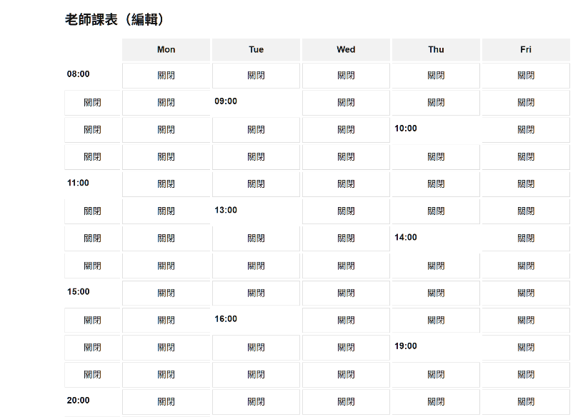
"use client";
import { useMemo, useState, useEffect, Fragment } from "react";

type Slot = { day: number; time: string; available: boolean };
type TeacherWeek = { teacherId: string; slots: Slot[] };

const DAYS = ["Sun","Mon","Tue","Wed","Thu","Fri","Sat"];
const ORDER = [1,2,3,4,5,6,0]; // 顯示順序：Mon→Sun
const TIMES = ["08:00","09:00","10:00","11:00","13:00","14:00","15:00","16:00","19:00","20:00"];
const TEACHER_ID = "t-001"; // 之後會改成登入帳號

function seedWeek(): TeacherWeek {
const slots: Slot[] = [];
for (let d = 0; d <= 6; d++) { // 0..6 = Sun..Sat
for (const t of TIMES) {
slots.push({ day: d, time: t, available: Math.random() > 0.5 });
}
}
return { teacherId: TEACHER_ID, slots };
}

export default function Page() {
const initial = useMemo(seedWeek, []);
const [week, setWeek] = useState<TeacherWeek>(initial);
const byKey = (d: number, t: string) =>
week.slots.find(s => s.day === d && s.time === t);

const toggle = (d: number, t: string) => {
setWeek(w => ({
...w,
slots: w.slots.map(s =>
s.day === d && s.time === t ? { ...s, available: !s.available } : s
),
}));
};

useEffect(() => {
fetch(`/api/availability?teacherId=${TEACHER_ID}`)
.then(r => r.ok ? r.json() : [])
.then((rows: { day:number; time:string }[]) => {
const set = new Set(rows.map(r => `${r.day}-${r.time}`));
setWeek(w => ({
...w,
slots: w.slots.map(s => ({ ...s, available: set.has(`${s.day}-${s.time}`) }))
}));
})
.catch(() => {});
}, []);

return (
<main style={{ padding: "24px", maxWidth: 960, margin: "0 auto" }}>
<h1 style={{ fontSize: 24, fontWeight: 700, marginBottom: 16 }}>老師課表（編輯）</h1>

<div style={{ display: "grid", gridTemplateColumns: "100px repeat(5, 1fr)", gap: 4 }}>
<div />
{[1, 2, 3, 4, 5].map(d => (
<div key={d} style={{ textAlign: "center", fontWeight: 600, padding: "8px 0", background: "#f2f2f2" }}>
{DAYS[d]}
</div>
))}

{TIMES.map((t) => (
<Fragment key={t}>
<div key={`label-${t}`} style={{ padding: "8px 4px", fontWeight: 600 }}>{t}</div>
{ORDER.map((d) => {
const s = byKey(d, t);
const on = !!s?.available;
return (
<button
key={`${d}-${t}`}
onClick={() => toggle(d, t)}
style={{ padding:"10px 8px", border:"1px solid #ddd", background: on ? "#e6ffec" : "#fff" }}
aria-pressed={on}
>
{on ? "可預約" : "關閉"}
</button>
);
})}
</Fragment>
))}
</div>

<p style={{ marginTop: 16, color: "#666" }}>點格子切換可預約時段。下一步我會教你如何儲存到資料庫。</p>
</main>
);
}

修改後畫面顯示

