**Tower defense game description**

**Background setting:**

In the misty virgin forest, there is a Nottingcastle that has condensed hundreds of years of human wisdom. It is guarded by Robin and his friends. One day, the evil sprites found the treasure and wanted to take it for themselves. Will the heroic Robins succeed in protecting the castle?

This is a tower defense game. The mission is to protect castle against sprites’ invasion. This castle has 10 health, which means 10 chances of being “break-in” by the sprites. When the health is 0, the mission fails. There are four types of sprites: scorpion (weak health), zombie (moderate health), knight (strong health) and boss (thick blood).

The operation is very simple, just drag and drop from the menu bar on the right side to install guarder. There are two types of guarder: cloth warrior and armor warrior. They could defeat any sprites within a certain radius. In the course of the game, two support devices could be added around the guarder to enhance their attack range and attack strength respectively.

**Scene map:**

The start screen includes the name of the game and the button to enter the game. In the main interface of the game, when sprites appear, they just come from one side and would attack the castle from the specific road. The upper left-hand corner shows the game progress, health and stars. The bottom left corner is the pause and sound button. The menu bar on the right shows the guards and support towers.

**Role setting:**

The characters in the game are divided into evil sprites and guarders two camps. The player is in the guarder camp. They cannot switch sides. In this game, there are 12 waves totally. Players need to defeat all sprites in order to win. Every time all sprites is defeated in the screen, it would automatically pause and save progress. If the protect mission fails, the system will automatically jump to the main interface, there is a chance to play once. The main characters and features of the two camps are shown in figure 1 and figure 2.

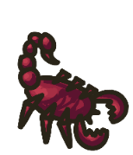 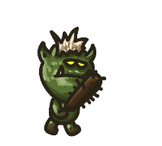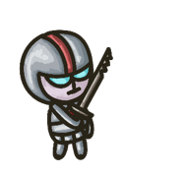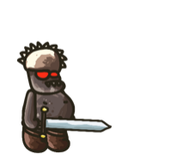

(Figure 1: four types of sprites: scorpion, zombie, knight and boss)

Scorpion: it has weak health. But may be caught off guard when a group of monsters appear. Kill +10 stars.

Zombie: it moves moderately and has more blood. if the fire in the case of weak need to target it. Kill + 30 stars.

Knight: it is a strong sprite. Kill + 50 stars.

Boss: it is Absolutely strong. But it also extremely slow and has a lot of blood, which only at the end of the line in each wave. Kill + 500 stars.

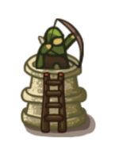  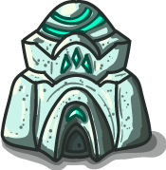 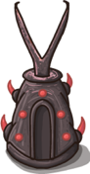

(Figure 2: cloth warrior and armor warrior; energy fortress and training cave)

At the beginning of the game, there are 3,000 stars that could be used to build guarders.

Cloth warrior: it is the base guarder, which has low damage but larger range. It costs 500 stars to build. When a sprite passes within its attack radius, it deals damage.

Armor warrior: It has lower level of range while high level of damage, which is costs more (750 stars).

Energy fortress: The energy store itself has no attack capability. But if it is placed around the guarder in the certain radius, which allows the guarder to have a larger attack radius. 1000 stars are needed to build it.

Training cave: It is also a kind of support tower, which could increase the attack ability of the guarders. It needs 1000 stars.