Parametric Cardiac ¹⁸F-Flutemetamol PET to Evaluate the Impact of Six-Month Tafamidis Treatment in Patients with ATTR Cardiac Amyloidosis
Qiong Liu¹, Tiantian Shi^{2,3}, Paul Gravel⁴, Aakanksha Sharma², Cinthia De Freitas², Ramesh Fazzone-Chettiar², Koen Van Laere⁵, Andrea Baldick², Cesia Gallegos Kattan², Xueqi Guo¹, Liang Guo¹, Huidong Xie¹, Xiongchao Chen¹, Bo Zhou¹, Yi-Hwa Liu², Richard E. Carson^{1,4}, Chi Liu^{1,4}, Edward Miller^{2,4}

¹Department of Biomedical Engineering, Yale University, New Haven, CT
²Department of Internal Medicine (Cardiovascular Medicine), Yale University, New Haven, CT
³Department of Internal Medicine, University of Texas Southwestern Medical Center, Dallas, TX
⁴Department of Radiology and Biomedical Imaging, Yale University, New Haven, CT
⁵Department of Nuclear Medicine and Molecular Imaging, KU Leuven, Leuven, Belgium

Total word count: 4996
Disclosures: None
First Author:
Qiong Liu, PhD.
Department of Biomedical Engineering
New Haven, Connecticut 06520, USA
Phone: 475-280-1364
E-mail: qiong.liu@yale.edu
Corresponding Authors:
Chi Liu, PhD
Department of Radiology and Biomedical Imaging
New Haven, Connecticut 06520, USA
Phone: 203‐785‐4269
E-mail: chi.liu@yale.edu
Edward Miller, MD, PhD
Department of Internal Medicine (Cardiovascular Medicine)
New Haven, Connecticut 06520, USA
Phone: 203‐785‐7191
E-mail: edward.miller@yale.edu

ABSTRACT

Background: In transthyretin cardiac amyloidosis (ATTR-CA), static ¹⁸F-flutemetamol PET derived Standardized Uptake Values (SUV) inadequately captures intricate tracer kinetics, limiting accurate quantification of amyloid burden. We developed dynamic parametric PET imaging methods to improve the quantification assessment in ATTR-CA.

Methods: Twelve treatment-naive ATTR-CA patients underwent 60-min dynamic cardiac ¹⁸F-flutemetamol PET/CT at baseline and after six months of tafamidis treatment. Image-derived input functions were corrected for blood-to-plasma ratios and metabolites. Myocardium blood volume fraction (V_{B}) was estimated using a one-tissue compartment model (0-10 min), and volume of distribution (V_{T}) images were generated using the multilinear analysis (MA1) method (2–20 min). V_{T} was correlated with echocardiography, ⁸²Rb myocardial blood flow, and biomarkers.

Results: Mean myocardial V_{B} was 22% ± 6%. A two-tissue reversible model with metabolite- and plasma-corrected input functions provided optimal kinetic fits. MA1 using 2–20 min PET data produced V_{T} images with the lowest variance. V_{T} decreased significantly after 6 months of tafamidis treatment (2.11 ± 0.33 to 1.96 ± 0.20, p = 0.046).

Conclusion: Dynamic ¹⁸F-flutemetamol PET enables robust quantification of myocardial amyloid burden using metabolite-corrected two-compartment modeling. V_{T} imaging demonstrated sensitivity to treatment-related changes in ATTR-CA.

INTRODUCTION
Transthyretin cardiac amyloidosis (ATTR-CA) is a disease characterized by the accumulation of misfolded TTR proteins in the heart, resulting in cardiac hypertrophy and stiffening (1). Cardiac imaging with single-photon emission computed tomography (SPECT) tracers targeting amyloid fibrils or consequential myocardial calcium deposition (^{99m}Tc-PYP (2), ^{99m}Tc-DPD (3), and ^{99m}Tc-HMDP (4), respectively) has become a reliable diagnostic strategy for ATTR-CA. However, SPECT is limited by relatively low spatial and temporal resolution and its inability to accurately quantify disease burden or treatment response (5). Consequently, there is a growing interest in developing fully quantitative non-invasive imaging techniques for the quantification of the ATTR-CA disease burden.
Tafamidis, which works by stabilizing transthyretin, is an effective treatment of ATTR-CA (6). A randomized, doubleblind, placebo-controlled trial involving 441 patients with ATTR-CA showed that tafamidis reduced the risk of all-cause mortality and cardiovascular-related hospitalizations compared to placebo (6). However, quantifying tafamidis’s impact on disease progression remains challenging, which is important given its high cost (7).
Current semi-quantitative static PET analysis methods, such as Standard Uptake Value (SUV) and Tissue-to-Background Ratio (TBR), have inherent limitations in accurately representing radiotracer uptake/retention and by extension total amyloid burden in tracers such as ¹⁸F-flutemetamol where there is fast and patient-dependent tracer washout from the myocardium. To address these limitations, fully quantitative analytical approaches are required to mitigate sensitivity to scan timing and acquisition, potentially enabling longitudinal treatment monitoring. Parametric imaging of brain ¹⁸F-flutemetamol PET has been extensively studied, with Heurling et al. showing that its kinetics are described by a 2-tissue-reversible compartment model (8), which is fundamentally different than static retention imaging used for most cardiac radiotracers. The volume of distribution (V_{T}) of ¹⁸F-flutemetamol PET derived from the reference Logan model has been established as a reliable metric for brain amyloid burden (9). In contrast, the use of parametric imaging for cardiac ¹⁸F-flutemetamol PET remains uninvestigated.
The objectives of this study are to (1) perform dynamic cardiac ¹⁸F-flutemetamol PET imaging in patients with known ATTR cardiac amyloidosis, (2) evaluate ¹⁸F-flutemetamol tracer kinetics in the myocardium of ATTR-CA patients and derive parametric images from the dynamic scan, and (3) evaluate the response of six months’ tafamidis therapy on ATTR-CA patients.

METHODS
Study participants
Twelve patients (10 male, 2 female) newly diagnosed with ATTR-CA, with no history of anti-TTR therapies, were recruited from the Yale Infiltrative Cardiomyopathy Clinic. The study received institutional review board approval, and all participants provided written informed consent before inclusion. Patient ages ranged from 61 to 88 years (mean age 75.3 ± 8.6 years), and weights ranged from 62.6 to 99.8 kg (mean weight 81.4 ± 11.1 kg).
Image Acquisition
Cardiac PET scans were performed at baseline and after six months of tafamidis on either a GE Discovery 690 (first six patients) or Siemens Biograph Vision (subsequent six patients), with each patient scanned on the same scanner at both time points. Each session began with a 7-minute dynamic ⁸²Rb PET/CT (740–925 MBq) and a CT for attenuation correction, followed by a 60-minute dynamic scan after a bolus injection of 185 ± 10 MBq ¹⁸F-flutemetamol, with one patient receiving a lower, but usable dose at 92.5 MBq. The listmode data were binned into 34 frames (12 of 10 s, 13 of 1 min, and 9 of 5 min) and reconstructed using scanner-specific algorithms (GE: VUE Point HD with 24 subsets, 2 iterations, 3.125×3.125×3.27 mm³; Siemens: OSEM with TOF , 4 iterations, 5 subsets, 1.65×1.65×3 mm³). All frames were decay corrected to the study start time. After the completion of PET studies, all patients underwent transthoracic echocardiograms using standard acquisition protocols.
Kinetic modeling and parametric imaging workflow
Figure 1 provides an overview of the methodology. Left ventricle (LV) blood pool masks were applied to extract the blood pool time activity curve (TAC), serving as the image derived input function (IDIF). For the myocardium, both local and global masks were generated, producing ten myocardium TACs and a whole myocardium TAC. The IDIF underwent two key corrections. Population-based blood-to-plasma ratio correction (PBPC) accounts for the differences between whole blood and plasma concentrations in converting the IDIF to plasma activity. Similarly, Population-Based Metabolite Correction (PMC) adjusts for the parent tracer faction. Both corrections were derived from the methodology outlined in a prior brain PET study (10). Subsequent kinetic modeling, graphical analyses, and parametric image generation are detailed in Supplemental Materials (A–D) (11-16).

Clinical Correlation and Tafamidis Treatment Evaluation
To evaluate the effects of six months of tafamidis treatment in patients with ATTR-CA, clinical and imaging parameters were compared between baseline (Scan 1) and post-six-month treatment (Scan 2). The obtained parameters were grouped into PET imaging, echocardiographic, and laboratory categories to assess their correlations with ¹⁸F-flutemetamol V_{T} values. Statistical comparisons (paired t-test) of the parameters between Scan 1 and Scan 2 were conducted to evaluate the significance of changes. Additionally, we calculated the changes in each parameter between Scan 1 and Scan 2 to explore their correlations with changes in V_{T}.

RESULTS

Tracer Distribution in Dynamic Images
Dynamic ¹⁸F-flutemetamol PET images in two subjects are shown in Figure 2. The myocardium uptake and clearance rates of the ¹⁸F-flutemetamol tracer exhibit inter-subject variability. Specifically, as demonstrated in Figure 2, the tracer entered the myocardium within 2 minutes of injection and was washed out from it after 6 minutes for patient 1. On the other hand, patient 2 showed that myocardial uptake was detectable at the same post-injection time (6-7 minutes) and remained in the myocardium until 20 minutes post-injection.

1TC model fitting for early time points
For ¹⁸F-flutemetamol, the tracer uptake rate constant (K₁) ranged from 0.34 to 0.91, with mean values of 0.65 ± 0.19 at baseline and 0.61 ± 0.17 at 6 months (p = 0.021). The blood volume fraction (V_{B}) ranged from 0.11 to 0.34, with means of 0.21 ± 0.07 at baseline and 0.23 ± 0.07 at follow-up (p = 0.155).

Graphical Modeling
Figure 3 shows that the Logan plot is more linear than the Patlak plot, with linearity depending on the time window. The Patlak model produced a near‐zero slope value, which is expected for a reversible tracer. At later time points, the Logan plot exhibited an upward trend, suggesting possible metabolic uptake in the tissue; therefore, we evaluated the fitting range. A regression over the 2–20-minute interval yielded the lowest V_{T} variance, as determined by Multilinear Analysis (MA1) using the Ordered Least Squares (OLS) fitting (see panel (c)). For 120 myocardium curves from 12 patients, the MA1 model produced a V_{T} coefficient of variation of 0.030 ± 0.0001 and a mean R-squared of 0.997 ± 0.002 over 2–20 minutes, whereas the Patlak model had much lower R-squared values (0.371 ± 0.300 for 2–60 minutes and 0.304 ± 0.204 for 2-20 minutes).

Compartment Modeling
As shown in Figure 4, the 2TC model with V_{B} correction and using IDIF with both PBPC and PMC (orange curve) provided the best fit for the myocardial TAC, achieving the lowest Akaike Information Criterion (AIC) value of 68.47 compared to other settings. Table I shows that the 2TC model with V_{B} correction and using IDIF with both PBPC and PMC consistently yielded the lowest AIC values for each study.

Parametric Imaging
V_{T} images were generated voxel-by-voxel using MA1 method over 2-20 minutes. The input function used was an image-derived input function (IDIF) with both PBPC and PMC. The blood volume (V_{B}) values were derived from the 1TC model fitting of early time points. Polar maps of the 17-segment left ventricular V_{T} distribution are shown in Figure 5. The polar maps showed that amyloid deposition was heterogeneous, predominantly in the basal and mid segments (especially the septal and lateral walls) with lower uptake in the apical regions, consistent with prior reports regarding regionality (apical sparing) of cardiac amyloid deposition (1). Post-treatment scans revealed a more homogeneous pattern on the 17-segment maps, with 9 out of 12 patients showing reduced V_{T}. Figure 6 compares the mean values across the 17 segments for Scan 1 and Scan 2. Specifically, segments 3–4 (basal inferoseptal/inferior) had elevated V_{T} and reduced MBF, segments 7–8 (mid inferoseptal/inferior) showed increased MBF with lower V_{T}, and segments 9–10 (mid inferolateral/anterior lateral) had higher V_{T} with diminished MBF. Notably, ¹⁸F-flutemetamol scans in Scan 2 showed lower segmental V_{T} values with reduced variability, whereas ⁸²Rb MBF scans remained largely unchanged.

Echocardiographic and Other Lab Parameters
Table 2 summarizes the clinical, imaging, and laboratory parameters obtained from Scan 1 and Scan 2, highlighting statistically significant changes and correlations related to obtained ¹⁸F-flutemetamol V_{T} values.
From the PET imaging parameters, ¹⁸F-flutemetamol V_{T} values significantly decreased from 2.11 ± 0.33 to 1.96 ± 0.20 (p = 0.042), accompanied by a significant reduction in ¹⁸F-flutemetamol 1TC K₁ values, which dropped from 0.70 ± 0.22 to 0.64 ± 0.17 mL/min/g (p = 0.036). While V_{B} values slightly increased (0.21 ± 0.05 to 0.23± 0.07), and Standard Uptake Value Ratio (SUVR) (2-30 minutes, with left ventricle as the reference region) decreased (1.27 ± 0.27 to 1.20 ± 0.22), neither change reached statistical significance. Additionally, SUV (2-30 minutes) remained unchanged between Scan 1 and Scan2.
Significant increases were noted in echocardiographic parameters, including left atrial (LA) volume, which rose from 88.08 ± 30.16 mL to 97.42 ± 25.84 mL (p =0.009), and left ventricular (LV) end-diastolic volume, which increased from 141.25 ± 41.22 mL to 166.17 ± 58.92 mL (p =0.021).
Prealbumin levels also showed a significant increase, from 22.02 ± 3.65 mg/dL to 29.88 ± 4.36 mg/dL (p = 0.033). NT-proBNP levels trended downward, decreasing from 2219.40 ± 1141.63 pg/mL to 1795.30 ± 891.82 pg/mL (p = 0.047), consistent with a recent study (17).

DISCUSSION
Cardiac ¹⁸F-flutemetamol PET has gained increasing interest as a potential imaging biomarker for ATTR-CA. However, prior studies relying on static imaging at variable post-injection time points have reported inconsistent myocardial uptake patterns and diagnostic performance (18-21), underscoring the limitations of SUV-based methods and motivating the need for dynamic kinetic quantification. Our dynamic PET analysis revealed that ¹⁸F-flutemetamol is not statically retained in the heart and static images are not likely to be accurate for determining cardiac amyloid burden. Tracer uptake declines significantly after 30 minutes and remains low beyond 40 minutes (Figure 2) which may explain the low sensitivity observed in late-time acquisition studies.
To reduce noise and improve stability of V_{T} parametric imaging, we applied a one-tissue compartment model to the first 10 minutes of dynamic data to estimate a uniform whole-myocardium V_{B}. Graphical analysis was used to confirm tracer reversibility and optimize fitting ranges, followed by voxel-wise MA1 modeling to generate lower-noise V_{T} images. Polar maps (Figure 5 and Figure 6) revealed heterogeneous amyloid distribution. Notably, mean V_{T} decreased from 2.11 ± 0.33 to 1.96 ± 0.20 (p =0.042). Complementary evidence from previous ^{99m}Tc-PYP SPECT/CT studies further supports this observation, as they reported significant reductions in left ventricular wall-to-cavity ratios following tafamidis treatment (22-24). However, stable echocardiographic and renal clearance parameters (e.g., NT-proBNP and eGFR) over two years suggest that reduced PYP uptake reflects myocardial ATTR amyloid stabilization rather than true amyloid regression.
Our observation of modest echocardiographic improvement with tafamidis treatment is consistent with prior reports. Large cohort studies have shown that tafamidis treatment slows functional decline, with improvements in LV stroke volume, global longitudinal strain (GLS), and diastolic indices compared with placebo, while untreated patients demonstrate progressive myocardial thickening (25, 26). In our cohort, six months of tafamidis resulted in small increases in LA and LV end-diastolic volumes, LV ejection fraction, and GLS. While this data shows improvements on echocardiography in response to tafamidis, echocardiographic changes appear to be to subtle to use in routine practice for treatment monitoring.
Laboratory findings further illuminate tafamidis’ effects: prealbumin (TTR) levels increased significantly (22.02 ± 3.65 mg/dL to 29.88 ± 4.36 mg/dL; p = 0.033), suggesting enhanced TTR tetramer stability and potentially reduced amyloid formation. NT-proBNP decreased from 2219.40 ± 114.63 ng/L to 1795.30 ± 819.82 ng/L (p = 0.047), consistent with recent studies (17, 27). Moreover, changes in ¹⁸F-flutemetamol V_{T} correlated with improvements in GLS (R² = 0.68) and troponin T (R² = 0.39). Krammer T., et al. (28) showed that that total myocardial amyloid burden measured directly from LV endomyocardial biopsy correlates strongly with echocardiographic strain parameters, particularly the relative apical sparing pattern and reduced GLS.
However, the use of 5- and 10-s temporal frames may limit characterization of rapid early blood-pool dynamics. In addition, the modest sample size and absence of test–retest or external validation preclude definitive conclusions. Accordingly, this work should be viewed as a proof-of-concept demonstrating methodological feasibility, tracer kinetic characterization, and sensitivity to treatment-related changes.
In summary, ¹⁸F-flutemetamol PET shows promise for assessing treatment response in ATTR-CA. Future studies should include larger cohorts, spectral analyses, and prospective validation using established amyloid reference standards, such as serial histopathology or monoclonal antibody interventions.

Conclusion
We applied kinetic modeling and parametric ¹⁸F-flutemetamol PET imaging in ATTR-CA patients and observed significant V_{T} reduction over six months of tafamidis therapy—changes that may reflect amyloid stabilization, myocardial remodeling, and systemic improvement.

Sources of Funding
This study was supported by NCT05374564 and a research contract from Pfizer/GE.

Key Points
QUESTION: Can dynamic parametric ¹⁸F-flutemetamol PET imaging quantify myocardial amyloid burden and detect short-term treatment-related changes in transthyretin cardiac amyloidosis (ATTR-CA)?
PERTINENT FINDINGS: Using dynamic ¹⁸F-flutemetamol PET in ATTR-CA patients, V_{T} images generated by a two-tissue model with population-based blood-to-plasma and metabolite corrections and MA1 analysis (2–20 min) produced the lowest fitting errors. V_{T} values decreased significantly after 6 months of tafamidis therapy.
IMPLICATIONS FOR PATIENT CARE: ¹⁸F-flutemetamol PET V_{T} imaging shows promise as a quantitative measure of myocardial amyloid burden and for monitoring treatment response in ATTR-CA.

REFERENCES
1. Gillmore JD, Maurer MS, Falk RH, Merlini G, Damy T, Dispenzieri A, et al. Nonbiopsy diagnosis of cardiac transthyretin amyloidosis. Circulation. 2016;133(24):2404-12.
2. Castaño A, DeLuca A, Weinberg R, Pozniakoff T, Blaner WS, Pirmohamed A, et al. Serial scanning with technetium pyrophosphate (99m Tc-PYP) in advanced ATTR cardiac amyloidosis. Journal of Nuclear Cardiology. 2016;23:1355-63.
3. Longhi S, Guidalotti PL, Quarta CC, Gagliardi C, Milandri A, Lorenzini M, et al. Identification of TTR-related subclinical amyloidosis with 99mTc-DPD scintigraphy. JACC: Cardiovascular Imaging. 2014;7(5):531-2.
4. Galat A, Rosso J, Guellich A, Van Der Gucht A, Rappeneau S, Bodez D, et al. Usefulness of 99mTc-HMDP scintigraphy for the etiologic diagnosis and prognosis of cardiac amyloidosis. Amyloid. 2015;22(4):210-20.
5. Herholz K, Schopphoff H, Schmidt M, Mielke R, Eschner W, Scheidhauer K, et al. Direct comparison of spatially normalized PET and SPECT scans in Alzheimer’s disease. Journal of Nuclear Medicine. 2002;43(1):21-6.
6. Maurer MS, Schwartz JH, Gundapaneni B, Elliott PM, Merlini G, Waddington-Cruz M, et al. Tafamidis treatment for patients with transthyretin amyloid cardiomyopathy. New England Journal of Medicine. 2018;379(11):1007-16.
7. Kazi DS, Bellows BK, Baron SJ, Shen C, Cohen DJ, Spertus JA, et al. Cost-effectiveness of tafamidis therapy for transthyretin amyloid cardiomyopathy. Circulation. 2020;141(15):1214-24.
8. Heurling K, Buckley C, Vandenberghe R, Van Laere K, Lubberink M. Separation of β-amyloid binding and white matter uptake of 18F-flutemetamol using spectral analysis. American journal of nuclear medicine and molecular imaging. 2015;5(5):515.
9. Heeman F, Yaqub M, Hendriks J, Bader I, Barkhof F, Gispert JD, et al. Parametric imaging of dual-time window [18F] flutemetamol and [18F] florbetaben studies. Neuroimage. 2021;234:117953.
10. Heurling K, Buckley C, Van Laere K, Vandenberghe R, Lubberink M. Parametric imaging and quantitative analysis of the PET amyloid ligand [18F] flutemetamol. Neuroimage. 2015;121:184-92.
11. Morris ED, Endres CJ, Schmidt KC, Christian BT, Muzic RF, Fisher RE. Kinetic modeling in positron emission tomography. Emission tomography: The fundamentals of PET and SPECT. 2004;46(1):499-540.
12. Logan J, Fowler JS, Volkow ND, Wolf AP, Dewey SL, Schlyer DJ, et al. Graphical analysis of reversible radioligand binding from time—activity measurements applied to [N-11C-methyl]-(−)-cocaine PET studies in human subjects. Journal of Cerebral Blood Flow & Metabolism. 1990;10(5):740-7.
13. Ichise M, Toyama H, Innis RB, Carson RE. Strategies to improve neuroreceptor parameter estimation by linear regression analysis. Journal of Cerebral Blood Flow & Metabolism. 2002;22(10):1271-81.
14. Wu J, Lin S-f, Gallezot J-D, Chan C, Prasad R, Thorn SL, et al. Quantitative analysis of dynamic 123I-mIBG SPECT imaging data in healthy humans with a population-based metabolite correction method. Journal of Nuclear Medicine. 2016;57(8):1226-32.
15. Nesterov SV, Han C, Mäki M, Kajander S, Naum AG, Helenius H, et al. Myocardial perfusion quantitation with 15 O-labelled water PET: high reproducibility of the new cardiac analysis software (Carimas™). European journal of nuclear medicine and molecular imaging. 2009;36:1594-602.
16. Sciagrà R, Lubberink M, Hyafil F, Saraste A, Slart RH, Agostini D, et al. EANM procedural guidelines for PET/CT quantitative myocardial perfusion imaging. European journal of nuclear medicine and molecular imaging. 2021;48:1040-69.
17. Kao T-W, Hung Y-H, Yu A-L, Cheng M-F, Su M-Y, Chao C-C, et al. Effect of Tafamidis on Clinical and Functional Parameters in Transthyretin Amyloid Cardiomyopathy. JACC: Advances. 2025;4(2):101511.
18. Dietemann S, Nkoulou R. Amyloid PET imaging in cardiac amyloidosis: a pilot study using 18 F-flutemetamol positron emission tomography. Annals of nuclear medicine. 2019;33:624-8.
19. Möckelind S, Axelsson J, Pilebro B, Lindqvist P, Suhr OB, Sundström T. Quantification of cardiac amyloid with [18F] Flutemetamol in patients with V30M hereditary transthyretin amyloidosis. Amyloid. 2020;27(3):191-9.
20. Papathanasiou M, Kessler L, Carpinteiro A, Hagenacker T, Nensa F, Umutlu L, et al. 18F-flutemetamol positron emission tomography in cardiac amyloidosis. Journal of Nuclear Cardiology. 2022;29(2):779-89.
21. Han EJ, Sung YE, Jung M-H, Youn J-C. 18F-Flutemetamol PET/CT for Transthyretin Amyloid Cardiomyopathy: Timing Matters. Clinical Nuclear Medicine. 2022;47(12):1074-6.
22. Bellevre D, Bailliez A, Maréchaux S, Manrique A, Mouquet F. First follow-up of cardiac amyloidosis treated by tafamidis, evaluated by absolute quantification in bone scintigraphy. JACC Case Rep. 2021;3(1):133-5.
23. Tasaka T, Ogimoto A, Saito M, Koike S, Kono T, Ohshima K, et al. Assessing the effectiveness of tafamidis therapy in patients with transthyretin cardiac amyloidosis using 99mtechnetium pyrophosphate cardiac imaging. Journal of Nuclear Cardiology. 2024.
24. Vijayakumar S, Pabon AR, Clerc OF, Cuddy SA, Gu Y, Watts C, et al. Quantitative 99mTc-pyrophosphate myocardial uptake: changes on transthyretin stabilization therapy. Journal of Nuclear Cardiology. 2024;39:102019.
25. Shah SJ, Fine N, Garcia-Pavia P, Klein AL, Fernandes F, Weissman NJ, et al. Effect of tafamidis on cardiac function in patients with transthyretin amyloid cardiomyopathy: a post hoc analysis of the ATTR-ACT randomized clinical trial. JAMA cardiology. 2024;9(1):25-34.
26. Henein MY, Pilebro B, Lindqvist P. Disease progression in cardiac morphology and function in heart failure: ATTR cardiac amyloidosis versus hypertensive left ventricular hypertrophy. Heart and Vessels. 2022;37(9):1562-9.
27. Ioannou A, Cappelli F, Emdin M, Nitsche C, Longhi S, Masri A, et al. Stratifying disease progression in patients with cardiac ATTR amyloidosis. Journal of the American College of Cardiology. 2024;83(14):1276-91.
28. Krammer T, Baier MJ, Lutz V, Hübner AC, Zschiedrich T, Lukas D, et al. Left ventricular transthyretin amyloid load and apical sparing in patients with newly confirmed transthyretin amyloid cardiomyopathy. European Journal of Heart Failure. 2025.

FIGURES
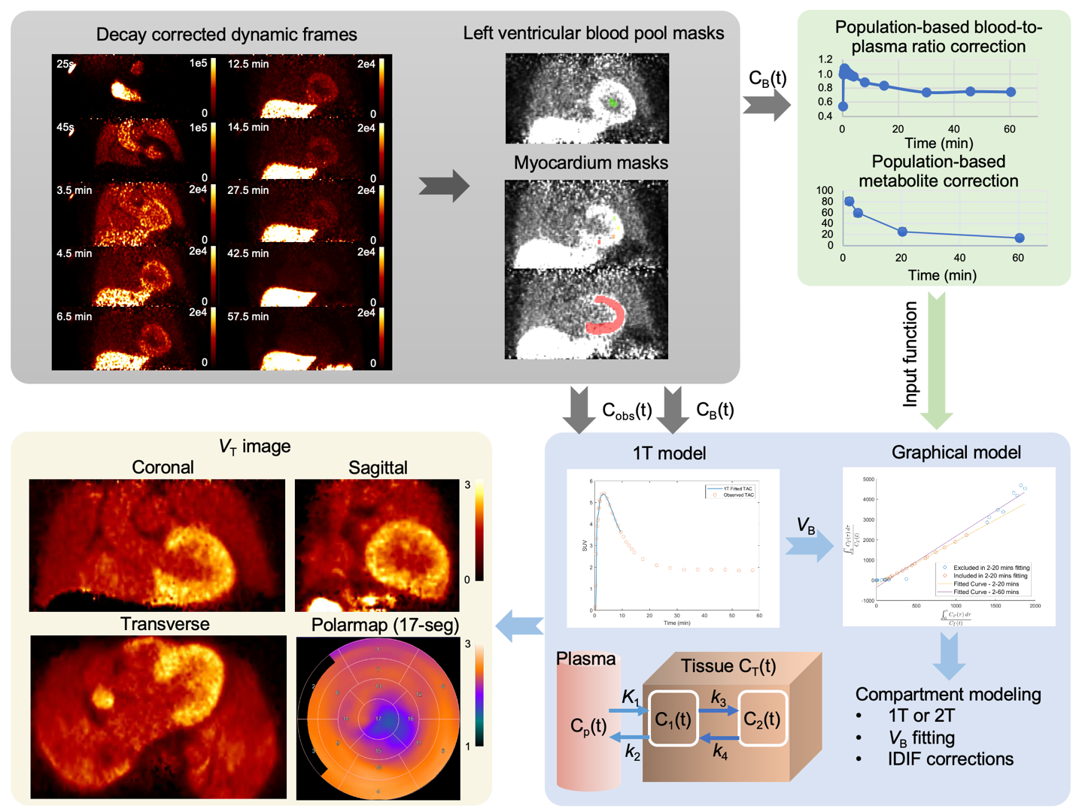
Figure 1. Schematic representation of dynamic PET data kinetic modeling and parametric imaging process. The workflow includes: 1. data acquisition and mask application for the left ventricle (LV) blood pool and myocardium; 2. population-based corrections for image-derived input function; 3. regional compartment modeling and graphical analysis; and 4. the generation of parametric images.
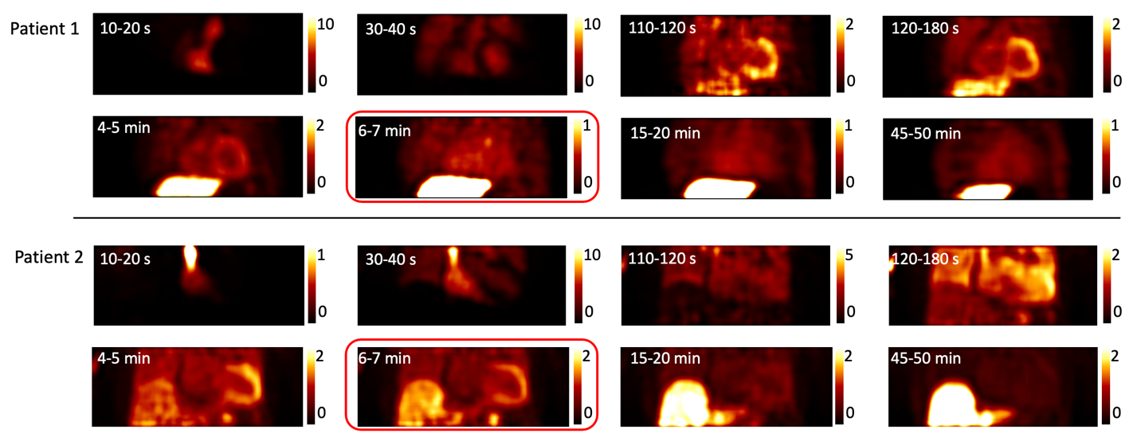
Figure 2. Transaxial dynamic images, depicted in units of Bq/mL and scaled by 10⁴, illustrate the ¹⁸F-flutemetamol uptake and clearance dynamics in two distinct patients exhibiting varying levels of tracer absorption and clearance.
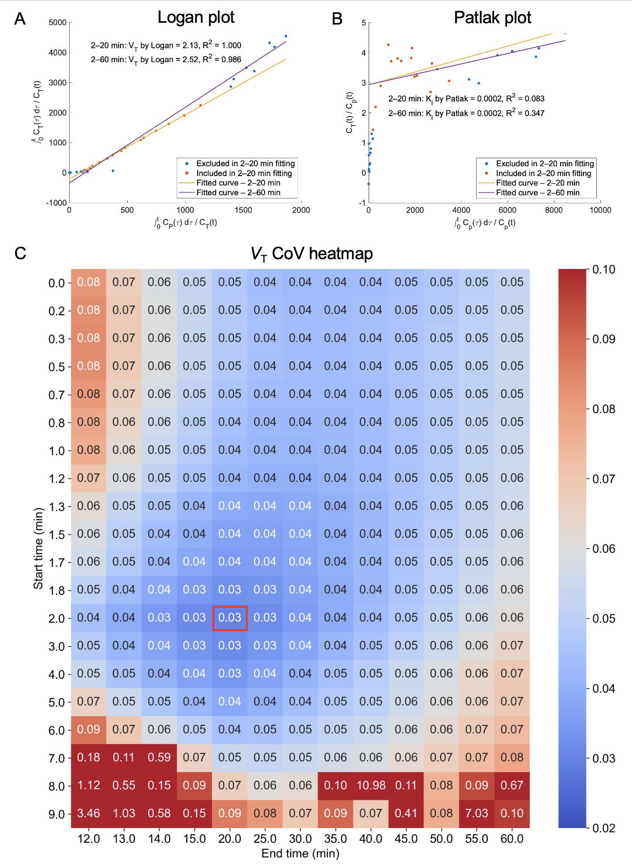
Figure 3. Graphical model fitting results for a myocardium TAC from a patient, showing the Logan plot (B), Patlak plot (A) for 2 to 20-minute and 2 to 60-minute fitting durations and the coefficient of variation (CoV) for V_{T} estimation from linear fitting across various start and end time options (C). The lowest V_{T} CoV was achieved when the start time was set to 2 minutes and the end time to 20 minutes.
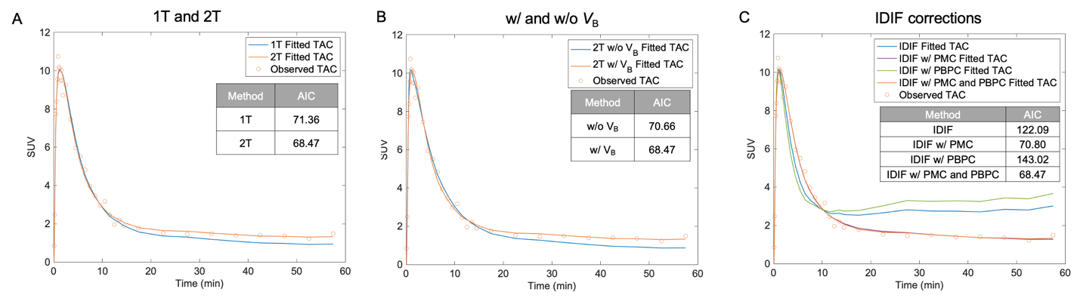
Figure 4. Representative myocardial TAC compartment modeling results. (A) Comparison of 1TC and 2TC model fitting. (B) Evaluation of the 2TC model with and without V_{B} correction. (C) Performance of the 2TC model using different input functions: IDIF with Population-based Metabolic Correction (PMC), IDIF with Population-based Blood-to-Plasma Correction (PBPC), IDIF with both PMC and PBPC, and IDIF without correction. AIC values for each method are displayed in the figure.
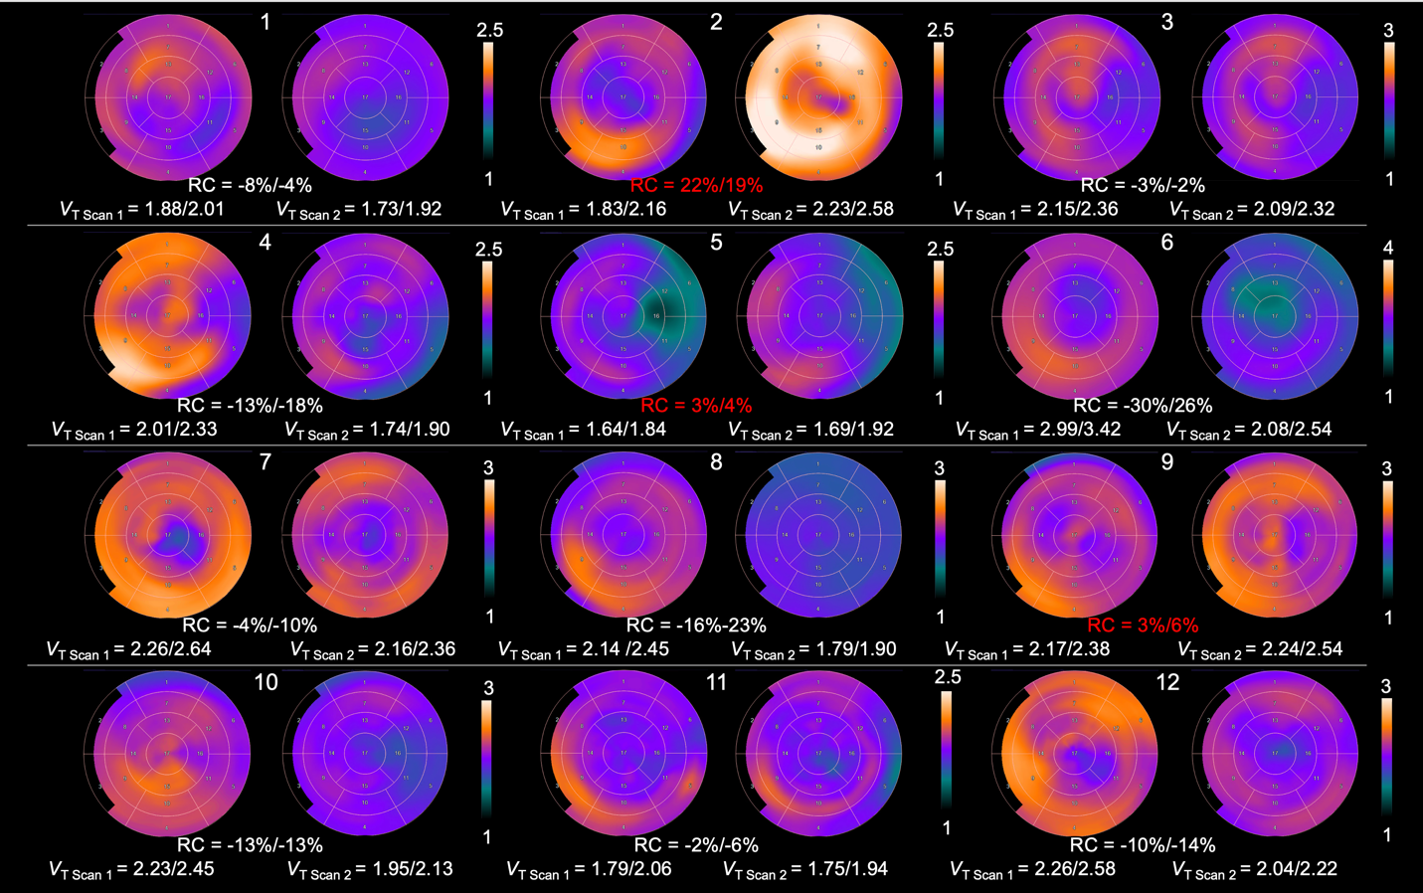
Figure 5. Polar maps of V_{T} for 12 patients, generated from dynamic PET images acquired over 2 to 30 minutes. The mean V_{T} values and the max V_{T} values from the 17 segments of the myocardium are shown at the bottom. The relative changes (RC) between scans, calculated as (Scan 2−Scan 1)/Scan 1 was shown in the middle of each two scans with the positive RCs highlighted in red.

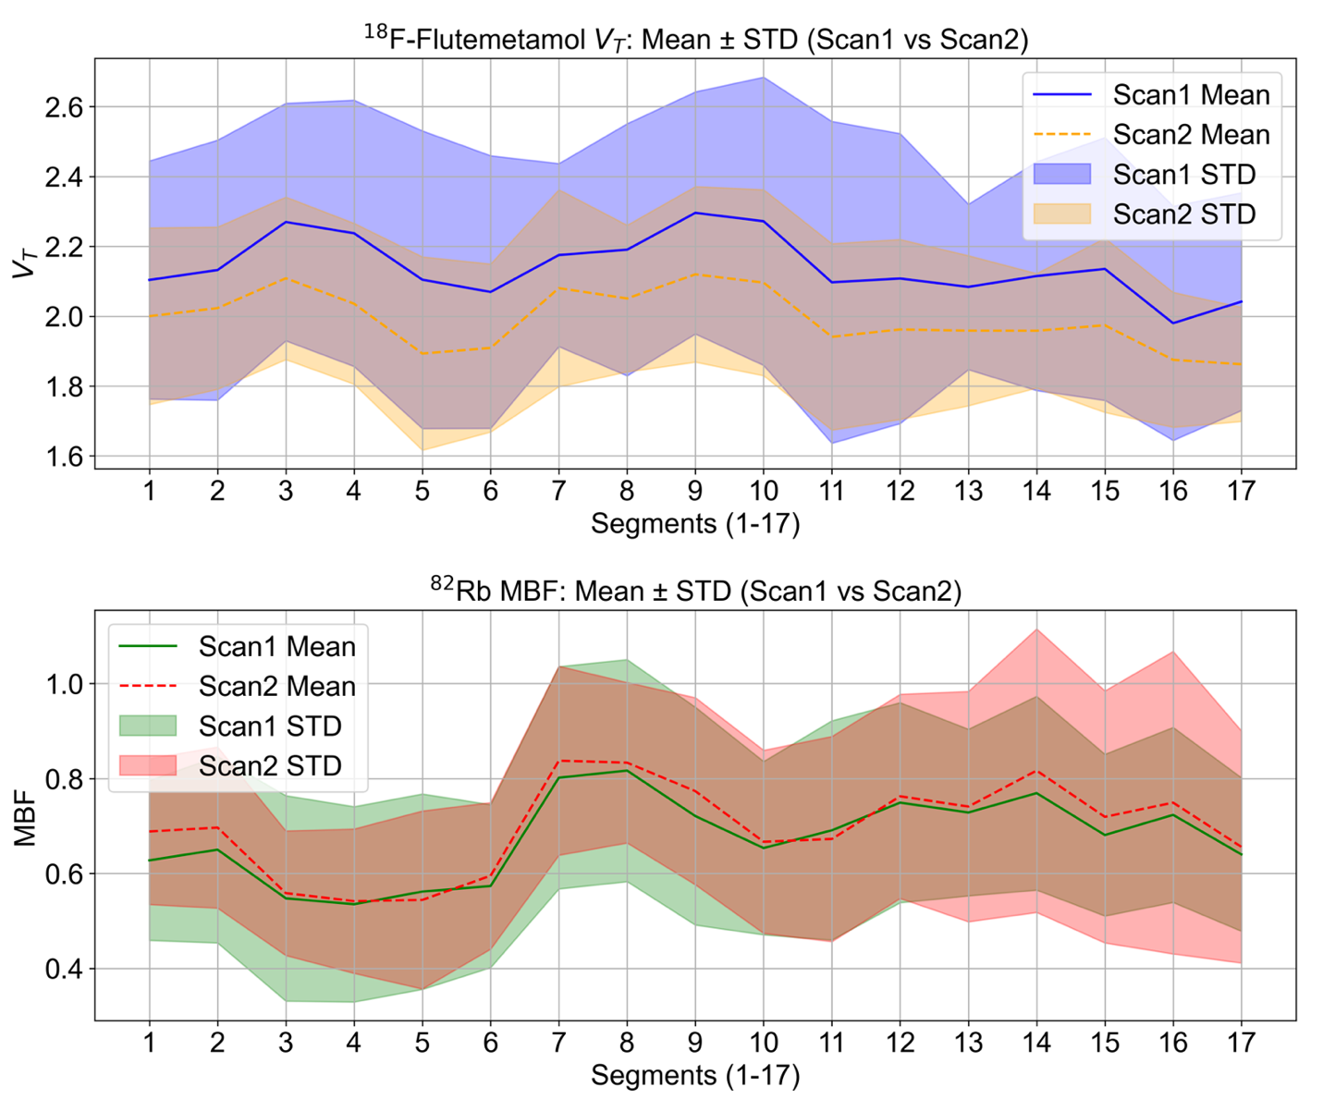
Figure 6. Comparison of the mean 17-segment data derived from V_{T} polar maps of ¹⁸F-flutemetamol and ⁸²Rb MBF polar maps across 12 patients for Scan 1 and Scan 2.

TABLES

Table 1. AIC values for 12 patients across various models, presented as mean ± standard deviation. The models include: (1) 1-tissue compartment model with VB fitting using IDIF and both corrections (1TC), (2) 2-tissue compartment model without VB fitting using IDIF and both corrections (2TC without VB), (3) 2-tissue compartment model with VB fitting using IDIF directly (IDIF), (4) 2-tissue compartment model with VB fitting using IDIF and PBPC correction (IDIF w/ PBPC), (5) 2-tissue compartment model with VB fitting using IDIF and PMC correction (IDIF w/ PMC), and (6) 2-tissue compartment model with VB fitting using IDIF and both corrections (2TC).
Model | Patient 1 | Patient 2 | Patient 3 | Patient 4 | Patient 5 | Patient 6 | Patient 7 | Patient 8 | Patient 9 | Patient 10 | Patient 11 | Patient 12
Scan 1
1TC | 72.2 ± 14.4 | 86.5 ± 13.1 | 74.3 ± 6.6 | 98.6 ± 12.6 | 98.4 ± 8.3 | 152.2 ± 13.1 | 106.4 ± 19.4 | 95.0 ± 9.5 | 88.5 ± 10.4 | 94.0 ± 10.3 | 118.3 ± 15.6 | 122.0 ± 10.7
2TC without VB | 107.3 ± 17.5 | 90.2 ± 27.4 | 75.7 ± 15.8 | 109.0 ± 12.3 | 70.5 ± 30.4 | 156.9 ± 12.9 | 112.0 ± 17.2 | 133.1 ± 9.2 | 99.5 ± 17.9 | 102.1 ± 14.1 | 132.8 ± 14.8 | 132.9 ± 9.8
IDIF | 87.2 ± 8.3 | 79.8 ± 16.3 | 71.1 ± 10.6 | 99.0 ± 6.2 | 66.4 ± 15.5 | 163.2 ± 12.3 | 108.0 ± 14.0 | 116.6 ± 6.2 | 118.9 ± 8.8 | 112.7 ± 10.9 | 137.3 ± 13.2 | 134.5 ± 9.4
IDIF w/PBPC | 108.8 ± 6.5 | 95.3 ± 11.3 | 93.4 ± 11.7 | 112.3 ± 5.3 | 79.5 ± 14.7 | 170.0 ± 10.6 | 117.1 ± 10.0 | 129.5 ± 4.5 | 138.1 ± 9.5 | 127.7 ± 9.4 | 147.2 ± 8.9 | 143.7 ± 8.6
IDIF w/PMC | 62.9 ± 16.1 | 69.0 ± 20.6 | 50.4 ± 5.4 | 89.1 ± 10.6 | 60.2 ± 18.3 | 157.0 ± 14.0 | 102.8 ± 18.6 | 97.8 ± 9.6 | 83.6 ± 8.8 | 94.2 ± 11.8 | 121.9 ± 15.4 | 124.9 ± 10.4
2TC | 61.3 ± 15.7 | 69.0 ± 20.5 | 50.2 ± 5.3 | 89.0 ± 10.5 | 60.2 ± 18.1 | 155.8 ± 13.5 | 101.8 ± 18.5 | 97.7 ± 9.6 | 83.6 ± 9.5 | 94.1 ± 12.2 | 121.2 ± 15.0 | 124.8 ± 10.4
Scan 2
1TC | 88.1 ± 22.9 | 65.4 ± 6.7 | 58.6 ± 11.8 | 49.9 ± 20.4 | 71.6 ± 17.6 | 57.1 ± 12.4 | 90.5 ± 10.9 | 100.6 ± 24.3 | 94.2 ± 12.2 | 97.4 ± 15.1 | 138.9 ± 16.3 | 111.9 ± 23.0
2TC without VB | 100.5 ± 27.2 | 56.6 ± 26.9 | 91.9 ± 13.5 | 74.3 ± 14.1 | 112.8 ± 18.5 | 88.7 ± 13.7 | 101.0 ± 25.0 | 132.6 ± 18.4 | 115.9 ± 5.0 | 117.6 ± 11.7 | 147.9 ± 15.3 | 129.9 ± 22.5
IDIF | 73.7 ± 23.9 | 63.2 ± 14.8 | 58.4 ± 13.8 | 60.4 ± 9.4 | 77.8 ± 13.7 | 89.3 ± 7.2 | 96.4 ± 10.2 | 127.0 ± 15.8 | 121.7 ± 6.3 | 120.1 ± 7.5 | 156.6 ± 11.2 | 135.6 ± 15.4
IDIF w/PBPC | 94.9 ± 18.5 | 85.7 ± 11.3 | 79.7 ± 10.9 | 81.5 ± 11.4 | 97.5 ± 8.6 | 106.3 ± 6.0 | 106.6 ± 9.0 | 141.1 ± 12.2 | 137.4 ± 5.8 | 138.7 ± 5.5 | 168.1 ± 9.0 | 148.2 ± 12.8
IDIF w/PMC | 59.0 ± 2.96 | 39.6 ± 10.0 | 36.4 ± 22.4 | 32.9 ± 19.2 | 56.1 ± 24.0 | 58.7 ± 13.2 | 89.2 ± 12.7 | 104.1 ± 25.2 | 93.8 ± 12.3 | 93.6 ± 16.4 | 141.7 ± 16.7 | 115.1 ± 23.7
2TC | 58.7 ± 29.7 | 39.6 ± 19.0 | 35.6 ± 22.3 | 30.1 ± 19.0 | 56.4 ± 23.9 | 56.8 ± 13.2 | 88.3 ± 12.6 | 102.7 ± 25.2 | 93.7 ± 12.2 | 92.9 ± 16.8 | 140.9 ± 16.5 | 114.8 ± 23.5

Table 2. Comparison of clinical and imaging parameters between Scan 1 and Scan 2, expressed as mean ± standard deviation. Parameters are organized by modality—first PET, then echocardiography, then biomarkers—and within each group are ordered by smallest to largest Wilcoxon signed-rank test p-value. The “Status” column indicates the direction of change (↑ for an increase, ↓ for a decrease, and – for no change). Statistically significant differences (p < 0.05) are highlighted in bold. Correlation coefficients (R²) greater than 0.5 are also highlighted in bold.

Parameter | Scan 1 | Scan 2 | Status | P-value | R² w/ V_{T} | R² /w ΔV_{T} | R² /w SUV | R² /w ΔSUV | R² /w SUVR | R² /w ΔSUVR
PET
Flu 1TC K₁ (mL/min/g) | 0.70 ± 0.23 | 0.64 ± 0.18 | ↓ | 0.036 | 0.01 | 0.00 | 0.48 | 0.18 | 0.47 | 0.15
Flu Logan V_{T} | 2.11 ± 0.34 | 1.96 ± 0.21 | ↓ | 0.042 | - | - | 0.14 | 0.04 | 0.37 | 0.16
SUVR | 1.27 ± 0.28 | 1.20 ± 0.23 | ↓ | 0.098 | 0.37 | 0.16 | 0.43 | 0.61 | - | -
Flu 1T V_{B} | 0.21 ± 0.05 | 0.23 ± 0.07 | ↑ | 0.187 | 0.05 | 0.11 | 0.07 | 0.04 | 0.00 | 0.05
⁸²Rb 1TC K₁ (mL/min/g) | 0.46 ± 0.08 | 0.47 ± 0.07 | ↑ | 0.395 | 0.01 | 0.07 | 0.39 | 0.20 | 0.29 | 0.02
⁸²Rb 1TC V_{B} | 0.23 ± 0.08 | 0.22 ± 0.06 | ↓ | 0.412 | 0.09 | 0.00 | 0.13 | 0.13 | 0.01 | 0.07
⁸²Rb MBF | 0.67 ± 0.18 | 0.68 ± 0.17 | ↑ | 0.429 | 0.01 | 0.00 | 0.38 | 0.20 | 0.26 | 0.02
SUV | 2.36 ± 0.75 | 2.36 ± 0.53 | - | 0.438 | 0.14 | 0.04 | - | - | 0.43 | 0.61
Echocardiographic
LA Volume (ml) | 88.08 ± 31.50 | 97.42 ± 26.99 | ↑ | 0.009 | 0.00 | 0.01 | 0.00 | 0.00 | 0.06 | 0.23
LV End-Diastolic Volume (ml) | 141.25 ± 43.05 | 166.17 ± 61.54 | ↑ | 0.021 | 0.01 | 0.33 | 0.00 | 0.01 | 0.05 | 0.08
MV Septal Velocity (cm/sec) | 6.31 ± 3.46 | 4.48 ± 1.03 | ↓ | 0.048 | 0.00 | 0.00 | 0.03 | 0.09 | 0.00 | 0.01
Posterior Wall Thickness (cm) | 1.57 ± 0.21 | 1.48 ± 0.21 | ↓ | 0.074 | 0.10 | 0.00 | 0.02 | 0.21 | 0.16 | 0.09
LV End Dias. Internal Dim (cm) | 4.13 ± 0.62 | 4.29 ± 0.52 | ↑ | 0.084 | 0.02 | 0.00 | 0.06 | 0.41 | 0.10 | 0.01
MV Lateral Velocity (cm/sec) | 7.07 ± 2.45 | 6.18 ± 2.77 | ↓ | 0.096 | 0.04 | 0.37 | 0.07 | 0.01 | 0.03 | 0.01
Global Longitudinal Strain (%) | -11.02 ± 3.91 | -11.36 ± 3.52 | ↑ | 0.221 | 0.00 | 0.68 | 0.01 | 0.27 | 0.19 | 0.18
Interventricular Septal Thickness (cm) | 1.55 ± 0.23 | 1.51 ± 0.25 | ↓ | 0.236 | 0.10 | 0.09 | 0.01 | 0.00 | 0.11 | 0.02
LV End Sys. Internal Dimension (cm) | 3.09 ± 0.68 | 3.21 ± 0.61 | ↑ | 0.291 | 0.12 | 0.09 | 0.10 | 0.01 | 0.06 | 0.03
LV Ejection Fraction (%) | 52.25 ± 11.31 | 53.00 ± 9.83 | ↑ | 0.361 | 0.09 | 0.05 | 0.12 | 0.06 | 0.04 | 0.02
TV Annular Velocity (cm/sec) | 10.76 ± 2.13 | 10.50 ± 2.40 | ↓ | 0.395 | 0.06 | 0.20 | 0.25 | 0.25 | 0.03 | 0.26
Left Atrial Diameter (cm) | 5.02 ± 0.78 | 4.97 ± 0.64 | ↓ | 0.465 | 0.01 | 0.01 | 0.01 | 0.02 | 0.01 | 0.10
Biomarkers
Prealbumin (mg/dL) | 22.02 ± 4.21 | 29.88 ± 5.04 | ↑ | 0.033 | 0.05 | 0.06 | 0.38 | 0.97 | 0.27 | 0.68
NT-proBNP (pg/ml) | 2219.40 ± 1203.38 | 1795.30 ± 940.06 | ↓ | 0.047 | 0.02 | 0.22 | 0.22 | 0.01 | 0.20 | 0.19
Albumin (g/dL) | 4.12 ± 0.26 | 4.30 ± 0.27 | ↑ | 0.108 | 0.21 | 0.03 | 0.08 | 0.80 | 0.05 | 0.95
eGFR (mL/min/1.73 m²) | 52.33 ± 10.35 | 54.50 ± 6.59 | ↑ | 0.198 | 0.00 | 0.05 | 0.02 | 0.17 | 0.17 | 0.09
Creatine lab (mg/dL) | 1.24 ± 0.36 | 1.20 ± 0.25 | ↓ | 0.287 | 0.00 | 0.06 | 0.01 | 0.11 | 0.09 | 0.10
Troponin T (ng/ml) | 52.75 ± 28.49 | 47.00 ± 15.66 | ↓ | 0.500 | 0.01 | 0.39 | 0.02 | 0.21 | 0.01 | 0.56

