Fold1
===============================================================================
完整评估指标报告
===============================================================================

【训练集指标】

Horizon: 6m
样本数: 15,688 | 正样本: 100 | 基准率: 0.0064
ROC-AUC: 0.9951 | PR-AUC: 0.6188
Brier Score: 0.0505 | Log Loss: 0.2425
Top1%: Precision=0.4872, Recall=0.7600
Top5%: Precision=0.1276, Recall=1.0000
Top10%: Precision=0.0638, Recall=1.0000

Horizon: 12m
样本数: 15,688 | 正样本: 161 | 基准率: 0.0103
ROC-AUC: 0.9956 | PR-AUC: 0.6963
Brier Score: 0.0773 | Log Loss: 0.3233
Top1%: Precision=0.6538, Recall=0.6335
Top5%: Precision=0.2054, Recall=1.0000
Top10%: Precision=0.1027, Recall=1.0000

Horizon: 18m
样本数: 15,688 | 正样本: 246 | 基准率: 0.0157
ROC-AUC: 0.9954 | PR-AUC: 0.7513
Brier Score: 0.0902 | Log Loss: 0.3778
Top1%: Precision=0.7885, Recall=0.5000
Top5%: Precision=0.3138, Recall=1.0000
Top10%: Precision=0.1569, Recall=1.0000

Horizon: 24m
样本数: 15,688 | 正样本: 343 | 基准率: 0.0219
ROC-AUC: 0.9961 | PR-AUC: 0.8151
Brier Score: 0.1208 | Log Loss: 0.4563
Top1%: Precision=0.8590, Recall=0.3907
Top5%: Precision=0.4349, Recall=0.9942
Top10%: Precision=0.2188, Recall=1.0000

【验证集指标】

Horizon: 6m
样本数: 7,524 | 正样本: 140 | 基准率: 0.0186
ROC-AUC: 0.9910 | PR-AUC: 0.7060
Brier Score: 0.0465 | Log Loss: 0.2335
Top1%: Precision=0.7733, Recall=0.4143
Top5%: Precision=0.3564, Recall=0.9571
Top10%: Precision=0.1848, Recall=0.9929

Horizon: 12m
样本数: 7,524 | 正样本: 194 | 基准率: 0.0258
ROC-AUC: 0.9922 | PR-AUC: 0.8231
Brier Score: 0.0668 | Log Loss: 0.2933
Top1%: Precision=0.9600, Recall=0.3711
Top5%: Precision=0.4894, Recall=0.9485
Top10%: Precision=0.2553, Recall=0.9897

Horizon: 18m
样本数: 7,524 | 正样本: 236 | 基准率: 0.0314
ROC-AUC: 0.9845 | PR-AUC: 0.8004
Brier Score: 0.0745 | Log Loss: 0.3196
Top1%: Precision=0.8533, Recall=0.2712
Top5%: Precision=0.5691, Recall=0.9068
Top10%: Precision=0.3032, Recall=0.9661

Horizon: 24m
样本数: 7,524 | 正样本: 279 | 基准率: 0.0371
ROC-AUC: 0.9634 | PR-AUC: 0.7665
Brier Score: 0.1076 | Log Loss: 0.4061
Top1%: Precision=0.8800, Recall=0.2366
Top5%: Precision=0.6277, Recall=0.8459
Top10%: Precision=0.3351, Recall=0.9032

【测试集指标】

Horizon: 6m
样本数: 9,118 | 正样本: 192 | 基准率: 0.0211
ROC-AUC: 0.9895 | PR-AUC: 0.6918
Brier Score: 0.0425 | Log Loss: 0.2231
Top1%: Precision=0.7912, Recall=0.3750
Top5%: Precision=0.3978, Recall=0.9427
Top10%: Precision=0.2053, Recall=0.9740

Horizon: 12m
样本数: 9,118 | 正样本: 246 | 基准率: 0.0270
ROC-AUC: 0.9647 | PR-AUC: 0.7174
Brier Score: 0.0625 | Log Loss: 0.2822
Top1%: Precision=0.9121, Recall=0.3374
Top5%: Precision=0.4681, Recall=0.8659
Top10%: Precision=0.2492, Recall=0.9228

Horizon: 18m
样本数: 9,118 | 正样本: 296 | 基准率: 0.0325
ROC-AUC: 0.9517 | PR-AUC: 0.6842
Brier Score: 0.0670 | Log Loss: 0.2939
Top1%: Precision=0.9121, Recall=0.2804
Top5%: Precision=0.5033, Recall=0.7736
Top10%: Precision=0.2733, Recall=0.8412

Horizon: 24m
样本数: 4,312 | 正样本: 163 | 基准率: 0.0378
ROC-AUC: 0.9423 | PR-AUC: 0.6868
Brier Score: 0.0930 | Log Loss: 0.3601
Top1%: Precision=0.8837, Recall=0.2331
Top5%: Precision=0.5674, Recall=0.7485
Top10%: Precision=0.3202, Recall=0.8466

▶ 特征重要性 ...
特征重要性已保存：./output\feature_importance.csv
Top 10 重要特征：
feature importance rank
f58 2839.518372 1
f3 854.788120 2
f7 815.882317 3
f11 794.439339 4
f1 681.673988 5
f49 421.363747 6
f17 355.817734 7
f64 347.401569 8
f42 339.804283 9
f8 284.945911 10
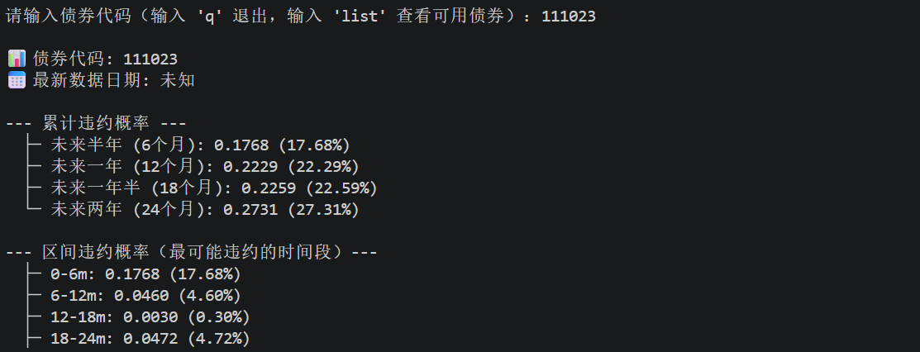
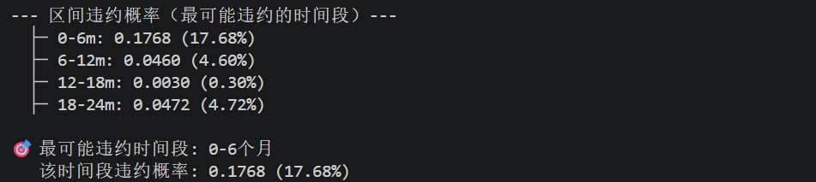

Fold2
===============================================================================
完整评估指标报告
==============================================================================

【训练集】

Horizon: 6m
样本数: 23,212 | 正样本: 240 | 基准率: 0.0103
ROC-AUC: 0.9971 | PR-AUC: 0.8060
Brier Score: 0.0084 | Log Loss: 0.0326
Top1%: Precision=0.7672, Recall=0.7417
Top5%: Precision=0.2060, Recall=0.9958
Top10%: Precision=0.1034, Recall=1.0000

Horizon: 12m
样本数: 23,212 | 正样本: 355 | 基准率: 0.0153
ROC-AUC: 0.9971 | PR-AUC: 0.8342
Brier Score: 0.0191 | Log Loss: 0.0860
Top1%: Precision=0.8621, Recall=0.5634
Top5%: Precision=0.3052, Recall=0.9972
Top10%: Precision=0.1530, Recall=1.0000

Horizon: 18m
样本数: 23,212 | 正样本: 482 | 基准率: 0.0208
ROC-AUC: 0.9963 | PR-AUC: 0.8148
Brier Score: 0.0262 | Log Loss: 0.1279
Top1%: Precision=0.8319, Recall=0.4004
Top5%: Precision=0.4138, Recall=0.9959
Top10%: Precision=0.2077, Recall=1.0000

Horizon: 24m
样本数: 23,212 | 正样本: 622 | 基准率: 0.0268
ROC-AUC: 0.9951 | PR-AUC: 0.8208
Brier Score: 0.0479 | Log Loss: 0.2374
Top1%: Precision=0.8793, Recall=0.3280
Top5%: Precision=0.5276, Recall=0.9839
Top10%: Precision=0.2680, Recall=1.0000

【验证集】

Horizon: 6m
样本数: 9,118 | 正样本: 192 | 基准率: 0.0211
ROC-AUC: 0.9900 | PR-AUC: 0.7816
Brier Score: 0.0098 | Log Loss: 0.0378
Top1%: Precision=0.8681, Recall=0.4115
Top5%: Precision=0.3890, Recall=0.9219
Top10%: Precision=0.2064, Recall=0.9792

Horizon: 12m
样本数: 9,118 | 正样本: 246 | 基准率: 0.0270
ROC-AUC: 0.9741 | PR-AUC: 0.7472
Brier Score: 0.0122 | Log Loss: 0.0606
Top1%: Precision=0.9341, Recall=0.3455
Top5%: Precision=0.4681, Recall=0.8659
Top10%: Precision=0.2470, Recall=0.9146

Horizon: 18m
样本数: 9,118 | 正样本: 296 | 基准率: 0.0325
ROC-AUC: 0.9790 | PR-AUC: 0.7055
Brier Score: 0.0172 | Log Loss: 0.0845
Top1%: Precision=0.8901, Recall=0.2736
Top5%: Precision=0.5231, Recall=0.8041
Top10%: Precision=0.2986, Recall=0.9189

Horizon: 24m
样本数: 4,312 | 正样本: 163 | 基准率: 0.0378
ROC-AUC: 0.9835 | PR-AUC: 0.7222
Brier Score: 0.0294 | Log Loss: 0.1578
Top1%: Precision=0.8837, Recall=0.2331
Top5%: Precision=0.5721, Recall=0.7546
Top10%: Precision=0.3619, Recall=0.9571

【测试集】

Horizon: 6m
样本数: 9,118 | 正样本: 192 | 基准率: 0.0211
ROC-AUC: 0.9900 | PR-AUC: 0.7816
Brier Score: 0.0098 | Log Loss: 0.0378
Top1%: Precision=0.8681, Recall=0.4115
Top5%: Precision=0.3890, Recall=0.9219
Top10%: Precision=0.2064, Recall=0.9792

Horizon: 12m
样本数: 9,118 | 正样本: 246 | 基准率: 0.0270
ROC-AUC: 0.9741 | PR-AUC: 0.7472
Brier Score: 0.0122 | Log Loss: 0.0606
Top1%: Precision=0.9341, Recall=0.3455
Top5%: Precision=0.4681, Recall=0.8659
Top10%: Precision=0.2470, Recall=0.9146

Horizon: 18m
样本数: 9,118 | 正样本: 296 | 基准率: 0.0325
ROC-AUC: 0.9790 | PR-AUC: 0.7055
Brier Score: 0.0172 | Log Loss: 0.0845
Top1%: Precision=0.8901, Recall=0.2736
Top5%: Precision=0.5231, Recall=0.8041
Top10%: Precision=0.2986, Recall=0.9189

Horizon: 24m
样本数: 4,312 | 正样本: 163 | 基准率: 0.0378
ROC-AUC: 0.9835 | PR-AUC: 0.7222
Brier Score: 0.0294 | Log Loss: 0.1578
Top1%: Precision=0.8837, Recall=0.2331
Top5%: Precision=0.5721, Recall=0.7546
Top10%: Precision=0.3619, Recall=0.9571

Brier Score: 0.0158 | Log Loss: 0.0675
Top1%: Precision=0.7353, Recall=0.3571
Top5%: Precision=0.2815, Recall=0.6857
Top10%: Precision=0.1892, Recall=0.9214

Fold3
===============================================================================完整评估指标报告
===============================================================================
【训练集指标】

Horizon: 6m
样本数: 32,330 | 正样本: 432 | 基准率: 0.0134
ROC-AUC: 0.9910 | PR-AUC: 0.6184
Brier Score: 0.0956 | Log Loss: 0.3650
Top1%: Precision=0.6285, Recall=0.4699
Top5%: Precision=0.2574, Recall=0.9630
Top10%: Precision=0.1330, Recall=0.9954

Horizon: 12m
样本数: 32,330 | 正样本: 601 | 基准率: 0.0186
ROC-AUC: 0.9903 | PR-AUC: 0.6689
Brier Score: 0.1049 | Log Loss: 0.3927
Top1%: Precision=0.7523, Recall=0.4043
Top5%: Precision=0.3527, Recall=0.9484
Top10%: Precision=0.1853, Recall=0.9967

Horizon: 18m
样本数: 32,330 | 正样本: 778 | 基准率: 0.0241
ROC-AUC: 0.9934 | PR-AUC: 0.8168
Brier Score: 0.1029 | Log Loss: 0.3866
Top1%: Precision=0.9567, Recall=0.3972
Top5%: Precision=0.4592, Recall=0.9537
Top10%: Precision=0.2400, Recall=0.9974

Horizon: 24m
样本数: 27,524 | 正样本: 785 | 基准率: 0.0285
ROC-AUC: 0.9932 | PR-AUC: 0.8191
Brier Score: 0.1088 | Log Loss: 0.4065
Top1%: Precision=0.9382, Recall=0.3287
Top5%: Precision=0.5334, Recall=0.9350
Top10%: Precision=0.2845, Recall=0.9975

【验证集指标】

Horizon: 6m
样本数: 12,649 | 正样本: 263 | 基准率: 0.0208
ROC-AUC: 0.9810 | PR-AUC: 0.5674
Brier Score: 0.0873 | Log Loss: 0.3468
Top1%: Precision=0.6349, Recall=0.3042
Top5%: Precision=0.3513, Recall=0.8441
Top10%: Precision=0.1978, Recall=0.9506

Horizon: 12m
样本数: 5,827 | 正样本: 146 | 基准率: 0.0251
ROC-AUC: 0.9851 | PR-AUC: 0.6106
Brier Score: 0.0884 | Log Loss: 0.3494
Top1%: Precision=0.6897, Recall=0.2740
Top5%: Precision=0.4364, Recall=0.8699
Top10%: Precision=0.2406, Recall=0.9589

Horizon: 18m
样本数: 12,649 | 正样本: 375 | 基准率: 0.0296
备注: Using all labels (no valid mask)
ROC-AUC: 0.9858 | PR-AUC: 0.6990
Brier Score: 0.0874 | Log Loss: 0.3470
Top1%: Precision=0.7698, Recall=0.2587
Top5%: Precision=0.5174, Recall=0.8720
Top10%: Precision=0.2856, Recall=0.9627

Horizon: 24m
样本数: 12,649 | 正样本: 416 | 基准率: 0.0329
备注: Using all labels (no valid mask)
ROC-AUC: 0.9855 | PR-AUC: 0.6849
Brier Score: 0.0901 | Log Loss: 0.3532
Top1%: Precision=0.7381, Recall=0.2236
Top5%: Precision=0.5570, Recall=0.8462
Top10%: Precision=0.3180, Recall=0.9663

【测试集指标】

Horizon: 6m
样本数: 14,693 | 正样本: 338 | 基准率: 0.0230
备注: Using all labels (no valid mask)
ROC-AUC: 0.9829 | PR-AUC: 0.6901
Brier Score: 0.0854 | Log Loss: 0.3428
Top1%: Precision=0.7397, Recall=0.3195
Top5%: Precision=0.4237, Recall=0.9201
Top10%: Precision=0.2233, Recall=0.9704

Horizon: 12m
样本数: 14,693 | 正样本: 377 | 基准率: 0.0257
备注: Using all labels (no valid mask)
ROC-AUC: 0.9848 | PR-AUC: 0.7247
Brier Score: 0.0853 | Log Loss: 0.3426
Top1%: Precision=0.7808, Recall=0.3024
Top5%: Precision=0.4755, Recall=0.9257
Top10%: Precision=0.2498, Recall=0.9735

Horizon: 18m
样本数: 14,693 | 正样本: 397 | 基准率: 0.0270
备注: Using all labels (no valid mask)
ROC-AUC: 0.9859 | PR-AUC: 0.7561
Brier Score: 0.0851 | Log Loss: 0.3421
Top1%: Precision=0.8356, Recall=0.3073
Top5%: Precision=0.5000, Recall=0.9244
Top10%: Precision=0.2634, Recall=0.9748

Horizon: 24m
样本数: 14,693 | 正样本: 411 | 基准率: 0.0280
备注: Using all labels (no valid mask)
ROC-AUC: 0.9866 | PR-AUC: 0.7388
Brier Score: 0.0868 | Log Loss: 0.3460
Top1%: Precision=0.7808, Recall=0.2774
Top5%: Precision=0.5204, Recall=0.9294
Top10%: Precision=0.2737, Recall=0.9781

-> 特征重要性 ...
特征重要性已保存：./output\feature_importance.csv
Top 10 重要特征：
feature importance rank
f58 2452.958832 1
f59 1184.412643 2
f7 1024.248001 3
f1 628.187061 4
f56 533.308666 5
f3 510.926977 6
f11 446.729303 7
f34 385.497639 8
f45 374.803379 9
f42 360.294466 10
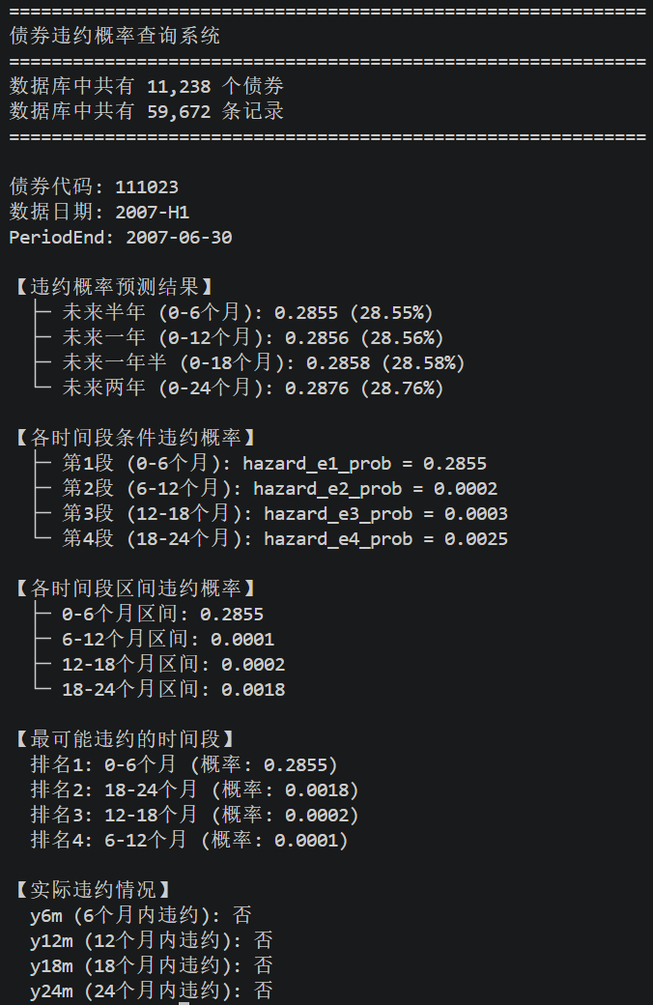

Fold4
