Development of a Java Framework for Parametric Aircraft Design - The Performance Analysis Module
Laurea Specialistica in Ingegneria Aerospaziale e Astronautica | Seduta del 05/04/16
Relatore/Relatori  Prof. Ing. Fabrizio Nicolosi (DIAS)  Prof. Ing. Agostino De Marco (DIAS) | Candidato  Vittorio Trifari
Keywords
“Java Framework”, “Performance Analysis”, “Aircraft Design”
Abstract
- Analysis of scenario
This thesis has the main purpose of providing a comprehensive overview about the development, in Java, of a software dedicated to the preliminary design of an aircraft, focusing on the performance analysis module.
The point of view from which this subject will be observed expects first to define methodologies and theoretical aspects necessary for the examined performance calculation for then to show, in more detail, the implementation of these latter within the software; this will be seen both from the point of view of the developer, through a detailed explanation of the architecture of the different calculation modules, both of a potential user developer, by showing some commented examples of use supplied with graphical and numerical results suitable, among other things, also to the validation of calculations performed.
- Statement of the problem

The objective of this work has been to design and test several Java classes in charge of the calculation of some important aircraft performance still not implemented inside the preexisting version of the software. In particular, these required performance were the Payload-Range chart, the Cruise Grid chart, the Take-off and Landing field length and, in order to calculate these latter, the evaluation of high lift devices effects on the wing.
- Adopted methodology
Preliminary design equations have been used in order to calculate the Payload-Range chart points, and to build up the cruise grid chart. Use of semi-empirical equations in order to evaluate high lift devices effects. Wide use of Java libraries in order to manage complex calculations such as the take-off run integration. The results obtained have been validated by comparing them with flight manual data, or public domain data, related to the aircraft used to test the calculation module.
- Main results
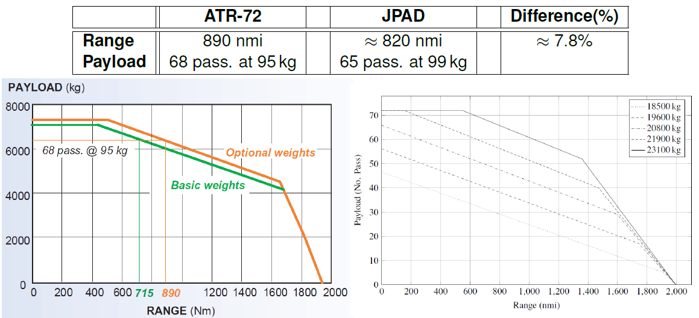
The two aircraft analyzed have been the ATR-72 and the B747-100B. The Payload-Range charts obtained show a difference in the design range of less than the 10% with respect to the ATR-72 brochure and with the B747-100 flight manual.

The cruise grid chart of the B747-100B shows that, for a long range flight, the optimum Mach number is around M=0.82. This result is in accordance with the real cruising speed of about M=0.83. Regarding the ATR-72, the long range Mach number, and the maximum range Mach number, are lower than the real cruising Mach number but, since the short distances this aircraft have to cover, the chart shows that it is possible to fly at an higher speed with a lower specific range.
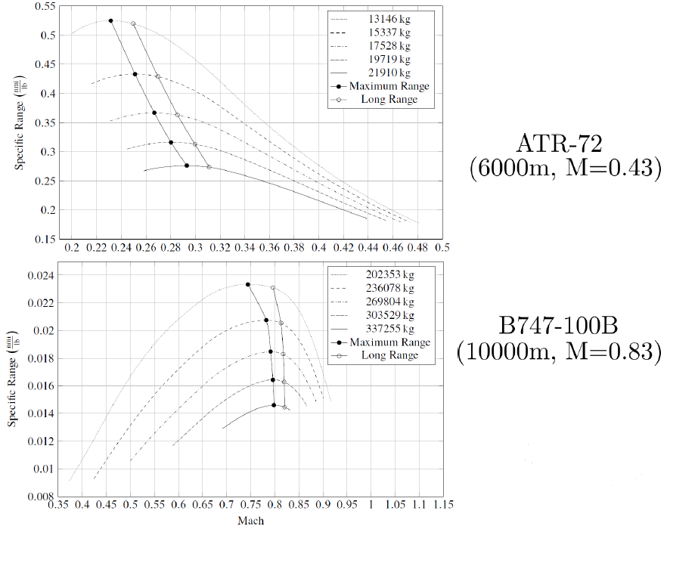
Regarding the high lift devices effects it is possible to notice the different effect upon the CL_{max} and the α_{max} caused by the presence of flaps only (left image), or both flaps and slats (right image). The CL_{max} data in take-off and landing have been compared with the one proposed by some books (in particular for the B747-100B) and with some data numerical data for the ATR-72.
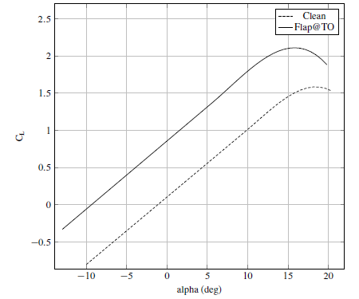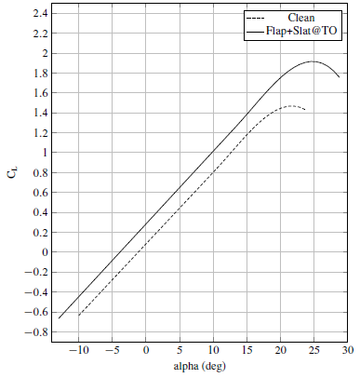
Finally the take-off and landing results show a difference with the statistical field length (and with the flight manual data) of less than the 10% validating the calculation made. In particular this uncertainty is due to some unknown parameters like the friction coefficient with the ground or some other coefficients which describes the rotation maneuver.
 | ATR-72 public data | ATR-72 from software | Difference (%)
FAR-25 TO field length | 1300m | 1350m | ≈4%
FAR-25 LND field length | 1067m | 1147m | ≈7%

