Aircraft Solid Modeling with JPAD and Automatic Workflows for High-Fidelity Numerical Aerodynamic Simulations
Laurea Magistrale in Ingegneria Aerospaziale | Seduta del 04/10/18
Relatore  Prof. Ing. Agostino De Marco (DAF) | Candidato  Mario Di Stasio
Keywords:
“Java Framework”, “CAD Modeling”, “Aircraft Design”
Abstract
- Analysis of scenario
The main goal of this thesis work is to give an overview on the development of a Java-based library, to be integrated in JPAD (a software dedicated to preliminary aircraft design), whose purpose is dealing with the automatic production of aircraft CAD models. Generating CAD models can be an important achievement for a software such as JPAD for the following reasons: it gives an immediate feedback about the data provided to the application, so that in case of mistakes these can be almost immediately detected; but most importantly, it allows the user to run a CFD analysis by means of an external tool. In fact, nowadays there is an ever increasing demand in the aerospace industry to use CFD analysis even in the preliminary and conceptual phases of aircraft design. This is due to the fact that CFD simulations can predict the compressible and viscous flow fields around the aircraft in a much more accurate way than the traditional techniques of the preliminary design phase.
- Statement of the problem
The main objective for this work has been the designing and testing of several Java classes and utilities intended to be used in order to generate, in an automatic fashion, both fuselage and lifting surface CAD counterparts for the aircraft objects imported into JPAD. The same classes have also been used in order to test the capabilities of a framework realized with the purpose of automatically generate workflows involving CFD analysis.
- Adopted methodology
In order to actually be able to generate CAD shapes, it has been necessary to adopt an external library, Open CASCADE Technology, which is designed for rapid production of sophisticated CAD applications. With regard to the CFD side, STAR-CCM+ software has been choosed, along with its capability to provide support for recording and playing macros, which are conveniently written in Java and can also be run in batch mode.
- Main results
The Java classes and utilities created for CAD purposes have proven to be quite versatile, since they have been tested for several aircraft configurations with positive results. Besides, the models produced by the use of the aforementioned classes come equipped with solutions, such as the modeling of wing tips, that make them ready to be imported and used into a suite for aerodynamics investigations. Some efforts have also been made in order to automatically generate wing-to-fuselage fairings, and produce functions for the modeling of control surfaces. Positive results have been obtained in this sense too, though still more refinements are needed.

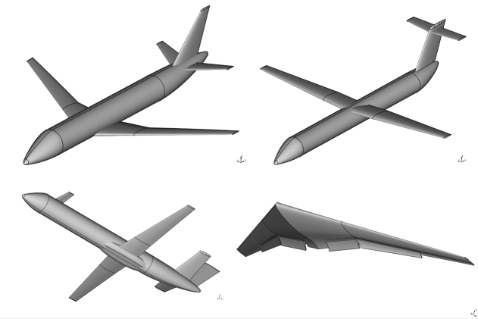

On the CFD side, the designed framework of STAR-CCM+ macros and Java classes has proven to be ready to be used in order to support the automatization of analysis workflows, both for single simulations and parametric studies.
