Development of a Java-Based Framework for Aircraft Preliminary Design
Wing Aerodynamic Analysis Module, Aircraft Longitudinal Static Stability Module
Laurea Magistrale in Ingegneria Aerospaziale | Seduta del 05/04/16
Relatori  Prof. Ing. Fabrizio Nicolosi (DIAS)  Prof. Ing. Agostino De Marco (DIAS) | Candidato  Manuela Ruocco
Keywords
“Aircraft Design”, “Java”, “Longitudinal Static Stability”

Abstract
- Analysis of scenario
The conceptual and preliminary design phases play a key role for the best development of future transport aircraft. In this scenario a software framework that could help in finding a configuration which satisfies several basic requirements and eventually a constrained optimum, is an essential tool for academic and industrial aircraft design activities.
The purpose of this Thesis work is to introduce the features and the potentialities of ADOpT (Aircraft Design and Optimization Tool), a java-based framework conceived as a fast and efficient tool useful as support in the preliminary design phases of an aircraft, and during its optimization process.
The use of Java permitted to have access to a powerful programming language that has given added value to my academic background.
- Statement of the problem
The main purpose of this Thesis is to create and to make operative the modules for the analysis of Lift, Drag and for Longitudinal Static Stability on an aircraft. During the work development has been necessary to introduce a tool for calculating the downwash which takes into account the non-linear effects due to the location of the vortex plane. In order to complete the aerodynamic analysis module the induced angle of attack has been calculated for a number of stations along the semi-span.
- Adopted methodology
The software presented in this Thesis work is completely written in Java. In particular, the Eclipse IDE has been chosen to develop ADOpT and its reference library JPAD. The implemented algorithms are both semi-empirical and analytical. The obtained results have been validated using experimental data or numerical analysis.
- Main results
With the developed module it is possible to execute an aerodynamic analysis on an isolated wing or on an aircraft drawing the complete curve of C_{L} vs alpha and evaluating the C_{L max} with an accuracy of 0.01% referring to the stall path. It is also possible to evaluate the fuselage effects on wing lift and draw the lift curve with high lift devices.

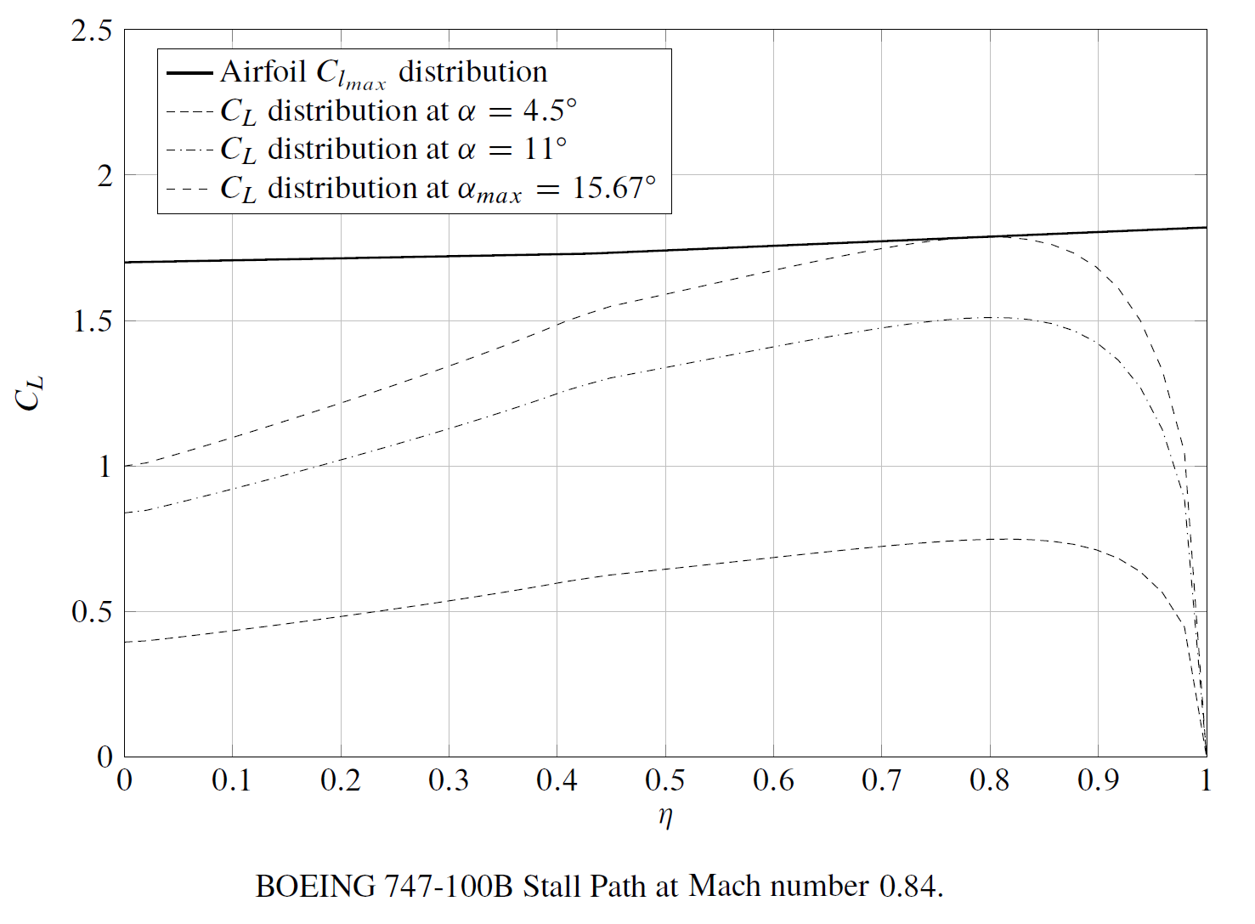
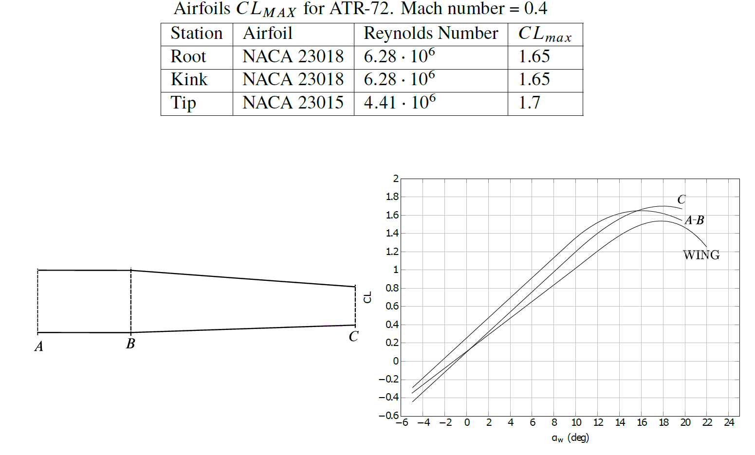

Starting from 2D data of airfoils and the local induced angle of attack, it is possible to evaluate the
parasite and induced drag of a lifting surface. The high-lift devices effect on drag has been considered.
The downwash gradient and the angle of downwash have been evaluated considering the variable distances between the horizontal tail and the vortex plane. In this way the downwash calculation turns out to be more accurate.
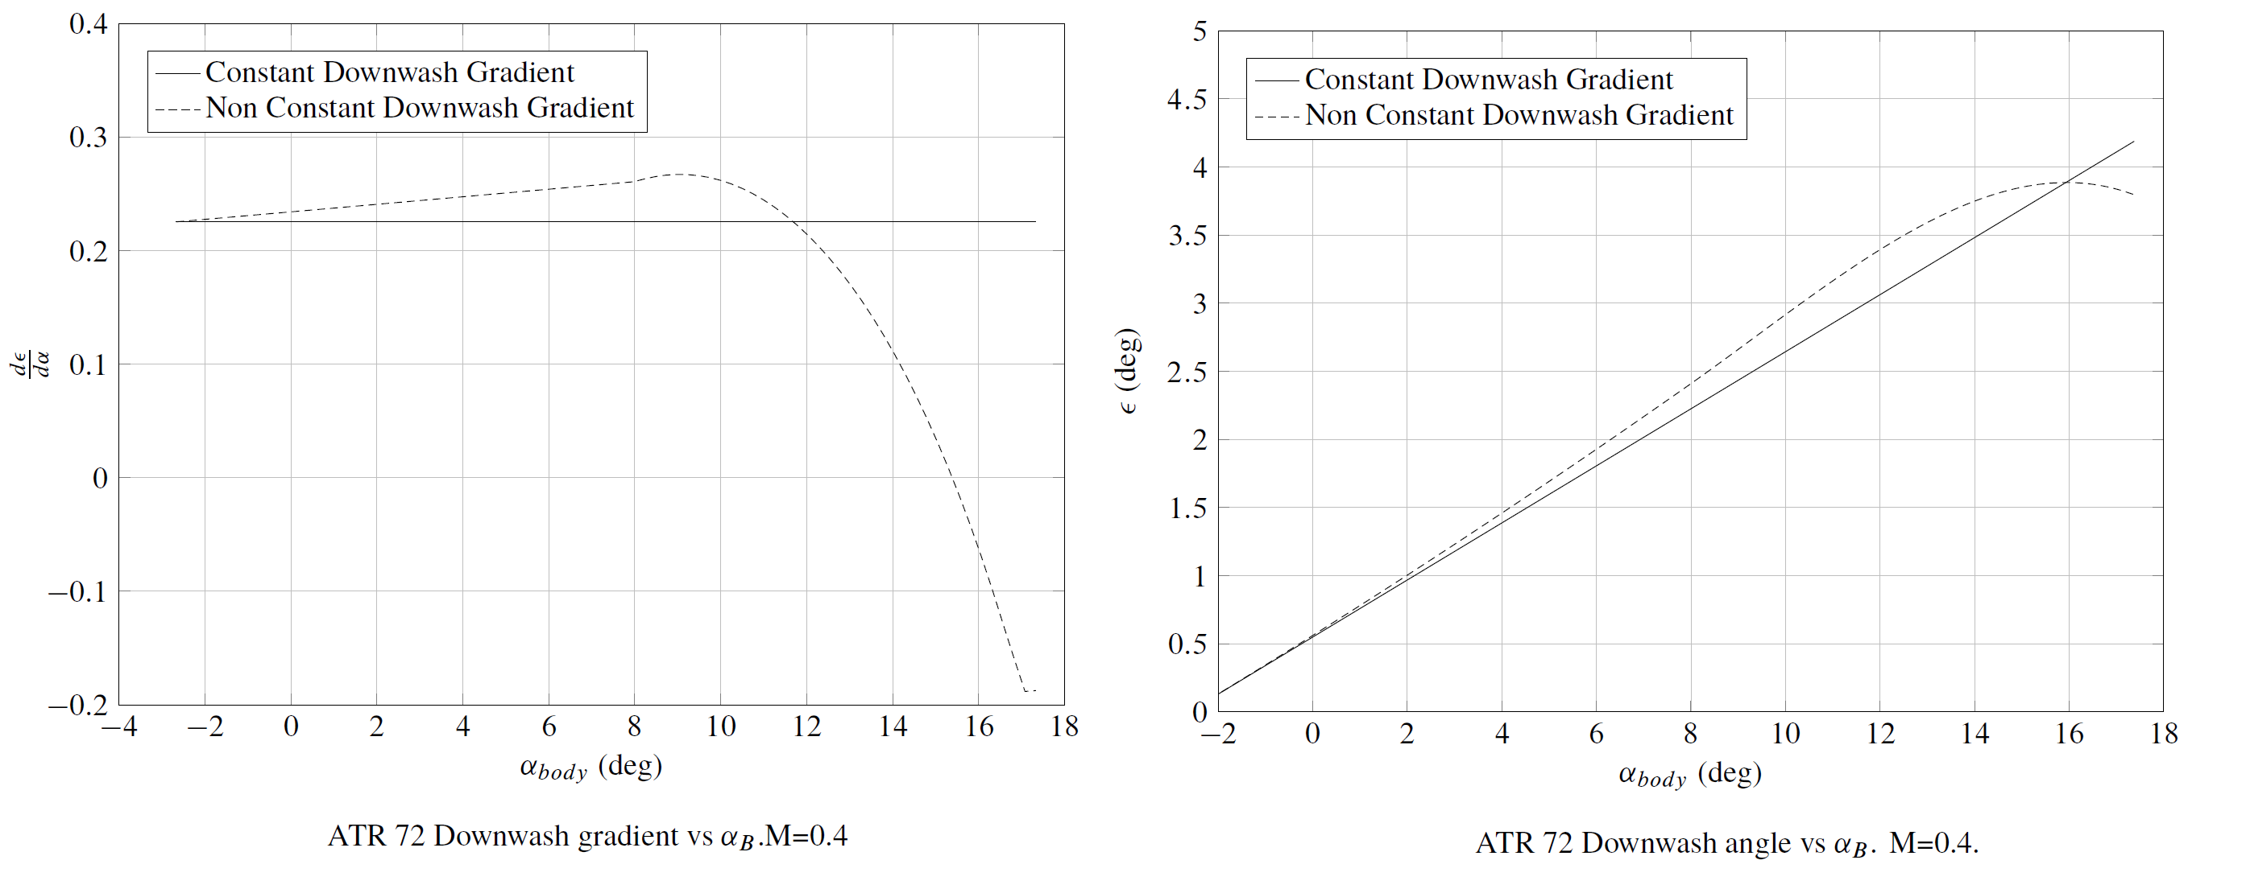

All these features are incorporated in the calculation of longitudinal static stability that is possible to execute for a given aircraft and a flight condition. The stability calculation considers also the propulsion effects, the fuselage pitching moment effect, and the pendular stability due to the drag.
