GLFS 2017 Q4 -- Automated Cleaning & Imputation Report (emig)
Rendered automatically by Scripts/report.py -- every figure below is computed from the pipeline's own output at render time.

1. Dataset Overview
Source: GLFS 2017 Q4 microdata (survey round 174), Bureau of Statistics, Guyana -- household emigration module (emig) track. Row/household counts verified against the source methodological report at ingest (Outputs/logs/emig_ingest.log).
Size: 659 rows x 28 columns (raw, as loaded by ingest.py). Date this raw file first entered the project's version control: 2026-08-06 (not separately logged as a download timestamp; this is the earliest git record of the file).
Variable scope: this report's cleaning/imputation sections cover the assigned named variables only -- sex, age, hours worked, industry (ISIC), occupation (ISCO) -- per the brief's Section 1.2. Every column in the dataset, including the ones outside that scope, is documented in the accompanying data dictionary (Outputs/data_dictionary/emig_data_dictionary.csv).

2. Data Quality Diagnostics (Before Cleaning)
Average missingness across all 28 raw columns: 12.5%. Most of this is structural (skip-pattern) missingness, not a data-quality defect -- see Outputs/diagnostics/emig_report.md for the full column-by-column breakdown.
- Age (q7_06): 28 row(s) carry a -1 ('don't know') sentinel value, not a real age.
- Duplicate person-records: 0 found (exact-match key hhid+emig).
Note on the chart below: missingness legitimately RISES after cleaning for sentinel-corrected columns. clean.py converts placeholder values (-1, 99) -- which are not counted as missing in the raw data, since they are literal numbers -- into honest NaN. A taller 'after cleaning' bar for those columns reflects more accurate missingness reporting, not a defect introduced by cleaning.
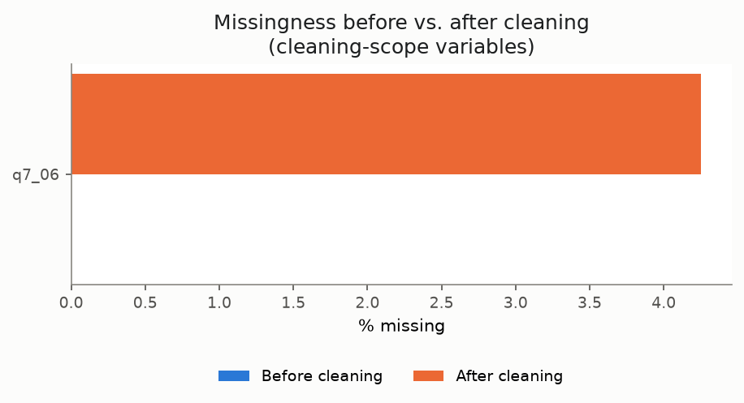

3. Cleaning Decisions
For each class of issue found: what was done, and why. Full evidence in CLEANING_PLAN.md and Scripts/clean.py.
Issue | Decision | Evidence
Exact-duplicate person-records | Dropped (keep first) | 0 found
Age (q7_06) = -1 sentinel | Corrected to NaN | 28 row(s) -- verified 'don't know' placeholder

4. Imputation Applied
Method chosen per variable, per brief Section 3.3 -- justification checked against the actual data, not assumed.
Variable | Method | Rows imputed | Applicable population
Age (q7_06) | Median | 28 | Everyone (age has no applicability gate)

5. Post-Cleaning Summary
Final dataset: 659 rows x 29 columns (1 imputation-flag column added on top of the cleaned data). Average missingness across all columns: 12.0% (mostly structural skip-pattern missingness, not incidental gaps).
Variable | Mean | Median | Min | Max
Age | 39.6 | 38 | 0 | 98
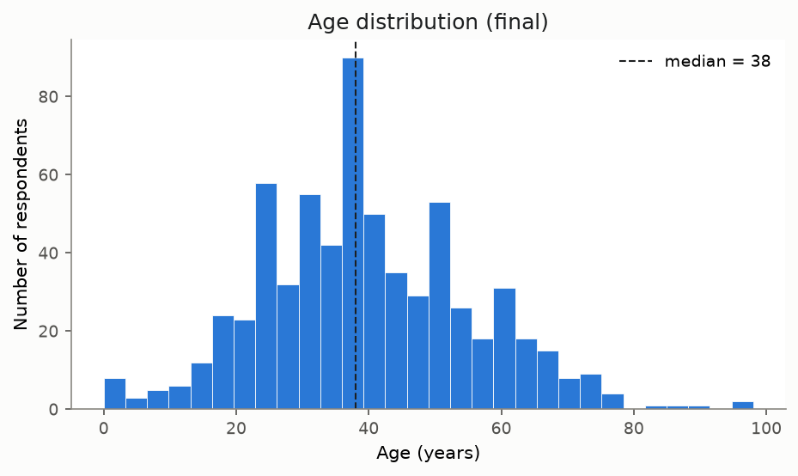

6. A Chart That Tells a Story
Self-reported reasons for having moved out of Guyana.
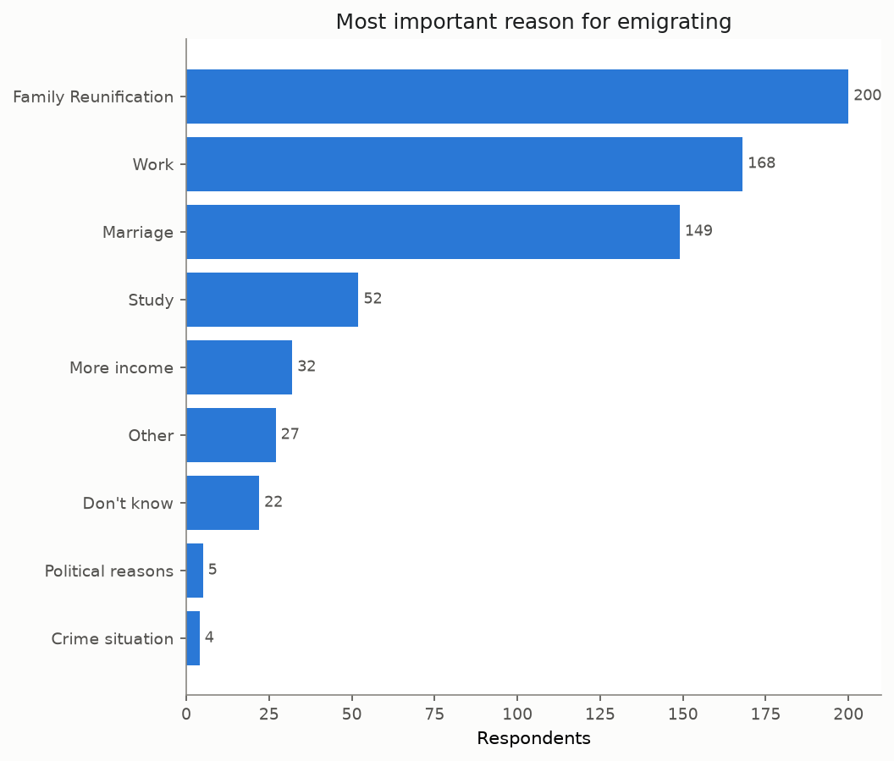

7. Limitations and Known Risks
- Cleaning and imputation are scoped to the assigned named variables only (brief Section 1.2) -- other columns are documented in the data dictionary but not reviewed for quality issues.
- Structural vs. incidental missingness is only classified for a verified, bounded set of single-parent skip gates (config.SKIP_PATTERNS) -- not exhaustive coverage of the full questionnaire's skip logic.
- Free-text consolidation only auto-merges pairs at >=0.98 similarity; the noisier 0.90-0.97 band is left flagged for manual review, not merged.
- Imputation uses simple median fill only (brief Section 3.3's basic-methods ceiling) -- no multivariate or model-based imputation.
- Monetary fields are outlier-flagged (1.5x IQR) but never altered -- genuine right-skewed income data will trigger some flags that aren't actual errors.
- emig has no documented expected row/household count in the source methodological report, unlike ind -- ingest.py logs its counts for the record only, without a pass/fail check.

