GLFS 2017 Q4 -- Automated Cleaning & Imputation Report (ind)
Rendered automatically by Scripts/report.py -- every figure below is computed from the pipeline's own output at render time.

1. Dataset Overview
Source: GLFS 2017 Q4 microdata (survey round 174), Bureau of Statistics, Guyana -- individual records (ind) track. Row/household counts verified against the source methodological report at ingest (Outputs/logs/ind_ingest.log).
Size: 13,853 rows x 175 columns (raw, as loaded by ingest.py). Date this raw file first entered the project's version control: 2026-08-06 (not separately logged as a download timestamp; this is the earliest git record of the file).
Variable scope: this report's cleaning/imputation sections cover the assigned named variables only -- sex, age, hours worked, industry (ISIC), occupation (ISCO) -- per the brief's Section 1.2. Every column in the dataset, including the ones outside that scope, is documented in the accompanying data dictionary (Outputs/data_dictionary/ind_data_dictionary.csv).

2. Data Quality Diagnostics (Before Cleaning)
Average missingness across all 175 raw columns: 67.5%. Most of this is structural (skip-pattern) missingness, not a data-quality defect -- see Outputs/diagnostics/ind_report.md for the full column-by-column breakdown.
- Sex (q1_03): 0 missing (0.0%), clean text values.
- Age (q1_04): 12 row(s) carry a -1 ('don't know') sentinel value, not a real age.
- Hours worked (q3_03): 88 row(s) carry a 99 top-code sentinel; every other value caps at 98.
- Industry/occupation (isic_code/isco_code): missing exactly matches the 9,064 rows with no main job -- structural, not incidental.
- Duplicate person-records: 0 found (exact-match key hhid+member).
Note on the chart below: missingness legitimately RISES after cleaning for sentinel-corrected columns. clean.py converts placeholder values (-1, 99) -- which are not counted as missing in the raw data, since they are literal numbers -- into honest NaN. A taller 'after cleaning' bar for those columns reflects more accurate missingness reporting, not a defect introduced by cleaning.
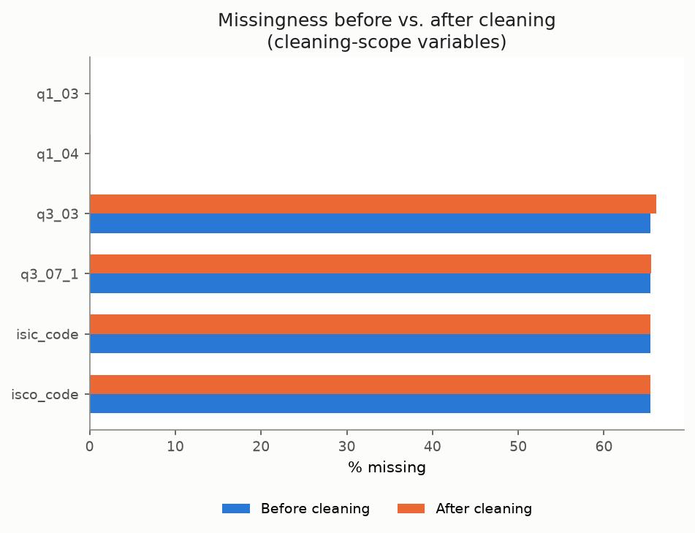

3. Cleaning Decisions
For each class of issue found: what was done, and why. Full evidence in CLEANING_PLAN.md and Scripts/clean.py.
Issue | Decision | Evidence
Exact-duplicate person-records | Dropped (keep first) | 0 found
Age (q1_04) = -1 sentinel | Corrected to NaN | 12 row(s) -- verified 'don't know' placeholder
Hours worked (q3_03) = 99 sentinel | Corrected to NaN | 88 row(s) -- confirmed top-code, checked against every other hours column first
Industry/occupation leading-zero stripping | Zero-padded before classification | 0 of 4,789 coded rows failed to classify after the fix
Free-text near-duplicates (>=0.98 similarity) | Auto-merged to most frequent form | 648 row(s) changed across 6 free-text columns
Monetary outliers (1.5x IQR) | Flagged only, not altered | 583 flag(s) across 509 unique row(s)
Employment skip-logic (isco_code filled with no evidence of employment) | Flagged only, not altered | 0 unexplained violation(s)

4. Imputation Applied
Method chosen per variable, per brief Section 3.3 -- justification checked against the actual data, not assumed.
Variable | Method | Rows imputed | Applicable population
Age (q1_04) | Median | 12 | Everyone (age has no applicability gate)
Hours worked, main job (q3_03) | Median | 88 | Has a main job (q3_16 not null)
Hours worked, main job, day 1 (q3_07_1) | Median | 14 | Has a main job (q3_16 not null)
Hours worked, main job, day 2 (q3_07_2) | Median | 15 | Has a main job (q3_16 not null)
Hours worked, main job, day 3 (q3_07_3) | Median | 14 | Has a main job (q3_16 not null)
Hours worked, main job, day 4 (q3_07_4) | Median | 15 | Has a main job (q3_16 not null)
Hours worked, main job, day 5 (q3_07_5) | Median | 14 | Has a main job (q3_16 not null)
Hours worked, main job, day 6 (q3_07_6) | Median | 15 | Has a main job (q3_16 not null)
Hours worked, main job, day 7 (q3_07_7) | Median | 15 | Has a main job (q3_16 not null)
Hours worked, other job (q3_08) | Median | 1 | Has a second job (q3_01 == 'Yes')
- Hours worked, other job (q3_04): left missing -- 100% structural, confirmed 0 incidental gaps.
- Industry/occupation (isic_code/isco_code): left missing -- confirmed structural (no main job).
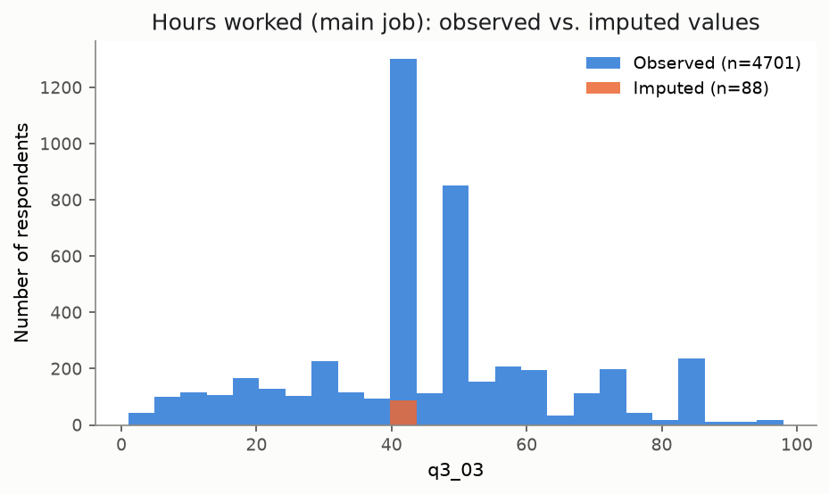

5. Post-Cleaning Summary
Final dataset: 13,853 rows x 189 columns (10 imputation-flag columns added on top of the cleaned data). Average missingness across all columns: 63.9% (mostly structural skip-pattern missingness, not incidental gaps).
Variable | Mean | Median | Min | Max
Age | 30.7 | 26 | 0 | 99
Hours worked (main job) | 44.5 | 40 | 1 | 98
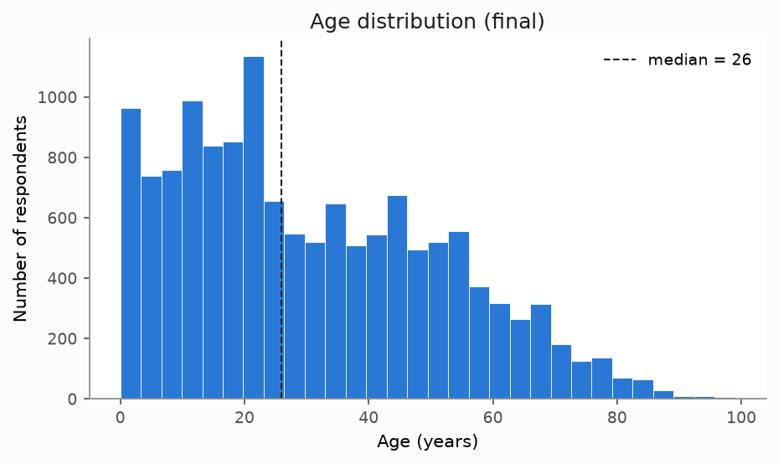
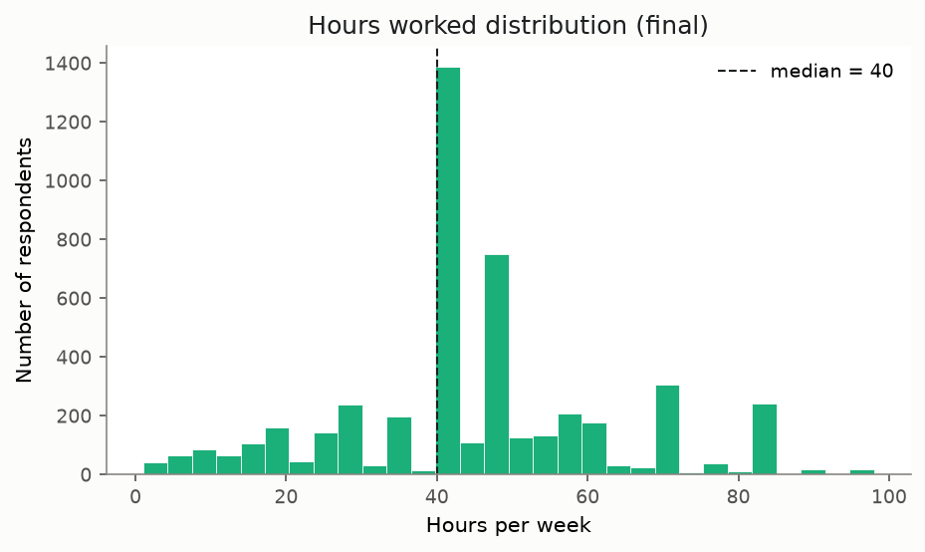

6. A Chart That Tells a Story
Employment status among respondents with a main job.
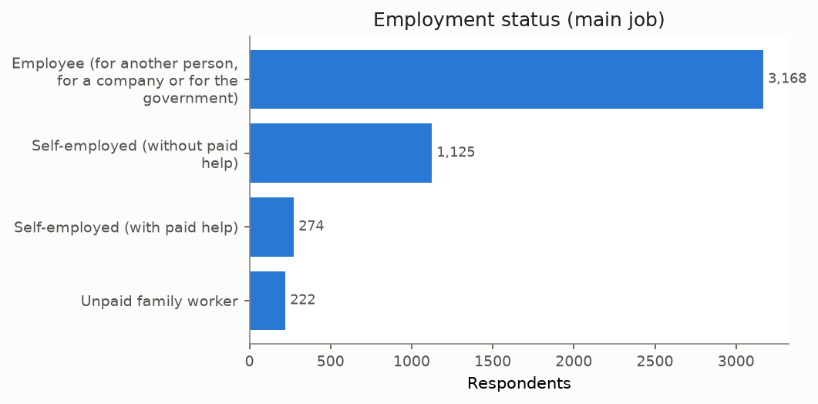

7. Limitations and Known Risks
- Cleaning and imputation are scoped to the assigned named variables only (brief Section 1.2) -- other columns are documented in the data dictionary but not reviewed for quality issues.
- Structural vs. incidental missingness is only classified for a verified, bounded set of single-parent skip gates (config.SKIP_PATTERNS) -- not exhaustive coverage of the full questionnaire's skip logic.
- Free-text consolidation only auto-merges pairs at >=0.98 similarity; the noisier 0.90-0.97 band is left flagged for manual review, not merged.
- Imputation uses simple median fill only (brief Section 3.3's basic-methods ceiling) -- no multivariate or model-based imputation.
- Monetary fields are outlier-flagged (1.5x IQR) but never altered -- genuine right-skewed income data will trigger some flags that aren't actual errors.
- panelid is named like a unique respondent ID but has only 18 distinct values across 13,853 rows -- documented so it is never mistaken for a join key.

