**Algorithms (CSCI 323 & 700)**

**Spring 2016 - Homework #7**

**(Due at the beginning of class on 4/13/2016)\***

1. Compare a Fibonacci heap with an ordinary binary heap in terms of structure, time complexity of operations, and other possible advantages and disadvantages.
2. Use Dijkstra’s algorithm to find the shortest path from source vertex “1” to each of the other five vertices in the weighted graph below. Show the “distance” (d) and “predecessor” (p) arrays after initialization of those arrays and then after each of the subsequent five iterations (after the next closest vertex has been chosen). As the graph is undirected, assume that each edge has the same cost in both directions.

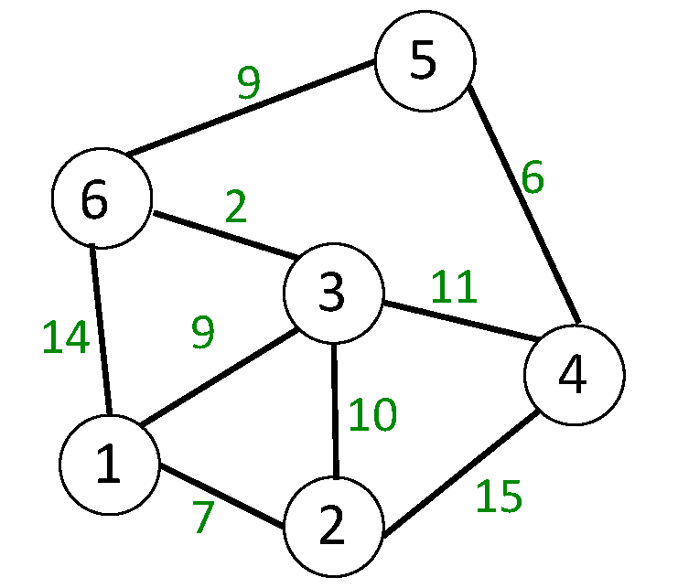

1. Use Prim’s algorithm to find the minimum spanning tree for the weighted graph above, growing the MST from vertex 1. Show the “mincost” and “closest” arrays after initialization and after each of the subsequent five iterations.
2. Given an array a[1..n] of integers, the “largest contiguous subsequence problem” aims to find the subsequence a[i..j] (1 ≤ i ≤ j ≤ n) such that the sum of those elements is larger than the sum of any other contiguous subsequence. (a) Find a brute-force algorithm that solves the problem in Θ(n3) time. (b) Find a dynamic programming algorithm that solves the problem in Θ(n) time. (Hint: make only a single pass through the array and determine whether or the current element increases the subsequence.)

* Only if you will not be able to attend class on the due date, submit your solutions - *before 6:00 p.m. on the due date* - to the instructor at LT.CS320@yahoo.com