CS 344-715

Lecturer: Simina Fluture, PhD

Homework 1 Yuqian Zhang

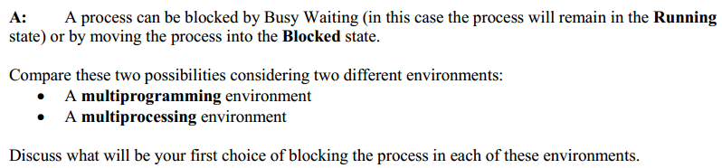

**My solution:**

**A multiprogramming environment:**

* Only 1 CPU and multiple processes ready for execution in main memory.
* There is competition among processes for resources (memory, the CPU, etc.).
* Multiprogramming systems are designed to maximize CPU usage.
* OS checks the cause of interrupt, saves current process state and gives next process to execute.

**First choice of blocking the process:** One common ready queue in block state. We should avoid using busy wait in multiprogramming environment because the CPU waiting time could be used to execute a different task. If we do busy wait, it is a waste of CPU waiting time.

**A multiprocessing environment:**

* More than 1 CPUS and many processes ready for execution.
* CPUs share the computer bus, system clock, main memory and peripheral devices.

1. Symmetric Multiprocessing (SMP)
   * All CPUs are equal/peers.
   * All CPUs have equal priorities to access resources.
   * Any idle CPU is okay.
   * There is only one common ready queue for all CPUs. Schedulers run in mutual exclusion fashion.
   * Multiprocessor system with centralized shared memory operating under a single operating system with 2 or more homogenous processors.

**First choice blocking the process:** One common ready queue in block state. In SMP, all CPUs have equal priorities and each CPU may do a different task. Busy wait may waste a lot of CPU time that can be assigned to other tasks.

1. Asymmetric Multiprocessing (Master-Slave)
   * One master CPU and many slave CPUs
   * Master CPU controls the system and schedules other CPUs.
   * OS executes on the master CPU
   * Each CPU has one common ready queue

**First choice blocking the process:** One common ready queue for each CPU. Since schedulers must execute in a mutual exclusion fashion.



**My solution:**

**Support a Symmetric Multiprocessing environment:**

OS/2 Warp Server 4.0, OS/2 for SMP 2.11, Novell NetWare 4.1 SMP, Novell UnixWare SMP 2.0, SCO Open Server 5.0 with SCO MPX 3.0, Banyan Vines, IBM PC Server 320, 325, 330, 520, 704 and 720,

**Support an Asymmetric Multiprocessing environment:**

PS/2 Server 195 and Server 295

Reference: http://ohlandl.ipv7.net/CPU/ASMP_SMP.html

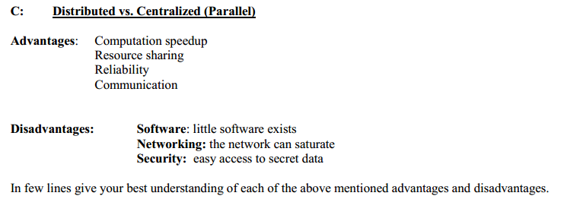

**My solution:**

**Advantages:**

**Computation speedup:**

- Distributed computing: A problem is divided into many tasks, each of them is solved by one or more computers, which communicate with each other by message passing. There is no physical limitation to add more computers to increase the computing power.

- Centralized computing: It is difficult to add more CPUs in a computer. In other word, the computing power is limited.

**Resource sharing:**

- Distributed computing: CPUs do not share main memory, system clock and other resources.

- Centralized computing: CPUs share the main memory and other resources.

**Reliability:**

- Distributed computing: If one computer fails, it doesn’t impact the whole system because they are independent.

- Centralized computing: If one processor fails, the whole system is impacted since all CPUs are using the shared main memory.

**Communication:**

- Distributed computing: Information is communicated only through message passing between the processors.

- Centralized computing: Information can be communicated by shared variable and message passing. All processors may have access to a shared memory. And communicating through shared variable is always 1st choice because it is much faster than message passing.

**Disadvantages:**

**Software: little software exists**

- Distributed computing: We do not have much experience in designing, implementing, and using distributed software.

- Centralized computing: There are a lot of software which can be used by people.

**Networking: the network can saturate**

- Distributed computing: By using network, it might cause losing messages, of which requires special software to take care. When the network saturates, it must either be replaced or another one be added. If network saturates, the cost of fixing it is a great expense on both money and time.

- Centralized computing: Network is not used and will not be a problem.

**Security: easy access to secret data**

- Distributed computing: Secret data is at high risk since information transferred by network can be easily accessed and revised.

- Centralized computing: It is easier and safer to protect secret data in one computer because it is not connected by network.